Action Plan for Implementing the Convention on Biological Diversity’s
Programme of Work on Protected Areas



(INSERT PHOTO OF COUNTRY)

(Swaziland)

Submitted to the Secretariat of the Convention on Biological Diversity
[March 2012]

Protected area information:

PoWPA Focal Point:
Wisdom Mdumiseni D. Dlamini, Swaziland National Trust Commission, P.O. Box 100, Lobamba, Swaziland, Tel: (+268) 2416 1489, Fax:(+268) 2417 1875, email: director@sntc.org.sz

Lead implementing agency:
Swaziland National Trust Commission (SNTC)

Multi-stakeholder committee:
Biodiversity Programme Implementation Committee: members of which include representatives of Academia (University of Swaziland), Government and Civil Society(Communities and Private Sector)

Description of protected area system

National Targets and Vision for Protected Areas
(Insert national targets for protected areas/Target 11 of the Aichi Targets. Include rationale from protected area gap assessment, if completed, along with any additional information about the vision for the protected area system, including statements about the value of the protected area system to the country)
Following Swaziland’s ratification of the Convention on Biological Diversity in 1994, it developed a national Biodiversity Strategy and Action Plan (BSAP). This BSAP highlights an urgent need for increased protection of representative examples of biodiversity.
The protection-worthy areas survey (gap assessment) undertaken in 2002/2003 identified an urgent need for the above laws to state objectives for proclaiming different classes of conservation areas and to state associated restrictions on activities. In the survey, the advantages of using the internationally accepted IUCN guidelines for protected area categories (IUCN 1994) as a basis for proposing categories of protected areas relevant to the needs of the people and environment of Swaziland were also highlighted. Furmore, theneed for the law to recognise lower categories (IUCN V and VI) of conservation area albeit with some customized specifications that address the economic and social needs of the country was also identified.
Currently, only 3.7% of the country is protected although this figure rises to 11.3% when considering areas that are not yet proclaimed but under conservation management and within TFCAs. The target is that by 2020 at least 11.5% of the total land area must be protected and at least 10% of each of the country’s major habitats/ecosystems must be under some form of protection. The gap assessment identified 15 new priority areas of the country as protection-worthy based on biodiversity and socio-economic indicators, as well as overall degree of threat. The survey also recommended for the addition of new categories of protected areas in addition to those identified in the current legislation.
Swaziland is participating in the regional Transfrontier Conservation and Resource Area programme and is working with neighbouring countries to declare and oeprationalise four trans‐frontier parks – the Lubombo Conservancy‐Goba TFCA, the Lubombo Nsubane‐Pongola TFCA, Usuthu‐Tembe‐Futi TFCA and the Songimvelo‐Malolotja TFCA. TFCA’s offer opportunities for community involvement and private sector participation which is critical in the design and implementation of TFCA initiatives. The active involvement of the different tourism authorities from the three countries in the initiative successfully complements their implementation.

Coverage
(Amount and % protected for terrestrial and marine; maps of protected area system)
Swaziland has an established network of seven terrestrial protected areas covering 3.7% of the country. This figure rises to 11.3% when considering other areas that are under strict conservation management. Nevertheless, there is uncertainty if the current protected area network protecting a representative sample of ecosystems. This will gradually be addressed through a more active and streamlined process of gazetting new areas in consultation with the land owners and communities affected. In Swaziland there are three types of conservation areas:
- areas gazetted as National Parks or Nature Reserves under the Swaziland National Trust Commission (SNTC) Act of 1972 (amended in 1973).
- areas gazetted as Game Reserves or Sanctuaries under the Game Act of 1953 (amended in 1991 and 1993)
- non‐gazetted areas.

National Parks and Nature Reserves have equal protection status and are afforded the maximum level of protection to the ecosystem as a whole, with restrictions on access and on any activities that affect the natural ecosystem (from removing rocks to poaching).
Game Reserves or Sanctuaries have equal protection status and afford a maximum level of protection to animals and birds within the area, placing firm restrictions on access and on any activities which directly harm such species.
Non‐gazetted areas have no restrictions on activities other than those which apply to any normal area of land under similar ownership.
A ‘conservation area’ means ‘any natural area which is actively managed with biodiversity conservation as a primary objective.’ The concept of ‘conservation area’ is therefore distinct from that of ‘protected area’ which means ‘any area which is proclaimed by law as an area for biodiversity conservation.’ In total there are 17 conservation areas in Swaziland, under various ownership and management scenarios, and with varying levels of legal protection and enforcement. There are a number of other private farms and national areas which contain wildlife and which are in a natural state. Some are even actively managed to conserve wildlife (for example IYSIS and the Big Bend Conservancy employ rangers to curb game poaching on their extensive cattle ranches). Only six areas have been proclaimed, and these cover 86% of the total area under conservation. Three of the six gazetted areas are Nature Reserves proclaimed under the SNTC Act and managed by the SNTC (Mlawula) or where some aspects of management have been contracted out by the SNTC to a private company (Malolotja and Mantenga). The other three gazetted areas are managed privately by Big Game Parks, and include:
- Wildlife Sanctuary proclaimed under the SNTC Act (Mlilwane)
- Game Reserve proclaimed under the SNTC Act (Mkhaya)
- Royal National Park, proclaimed under the Game Act (Hlane).
The remaining 11 conservation areas (Shewula, Mbuluzi, Simunye, Nisela, Sibhetsumoya, Mhlosinga, Phophonyane, Mutimuti, Oberland, Hawane, Shonalanga) are not gazetted and have no legal conservation status.
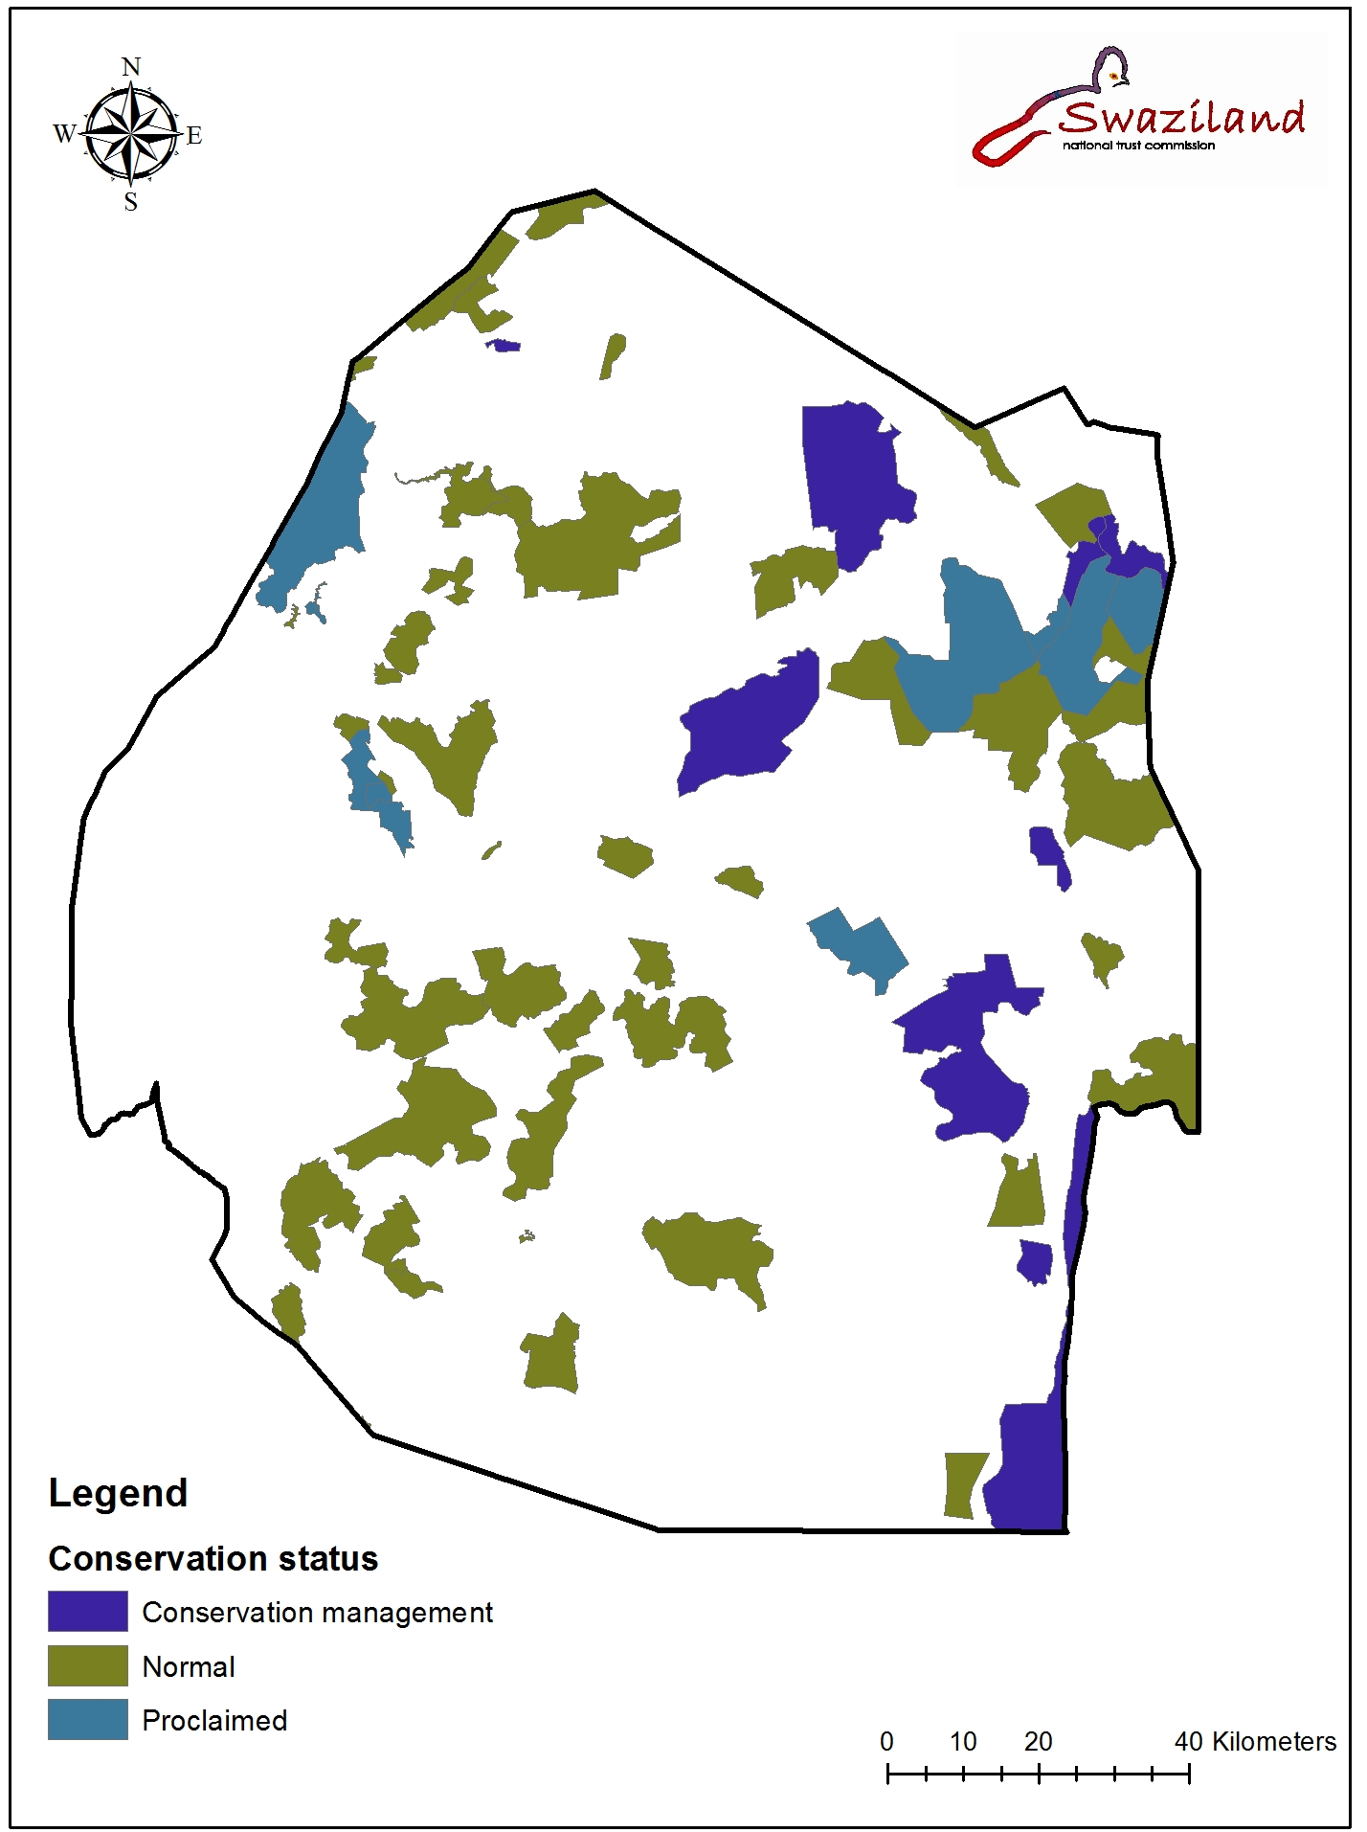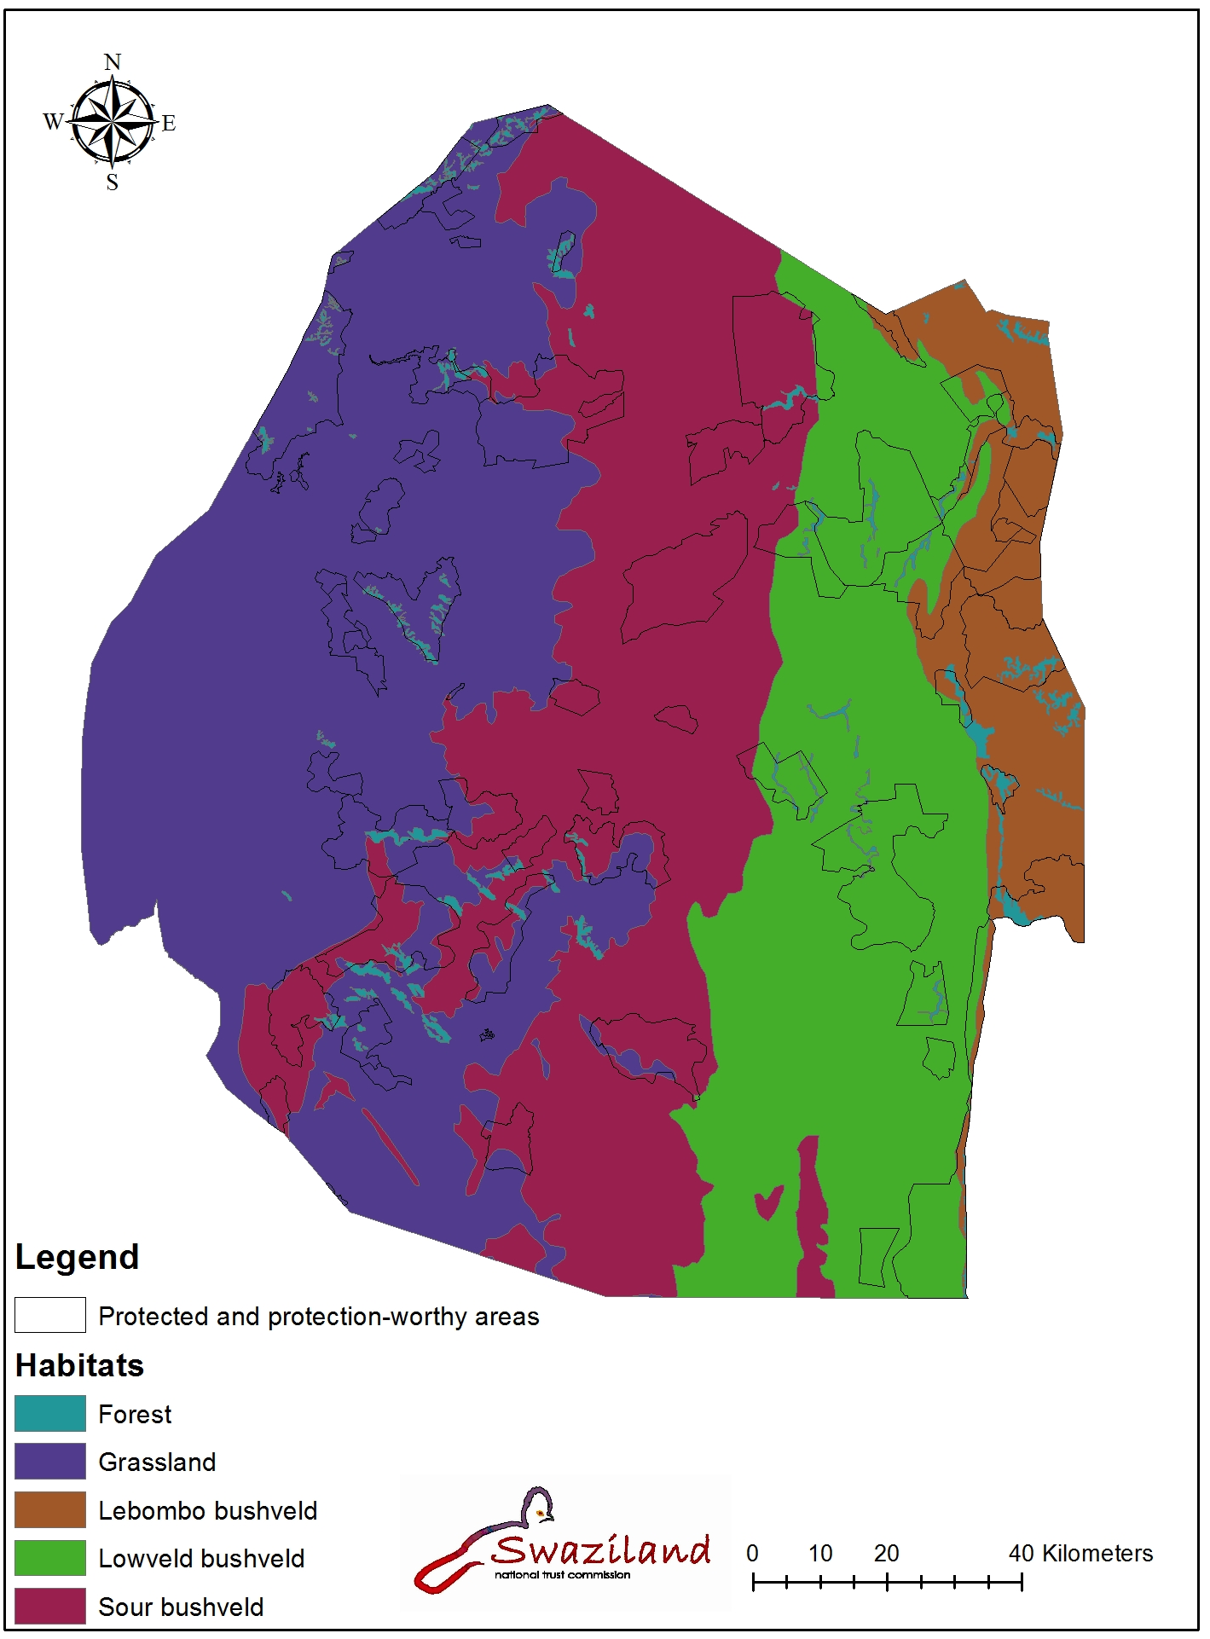

Description and background
(Summary description)
Despite a number of conservation planning exercises, Swaziland has a history of reserves being established in a relatively unsystematic manner. Swaziland’s first reserve, Hlatikulu, was proclaimed in 1905, and it’s second, Ubombo, in 1907 (Hackel & Carruthers 1993). The primary goal for these areas was the conservation of large mammal species. Up until 1917, these areas covered well over 10% of the country and appeared to be achieving their goal. Thereafter, an outbreak of Nagana (sleeping sickness) resulted in game being seen as a threat to the livestock industry and with concurrent economic recession, the majority of the area was de-proclaimed. By 1922 both reserves had been entirely de-proclaimed. Forty two years later, following the near decimation of Swaziland’s large mammals (Reilly 1994), the Kingdom’s first existing reserve, Mlilwane Wildlife Sanctuary, was proclaimed under the Game Act of 1953. Later in 1967, Hlane Game Reserve was proclaimed under the same act. In 1972, the Swaziland National Trust Commission (SNTC) was formed specifically to conserve areas and features representative of Swaziland’s natural and cultural heritage. As part of the establishment of SNTC, an initial assessment of protection worthy areas in Swaziland was done in 1972 (Grimwood 1973). The report was a first step towards developing a plan for creating “a pattern of [National] parks representative of all of the four main regions of Swaziland and covering as many as possible of the various ecosystems of each of them” (Grimwood 1973). Grimwood’s work involved approximately 4 months of aerial and field based investigation. This report identified 6 protection worthy areas including Mlilwane and Hlane. Following this report, one of the proposed areas was proclaimed, Malolotja Nature Reserve, in 1977.
A second survey of national protection worthy areas was commissioned by SNTC in 1978 (Reilly 1979). The survey identified 31 protection worthy areas, including Mlilwane, Hlane and Malolotja, which would have resulted in protection of 9.47% of the Kingdom. Of this, 58% was proposed as National Parks, 13% as Nature Reserves, 24% as National Landscapes and 5% as National Wetlands. Only one of the 31 areas proposed was proclaimed, Mlawula Nature Reserve, in 1980. A fifth reserve, Mkhaya Game Reserve, was proclaimed in 1985 although it was not identified in either of the surveys. Two areas adjacent to existing reserves, Hawane (Malolotja) and Mantenga (Mlilwane) have since been proclaimed in 1992 and 1994 respectively. These total Swaziland’s seven existing reserves, which cover 64100 ha, only 3.7 % of the country.
As part of the Ministry of Agriculture and Co-operatives’ National Forest Policy and Legislation Project, another avenue for setting aside areas for the conservation of flora was created through the Flora Protection Act of 2000. This Forest Policy and Legislation Project commissioned a desk-top assessment of protection worthy areas in 2000 (Deale et al. 2000). This identified 11 areas in addition to the 30 previously identified (excluding proclaimed areas), and did a preliminary desk-top prioritization of these 41 areas in terms of their conservation value.

Governance types
(Summary matrix of governance types)
At present in Swaziland there are three laws that permit areas to be set aside for conservation, the SNTC act of 1972, the Game act of 1953 amended in 1991 and 1993, and the Flora Protection act of 2000. The SNTC Act refers to National Parks (all land owned by the state), Nature Reserves (at least some of the land not owned by the state) and National Monuments. The Game Act refers to Game Reserves and Wildlife Sanctuaries. The Flora Protection Act refers to Flora Reserves and Botanical Gardens.
The Game act and Flora Protection Act focus on specific components of biodiversity (Game and Plants) rather than specific geographic areas. Both contain lists of specially protected animals and plants with restrictions on activities that threaten the survival of these. Both are applicable throughout the country and can therefore be enforced anywhere. Although areas can be designated for conservation under these acts, the objectives of doing such are not clearly specified and there is little explicit restriction on activities within these areas. On the other hand, the SNTC act focuses on specific geographical areas. It was developed specifically to set aside areas for conservation and gives the strongest power to conserve areas and the broadest inclusion of all components of biodiversity.

IUCN category (primary management objective) | IUCN Governance type
IUCN category (primary management objective) | A. Governance by governments |  |  | B. Shared governance |  |  | C. Private governance |  |  | D. Governance by indigenous peoples and local communities
IUCN category (primary management objective) | Federal or national ministry or agency in charge | Local ministry or agency in charge | Management delegated by the government (e.g. To an NGO) | Transboundary protected area | Collaborative management (various pluralist influences) | Collaborative management (pluralist management board | Declared and run by private individual | Declared and run by non-profit organisations | Declared and run by for-profit individuals | Declared and run by indigenous peoples | Declared and run by local communities
I – Strict nature or wilderness protection
II – Ecosystem protection and recreation |  | A |  | E, B |  |  |  |  | B
III – Protection of natural mon-ument or feature
IV – Protection of habitats and species |  |  | C |  |  |  | F
V – Protection of landscapes or seascapes
VI – Protection and sustainable resource use |  |  |  | E |  |  |  |  |  |  | D

Case A: Malolotja, Mlawula and Mantenga Nature Reserve. Owned and managed by the Swaziland National Trust Commission on behalf of the state to protect species and habitats unique to those areas;
Case B: Royal Jozini Big 6. Managed by the private sector in cooperation with local communities to reduce grazing and restore Lowveld ecosystems and transboundary conservation;
Case C: Hlane National Park. Important area of the country’s large game species, the adjacent area being used for royal hunting expeditions.
Case D: Shewula Community Conservation Area. Proposed by the Shewula Community on their traditional lands and currently managed according to traditional Swazi law and custom;
Case E: Lubombo Conservancy, Royal Jozini Big 6.
Case F: Mlilwane and Mkhaya Game Reserve.

Key threats
(Description of key threats, and maps, if available)
Although numerous actual and potential threats to Swaziland’s biodiversity exist, a comprehensive study of these threats and their impact is missing. Regional threats include factors such as atmospheric and water pollution, reductions of flow in rivers that have their sources in South Africa, cross‐border smuggling of organisms and the increasing spread of alien invasive plant species from neighbouring countries. Local threats to Swaziland’s biodiversity can be grouped into the following categories: 1) those that destroy or alter the habitat, 2) over‐exploitation, 3) the impact of exotic species, 4) weak law enforcement, 5) i inadequate awareness of value of resources, 6) human population growth, 7) lack of equity in ownership and management of biodiversity and 8) climate change.
Natural processes, e.g. erosion, and human activities, i.e. agriculture, forest plantations, and human settlements, are causing a decrease in the diversity and distribution of Swaziland's natural flora and fauna. Large‐scale irrigated agriculture, particularly monoculture agriculture such as sugar cane, pineapple and citrus production has resulted in clearing of large tracts of land and destruction of the natural vegetation. This in turn, results in loss of the animals which depend on it.
Regional threats to the biodiversity of Swaziland include factors such as atmospheric and water pollution; reduction of flow in rivers which have their sources in South Africa; cross‐border smuggling of indigenous species and species products; and the washing downstream of alien invasive plant species (such as Chromolaena odorata, Lantana camara, Sesbania punicea and Melia azedarach) from neighboring South Africa.
Ever increasing poverty, particularly in the rural areas, is resulting in the rapid degradation of these resources in a vicious cycle of declining availability of these hitherto free resources. This combined with recurrent drought and climatic changes, is resulting in a heavily degraded natural environment that responsible agencies are battling to address in light of higher national priorities.
Land degradation, fragmentation of habitats, alien plant invasions and rapid degradation of the biological resources are the key challenges to be addressed by the country. The various policy and legislative initiatives launched by government since Rio have so far remained mostly on paper, are not cross‐sectoral or integrated and most importantly are not matched by adequate funding and expertise to implement the measures recommended by stakeholders.
Barriers for effective implementation
(Description of key barrier s for effective implementation)

As outlined above, little progress has been made in implementing the Swaziland’s commitments to the CBD’s Programme of Work on Protected Areas. Challenges remain and there are some examples of where Swaziland is falling short of its targets.
In spite of the progress made in establishing a coherent policy and legal framework for biodiversity conservation (an ongoing process), there remains an under‐appreciation among key decision‐makers, both in government and the private sector, of the important role of biodiversity in the economy and for society at large. The sector needs to find ways of communicating its message more effectively.
Financial resources to implement priority activities are an ongoing challenge – national government support and allocation of budget to organs of state with biodiversity responsibilities is critical, as is external support from sources such as the Global Environment Facility, the UNDP and (potentially) the Critical Ecosystem Partnership Fund – without this support, the bioregional programmes would not have been able to progress as they have done. Swaziland’s classification as a lower‐middle income country has contributed to the difficulty in accessing donor funding for conservation and environmental management.

Status, priority and timeline for key actions of the Programme of Work on Protected Areas

Status of key actions of the Programme of Work on Protected Areas
Status of key actions of the Programme of Work on Protected Areas | Status
- Progress on assessing gaps in the protected area network (1.1) | 4 – this needs to be updated
- Progress in assessing protected area integration (1.2) | 1
- Progress in establishing transboundary protected areas and regional networks (1.3) | 3
- Progress in developing site-level management plans (1.4) | 4 – these need to be updated
- Progress in assessing threats and opportunities for restoration (1.5) | 2
- Progress in assessing equitable sharing of benefits (2.1)  - Progress in assessing protected area governance (2.1) | 2
- Progress in assessing the participation of indigenous and local communities in key protected area decisions (2.2) | 2
- Progress in assessing the policy environment for establishing and managing protected areas (3.1)  - Progress in assessing the values of protected areas (3.1) | 1
- Progress in assessing protected area capacity needs (3.2) | 1
- Progress in assessing the appropriate technology needs (3.3) | 1
- Progress in assessing protected area sustainable finance needs (3.4) | 2
- Progress in conducting public awareness campaigns (3.5) | 3 - ongoing
- Progress in developing best practices and minimum standards (4.1) | 0
- Progress in assessing management effectiveness (4.2) | 2
- Progress in establishing an effective PA monitoring system (4.3) | 2
- Progress in developing a research program for protected areas (4.4) | 2
- Progress in assessing opportunities for marine protection | n/a
- Progress in incorporating climate change aspects into protected areas | 1
Status: 0 = no work, 1 = just started, 2 = partially complete, 3 = nearly complete, 4 = complete
(Insert notes as appropriate)

Priority actions for fully implementing the Programme of Work on Protected Areas:
(Insert priority actions)

Timeline for completion of key actions
(Insert timeline)

Action Plans for completing priority actions of the Programme of Work on Protected Areas
(Insert detailed action plans)

Action 1: Expand the protected area network to 11.5% of the total land area and ensure that at least10% of each major ecosystem/habitat is protected by 2020.
Key steps | Timeline | Responsible parties | Indicative budget
Identify opportunities for Swaziland to strengthen participation in existing trans-boundary protected landscapes | 2015 | SNTC | 100,000
Analyse land use change over past 15 years and update protected area, biodiversity and ecosystems data including land use, land cover, land degradation and forest inventory with special attention given to identify opportunities for new protected areas (Gap Assessment) | 2014 | MTEA/SEA/SNTC | 600,000
Develop protected area guidelines for applicable categories of protected areas | 2014 | SNTC/MTEA | 200,000
Identify and resolve key institutional and legal hurdles to prioritise the proclamation of new protected areas (Policy assessment) | 2014 | SNTC/SEA/MTEA/MOJCA | 100,000

Action 2: Integrate protected area management into the wider landscape (biosphere) and other sectors
Key steps | Timeline | Responsible parties | Indicative budget
Develop an appropriate Natural Resource Accounting system including valuation of protected areas, biodiversity and environmental services | 2015 | MTEA/SEA/SNTC | 300,000
Capacity building of stakeholders (private, communities, local authorities) in integrated landscape management (with conservation, ecotourism, enhancement of carbon stocks and sustainable land management) | 2014 | MTEA/SNTC/SEA | 500,000
Review and identify eco-tourism opportunities in the wider production landscape through community /private /public partnerships in areas such as the Lubombo region, building upon management plans proposed under the Critical Ecosystem Partnership Fund (CEPF) | 2015 | SNTC/SEA/Lubombo Conservancy | 350,000
Develop or adapt sustainable land management best practices for testing in selected pilot areas in suitable and representative ecosystems / forestry types / production landscapes within a defined geographic context, e.g. watershed and administrative (lower level) | 2014 | MTEA/SEA/MOA/SNTC | 1,200,000

Action 3: Revise protected area management plans by 2015 to include climate change mitigation and adaptation and other key emerging issues.
Key steps | Timeline | Responsible parties | Indicative budget
Interpret climate data to determine climate change and trends using available baseline data set for 1960-2010 5 and analyse climate change influences on present AEZ and ecosystems. | 2014 | MTEA/Swaziland Meteorological Services/SEA | 150,000
Prepare comprehensive protected area management plans, with a focus on harmonizing and promoting activities that respond to climate change and land degradation. | 2015 | MTEA/MOA/SNTC/SEA | 50,000

(Insert more as needed)

Key assessment results
Ecological gap assessment (insert summary findings if available)
In 2002 a survey to identify protection worthy areas was carried out and using a variety of assessment criteria, 44 protection‐worthy areas were ranked in terms of priority for conservation. No new protected areas have been declared since 1994 when the Mantenga Nature Reserve was proclaimed, though new areas are in the pipeline for proclamation: Phophonyane Nature Conservancy (600 ha), Muti Muti Nature Conservancy (6,000 ha) and Mlumati Nature Reserve (400 ha).

Management effectiveness assessment (Insert summary findings if available)
N/A
Sustainable finance assessment (Insert summary findings if available)
N/A
Capacity needs assessment (Insert summary findings if available)
N/A
Policy environment assessment (Insert summary findings if available)
N/A
Protected area integration and mainstreaming assessment (Insert summary findings if available)
There has not been any assessment of PA integration and mainstreaming although some preliminary analysis was done through the protection-worthy areas survey of 2002 and in the preparation of the 4th National Report to the CBD.
Although it still faces challenges, Swaziland is making steady progress towards mainstreaming protected areas in various other sectors both the public and private. This is achieved mainly through the use of EIAs during project formulation and ensures to some degree that the biological resources likely to be affected are assessed and where necessary mitigated for. The responsibility for managing and conserving biodiversity cuts across national and local government structures as well as government agencies, NGOs, the private sector and communities.

Protected area valuation assessment (Insert summary findings if available)
N/A
Climate change resilience and adaptation assessment (Insert summary findings if available)
As part of the country’s Second National Report to the UNFCCC, a biodiversity vulnerability and adaptation assessment was undertaken. Key findings reveal that many of Swaziland’s most valued natural areas, and the rich biodiversity they support, are most vulnerable to climate change. They include the montane grassland, the Lebombo bushveld, Lowveld bushveld and the aquatic ecosystems. The magnitude and rate of climate change pose particularly severe challenges for the country’s natural ecosystems. The interaction of climate change with existing stresses – such as land clearing, fire and alien invasive species – and the different migration rates of species and consequent formation of novel ecosystems, add further levels of complexity. In summary, climate change is likely to induce the following:
- Large-scale vegetation (habitat) and species shifts particularly grasslands and the Lebombo bushveld.
- A re-arrangement of current plant communities and ecosystems resulting in significant changes in habitat quality.
- A general expansion of sour bushveld species ranges westwards (south-westwards) and upslope (for grassland species, this will mean drastic range contractions).
- Loss of ecosystems resulting in significant changes in habitat availability for a number of species fauna.
- Significant changes are required in policy and management for biodiversity conservation to meet these types of challenges.

(Insert other assessment results if available)

