Action Plan for Implementing the Convention on Biological Diversity’s
Programme of Work on Protected Areas
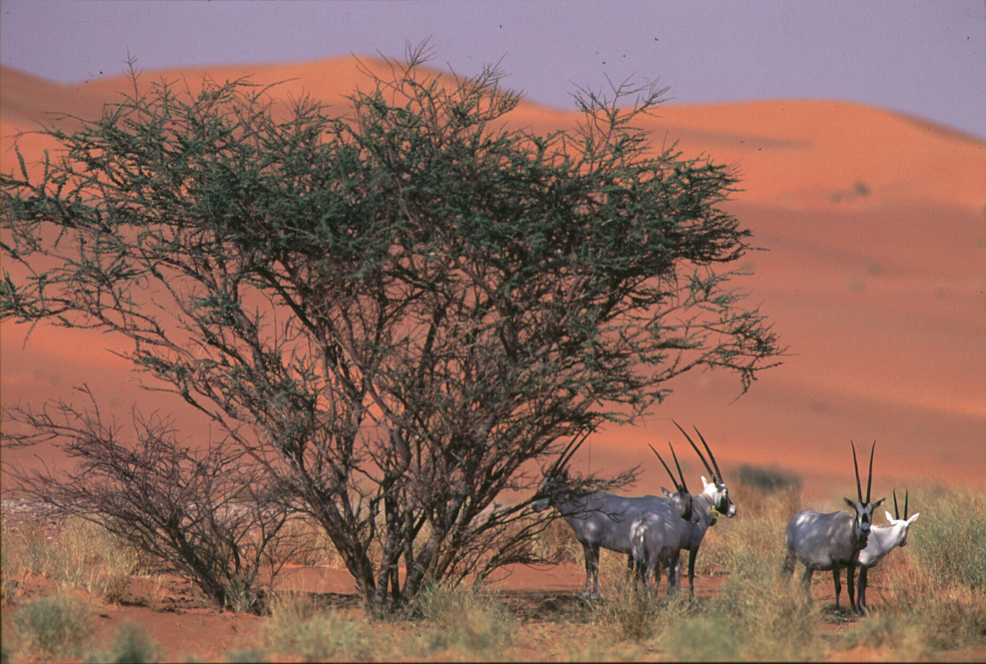
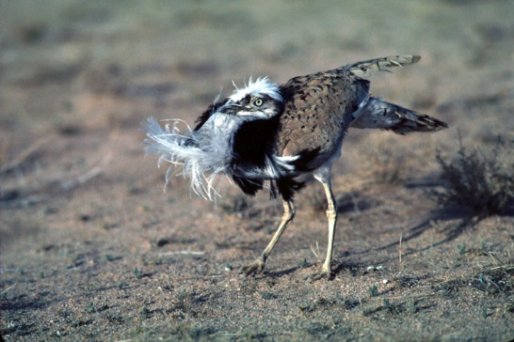 | 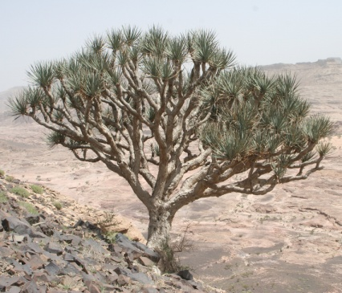 | 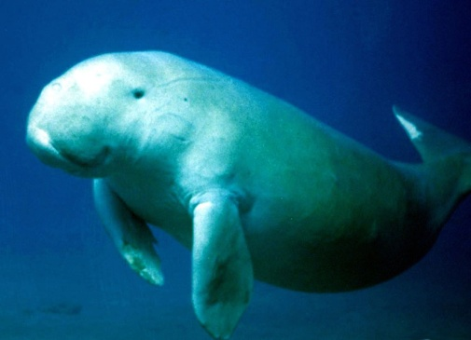

Kingdom of Saudi Arabia
Submitted to the Secretariat of the Convention on Biological Diversity 25 June 2012

Protected Areas Information

PoWPA Focal Point: (Name, contact details)
Mr. Kutaiba H. Al-Saadon
Director
Department of Protected Areas Planning
Saudi Wildlife Authority
P.O. Box 61681
Riyadh 11575
Saudi Arabia
+966 1 441 9655
+966 1 441 9655
sadon2@windowslive.com
Mobile: 00 966 505 228 581
Lead implementing agency:
Saudi Wildlife Authority
P.O. Box 61681
Riyadh 11575
Saudi Arabia
+966 1 441 8700
+966 1 441 0797
sg@swa@.gov.sa and info@conserv-train.org.sa

Multi-stakeholder committee: (Add description)
The implementation of the Convention on Biological Diversity (CBD) and its programmes is overseen by the National Biodiversity Committee – a multi-stakeholder committee represented by stakeholders / agencies including the Ministry of Agriculture, Ministry of Planning, Ministry of Education, King Saud University, businesses and two non-government organizations (Saudi Environmental Society and Friends of the Environment).

Description of protected area system

National Targets and Vision for Protected Areas

The Kingdom of Saudi Arabia has two policy documents: the National Biodiversity Strategy and Action Plan (NBSAP) and the Protected Area System Plan, which set national targets and a vision for Protected Areas in the Kingdom.

The National Protected Area System Plan is the guiding document for Saudi Arabia to fulfill its obligations with regard to in situ conservation under the Convention on Biological Diversity. The National Protected Area System Plan was first published in 1990 and later revised in 2010. The System Plan identifies sites for protection, provides a gap assessment, and includes a Policy Statement that serves as the vision for the national network of Protected Areas. The Policy states:

“maximize the potential of protected areas for the conservation of biological diversity and for bringing equitable and sustainable benefits to local communities.”

In addition to this the National Biodiversity Strategy proposes 17 Strategic goals out of which the first two are directly relevant to the implementation of the PoWPA:

NBSAP Strategic Goal 1 (In-Situ Conservation - Inside Protected Areas)

“To protect terrestrial, marine and freshwater ecosystems by means of establishing a
comprehensive system of protected areas for in-situ conservation of biodiversity in Saudi
Arabia.”
NBSAP Strategic Goal 2 (In-situ Conservation - Outside Protected Areas)

“To conserve and manage terrestrial, marine and freshwater biodiversity by securing the
safety of wild populations of flora and fauna in their natural habitats outside the boundaries
of recognized protected areas.”
Furthermore, the National Strategy proposes a set of 23 actions for the realization of these two Strategic Goals.

Coverage
The existing Protected Area coverage including existing protected areas managed by the SWA and partner agencies is 4.90% and will increase to 10.42% under the revised System Plan.
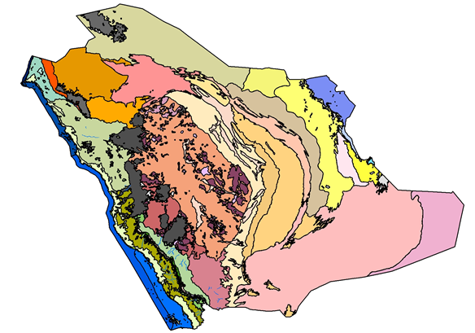

Bioregions of the Kingdom of Saudi Arabia: 45 terrestrial and 7 marine; 52 bioregions in all (source: revised Protected Area System Plan). The revised Protected Area System Plan achieves 98% representation of these bioregions, although there is a wide variance in the coverage of individual bioregions.

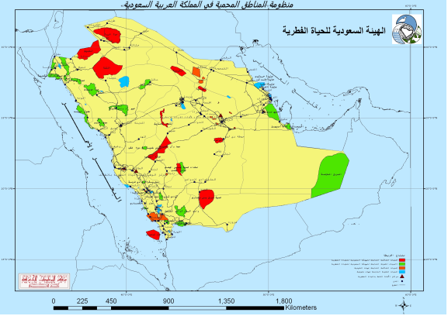
Map of Saudi Arabia’s Protected Area System. The 15 existing protected areas managed by the SWA are shown in red, and the 18 existing protected areas managed by partner agencies in orange. The 20 proposed protected areas to be managed by SWA and the two proposed extensions of existing protected areas are in green and the 22 proposed protected areas to be managed by partner agencies are shown in blue. (Source: revised Protected Area System Plan).

Description and background
The Kingdom of Saudi Arabia occupies three-fourths of the Arabian Peninsula and a considerable expanse of the coastal waters of both the Red Sea and the Arabian Gulf. The Saudi Wildlife Authority (SWA) is the main agency charged with the conservation and restoration of the Kingdom’s biological diversity and manages 15 protected areas within the Kingdom. In addition, 18 protected areas are managed by partner agencies including Ministries, other national and local authorities, and local communities. A revised Protected Area System Plan prepared by the SWA shows that the existing protected area network represents 29 out of the 47 terrestrial and 7 marine bioregions in the Kingdom. The revised system plan aims to fill gaps in the network so as to increase the representation to 51 out of these 52 bioregions. This Action Plan draws elements from the National System Plan and the National Biodiversity Strategy in order to set a course for the implementation of the Programme of Work for Protected Areas (PoWPA) in Saudi Arabia.
Governance types
(Summary matrix of governance types)
Governance types  PA Categories | - Government  Managed Protected Areas |  |  | B. Co-managed Protected Areas |  |  | C. Private Protected Areas |  |  | D. Community Conserved Areas
Governance types  PA Categories | Federal or national ministry or agency in charge | Local / municipal ministry or agency in charge | Government-delegated management (e.g. to an NGO) | Transboundary management | Collaborative management (various forms of pluralist influence) | Joint management (pluralist management board) | Declared and run by individual land-owner | ….by non-profit organizations (e.g. NGO, universities, co-operatives) | … by for profit organizations (e.g. individual or corporate land-owners) | Declared and run by indigenous peoples | Declared and run by local communities
Ia – Strict Nature Reserve | √
Ib – Wilderness Area | √
II – National Park | √
III – Natural Monument | √ | √
IV- Habitat / Species management | √ | √ |  |  |  |  |  |  |  |  | √
V- Protected Landscape / Seascape | √ | √ |  |  | √ | √ |  |  |  |  | √
VI-Managed Resource Protected Area | √ |  |  |  |  | √ |  |  |  |  | √

Key threats
The National Protected Area System Plan and the NBSAP identify the following threats:
- Illegal Hunting
- Overgrazing
- Urban expansion, road construction
- Agricultural expansion and use of insecticides
- Littering
- Invasive species and introduction of exotic
- Overfishing,
- Mining
- Destruction of mangroves and woodlands

Preliminary Threat Ranking
(based on the threats identified for Terrestrial Biodiversity in the NBSAP)
Threats | Severity
Degradation of rangelands | Very High
Uncontrolled cutting of trees and shrubs [Western & Central Regions) | High
Land conversion – urbanization, agricultural expansion in virgin areas | High
Periodic drought | Medium
Overhunting | Very High
Loss of water resources | High
Invasive alien species | Medium

Barriers to effective implementation
- Inter-agency coordination
- Participation of local communities
- Legislation and Enforcement

Status, priority and timeline for key actions of the Programme of Work on Protected Areas

Status of key actions of the Programme of Work on Protected Areas
Status of key actions of the Programme of Work on Protected Areas | Status
- Progress on assessing gaps in the protected area network (1.1) | 3
- Progress in assessing protected area integration (1.2) | 1
- Progress in establishing transboundary protected areas and regional networks (1.3) | 0
- Progress in developing site-level management plans (1.4) | 2
- Progress in assessing threats and opportunities for restoration (1.5) | 2
- Progress in assessing equitable sharing of benefits (2.1)  - Progress in assessing protected area governance (2.1) | 1
- Progress in assessing the participation of indigenous and local communities in key protected area decisions (2.2) | 1
- Progress in assessing the policy environment for establishing and managing protected areas (3.1)  - Progress in assessing the values of protected areas (3.1) | 1  2
- Progress in assessing protected area capacity needs (3.2) | 4
- Progress in assessing the appropriate technology needs (3.3) | 0
- Progress in assessing protected area sustainable finance needs (3.4) | 0
- Progress in conducting public awareness campaigns (3.5) | 2
- Progress in developing best practices and minimum standards (4.1) | 1
- Progress in assessing management effectiveness (4.2) | 1
- Progress in establishing an effective PA monitoring system (4.3) | 2
- Progress in developing a research program for protected areas (4.4) | 2
- Progress in assessing opportunities for marine protection | 3
- Progress in incorporating climate change aspects into protected areas | 1
Status: 0 = no work, 1 = just started, 2 = partially complete, 3 = nearly complete, 4 = complete

Priority actions for fully implementing the Programme of Work on Protected Areas:

The following PoWPA actions directly correspond to the Saudi Arabian NBSAP and are priority actions for the Kingdom:

1.1.2 Protect large unfragmented blocks
1.1.4 Assess governance types
1.1.5 Assess ecological gaps
1.1.7 Encourage PAs that benefit indigenous communities
1.2.1 Evaluate lessons learned
1.2.2 Implement steps to improve policy integration
1.4.2 Identify measurable biodiversity conservation targets for sites
1.4.4 Develop or update management plans
1.4.6 Ensure adequate staffing
1.5.4 Control risk from alien invasive species
2.1.1 Assess economic costs & benefits of PA establishment & develop equitable benefits sharing
2.1.6 Strengthen genetic resource access policies
3.1.2 Assess PA contributions to national economies
3.1.4 Improve PA governance
3.2.1 Complete national PA capacity needs assessment
3.5.1 Establish education programs on PA importance
3.5.6 Evaluate impacts of education programs
4.1.2 Develop outcomes monitoring system for PoWPA
4.2.2 Assess PA management effectiveness in 30% of sites and across system
4.3.1 Implement status and trends monitoring
4.3.5 Encourage GIS and remote sensing
4.4.4 Encourage collaborative research

Action | 2012 | 2013 | 2014 | 2015 | 2016 | 2017 | 2018 | 2019 | 2020

Gap Assessment

Develop science-based Management Plans

Strengthen Patrolling and Enforcement

Encourage collaborative Research

Species Rehabilitation and Habitat Restoration

Community Participation

Capacity Building

Strengthen Policy & Legislative support

Communication & Awareness Generation

Timeline for completion of key actions

Action Plans for completing priority actions of the Programme of Work on Protected Areas

Action 1: (Conduct Gap Assessment)

Key steps | Timeline | Responsible parties | Indicative budget
Gap Assessment (1): Correct map of bioregions so that it is georeferenced and overlays perfectly on maps of existing and proposed protected areas, then complete comprehensive gap analysis of protected areas with respect to representation and hotspots | Up to 6 months | Conservation Department & Research,  SWA  GIS / Gap Analysis specialist
Gap Assessment (2): Identify ecological corridors & buffer zones | Up to 6 months | Conservation Department & Research,  SWA
Train Protected Area Planning Dept. staff and PA managers to use GIS | 2 -3 months | Conservation Department & Research,  SWA
Conduct Stakeholder consultation workshops at existing and proposed Protected Areas | 2 -3 years | Conservation Department & Research,  SWA
Develop Bioregional Plans as a means of integrating PAs into the wider landscape | Depends on partner agencies | SWA, Ministry of Agriculture, Ministry of Municipal & Rural Affairs, Ministry of the Interior, & provincial government bodies

Action 2: (Develop science-based Management Plans)
Key steps | Timeline | Responsible parties | Indicative budget
Identify data requirements for developing Management Plans | 3 months | Conservation Department & Research,  SWA
Define a standard format for Management Plans | 2 months | Conservation Department
Ensure congruence between Management Plans reflect and the values and policies described for individual protected areas in the Protected Area System Plan | Ongoing | Conservation Department
Update Species Action Plans and implement them in Protected Areas |  | Conservation Department & Research, SWA, Research Centers
Form a research team to support PA managers in developing Management Plans | 3 months | Conservation Department & Research,  SWA
Form a Local Management Committee for each PA represented by local stakeholders | Up to 3 years | SWA with Local Authorities & Local community representatives
Train PA managers to use tools (e.g. software) to monitor implementation of Plans | 3 months | Conservation Department with Training Center
Conduct a Management Effectiveness Assessment for the Protected Area Network | 6 months | Conservation Department & Research, SWA
Develop Sustainable Finance Plans for each PA | 6 months | Conservation Department & Finance Department

Action 3: (Strengthen Patrolling and Enforcement)

Key steps | Timeline | Responsible parties | Indicative budget
Employ adequate number of staff for each PA | Up to 6 months | Conservation Department & Personnel Department
Ensure PA staff is adequately trained prior to assuming / resuming duties | Up to 1 year | Training Center, SWA
Ensure PA staff and all stakeholders are knowledgeable of relevant laws | 1 year | Dept. of Public Awareness
Ensure PA is properly equipped | 1 year | Conservation Department
Strengthen patrolling practices in Protected Areas | 2 years | Conservation Department
Use technology for communication, patrolling and reporting violation | 6 months | Conservation Department
Ranger training in use of GPS and mapping routes, animal & plant distribution |  | Training Center, SWA
Researchers in field to provide training to rangers on censusing methods |  | Research Centers, Training Center, SWA
Establish local management committees to support PA staff in reporting violations | 6 months | SWA,  Local Authorities, & Local Communities
Tighten collaboration between SWA personnel and local police & border guard / coast guard authorities |  | SWA,  Local Police, & Border Guards / Coast Guards
Establish a network of hunters and interact with them on a regular basis |  | SWA & Hunters' Associations

Action 4: (Encourage Collaborative Research)

Key steps | Timeline | Responsible parties | Indicative budget
Develop an open-source central database on the national CHM | 6 months | SWA with Partner agencies
Establish centralized database system with strong links to SWA research centers |  | SWA, Research Centers
Library of the SWA and SWA research centers to be linked online and to share publication online |  | SWA, Research Centers
Establish National Research Program for PAs and encourage inter-agency coordination to implement the Program | Up to 1 year | SWA with Partner agencies
Develop monitoring programs for key taxa inside and outside PAs | Ongoing | Research Centers, SWA
Undertake Ecosystem Valuation for PAs | 6 -8 months | SWA Research Staff with collaborating Universities
Conduct Social Surveys to assess dependence of Local Communities | 6 -8 months | SWA Research Staff with collaborating Universities
Develop long-term program to monitor impact of Climate Change and drought | Ongoing | SWA Research Staff with collaborating Universities
Document Genetic Resources within PAs | 2 years | SWA with KACST
Document Traditional Knowledge | 3 years | SWA with collaborating Universities,  & IUCN specialists
Initiate regional cooperation with the GCC countries on conservation and reintroduction programs for the following species:  - Houbara bustard  - Arabian oryx  - Arabian Leopard  - Migratory birds  - Endemic species  - Sea turtles and dugongs |  | SWA with relevant conservation agencies in GCC, Research Centers

Action 5: (Species Rehabilitation and Habitat Restoration)

Key steps | Timeline | Responsible parties | Indicative budget
Proclaim proposed protected areas as indicated by Protected Area System Plan | 5-7 years | SWA Conservation Dept, other government agencies, local communities
Further enhance and develop Species re-introduction protocols | 6 months | SWA Research Centers
Further strategize the captive breeding programs for threatened species |  | SWA Research Centers
Implement National Strategies for the following species, translate into Arabic, and make available to researchers and PA managers:  a) Houbara bustard  b) Arabian Oryx  c) Arabian Leopard  d) Ostrich |  | SWA  SWA Research Centers
Complete the ongoing assessment of Important Plant Areas | 2 years | SWA Research & Conservation Departments,  Royal Botanic Garden, Edinburgh,  IUCN Arabian Plants Specialist Group
Conduct new assessment of Important Bird Areas | 2 years | SWA Research & Conservation Departments,  SWA Research Centers, Birdlife International
Implement database of plant and animal species with GIS mapping and make available to researchers and PA managers |  | SWA Research & Conservation Departments
Make detailed maps of bioregions / habitats and species distribution maps readily available to PA managers |  | SWA Research & Conservation Departments
Build capacity for genetic studies and develop strategy with respect to genetic mixing | 1 to 1.5 years | SWA Research Centers
Develop and strengthen genetic laboratories in SWA Research Centers and/or collaborate with other institutions |  | SWA Research Centers,  SWA, KACST,  genetic research labs
Identify critical sites in need for ecological restoration | 1 year | Conservation Dept & Research Centers
Involve and build capacity of local people in the propagation and re-planting of native trees & plant communities in woodlands and mangroves | 1 to 1.5 years | Conservation Dept with Local Authorities & Community Representatives
Establish Local Management Committees to oversee fuel wood and fodder collection | 2 years | Conservation Dept with Local Authorities & Local Community Representatives
Provide Local Management Committees with financial and technical support to implement Sustainable Grazing Regimes | 1 -2 years | SWA with Ministry of Agriculture
Develop Species Action Plans and deploy field teams with targets to significantly reduce the expanse of Invasive Species | 1 year – ongoing | Conservation Dept & Research Centers

Action 6: (Community Participation)
Key steps | Timeline | Responsible parties | Indicative budget
Train PA staff in developing programs for Community based Conservation (CBC) | 2 years | Training Center & Conservation Dept.
Conduct social surveys for all PAs | 1 to 1.5 years | Conservation Dept with Research Centers
Conduct socio-economic studies in and around all protected areas to assess economic interdependence and identify possible incentive measures |  | Conservation Department & Research, SWA,  & collaborating Universities,
Assess feasibility for diverse PA governance including Community Reserves & Private Reserves | 6 -8 months | SWA Research Centers
Establish Local Committees | Up to 1 year
Provide financial & technical support to Local Committees to implement Sustainable Grazing Programs / Woodland Management etc in PA buffer zones | 1 year - ongoing | SWA in coordination with Local Authorities and Community Representatives

Recognize Linkages between poverty and biodiversity
The poor do not, as a rule, destroy biodiversity since their needs are limited;
• The poor are used as agents of destruction by the rich;
• Economic development cannot be achieved without an impact on biodiversity if not
locally then elsewhere;
• The relative impact of poverty is felt more by women.
Helping rural people set the priorities for development in their own communities, through
effective bodies, by providing access to discretionary funds, by building
local capacity to plan and implement local economic development;
• The provision of physical infrastructure and social services (eg., water and sanitation,
transport, health services and schools);
• Wider access to productive resources in the rural areas, especially through:
a) Land tenure reform, land redistribution and land restitution;
b) Extension of water supplies, and the reform of water laws to protect the rights of
water users;
c) Rural financial services for investment in rural livelihoods;
d) Periodic systems as the organizing and coordinating framework for rural activities
(spatial and temporal) for investment in trade, service delivery, transport and
information – thus raising incomes for rural men and women by providing opportunities
for increasing farm and non-farm production in poor areas; and
• Ensuring the safety and security of the rural population.

Action 7: (Capacity Building)
Key steps | Timeline | Responsible parties | Indicative budget
Translate NBSAP into Arabic & provide copies to SWA Departments, PA managers, Head Rangers, Research Centers & Training Center | Up to 1 year | SWA
Translate revised Protected Area System Plan into Arabic & provide copies to SWA Departments, PA managers, Head Rangers, Research Centers & Training Center | Up to 1 year | SWA
Train senior field personnel, e.g., PA Managers, Head & Deputy Head Rangers, & other selected rangers in implementation of NBSAP & PA Action Plans |  | SWA
Conduct National Training Needs Assessment for implementing Action Plans | Ongoing | Training Center, SWA
Train government officers in partner agencies to implement the NBSAP | Up to 1 year | Training Center, SWA
Build Capacity of PA managers to implement PoWPA | Up to 1 year | Training Center, SWA
Develop the Training Center to meet National and Regional training needs | 1 -2 years | SWA

Local capacity building
Improving skills in identifying species and biological communities;
• Enabling a better understanding of ecosystems – boundaries, functions and services;
• Increasing capability to appreciate the value of biodiversity;
• Providing clues to recognize changes in the local environment, using biodiversity as a tool;
• Monitoring biodiversity loss.

Action 8: (Strengthen Policy & Legislative support)
Key steps | Timeline | Responsible parties | Indicative budget
Adopt National Policy for Protected Areas / Biodiversity | Up to 1 year | SWA
Establish an Inter-agency coordination committee to implement Policy | Up to 1 year | SWA with Partner agencies
Implement procedures for biodiversity inclusive EIAs and SEAs near Protected Areas | Up to 1 year | SWA & PME
Develop Compliance Plan for the General Environment Act (2001) | Up to 1 year | SWA, PME in collaboration with relevant government agencies and Department of Justice
Conduct consultations for negotiated rule-making involving major stakeholder groups and businesses | Up to 1 year | SWA
Train Enforcement Officers | 6 – 8 months | Training Center
Ensure that Protected Area legislation & regulations are available in Arabic and English at all Protected Area head ranger stations | 6 months | SWA
Involve Businesses to implement standards practices | Up to 1 year | SWA with partner agencies

Action 9: (Communication & Awareness Generation)
Key steps | Timeline | Responsible parties | Indicative budget
Train PA Managers, Head Rangers, Deputy Head Rangers, & selected rangers in interpretation & environmental awareness to communicate with local communities and visitors to Protected Areas | 3 years | Training Center  SWA
Train all PA Managers and rangers in environmental ethics and minimum impact practices (Leave No Trace) to reduce their own impacts and give guidance to visitors in Protected Areas | Initial training 3 years, then Ongoing | Saudi Commission for Tourism and Antiquities, Training Center,  SWA
Ensure that all tour guides and outfitters working in protected areas are trained and certified in environmental ethics and minimum impact practices (Leave No Trace) | One year, then Ongoing | Saudi Commission for Tourism and Antiquities, Training Center,  SWA
Researchers working in PAs to provide updated information to rangers and to local stakeholders |  | Research Centers
Use web-based tools to promote awareness | 6 -8 months | Dept. of Public Awareness, SWA
Develop Visitor Centers at Protected Areas | Ongoing | SWA
Enhance awareness of the economic value of Protected Areas to stakeholders and decision-makers |  | SWA
Establish Awards for stakeholders and Businesses for complying to the NBSAP |  | SWA

STAKEHOLDER ENGAGEMENT AND STRATEGIC COMMUNICATION
(a) Engage opinion leaders (e.g., tribal leaders & district authorities);
(b) Use informal communication (e.g. informal face-to-face meetings);
(c) Encourage the participation of all sectors of the society;
(d) “Listen” rather than “educate”;
(e) Consider the needs and interests of other stakeholders, negotiate and develop common objectives (win-win situation to avoid conflicts);
(f) Communicate formally with decision-makers and politicians (e.g. send official letters, hold workshops, etc.);
(g) Build solid partnerships and networks;
(h) Define clear goals before communicating with stakeholders;
(i) Apply evaluation and monitoring at every stage of the process of developing a communication strategy;
(j) Define technical terms and use simple wording;
(k) Integrate the main messages into informal school education curricula;
(l) Provide access to information and material.
Key assessment results
Ecological gap assessment
The revised Protected Area System Plan prepared by the Saudi Wildlife Authority (SWA) in 2011 identifies key gaps in the current PA network, and serves as a Gap Assessment. The System Plan highlights that only 29 bio-regions out of the 52 are currently represented in the PA network and proposes the protection of 44 additional sites. Although the System Plan proposes new Protected Areas, a detailed Gap Assessment will be undertaken again to monitor the effectiveness of the proposed Plan.
Management effectiveness assessment
Beginning from 2012, as a part of a program to raise the level of PA management in the Kingdom, the SWA will recruit highly experienced expatriate Protected Area mentor wardens to work closely with existing PA staff. A Management Effectiveness Assessment will be conducted as one of the activities within this program, which will determine its future course.
Sustainable finance assessment
The annual budgets for Protected Areas are determined by management authorities such as the SWA, Ministry of Agriculture, etc. and are allocated by the central Government. A sustainable finance assessment is yet to be undertaken.
Capacity needs assessment
The SWA Training Center is responsible for capacity building of PA staff and conducts an annual Training Needs Assessment prior to scheduling training programs. In 2012, the following training needs have been identified within SWA Protected Areas and consequently training programs are planned to fulfill these needs:
- Legislation: international and regional conventions
- Research: population census techniques for ungulates
- Awareness generation
- Rangeland and woodland management
- Geographic Information System (GIS)
- Coastal Zone Management
- Management of invasive flora and fauna

In addition to this, the Training Center regularly conducts a Ranger Training Program which trains new recruits on Protected Area management, Patrolling, Natural Resource Management, Safety, First Aid and Outdoor survival, navigation, mapping, tourism and awareness generation. Training in the minimization of their own and visitors’ environmental impacts (Leave No Trace) is scheduled to be added to the Training Program in 2012.
Policy environment assessment
The revised System Plan proposes a draft Policy for Protected Areas in the Kingdom. Although an assessment of the policy environment has not been undertaken, the expatriate wardens that will be recruited in 2012 will also be involved in assessing policies relevant to Protected Areas.
Protected area integration and mainstreaming assessment
Although an assessment for PA integration and mainstreaming has not been done, integration and mainstreaming is happening at a greater level than in previous years. In the present scenario, mainstreaming takes place in an ad-hoc manner with some level of success amongst agencies such as the Ministry of Agriculture and the Riyadh Development Authority.
Protected area valuation assessment
The NBSAP identifies the economic value of wildlife and the need to conserve it. In addition, the socio-economic benefits of each existing and proposed Protected Area are identified in the revised System Plan. A PA valuation assessment has not been undertaken till date but may be done in the near future as a result of regional capacity building workshop organized by the CBD and TEEB early in 2012.
Climate change resilience and adaptation assessment
The impact of climate change on biodiversity is being monitored in Saudi Arabia and in 2011, the Saudi Biological Society organized a conference to discuss this issue. However, a formal assessment on resilience and adaptation is yet to be done for Protected Areas although it is considered a priority issue.

