Action Plan for Implementing the Programme of Work on Protected Areas
of the Convention on Biological Diversity
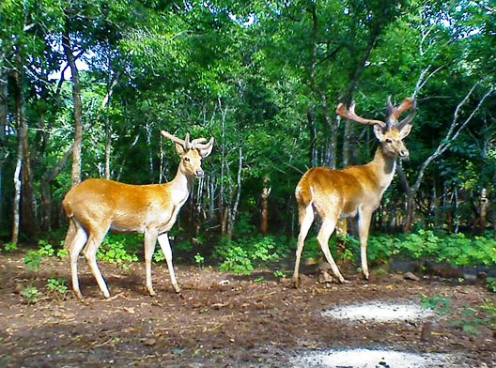
Golden Deer (Rucervus eldi thamin) in Popa Mountain Park

(Republic of the Union of Myanmar)

Submitted to the Secretariat of the Convention on Biological Diversity [31-5-2012]

Protected area information:
PoWPA Focal Point:
Mr. Win Naing Thaw
Director, Nature and Wildlife Conservation Division (NWCD)
Forest Department
Ministry of Environmental Conservation and Forestry
Nay Pyi Taw, Myanmar
E-Mail: nwcdfdmof@gmail.com

Lead implementing agency:
Nature and Wildlife Conservation Division
Forest Department
Ministry of Environmental Conservation and Forestry

Multi-stakeholder committee: (Add description)
Not yet available.

Description of protected area system
Coverage
Currently, Myanmar has 37,894 km² in 36 PAs representing diverse ecosystems, which cover 5.60% of the total area (Figure 1). In addition, other seven areas that occupy 1.07 % of the country total land have been proposed to be established as PAs. Approximately 95% of the total PAs are terrestrial PAs (Table 1). Wetland PAs and marine PAs are only 4.13% and 1.03%, respectively.

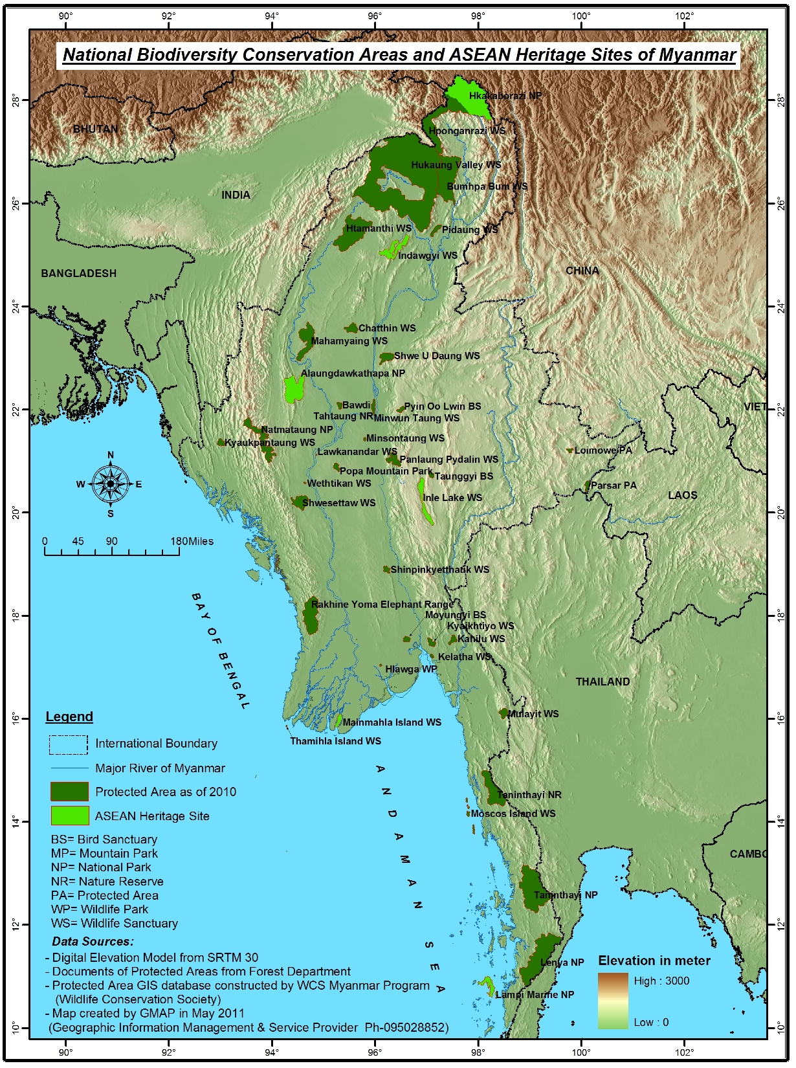
Figure 1. Location of Protected Areas and ASEAN Heritage Sites of Myanmar.

Table 1. Protected Area by Type of Habitat.
Habitat | No. of PAs | Area (ha) | % of Total PAs | % of Country’ areas PAs
Marine PAs | 4 | 39,160 | 1.03 | 0.06
Terrestrial PAs | 28 | 3,593,892 | 94.84 | 5.31
Wetland PAs | 4 | 156,396 | 4.13 | 0.23
Grand Total | 36 | 3,789,448 | 100.00 | 5.60

Description and background
In Myanmar, the Kings initiated biodiversity conservation as early as 1775 when teak was proclaimed a Royal Tree. The vicinity of the king’s palace was declared a refuge area for the wild animals in the city of Yadanapon (now Mandalay) in 1850. The Elephant Preservation Act was enacted in 1879, and amended in 1883. The Forest Department (FD) was given responsibility for wildlife protection under the Burma Forest Act of 1902, which designated wild animals as "forest produce" and provided for the making of rules to control hunting and fishing in Reserved Forests. The first Game Sanctuaries were established in 1911, but ratified protected areas were not set up until 1920. The Burma Wildlife Protection Act was imposed in 1936. In 1927, a post of Game Warden was created within the FD with specific responsibilities for wildlife conservation and management, including control of keddah operations for capturing wild elephants. The post of Game Warden lapsed at the time of the Japanese occupation in 1942 and has never been revived. Since the War and subsequent independence, the FD has retained general responsibility for wildlife conservation. During this time there has neither been any departmental unit with specific responsibilities nor any staff with professional training in this particular field. However, the Nature and Wildlife Conservation Division (NWCD) was created within the FD when the "Nature Conservation and National Parks Project" was implemented from 1981 to 1984. Protected Area System (PAS) management was introduced since then and the Protection of Wildlife and Protected Areas Law was enacted in 1994.
Prior to 1996, protected areas constituted less than 1 % of the total land area with individual PAs ranging in size from 0.47 km² to 2,150 km² (Figure 2). Since 1996 the establishment of protected areas shifted from protection of certain species or habitats to protection of entire landscapes or ecosystems. Twelve new protected areas ranging in size from 23 km² to 11,002 km² were added to the protected area system between 1998 and 2010. This period coincides with WCS’s conservation work to strengthen the capacity of FD staff especially their institutional capacity for establishing PAs. The Northern Forest Complex in particular is evidence of successful collaboration between government and a NGO for biodiversity conservation.
Figure 2. Cumulative Protected Areas between 1920 and 2010.
Governance types
NWCD is responsible for nature conservation and PAs. PAs in Myanmar are being managed by the very common approach of elsewhere of the world, “Fence and Fine Approach”. Recognizing the importance of the integration people inspiration, attitudes, perceptions and resource needs in the management, Myanmar is initiating the practising community based natural resource management (CBNRM) particularly in PAs in Northern Forest Complex.
Key threats
PAs in Myanmar are facing with several threats that range from small scale (Subsistence level) to large scale (Commercial level). The major threats, which cause the degradation of the diverse flora and fauna of the country are mentioned in Table 2.

Table 2. Major threats faced by the PAs in Myanmar.
No. | Small scale threats |  | No. | Large scale threats
1 | Hunting and wildlife trade for subsistence |  | 1 | Permanent human settlements and land reclamation
2 | Fuel wood collection |  | 2 | Plantations
3 | Extraction of non-wood forest products |  | 3 | Timber extraction
4 | Grazing |  | 4 | Geological exploration by large companies
5 | Fishing |  | 5 | Construction of dam and reservoir
6 | Shifting cultivation |  | 6 | Expansion of roads
7 | Mining (gold panning) |  | 7 | weakness of law enforcement
 |  |  | 8 | Lack of awareness and conservation ethic
 |  |  | 9 | Disposal of toxic chemicals into water bodies such as rivers, lakes and seas

Furthermore, impacts of Climate Change on wild flora and fauna, introduction of alien invasive species that causes harmful impacts on native biodiversity and threats of genetically modified organisms (GMOs) need special attention in conserving biodiversity for a long term. In order to minimize the above mentioned threats, close cooperation and collaboration from the outside agencies are needed.
Barriers for effective implementation
Though Myanmar has been doing her best to conserve the biodiversity richness, loss of biodiversity and the habits have been reported from the protected areas that have been established as a major conservation measure to conserve biodiversity and to reduce forest depletion. Many barriers need to address immediately for achieving the meaningful biodiversity conservation in Myanmar. The major barriers are
- lack of basic infrastructure,
- inadequate financial resources,
- insufficient on-site personnel,
- lack of site-based management plans,
- weak enforcement on illegal trade of wildlife and their parts,
- lack of proper environmental impact assessment for development projects,
- lack of people participation in biodiversity conservation activities, and
lack of clearly defined land use policy.

National Targets and Vision for Protected Areas
Myanmar’s Forest Policy (1995) mandates to increase protected areas to 5 % of the country’s total land area. In 2000, this target was adjusted to 10% of total land area by 30-year Forestry Master Plan of Ministry of Environmental Conservation and Forestry. According to the Protection of Wildlife and Protected Areas Law (1994), protected areas are designated and regulated and managed to achieve conservation objectives.

Progress in and plans for achieving the goals of the Programme of Work on Protected Areas
Progress: 0 = no work, 1 = just started, 2 = partially complete, 3 = nearly complete, 4 = complete
Goals of the Programme of Work on Protected Areas | Progress  0-4
- Progress in establishing and strengthening national and regional systems of protected areas (1.1) | 2
- Progress in integrating protected areas into broader land- and seascapes and sectors so as to maintain ecological structure and function (1.2) | 2
- Progress in establishing and strengthening regional networks, transboundary protected areas (TBPAs) and collaboration between neighbouring protected areas across national boundaries (1.3) | 1
- Progress in substantially improving site-based protected area planning and management (1.4) | 1
- Progress in preventing and mitigating the negative impacts of key threats to protected areas (1.5) | 2
- Progress in promoting equity and benefit-sharing (2.1)  - Progress in assessing and implementing diverse protected area governance types (2.1) | 1
- Progress in enhancing and securing involvement of indigenous and local communities and relevant stakeholders (2.2) | 1
- Progress in providing an enabling policy, institutional and socio-economic environment for protected areas (3.1)  - Progress in assessing the contribution of protected areas to local and national economies (3.1) | 1
- Progress in building capacity for the planning, establishment and management of protected areas (3.2) | 2
- Progress in developing, applying and transferring appropriate technologies for protected areas (3.3) | 2
- Progress in ensuring financial sustainability of protected areas and national and regional systems of protected areas (3.4) | 2
- Progress in strengthening communication, education and public awareness (3.5) | 2
- Progress in developing and adopting minimum standards and best practices for national and regional protected area systems (4.1) | 0
- Progress in evaluating and improving the effectiveness of protected areas management (4.2) | 2
- Progress in assessing and monitoring protected area status and trends (4.3) | 2
- Progress in ensuring that scientific knowledge contributes to the establishment and effectiveness of protected areas and protected area systems (4.4) | 1
- Progress in marine protected areas | 2
- Progress in incorporating climate change aspects into protected areas | 1

Priority activities for fully implementing the Programme of Work on Protected Areas:
Activities | Timeline
- Pilot for Strengthening patrolling through communication participation | 2013-2015
- Pilot for buffer zone management in peripheral areas around protected areas. | 2013-2016
- Capacity building for developing site-based management plan | 2013-2014
- Promote conservation education programs. | 2013-2016
- Promote local communities participation in biodiversity conservation. | 2013-2016
- Promote regional coordination to protect the ASEAN Heritage Parks and Reserves. | 2013-2016

Action Plans (detailed steps) for completing priority activities for fully implementing the Programme of Work on Protected Areas:
Activity 1: Pilot for strengthening patrolling through community participation
Key steps | Timeline | Responsible agencies | Indicative budget (US$)
Preliminary assessment | 2013-2014 | NWCD, NGO, INGO | 3500
Establishment of guard posts and supporting material | 2013-2014 | NWCD, NGO, INGO | 10000
Formation of patrolling team | 2013-2014 | NWCD, NGO, INGO | -
Participatory patrolling | 2014-2015 | NWCD, NGO, INGO | 10000
Evaluation on results | 2014-2015 | NWCD, NGO, INGO | 1500

Activity 2: Pilot for buffer zone management in peripheral areas around protected areas.
Key steps | Timeline | Responsible agencies | Indicative budget (US$)
Preliminary assessment | 2013-2014 | NWCD, NGO, INGO | 3500
Buffer demarcation | 2013-2014 | NWCD, NGO, INGO | 3000
Defining rights and obligations | 2013-2014 | NWCD, NGO, INGO | -
Providing subsidies | 2013-2014 | NWCD, NGO, INGO | 20000
Evaluation | 2014-2016 | NWCD, NGO, INGO | 1500

Activity 3: Capacity building for developing site-based management plan
Key steps | Timeline | Responsible agencies | Indicative budget (US$)
Appoint National Consultant | 2013-2014 | NWCD, NGO, INGO | 5000
Trainings | 2013-2014 | NWCD, NGO, INGO | 50000
Demonstration | 2013-2014 | NWCD, NGO, INGO | 3000

Notes: The implementation of all priority activities above mentioned will be achieved through the technical and financial supporting from external organizations.
In this regards, Myanmar would like to appreciate UNEP if the advices on getting technical and financial support could be kindly provided.

Key assessment results
Ecological gap assessment
Wildlife Conservation Society, WCS-Myanmar Program, the leading INGO of Myanmar for conservation, is revising the Myanmar: Investment Opportunities in Biodiversity Conservation (2005)” as the “Myanmar Biodiversity Conservation Investment Vision (2012)” and the first draft is accomplished. In the new revision, conservation corridors and key biodiversity areas (KBAs) are updated in accordance with the current scenarios.

Management effectiveness assessment
Two independent studies have been conducted in Myanmar to understand the effectiveness of protected areas. The results of those studies have been published in international journals. (Songer, M., Aung, M., Senior, B., DeFries, R. and Leimgruber, P. 2009. Spatial and temporal deforestation dynamics in protected and unprotected dry forests: a case study from Myanmar (Burma). Biodiversity Conservation 18: 1001–1018 and Htun, N.Z., Mizoue, N., Kajisa, T. and Yoshida, S. 2010. Deforestation and forest degradation as measures of Popa Mountain Park (Myanmar) effectiveness. Environmental Conservation 36 (3): 218–224). Both studies obviously revealed that the PAs are much effective for forest conservation than outside.

Sustainable finance assessment (Insert summary findings if available)
Not yet. But we are giving this assessment as the top priority. We can start this assessment if we received the technical and financial assistance from relevant organizations.

Capacity needs assessment (Insert summary findings if available)
Not yet. But we are giving this assessment as a top priority. We can start this assessment if we received the technical and financial assistance from relevant organizations.

Policy environment assessment (Insert summary findings if available)
Not yet.

Protected area integration and mainstreaming assessment (Insert summary findings if available)
Not yet. But we are giving this assessment as a top priority. We can start this assessment if we received the technical and financial assistance from relevant organizations.

Protected area valuation assessment (Insert summary findings if available)
Not yet. But we are giving this assessment as a top priority. We can start this assessment if we received the technical and financial assistance from relevant organizations.

Climate change resilience and adaptation assessment (Insert summary findings if available)
Not yet. But we are giving this assessment as a top priority. We can start this assessment if we received the technical and financial assistance from relevant organizations.

