Action Plan for Implementing the Convention on Biological Diversity’s
Programme of Work on Protected Areas

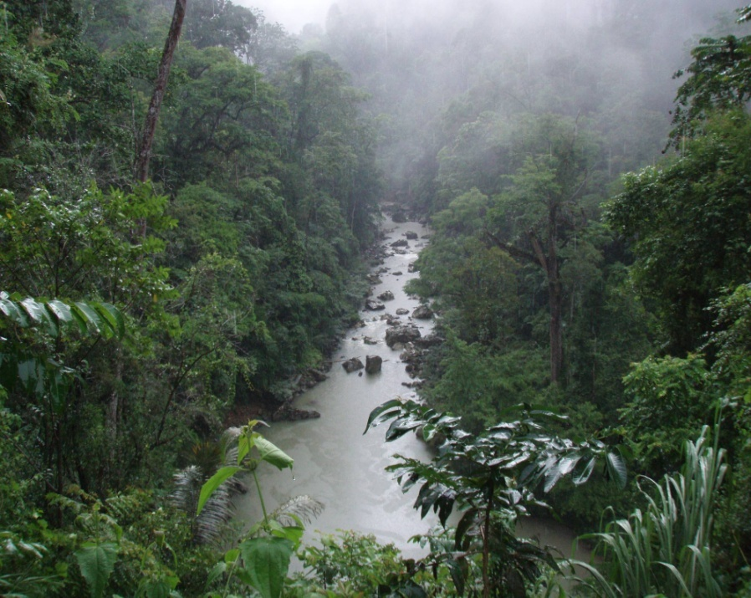

Lao People’s Democratic Republic

Submitted to the Secretariat of the Convention on Biological Diversity May, 2012

Protected area information:
PoWPA Focal Point:
Mr. Bouaphanh Phanthavong
Deputy Director, Department of Forest Resource Management (DFRM)
Ministry of Natural Resources and Environment (MoNRE)
Vientiane, Lao PDR
Tel & Fax: (856-21) 216921; 217161
E-mail: phanthavong2020@hotmail.com

Lead implementing agency: (Add name of primary government agency)
Department of Forest Resources Management, MoNRE
Multi-stakeholder committee: (Add description)
During the implementation of PoWPA on “Sustainable Financing Protected Areas Management”, there was established a National Implementation Support Partnership (NSIP) that includes representatives of key government institutions, relevant NGOs and the private sector. The NSIP has been formed as the project Technical Advisory Unit chaired by DFRC, whose members consist of representatives from the following line ministries and institutions, coordinated by DFRC:
- Ministry of Agriculture and Forestry
- Ministry of Finance
- Water Resources and Environment Administration (WREA) represented by the Department of Environment (DoE)
- Lao National Tourism Administration (LNTA)
- National Land Management Authority (NLMA)
- Ministry of Planning and Investment (MPI) – was later proposed to be added
- Department of Forestry (DoF)
- Electricite du Laos (under the umbrella of Department of Electricity, MEM)
- National University of Laos (NUoL) represented by the Faculty of Forestry (FoF)
- International Union for Conservation of Nature (IUCN) in Lao PDR
- Wildlife Conservation Society (WCS)
- Worldwide Fund for Nature (WWF)

Description of protected area system

National Targets and Vision for Protected Areas
(Insert national targets for protected areas/Target 11 of the Aichi Targets. Include rationale from protected area gap assessment, if completed, along with any additional information about the vision for the protected area system, including statements about the value of the protected area system to the country)
National Target: Maintain ecosystem function and services for people well-being
Vision: A healthy protected area ecosystem, characterized by diversity and abundance of flora and fauna, with clear objectives and adequate institutional structure and effective function that allows future generation to benefit from this rich natural heritage.
Currently, Lao PDR has about 41% of forested area of the total area of the country, of which 17% is declared as national protected areas. The objective of National Protected Areas is to protect natural areas for conservation of flora and fauna, maintenance of ecological stability and watershed functions, and to preserve historically, aesthetically, culturally or scientifically valuable sites. Objectives should be achieved through local participatory management benefiting NPA residents.

Coverage
(Amount and % protected for terrestrial and marine; maps of protected area system)
National Protected Areas system formally established in 1993, up to now, there are 24 National Protected Areas (NPAs) plus two corridors that make up the NPA System cover almost 17% of the total land of the country, representing a variety of ecosystems found throughout Lao PDR.
PA category/type | Quantity | Surface area, hectares | Corresponding IUCN category | Management authority
National Protected Areas (NPA) | 24+2 Corridors | 3,800,000 ha | Category VI | Department of Forest Resource Management (DFRM),MoNRE
Provincial Protected Areas (PPA) | 57 | 932,000 ha | Unknown | Provincial Forest Resource Management Office(PFRM), MORE
District Protected Areas (DPA) | 144 | 504,000 ha | Unknown | District Forest Resource Management Office (DFRM), MORE

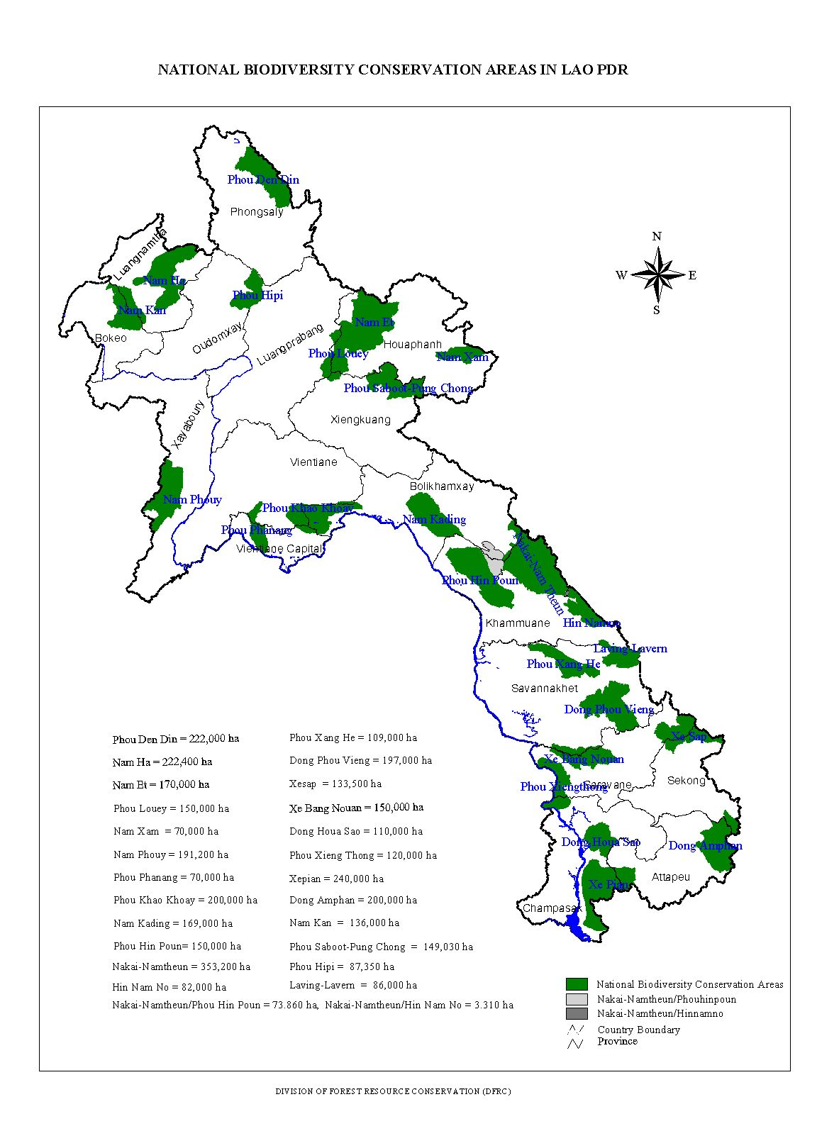
Description and background
Governance types
(Summary matrix of governance types)
Protected Areas in Lao PDR are classified into three categories: National PAs, Provincial PAs and District PAs. Most of NPAs are currently prepared based on the agreed approach of co-management which will lead by the government and local community. Government policy encourages local communities to actively participate in the protected area management in order to ensure that natural resources in the protected areas be sustainably used for their people well-being and at the same time protected habitats for certain threatened and endangered species. Key threats (Description of key threats, and maps, if available).

Threat 1. Poverty-driven unsustainable use of resources
During the Initial PoWPA Analysis and Priority Setting activities, most stakeholders identified people and poverty as one of the greatest threats to protected areas. Every NPA in Lao PDR has communities living inside or next to the boundaries that rely heavily on natural resources found within the NPAs. Most of these communities harvest wood and non-timber forest products in increasingly greater quantities, threatening to degrade valuable habitat. These communities often use land within NPAs for rice and vegetable cultivation, as well as for raising livestock, resulting in patches of cleared forestland. Additionally, many NPAs are experiencing an influx of new people moving into villages within NPA boundaries, exerting even greater pressure on the resource base.

Threat 2. Illegal logging and other resource extraction
Forest cover in Lao PDR has declined from 70% in 1940 to 41% in 2006. In the time period since the NPA system was established in Lao PDR, forest cover declined from 47% to 41%. The government has identified the main sources of destruction as “slash and burn, illegal logging, and over-cutting of trees.” The majority of stakeholders who participated in the Initial PoWPA Analysis identified illegal logging as a primary threat to NPAs. This is leading to habitat degradation, threatening the survival of some endangered species.

Threat 3. Encroachment
Encroachment from plantations and agricultural activities was the third most common threat identified in the Initial PoWPA Analysis. The government has also recognized it as a growing problem for managing NPAs and biodiversity. This is primarily due to the lack of boundary demarcation, protected areas zonation (including land use) and poor law enforcement in most NPAs. It is also partially due to unclear roles and responsibilities of various government agencies.
Barriers for effective implementation
(Description of key barrier s for effective implementation)
The issues identified by stakeholders as part of the PoWPA analysis and priority setting reflect several barriers in achieving the targets of the PoWPA. These include:
Barrier 1. The limited financial capacity of the GoL coupled with the exodus of donor funding has left the NPA system mostly crippled.
Up to this point, Lao PDR has been successful in establishing a NPA system and identifying the gaps and capacity needs of the system, but have been financially crippled by the exodus of international funding for biodiversity. As these traditional funding sources dry up, it is apparent that Lao PDR needs to diversify their funding base for PAs. As Inbar (2004) stated, “the donation-driven model is often unsustainable, both economically and environmentally.” This is particularly evident in Lao PDR, where the quality and quantity of biodiversity continues to decline at a rapid rate fueled in part by a lack of donor funds. Lao PDR needs to develop and implement a financing strategy for the national system as well as for individual PAs: this will be “the foundation for enabling effective implementation of [management] strategies” (Bruner et al 2003).
At each stakeholder consultation held during the PoWPA activities, participants mentioned that once a given donor left a project, all activities in the NPA ceased to exist and little knowledge was transferred upon the completion of the project. Donor dependency is a sad reality in least-developed countries like Lao PDR. Projects can flourish and then disappear, resulting in effectively little to no impact for sustainable biodiversity conservation. There is an urgent need to find funding to implement even minimal management for NPAs in Lao PDR.

Barrier 2. Lack of Capacity in Human Resources
Capacity building is repeatedly identified as a key element necessary for promoting management effectiveness in NPAs. At each stakeholder consultation, participants articulated challenges relating to insufficient training and knowledge of existing staff, an overall lack of staff, the absence of current scientific and technical information pertaining to individual NPAs, as well as a lack of knowledge among communities in and nearby NPAs. These same issues are identified in every review and analysis of NPAs in Lao PDR.
Central to the issue of capacity development is the lack of financial resources to carry out training with staff and communities as well as the lack of funding to hire the minimum staff required for each NPA in Lao PDR. Additionally, as demonstrated in Stakeholder Consultation #8, even if the capacity does exist in an NPA, the staff do not have the money to buy fuel for the vehicles to travel to necessary sites to implement any activities. The GOL is committed to providing adequate staffing and equipment to each NPA, as declared in PM Decree No. 25, yet the funding source for these expenditures remains undetermined.
Work is progressing on some capacity development activities. The Wildlife Conservation Society (WCS) is currently developing a training curriculum for NPA managers in partnership with the GOL and the National University of Laos (NUOL). Additionally, the World Wildlife Fund (WWF) conducted a study outlining action steps for meeting capacity gaps in NPA management. In 2001 the GOL published an NPA Manager’s Handbook, and in 2003 the GOL partnered with the ASEAN Regional Centre for Biodiversity Conservation to develop guidelines for competence standards for NPA staff. The GOL is committed to continue building capacity with ongoing and future partnerships with NGOs and the NUOL.
Barrier 3. Poor governance and lack of clarity in management objectives
Lao PDR has tried to establish ‘good governance’ structures since the establishment of the NPA system. Participatory management has been a cornerstone of government policy regarding natural resource management and has been reaffirmed numerous times in laws and policies. Unfortunately, as already evidenced in this report, the complex structure of decision-making and responsibility within the GOL has made it very difficult to establish better NPA governance and implement participatory schemes. The difficulty is further compounded, in the case of participatory management, by a lack of funding to train and involve communities in NPA management. The result of poor governance compounds the multitude of issues affecting NPAs in Lao PDR and urgent action is required.
The PoWPA analysis revealed two major challenges stalling the improvement of governance structures in Lao PDR’s NPAs: 1) lack of clarity of management objectives for individual NPAs; and, 2) lack of clarity of responsibility and decision-making power between the national, provincial, and local levels. Lao PDR recognizes these limitations and is currently undergoing restructuring aimed at streamlining roles and responsibilities across all government levels. Additionally, as part of a joint national review, the GOL is creating a work plan to clarify and adjust primary management objectives for each NPA in an attempt to create a more robust NPA system. Coupled together, these two main activities will place the GOL in a better position to address governance issues and improve NPA management effectiveness.
- Inadequate capacity among Protected Areas staff and Buffer Zone representatives
PA staff members do not have adequate capacity to understand the dynamics of the PA systems and are poorly equipped with management skills. Although they are provided with some training, the PA vocational training has not been systematic and does not adequately meet in the changing context. So, it is important to enhance the capacity of the staff members, mainly working at the field level as the management challenges are changing day by day.
2. Biodiversity information database
Documentation of information required for planning and management is weak. The gap analysis indicated need of gathering and collating basic scientific and socioeconomic data, which are prerequisite for scientific management of PAs. PA officers are not well trained in collecting and analysing sceitific data. At the same time, the central level biodiversity database lacks a module on the quality of work of protected area officers, and this further deprives authorities from proper PA decision making.
3. Low level of conservation awareness
The level of conservation awareness among local communities is still low. Any intervention in the area would positively or negatively effect biodiversity and livelihood of local people. This understanding along with willingness for conservation and sustainable development is essential.
4. Legal instruments and institutional capacity
Though there are several legal documents and an institution for conservation and management of these areas, the practicality of legal provisions and capacity of institution have been barriers to achieve conservation goal.

Status, priority and timeline for key actions of the Programme of Work on Protected Areas

Status of key actions of the Programme of Work on Protected Areas
Status of key actions of the Programme of Work on Protected Areas | 2Status
- Progress on assessing gaps in the protected area network (1.1) | 3
- Progress in assessing protected area integration (1.2) | 2
- Progress in establishing transboundary protected areas and regional networks (1.3) | 1
- Progress in developing site-level management plans (1.4) | 2
- Progress in assessing threats and opportunities for restoration (1.5) | 2
- Progress in assessing equitable sharing of benefits (2.1)  - Progress in assessing protected area governance (2.1) | 1
- Progress in assessing the participation of indigenous and local communities in key protected area decisions (2.2) | 0
- Progress in assessing the policy environment for establishing and managing protected areas (3.1)  - Progress in assessing the values of protected areas (3.1) | 1
- Progress in assessing protected area capacity needs (3.2) | 3
- Progress in assessing the appropriate technology needs (3.3) | 1
- Progress in assessing protected area sustainable finance needs (3.4) | 3
- Progress in conducting public awareness campaigns (3.5) | 2
- Progress in developing best practices and minimum standards (4.1) | 1
- Progress in assessing management effectiveness (4.2) | 2
- Progress in establishing an effective PA monitoring system (4.3) | 2
- Progress in developing a research program for protected areas (4.4) | 0
- Progress in assessing opportunities for wetland protection | 1
- Progress in incorporating climate change aspects into protected areas | 0
Status: 0 = no work, 1 = just started, 2 = partially complete, 3 = nearly complete, 4 = complete
(Insert notes as appropriate)

Priority actions for fully implementing the Programme of Work on Protected Areas:

Action Plans for completing priority actions of the Programme of Work on Protected Areas
Action 1: Improved management effectiveness of existing and new protected areas through increased revenue for protected area systems to meet total expenditures required for management
Key steps | Timeline | Responsible parties | Indicative budget  USD
- Strengthened Institutional Capacity to develop protected area planning and management  - Enhanced new institution of DFRM of MoNRE with their capacity to manage 2 main forest types, NPAs (Conservation Forest)and Protection Forests (US$160,000)  1.2 Enhanced skills of national institutions to monitor environmental changes in the NPAs (US$160,000)  1.3 Protected area staff undertook local and international training to improve protected area management skills (US$40,000) . | 2020 | DFRM , PFRM  & DFRM | 360,000
- Improved Site Based Management Capacity  - Developed effective and comprehensive management with strict law enforcement at least four national protected areas (US$3,200,000)  - Developed management plans and substantive funding to enforce BD protection in at least 10 NPAs (from existing 2 ) , 5 PPAs, 3 protection forests and 2 corridors (US$4,000,000)  2.3 Established National Medicinal Plants Preservation and management plans to support primary health care programs in at least one site per province (US$720,000) | 2020 | DFRM, PFRM & DFRM | 7,920,000
- Controlled Green Crime in the National Protected Area  - Controlled wildlife hunting and trade by improved law enforcement (US$400,000)  - Developed Strategy and action plan to protect endangered species and improved wildlife protection (at least five endangered species in the Lao Red List are fully protected) regulation(US$100,000)  - Collaborated with law enforcement agencies to supress green crime including CITES, ASEAN WEN and FLEGT(US$160,000) | 2020 | DFRM, PFRM, DFRM & DoFI | 660,000
- Developed Conservation education and law dissemination to the public  4.1 Trained NPA staff on conservation education at central, provincial and district levels (US$)100,000  4.2 Developed conservation education materials (US$80,000)  4.3 Conducted conservation through mass media and at the grass root level (US$200,000) | 2020 | DFRM, PFRM and DFRM | 380,000
5. Developed financial sustainability for Protected Area Management  5.1 Established financial mechanisms towards revenue contribution for protected areas and/or communities from ecotourism, entry fee, research, fine, development affected NPA and donors. (US$50,000)  5.1 Developing policy framework/directive for the introduction of innovative NPA financial mechanisms (PES) & piloting in 2 NPA(US$50,000) | 2015 | DFRM, DOF, MCIT & MoF | 100,000
- Strenghtening Collaborations for protected area and wildlife conservation between Laos and Vietnam  Joint Partenership on conservation initiatives between Hin Nam No NPA and Phong Nha-Kebang Nature Reserve together in line with Integrated Nature Conservation and Sustainable Resource Management in Hin Nam No NPA being started with GIZ support.  EFLEGT, including the capacity at the immigration borders | 2015 | MoNRE | 250,000

Action 2: Capacity building for addressing the illegal trans-boundary wildlife trade
(Include national species conservation like tiger, gibbon, saola, giant catfish, and others into the NBSAP or NAPA and NSEDP)
Consultative mechanism established for proactive and constructive engagement of all interested stakeholders (4, ie at each site, plus 1 nationally)

Key steps | Timeline | Responsible parties | Indicative budget
(i) strengthened capacity of insitutions mandated with wildlife trade control  (ii) strengthened capacity of CITES agencies  (iii) improved capacity for on-ground wildlife poaching and trade control in/around project sites | 2015 | MoNRE, MoST,  DFRM, DoFI, PFRM & DFRM | 450,000
(iv) reduced threats to protected areas nationally from innapropriate development | 2015 | MoNRE, MoEM, MoPT
(v) improved coordination between Laos-Vietnam on controlling illegal trade in wildlife and timber | 2015 | DFRM, DOF, DoFI & DoC | 350,000
(vi) reduced illegal timber and wildlife poaching and trade | 2015 | DFRM, DoFI, PFRM & DFRM | 450,000
(vii) increased profile of institutions that manage and protect wildlife and protected areas, and increased recognition of the importance of biodiversity by high levels of government | 2015 | DFRM, MoNRE | 350,000
(viii) livelihood improvement in the selected NPA concerned communities on sustainable management and use of NTFPs and income-generating activities | 2015 |  | 250,000

Action 3: (Sustainable Forest Management is enhanced and incorporated in the NPAs, and improved NPA connectivity through biodiversity corridors, forest restoration, and upgrading of PPA to NPA, improved management of the Protection Forests, and village/community forests)
Key steps | Timeline | Responsible parties | Indicative budget
Improved natural resource management to improve connectivity | 2015 | DFRM, PFRM & DFRM | 350,000
Conducted land use planning, zoning in key connectivity areas | 2012 | DFRM, PFRM & DFRM | 580,000
Restored ecosystem functions in some connectivity areas | 2013 | PFRM, DFRM | 350,000
Conducted demarcation of corridor areas | 2015 | PFRM & DFRM | 250,000
Established of village forest | 2013 | PFRM & DFRM | 450,000

Key assessment results
Ecological gap assessment
The high international conservation significance of forests and other habitats in Laos has been noted through ecoregional analysis (e.g., MacKinnon, 1986, Berkmüller, et al. 1995b, Duckworth, et al. 1999). Ecoregions are contiguous habitats or ecosystems recognized by WWF as areas of highest significance in the world for biodiversity conservation. There are five larger ecoregions in Indochina, out of which four are located in Laos:
- • Annamite Range Moist Forests;
- • Indochina Dry Forests;
- • Northern Indochina Sub-tropical Moist Forests;
- • Mekong River and its catchment.

The country’s diverse ecological habitats are populated by various plant communities/species and provided sanctuaries to numerous significant species of reptiles and amphibians, mammals including bats, birds, insects, and indigenous fish species living in the Mekong River and its tributaries. There is a need to focus for more studies (academic and apply research) on the ecological gap as priority of actions for the national targets for specific ecological habitats, including significant and unique characteristic habitat of high-values, threathened and endemic species.

Management effectiveness assessment
As in November 2011 the Lao government issues a decree number 435/PO on the establishment of the Ministry of Natural Resources and Environment in which the Department of Forest Resources Management is the key organization responsible for the protected area and wildlife management in Lao PDR. The establishment of the Department of Forest Resources Management is the government’s intention to improve the effectiveness of the protected area and wildlife management. The new department will have more power than it was in the past in coordinating with the line ministry to ensure that activities of the line-ministry’s sectors be complied with the forestry and wildlife conservation laws while more budget will be allocated from the government to manage the protected areas and wildlife. Department’s staff members will be increased at the central, provincial and district levels to play the role in planning, managing and monitoring. However, the new department needs to strengthen its institution and personnel at all levels so as to it can manage the natural resources sustainably.

Sustainable finance assessment
Sustainable financing mechanisms for NPA management are a relatively new concept with initial discussions and work underway in Lao PDR, but the whole process will take considerable time to realize given the legal, policy and institutional implications. It appears highly necessary that more direct allocation of funds from the central government budget to Forest Development Fund (FDF) is of vital and urgent need if NPA resources are to be protected while waiting for the genuine sustainable financing models to be put in place and operational.

As the Environment Protection Fund (EPF) has a relatively better access to funding network, both domestic and international funding sources, it is essential that better coordination between the EPF and FRDF be established to avoid fundraising duplication and competition, especially when dealing with the same fund providers. Moreover, the fact that EPF has been funding many protected area management projects mainly focusing on provincial level protected areas, closer cooperation and collaboration should be enhanced between the EFP and FDF, whereby protected area management and biodiversity conservation funding portfolios can be shared to enhance the effectiveness and synergies, including fund sharing where possible.

For short-term consideration, there is a need to concentrate on the payments from ecotourism, hydropower, mining and other development as external sources. However, the long-term consideration is REDD scheme and payment for environmental or ecological services (PES) are recommended.

Capacity needs assessment
Lao PDR protected area management suffers greatly from the lack of human capacity in terms of both personnel number and expertise compounded by the limited logistical hardware with which to put management into a strong functioning ground. Human resource capacity and capabilities related to protected area management are the critical aspect that needs to be vigorously addressed, especially in terms of strengthening the technical and managerial skills to enhance NPA planning and management effectiveness. Among the relevant disciplines on which protected area staff training should be focused including skills for natural resources, agriculture and community development. The focus for other fields are due to the need for enhancing capacity for livelihood improvement of local communities inside the PA and buffer zones. In addition, capacity of PA staff for preparing project funding proposals is highly required, therefore there is a perceived need for training in English skills to enhance the capacity for reporting and funding proposal development.

Policy environment assessment:
Up till now there exist sound policy and legal framework as principle legal instrument addressing the environment in Lao PDR, including the new decree of forests, water resources and others. This provided quite solid background for PA management, however the reality is that technical capacity for implementation remains inadequate. Raising the profile of PA management is critical to the success of PA management, including the integration og the PA and provincial and sector planning; and support for NPAs at the provincial level because of their national role and designation

Protected area integration and mainstreaming assessment
Natural resources management is one of the Millennium Development Goal which targets to integrate the principles of sustainable development into country policies and programs in order to reverse loss of environmental resources. Protected areas and wildlife is part of ecosystem that provides service for the people well-being. In order to make sure the integration of socioeconomic development and conservation, environmental assessment should be conducted before implementing development activities so that environmental problems can be mitigated. In addition, a design of the country land use planning to endure the breeding pools and the connectivity of wildlife species is set aside for the long term survival of biodiversity.

Protected area valuation assessment
It was observed from various studies that development planners from different sectors have not appreciated the full value of protected areas (PAs) as seen that PAs are perceived as having little economic or development value and generate few obvious financial benefits or public revenues, they have been given low priority in development plans (ICEM2003b). In reality, PAs are important contributors to development and all other sectors. Therefore there is a need to incorporate the PA values into the policy and planning process in order to demonstrate PAs as productive assets in the economy and integrating PAs in economic development planning at national and other levels, including improvement of the coordination of PAs with sectoral plan and development projects.

Recently, there is a new recognition of the main function of PAs for the conservation of wild species and natural ecosystems to maintain the flow of (largely unaccounted for) goods and services that will secure wider social, economic and environmental benefits. In order to get PAs effective management there is a need to raise the PA economic values and these should incorporate into all sector development planning process; and then the budget allocation for PA management will be increased from various sources, in particular the public budget allocation.

Climate change resilience and adaptation assessment
Climate change is a global problem and affects all of us. Climate change doesn’t only affect human being but also ecosystem. Protected area can help people cope with climate change through maintaining natural ecosystems and reducing green house gas emission through carbon storage and sequestration. On top of that, protected area helps to reduce risk and impacts from extreme events such as storms, droughts and flash flooding. Adaptation of vulnerable people need ecosystem. Therefore, healthy ecosystem provides vulnerable people resilience successfully.

It was decided that a Technical Advisory Unit is appropriate and more practical in terms of endorsement requirement than it would otherwise be with a more conventional Steering Committee.

