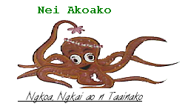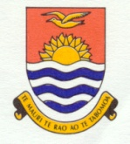

KIRIBATI FOURTH NATIONAL REPORT TO THE CONVENTION ON BIOLOGICAL DIVERSITY
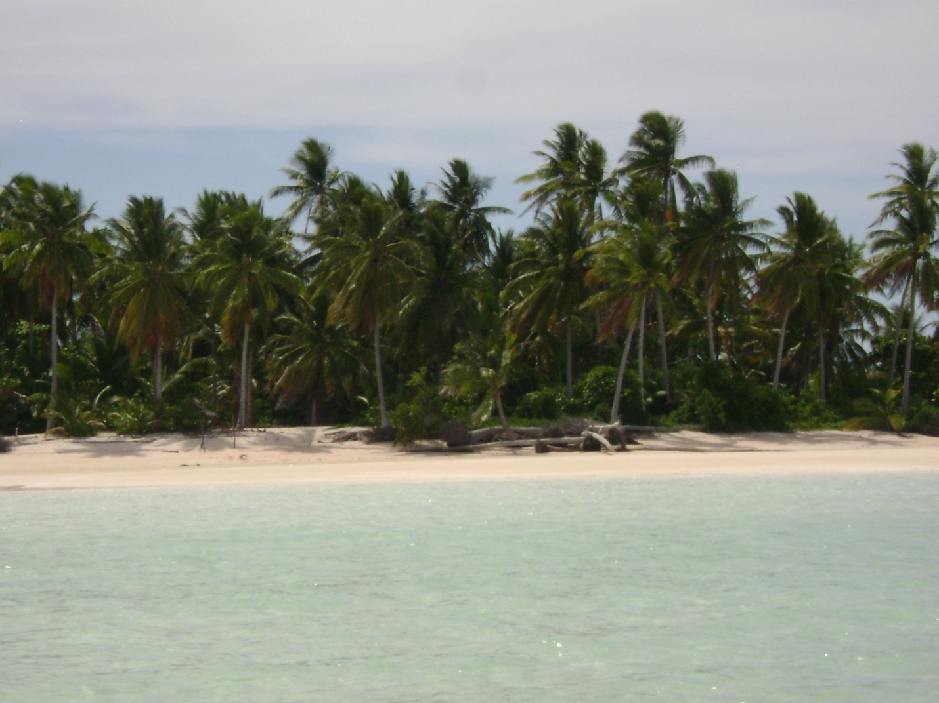
Aranuka Island (Gilbert Group) Picture by: Raitiata Cati

Prepared by: Environment and Conservation Division - MELAD
20th September 2010

Contents

Acknowledgement 4
Acronyms 5
Executive Summary 6
Chapter 1: OVERVIEW OF BIODIVERSITY, STATUS, TRENDS AND THREATS 8
1.1 Geography and geological setting of Kiribati 8
1.2 Climate 9
1.3 Status of Biodiversity 10
1.3.1 Soil 12
1.3.2 Water Resources 12
1.4Terrestrial Fauna and Flora 13
1.4.1 Marine Fauna and Flora 15
1.5. National Progresses towards meeting the three objectives of the CBD 17
1.5.1. Marine Turtle Monitoring and Tagging Project 17
1.5.2. Programme of Work on Protected Areas (PoWPA)– phase I & II outcomes 19
1.5.3. Mangrove Replanting under the Kiribati Adaptation Project (KAP) II Project 23
1.5.4 MANAGEMENT OF IAS AT NATIONAL LEVEL 30
“Before and after” eradication 32
1.6 Overview of the national protected area system 33
1.6.1 Phoenix Islands Protected Area 34
1.6.2 Summary of key biodiversity areas designated or suitable for protected areas 38
1.7 Threats and challenges to biodiversity conservation and management 41
1.7.1 Over-exploitation and unsustainable harvesting methods and practices 41
1.7.2 Climate change 42
1.7.3 Data and Information Gap 45
1.7.4 Habitat loss 45
1.7.5 Waste and pollution 46
1.7.6 Community support 47
1.7.7 Increased population 47
1.7.8 Public Awareness 48
1.7.9 Inadequate integration of customary right users in biodiversity conservation 49
1.7.10 Invasive Alien Species 50
1.7.11 Agricultural pest and disease infestations and epidemics 52
1.7.12 Fishing gears 53
1.7.13 Institutional and financial gaps. 54
1.7.14. Summary and rating of threats and challenges. 54
Chapter 2: NBSAP 59
2.1 Overview of NBSAPs 59
2.2 Status and Progress towards NBSAP 60
2.3 Challenges in implementing NBSAP 65
Chapter 3- Sectoral and Cross-Sectoral Integration of Biodiversity Considerations 67
3.1 Introduction 67
3.2 Mainstreaming Biodiversity Conservation in National Policies and Plans 67
3.3 Legal Framework relevant to Biodiversity Conservation 68
3.3.1The Environment Amendment Act 2007 68
3.3.2 The Wildlife Conservation Ordinance 69
3.3.3 The Phoenix Islands Protected Area (PIPA) Regulations 2007 71
3.3.4 The Fisheries Ordinance (Cap 33) & Fisheries (Amendment) Act 1984 72
3.3.5 Other relevant legislations 73
3.4 Institutional Arrangements 74
3.5 Links with Millennium Development Goals 75
Chapter 4– CONCLUSIONS: PROGRESS TOWARDS 2010TARGET 76
4.1 Introduction 76
4.2 Overall Assessment of Results. 80
Annex I: List of National Biodiversity Committee Members 82
References: 84

Acknowledgement

The compilers of this report would like to acknowledge the United Nations Environment Programme (UNEP) and the Global Environment Facility (GEF) for making this reporting possible through the provision of financial assistance. The Government of Kiribati is also indebted to the support from regional CROP (Council of Regional Organizations in the Pacific) agencies namely Secretariat of the Pacific Regional Environment Programme (SPREP) for its continued technical support and advice throughout the process and development of this Fourth National Report to the Convention on Biological Diversity (CBD).

Much gratitude are owed to Ministry of Environment Lands and Agriculture Development (MELAD) staff and administration, in particular Environment & Conservation Division (ECD) in overseeing and coordinating implementation of the Biodiversity and Wildlife Conservation and Management programs including implementation of the National Biodiversity Strategies and Actions Plan at all levels of society in Kiribati. Without their support and dedication, the completion of this report would not be possible.

Our sincere thanks also to all members of the National Biodiversity Planning Committee for their time and productive contributions to all biodiversity related projects, in particular their contributions to relevant information rendered to the development and completion of this 4th National Report. Additionally, we would like to acknowledge the participations and contributions of grassroots communities of all outer islands visited in sharing relevant information that are useful to this cause.

Acronyms

ALD – Agriculture and Livestock Division
CBD – Convention on Biological Diversity
CROP agencies – Council of Regional Organizations in the Pacific
ECD – Environment and Conservation Division
EEZ – Exclusive Economic Zone
EIA – Environmental Impact Assessment
ENSO – El Nino/La Nina Southern Oscillation
EYC- Environmental Youth Club
GEF – Global Environment Facility
GPS – Global Positioning System
ISME – International Society for Mangrove Ecosystem
KANGO – Kiribati Association of Non Governmental Organization
KAP II – Kiribati Adaptation Project Phase II
KDP – Kiribati Development Plan
KOIL- Kiribati Oil Company Limited
KPA – Key Policy Area
KTO – Kiribati Tourism Office
MCTTD – Ministry of Communication, Transport and Tourism Development
MDG – Millennium Development Goals
MELAD – Ministry of Environment, Lands and Agricultural Division
MEA – Multi-lateral Environment Agreement
MFMRD – Ministry of Fisheries and Marine Resource Development
MOP – Ministerial Operational Plan
MPA – Marine Protected Areas
NBSAP – National Biodiversity Strategy Action Plan
NGOs – Non-governmental Organization
NDS – National Development Strategy
OUV – Outstanding Universal Value
PIPA – Phoenix Islands Protected Area
POWPA – Programme of Work on Protected Areas
SOPAC- South Pacific Applied Geosciences Commission
SPREP – Secretariat for the Pacific Regional Programme
UNEP – United Nation Environment Programme
WHC – World Heritage Committee

Executive Summary

This fourth national report to the CBD is compiled by Environment and Conservation Division (ECD) of Ministry of Environment, Lands and Agricultural Development (MELAD) to meet Kiribati’s international reporting obligations under the CBD. ECD is the environment authority responsible for the conservation and management of Kiribati’s environment for sustainable development. It is also responsible for fulfilling the environment portfolio of MELAD at national level.

The status, trends and threats of Kiribati’s biodiversity are summarized in this report. It also illustrated how biodiversity conservation and management are mainstreamed across different sectors to effectively address different biodiversity conservation and management issues.

Significant progresses have been made since the finalization and endorsement of the first National Biodiversity Strategies Actions Plan (NBSAP) in 2007. These reflect Government of Kiribati’s commitment to achieving the three objectives of the CBD and fulfilling national obligations as a CBD Party. These include some of the following.

The recognition and inclusion of the environment as one of the key policy areas under the Kiribati Development Plan (KDP) 2008 – 2011. Under this policy area, the conservation and management of biodiversity amongst other environmental issues is recognized as a national development planning issue. Furthermore, is the announcement and declaration of the Phoenix Islands Protected Areas (PIPA) as first, the world’s third largest marine protected area at the Eighth Meeting of the Conference of the Parties to the Convention on Biological (CBD COP8) held in Brazil in 2006. Since January 2008, the expansion and full legal establishment of PIPA covering a total area of 408,250 km² has resulted in PIPA as the world’s largest MPA. The PIPA represents 11.7% of the Kiribati total Exclusive Economic Zone (EEZ). It also represents 17% of the global area of MPAs currently designated worldwide.

Additionally, since July 2010, the PIPA was inscribed as a World Heritage Site. As an MPA, it consists of the last intact coral reef species and ecosystems, important seamounts and vast variety of marine species still yet to be fully explored. A high level of endemism is suspected within this site and its pristine status gives PIPA an unquestionable Outstanding Universal Value (OUV). Another important milestone is the amendment of the Environment Act 1999 in 2007 to include, among others, conservation provisions including ‘Protected Species’ & ‘Protected Areas’ regulations. This legislation includes and integrates to some extent, elements of both the Convention on Biological Diversity and other related biodiversity Multi-Environment Agreements such as the World Heritage Convention.

The Government of Kiribati is continually engaged with implementation of several biodiversity related projects such as the Programme of Work on Protected Areas (POWPA phase I and II), turtle tagging and monitoring project, the Ramsar Convention Small Grants Programme – North Tarawa Ramsar Project small grants at national level, Invasive Alien Species (IAS) eradication and control including bio-security related projects undertaken in Kiritimati island, within the Line Group and in the PIPA within the Phoenix Group. Altogether, the implementation of these projects contributes also to meeting the three objectives of the CBD.

However, despite these, there are still constraints impeding further progresses toward achieving the CBD 2010 Targets. These include limited financial and human resources; limited capacity; lack of technology; limited data; limited and insufficient effective awareness raising to all levels of society in Kiribati; limited coordination, integration and cooperation amongst line ministries and sectors; environment legislation gaps, to name a few. These constraints are continually addressed through existing and available resources of the biodiversity and wildlife conservation and management programme at MELAD and national government levels.

Last but not least, Kiribati recognizes and promotes the practice of traditional knowledge and practices and integrates these in the management and conservation of biodiversity. Since time immemorial, the people of Kiribati have strong traditional links and connections with nature, in particular the biodiversity-based resources that support local livelihoods within their surrounding environment. This link and connections are vital element in natural resources conservation and sustainable development.

Chapter 1: OVERVIEW OF BIODIVERSITY, STATUS, TRENDS AND THREATS

1.1 Geography and geological setting of Kiribati
Kiribati is a coastal atoll nation, consisting of three main island groups scattered over 3 million km² of the Central Pacific, between latitudes 4° N and 3° S, and longitudes 172° E and 157° W (Fig. 1). The total land area is 810.8 km², comprising of 33 low-lying coral islands, 10 of which are coral atolls, ‘located between about 5⁰ N and 7⁰ S, and 168⁰ E and 168⁰ W longitudes. The atolls are clustered into three groups; the Gilbert Group in the west, the Line Group in the east, and the Phoenix Group. The total land area of all the atolls is about 800 sq km, compared with a distance of about 4000 km between the most westerly atoll of Banaba (Gilbert Group) and Kiritimati (Line Group) in the east. Each of the groups is so far from each other that they have their own distinct EEZs with a total sea area of some 3.5 million sq km and international high seas separating them (Kiribati BPoA report, page 1, 2010).
The Gilbert Island group consists of 17 islands (including Banaba) with a total land area of 285.7 km². Land ownership within these islands is by traditional land tenure system. Tarawa Atoll, in the Gilbert group and the location of the capital, consists of more than 20 named islets, the southern six of which are linked by causeways. The distance between Tarawa and outer islands in the Gilbert group ranges between 51 km and 600 km (Thaman et. al 1995).
The Phoenix Island group consists of 8 largely uninhabited islands with a total land area of just 28.6 km² located some 1,750 km east of Tarawa. This island group is now the Phoenix Islands Protected Area (PIPA). All islands within this group belong to the Government of Kiribati. The only inhabited island of the Phoenix group is Kanton (Canton) Island with the land area of 9 km². This island housed government officials who are stationed there for government administration purposes.
The Line Island group consists of 8 islands with a total land area of 496.5 km², extending over a north-south distance of 2, 100 km, located at a distance of between 3, 280 and 4, 210 km east of Tarawa, and some 800 km south of Hawaii (Figure 1). This group includes the largest island in Kiribati and also the biggest atoll in the world, Kiritimati with a total area of 388.4 km².

Most of the islands are no more than 2 km wide, or more than 6 m above sea level, except Banaba, which is also the only raised limestone island in Kiribati with worked out phosphate desposits that rise about 87 m above mean sea level. ‘Banaba is now dilapidated place of rock pinnacles and deep trenches that are remnants of active phosphate mining in the past. Most atolls are typical coral atoll formation of narrow strips of land with natural passages through them, and enclosing lagoons. (Kiribati BPoA report, page 1, 2000).

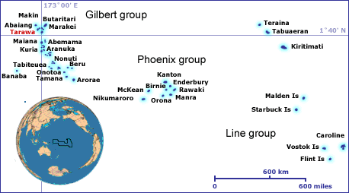

Figure 1: Map of Kiribati
(Source: http://www.kiribatitourism.gov.ki/index.php/aboutkiribati/aboutkiribatioverview)

1.2 Climate

A dominating weather system that affects Kiribati is the ENSO. El Nińo brings heavy rainfall; it raises the level of land and marine productivities. La Nińa is associated with the reverse conditions, that is, drought conditions (Kiribati BPoA report, page 42, 2000). Overall, Kiribati enjoys an “equatorial maritime” climate. Temperature normally ranges between 23⁰ C and 34⁰ C with a mean of 28⁰ C, although much higher temperatures have been recorded. The average rainfall generally ranges between 1,240 mm in the South to 3,125 mm in the north. However, the rainfall range is from 782 mm per annum on Christmas Island to 3,385 mm on Washington Island.

The Northern part of the Republic of Kiribati is on the average 10⁰ C cooler than those islands in the Southern part. Prevailing winds are easterly and hurricanes are unknown. All the islands consist of coral reef formations rising to no more than 4 metres above sea level, except for Banaba which is a raised limestone island. Banaba is also the only island that has more fertile soils than other low-lying coral atolls.

The climate of Kiribati is pleasant from April to October, when the north-easterly winds predominate. During the rest of the year, westerly gales occasionally bring heavy rains. Despite the moderate to heavy rainfall, occasional severe droughts do occur and this is attributable primarily to the extremely low elevation of the islands and the soil porosity (http://www.climate.gov.ki/Climate_change_effects_in_Kiribati.html).

1.3 Status of Biodiversity

The natural resources of Kiribati are either extremely limited as in the case of terrestrial or abundant and extremely vast and difficult to utilize and manage as in the case of lagoon, near-shore resources, and oceanic marine and seafloor resources within its extended EEZ. As a coastal nation, the marine and coastal biodiversity have been instrumental for economic development including revenue/income generation as well as providing the basis for local livelihoods. Life in Kiribati is centered around the sea and the various resources and habitats found therein. Marine resources and the environment have dominated small scale income generation at the family and island levels.

Biological diversity (Biodiversity) is defined as the variability among living organisms from all sources including, inter alia, terrestrial, marine and other aquatic ecosystems and the ecological complexes of which they are part; this includes diversity within species, between species and of ecosystems (Handbook on the Convention on Biological Diversity, 2001). Within the context of Kiribati as an atoll nation, the biodiversity includes all terrestrial and marine ecosystems, all plant and animal species and varieties found in these ecosystems and the traditional knowledge, uses and beliefs and local language that people have, in relation to these ecosystems and species. These knowledge systems have enabled the people to live harmoniously with their environment (on land and at sea) and enabled them to survive in these limiting environment conditions for many generations.

Kiribati has always relied on the biodiversity as the only capital available to sustain both the people and the country’s livelihoods, cultural identity and socio-economic well-being. Compared to other island countries, atolls like Kiribati have some of the lowest levels of biodiversity on earth and only one known endemic species - Bokikokiko. However, this is the only biodiversity available and both people and the country rely on it for economic and social survival. Biodiversity is interwoven into the fabric of people’s lives as island dwellers. For instance, the sea has been and continues to provide the people with their only main source of protein- fish. Similarly, despite the limitations of land, soil, and water resources, people have developed sophisticated subsistence agricultural systems based on coconut, breadfruit, pandanus, native fig (Ficus tinctorial), banana on the wetter islands, and the cultivation of the giant swamp taro (Cyrtosperma chamissonis) (Redfern, 2005). Apart from the capital island, the majority of local communities still continue to live simple lifestyles in harmony with nature – and Kiribati needs to enable this to continue.
Hence, agricultural biodiversity in Kiribati is poor with very few crops and traditional tree crops are coconut trees, pandanus, and breadfruit trees. “Bwabwai” (Cyrtosperma chamissionis), a giant variety of taro is also cultivated in swampy areas and pits that are kept and maintained for the purpose. These crops form the main components of traditional Kiribati meal. There are varieties of these traditional tree crops. Even for the coconut trees, the people used to know which trees bear better coconuts for eating. Dwarf varieties of coconut trees have been introduced, and proved suitable also for toddy cutting. There are many varieties also of the bwabwai, and the pandanus trees. In the case of the latter there is a noticeable depletion of the varieties (Kiribati National Assessment Report for the Review of the Barbados Programme of Action + 10, page 1, 2000).
Sadly a very large percentage of this biodiversity is seriously threatened and in need of some form of protection. Everything that belongs to the State, including common and public resources such as in-shore fishery resources are open to over-exploitation. The marine environment and resources, in particular are seen as the commons (entities) that is open for unsustainable exploitation and utilization, thus, vulnerable to the ‘tragedy of the commons’ issue. Unsustainable harvesting and utilization is one of the many threats facing marine and coastal biodiversity in Kiribati. Similarly, there is a national need to undertake strategic resource management measures that would safeguard the deteriorating status of natural resources for future generations of I-Kiribati. At the same time, it is essential to take into consideration traditional conservation practices, knowledge, skills and ethics that are effective in the day- to- day utilization and management of natural resources available.
Unless there are formal controls or regulations in place, individually, people would do the most to harvest and utilize these resources to the maximum, engaging in destructive activities that would allow maximum gain. Collectively, the consequences of their doing are not seen as their problem, but rather a problem that is left for Government to solve alone.

1.3.1 Soil

The soil in Kiribati is alkaline limestone with thin soil of humus and the land is infertile (Kiribati National Assessment Report for the Review of the Barbados Programme of Action + 10, page 1, 2000). The soil is among the poorest and most infertile in the world. Derived from coral limestone, the soils are young, shallow, alkaline, coarse-textured and deficient in most essential nutrients required for plants growth. Activity of soil micro-organisms is limited, soil water-retention capacity is very low due to coarse texture and ground water is often brackish. Soil fertility and productivity are highly dependent on the organic matter and content of the soil. Fertility is highly dependent on organic matter to lower the soil pH, to capture and recycle plant nutrients and to retain water in the excessively fast draining soils. Plant nutrition is dependent on the humus cycle and the maintenance of the vegetation cover. The level of organic matter can be relatively high in undisturbed soils under natural vegetation but this can decrease dramatically as a result of clearance by fire or replacement by monoculture farming of coconut trees and introduced plants (e.g. cucumbers, English cabbage),
(http://www.fao.org/ag/AGP/AGPC/doc/Counprof/southpacific/kiribati.htm).

1.3.2 Water Resources

The only permanent freshwater resource available is the groundwater lens of often slightly brackish freshwater that is often limited in supply. Freshwater lens is hydrostatically floating on the higher density saltwater beneath the island. This is due to the flat topography and the very porous nature of the soils. In many islands, freshwater lenses have formed where favorable conditions exist. Elevation, shape and width of islets, including the amount of water use and rainfall are important in determining the height of freshwater lens above sea level and the level of salinity. These could vary from island to island. The depth of water wells in most islands varies from 0.5 m to 3.0 m (Thaman et. al 1995). There is only one freshwater lake existing found on Teraina Island, in the Line Group.

Present water supplies are combination of groundwater extraction, collection and distribution schemes, rainwater collection in a variety of tanks and privately owned or communal well (Christmas (Kiritimati) Island Water Resources Study- Volume 1, 1983 p. 38). In South Tarawa, groundwater extraction from the two main water reserves existing at Bonriki and Buota, is carried out at the island level to serve the domestic water needs of the growing population living therein. Similarly, Kiritimati Island has existing water reserves specifically created to serve the water needs of people living in the four main villages namely London, Tabwakea, Banana and Poland. Rainwater catchments in the form of tanks have been introduced to the islands to further enhance catchments of falling rains to supplement the limited water supplies.

1.4Terrestrial Fauna and Flora

Terrestrial fauna in this program consists of land animals and avifauna. Flora covers all plants and vegetation and plantlike entities. Most common fauna include pigs, fowls, cats, dogs, rats, rabbits, birds, lizards, and the list goes on. The most vulnerable species are avifauna birds. These include phoenix petrels (pterodroma alba), polynesian storm-petrels (nesofregetta fuliginosa), shearwaters, terns and noddies. Others are vulnerable to varying degrees. Avifauna faces greatest threat in the Line and Phoenix Group due to poaching, habitat destruction and introduced predators (rabbits, cats and rats). The only endemic vertebrate species is the Line Islands Warbler (Acrocephalus aequinoctialis) or locally known as Bokikokiko. In the Gilbert Group habitat destruction has the greatest impact on avifauna. Islets are disappearing because of natural and natural events, or mainland habitats are being cleared for coconut plantations and agricultural purposes. Most of the seabirds found here are migratory, some find permanent nesting sites in some atolls like Nonouti Island like those in the Line and Phoenix Group. This latter group is one of the world class sanctuaries for avifauna and bird watching is one of the most attractive activities in the islands, (Kiribati Country Report, 2006).

Figure 2: Polynesian storm-petrels (nesofregetta fuliginosa). Photos from: Dr Ray Pierce.

The indigenous vegetation and flora in the atolls of the Gilbert Group are among the poorest on earth. With the exception of uninhabited islands in the Line and Phoenix Group the coastal strands, mangroves and inland forest vegetation have been severely modified due to human habitation and removal of certain plant species for construction, canoe building and other domestic uses. The expansion of villages and coconut plantations contribute in a significant way to the shrinking indigenous vegetation acreage (Tebano 1999). In the case of Banaba, open-cast phosphate mining has virtually reduced and removed the old and indigenous species. The vegetation and flora of Kiribati constitute of a critical ecological and cultural resource and a basis for sustainable development. This is particularly true for the indigenous species, virtually all of which have cultural uses in the subsistence economy.

In terms of specific cultural utility, the most widely reported uses for atoll plants are for medicine, general construction, body ornamentation, fuel wood, ceremony and rituals, cultivation or ornamental plants, food, boat or canoe construction, dyes, magic, and fishing equipment, to name a few.

1.4.1 Marine Fauna and Flora

Most common marine fauna constitute of finfish, holothurians, crustaceans, copepods, arthropods, molluscs, cnadaria, annelids and many more. The marine fauna includes between 600 and 800 finfish species and hundreds of other species. The most commonly exploited marine species include lobsters, giant clams, Anadara, sea cucumbers, sharks, groupers and others (Fisheries-Tebano per. comm., 2010). Turtles, whales and dolphins are considered marine animals and mammals. Corals which are also regarded as animals are rarely exploited for commercial purposes but their destruction is overwhelming and their impact on marine fauna could be drastic.

The marine flora comprises mainly of microalgae, algae and seaweeds. The most common species is turtle grass, Halimeda and sea-grape. Of particular importance is the mangrove ecosystem.

1.4.1.1 Turtles

Turtles nest on land but spend most of its time at sea. Turtles are occasionally caught for special occasions and currently are utilized for small commercial gathering on the islet of Betio in South Tarawa (per. comm., 2009). Seven species of marine turtles are recognized globally. Six of these species occur in the Pacific. In Kiribati, two species of marine turtles have been positively identified to occur in Kiribati waters and include green turtle (Chelonia mydas, locally called Te On), and hawksbill turtle (Eretmochelys imbricata, locally called Te tabakea or Te borauea). Loggerhead (Caretta caretta, Te on n ae), olive ridley (Lepidochelys olivacea, Te on mron) and the leatherback (Dermochelys coriacea, Te kabi n waa) have been reported to occur in Kiribati only through descriptions (SPREP 2010).

1.4.1.2. Importance of marine turtles locally

The primary utilization of turtles is the meat and egg consumption, which are important traditional food. As quoted by Onorio, 1979, turtle havesting was intense and one report (Beaglehole, quoted in Bell, 2010) estimated a catch of 200-300 green turtles in 8 days by a single ship during the 18th century – an era when (green) turtles were ample.

Beside their significance in the traditional food diet, turtles are also an important totem. Some traditional belief consider hawksbill turtles sacred as they believe their god disguises itself as an hawksbill and therefore forbid to eat or harm an hawksbill (Bell, 2010).

In terms of harvesting, a study in 1979 indicated that the use of gillnets (over 85%) is a popular fishing method, whilst spearing followed with 7%, diving, tying and hooking 6% and finally turtles caught while nesting incurred a percentage of 0.3%. It is important to note that these data are out dated and there is a need to update these findings for an accurate analysis. This is also one of the reasons why Government of Kiribati is also involved in the South Pacific Turtle Tagging and Monitoring Programme at the country level, in order to compile, record and update accurate data on the status of turtles at the national level (Bell, 2010).

Ornamental usage of turtles from their shell exists and it was reported that a 40-50cm shell was sold for $8.00 in the 1970s. The use of turtle shells as decoration material is believed to continue to the present days (Bell, 2010).

1.4.1.3 Mangroves

Mangrove ecosystems contribute to either directly or indirectly, through primary and secondary productivity, to the nutritional requirements of a high proportion of marine food species. The mangrove ecosystems also play an important role in sustaining the livelihoods of the Kiribati people. Mangroves and coastal strand forests stabilize tidal-zone soils and reduce the impact of storm surge and ocean salt spray. Besides providing habitat and sources of food to a variety of oceanic organisms, mangroves also contribute to the marine pollution control. For instance, its ability to absorb nutrients (run-off) through its root transported in the soils and water from land to the sea. Mangroves are also culturally important in Kiribati. These have provided sources of building materials, dyeing, medicine etc.

There are 65 known species of mangroves worldwide, four of which are present in Kiribati which includes: i) Rhizophora stylosa locally know as ‘te tongo’; ii) Bruguiera gymnorhiza locally known as ‘te tongo buangi’; iii) Lumnitzera littorea locally known as ‘te aitoa’; iv) and the Sonneratia alba otherwise known as ‘te aitoa’. The island of Makin and Butaritari in the Northern Gilberts are the only ones to have all four species. Other islands either has one or two species. The first two species are non-existent in all other islands except for South Tarawa that has one single tree of Lumnitzera littorea in the village of Eita. Legends told a long time ago of a ghost named Auriaria brought this particualr tree to Eita village from Makin for love of its scented red flowers and hard wood.

1.5. National Progresses towards meeting the three objectives of the CBD
Government has made progress in addressing some of the prioritized issues facing marine and coastal biodiversity as follows:

- Environment Act (as amended) – act now includes provisions on conservation, including draft regulations on protected areas and protected species;
- Formalization of list of nationally protected areas and protected species under the draft regulations aforementioned;
- Listing of the PIPA as WH site;
- Implementation of the Kiribati NBSAP through biodiversity-related projects such as PoWPA phase I and II; Mangrove Replanting and Outreach in designated islands; Turtle Tagging and Monitoring Programme; Small Grants Programme on Ramsar; IAS eradication and control programs (undertaken in Kiritimati and the PIPA)

1.5.1. Marine Turtle Monitoring and Tagging Project

Under the SPREP Marine Turtle Monitoring Project, Kiribati undertook turtle tagging (flipper and satellite) and monitoring activities on a number of its islands namely North and South Tarawa including several islands from Line Group. During the initial implementing period of this project, 2007-2008, 19 nesters were reported for Nooto, North Tarawa and 1 for Marenanuka during the same period (ECD Data 2007-2008). Surveys on Kiritimati island reported sighting of 2 green turtle nesters (WCU Data 2009) and 32 nests (old and new) for the Line Group (Bell, 2010). Figure 2 and 3 below illustrate the statistics of the surveys for North Tarawa and the Line Islands.
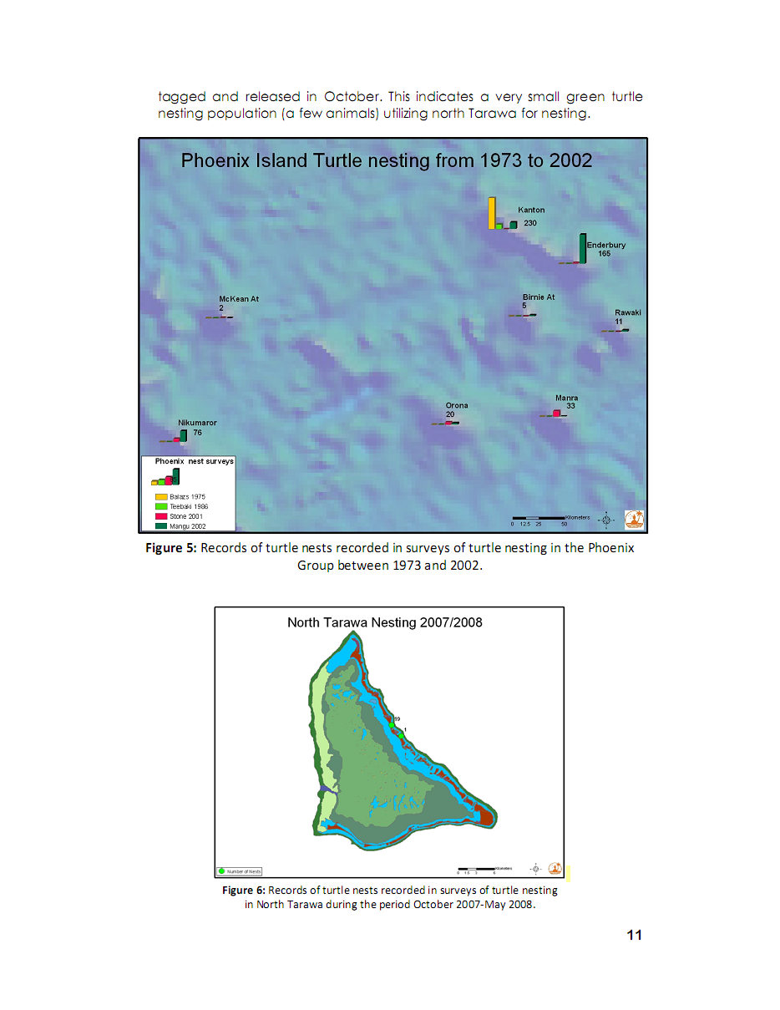
Figure 2: Records of turtle nests sighted in North Tarawa for October 2007 – May 2008. (Source: Bell 2010)

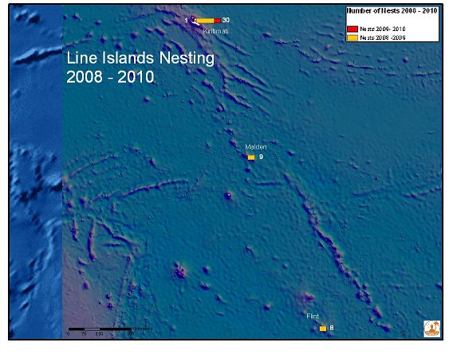
Figure 3: Records from turtle nest surveys from Oct 2008/May 2009 and Oct 2009/May 2010 for the Line Islands. (Source: Bell, 2010).

Turtle tagging activities were performed within the 2007-2010 period and an approximation of 20 turtles have been tacked and released (ECD Data, 2009). A satellite tag is yet to be mounted as a nester has not been spotted since the satellite tag was received by the Environment and Conservation Division in 2010.

The last turtle survey for Phoenix Islands was reported for 2002. Figure 3 below illustrate the records from 1973 – 2002.
Figure 4: Records of turtle nest surveys from 1973 – 2002. (Source: Bell, 2010)

1.5.2. Programme of Work on Protected Areas (PoWPA)– phase I & II outcomes

Based on the series of outer islands consultations undertaken as part of the implementation of the PoWPA phased projects, the table below summarizes the list of marine species threatened in the Gilbert group, from a community perspective:

Table 1: Status of selected marine species for the Gilbert Group

Island | Group / Location | Common name | Scientific name | Status/Comments
Aranuka (2008) | Central Gilbert | Te Anaa – Garfish | Rynchorhamphus georgi | Disappeared (threatened
Arorae (2008) | Southern Gilbert | Shark | All shark species | Overfished for overseas commercial shark fin trade
Beru  (overall, marine resources are a great concern) | Southern Gilbert Group  Latitudes: 4° N and 3° S Longitudes: 172° E and 157° W | Bonefish | Albula glossodonta (vulpes) | Overfished with small mesh size nets (VU, CT)
Beru  (overall, marine resources are a great concern) |  | Land crab (mangrove crab) | Cardissoma sp. | Overharvested, mangrove habitats destroyed by causeways, increasing human population (VU, CT)
Beru  (overall, marine resources are a great concern) |  | Sarguin clam (koikoi) | Asaphis violescens | Overharvested, mangrove habitats destroyed by causeways, increasing human population (VU, CT)
Beru  (overall, marine resources are a great concern) |  | Nikatona |  | Overharvested, mangrove habitats destroyed by causeways, increasing human population (VU, CT)
Beru  (overall, marine resources are a great concern) |  | Giant clams | Tridacna gigas, T. maxima, T. squamosa | Overharvested, increasing human population (VU, CT)
Beru  (overall, marine resources are a great concern) |  | Sea cucumbers | Holothuridae - | Overharvested for commercial trade (VU, CT)
Beru (2007) | Southern Gilbert | Sea cucumbers | Holothuria spp. | Depleted and overfished
Butaritari | Northern Gilbert Group | Land crab | Cardissoma sp | Heavily harvested, increasing human population (VU, CT)
Butaritari | Northern Gilbert Group | Birds – Avifauna:  Te Kunei Te Io - Brown or Common Noddy;  Te Karakara - Greater crested tern  Te Kiakia- Black-naped tern | Anous stolidus  Sterna Bergii  Sterna sumatrana | Islets within the lagoon and reef edges must be protected to ensure birds population
Butaritari | Northern Gilbert Group | Mangrove forest |  | Great variety is abundant between Butaritari and Ukiangang villages at the southern portion of the island
Butaritari (2008) | Northern Gilbert Group | Sea cucumber | Holothuridae spp | Overfished
Butaritari (2008) | Northern Gilbert Group | Aitoa - Mangrove | Lumnitzera littorea  (white flower) | Threatened, VU (rare and endemic); the red flowered one is found on Makin and one single tree in Eita, South Tarawa
Butaritari (2008) | Northern Gilbert Group | 4 species | Rhizophora stylosa; B. samoensis (gymnorrhiza); L. littorea | All found in Butaritari;
Kuria | Central Gilbert | Anaa – Garfish  Mwaake – thin garfish  Mullet  Awai  Ikakoaa  Bukinrin  Aubunga | Valamagi sp  Aprion sp.  Aphreus sp.  Pristimomoides auricillia  T. gigas | Gars disappeared after the closure of the passageway between the two main islets of Kuria in the late 1980s.  Increasing human population is exacerbating the decline of most fish species. T. gigas is depleted.
Maiana | Central Gilbert | Bonefish | Albula glossodonto | Overfishing after scrapping of bylaw
Maiana | Central Gilbert | Clam shell | Anadara holosorecia | Overfishing and change in lagoon current after western lagoon passage blasting and opening in late 1980s.
Maiana 2007 | Central Gilbert | n/a | n/a | No comments
Makin | Northern Gilbert | Koikoi – clam shell | Asaphis violescens | Very rare after the construction of a causeway across an inlet passage
Makin | Northern Gilbert | Ibo - Sipunclid | Sipunclid | Very rare after the construction of a causeway across an inlet passage
Makin | Northern Gilbert | Land crab | Cardissoma sp. | Very rare after the construction of a causeway across an inlet passage
Makin | Northern Gilbert | Turtle - | Turtle sp. | Onne Islet is ideal for turtle breeding ground and needs to be protected.
Marakei | Northern Gilbert | Clam shell - Bun | Anadara holoserica | Depleted and disappeared both eastern and western inland passages become shallower after bridges were constructed.
North Tarawa | Central Gilbert | Shellfish | T. gigas; T. maxima;  T. squamosa; T. hippopus | Overexploited, overpopulation by South Tarawa fishermen; law ineffective
North Tarawa | Central Gilbert | Shellfish | Anadara holoserica  Strombus luhuanus  Barbatia sp. | Overfishing and large human population; no bylaw to protect them
North Tarawa | Central Gilbert | Holothuridae | Holothuria sp. | Commercial fishing for overseas markets; law inefficient
North Tarawa | Central Gilbert | Finfish - bonefish | - glossodonto | Commercial fishing; bylaw ineffective
North Tarawa | Central Gilbert | Land crab | Cardissoma sp. | Overharvest and destruction of mangrove habitats
North Tarawa | Central Gilbert | Turtle nesting ground | (POWPA) | Taratai/Nuatabu/Nooto ocean side (POWPA)
North Tarawa (2008) | Central Gilberts | All marine resources | All | Overfishing, overpopulation
Nonouti (2007) | Central Gilbert | Sea cucumber – white teat fish | Holothuria sp. | Overfished for commercial trade
Onotoa | Southern Gilbert | Giant clams | T. gigas  T. maxima  T.squamosa | Overharvest and impact of causeway between Temao and Ptoae villages
Onotoa | Southern Gilbert | Mudflat Worm | Sipunclid sp. | Overharvest and impact of causeway between Temao and Otoae
Onotoa | Southern Gilbert | Sea cucumber | Holothuridae | Overharvest for commercial trade
Onotoa (2007) | Southern Gilbert | Sea cucumber – white teat | Holothuria sp.
Tamana | Southern Gilbert | Sharks |  | Overfishing for commercial trade
Source: T. Tebano, 2010; Protected Areas and Protected Species Report

Using the technical expertise of SPREP and CI – Pacific, the list provided in the table above is useful towards further analysis in the identification of key biodiversity areas. Such areas, upon confirmation and identification, would further provide the basis of identifying potential areas to be designated as protected areas under the Environment Act 1999 (as amended 2007). As well as providing the basis for establishing co-managed areas with local communities concerned to safeguard these key biodiversity areas at the island and village levels.

1.5.3. Mangrove Replanting under the Kiribati Adaptation Project (KAP) II Project

Since the completion and endorsement of the Kiribati NBSAP in 2007, significant progresses have been made to conserve and manage mangroves at the island and national levels. Mangroves are now protected under the Environment Act as amended 2007. Under the Kiribati Adaptation Project (KAP) II, the role of mangroves in climate change adaptations and mitigations are recognized. Efforts have been made in updating areas covered with existing mangroves in several islands of Kiribati such as South Tarawa, North Tarawa, Butaritari, Makin, Aranuka and Maiana. Past studies undertaken in Kiribati in 1996, indicated that there were 268 hectares of mangroves for the Gilbert group: 177 hectares in Butaritari; 57 hectares for Tarawa; 21 hectares in Maiana; and 14 hectares in Aranuka. This project also provided opportunities to update these data and determine whether the areas indicated have decreased or increased in mangrove coverage, over a decade and a half. Mangrove replanting efforts were concentrated on these islands and Makin is included on the basis that this island is one of the only two islands that house all four species of mangroves existing in Kiribati.

The Government of Kiribati is putting national efforts to promote mangrove conservation and management including mangrove replanting along the coasts of the designated islands, as a soft option measure to address coastal erosion including its important roles in climate change adaptations and mitigations. MELAD through ECD is instrumental in executing these activities to address coastal erosion and equally to enhance and conserve the marine life associated within the mangrove ecosystem. Mangrove replanting is also integrative of MELAD Ministry Operational Plan (MOP) on annual basis since 2005. Each year, ECD in collaboration with local communities, environmental youth groups, schools and regional and international partners (ISME, International Society for Mangrove Ecosystems) and SPREP - Secretariat for the Pacific Regional Programme, are able to plant on average 20,000 seedlings. It is important to note that the majority of these seedlings planted are limited to the capital Tarawa largely due to financial constraints.

Besides demarcation, extensive mangrove replanting and community outreach campaigns were performed on all the five designated islands. More than 40 thousand mangrove seedlings were planted alone in 2010 in these five islands and more than 20 outer island communities were consulted (ECD/KAP II Data, 2010). It is envisaged that these similar activities (mangrove demarcation, replanting and community outreach) will be extended to other outer islands in the near future.
The following diagrams provided updated mangrove coverage areas for the islands targeted in the Mangrove Replanting project.

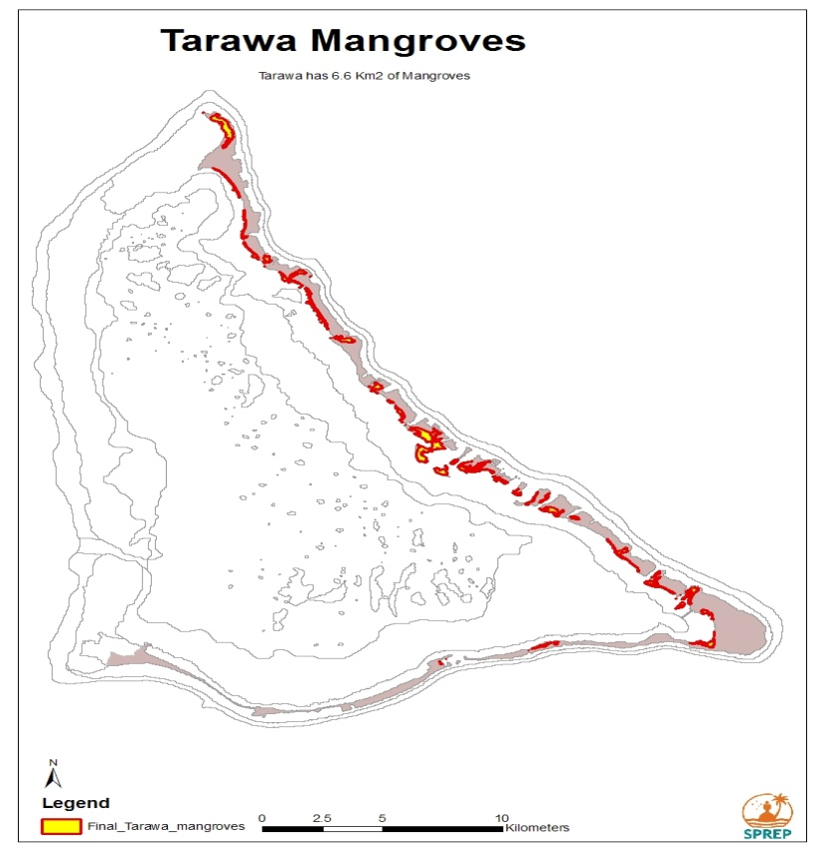
Fig 5: Tarawa (North and South) mangrove coverage
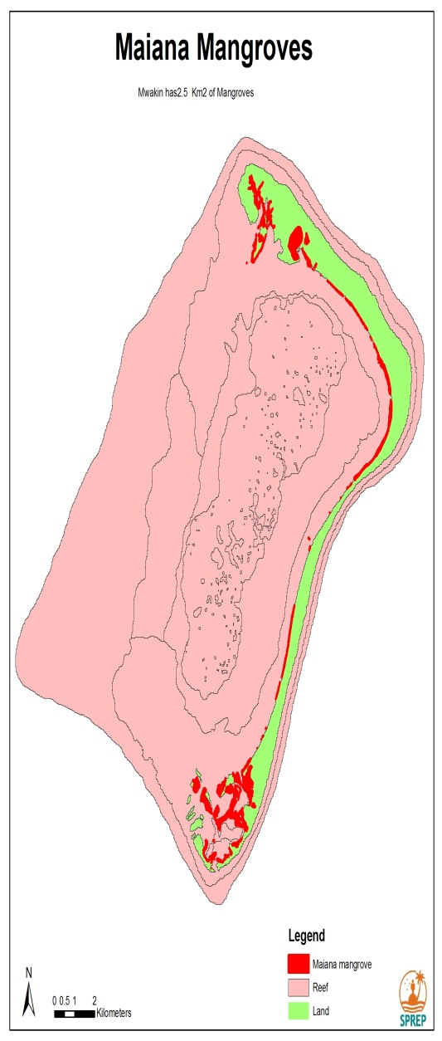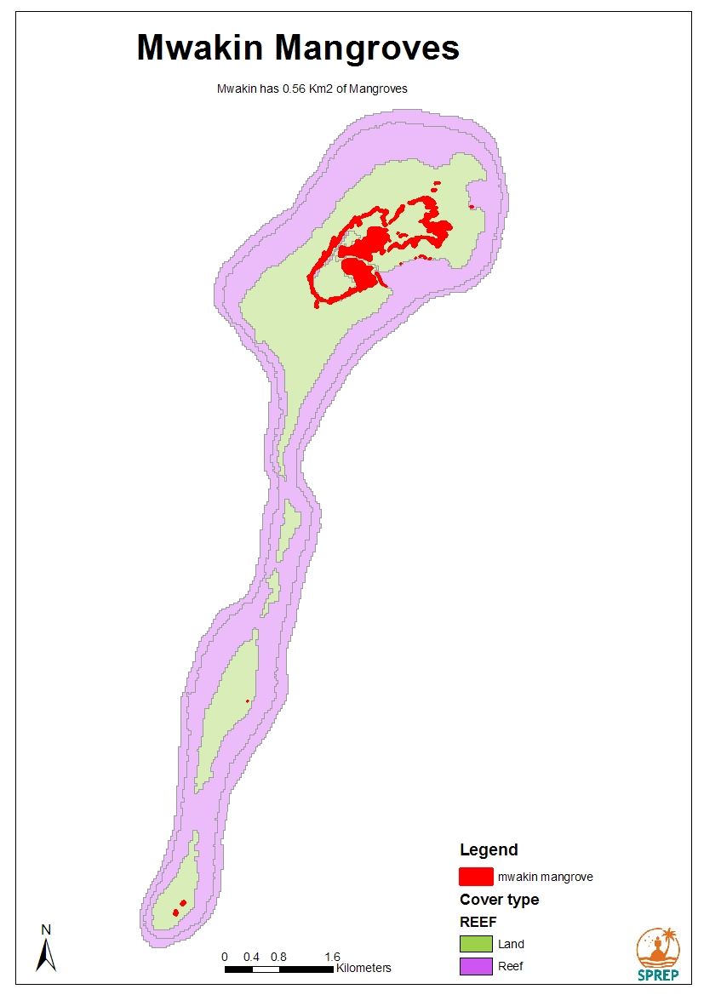
Fig 6 and 7: Maiana and Makin mangrove coverage

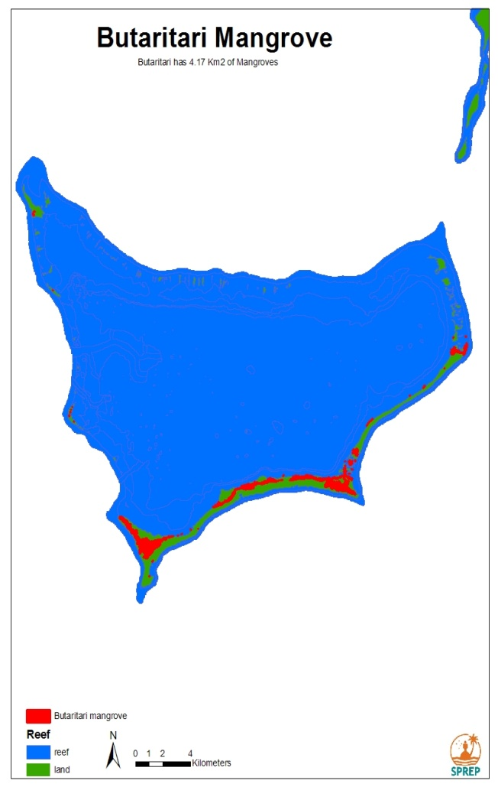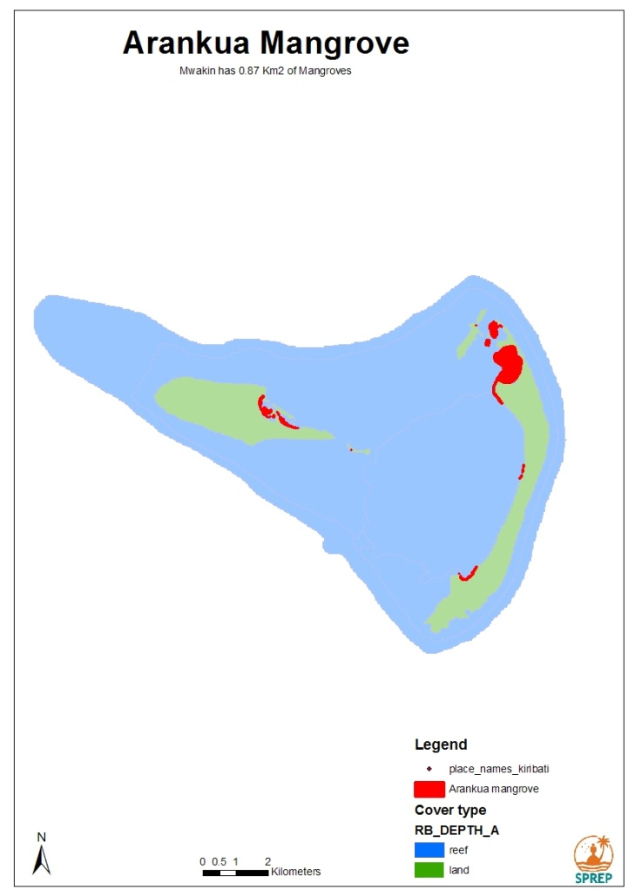
Fig 8: Butaritari mangrove coverage Fig 9: Aranuka mangrove coverage

1.5.3.1Summary of Results

Table 2: Mangrove Demarcation
Island | Area (1996 USDA Forest Service) | Area (KAP II Mangrove Replanting, Data Update and Outreach)
Butaritari | 177 hectares | 417 hectares
Tarawa (North and South) | 57 hectares | 660 hectares
Maiana | 21 hectares | 250 hectares
Aranuka | 14 hectares | 87 hectares
Makin | No data | 56 hectares
TOTAL | 269 hectares | 1414 hectares (Makin not included)

Table 3: Mangrove Replanting

Island | Phase I | Phase II
Butaritari | 1600 | 2132
North Tarawa | 2570 | 1020
South Tarawa | 9890 | 5759
Maiana | 2124 | 2312
Aranuka | 3243 | 2308
Makin | 1057 | 1018
TOTAL | 20,484 | 14,549

Table 4: Education Outreach

Island | No. of outreach campaigns undertaken | Approach used | Estimated No. of public reached
Butaritari | 8 | - Informal community outreach – public consultation  - School visit  - Island Council Consultation | 220
Tarawa (North and South) | 2 | - Informal community outreach – public consultation  - Media Campaigns (national radio and local newspaper)  - School visits and competitions | 40% of Kiribati population (≈40,000)
Maiana | 13 | - Informal community outreach – public consultation  - Island Council Consultation | 350
Aranuka | 14 | - Informal community outreach – public consultation  - Island Council Consultation  - School visits | 400
Makin | 12 | - Informal community outreach – public consultation  - Island Council Consultation  - School visits | 350

1.5.4 MANAGEMENT OF IAS AT NATIONAL LEVEL

At the national level, there are the management tools that exist to address IAS. These are as follows:

- Kiribati National Development Plan (on a broad scale, where IAS us recognized as one of the many issues under the environment key policy area
- Kiribati NBSAP (certain areas are given priority in terms of available funding tapped from GEF and other possible funding sources, depending on the nature and focus of biodiversity related projects funding secured at national level (e.g. CEPF, NZAid, etc)
  - IAS Strategic Actions Plan (Gilbert Group) – still in draft (need more work to complete)
  - IAS Strategic Actions Plan (Kiritmati and Line Islands Group – in final draft and is yet to be endorsed)
- Legal back up provided to addressing IAS issues include:
  - Environment Act (as amended) particularly provisions on Conservation, including protected areas, protected species and environment license
- Securing and implementation of IAS regional and national projects in Kiribati (e.g. IAS regional project (in the process of funds release); Kiritmati and Line Islands Restoration Project – secured under CEPF and which SPREP is taking the lead in coordinating this with Government of Kiribati; various technical supports and projects through PII (which mainly involves technical support of Ray Pierce).
- IAS active management, including a full invasive species assessment of the PIPA islands, two successful island invasive species eradications, secure plans for two more and partnerships with centres of expertise eg New Zealand show that PIPA’s management is working and these island biodiversity values will continue to increase. Note that rabbits have been eradicated successfully from PIPA (Rawaki Is).

1.5.4i. Achievements of IAS at National Level

IAS management efforts within the PIPA reflects:
A multi-agency partnership -
Government of Kiribati (MELAD/ECD/WCU);
Phoenix Islands Protected Area (PIPA);
New Zealand Government (NZAID);
New Zealand Department of Conservation (DOC);
Pacific Expeditions (PE);
Pacific Invasives Initiative (PII);

The following provided background information on how IAS issues within the PIPA area are addressed:

Timetable
2005 – invasives proposal selected by PII
2006 – conservation survey funded by CEPF
2007 – consultation with Kiribati Government
– eradication proposal funded by NZAID
2008 – training workshop (April). MELAD/ECD/WCU/Police/Customs/…
– eradication expedition (May-June) (involvement of key technical staff of Government of Kiribati)
2009 – monitoring and surveillance expedition

Achievements
- Management Plan for Phoenix Islands Protected Area (PIPA) drafted. This subsequently plays a very important role towards finalization and endorsement of the PIPA Management Plan itself;
- Rats (1 island) and rabbits (1 island) successfully eradicated;
- Rat and cat eradications being planned for other islands (work on PIPA continuing);
- Draft Biosecurity guidelines for the Phoenix Islands prepared;
- Wildlife Conservation Unit and PIPA Office have gained knowledge and skills for managing invasives species (capacity strengthened)
- Funding leveraged

“Before and after” eradication
Rats on McKean Island from shipwreck
Brodifacoum hand-broadcast in June 2008
No sign of rats during surveillance in December 2009
18 months rat-free has seen increase in bird populations and recovery of ecosystem

1.6 Overview of the national protected area system

Kiribati has unique and diverse marine biodiversity including seamounts that remains to be fully explored with suspected high level of endemism. Its biodiversity includes all terrestrial and marine ecosystems, all plant and animal species found in these ecosystems and the traditional knowledge, uses and beliefs and local language that the people of Kiribati have related to their ecosystems and species.

Government of Kiribati is also involved in the implementation of the GEF supported Programme of Work on Protected Area phase I & II projects at the country level. The implementation of the POWPA projects in Kiribati compliments ongoing Government’s efforts in identifying and establishing potential areas of biodiversity significance (both nationally and internationally), as protected areas at the national level, particularly within islands in the Gilberts and Line Islands Groups.

There are also existing conservation areas and reserves that are administered under the Fisheries Division, Environment and Conservation Division and Wildlife Conservation Unit (WCU) of Environment and Conservation Division as follows:

Kiribati has established a system of marine protected areas that aim to conserve marine biological diversity. These areas also serve as ecologically representative networks of protected areas at sea, which are administered by Fisheries Division of Ministry of Fisheries and Marine Resources Development (MFMRD). Currently there are 12 Marine Protected Areas that are primarily set up for stock enhancement of marine species that have been identified and confirmed as declining in numbers, yet important for our livelihoods and economic well being. Additionally, Fisheries Division is also working on developing seasonal closed areas in the Gilbert Group and is working with local island governments to develop a by-law on these closed areas and seasonal closed areas for appropriate legal back up at both national and island levels.

- Under the Wildlife Conservation Ordinance, the following have been designated as conservation closed areas and wildlife sanctuaries. These are administered jointly by Environment & Conservation Division and Wildlife Conservation Unit of Environment & Conservation Division:
(refer to GEF consultations)

Northern Line group:

Kiritimati Island (Wildlife sanctuary)
- Designated conservation closed areas on Kiritimati Island include Ngaontetaake; Dojin; Tanguoua; Koil; Toyota; Mouakena; Motu Tabu islet; Motu Upua islet; and Cook Islet.

Southern Line group: Starbuck Island and Malden also designated as both Wildlife Sanctuaries and Closed areas.

- These islands and areas are protected under the Wildlife Conservation Ordinance CAP 100. They are designated as wildlife sanctuaries and closed areas to protect the abundant and unique birdlife existing therein.

- These areas and islands are also globally significant seabird sites that function as critical refuge for migratory, resident and breeding marine and terrestrial biota and critical habitat for many endemic, depleted and endangered species.
Phoenix Islands group:

- Under the Phoenix Islands Protected Areas (PIPA) Regulation of Environment Act 1999 (as amended 2007), the Phoenix Islands Protected Area (PIPA) is designated as the protected area.

1.6.1 Phoenix Islands Protected Area

The 408,250km² Phoenix Islands Protected Area, covering about 12% of Kiribati’s EEZ, holds some of the world’s most pristine coral reefs as well as a great abundance and diversity of tropical marine life. PIPA represents a near-pristine reef island system. PIPA is one of the Earth’s last intact oceanic coral archipelago ecosystems. And it’s the first reserve to place such a large area of open - ocean off-limits to commercial fishing. The reserve is one of the planet’s ecological bright spots, the boldest, most dramatic effort to save the oceans’ coral reefs, the richest habitat in the seas. This marine reserve is uniquely unspoiled, largely untouched by man and is a center for marine science, recreational diving and eco -tourism. Though coral reefs cover less than half a percent of the oceans’ area, they host more than 25% of its known fish species. The PIPA represents a marine wilderness area that has had very limited human exploitation due to their extremely remote location.

This unique ecosystem and its robustness today, as evidenced by its recent incredible recovery post-coral-bleaching, is of outstanding universal value. This type of finding is rare, if not absent from other tropical archipelagos worldwide site as of 1st August 2010. The status of the seabird diversity (19 species) found within the PIPA today is still the same as was in the 1960s. Today PIPA supports what are likely the largest breeding populations of great and lesser frigatebirds—two key ecosystem indicator species for the region. Furthermore, while the diversity of species in PIPA may not be high, the unique location of PIPA as a connectivity site for migrating and breeding seabirds is what makes it such an important location to be recognized and preserved.

Despite their modest land areas, the PIPA atolls provide ideal sites for the protection and recovery of seabird populations because most of the atolls are uninhabited, have poor access, and pests can be readily removed and prevented from reinvading. Biota such as storm-petrels and petrels are actually more readily secured on these small islands than on large islands. The security and potential for globally important and threatened seabird recovery is an important value of PIPA.

Areas within the PIPA are almost entirely open ocean habitat where the only current use is tuna fishing, this naturally focuses on strengthening fisheries management (including surveillance) and increasingly limits fishing effort. This also includes increasing protection of seamounts, noting that there is no trawling allowed in PIPA. Government of Kiribati has also completed, with the assistance of PIPA partners and members of the PIPA National Management Committee, and endorsed the PIPA management plan. The PIPA Management Committee is the national management authority for PIPA established under regulation and has been operational for more than 2 years with a proven track record of sound decision making and management of PIPA.

PIPA’s management is a ‘whole of government with partners’ approach and significant government staff and resources in the relevant line agencies are allocated to implement PIPA’s management. PIPA Management Committee comprised of government staff from all stakeholder agencies met regularly, decide and allocate management tasks most suited to their agency and implement them. NGO partners, including Conservation International and New England Aquarium, assist with resources and expertise. Important bilateral relationships have also enabled great partnership and support from including New Zealand , Australia and the USA. The MELAD PIPA staff are facilitators in this management process.
For PIPA this has had proven management success eg capture and fining of IUU vessel, full feasibility assessment of island restoration, eradication of rabbits and rats from 2 islands and we are very proud of these increasing achievements.
Additionally, Kiribati phased approach to building the management and resourcing of PIPA already has prioritized monitoring, surveillance and law enforcement. This has seen early success with prosecution and conviction ($4.8 M AUD fine) of an IUU vessel caught in PIPA under the USA Kiribati Shiprider’s Agreement. This remains a high priority area which Kiribati continues to invest in. Further, it is important to note as Party to the Nauru Agreement (PNA) Kiribati has implemented 100% observer coverage on all DWFN vessels, including those licensed in PIPA and associated restrictions on neighboring high seas as part of gaining a Kiribati license. These PNA measures are implemented by 8 Pacific Island states, including Kiribati, and are recognized globally as highly innovative with early success. Capacity is increasing at site, national and regional level and with partnerships for surveillance with neighboring Pacific Islands states, NZ, Australia and USA.
Further, the approved UNEP GEF PIPA project will provide, along with partner investments, the needed resources for management of PIPA and implementation of priority actions agreed in PIPA’s 2010-2014 Management Plan.

Information on PIPA revealed that the coral reefs and bird populations of these islands are unique, virtually untouched by man –-a true wilderness of natural beauty. In protecting the pristine nature of the islands, Government of Kiribati decided that it would not only fulfill its commitment under the Convention on Biological Diversity but the protection would also:
- help deter illegal fishing activities;
- serve as an insurance against loss or decline of marine & terrestrial species in the Gilberts & Line group of islands;
- ensure conservation of some important economic species that have declined elsewhere in Kiribati especially in densely populated areas;
- make a MPA contribution to the urgently needed measures for conservation of tuna and seamounts;
- foster the development of ecotourism and importantly for our developing nation; and
- ensure that Kiribati will be compensated for the loss of fishing revenue when closing off these islands as Protected Areas.

As of August 2010 during the World Heritage Committee Meeting held in Brazil, PIPA was successfully inscripted on the world heritage natural site and became the largest MPA on the world heritage list.
Figure 10: PIPA Boundary

1.6.2 Summary of key biodiversity areas designated or suitable for protected areas

The table below provides a summary of islands, where key biodiversity areas (currently designated Protected Areas and potential areas yet to be designated as Protected Areas) in Kiribati need gap ecological assessment and analysis.

Table 5: Existing PA and potential key biodiversity areas yet to be analyzed and assessed

PA category/  type | Quantity | Surface area, hectares | Corresponding IUCN category | Management authority
Phoenix Islands Group
Phoenix Islands Protected Area: | 8 whole islands | 408,250 km² encompassing terrestrial and marine protected areas | 1b | PIPA/ECD MELAD
Line Islands Group
Kiritimati Island & associated conservation closed areas | Island (wildlife sanctuary) | Yet to be determined | Yet to be determined | WCU-ECD MELAD
Tabuaeran Island | Yet to be determined | Yet to be determined | Yet to be determined | Yet to be determined
Teraina Island | Yet to be determined | Yet to be determined | Yet to be determined | Yet to be determined
Starbuck Island | Whole Island | Yet to be determined | Yet to be determined | WCU-ECD MELAD
Malden Island | Whole Island | Yet to be determined | Yet to be determined | WCU-ECD MELAD
Gilbert Islands Group
Makin | Yet to be determined | Yet to be determined | Yet to be determined | Yet to be determined
Butaritari | Yet to be determined | Yet to be determined | Yet to be determined | Yet to be determined
Marakei | Yet to be determined | Yet to be determined | Yet to be determined | Under consideration by Fisheries Division in close consultation with Marakei Island Government to protect
Abaiang | Yet to be determined | Yet to be determined | Yet to be determined | Under consideration by Fisheries Division in close consultation with Abaiang Island Government to protect
North Tarawa | One marine and terrestrial closed area proposed and undergoing process at the national level for formal establishment | Yet to be determined | Yet to be determined | ECD- MELAD & Fisheries Division (separate protected areas programmes running)
South Tarawa | Yet to be determined | Yet to be determined | Yet to be determined | Yet to be determined
Maiana | Yet to be determined | Yet to be determined | Yet to be determined | Yet to be determined
Kuria | Yet to be determined | Yet to be determined | Yet to be determined | Yet to be determined
Aranuka | Yet to be determined | Yet to be determined | Yet to be determined | Yet to be determined
Abemama | Yet to be determined | Yet to be determined | Yet to be determined | Yet to be determined
Nonouti | Certain marine areas around the island, where seasonal closed and/or closed marine areas exist | Yet to be determined | Yet to be determined | Under consideration by Fisheries Division in close consultation with Nonouti Island Government to protect
Tabiteuea North | Certain marine areas around the island, where seasonal closed and/or closed marine areas exist | Yet to be determined | Yet to be determined | Under consideration by Fisheries Division in close consultation with Tabiteuea North Island Government to protect.
Tabiteuea Maiaki | Yet to be determined | Yet to be determined | Yet to be determined | Yet to be determined
Beru | Yet to be determined | Yet to be determined | Yet to be determined | Yet to be determined
Onotoa | Yet to be determined | Yet to be determined | Yet to be determined | Yet to be determined
Nikunau | Yet to be determined | Yet to be determined | Yet to be determined | Yet to be determined
Tamana | Yet to be determined | Yet to be determined | Yet to be determined | Yet to be determined
Arorae | Yet to be determined | Yet to be determined | Yet to be determined | Yet to be determined

1.7 Threats and challenges to biodiversity conservation and management

Issues/challenges surrounding marine and coastal biodiversity are multi-facet in nature and complex. However, Government is often expected to ensure that marine and coastal biodiversity do not decline in status but remain abundant, to serve the needs of the general public.

Kiribati economy and physical environment are highly susceptible to global changes. At the country level, this susceptibility is exacerbated by high population growth and its concentration at South Tarawa, the capital and urban area of the country. Degradation of the environment is evident from extensive coastal erosion, increasing loss of biodiversity, water and sea pollution, and a becoming insurmountable problem of unmanaged wastes, (Kiribati National Assessment Report for the Review of the Barbados Programme of Action + 10, page 30, 2000).

Kiribati is facing many challenges in implementing the relevant Programmes of Works that would assist with meeting international obligations under the CBD at the national level. Of particular importance include some of the following: costly management of designated protected areas (the geography make up of the island, designated protected areas are remote and far from the capital island) due to limited human, technical and financial resources.
The main threats and challenges are listed below:

1.7.1 Over-exploitation and unsustainable harvesting methods and practices

Largely due to overpopulation and uncontrolled urban drift experienced in Kiribati especially within the island capital of Tarawa, the demand to consume natural resources is also high that some resources are overexploited.

This includes the overexploitation of fisheries resources (seaweeds, finfish, beche-de-mer, crabs and lobsters, shellfish, corals and other marine invertebrates) formerly reserved for local subsistence consumption, and now rapidly expanding to local and export commercial production. Overexploitation is often associated with the use of more efficient and modern fishing technologies (better motorized boat, improved spear guns and line fishing methods, improved preservation and refrigeration and distribution, more efficient nets, night and SCUBA or hookah spear fishing). Terrestrial and agricultural resources are likewise impacted by the increasing population on South Tarawa.

1.7.2 Climate change

Biodiversity is an important asset in addressing climate change through ecosystem-based mitigation and adaptation. There is strong evidence that healthy ecosystems are more resilient to climate change impacts, thereby helping to buffer island communities against them. As a low lying atoll nation, climate change remains the greatest threat to the livelihoods, security and well-being of the peoples of Kiribati. The degree of urgency for real commitments to emissions reduction must be commensurate with the science and associated impacts of Climate Change on the most vulnerable communities. It cannot be viewed in the short term impacts to traditional industrial growth or political tenure, but in the longer term sustainability of economies, societies and people the world over. A meaningful legally binding agreement on emissions reduction must be reached urgently and without delay. National efforts are focusing on the mainstreaming of climate change into national plans and systems as well as developing appropriate adaption strategies.

All of Kiribati is coastal. People in Kiribati are observing extensive coastal erosion taking place, not only of the beach but also of the land, displacing now some of them from their traditional house plots since the early 1900, and felling coconut trees, papaya trees and other varieties of vegetation at the coastal areas. Many of the country’s islands are so narrow that there really is no place to go. Half of the population is living on the capital South Tarawa making it heavily densely populated. The atolls of Kiribati are experiencing increased wave heights and frequency and we can see that this is placing increased pressure on the shoreline and seawalls. We have observed that storm surges occur far more often than in the past. High wave break over coastal land and seawalls causing flooding and more often than in the past causing destruction to settled areas and fruit trees. Cyclones and hurricane occur more frequently in the ocean area surrounding Kiribati and these generate waves that damage the atolls.

Many of the crops grown in Kiribati are affected by changes in climate. Production of copra – the main cash crop for about 55 percent of Kiribati population is sensitive to rainfall, as coconuts require annual rainfall of at least 1,000 – 1,500 millimeters. Te babai (giant taro) is extremely sensitive to reduction in groundwater. Te babai pits are also prone to saltwater and intrusions as a result of storm surges and over wash.

Climate variability may also affect agricultural production, especially during La Nina years, when droughts are most likely to occur. Sea level rise could affect agriculture crops in two major ways: first is through saltwater intrusion, which would affect te babai production in particular. Second, through loss of coastal land due to inundation, this could reduce production of copra, breadfruit, and pandanus.

Climatic changes are exerting threats to the birdlife population through heavy rainfalls and strong winds especially during the El Nino seasons. Important bird habitat and nesting grounds were destroyed elevating the death rate and number of abandoned chicks and juveniles. For instance, during the El Nino season towards the end of 2009 to early March 2010, 5 nesting colonies in the Southeast end of Kiritimati Island Peninsula along with number of nesting grounds at the Central area lagoon area of the island – a popular habitat occupied by shearwater, noddies and terns were badly affected by flooding from the prolonged period of heavy rainfall. (WCU data, 2010). Estimates of the cost of damage could not be made due to data and time constraints.

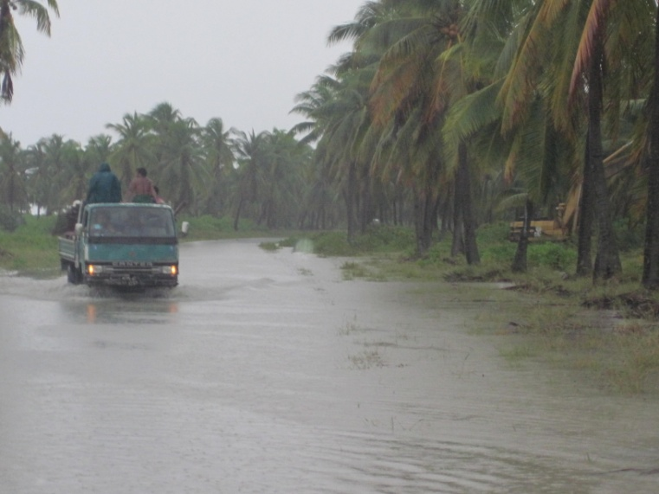
Fig 11:. The floods during the El Nino season in 2009 - Kiritimati Island. Source: WCU-ECD 2010

Climate change exacerbates public health problems in Tarawa. The incidence of ciguatera poisoning, diarrhoeal disease, malnutrition, and vectoborne diseases such as dengue fever, rise as a result of increased temperatures and changes in rainfall. Tarawa has experienced cholera outbreaks in the past. It is possible that increased temperatures may enhance the pathway of cholera transmission through the high level sewage system.
The indirect public health effects of climate change could be far-reaching. They could include increases in malnutrition due to losses of subsistence agriculture and fisheries; deterioration in standards of living due to impacts on primary sectors, loss of land and infrastructure, leading to increased crowding and land shortage, and the immense economic, social and cultural impacts associated with population relocation if it was required as a result of inundation or water shortages. These diffuse effects could well prove to be the most important impacts of climate change on the public health of the atoll, (Kiribati Country Report 2006 & http://www.climate.gov.ki/abaiang.html)
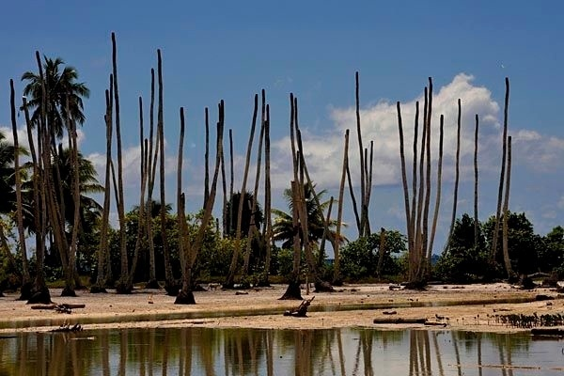

Fig.12: Former fresh water pond that now is flooded with sea water, killing coconut trees and milk fish stocks both vital parts of the local diet(Abaiang Island in the Northern Kiribati)Source: http://www.climate.gov.ki/abaiang.html

1.7.3 Data and Information Gap

There are gaps in effective and sustainable management of coastal fisheries and conservation of biological diversity due to insufficiency of concrete scientific information on the status of the fishery and marine biological diversity. Knowledge in Kiribati on the biodiversity of both the terrestrial and marine zones is lacking. There is lack of database and information available and accessible on in-depth scientific research undertaken on marine resources available in Kiribati’s waters. This includes technical and scientific information in terms of their status, the pressures associates and the sustainable yield and alternatives for these resources. Recent scientific studies have so far focused on certain islands, particularly those in the Phoenix Groups. It is suspected that more than 50% of the marine resources within Kiribati are yet to be discovered.

1.7.4 Habitat loss

Loss of valuable inshore habitats - coral reefs, sea grass beds, mangrove forests - leads to a significant decrease in the ability of marine creatures to withstand fishing pressure. Participatory research techniques can help local resource users understand these relationships and modify their behavior accordingly. When fishing success decreases, subsistence fishers employ ever more destructive fishing techniques and catch ever smaller fish and invertebrates. The loss of important fish and invertebrate stocks in turn cause the coral reef habitats to degrade even further. This cycle of destruction can only be altered by a united community approach and support - at least in spirit - by National Fisheries. These strengths, weaknesses, opportunities and threats encourage the emergence of an entirely new approach to resource assessment and economic policy making. It is an approach with great potential for harmonizing sustainable policy between sectors and between levels of society (Kiribati Country Report 2006)

Deforestation is also taking its toll on habitat loss across the island archipelago. The competition for land space and biodiversity services (construction and timber materials etc) has increased to an undesirable rate resulting in deforestation. Similarly, indiscriminate burning of forest is a concern with similar results. These practices have and continue to degrade the natural state of terrestrial resources.

Despite its outstanding values, mangroves also face imminent threat of destruction from development activities, pollution and other human activities such as causeway and channel constructions etc. Nationally, the values of mangroves are usually undermined by the local communities which consequently lead to the degradation of these priceless resources. Therefore, mangrove management and restoration is essential for all levels of society which precludes the necessity of including the education and outreach component of the KAP II Mangrove.

1.7.5 Waste and pollution

In Kiribati, the majority of waste is plastic, clothes, bottles, oils and tins and waste management remains a challenge. Because of the limited space, waste disposal is often a problem. There are currently three landfills established on South Tarawa, two of which are currently operational. Illegal waste disposal and littering is a recurring challenge throughout the nation.

Water pollution is of equal concern and this often refers to the oil spillage but moreover, using the ocean as a dumping ground – a practice quite common in Kiribati. Some cultural practices are affecting water quality and such practices include domestic pig sties. It is anticipated that more than 90% of household in Kiribati contain a pigsty and if unmanaged properly deteriorates the water quality (both underground water lens and ocean). Similarly, there have been documented cases on deliberate oil spills by private bus companies in Tarawa. Fortunately, these actions were quickly controlled by the Environment and Conservation Division but it is anticipated that some damage were already done to the affected environment.

The government through the Environment and Conservation Division has regulated and is slowly controlling waste and pollution issues through the Environment Amendment Act 2007. The limitation of this Act however, is that its pollution provisions (on land) are mostly exclusive to Tarawa only.

1.7.6 Community support

Grassroots support is one of the most important ways to conserve biodiversity. The Government continues to invest in and enhance efforts and resources to strengthen and promote the participation and involvement of local communities in environmental protection and management at the national level. This also includes working closely with local communities to revive, promote and strengthen traditional knowledge and practices that enhance and support biodiversity conservation and management at the island and village levels and likewise the inclusion of the community in the development process of all conservation related initiatives. Similarly, community engagement in field activities is equally important not only in terms of capacity building but through building a sense of community ownership.

1.7.7 Increased population

The encroachment of reclaimed areas into the lagoon or oceans to extend space for residential purposes (to built houses on) is common on South Tarawa in particular. During the census that was done during the year 2005, the total population recorded was 90,000 which is quite a large number. 43% of the population lives on the Capital island of South Tarawa where the main purpose of the urbanization is mainly for opportunity, education, medical services and also for economical growth.
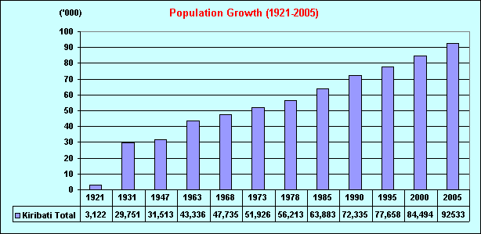

Figure 13: Population trend in South Tarawa. Source: Kiribati Statistics Office, 2005

1.7.8 Public Awareness

Commonly defined, public awareness is one of the main ways on how key messages can be spread to the community which remains a challenge in Kiribati in terms of ineffective results.

Though there are constant outreach campaigns delivered to the outer and rural areas of Kiribati, the majority of community outreach programs (formal and informal) and understanding on issues affecting the natural environment are restricted to the capital island (South Tarawa) and North Tarawa islands. This is due to high transportation costs between the Capital Island and outer islands, due to the isolation and remote nature of the islands of Kiribati.

There is urgent need to integrate environmental science and issues in the national school curriculum from primary level onwards to promote environmental concerns to the younger and future generations. Moreover, there is continued lack of accountability from the general public for the impacts of one’s action on the environment – a challenge very much hard to tackle and change within an individual. Insufficient talk between the Government and local communities/outer islands, on how the customary rights of natural resources and the environment (on land and at sea) can play a role in nature conservation. This leads to the disconnection of the linkages and distorts the balance between the natural environment, economics and sustainable development. Insufficient formal and informal outreach programs on protected areas and lack of local communities participation and supports towards biodiversity conservation initiatives.

1.7.9 Inadequate integration of customary right users in biodiversity conservation

Customary rights of the natural resources, particularly terrestrial resources are very strong in Kiribati just like other Pacific Island nations. Customary rights have helped people to traditionally manage their natural resources and land and live harmoniously with nature since time immemorial. There are 3 islands groups in Kiribati – they represent the range from traditional customary tenure (Gilbert Group) to modern colonization (particularly the inhabited islands of the Line Islands Group) to un-inhabited lands, except for a small government-paid caretaker population on one atoll (Kanton Island of the Phoenix Group). The proposal now reflects this diversity, and emphasis on community management is primarily built from customary tenure for Gilbert Group (but significant exceptions for Tarawa Atoll due to immigration). With the Gilbert Group itself (which is the primary focus of the application), traditional customary tenure is varied according to each island in the Northern, Central and Southern parts. Under this, each family have their own right for decision making regarding to the use of their lands.

The people of Kiribati have depended very much on their traditional knowledge system (traditional skills of cultivation and fishing, traditional herbal medicine, to name a few) for survival in the atolls. Much of these knowledge systems are sustainable and can certainly contribute to traditional natural resources management. Further, in Kiribati, no person is allowed to access or utilize natural resources found within land plots or areas that do not belong to him/her, unless he/she is family. There are exceptions where there is pre-existing arrangement (based on special request by non family member to enter family land plots/areas to utilize natural resources available) or understanding made by elders of different families.

The problem is that the role of traditional customary rights to natural resources and the environment existing in Kiribati has not been fully explored and tested on how these can be used towards better biodiversity conservation. Currently, there is minimal to zero dialogue undertaken at grassroots level, to learn about customary rights and discuss how traditional land owners (and natural resources owners of the commons) can play a role in protected areas (Kiribati Country Report, 2006 & Kiribati 2nd Quarter Report, 2010).

1.7.10 Invasive Alien Species

“Invasive species” (often called pests and weeds), are plants, animals and other organisms taken beyond their natural range by people, deliberately or unintentionally, and which become destructive to the environment or human interests. Pacific islands are particularly vulnerable to invasive species, because of their isolation and relatively recent human occupation. Kiribati is also no exception with issues surrounding and facing IAS.

In Kiribati, bio-security remains an unresolved serious problem for Kiritimati and Kiribati generally -without significantly improved quarantine effort, it will threaten to undermine recent biodiversity gains in Phoenix Islands and Kiritimati, and in the Line Islands generally. Specifically, impacts of IAS species, particularly rats, on agriculture is also high and costing a lot of Government expenditures to control/manage at national level. Impacts are also affecting local livelihoods (e.g. major impacts on coconuts, which provide mainstay and sources of income generation by many grassroots people, particularly those living in outer islands). Within the PIPA, invasive species are also clearly acknowledged as a threat. Especially when looking at protecting the critically important Phoenix Islands – which is also home to globally important seabird populations and vital to migratory bird routes across the Central Pacific.

These invasive species also exert a costly toll from human economies that depend on resources and services provided by healthy ecosystems. Agriculture is still predominantly subsistence based on both traditional and introduced food crops and livestock. Already, prospects for development in the agricultural sector are constrained by the country’s natural harsh environment, which is further exacerbated by smallness, fragmentation and livestock. The presence and persistence of invasive alien species in Kiribati is not helping the national situation, where agriculture development is concerned. Some examples of invasive alien species currently existing in Kiribati include Pacific or Polynesian rat (Rattus exulans; Ship rat – Rattus rattus; House mouse – Mus musculus; Asian rat – Rattus tanezumi (present on Mckean Island of the Phoenix Islands Group; Feral cats (Felis catus) – present on Kiritimati Island; Feral rabbits (Oryctolagus cuniculus) – present on Rawaki Island of the Phoenix Group; wedelia – (Wedelia Trilobata), and mynah birds (Acridotheres tristis). Wedelia, is a creeping mat-forming perennial herb with fast growing rounded stems up to 40 cm long or longer and grows upward (ascend) when flowering (Thaman, 2002). This species also exists in Kiribati and has been sighted on Tabonuea & Antekana in Butaritari (2001) and in several places around the capital island of South Tarawa. The source of introduction was unknown and although it is highly invasive and pose serious threats to the environment if not eradicated immediately, many people in Kiribati, particularly those in Butaritari and South Tarawa are not aware of its existence. Mynah bird (Acridotheres tristis) commonly known as the Common or Indian mynah has been found to be one of the invasive species in all continents. They are within the top 100 world’s most serious invasive species as determined by the Invasive Species Group of the World Conservation Union (IUCN) Mynah birds. There has been attempt to eradicate these species where an eradication program has been establish to address the issue. Effective eradication on the other hand is being undertaken mostly within the Line and Phoenix groups and have been successful.

Introduction of new and additional invasive alien species (including agricultural pests and diseases). The direct negative impacts on native species and terrestrial and aquatic habitats by alien invasive species such as Pacific or Polynesian rat – Rattus exulans; Ship rat – Rattus rattus; House mouse – Mus musculus; Asian rat – Rattus tanezumi (present on McKean Island of the Phoenix Group); Feral cats (Felis catus) – present on Kiritimati Island; Feral rabbits (Oryctolagus cuniculus) – present on Rawaki Island of the Phoenix Group); introduced frogs in Kuria and Abemama Islands (Gilbert Group) and Agricultural pests and diseases – ‘te bwabwai’ (giant swamp taro) beetle – Papuana spp.; coconut scale insect on Tab.North, Tab.South & Nonouti (Gilbert Group); mango fruit-fly – Ceratitis cosyra. Incomplete knowledge on the impacts of invasive species such as rats on biodiversity based livelihoods resources such as local food crops and trees in the Gilbert and Line Groups (Kiribati Country Report, 2006).

1.7.11 Agricultural pest and disease infestations and epidemics

Epidemic pest and disease infestations have a very negative impact on biodiversity, especially where mono cropping, large scale livestock operations and indiscriminate use of pesticides are concerned. Indicators in downward health trends in South Tarawa are the increase in the number of diarrhoea and the risk in the incidence of respiratory infections. The latter is a function of overcrowding in squatter areas. The incidence of diarrhoea, the major cause of death of infants and children in Kiribati, is high.

In Kiribati the Papuana taro beetle has made it very difficult to practice traditional pit excavation planting of giant taro (Cyrtosperma), the only major staple root crop on many low-lying atolls. Banana cultivation, primarily for export, but also as an extremely important local staple and fruit crop, is plagued by bunchy-top virus and black leaf-streak fungus (Mycosphaerella spp) as well as by the banana scab moth and root nematodes.

The most serious pests are the insects and the non-insects (mites, slugs, crabs and rats). Insect pests that have important economic implications in Kiribati include:

- Taro/Bwabwai beetle- Papuana huebneri). This is a serious and major pest problem affecting ‘te bwabwai’ crops, taro and banana on Tarawa.
- Breadfruit/Pandanus Egyptian fluted scale- Icerya aegyptica. Occasional serious throughout the country;
- Coconut flat moth- Agonoxena argaula. Occasional serious throughout the country;
- Coconut mealybugs- Pseudococcus oceanicus and Palmiculator. Occasional serious throughout the country;
- Cucumber/tomato green striped semilooper- Plusia chalcites. Serious on leaves and bores into fruits;
- Spiralling white fly- Aleurodicus dispersus. Causes serious damage to fruits and leaves of vegetables, breadfruits, coconuts, pawpaw, ornamental plants;
- Mango fruit fly- (Bactrocera frauenfeldi). This causes damage to fruits of breadfruits, quava, Indian jujube and mango fruits.

The non-insect pests include the ship rat (Rattus rattus), a red spider mite (Tetranychus cinnabarinus) and vegetable mite (Tetranychus spp), the latter two are very active during dry periods. Hence, the recent shift in weather patterns, which also involves Kiribati, has the potential to affect populations of insect pests and diseases (e.g. mealeybugs, bwabwai beetle, fungal diseases) hence could have adverse effects on the agro-biodiversity in Kiribati.

However, past insect problems that are likely to recur include the bwabwai/sweet potato burrowing cockroach (Pycnoscelots surinamansis) that became serious on ‘bwabwai’ crops in the islands of Makin and Nikunau in 1983-1984; a coconut stick insect (Graeffea crouanii) that appeared in large numbers on coconut leaves at Kenna, Abemama island in 1984; and a coconut hole shot borer (Xyleborus perforans) that appeared in Teraina in 1994, which damage fresh coconut meats (Kiribati Country Report,2006).

1.7.12 Fishing gears

The people of Kiribati are good fishermen. The high knowledge of fishing also leads them to use more advance and technical form of fishing methods. Some of the fishing methods are so destructive in a way that they can be so harmful to marine fauna and fish at sea.

Coral reefs are degraded from pollution, physical breakage, and overfishing near all centers of human population in the Gilbert Group, even small villages. While local people realize the problem, they believe the responsibility to do something rests with the national fishery, or environmental organization. Participatory techniques bring the responsibility home to those who are actually causing the damage to the reefs. Purse seiners and use of dynamite fishing are the ones that are very destructive to the life of marine creatures living out there.

1.7.13 Institutional and financial gaps.

The inadequate scientific baseline biological information on the status of biodiversity limits management scheme with respect to monitoring and adaptive management. However, the insufficient skilled human resources impede the sustainability of natural resources management. Insufficient biodiversity legislation hinders enforcement and compliance, and also the insufficient and unsustainable funding does not sustain the management of biodiversity conservation activities.

1.7.14. Summary and rating of threats and challenges.

Table 6: Threats rating of national concerns

Threats | Rating | Actions done to address the issue
Overexploitation of natural resources – (e.g. decrease availability of medicinal plants on South Tarawa only, over-exploitation of coconut crabs (Butaritari)) | High | Enforcement of Environment Act 1999 (as amended 2007) on provisions regulating resource exploitation. There is however a legislation gap on this issues and MELAD through ECD is working to fill this gap.
Food security | High | Establishment of gene banks throughout Kiribati (especially the Gilbert Islands) through ALD. Different varieties are collected and propagated in the gene banks for public dissemination.
Climate change | High | Mitigation and adaptation measures are being implemented nationally to combat climate change issues. Coastal protection (both hard and soft options) has been implemented by different sectors namely MELAD, Public Works and Kiribati Adaptation Project II (KAP II). Water improvement is also an important aspect to climate change adaptation – implemented by the government of Kiribati.
Data and information Gap | High | Surveys undertaken especially at outer islands on mangroves, turtles and sea cucumber and other important marine and terrestrial species. At the time being, there is not enough scientific data to draw up a conclusion on their national status.  Ministries withhold their own data for their sectors, difficulty to access other sectors’ data.
Habitat Loss | High | The Kiribati government is recognizing the need for resource management through the establishment of protected areas to conserve and manage the important marine and terrestrial habitats and ecosystems. PIPA is one good example of this effort. Other potential sites for conservation and management are currently identified and analyzed through the Programme of Works on Protected Areas project which MELAD is implementing jointly with its National Biodiversity Planning Committee.
Coastal erosion (due to natural & human impacts) of cultural heritage sites in outer islands (e.g. North Tarawa) | High | Cultural mapping has been undertaken in all outer islands (Gilberts Islands)
Waste and pollution | Increase | A new joint enforcement team initiated by ECD has been formed comprising of Environment, Health Inspectors, Police and Council jurisdictions (for Tarawa and Betio – TUC and BTC) in an effort to tackle waste and pollution concerns at the national level.
Community support | High | EYC (Environmentally Youth Club) is now actively working with Environment voluntary to undertake most environment campaigns at the national level including mangrove planting, cleaning of public places etc.  Besides engaging EYC, the engagement of grassroots in the decision making prior an initiative is now commonly recognized and practiced across all sectors.
Increased population | High | According to 2008, it has been confirmed that total population is 110,356, 43% of which reside on S/Tarawa. An effort by the government to address overpopulation issues is now ongoing through the Sustainable Town Planning (STP) Project under the Ministry of Internal and Social Affairs (MISA).
Limited & ineffective public awareness | High | Increase in number of awareness initiatives undertaken nationally and extended to the outer islands. Though government budget is minimal for this component, sectors and ministries are tapping external aids to support such outreach activities.
Inadequate & limited integration of customary management measures that support biodiversity conservation. Such measures are no longer practiced and maintained. | Medium | Exploring the concept of local partnership through community based conservation approaches that integrates customary management measures that support biodiversity conservation with Local Government, outer islands, villages, etc, through the implementation of the Programme of Work on Protected Areas Project.
Invasive species | Medium | An effort to control and prevent the spread and impacts of invasive alien species are of continuing interest to the government of Kiribati. Substantial progress has been made from the Line and Phoenix Islands rat and rabbit eradication. There are plans to extend this project to the other parts of the Line and Phoenix Group in the near future.
Exotic pest and disease infestations and epidemics (e.g. fungus/bacteria/virus – plant/animal diseases; zoonotic diseases – livestock; pests – mealey bugs, te bwabwai beattle, caterpillar. | High | Higher pest and disease resilient agricultural crop varieties are being introduced in the country.
Use and types of destructive fishing gears | Medium/High (South Tarawa) | Fisheries Division (Ministry of Fisheries and Marine Resources Development) has undertaken the study on the destructive fishing methods in 2008/9/ The final report with recommendations from this study, is yet to be shared to MELAD ECD.  Legislations (Act and regulations) are either developed or amended to regulate the use of destructive fishing gears. Environment mechanisms (ie EIA) is an operational tool used by the government to scrutinize potential impacts from developments and other activities that would impact the environment.
LG Sitting allowance system  Tamana & Arorae (exception) | High | Need dialogue between MISA, Island Governments, MELAD & other government sectors. No action has been undertaken to address this issue.
Institutional gap (Government & Local Government levels, NGOs & private sector engagement)  - Lack of coordination, collaboration& cooperation | High | Yet to be explored (Government sectors need to be encouraged to collaborate and pool their resources in all outer islands programmes’ implementation)
Limited and inadequate Resources (financial & technical resources) | High | The multi-disciplinary stakeholders biodiversity committee is one of the mechanisms established to address institutional gaps. Additionally, the Kiribati Development Plan (2008 – 2011), NBSAP and other existing plans and strategies recognizes helps to strengthen these partnership role and coordination. External aids and assistance are continually being tapped by the ministries to support the MEA implementations and national priority activities.

Chapter 2: NBSAP

2.1 Overview of NBSAPs

The formulation and development of the Kiribati National Biodiversity Strategies and Action Plan (K-NBSAP) is based on the outcomes and recommendations of the various national and follow-up Participatory and Learning Actions (PLA) workshops, community consultations and the biodiversity surveys undertaken in selected islands of the Gilberts Group and Kiritimati Island, which also represented the Line and Phoenix Groups.

The overall objectives of the biodiversity surveys, informal discussions with local communities, national and follow up workshops were to rapidly gather and discuss in-depth information on terrestrial and marine biodiversity that could be again used by local communities to identify actions that can be taken at the resource owner/user level, community or island level to protect, conserve and sustainable use the existing terrestrial and marine biodiversity as the basis for all cash and non-cash income (now and in the future). However, the key objective in the development of the K-NBSAP is to mobilize the participation of all consulted stakeholders that is multi-disciplinary in nature, which plays key roles in the subsequent implementation of the Plan, once it is final. This approach is aimed at fostering a sense of ownership of the Plan amongst all stakeholders concerned from different sectors of government, Fisheries Division, Ministry of Fisheries and Marine Resource Development, Mineral Division, Ministry of Natural Resources Development, Ministry of Environment, Lands and Agricultural Development, Kiribati National Tourism Office, Environmental Health and Inspection from Ministry of Health and Medical Services, Attorney Office, Ministry of Finance, Public Work and Utilities, Ministry of Internal and Social Affairs, Ministry of Education, Quarantine Office, Custom Office, . Non Governmental Organizations (NGOs) like KANGO, Maurin Kiribati Traditional Medicine, Women Federation, Atoll Research, and grassroots people, to ensure their cooperation and support in the implementation of the various stages of the K-NBSAP.

The NBSAP has the following goals for the next 5 year period.
- Improvement of informal education and public awareness at local community levels, which would form the basis for improved decision-making and participatory approach in biodiversity protection.
- Sustainable use and management of land and terrestrial resources that are in line with traditional and customary land and marine tenure systems
- Biological resources shall be enhanced, used and managed to maintain biological diversity in the short and long term run.
- Available data and information on national biodiversity shall be expanded and made available to policy makers and the public.
- Activities that pollute and threaten biodiversity shall be minimized.

2.2 Status and Progress towards NBSAP

Table 7: NBSAP status and progress

5 year Objectives | 5 Year Target
Ojective 1.1 | Create incentives and mechanisms that would form the basis of establishing community based environmental protection and management
Intended outcomes | Means of measurement | Indicators | Assumption | Status
For the protection of ecosystems, species, and species habitat | Kiribati Country report | Reports, monitoring of the place, Environment Act | More conservation network and more involvement of communities to protect and conserve the environment | There is still need to formalize protected areas as a commitment to the NBSAP. Nooto proposed Ramsar site is now a pending site to be declared protected nationally. There are plans to establish more conservation sites in the future.
Objective 1.2 | Create sustainable financial mechanism for the protection and management of biological diversity
Intended outcomes | Means of measurement | Indicators | Assumption | Status
To increase long term through financial funding for doing actions and mechanisms that contribute to the protection and conservation of biodiversity | National Reports, number of biodiversity related activities undertaken nationally | Increased number of external funded projects aimed at biodiversity conservation. | To maximize protection, and to invent other ways that are more efficient in conserving and protecting biodiversity | A number of externally supported conservation projects implemented for mangrove rehabilitation, turtle conservation, species eradication, protected areas, and public awareness projects.
Ojective 1.3 | Increase the number of conservation areas under effective management and planning
Intended outcomes | Means of measurement | Indicators | Assumption | Status
Increase number of conservation from the communities passion to designate their areas in which certain species were found at. | National reporting, community consultations, national workshops | Establishment of community-based protected areas, number of consultations and workshops | To increase the conservation and protection of certain species, certain ecosystems of national importance and promote community ownership. | A number of efforts have been made to establish community based protected areas though most have not been successful. One that is making solid progress is the community based protected area of Nooto which is undergoing government endorsement.
Objective 1.4 | Protect species, viable populations and associated habitats of ecological, natural heritage and cultural significance
Intended outcomes | Means of measurement | Indicators | Assumption | Status
To maintain natural and cultural heritage so that viable populations and certain habitats, ecosystems within that place was being conserved and protected. | Have a national protected site inscribed on the World Heritage list. | PIPA inscribed on the World Heritage List | To keep track of natural and cultural heritage sites so that those certain species and their habitats that exist in within that site are protected | A significant achievement in this area is the inscription of PIPA as a World Heritage Site. This marks the heritage properties present within our natural and perhaps cultural sites. Protection initiatives are ongoing for the smaller scale protected areas to conserve species of national importance
Objective 1.5 | Regulate access and benefit sharing of island biodiversity that include bio-prospecting
Intended outcome | Means of measurement | Indicators | Assumption | Status
To have the ability to regulate benefit sharing of the biodiversity of the island which involve institutions from overseas to have a research at. | Outer island visits and surveys, bilateral or multilateral agreements on natural resource based researches | Number of scientific data produced on benefit sharing, number of surveys and researches conducted nationally | To widen the capacity of Island biodiversity to be managed, and to know it uses and thus can be integrated as appropriate legal back up on benefit sharing and bio-prospecting on biodiversity. | A number of outside researches from a variety of institutions have visited Kiribati to undertake different researches. Copies and knowledge obtained from these researches are stored with concerned ministries and sectors.
Objective 1.6 | Improve and enhance knowledge and understanding on the status of biological diversity amongst different sectors of society and the general public
Intended outcome | Means of measurement | Indicators | Assumption | Status
To give more broad understanding to other bodies of the government especially key stakeholders with information, workshops, training, consultation, and surveys at outer island. | Working groups or national committees, workshops and national consultations on the mainland as well as the outer islands | Working group or national biodiversity planning committee established and coordinated by MELAD-ECD, various outer island visits and consultations undertaken. | Expand the knowledge on government initiatives across all sectors and different communities. | The National Biodiversity Planning Committee established to steer and endorse national biodiversity related activities. A series of outer island visits and consultations have increased and continues to increase using external funding together with government support.
Objective 1.7 | Improve collaboration amongst departments and relevant CROP agencies (e.g SPREP, SOPAC, USP, etc.)
Intended outcome | Means of measurement | Indicators | Assumption | Status
For capacity building and for more wide network in improving the work for conserving and protecting biodiversity | Reports, Agreement with CROP agencies | Number of TAs received from CROP agencies, number of training and meetings organized by CROP agencies, number of agreements between departments and CROP agencies. | Improved human and resource capacity and coordination between departments and CROP agencies. | Capacity building and trainings are constantly received by Kiribati from international partners and CROP agencies. Financial support are also provided through these agreements which have enabled activities related to the promotion of biodiversity and their conservations
Objective 1.8 | Eliminate destructive actions and activities that degrade viable populations of species and their associated habitats and ecosystems
Intended outcome | Means of measurement | Indicators | Assumption | Status
To minimize the effect of actions and activities that causes the decrease in number of important natural species. | EIA reports, State of the Environment Reports, MOP reports, Financial mechanisms for protected areas and species | The number of EIA reports, increase in financial support to protected areas and protected species mechanisms, formalization of the protected areas and protected species regulations. | Effective legal mechanisms in place to protect and conserve the viable species populations and their associated habitats and ecosystems. | Drafting of the Protected Areas and protected Species Regulations pertinent to the Environment Act 1999 (2007) is undertaken and hopefully to be formalized in the upcoming year. This will enhance species and areas protection and likewise eliminate the impacts from destructive activities.

2.3 Challenges in implementing NBSAP

The implementation of the Kiribati NBSAP though has set precedence for biodiversity conservation initiatives at the national level, bears challenges and obstacles impacting the progress of the ground activities relevant to NBSAP commitments.

The geography of Kiribati is comprised of scattered islands each fragmented to each other, the outreach and visits to these islands are very costly and likewise requires extended duration of visits. Because finance is usually a constraint from time to time, the proximity of is an overall challenge resulting in the limited coverage for the islands of Kiribati.

Though awareness on biodiversity conservation has accelerated to some level nationally, there is still urgent need of actions to progress this to a higher level and to effectively reach out to the public at large for a solid impact on the human behavior and actions towards biodiversity conservation. This is a very crucial element in the protected area and species process and in order to obtain a full support of the community and grassroots in the establishment and management of any protected areas and species.

Another challenge faced during the implementation of the NBSAP components is the limited support between line ministries in implementing and administering their relevant areas of influence. The establishment of the National Biodiversity Planning committee by MELAD-ECD has addressed this issue though not entirely.

The absence of a protected areas and protected species regulation is another factor impacting the effective implementation of the NBSAP. The enactment of these regulations will provide legal grounds to support the management of the designated areas and species. It is important to note that these regulations are in draft form and is undergoing finalization and it is envisaged to be formalized and endorsed in the near future.

Besides the constant challenges and constraints continually faced in implementing the goals and targets of the NBSAP, Kiribati is still determined and committed in achieving its targets. Significant progress has been made in some areas such as the PIPA. Kiribati is also tapping and utilizing external funding sources to support the ground and enabling activities of the NBSAP.

Chapter 3- Sectoral and Cross-Sectoral Integration of Biodiversity Considerations

3.1 Introduction

This section outlines the relevant national policies, plans and legal framework that support biodiversity conservation and their relevancy to other government and non-government institutions and their responsibilities.

3.2 Mainstreaming Biodiversity Conservation in National Policies and Plans

Kiribati has made significant progress by recognizing and mainstreaming environment into its current Kiribati Development Plan (KDP) 2008-2011, an area which the previous version formerly known as the National Development Strategy (NDS) 2004-2007 excluded.
The inclusion of Environment as one of the six key policy areas (KPA) of the KDP not only adheres its priorities and strategies to the Environment and Conservation Division (ECD) but extends across all relevant sectors such as the Fisheries, Agriculture, Tourism, Attorney General’s office, Office of the Beretitenti, Education, and Police.
Besides committing to its MEAs obligations, Kiribati ensures that these are also in line with its national priorities under the KDP.

The key issues identified under the KPA of the Environment relevant to biodiversity are: -
Issue 1: Protection and replenishment of natural resources
Issue 2: Protection of island biodiversity (plants, animals and living systems)
Issue 5: Monitor and Control Coastal erosion

The first two issues endeavor for resource and ecosystem protection and replenishment while the third looks into coastal erosion in which mangroves and coastal vegetation are considered as soft option activities.

The current KDP demonstrates the integration of new KPAs in particular – the environment pertinent to its theme “Enhancing economic growth for sustainable development” and illustrates the government’s intention for efficient coordination across sectors at the national level to achieve cross cutting issues and this thus far has been accomplished.

3.3 Legal Framework relevant to Biodiversity Conservation

Nationally, there are four existing legislations that supports meeting the objectives of the CBD, in particular, where biodiversity conservation and management is concerned. Three of these legislations are administered by MELAD. These legislations includes the following:

- Environment Act 1999 (as amended 2007);
  - PIPA Regulations 2007;
- Wildlife Conservation Ordinance CAP100 (revised edition 1977);
- Recreational Reserves Act (1996);
- Fisheries Ordinance 1979
  - Lines and Phoenix Islands Prohibited Fishing (Bonefish) Regulations.

3.3.1The Environment Amendment Act 2007

The Environment Act 1999 (as amended 2007) now includes legal provisions for conservation in which it prescribes coral reefs, mangroves, and sea grass as protected ecosystems. Before the amendment in 2007, the principal Environment Act 1999 failed to include conservation and thus was a constraint. Designation of areas and species to be protected under the act may be prescribed by regulation through the Minister of MELAD.

Hence, the amendment to the principal Environment Act 1999, indicates and reinforces ongoing Government’s efforts and commitment towards legal protection to areas of importance which house globally significant and nationally significant biodiversity values at the national level.

All species of mangroves are protected under Section 23 of the Environment Act (as amended 2007). It states: “a person who causes harm or allows harm (other than insignificant harm) to a ...mangrove….other than in accordance with an environment licence commits an offence”. The same provision also applies to all species of seagrass and coral reefs.

The provision incurs a maximum penalty fine of $10,000.00 or 2 years imprisonment.

Specifically, Section 26 of the Environment Act sets out a number of offences applying to protected areas including:
A person who engages in conduct which results in -

Harm to an organism in a protected area; or
Harm to environment in a protected area,

other than in accordance with an environment licence or management plan for the area, commits an offence with a maximum penalty of a fine of $100,000 and/or imprisonment for five years.

3.3.2 The Wildlife Conservation Ordinance

The Wildlife Conservation Ordinance (revised edition 1997) though is in urgent need of updating is a standing legislation for the closed and protected areas and sanctuaries in the Line Island Group of Kiribati. Under this ordinance, turtles are protected on land under Section 7: “No person shall hunt, kill or capture any wild turtle on land except under and in accordance with the terms of a valid written licence granted to that person by the Minister under this section”.

Within specific areas, ‘te on’ - Green Turtle (Chelonia mydas) is protected in the following areas according to Schedule 2 of the Wildlife Conservation Ordinance (Protected Birds and Animals Notice – LN 5 of 1979):

Birnie Island
Caroline Island
Christmas Island
Flint Island
Gardner Island (Nikumaroro
Hull Island (Orona)
Malden Island
McKean Island
Phoenix Island
Starbuck Island
Sydney Island (Manra)
Vostock Island

The extent of the area where the species is protected only extends to the low tide mark of the listed islands. Of importance to ‘turtle conservation’ under this ordinance include the following provisions:

Section 5: ‘No person shall hunt, kill or capture the Green Turtle within these areas or acquire or dispose of to another person a turtle unlawfully killed or captured or any part or product of a turtle except under and in accordance with the terms of a valid written licence granted to that person by the Minister’;
Section 6: ‘No person shall search for, take or wilfully destroy, break or damage the eggs or nest of the Green Turtle in its designated area or acquire or dispose of to another person the eggs or nest of a Green Turtle unlawfully taken except under and in accordance with the terms of a valid written licence granted to that person by the Minister’;

Section 9: ‘It is prohibited to possess any part or product of the Green Turtle’.
It is important to note that there is no definition of turtle in the Wildlife Ordinance but the specific inclusion of turtles under the Ordinance indicates that turtles are not included in the definition of fish and would therefore be protected within the wildlife sanctuaries.

Similarly, under this ordinance, wildlife sanctuaries have been declared under the Wildlife Ordinance by LN 24/77 at the following areas:

Birnie Island
Christmas Island
Malden Island
McKean Island
Phoenix Island
Starbuck Island

Wildlife sanctuaries only extend to the low tide mark, where under Section 8: ‘No person shall in a wildlife sanctuary hunt, kill or capture any bird or other animal (other than a fish) or search for, take or wilfully destroy, break or damage the eggs or nest of any bird or other animal except under and in accordance with the terms of a valid written licence granted to that person by the Minister’.

Hence, green turtles and all species of avifauna that exist in Kiribati, especially those existing on Kiritimati and other islands in both the Line and Phoenix Grousp, are protected under this ordinance. It is important to note that this ordinance is exclusive to the Line and Phoenix Islands Groups.

3.3.3 The Phoenix Islands Protected Area (PIPA) Regulations 2007

The Phoenix Islands Protected Area (PIPA) Regulations 2007 of the Environment Act 1999 (as amended 2007) provides legal framework for the designated Phoenix Island Protected Area. Under this Regulation, turtles are currently protected within the Phoenix Island Protected Area (PIPA) which is a protected area under the Environment Act.

The following areas are prescribed as protected areas under section 5 of the Phoenix Islands Protected Areas Regulations 2008:

Birnie Island
Enderbury Island
Kanton Island (Abariringa)
Manra (Sydney)
McKean Island
Nikumaroro (Gardner Island)
Orona (Hull Island)
Rawaki (Phoenix Island)

The protected area includes the lagoons and internal waters of each island and those parts of the adjacent Kiribati territorial sea and exclusive economic zone within the area bounded by straight lines connecting the points outlined in the Regulation. PIPA‘s boundaries consists of a heptangular (7 corner points) shaped area that encompass about 408,250 sq km including 8 atoll/reef islands, two submerged reefs and at least 14 identified seamounts and their surrounding mainly deep water marine area. Under this regulation the Phoenix Islands Protected Area is a designated protected area which is alsoKiribati’s marine and terrestrial protected area encompassing an area of 410,500sq km, and thus stands as the largest MPA World Heritage Site.

3.3.4 The Fisheries Ordinance (Cap 33) & Fisheries (Amendment) Act 1984

The Fisheries Ordinance 1979 – Lines and Phoenix Islands Prohibited Fishing (Bonefish) Regulations was established to regulate and protect the bonefish species population within the waters of Kiritimati Island. This was and remains an effective regulation. Sport fishing is a popular tourist recreational activity in Kiritimati and bonefishes caught (and released) during these sporting events are usually large in size.

Specifically, where turtles are concerned, the Fisheries Act specifically includes turtles, their young and eggs in the definition of fish under section 3. A licence is required for any local or foreign “fishing vessel” to operate within the Economic Exclusive Zone (EEZ) of Kiribati. A "fishing vessel" means any vessel used or adapted for use for fishing commercially and includes support vessels and craft, an helicopter and light aircraft used in fishing operation, but does not include a sailing boat or paddling canoe of native design or a boat, punt or barge having an overall length of less than 7 metres, whether powered by an engine or not. However, there is no specific provision concerning the management, protection or conservation of turtles. Though Section 45(2)(d) generally provides for the discretion to prescribe regulation to conserve and protect all species of fish, there has been no regulation in place on turtles (Bell, 2010).

3.3.5 Other relevant legislations

Other legal framework deemed relevant to biodiversity conservation in one way or another are listed below:

Table 8: List of relevant legislations to biodiversity conservation

LEGISLATION | Level of Relevancy
Native Lands Ordinance – Chapter 61 of Laws of Kiribati | Medium
Foreshore and Land Reclamation Ordinance | Medium
Importation of Animals Ordinance | High
Land Planning Ordinance | High
Local Government Act 1984 | Low
Marine Zones (Declaration) Act 1983 | Medium
Native Lands Ordinance | Low
Neglected Lands Ordinance | Low
Non-Native Land (Restriction on Alienation) Ordinance | Low
Plants Ordinance | High
Prohibited Areas Ordinance | High
Public Highways Protection Act 1989 | Medium
Public Utilities Ordinance | Low
Quarantine Ordinance | High
Recreational Reserves Act 1996 | High
State Acquisition of Lands Ordinance | Low
State Lands Act 2001 | Low
State Pre-Emptive Right of Purchase Act 2001 | Low

3.4 Institutional Arrangements

The three key divisions playing major roles in biodiversity and more or less conservation are ECD, Agriculture and Livestock Division (ALD), and Fisheries Division. ECD and ALD are under one administration – MELAD whilst Fisheries is under the Ministry of Fisheries and Marine Resources Development (MFMRD). The NGOs in Kiribati nonetheless contribute to biodiversity conservation in addressing certain issues that cross their portfolios.

The MELAD coordinates environmental and conservation issues through its Environment and Conservation Division and similarly coordinates roles in agriculture and biosecurity issues through its Agriculture and Livestock Division. It is important to note that biosecurity is a cross-cutting issue both dealt by ALD and ECD.

Fisheries contributes over $20 million per annum to the national economy (Wikipedia, 2011) making it the most important source of income for the nation. Amongst the MFMRD’s portfolio lies the conservation responsibility for the marine resources and ecosystems. In this respect, Fisheries Division plays a coordinating role in the marine protection initiatives.

The Kiribati Tourism Office (KTO) under the jurisdiction of the Ministry of Communications, Transport and Tourism Development (MCTTD) plays an important in biodiversity conservation in the context of its tourism model. Though the scale of tourism is comparatively low in Kiribati compared to other countries in the region, eco-tourism is promoted from KTO.

A national multi-stakeholder committee formally known as the National Biodiversity Planning Committee comprises of representatives from line ministries as well as NGOs and freelances. This committee coordinated by the ECD is an instrumental body in steering and endorsing any national biodiversity activities. The full list for members of this committee is attached as annex I.

3.5 Links with Millennium Development Goals

The eight MDGs are all integrated in the KDP 2008-2011 under the different key policy areas or KPAs. This shows the government’s commitment to achieving the millennium development goals as a member state of the United Nations.

Goal 7 – “Ensure environmental sustainability” is somewhat in a similar context to the theme of the KDP 2008-2011 as aforementioned which is “Enhancing economic growth for sustainable development” in which both endure for sustainability. The policy and legal framework for biodiversity nationally are operational mechanisms addressing goal 7 of the MDG.

It is important to note that Kiribati a poorly resourced and developing atoll nation commitments to ensuring environmental sustainability in declaring its Phoenix Islands a protected area - a significant sea and territorial area totaling to 410,500sq km and constitutes 17% of Kiribati’s EEZ. This step as described by the nation’s president is Kiribati’s gift to humanity, bearing in mind fisheries is the nation’s main source of economy, yet it has taken the extra mile in closing off fisheries activities and protecting the pristine environment within the PIPA zone. This achievement remains the nation’s milestone in goal 7 of the MDG. Ongoing progresses are still being undertaken at the national level across sectors in addressing the eight goals of the MDG.

Chapter 4– CONCLUSIONS: PROGRESS TOWARDS 2010TARGET

4.1 Introduction

The following table summarizes the national achievements and progresses in collaboration with the 2010 Target of the Convention on Biological Diversity (CBD).

Table 9: National Progress/Achievements against 2010 Goals and Targets
2010 Goals and Target | National Progresses/Achievements
Goal 1. Promote the conservation of the biological diversity of ecosystem habitats and biomes
Target 1.1 At least 10% of each of the world's ecological regions effectively conserved  Target 1.2: Areas of particular importance to biodiversity protected | 17% of Kiribati’s EEZ protected through PIPA – the largest MPA World Heritage Site. Progress to conserve other important ecosystems at the national level are still ongoing.  3 wildlife sanctuaries and 9 closed areas protected and indicated in the NBSAP 2005-2010. Another site Nooto proposed Ramsar site of 2678.89 acres within the Gilbert group is undergoing endorsement procedure from the highest level nationally to be formally declared protected as well as proceed with accession to Ramsar Convention. Though there is limited government budget allocation for this component, MELAD is tapping external funding to achieve this target.
GOAL 2: Promote the conservation of species diversity
Target 2.1: Restore, maintain, or reduce the decline of populations of species of selected taxonomic groups  Target 2.2: Status of threatened species improved | The successful eradication of ship rats and rabbits on PIPA and some closed areas in Kiritimati has minimized if not prevent the decline in the avifauna population heavily present with these islands. Further eradication activities to be continued this year and to extend outwards to other parts of Kiritimati and Phoenix. External funding sources has been secured for this purpose.  By international context, there is no threatened terrestrial species present in Kiribati. Just over ten are present for marine species. Past national surveys has indicated some local species to be threatened. The status of these species are yet to be fully studied and analysed. Phoenix and Storm Petrel are now threatened by IUCN redlist
Goal 3. Promote the conservation of genetic diversity
Target 3.1: Genetic diversity of crops, livestock, and of harvested species of trees, fish and wildlife and other valuable species conserved, and associated indigenous and local knowledge maintained. | ALD has been instrumental in coordinating this target. A nursery has been developed consisting of all genetic diversity of food crops that can be grown in Kiribati. These species are then disseminated to the outer islands to the communities.
Goal 4. Promote sustainable use and consumption.
Target 4.1: Biodiversity-based products derived from sources that are sustainably managed, and Production areas managed consistent with the conservation of biodiversity.  Target 4.2 Unsustainable consumption, of biological resources, or that impacts upon biodiversity, reduced  Target 4.3: No species of wild flora or fauna endangered by international trade | Biodiversity-based products have been a practice with the indigenous community since time immemorial . These products include mats, handicrafts, dancing costumes etc. These are usually marketed nationally. Management of product ion areas is yet to be fully formalized. It is envisaged that this are to be determined soon and conserved to sustain biodiversity-based incentives.  The enactment of the Environment Act (as amended 2007) and other regulations ie PIPA regulations are addressing unnatural impacts towards biodiversity. The draft Protected Areas and Protected Species regulations soon to be formalized should help address this issue.  Kiribati is proud to declare that to date no wild flora nor fauna is endangered by international trade
Goal 5. Pressures from habitat loss, land use change and degradation, and unsustainable water use, reduced
Target 5.1. Rate of loss and degradation of natural habitats decreased | The declaration of the Phoenix Islands Protected Areas addresses amongst many this issue.
Goal 6. Control threats from invasive alien species
Target 6.1. Pathways for major potential alien invasive species controlled  Target 6.2. Management plans in place for major alien species that threaten ecosystems, habitats or species. | The biosecurity legislation and enforcement by ALD is still operational. It is important to note also the ECD has just recently joined the boarding party for incoming international vessels to inspect all environmental concerns.  Invasive species Action Plan for Kiritimati and Tarawa developed.
Goal 7. Address challenges to biodiversity from climate change, and pollution
Target 7.1. Maintain and enhance resilience of the components of biodiversity to adapt to climate change.  Target 7.2. Reduce pollution and its impacts on biodiversity | ECD at the national level is currently implementing a mangrove rehabilitation and education project funded by the Kiribati Adaptation Project II. Five pilot islands are targeted under this project to help strengthen their resilience to climate change through mangrove rehab.  The Environment Act 1999 (as amended 2007) is regulating pollution on land and sea in effort to conserve and protect the environment and the associated life including biodiversity.
Goal 8. Maintain capacity of ecosystems to deliver goods and services and support livelihoods
Target 8.1. Capacity of ecosystems to deliver goods and services maintained.  Target 8.2. Biological resources that support sustainable livelihoods, local food security and health care, especially of poor people maintained | Ecosystems within the Phoenix islands have been maintained through the declaration of the PIPA. For the Gilbert and Line Groups, Protected Species and Protected Areas Regulations are undergoing screening process for formalization. These regulations are envisaged to address this issue as well.  The protection of mangroves, coral reefs and sea grass has enhanced the support for livelihoods at the national level. Enactment of the draft Protected Species and Protected Areas regulations will support this component.
Goal 9 Maintain socio-cultural diversity of indigenous and local communities
Target 9.1. Protect traditional knowledge, innovations and practices  Target 9.2. Protect the rights of indigenous and local communities over their traditional knowledge, innovations, and practices, including their rights to benefit sharing. | Traditional knowledge and practices are an important element of the conservation practice and these are greatly encouraged to maintain the linkages between the people and their livelihoods and promote ownership rights. These practices are also recognized by law (Environment Act 1999 (as amended 2007) amongst other national legislations.  As aforementioned in target 9.1 above, these rights are fully recognized by certain legislations such Environment Act. However, improvement is required for the full protection of these rights.
Goal 10. Ensure the fair and equitable sharing of benefits arising out of the use of genetic resources
Target 10.1. All access to genetic resources is in line with the Convention on Biological Diversity and its relevant provisions  Target 10.2. Benefits arising from the commercial and other utilization of genetic resources shared in a fair and equitable way with the countries providing such resources in line with the Convention on Biological Diversity and its relevant provisions | Currently, there is no existing national legislations that regulate the access to genetic resources and the sharing of benefits arising out of the use of these genetic resources. Kiribati is now in its preparatory stage to ratify the Nagoya Protocol on Access and Benefit Sharing
Goal 11: Parties have improved financial, human, scientific, technical and technological capacity to implement the Convention
Target 11.1. New and additional financial resources are transferred to developing country Parties, to allow for the effective implementation of their commitments under the Convention in accordance with Article 20.  Target 11.2. Technology is transferred to developing country Parties, to allow for the effective implementation of their commitments under the Convention, in accordance with its Article 20, paragraph 4. | External funding sources are the main financial supporter for the implementation of Kiribati’s obligations to the CBD. The national government nonetheless supports these obligations financially (though on a much smaller scale than External Aid) and likewise through in-kind.  Kiribati has received a number of technologies to drive the implementation of national activities relevant to their commitments under the convention. These include invasive eradication technologies and mangrove demarcation equipments such as GPS.

4.2 Overall Assessment of Results.
The overall commitment of Kiribati as a whole to the targets and goals of the CBD is steady for most areas but progressing, while one or two targets are further advanced to the rest. This refers to the first goal of the 2010 target in relation to protected Areas.

The biodiversity is a crucial element for survival for the people of Kiribati in terms of sustenance and livelihoods. Equally important is that the biodiversity drives the national economy and the social activities for both the rural and more urbanized part of the nation.

In Tarawa, the main capital centre, the status of biodiversity has been impacted by the increased and still increasing urban drift from the outer islands to the capital. This move has contributed to the high population on Tarawa and thus the environmental concerns now experienced throughout the capital island. The government however has taken initiatives to mitigate and control these impacts through erecting legislations and implementing conservation measures such as protected areas and the like.

The major constraints encountered for biodiversity conservation are legislation gaps, limited funding, resources and capacity at the national level, limited coordination between key sectors in implantation and planning phases, lack and need of effective public awareness, fragmentation of islands within Kiribati incurring high cost for activity implementation and limited data on resources. The MEAs that Kiribati is a signatory to are offering financial support for biodiversity conservation and these has resolved or supported some though not entirely the constraints as aforementioned.

Kiribati through its relevant government sectors and NGOs are and will continue to move forward to protect their natural environment and biodiversity through conservation measures and initiatives. It is important to note that many factors are urgently needed to accelerate such initiatives and the foremost of these are enhanced funding support, capacity building and awareness.
-----------------------------------------------------------------------

Annex I: List of National Biodiversity Committee Members
Name | Position | Division/Ministry | Email
Riitite Tekiau | Assistant Secretary | MELAD  Ph: 28211 | Riitite.Tekiau2@gmail.com
Nenenteiti Teariki-Ruatu (Mrs) | Deputy Director ECD | ECD  Ph: 28000 | nteariki@gmail.com
Turang Teuea-Favae (Mrs) | Ag BCO | ECD  Ph: 28000 | turangf@environment.gov.ki
Tekimau Otiawa | Assistant BCO | ECD | tekimauo@environment.gov.ki
Raikaon Tumoa (Mr)/ Tuake Teema (Mr) | Principle Fisheries Officer | Fisheries Division  Ph: 28095 | raikaont@fisheries.gov.ki  tuaket@fisheries.gov.ki
Tekautu Ioane (Mr) | Culture Office | Culture Office, Bik  Ph: | tekautun@yahoo.com
Teretia Mantaia (Mrs) | State Advocate | AG’s Office  Ph: 21242 | teretia_mantaia@yahoo.com
Tarataake Teannaki (Mr) | Snr Tourism Officer | KNTO  Ph: 26003 | sto@mcttd.gov.ki
Dr Alolae Cati | Advisor | MKTM  Ph: 28100/50095 | alolaec@yahoo.com
Bwere Eritaia (Mr) | Consultant | Culture/Environment Freelance  Ph: 22234 | beritaia@gmail.com
Dr Temwakei Tebano | Consultant | ThEco Care  Ph: 21538 | t.tebano@yahoo.com
Ata Binoka (Mr) | Quarantine Officer | ALD  Ph: 28108 | b_aata@yahoo.com.au
Meronga Taru(Mrs) | Curriculum Officer | CDRC  Ph: | m_raeao@yahoo.com
Conchitta Tatireta(Ms) | Project Officer | MELAD  Ph: 28211 | conchitta@melad.gov.ki
Kum-On Tarawa (Mr) | Officer | FSPK | kumon.tarawa@gmail.com
Amon Timan (Ms) | Board member | KANGO | kango@tskl.gov.ki
Reei Tioti (Ms) | Snr Lands Management Officer | LMD  Ph: | reei.lmd@melad.gov.ki  maianateburakewe@gmail.com
Faitele Mika (Ms) | Snr Planning Officer | NEPO  Ph: | mfaitele@hotmail.com
Mourongo Kataatia (Mr) | Chief Water Engineer | Works, MPWU  Ph: 26192 | awe@mpwu.gov.ki
Taati Eria | Ag. EAO | ECD-MELAD | taatie@environment.gov.ki

References:

- Aregheore.M.E, PhD, Country Pasture/Forage Resource Profile, Marfel Consulting (Agricultural and Educational Services), Canada, 2005, http://www.fao.org/ag/AGP/AGPC/doc/Counprof/southpacific/kiribati.htm, accessed on 15th Sept 2010.
- Island Water Resources Study- Volume 1, 1983 p. 38
- Handbook of the Convention on Biological Diversity. (2001). Earthscan Publications
  - Ltd, UK.

Kiribati National Assessment Report for the Review of the Barbados Programme of Action + 10, Ministry of Finance and Economic Development, June 2000.

- Kiribati Climate change, Office of the President, October, 2010 <http://www.climate.gov.ki/abaiang.html>, accessed 8th August 2010
- PIPA Management Plan, 2009. Ministry of Environment, Lands and Agricultural Development
- Redfern, T. (2005). Contribution from Agriculture Division to National AdaptationProgram of Action (NAPA) National Workshop. Environment and ConservationDivision, MELAD. Bikenibeu, Tarawa. Republic of Kiribati.
- Tebano, T, 2008. KAP II Outer Islands Consultation, Risk Management, Capacity Building, Island Profiling (Makin, Butaritari, Marakei, North Tarawa, Maiana, Kuria, Onotoa, Tamana).
- Tebano.T, 2010, Reports on POWPA for national concerns
- Thaman, R,R and Tebano, T., 1994:A Preliminary Listing of Plants and Fishes of Kiribati.
- The Kiribati Country Report to the Conference of Parties (COP) of The Convention on Biological Diversity (CBD), 2006, MELAD-ECD.
- Teuea.T, Kiribati 2nd Quarter Report, Biodiversity and Conservation Officer, Environment and Conservation Division, 2010.
- Wikipedia Encyclopedia, Millennium Development Goals, <en.wikipedia.org/wiki/Millennium_Development_Goals>, accessed on 17th September 2010

World Bank, 2009. Convenient Solutions to an Inconvenient Truth: Ecosystem-based Approaches to Climate Change
N. Dudley, et al. (eds.), 2010. Natural Solutions: Protected areas helping people cope with climate change, IUCN-WCPA, TNC, UNDP, WCS, The World Bank and WWF.

