Action Plan for Implementing the Programme of Work on Protected Areas
of the Convention on Biological Diversity

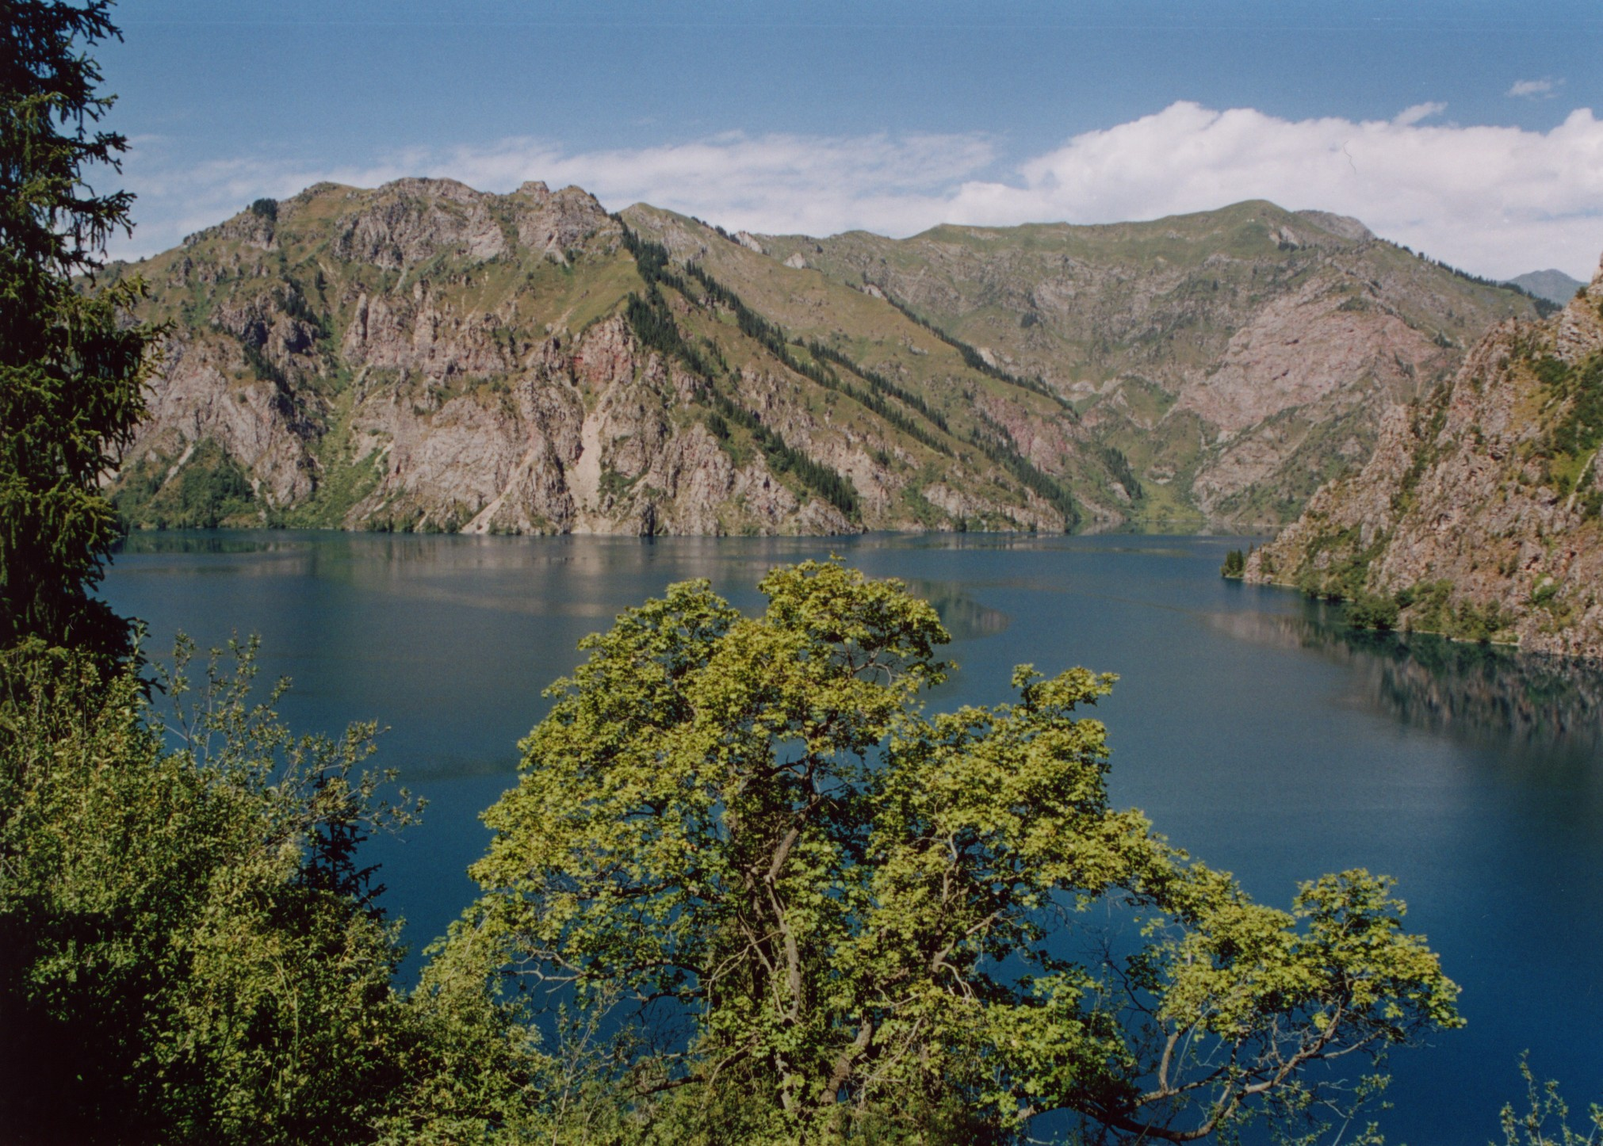
Kyrgyzstan

Submitted to the Secretariat of the Convention on Biological Diversity 2012.06.08.

Protected area information:

PoWPA Focal Point: Kylychbek Zhundubaev
tel/fax: + 996 312 564195
email: kylychbekkg@gmail.com

Lead implementing agency: The State Agency on Environment Protection and Forestry under Government of the Kyrgyz Republic
Multi-stakeholder committee: The National Science Academy of the Kyrgyz Republic, Reserves, National Parks, The Registration Service of the Kyrgyz Republic, Local Governments, Research Institutions.

Description of protected area system
Coverage
There are 4 different types of 87 protected areas (PAs) in the Kyrgyz Republic with total territory of 1200872 hectares what is 6.0% of territory of the republic.

Description and background
Out of them 10 state reserves (IUCN I a,b category) with a territory of 596 345.4 hectares, 9 national parks (IUCN II category) – 302 949.2 hectares and 68 preserves (IUCN III, IV categories) – 301 426.7 hectares are functioning for efficient conservation of the ecosystems.
According to the Law about PAs (2011.05.03. #18) reserves and parks are nature protection, research and ecological educational institutions
Role of the protected areas is important in organization of research of dynamics of biodiversity and response of biosphere on climate change and development of desertification processes, and in organization of environmental education, development of recreation and tourism activity as well.

Governance types
10 reserves and 9 parks are set aside PAs, out of them 10 reserves, 8 national parks and Biosphere Reserve “Issik-Kul” (all administrative territory of the Issi-Kul region) are under the State Agency on Environment and Forestry governance (central). 1 park is under President Administration governance. Preserves governance are under main land owners (municipality). Botanical garden named after E. Gareev is under the National Science Academy of the Kyrgyz Republic, zoological park “Karakol” is under the Mayer of Karakol city.

According to Law “About PAs” (2011) PAs are divided:
- The State Natural Reserves
- The State Natural Parks
- The State Preserves (forest, complex, botanical, zoological, geological and seasonal preserves)
- The State Natural Monuments
- The State Botanical, Dendrological garden, zoological parks
- Biosphere Territories or biological reserves
- The transboandry PAs international importance

Key threats
Mining;
agriculture;
illegal logging and hunting;
introduction of invasive species;
forest fires;
natural disasters in man-caused characters;
lack of qualified and skilled managers;
lack of funding.

Barriers for effective implementation
Lack of financial and human capacities in conservation management, lack of effective monitoring, and assessment of PAs. low public awareness of nature conservation, sustainable utilization of natural resources, low implementation of legislation, lack of interrelationship with stakeholders.

National Targets and Vision for Protected Areas
Increasing of the PAs area, establishing new PAs;
Developing and implementing measures on rare and endangered species conservation.
Survey and monitoring of the biodiversity including inventory of the fauna and flora in PAs;
Developing policy for all sectors which provides sustainable conservation and use of biodiversity;
Develop the capacity building program for all stakeholders and exchange experience, carry out regularly trainings;
Creation of information and ecological centers;
Identification of key territories for tourism development taking into account vulnerable ecosystem, work out tourism routs and development of the tourist infrastructures;
Development international corporation.

Progress in and plans for achieving the goals of the Programme of Work on Protected Areas
Progress: 0 = no work, 1 = just started, 2 = partially complete, 3 = nearly complete, 4 = complete
Goals of the Programme of Work on Protected Areas | Progress 0-4
- Progress in establishing and strengthening national and regional systems of protected areas (1.1) | 2
- Progress in integrating protected areas into broader land- and seascapes and sectors so as to maintain ecological structure and function (1.2) | 2
- Progress in establishing and strengthening regional networks, transboundary protected areas (TBPAs) and collaboration between neighbouring protected areas across national boundaries (1.3) | 3
- Progress in substantially improving site-based protected area planning and management (1.4) | 2
- Progress in preventing and mitigating the negative impacts of key threats to protected areas (1.5) | 2
- Progress in promoting equity and benefit-sharing (2.1)  - Progress in assessing and implementing diverse protected area governance types (2.1) | 1
- Progress in enhancing and securing involvement of indigenous and local communities and relevant stakeholders (2.2) | 2
- Progress in providing an enabling policy, institutional and socio-economic environment for protected areas (3.1)  - Progress in assessing the contribution of protected areas to local and national economies (3.1) | 2
- Progress in building capacity for the planning, establishment and management of protected areas (3.2) | 2
- Progress in developing, applying and transferring appropriate technologies for protected areas (3.3) | 1
- Progress in ensuring financial sustainability of protected areas and national and regional systems of protected areas (3.4) | 1
- Progress in strengthening communication, education and public awareness (3.5) | 1
- Progress in developing and adopting minimum standards and best practices for national and regional protected area systems (4.1) | 2
- Progress in evaluating and improving the effectiveness of protected areas management (4.2) | 2
- Progress in assessing and monitoring protected area status and trends (4.3) | 1
- Progress in ensuring that scientific knowledge contributes to the establishment and effectiveness of protected areas and protected area systems (4.4) | 1
- Progress in marine protected areas | NA
- Progress in incorporating climate change aspects into protected areas | 1

Priority activities for fully implementing the Programme of Work on Protected Areas:
Activities | Timeline
1. completion and effective implementation of management plans of the reserves and parks, improving the effectiveness of protected areas management | 2013-2015
2. development and carry out capacity building training for PAs managers and rangers | continuous
3. public awareness in nature conservation policy and nature conservation measures | continuous
4. improvement partnership with other stakeholders (local government, research institutions, NGO etc.) | continuous
5. conservation, survey and biodiversity monitoring | continuous
6. granting of sustainable financing | continuous
- development for tourist infrastructure | continuous

Action Plans (detailed steps) for completing priority activities for fully implementing the Programme of Work on Protected Areas:

Activity 1:

Key steps | Timeline | Responsible agencies | Indicative budget
Preparation and approval of management plans all PAs | 2015 | The State Agency | in framework of GEF 5
Collection and generalization of materials | continuous | The State Agency
improvement partnership with other stakeholders (local government, research institutions, NGO etc.) in PAs activities | continuous | The State Agency
Development and implementation community based conservation elements in PAs | continuous | The State Agency and National Academy Science and other stakeholders

Activity 2:
Key steps | Timeline | Responsible agencies | Indicative budget
Inventory of the biodiversity, monitoring | continuous | The State Agency and National Academy Science and other stakeholders
Identification and map rare and endangered species of plant and wildlife habitat | 2013-2015 | The State Agency and National Academy Science and other stakeholders
Identification of potential territories for new PAs | 2013-2015 | The State Agency and National Academy Science and other stakeholders
Development conservation action plans for rare and endangered plants and wild animals | 2013-2015 | The State Agency and National Academy Science and other stakeholders

Activity 3:
Key steps | Timeline | Responsible agencies | Indicative budget
Preparation of training program for PAs managers and rangers and development of certification system | 2013-2014 | The State Agency and National Academy Science and other stakeholders
Improvement of stakeholders involvement in training process | Continuous | The State Agency and National Academy Science and other stakeholders

Key steps | Timeline | Responsible agencies | Indicative budget
Develop tourist routs in PAs | 2014 | The State Agency and Research Institutions
Development of the tourist infrastructures | continuous | The State Agency and donor organizations
Involvement of stakeholders (local communities, tourist agencies, etc.) | continuous | The State Agency and stakeholders
Development and implementation community based conservation elements in PAs | continuous | The State Agency and stakeholders

Key assessment results
Ecological gap assessment Econet of the PAs were completed in 2006.

Management effectiveness assessment (NA)

Sustainable finance assessment (NA)

Capacity needs assessment (NA)

Policy environment assessment (NA)

Protected area integration and mainstreaming assessment (NA)

Protected area valuation assessment (NA)

Climate change resilience and adaptation assessment (NA)

