South and West Asia Sub-Regional Workshop on the review of, and Capacity-Building for, the implementation of the CBD Programme of Work on Protected Areas

02- 04 April, 2007
Wildlife Institute of India, Dehradun, India

Review of Implementation of the
Cbd Programme of Work on Protected Areas:
India



April, 2007

S.No |  |  | Goal, & target |  |  |  | Key evaluation questions and national considerations |  |  | Response
 |  |  | Description |  |  |  |  |  |  | Response
1 |  |  | Goal: To establish and strengthen national and regional systems of protected areas integrated into a global network as a contribution to globally agreed goals.  Target: Establish a global network of comprehensive, representative and effectively managed national and regional protected area systems. |  |  |  | - Is the existing national protected area system comprehensive, ecologically representative and effectively managed (provide number of existing protected areas, total area covered, and type and percentage of biomes covered)?  - What are the definitions of "comprehensive", "ecologically representative" and "effectively managed" in your country?  - What is the progress made in quantitative and qualitative terms against the national targets relating to "comprehensiveness", "ecological representation", and "effective management"?  - What biomes are adequately represented?  - What biomes are underrepresented or not represented?  - What IUCN categories of protected areas are included?  - Do new protected areas established since COP-7 cover underrepresented ecosystems and biomes (number of new protected areas since COP-7, area covered by them, type and percentage of biomes covered by them)?  - Are there plans for the establishment of additional protected areas by the year 2010 (terrestrial) and 2012 (marine)?  - Have plans or actions for protected area system (incorporating elements for filling ecological gaps, securing financial resources, capacity-building, addressing policy, legislative and institutional barriers) been developed? |  |  | India’s national protected area system is based on a conservation planning framework. A ‘Biogeographical Classification of India’ was developed in the mid 1980’s. According to this classification there are 10 ‘Biogeographic Zones’ and 26 ‘Biogeographic Provinces’ in India. (see Fig. 1a and 1b and Table 1).  India currently has :  - 96 National Parks, covering an area of 38,029 km², which is 1.16% of country’s geographical area.  - 504 Wildlife Sanctuaries, covering an area of 118,128 km², which is 3.59% of country’s geographical area.  - 600 National Parks and Wildlife Sanctuaries, covering an area of 156,200 km², which is 4.75% of country’s geographical area.  In addition to the above, India has established 2 Conservation Reserves in the State of Uttarakhand, covering in area of 42.28 km², which is 0.001% of country’s geographical area.  The terms ‘comprehensive’, ecologically representative and effectively managed’ though not legally defined are well understood. The Wildlife Institute of India, a premier training and research institution, maintains a ‘National Wildlife Database’, which provides up-to-date information on the PA network of the country.  As per the ‘Biogeographical Classification of India’, 19 out of the 26 ‘Biogeographic Provinces’ are adequately represented in the PA system of India. The 7 under represented ‘Biogeographic Provinces’ are 3A, 4A, 6C, 6E, 7B, 8A and 9B (Table 1).  India’s national parks correspond to IUCN PA Category II and Wildlife Sanctuaries correspond to IUCN PA Category IV.  14 new PAs have been established covering an area of 1173.42 km² since COP-7 to make the PA coverage more representative.  Yes, there are recommendations to establish additional protected areas by the year 2010 (terrestrial) and 2012 (marine) to make it more representative. 67 new national parks and 203 new wildlife sanctuaries are recommended to be established as per Rodgers* et al 2002. However, due process as per provisions of the Wildlife (Protection) Act, 1972 needs to be followed for establishment of new PAs. The PA coverage is proposed to be increased from the present 4.75% to 5.74% to make it more biogeographically representative. More effort is needed to plan and establish ‘marine protected areas’ to conserve the rich and varied marine and coastal biodiversity of the country.
2 |  |  | Goal: To integrate protected areas into broader land- and seascapes and sectors so as to maintain ecological structure and function.  Target: All protected areas and protected area systems are integrated into the wider land-and seascape, and relevant sectors, by applying the ecosystem approach and taking into account ecological connectivity and the concept, where appropriate, of ecological networks |  |  |  | - What measures haven been taken for developing enabling environment (legislation, policies, tools) for integrating protected areas into broader land and seascapes and sectoral interests (i.e. agriculture, infrastructure, energy)?  - Are the needs of protected areas taken into account in the wider land and seascape to address the need for connectivity, including ecological networks?  - Has the concept of the "ecosystem approach" been applied while developing protected area system? |  |  | On a conceptual level, the need for adopting the ecosystem approach and establishing/managing PAs in the regional context is well understood. However, in practice the sectoral interests and competing landuses make it difficult to integrate PAs into broader land and seascapes. Recently, the Ministry of Environment & Forets, Government of India has initiated the planning of a ‘Biodiversity Conservation and Rural Livelihoods’ project under which 6 landscapes have been identified around PAs to demonstrate the utility of the ecosystem approach/landscape level planning for protected area management.  Management Plans of PAs are also been developed applying the ‘ecosystem approach’.
3 |  | Goal: To establish and strengthen regional networks, transboundary protected areas (TBPAs) and collaboration between neighbouring protected areas across national boundaries.  Target: Establish and strengthen by transboundary protected areas, other forms of collaboration between neighbouring protected areas across national boundaries and regional networks, to enhance the conservation and sustainable use of biological diversity, implementing the ecosystem approach, and improving international cooperation. |  |  |  | - What collaboration across national boundaries has been implemented in relation to protected areas?  - Has any consultation process been established to identify potential transboundary, including marine, protected areas?  - How many protected areas feature in regional networks and how many of these are transboundary?  - Has the potential for regional cooperation under relevant conventions been utilised for the establishment of migratory corridors? |  | A national consultative process for planning and establishing ‘Transboundary PAs’ has been initiated. A ‘Task Force’ has been constituted by the Ministry of Environment and Forests, Govt. of India with representatives from the Ministry of External Affairs, Ministry of Home Affairs and other relevant stakeholders for planning and establishing Transboundary PAs. Twelve TBPAs covering mountains (4 nos.), forests (5 nos.), deserts (2 nos.) and coastal / marine (1 no.) biomes have been identified for enhancing regional cooperation with Bangladesh, Bhutan, China, Nepal and Pakistan. Twenty four PAs feature in the regional network out of which 12 PAs are being considered for the purposes of Transboundary PAs, under the IUCN framework for TBPAs.  Besides the above, India is committed to take appropriate management steps for migratory species under the relevant international conventions to which it is a signatory.
4 |  | Goal: To substantially improve site-based protected area planning and management.  Target: All protected areas have effective management using participatory and science-based site planning processes that incorporate clear biodiversity objectives, targets, management strategies and monitoring programmes, drawing upon existing methodologies and a long-term management plan with active stakeholder involvement. |  |  |  | - What percentage of protected areas (area and number) have up-to-date science-based management plans that  a) Are under development?  b) Are under effective implementation?  - Have consultation been undertaken involving protected area functionaries, local stakeholders and researchers to identify science-based biodiversity conservation targets? |  | The issue of having up-to-date science-based management plans for PAs is being actively pursued both by the Federal (Central) and Provincial (State) Governments. Currently, ca. 39% of the national parks have management plans; 22% are under preparation and 39% have no management plans. Similarly, only ca. 34% of wildlife sanctuaries have management plans; 16% are under preparation and 50% have no management plans. However, Annual Plan of Operations (APOs) outlining protected area management interventions and funds required are prepared for all PAs. The guidance for preparation of management plans is provided through ‘A Guide for Planning Wildlife Management in Protected Areas and Managed Landscapes’. The management plans are under effective implementation, subject to constraints due to inadequate manpower and insufficient funding resources. Consultations with relevant stakeholders and inputs from researchers are being taken to identify science-based biodiversity conservation targets. One of the best example of this process is the present exercise of preparation of a management plan for Gulf of Mannar Marine National Park and Biosphere Reserve. The management plan preparation process is being funded by the Gulf of Mannar Biosphere Reserve Trust set up by the Govt. of Tamil Nadu. The Wildlife Institute of India is conducting terrestrial islands and under-water coral reef and other marine animal surveys to update their status from the existing baseline information created by the Integrated Coastal and Marine Area Management (ICMAM) project of the Department of Ocean Development (DoD) and Zoological Survey of India (ZSI) during the earlier years. There is a need to adopt a similar approach for preparing/updating management plans of other important PAs especially World Heritage Sites/ Biosphere Reserves etc.
 | 5 |  | Goal: To prevent and mitigate the negative impacts of key threats to protected areas.  Target: Effective mechanisms for identifying and preventing, and/or mitigating the negative impacts of key threats to protected areas are in place. |  |  |  | - What measures have been put in place to identify, prevent and/or mitigate the negative impacts of threats?  - What measures have been taken to restore and rehabilitate the ecological integrity of protected areas? |  |  | Identifying, preventing and/or mitigating the negative impacts of key threats to PAs is a major challenge and task for the PA management. This is being done at the site level in consultation and cooperation of the relevant stakeholders. At the policy or strategic level, the Govt. of India has enacted enabling policy and legal instruments to minimize threats which may affect the ecological integrity of PAs. The National Environment Policy, 2006; the National Wildlife Action Plan, 2002-2016; the Wildlife (Protection) Act, 1972 are some of the prominent instruments for this purpose. The Ministry of Environment and Forests is in the process of preparation of a framework for regulating activities around PAs under the provisions of Environment Protection (EP) Act, 1986.
6 |  |  | Goal: To promote equity and benefit sharing.  Target: Establish mechanisms for the equitable sharing of both costs and benefits arising from the establishment and management of protected areas. |  |  |  | - What legislative or policy frameworks are in place to establish frameworks for the equitable sharing of costs and benefits arising from the establishment and management of protected areas?  - Have assessments been made of the economic and socio-cultural costs and benefits of protected areas, particularly for indigenous and local communities?  - What measures have been taken to avoid and mitigate negative impacts on indigenous and local communities?  - What mechanisms have been put in place to identify and recognize community conserved areas and how many such areas have been integrated into the national protected areas system? |  |  | Several Provincial (State) Governments have developed enabling legal provisions to facilitate the process and allow some benefits to be shared at the site level. However, no Federal (Central) legal framework is currently in place for equitable sharing of costs and benefits arising from the establishment and management of PAs across the country.  No assessments at a country-wide scale have been made of the economic and socio-cultural costs and benefits of PAs, particularly for indigenous and local communities.  Recently, the Govt. of India has enacted the ‘Scheduled Tribes (Recognition of Forest Rights) Act, 2006’ for empowering the tribal communities and protecting their access and use of forest resources. However, the impact of this legislation is yet to be observed.  Efforts are underway to identify and recognize areas which can be conserved with active participation of communities. However, more efforts are needed for identifying these areas and integrating them into the national protected areas system.
7 |  |  | Goal: To enhance and secure involvement of indigenous and local communities, and relevant stakeholders.  Target: Full and effective participation of indigenous and local communities, in full respect of their rights and recognition of their responsibilities, consistent with national law and applicable international obligations, and the participation of relevant stakeholders, in the management of existing, and the establishment and management of new, protected areas |  |  |  | - What mechanisms have been implemented to ensure full and effective participation of indigenous and local communities, in full respect of their rights and recognition of their responsibilities, consistent with national law and applicable international obligations, in the management of existing, and the establishment and management of new, protected areas?  - What measures have been taken to support areas conserved by indigenous and local communities?  - What mechanisms have been put in place to ensure the participation of relevant stakeholders, in the management of existing, and the establishment and management of new, protected areas? |  |  | To ensure full and effective participation of indigenous and local communities, in respect of their rights and recognition of their responsibilities in the management of existing and the establishment and management of new PAs, the Govt. of India through an amendment in the Wildlife (Protection) Act, 1972 has included two new legal categories of PAs. These are (a) Conservation Reserve and (b) Community Reserve.  Conservation Reserve: “The State Government may, after having consultations with the local communities, declare any area owned by the Government, particularly the areas adjacent to National Parks and Sanctuaries and those areas which link one protected area with another, as a conservation reserve for protecting landscapes, seascapes, flora and fauna and their habitat”.  “The State Government shall constitute a conservation reserve management committee to advise the Chief Wildlife Warden to conserve, manage and maintain the conservation reserve”  Community Reserve: “The State Government may, where the community or an individual has volunteered to conserve wildlife and its habitat, declare any private or community land not comprised within a National Park, sanctuary or a conservation reserve, as a community reserve, for protecting fauna, flora and traditional or cultural conservation values and practices”.  “The State Government shall constitute a Community Reserve management committee, which shall be the authority responsible for conserving, maintaining and managing the community reserve”.  State Forest Departments are in the process of identifying potential areas which could be designated as Conservation/Community Reserves.  Besides this, at the site level, PA managers engage and ensure participation of local communities in the management of PAs in various ways. However, more requires to be done in this respect.
8 |  |  | Goal: To provide an enabling policy, institutional and socio-economic environment for protected areas.  Target: By 2008 review and revise policies as appropriate, including use of social and economic valuation and incentives, to provide a supportive enabling environment for more effective establishment and management of protected areas and protected area systems. |  |  |  | - Are the appropriate policy, institutional and socio-economic frameworks in place to value goods and services and enable more effective establishment and management of protected areas?  - What kind of social and economic valuation methods and incentives for more effective establishment and management of protected areas are developed and incorporated into national policies, institutional and socio-economic structures?  - What are the main impediments to effective establishment and management of protected areas? Have measures been taken to overcome these? |  |  | Some policy, institutional and socio-economic frameworks exist to conduct economic valuation of the goods and services from PAs. However, as apart from the direct and tangible benefits there are a large number of indirect and intangible benefits from PAs, which are difficult to assess and quantify in monetary terms. Efforts are under way to develop expertise for ‘Natural Resource Accounting’ and implement this assessment for PAs across the country. Similarly, quantification of incentives for establishment of new PAs is difficult but the linkages between food, water, environmental security with establishment and effective management of PAs is being gradually understood by various sections of the society.  The major impediment is the lack of capacity and resources to undertake the task of economic evaluation of environmental goods and services emanating from the PAs. Besides this, establishment of PAs also leads to hardships to local communities mainly because of (a) restriction on access and use of resources inside PAs and (b) increase in wildlife-human conflicts. A range of strategies to mitigate wildlife-human conflicts including payment of compensation for losses suffered are being implemented, with only mixed success.
9 |  |  | Goal: To build capacity for the planning, establishment and management of protected areas.  Target: comprehensive capacity-building programmes and initiatives are implemented to develop knowledge and skills at individual, community and institutional levels, and raise professional standards. |  |  |  | - Has a comprehensive capacity-needs assessment for protected areas management been carried out?  - What capacity-building programmes have been undertaken or are being undertaken. How successful have the completed programmes been?  - Does your country consider a multidisciplinary approach to protected areas management? |  |  | A capacity-needs assessment for protected areas management has been undertaken. The Govt. of India has established Wildlife Institute of India (WII) as a premier training and research institution in the field of wildlife and protected area management and has provided enabling governance system and functional autonomy to fulfill its mandate. The WII organizes a wide array of regular and customized training programmes of various duration for a number of target groups not only from the forest/wildlife sector but also for policy makers, defence, customs, revenue, enforcement agencies, etc. These capacity building programmes have led to sensitization of over 5000 personnel on issues relating to wildlife and protected area management. Besides WII, the State Forest Departments are also implementing capacity building programmes either by setting up of their own training institutions or sponsoring their managers and frontline staff for training in other institutions.  The Directorate of Forestry Education (DFE) also organizes a range of capacity building programmes for managers and frontline staff on forestry and wildlife management.  The WII has come up as an important regional training institution and its training programmes are being well received by the countries in South and South East Asia. The UNESCO and IUCN have also recognized WII as a regional partner institution.  More support is needed from international agencies for sponsoring candidates from the region to WII and for customizing thematic courses as per training needs of these countries.
10 |  |  | Goal: To develop, apply and transfer appropriate technologies for protected areas.  Target: development, validation, and transfer of appropriate technologies and innovative approaches for the effective management of protected areas is substantially improved, taking into account decisions of the Conference of the Parties on technology transfer and cooperation. |  |  |  | - What new innovative approaches and technologies have been identified, developed and implemented for protected areas establishment and management on the national and regional level?  - Has there been collaboration within the country and/or with other countries to share information and technologies? |  |  | A number of innovative approaches and technologies are being planned and implemented for effective protected area management. Modern tools and technologies viz. Remote Sensing and GIS, Information Technology, Wildlife Forensics, Satellite Telemetry, Camera Traps, etc. are now being used by the PAs for assessment and management of resources. At the institutional level, WII has had several collaborative/sponsored programmes with a large number of international agencies/organizations such as FAO, UNDP, UNESCO, IUCN, UNEP, UNITAR, USFWS, USFS, USNPS, NORAD, ICIMOD, etc. The capacity developed at WII is being used by the countries of the region. There is however a need to establish/expand the scope of regional collaboration, for which the CBD Secretariat and other international agencies can play a meaningful role.
11 |  | Goal: To ensure financial sustainability of protected areas, and national and regional systems of protected areas.  Target: Sufficient financial, technical and other resources to meet the costs to effectively implement and manage national and regional systems of protected areas are secured, including both from national and international sources, particularly to support the needs of developing countries and countries with economies in transition and small island developing States. |  |  |  | - Have financial needs been identified? What are the results of this needs assessment (quantitative and qualitative)?  - What strategies are in place to meet these needs, and in particular to secure long-term funding for the national protected areas system?  - What financial support has been given to developing countries and countries with economies in transition and small island developing States?  - What proportion of the budget is dedicated to supporting the national protected areas system (What proportion of the total funding for the national protected areas comes from private and public funding sources, and how much from the state budget?)  - Have studies been made on the efficient use of the resources in contribution to financial sustainability of protected areas? |  | The functional needs for wildlife and protected area management have been identified at the Federal (Central) as well as Provincial (State) levels. These have been articulated in the planning process also. For the XI Five Year Plan (2007-2012) the total projected requirement for the Wildlife Sector at the Federal (Central) level is 3660.30 crores INR or 840 million US $. However, the actual funds made available are invariably less than those needed. For most PAs in India, almost all funds come from the Central and State Governments only, as other sources of funds are non-existent or minimal. A few NGOs provide small funding support to some PAs but in the national context, this support is almost negligible.  There is need to develop a comprehensive sustainable financing strategy for PAs so as to plug in gaps in PA funding.
12 |  | Goal: To strengthen communication, education and public awareness.  Target: Public awareness, understanding and appreciation of the importance and benefits of protected areas is significantly increased. |  | - Is there a review mechanism for public education programmes to measure if they have been effective in communicating the basic biodiversity values of protected areas?  - What education measures and programmes have been developed and implemented regarding protected areas, including for raising public awareness? |  |  |  | The Ministry of Environment and Forests, Government of India is conscious of the need to strengthen communication, education and public awareness for enhancing the understanding and appreciation of the importance and benefit of PAs. The State Forest Departments also organize a number of nature education and other awareness programmes. The Centre for Environment Education (CEE) plays an important role in this regard and organizes a range of programmes and activities to raise conservation awareness. A number of NGOs such as WWF, C.P.R. Ayar Environmental Education Centre etc. are also actively engaged in this pursuit. Several PAs have established ‘Conservation Education/ Interpretation Centres’. The Govt. of India has recently introduced ‘Environmental Education’ in the school curriculum.  There is however, a need to review the impact of conservation education programme to measure if they have been effective in communicating the basic biodiversity values of PAs.
13 |  | Goal: To develop and adopt minimum standards and best practices for national and regional protected area systems.  Target: Standards, criteria, and best practices for planning, selecting, establishing, managing and governance of national and regional systems of protected areas are developed and adopted. |  | - Have standards, criteria and best practices for a) site selection, b) management, c) governance, and d) long-term monitoring of outcomes been applied and documented? (Please provide a reference). |  |  |  | A comprehensive system of standards, criteria and best practices for (a) site selection (b) management and (c) governance has not been established. However, some guidance is made available by the Wildlife Institute of India through its wide array of training programmes and library / documentation resources. More work is needed in this direction.  The Ministry of Environment and Forests has recently formalized the monitoring methodology and protocols for the 17 Tiger Range States (Anon. 2006)*. These have also been applied in the field in 2006-2007. There is a proposal to extend and expand the monitoring methodology and protocols for the remaining States in the country so as to develop and implement a comprehensive and country-wide standardized monitoring system.
14 |  |  | Goal: To evaluate and improve the effectiveness of protected area management.  Target: Frameworks for monitoring, evaluating and reporting protected areas management effectiveness at sites, national and regional systems, and transboundary protected area levels adopted and implemented by Parties. |  | - Has your country evaluated management effectiveness of protected areas in a systematic way? If yes,  (a) What percentage of national protected area system surface area has been evaluated?  (b) What are the conclusions for the national protected areas system, and to what extent were results incorporated into management plans and strategies? |  |  |  | India has initiated the Management Effectiveness Evaluation (MEE) of PAs in a systematic way, using the IUCN-WCPA framework and adapting it to suit Indian conditions.  In 2005-06, 28 Tiger Reserves in the country, covering an area of 37,761 km² were evaluated. The final report was peer-reviewed by IUCN and some useful suggestions to improve the methodology and process have been made*.  Under UNESCO-IUCN project ‘Enhancing Our Heritage : Management and Monitoring for Success in World Natural Heritage Sites’, the management effectiveness evaluation of Keoladev National Park, Rajasthan and Kaziranga National Park, Assam have been comprehensively carried out.  The Govt. of India has constituted six ‘Expert Evaluation’ teams which are conducting MEE of 30 PAs across the country. This evaluation is being done at three levels viz. (i) National (ii) State and (iii) Site.  CBD target of implementing MEE of atleast 30% of each party’s PAs by 2010 will be met.  The conclusions and recommendations from MEE process will be incorporated at the policy level as well as the site level to enhance the effectiveness of PAs.

Fig 1. Biogeographic Classification of India: Zones

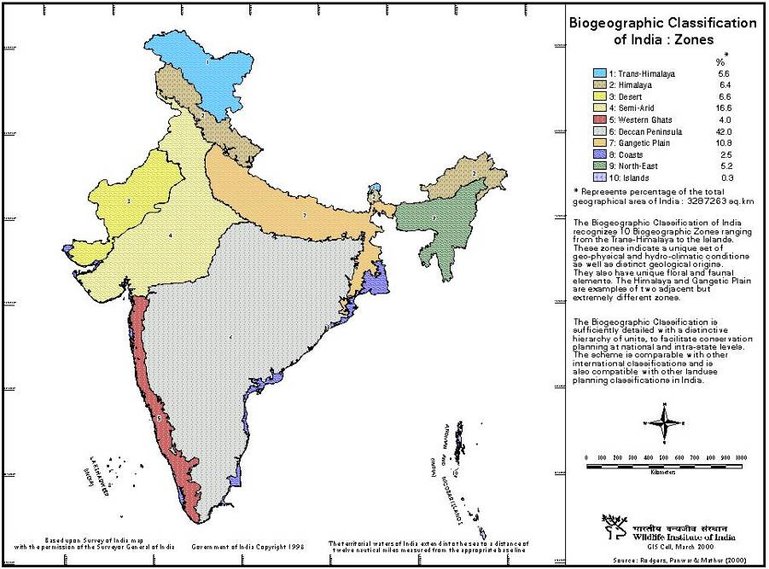

Fig 2. Biogeographic Classification of India: Zones

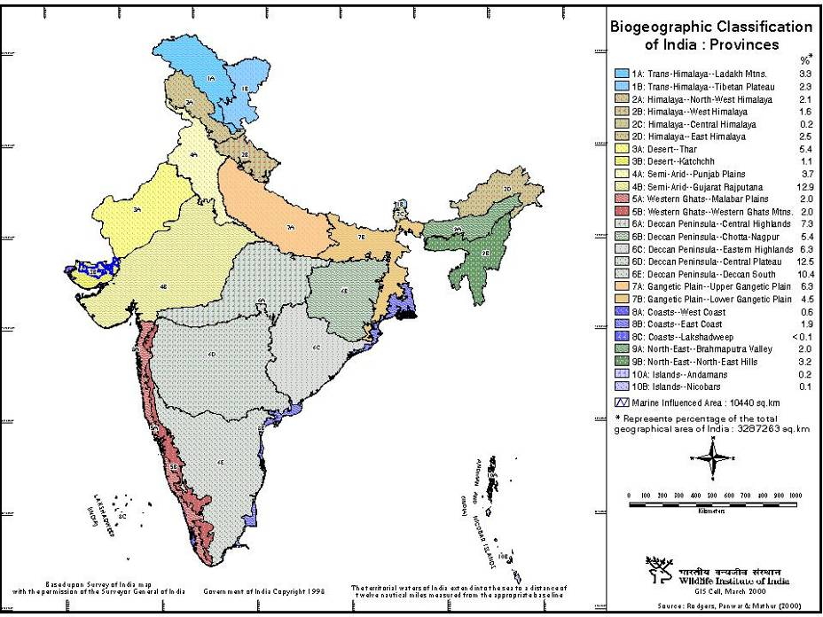

Table 1. Summary of Protected Areas Statistics in each Biogeographic Zone and Biogeographic Provinces

 |  |  | Existing Protected Area Status |  |  |  |  |  |  |  |  | Proposed Protected Area Status
zone | Province | Size | No. of | Area | % | No. of | Area | % | Total | Area | % | No. of | Area | % | No. of | Area | % | Total | Area | %
 |  | km² | Parks | km² |  | WLS | km² |  | PA | km² |  | Parks | km² |  | WLS | km² |  | PA | Km²
01 | A | 109754.00 | 2 | 4025.00 | 3.67 | 1 | 5000.00 | 4.56 | 3 | 9025.00 | 8.22 | 2 | -122.00 | -0.11 | 12 | 4985.00 | 4.54 | 14 | 4863.00 | 4.43
01 | B | 75069.00 | 1 | 1784.00 | 2.38 | 3 | 5443.00 | 7.25 | 4 | 7227.00 | 9.63 | 4 | 1600.00 | 2.13 | 1 | -100.00 | -0.13 | 5 | 1500.00 | 2.00
TOTAL |  | 184823.00 | 3 | 5809.00 | 3.14 | 4 | 10443.00 | 5.65 | 7 | 16252.00 | 8.79 | 6 | 1478.00 | 0.80 | 13 | 4885.00 | 4.41 | 19 | 6363.00 | 6.43
02 | A | 69401.00 | 4 | 1335.25 | 1.92 | 25 | 3648.00 | 5.26 | 29 | 4983.25 | 7.18 | 1 | 362.00 | 0.52 | 2 | 596.20 | 0.86 | 3 | 958.20 | 1.38
02 | B | 52072.00 | 4 | 3384.20 | 6.50 | 14 | 2874.13 | 5.52 | 18 | 6258.33 | 12.02 | 2 | -450.00 | -0.86 | 7 | 1127.34 | 2.20 | 9 | 677.34 | 1.34
02 | C | 5457.00 | 2 | 166.60 | 3.05 | 8 | 395.02 | 7.24 | 10 | 561.62 | 10.29 | 1 | 108.00 | 1.98 | 2 | 62.00 | 1.14 | 3 | 170.00 | 3.12
02 | D | 83743.00 | 2 | 2290.82 | 2.74 | 11 | 7606.37 | 9.08 | 13 | 9897.19 | 11.82 | 6 | 2317.00 | 2.77 | 7 | 989.05 | 1.18 | 13 | 3306.05 | 3.95
TOTAL |  | 210673.00 | 12 | 7176.87 | 3.41 | 58 | 14523.52 | 6.89 | 70 | 21700.39 | 10.30 | 10 | 2337.00 | 1.11 | 18 | 2774.59 | 1.33 | 28 | 5111.59 | 2.44
03 | A | 178296.00 | 1 | 3162.00 | 1.77 | 1 | 7.90 | 0.00 | 2 | 3169.90 | 1.78 | 1 | 1.00 | 0.00 | 9 | 527.10 | 0.30 | 10 | 528.10 | 0.30
03 | B | 35718.00 | 0 | 0.00 | 0.00 | 4 | 12906.19 | 36.13 | 4 | 12906.19 | 36.13 | 3 | 3600.00 | 10.08 | 2 | -4560.00 | -12.77 | 5 | -960.00 | -2.69
TOTAL |  | 214014.00 | 1 | 3162.00 | 1.48 | 5 | 12914.09 | 6.03 | 6 | 16076.09 | 7.51 | 4 | 3601.00 | 1.68 | 11 | -4032.90 | -1.88 | 15 | -431.90 | -0.20
04 | A | 122903.00 | 3 | 76.98 | 0.06 | 34 | 2264.71 | 1.84 | 37 | 2341.69 | 1.91 | 0 | 0.00 | 0.00 | 5 | 96.30 | 0.08 | 5 | 96.30 | 0.08
04 | B | 416576.00 | 7 | 1604.50 | 0.39 | 50 | 11604.74 | 2.79 | 57 | 13209.24 | 3.17 | 7 | 968.00 | 0.23 | 6 | 87.36 | 0.00 | 13 | 1055.36 | 0.23
TOTAL |  | 539479.00 | 10 | 1681.48 | 0.31 | 84 | 13869.45 | 2.57 | 94 | 15550.93 | 2.88 | 7 | 968.00 | 0.18 | 11 | 183.66 | 0.02 | 18 | 1151.66 | 0.20
05 | A | 66633.00 | 2 | 624.31 | 0.94 | 11 | 1223.52 | 1.84 | 13 | 1847.83 | 2.77 | 0 | 0.00 | 0.00 | 9 | 1094.08 | 1.64 | 9 | 1094.08 | 1.64
05 | B | 65546.00 | 14 | 3049.21 | 4.65 | 33 | 8149.35 | 12.43 | 47 | 11198.56 | 17.09 | 7 | 2008.50 | 3.06 | 16 | 2836.01 | 3.98 | 22 | 4844.51 | 7.05
TOTAL |  | 132179.00 | 16 | 3673.52 | 2.78 | 44 | 9372.87 | 7.09 | 60 | 13046.39 | 9.87 | 7 | 2008.50 | 1.52 | 25 | 3930.09 | 2.80 | 32 | 5938.59 | 4.32
06 | A | 241310.00 | 9 | 5109.10 | 2.12 | 25 | 8687.98 | 3.60 | 34 | 13797.08 | 5.72 | 1 | 312.00 | 0.13 | 5 | 1583.70 | 0.66 | 6 | 1895.70 | 0.79
06 | B | 178095.00 | 1 | 845.70 | 0.47 | 26 | 7500.95 | 4.21 | 27 | 8346.65 | 4.69 | 2 | 175.00 | 0.10 | 10 | 986.45 | 0.55 | 12 | 1161.45 | 0.65
06 | C | 208150.00 | 2 | 1458.37 | 0.70 | 15 | 3655.17 | 1.76 | 17 | 5113.54 | 2.46 | 3 | 741.00 | 0.36 | 15 | 5439.47 | 2.61 | 18 | 6180.47 | 2.97
06 | D | 410041.00 | 7 | 758.98 | 0.19 | 35 | 20500.24 | 5.00 | 42 | 21259.21 | 5.18 | 6 | 2396.57 | 0.58 | 17 | -6787.97 | -1.69 | 22 | -4391.40 | -1.10
06 | E | 342743.00 | 3 | 460.71 | 0.13 | 24 | 4076.50 | 1.19 | 27 | 4537.21 | 1.32 | 2 | 400.00 | 0.12 | 12 | 1977.43 | 0.58 | 14 | 2377.43 | 0.69
TOTAL |  | 1380339.00 | 22 | 8632.86 | 0.63 | 125 | 44420.84 | 3.22 | 147 | 53053.69 | 3.84 | 14 | 4024.57 | 0.29 | 59 | 3199.08 | 2.72 | 73 | 7223.65 | 4.00
07 | A | 206687.00 | 3 | 1830.80 | 0.89 | 17 | 4067.55 | 1.97 | 20 | 5898.35 | 2.85 | 0 | 0.00 | 0.00 | 1 | 10.00 | 0.00 | 1 | 10.00 | 0.00
07 | B | 148161.00 | 3 | 532.20 | 0.36 | 14 | 1376.52 | 0.93 | 17 | 1908.78 | 1.29 | 2 | 179.61 | 0.12 | 16 | 411.10 | 0.28 | 18 | 590.71 | 0.40
TOTAL |  | 354848.00 | 6 | 2363.00 | 0.67 | 31 | 5444.07 | 1.53 | 37 | 7807.13 | 2.20 | 2 | 179.61 | 0.05 | 17 | 421.10 | 0.12 | 19 | 600.71 | 0.17
08 | A | 29509.00 | 2 | 249.85 | 0.85 | 6 | 413.14 | 1.40 | 8 | 662.99 | 2.25 | 0 | 30.04 | 0.10 | 11 | 115.00 | 0.39 | 11 | 145.04 | 0.49
08 | B | 61778.00 | 3 | 1481.33 | 2.40 | 14 | 2627.79 | 4.25 | 17 | 4109.12 | 6.65 | 2 | 26.00 | 0.04 | 5 | 641.15 | 1.01 | 7 | 647.15 | 1.05
08 | C | 32.00 | 0 | 0.00 | 0.00 | 1 | 0.01 | 0.03 | 1 | 0.01 | 0.03 | 0 | 0.00 | 0.00 | 1 | 0.00 | 0.00 | 1 | 0.00 | 0.00
TOTAL |  | 91319.00 | 5 | 1731.18 | 1.90 | 21 | 3040.94 | 3.33 | 26 | 4772.12 | 5.23 | 2 | 56.04 | 0.06 | 17 | 756.15 | 0.81 | 19 | 792.19 | 0.87
09 | A | 66290.00 | 5 | 1977.79 | 2.98 | 18 | 1974.28 | 2.98 | 23 | 3952.07 | 5.96 | 1 | 100.00 | 0.64 | 6 | 940.00 | 1.42 | 7 | 1040.00 | 2.06
09 | B | 105050.00 | 7 | 664.58 | 0.63 | 18 | 1736.26 | 1.65 | 25 | 2400.84 | 2.29 | 7 | 1038.36 | 0.99 | 27 | 2882.07 | 2.74 | 34 | 3920.43 | 3.73
TOTAL |  | 171340.00 | 12 | 2642.37 | 1.54 | 36 | 3710.54 | 2.17 | 48 | 6352.91 | 3.71 | 8 | 1138.36 | 0.85 | 33 | 3822.07 | 2.23 | 41 | 4960.43 | 3.08
10 | A | 6196.00 | 9 | 1156.91 | 18.67 | 92 | 358.77 | 5.79 | 101 | 1515.68 | 24.46 | 12 | 562.00 | 9.07 | 9 | 400.60 | 5.66 | 21 | 962.60 | 14.73
10 | B | 2053.00 | 0 | 0.00 | 0.00 | 4 | 30.62 | 1.49 | 4 | 140.62 | 6.85 | 3 | 277.00 | 13.49 | 4 | 360.00 | 12.66 | 7 | 637.00 | 26.16
TOTAL |  | 8249.00 | 9 | 1156.91 | 14.02 | 96 | 389.39 | 4.72 | 105 | 1546.30 | 18.75 | 15 | 839.00 | 10.17 | 13 | 760.60 | 7.40 | 28 | 1599.60 | 17.57
Grand Total |  | 3287263 | 96 | 38029.18 | 1.16 | 504 | 118128.71 | 3.59 | 600 | 156157.89 | 4.75 | 75 | 16630.08 | 0.53 | 217 | 16669.44 | 0.52 | 292 | 33299.52 | 1.04

* W. Alan Rodgers, Hemendra S. Panwar and Vinod B. Mathur (2002). Wildlife Protected Area Network in India: A Review (Executive Summary). Wildlife Institute of India, Dehradun. 44p. Available at http://www.wii.gov.in/envis/panetworks/panetwork.html.
* Monitoring Tigers, Co-Predators, Prey and their Habitats: A Field Guide. Available at http://www.wii.gov.in/envis/sdnp/index.htm.
* Review of Tiger Reserve Assessment Reports, 2005; Evaluation Reports of Tiger Reserves in India, 2006. Available at http://www.wii.gov.in/envis/sdnp/index.htm.

