Action Plan for Implementing the Programme of Work on Protected Areas
of the Convention on Biological Diversity

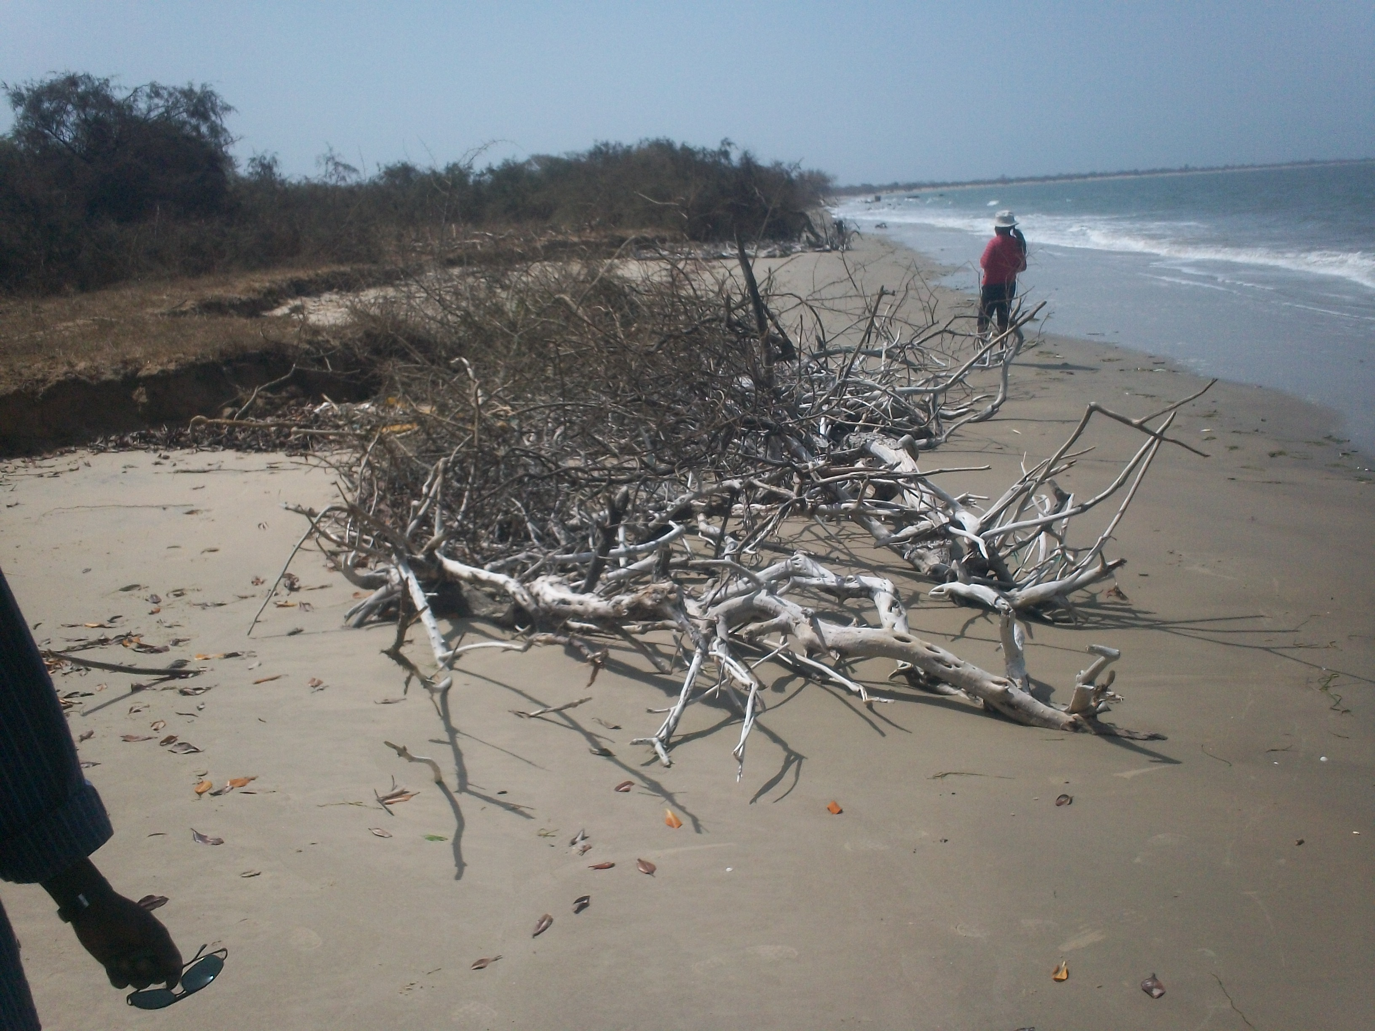

Source; Kawsu Jammeh (The eroding coastline of Nuimi National Park)

The Gambia)
Submitted to the Secretariat of the Convention on Biological Diversity [15th May 2012]

Protected area information:

PoWPA Focal Point: Kawsu Jammeh, Department of Parks and Wildlife Management, Ministry of Forestry and Environment, Kairaba Avenue, GIEPA House, Serrekunda KMC, The Gambia. Tel; 220 7349766 Email; kjammehsopee@yahoo.com
Lead implementing agency: Department of Parks and Wildlife Management

Multi-stakeholder committee: A steering committee comprising of representatives of land use agencies and NGOs is in place as the working group. This committee has now been transformed into a network, by increasing more stakeholders from the level of communities, media, security services, CSOs, regional governors, council of district chiefs and village development committee.
Description of protected area system
Coverage
Protected areas of the Gambia represents on 4.27% of the surface land and waterscape which only accounts for parks managed by Department of Parks and Wildlife Management. Department of Forestry is also responsible for managing forest parks accounting for 11%, though some are difficult to locate nowadays. Due to the current national definition of protected areas, forest park coverage is not considered as part of protected areas of the Gambia. However, Gambia is initiating a project titled ‘Gambia Protected Area Network and Community Livelihood Project’ that will help address the gap. However, it is difficult to determine the coverage as it relates to marine and terrestrial ecosystems.

(Amount and % protected for terrestrial and marine; maps of protected area system)

Description and background
Opened for signature at the Earth summit in Rio de Jeniero in 1992, and entered into force in December 1993, the Convention on Biological Diversity is an international treaty for the conservation of biodiversity, the sustainable use of the component of biodiversity and the equitable sharing of the benefits derived from the use of genetic resources. With 193 parties plus European Union, the convention has nearly earned universal participation among countries. The convention seeks to address all threats to biodiversity and ecosystem services, including threats emanating from climate change, through scientific assessment, the development of tools, incentives and processes, the transfer of technologies and good practices and the full and active involvement of relevant stakeholders such as youth, NGOs CSOs, business community, other land users, and more importantly indigenous and local communities.
The Gambia has ratified the convention in 1994 thus obliged to develop, adopt and implement the National Biodiversity Strategy and Action Plan and other related programme such as Programme of Work on Protected Areas which should be prioritized in all NBSAPs. Convention on Biological Diversity is a legally binding, landmark treaty requiring each party to take a comprehensive set of actions to conserve its country biodiversity.
Convention on Biological Diversity’s signatory government have committed to;
- Develop a national biodiversity strategy and action plan
- Integrate biodiversity concern into national decision-making
- Create a national system of protected area (PAs)
- Develop guideline for selection, establishment and management of protected areas; and
- Regulated and managed biological resources within and outside PAs
Since 1992, the conference of the parties (COP) to this convention has had several meetings to reach specific agreements and commitments for implementation through engagement of actors from diverse areas of interest related to the convention. In February 2004, the Convention on Biological Diversity held its seventh Conference of Parties (COP-7) in Kuala Lumpur, Malaysia, to debate, in depth for the first time in its 12 years of existence, issue related to Protected Areas. At COP-7, parties adopted a comprehensive Programme of Work on Protected Areas, containing an ambitious set of targets and timetable for action.
The Gambia has developed a great protected area system to ensure conservation and sustainable use of its rich aquatic and terrestrial biodiversity for the benefit of current and future generations. Despite many of them are not efficiently managed due to several setbacks such as lack of individual protected area budget, insufficient intellectual capacity, short of human resources and inappropriate and conflicting land use policies to name but few. Like many countries of the world, the Gambia is committed to implement the 92 activities of the Programme of Work on Protected Areas (POWPA Project). In 2006 Gambia made an assessment of where it stands in the implementation of the POWPA activities, and among these we selected four (4) priority goals for its first phase implementation that was funded through the Global Environment Facility (GEF) supported Global Action Programme administered by UNDP.
One of the priority goals selected as the first phase of POWPA implementation is to promote and establish a diverse protected area governance system through involvement of relevant stakeholders in the national implementation support partnership for the implementation of POWPA in the Gambia, which is guided by a common work plan agreed to be implemented by all partners including Regional Governments and Municipalities, media, NGOs and Central Government Actors.
The Gambia established a network among relevant stakeholders associated with owning, utilizing and managing protected areas and biodiversity that is referred to as GamPan for the implementation of POWPA in the Gambia. This network is documented and agreed as a voluntary protocol designed in a form of statute and agreement to be signed by diverse stakeholders and actors such as national agencies, international agencies, regional partners, NGOs, CBOs and Cooperate Agencies and individuals participating in meeting the CBD’s goals as mainstreamed in the National Biodiversity strategy paper and targeted in the programme of work on Protected Areas as well the Aichi target 2011.

Governance types
The law of biodiversity management has domesticated diverse governance which is still in draft stage. However, in practical we have a community managed protected area in Gunjur and three privately managed protected areas are under negotiation. The new project idea which is the second stage of POWPA implementation envisaged setting aside Indigenous Community Conserve Areas.

Key threats
(Description of key threats, and maps, if available)
The three most persistent pressures on protected area resources are logging, infrastructure developments and land conversion. Demand for timber and non timber products on protected areas are high due to unprecedented population growth. Most of the areas surrounding protected areas are degrading. Road construction and other infrastructural development have caused major disruption in the process and functions in particular of wetland ecosystems. Forest fires also contribute to changes and land cover and pose a major threat on the bio-physical resources within and outside the protected areas.
Protected areas in the Gambia continue to face other problems such as land cover degradation, coastal erosion and biodiversity lost. Climate change induced sea expansion and its associated coastal erosion is seriously affecting the Nuimi National Park and Tanji Bird Reserve. The rate of erosion is unprecedented and delayance in dealing with it may lead to the disappearance of Jinack Island.

Barriers for effective implementation
Barriers in the implementation of the POWPA
The only barrier at this stage is lack of sufficient financing for PAs.

National Targets and Vision for Protected Areas
(Insert national targets for protected areas/Target 11 of the Aichi Targets. Include rationale from protected area gap assessment, if completed, along with any additional information about the vision for the protected area system, including statements about the value of the protected area system to the country)
The Vision reads; We the people of the Gambia would like to ensure that by 2020, 15% of the country’s landscape and/or waterscape is transformed into a well managed and efficient protected areas system that ensure biodiversity conservation, economical development, sustainable use and benefit sharing of returns derived from biodiversity resources use therein for the welfare of the people.
We would also like to ensure a National Implementation Support Partnership (GAMPAN) well established and effective in monitoring, implementing and coordinating with synergies among all PAs management institutions and partners from public and private sectors to community arenas.
Finally we would also like to create a society that sees itself as an integral part of nature, recognizes different forms of life, adhere to sustainable use and maintenance of renewable natural resources in our will to preserve a planet rich in biodiversity resources, the only home for mankind.
Progress in and plans for achieving the goals of the Programme of Work on Protected Areas
Progress: 0 = no work, 1 = just started, 2 = partially complete, 3 = nearly complete, 4 = complete
Goals of the Programme of Work on Protected Areas | Progress 0-4
- Progress in establishing and strengthening national and regional systems of protected areas (1.1) | 3
- Progress in integrating protected areas into broader land- and seascapes and sectors so as to maintain ecological structure and function (1.2) | 1
- Progress in establishing and strengthening regional networks, transboundary protected areas (TBPAs) and collaboration between neighbouring protected areas across national boundaries (1.3) | 1
- Progress in substantially improving site-based protected area planning and management (1.4) | 3
- Progress in preventing and mitigating the negative impacts of key threats to protected areas (1.5) | 1
- Progress in promoting equity and benefit-sharing (2.1)  - Progress in assessing and implementing diverse protected area governance types (2.1) | 1  3
- Progress in enhancing and securing involvement of indigenous and local communities and relevant stakeholders (2.2) | 2
- Progress in providing an enabling policy, institutional and socio-economic environment for protected areas (3.1)  - Progress in assessing the contribution of protected areas to local and national economies (3.1) | 2  2
- Progress in building capacity for the planning, establishment and management of protected areas (3.2) | 2
- Progress in developing, applying and transferring appropriate technologies for protected areas (3.3) | 0
- Progress in ensuring financial sustainability of protected areas and national and regional systems of protected areas (3.4) | 1
- Progress in strengthening communication, education and public awareness (3.5) | 3
- Progress in developing and adopting minimum standards and best practices for national and regional protected area systems (4.1) | 2
- Progress in evaluating and improving the effectiveness of protected areas management (4.2) | 2
- Progress in assessing and monitoring protected area status and trends (4.3) | 1
- Progress in ensuring that scientific knowledge contributes to the establishment and effectiveness of protected areas and protected area systems (4.4) | 3
- Progress in marine protected areas | 3
- Progress in incorporating climate change aspects into protected areas | 2

Priority activities for fully implementing the Programme of Work on Protected Areas:
Activities | Timeline
1. PA Governance and Participation (goal 2.1 & 2.2) | 2012 - 2018
2. PA Network and Integration (goal 1.1, 1.2 & 1.3) | 2012 - 2018
3. Capacity building and public awareness (goal 3.3 & 3.5) | 2012 - 2018
5. Community livelihood and benefit sharing (goal 2.1) | 2012 - 2018
6. Biodiversity restoration and climate change resilience (goal 1.5) | 2012 - 2018
(Insert more as needed)

Action Plans (detailed steps) for completing priority activities for fully implementing the Programme of Work on Protected Areas:

Activity 1:
Key steps | Timeline | Responsible agencies | Indicative budget
- GamPan congresses, quarterly meetings and committee meetings |  |  | $145,000
- GamPan education and exchange visits |  |  | $30,000
- Park committee meetings |  |  | $ 25,000
- Designation and management of ICCAs |  |  | $50,000
- Resource policing and benefit sharing |  |  | $30,000

Activity 2:
Key steps | Timeline | Responsible agencies | Indicative budget
- Ecological gap assessment and analysis |  |  | $50,000
- Designation of atleast two more national parks, biosphere reserve and corridors |  |  | $300,000
- Negotiation for the designation of a park for peace |  |  | $25,000
- Expansion of PAs where necessary |  |  | $150,000
- Provide signpost, billboard, interpretation post etc |  |  | $15,000
- Facilitate ESMP, EIA,SEA,METT,RAPPAM etc |  |  | 10,000
- Procurement of twelve 4@4 Toyota vehicles and other office buy-outs |  |  | $1,000,000

Activity 3:
Key steps | Timeline | Responsible agencies | Indicative budget
- Capacity need assessment | 5 months |  | 25,000
- Establishment of Biodiversity Research and Training Center |  |  | 1,500,000
- Development of modules and facilitation of courses |  |  | 120,000
- Procurement of tools |  |  | 50,000
- Refreshment training for lecturers
- Specialized and postgraduate training for project staff and DPWM |  |  | 200,000
- Establishment of an Advisory Committee for BRTC $30 |  |  | 2,000,000
- Construction of offices |  |  | 1,000,000
- Budget for strengthening PA operation $400 |  |  | 1,000,000
- Environmental Olympic Competition amongst stakeholders |  |  | 300,000
- Public awareness and sensitization |  |  | 100,000

(Insert more as needed)
Key assessment results
Ecological gap assessment (insert summary findings if available)
Initially an institutional gap assessment was carried out but does not include ecological aspect.

Management effectiveness assessment (Insert summary findings if available)
Since 2005, METT and RAPPAM tools were used to measure management effectiveness of all protected areas on both site and system levels. The result of the RAPPAM assessment was produce in a book named ‘ Management Effectiveness Assessment of Protected Areas in the Gambia using WWF’s RAPPAM Methodology’ published in 2011.

Sustainable finance assessment (Insert summary findings if available)
Sustainable financing of protected areas is included in the GBMIS Project but does not sufficiently address the issue of having a national protected area financing plan.
Capacity needs assessment (Insert summary findings if available)
Under the new project idea, a capacity need assessment will be carried out prior to the commencement of interventions relating to capacity building. Such capacity intent goes beyond training and human resource capacity.

Policy environment assessment (Insert summary findings if available)

Protected area integration and mainstreaming assessment (Insert summary findings if available)

Protected area valuation assessment (Insert summary findings if available)

Climate change resilience and adaptation assessment (Insert summary findings if available)

(Insert other assessment results if available)

