Action Plan for Implementing the Convention on Biological Diversity’s
Programme of Work on Protected Areas

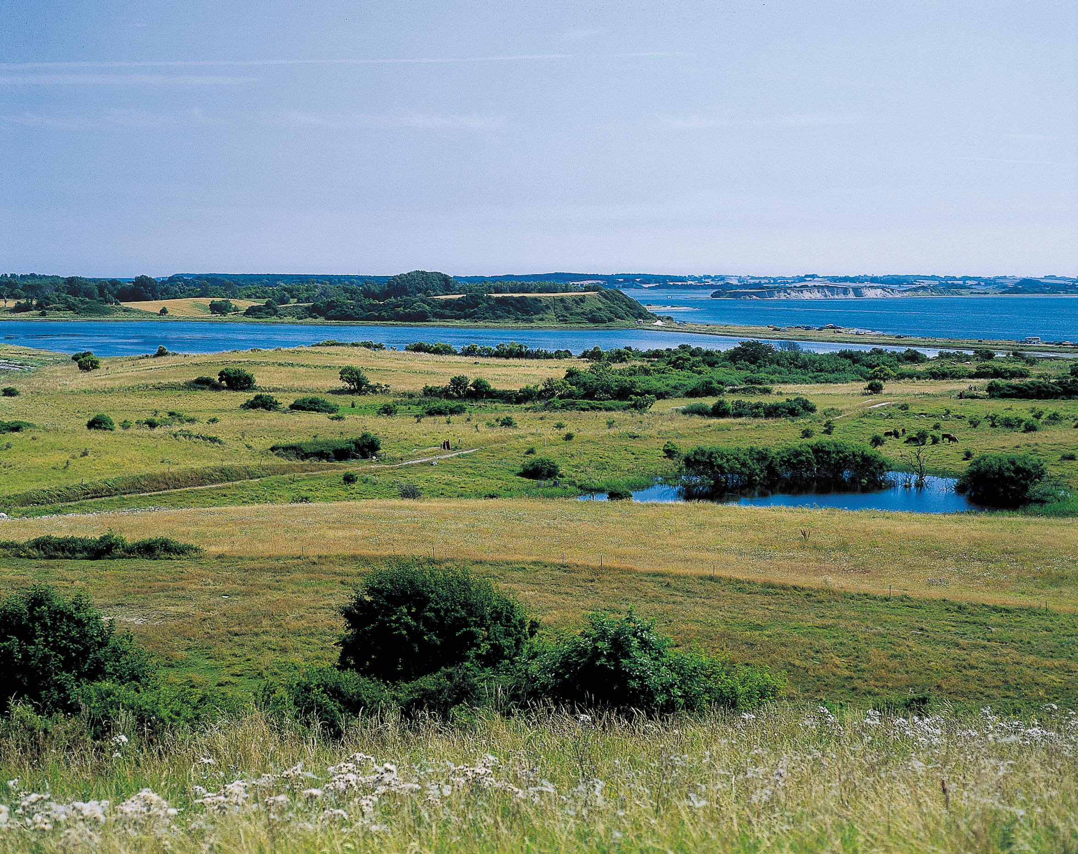

Denmark

Submitted to the Secretariat of the Convention on Biological Diversity 12 April 2012

Protected area information:

PoWPA Focal Point:
Lars Dinesen, Biologist, Nature Planning and Biodiversity,
Direct phone: (+45) 72 54 48 30, Mobile: (+45) 21 79 62 30, ladin@nst.dk

Lead implementing agency:
Nature Agency, Danish Ministry of the Environment,
Haraldsgade 53, DK - 2100 Copenhagen Ø, Denmark

Multi-stakeholder committee:

1. At the local level there is a dialogue regarding action planning and the implementation of the management planning in the Protected Areas between the authorities i.e. municipalities and local units of the Nature Agency on the one hand and local user groups and green groups on the other.
2. Dialogue with national organisations in ”Grønt Fremdriftsforum” with the participation of Green, Agricultural and Forest Organisations as well as Ministry of Food, Agriculture and Fisheries. This forum will oversee the implementation of management planning in the Natura 2000 Protected Areas and give input to future management planning phases.
3. A national coordination group is expected to be established soon comprising representatives from the Municipalities, the Ministry of Food, Agriculture and Fisheries and the Ministry of Environment to assess barriers for implementation and coordinate activities.
Moreover, meetings and discussions between the Agency for Nature and Organisations are undertaken ad hoc.
Description of protected area system

National Targets and Vision for Protected Areas

In 2010, the EU adopted a 2050 vision and 2020 target:

2050 Vision
By 2050, European Union biodiversity and the ecosystem services it provides — its natural capital — are protected, valued and appropriately restored for biodiversity's intrinsic value and for their essential contribution to human wellbeing and economic prosperity, and so that catastrophic changes caused by the loss of biodiversity are avoided.

2020 Headline Target
The headline target is the halting the loss of biodiversity and the degradation of ecosystem services in the EU by 2020, and restoring them in so far as feasible, while stepping up the EU contribution to averting global biodiversity loss.
In 2011 and in line with global Strategic Plan for Biodiversity 2011-2020, a EU Biodiversity Strategy to 2020 that has been adopted that focus in six keys targets.
Target 1 of the Strategy is to halt the deterioration in the conservation status of all species and habitats covered by EU nature legislation and achieve a significant and measurable improvement in their status so that, by 2020, compared to current assessments: (i) 100% more habitat assessments and 50% more species assessments under the Habitats Directive show an improved conservation status; and (ii) 50% more species assessments under the Birds Directive show a secure or improved status.

Coverage

EU’s Natura 2000 directives: 8,3% on land and 17,6% marine areas (see map and below);
The majority of the Danish forests are protected as forest through the National Forest Act. These forests cover 481.385 ha which equals around 11% of the Danish land area. However the forests that are protected as forest through the National Forest Act also encompass large areas of open land or inland waters;

The open-land habitat types are protected through § 3 in the Nature Conservation Act and cover almost 10% of the land area. Almost 50% of these areas have been designated as EU Natura 2000 sites, which gives them double protection. The §3 area outside Natura 2000 comprises about 234,704 ha;
More than 100 nature reserves have been designated under the Hunting and Wildlife Mannagement Act currently covering more than 330.000 ha;
Three National Parks comprising 188,970 ha;
Nature areas conserved under nature conservation orders.
One third of the protected area is in IUCN category I and II.

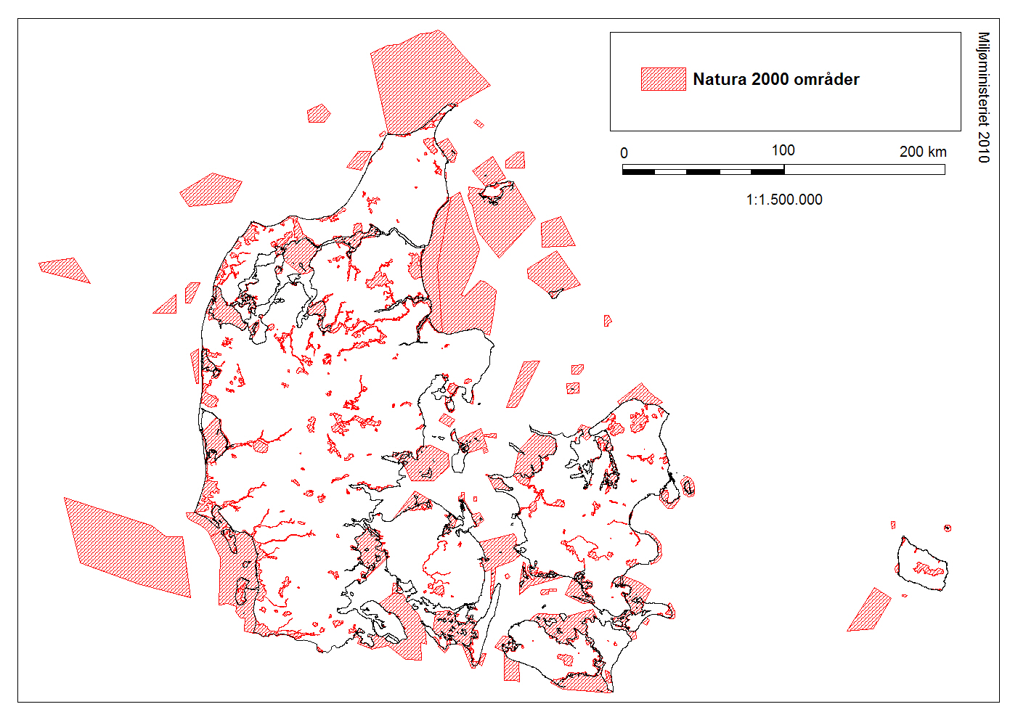
Fig. 1. Map showing the Danish Natura 2000 area including 8.3% of the Danish land surface and 17.7% of the marine waters.

Description and background
Denmark has designated 113 Special Protected Areas for birds (PA birds) and 261 Special Areas for Conservation (PA habitat, forming 252 Natura 2000 sites).

The PA habitat areas comprise about 19,300 km² about 84 % are marine area. The PA bird areas comprise 14,700 km² about 82 % are marine area. There is a considerable geographical overlap of the PA habitat and PA bird areas and taken together these Natura 2000 sites comprise about 3,590 km² and 18,686 km² land and marine area respectively i.e. 8,3% and 17,6% of the Danish territory respectively. Some sites are rather large especially some coastal or marine areas such as the Eastern Bay of Aalborg or Danish part of the Wadden Sea, which cover more than 1,500 km² each.
Nature reserves can be designated under the Hunting and Wildlife Management Act. The purpose of these areas is to protect wildlife for breeding, resting and foraging, especially birds.
Currently Denmark has more than 100 such reserves, covering more than 330.000 ha. Most of these areas are marine (i.e. more than 90%, about 294.000 ha). The rest are found in fresh water (30.000 ha) or on land (7.000 ha).
Denmark has designated 27 wetlands, primarily large coastal areas, as Ramsar sites.
The Danish Ramsar sites cover an area of app. 7.322 km². These sites are legally managed as Natura 2000 sites, as there is a 100% overlap between the designated Ramsar sites and the designated Natura 2000 areas.
The National Park Act was adopted by the Danish Parliament in May 2007. The National Park Act sets up the rules for the establishment and development of Danish National Parks. The objective by establishing National Parks is to create large coherent nature areas and to protect and improve nature and biodiversity, cultural heritage and public recreation with involvement of the local public. In June 2007 the Danish Government decided to begin the establishment of a network of National Parks and has so far given three areas national park status: Thy, Mols Bjerge and the Wadden Sea covering 188,970 ha.
The Nature Conservation Act §3 comprises a significant and important part of the Danish protected area. It comprises lakes, bogs, meadows, salt marshes, fens and heath above a certain size. Generally speaking these nature types are protected when they alone or in connection with other nature types have an area above 2500 m² apart from lakes where the protected area is above 100 m². Furthermore, water courses i.e. streams and rivers are included by designation in this general protection regime.
Danish § 3 Nature | Area
Lake | 64.344 ha
Bog | 92.241 ha
Meadow | 96.057 ha
Salt marsh | 44.207 ha
Fen | 27.665 ha
Heath | 84.377 ha
Total | 408.891 ha

Table 1. Protected Danish Nature covered by the Act on Nature Protection (§ 3).

Governance types
The Danish Natura 2000 planning process is anchored in an act on conservation objectives from 2003. The act contains obligations to develop management plans with objectives and priorities for the individual Natura 2000 sites as well as public hearings and a time frame. The act on conservation objectives forms the legal basis for the implementation of the article 6.1 of the Habitat Directive. The law comes with a number of statutory orders i.e. the statutory order on the development of conservation objectives, which provides details on a system of assessing conservation status i.e. standards for the individual habitats.
The system for forest habitats is contained in a parallel statutory order on the developing of objectives in forests. Moreover, a statutory order on the development of action plans at the local level, states that the municipalities or the state authority e.g. for certain forests and state land are responsible at the local planning level to implement conservation priorities at each Natura 2000 site to fulfil the management plan. Each site specific action plan will contain targets and has a six years time frame, however, twelve years for forests.
In 2012 the Ministry of Environment and the Ministry of Agriculture, Food and Fisheries have established a Commission on Nature and Agriculture in 2012 to improve sustainable use and promote biodiversity also between Protected Areas.
The National Strategy for Sustainable Development (2009) sets targets and principles for sustainable development including the objectives of securing a high degree of biodiversity.
The National Strategy on Natural Forests (1992-2040) has as overall objective to conserve the biodiversity on the Danish Forests, including the gene resources present in these areas;
The National Forest Programme (2002) sets targets for increasing the national forest area and managing the forests in a way that takes the protection of the biological diversity better into account;
The National Strategy on Biological Diversity (2004) brings together laws and establishes targets for the conservation of biodiversity;

The Action plan for Biodiversity and Nature Conservation (2004-2009) specifies actions to protect nature and biodiversity in accordance with the national Strategy and with EU legislation and the Convention on Biological Diversity;
The Action Plan for Nature Conservation (2005) specifies criteria for prioritising nature conservation by site of natural landscape or recreational value, when conservation cannot be done by use of other instruments;
The National Action plan on Alien Invasive Species (2009) gives a number of recommendations on actions to be taken. The action plan focuses on prevention, eradication, information and capacity building, research and administration.

Key threats
Cultivated fields comprise around 62 per cent of Denmark’s land area. The percentage seems to be slowly decreasing. Besides producing food crops, these fields are home to some species of plant and animal. Arable land is thus an important feature of the Danish countryside and is highly significant for biodiversity. The main threats to biodiversity in agricultural areas are cultivation, pesticides, pollution by nutrients, land drainage and the clearing of habitats such as hedges and ponds.
Open habitats are some of the most characteristic of Danish landscapes, including heath, commons, meadow, salt marsh, sand dunes and bog. Open habitats often need to be grazed or harvested to prevent them reverting to forest. Today, the threat comes from overgrowing and the impact of nutrients.
Large parts of Denmark would still be wooded if man had not influenced the landscape. Danish woods are both deciduous and coniferous with a high proportion devoted to plantation or production forest. There is a lack of knowledge of most woodland species, apart from birds. Some things are known about forest quality in terms of the amount of dead wood, the area of inactive forest and old forestry methods for example.
There are around 138,000 lakes and around 69,000 km of water courses in Denmark. The main threats to Danish watercourses are maintenance, the discharge of sewage and former practices to straighten and dam watercourses. The main threats to Danish lakes come from the introduction of agricultural nutrients and sewage. Over time, an unknown number of ponds have been drained or reclaimed for agriculture and an unknown number of new ponds have been dug.
Among the most important threats to the coastal ecosystem biodiversity is loss by natural disturbance caused by marine and wind erosion as well as cessation of grazing. Climate change imposes an important future threat because sea level rise may lead to significant loss of low altitude coastal habitats. Furthermore the protection of private property by the construction or enforcement of dikes may lead to coastal squeezing with terrestrial low-lying part of the coastal ecosystems. Agricultural improvement by drainage and fertilization continues to be a threat to habitat quality.

In Denmark, the seabed is generally soft, but reefs are also common. Reefs in particular harbour rich plant life (seaweed forests). Many Danish reefs have however been destroyed in the past by bottom-trawling or the removal of rock for use in jetties, for instance. The main threats to biodiversity in the sea and on the seabed are pollution by nutrients, bottom-trawling, deoxygenation and climate change. Increasing temperature may for instance speed up oxygen consumption and increase the risk of oxygen depletion in the bottom of the water column.
Nutrients, especially nitrogen (N), are a threat to vulnerable habitats such as heath, bog and meadows, because the species which live there are driven out when poor soil conditions cease to prevail. Large amounts of nitrogen compounds (NOx and NH3) are deposited in the atmosphere from livestock, industry and traffic from national as well as international sources. Nitrogen deposits over many years have led to the overloading of Danish ecosystems with nitrogen.
Also certain invasive species represent a threat to the native flora and fauna.

Barriers for effective implementation
The status of biodiversity in Denmark reflects the country’s high population density and a long history of intensive commercial exploitation of raw materials, soils, timber, water and stocks of wild species. The vast majority of the country is covered by highly modified urban, silvicultural and arable areas, where construction, cultivation and plantations limit biological diversity.
However, there are some natural areas left with high biological diversity and the PAs play a crucial role in protecting these remaining areas. The long protected coastal line, the extensive sea territory and more recent regulations to protect birds and mammals from unsustainable hunting has helped to protect large areas of important habitats and their biological diversity, including large populations of birds.
Some of these positive effects on threatened species will only manifest themselves fully after a long period of time, as some ecosystems react slowly to changes. Some of the barriers that affect the effective implementation of Natura 2000 network across the EU are:
Financial
One main barrier is the lack of sufficient funding and financial resources to guarantee the restoration of degraded areas, extensive monitoring and implementation of management plans.
Administrative
Conflicting policies due to lack of integration between different (sectoral) plans and processes to develop management plans.
Structural
Not enough connectivity and integration across EU protected areas
Development of new transportation infrastructures and demands from the energy sector are raising the pressure on land use.

Status, priority and timeline for key actions of the Programme of Work on Protected Areas

Status of key actions of the Programme of Work on Protected Areas
Status of key actions of the Programme of Work on Protected Areas | Status
- Progress on assessing gaps in the protected area network (1.1) | 4 – With regard to N2000 the Danish PA coverage is now regarded sufficient by the EU Commission both on land and in the marine areas.
- Progress in assessing protected area integration (1.2) | 4 – Well integrated into overall land use planning and across sectors.
- Progress in establishing transboundary protected areas and regional networks (1.3) | 3 – The Danish N2000 areas form part of the larger N2000 network at the EU level. The conservation of the Wadden Sea is undertaken in a partnership with Germany and the Netherlands.
- Progress in developing site-level management plans (1.4) | 4 – A management plan for each of the 246 Danish N2000 sites is public available. Newly designated areas will have a management plan developed.
- Progress in assessing threats and opportunities for restoration (1.5) | 3 – This is undertaken as part of the management planning process.
- Progress in assessing equitable sharing of benefits (2.1)  - Progress in assessing protected area governance (2.1) | 0  4 – Ongoing as part of the planning process.
- Progress in assessing the participation of indigenous and local communities in key protected area decisions (2.2) | 3 – through various fora at the central and local government levels.
- Progress in assessing the policy environment for establishing and managing protected areas (3.1)  - Progress in assessing the values of protected areas (3.1) | 4 – a number of policy documents and acts have been established / developed.  1 – Only in a very few cases.
- Progress in assessing protected area capacity needs (3.2) | 3 – Ongoing.
- Progress in assessing the appropriate technology needs (3.3) | 3 – Ongoing.
- Progress in assessing protected area sustainable finance needs (3.4) | 3 – Measures identified and under implementation. To improve access to certain EU funds.
- Progress in conducting public awareness campaigns (3.5) | 4 – Management plans in public hearings and public available. Brochures and leaflets produced. National Park events and through internet.
- Progress in developing best practices and minimum standards (4.1) | -
- Progress in assessing management effectiveness (4.2) | 1
- Progress in establishing an effective PA monitoring system (4.3) | 3 – Monitoring in place through the Danish NOVANA program and baseline reports public available.
- Progress in developing a research program for protected areas (4.4) | 1 – No systematic research in PA is conducted.
- Progress in assessing opportunities for marine protection | 2 – A marine network of PAs established as part of N2000. Management planning in progress.
- Progress in incorporating climate change aspects into protected areas | 1 – Preliminary discussions.
Status: 0 = no work, 1 = just started, 2 = partially complete, 3 = nearly complete, 4 = complete
(Insert notes as appropriate)

Priority actions for fully implementing the Programme of Work on Protected Areas:

Timeline for completion of key actions

2010 - 2015 | 2012 | 2013 | 2014 | 2015
First phase of PA management planning (N2000) | Management plans endorsed in 2011.  Action plans developed.  Implementation of activities. | Implementation | Implementation | Implementation
 | 2012 | 2013 | 2014 | 2015
Preparation of second phase of PA management planning (N2000) | Program of work | Development of revised and new management plans (for a few new sites).  Dialogue with stakeholders and / or technical consultations. | Public hearing of management plans. | Final revised and new management plans to be implemented 2016 – 2021.

Action Plans for completing priority actions of the Programme of Work on Protected Areas

Expected timeframe is 2010 – 2015 and the total budget is 1.8 billion DKR (about 240 million EUR).
Measure | Description | Financing
1. Open habitat management. | Securing open habitat types such as fens, marshes and salt marshes by mowing and/or grazing. | Danish state and EU RDP
2. Conversion to Natura 2000 habitat and management. | Preparing for grazing by removal of shrub/trees, establishment of fences and water facilities etc. Enhanced hydrology by block of ditches, stop of pumps etc. | Danish state and EU RDP.
3. Heath management. | Fire management of heath habitats, removal of shrub and cutting of peat. | Danish state and municipalities.
4. Fighting invasive species. | Fighting species such as rugosa rose, hogweed and mink. | Undertaken by municipality or state dependent on ownership.
5. Restricted utilisation of forest habitats. | Maintenance of permanent forest cover, natural germination, no use of pesticides and nutrients etc. | State funds and RDP.
6. Protected forests. | Stop for utilisation: No timber harvest, no removal of wood, no use of pesticides, calcium and nutrients, no drainage and soil management. | State funds and RDP.
7. Regulation of access and hunting | Establish or extend hunting free reserves for water birds. Regulate access nearby nest / breeding locality. | State and municipalities.
8. Restricted stream management, clean up lakes and establishment of new ponds | Undertaken by the implementation of the water plans. Additional tasks undertaken for Natura 2000 species. | Funds from municipality supplied by state funds. Some fund savings. If riparian zones are included, the RDP.
9. Natura 2000 habitats in existing legally protected Danish habitats. | Enhancing quality and enlargement of existing nature covered by Danish law (marsh, salt marsh fen etc.) to become Natura 2000 habitats. | State funds and RDP.
10. Conversion of farmland towards Natura 2000 habitats. | Interventions to re-establish or enlarge threatened habitats and species habitats by conversion of farmland. | State funds and RDP. Municipalities and LIFE+.
11. Conversion of open areas to Natura 2000 forest habitat. | Conversion of existing forest area to Natura 2000 forest habitat | State funds and RDP.
12. Establishment of fauna passages. | Re-design or establishment of fauna passages e.g. for otter or amphibians. | Municipality. Directorate for roads.
13. Re-establishment of natural dynamic. | According to goal evaluation in management plan when opposite Natura 2000 interests. | In some cases it may be associated with a cost.
14. Regulation of fishery. | Regulation to be put in place, | State funds.
15. Coastal protection. | When necessary to protect species and habitats. | [State funds.]

Key assessment results
Ecological gap assessment
A gap analysis on the existing network of protected and other managed natural areas in Denmark was undertaken in 2001 by independent researchers to examine the efficiency of these in terms of representing species. The network of managed areas represents species more effectively than random area selection; 99% of non-red-listed species and 85% of red-listed species occur within the managed areas.
For a summary see: http://www.dors.dk/sw2513.asp

Management effectiveness assessment
Not available.

Sustainable finance assessment
Specifically for the management plans a total budget of 240 of million EUR is reserved in the government budget for the coming 5 years to implement the plans in a first planning phase from 2010 to 2015. To secure the existing conservation status is a costly exercise because funds are needed to e.g. maintain traditional farming practices, to secure fragmented nature against deterioration, to compensate landowners etc. It was decided to use the EU RDP funds (agricultural support funds) to add up on as much of the nature management intervention as possible.

Capacity needs assessment
Not available.

Policy environment assessment
Denmark as a Party to the CBD are implementing the CBD PoWPA through a wide range of policies and measures of which some of the most important have been mentioned above.

Protected area integration and mainstreaming assessment
The strength of the Danish PA approach in relation to N2000 seems to be the development of legally binding management plans which are integrating responsibilities for private and municipality land, state land owners and resort ministries. All authorities are in principle obliged to implement the management plan for which part they are responsible and on their respective land. In order to secure responsibility the drafting authority, the Danish Agency for Nature, have individual dialogues with partners, used public hearings as well as technical consultations with the municipalities to reach a the Ministry of Food and Agriculture including the Fisheries Directorate and Ministry of Defence for planning on their land and the Ministry of Traffic for marine areas. Thus resort ministries have had a say on their part of the plan and a chance to comment on drafts.

Protected area valuation assessment (Insert summary findings if available)
Pilot studies in the largest Danish nature restoration project at Skjern Å have been conducted.
See for example Cost-benefit analysis of the Skjern river restoration in Denmark:

http://static.sdu.dk/mediafiles/Files/Om_SDU/Institutter/Miljo/fame/phd/nov03/dubgaard.pdf http://www.ecrr.org/publication/decmak_doc2.pdf

Climate change resilience and adaptation assessment
Identified changes to be adapted to include:

- Increasing biomass production
- Increasing temperatures give a longer and more favourable season for growth.
- Increased amounts of nutrients in inland waters
- Increased rainfall patterns give increased wash out of nutrients to inland waters and in combination with increasing temperatures it will result in increased growth of algae and mean poor light conditions and less oxygen in the water.
- Loss of nature along the coast line
- Higher sea level and increased storms will result in increasing erosion and reduced coastal areas.
- Increased erosion and flooding.
- River valleys including meadows will be flooded and may lack the time to adapt.
- Warmer climate and expansion of species range.
- Increased CO2 will influence the chemical composition in the sea

