Action Plan for Implementing the Convention on Biological Diversity’s
Programme of Work on Protected Areas

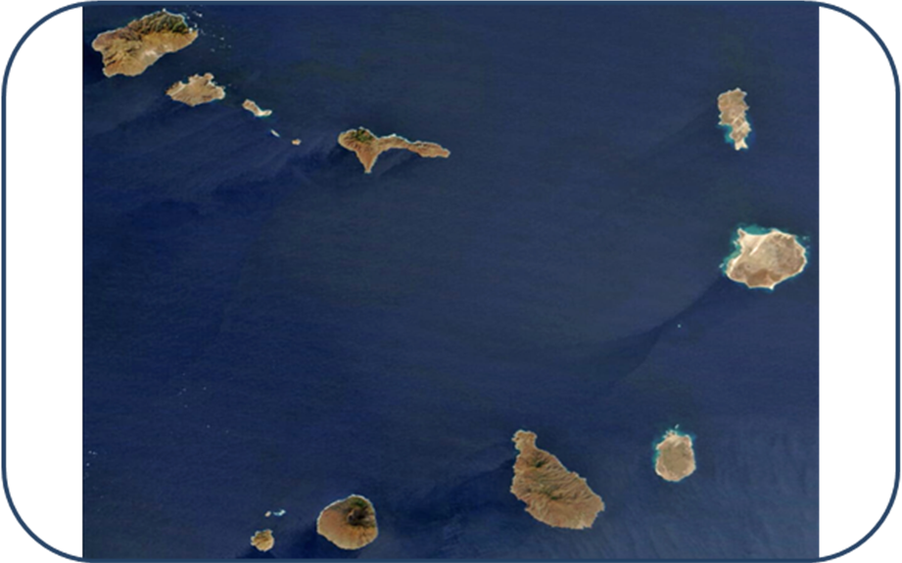

(Cape Verde)

Submitted to the Secretariat of the Convention on Biological Diversity [April 2012]

Protected area information:

PoWPA Focal Point:
Liza Helena Alves Lima
General Directorate of Environment – Ministry of Environment
CP nº 332-A - Praia
Republic of Cape Verde
Telf: +238 2618984
Fax: +238 2617511
E-mail: lizocahal@hotmail.com

Lead implementing agency:
General Directorate of Environment – Ministry of Environment

Multi-stakeholder committee:
No multi-stakeholder advisory committee has been formed. But the assessment of the status of key actions of the Programme of Work on Protected Areas, the priority actions and timeline was made with the collaboration of various numbers of stakeholders, at a meeting done in December 2011.

Description of protected area system

National Targets and Vision for Protected Areas
The National Protected Areas Strategy report is currently under development.

Coverage
Since the legal establishment of 47 PA in 2003, only 3 PA have approved the management plan and the boundary (Serra Malagueta Natural Park - SMNP, Monte Gordo Natural Park - MGNP and Fogo Natural Park -FNP) (Figures 1, 2 and 3). Cape Verde has 2.5% (10195 hectares) of terrestrial area protected and 0% of territorial waters protected.

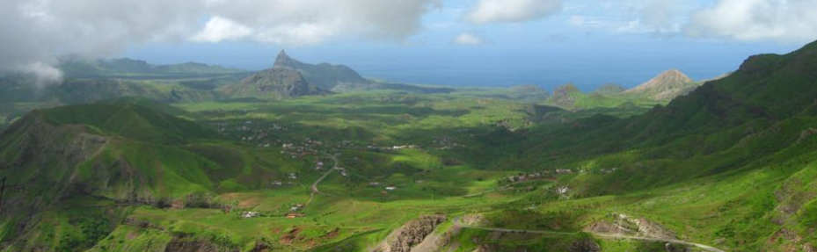
Fig. 1: Serra Malagueta Natural Park. (source: www.areasprotegidas.cv)

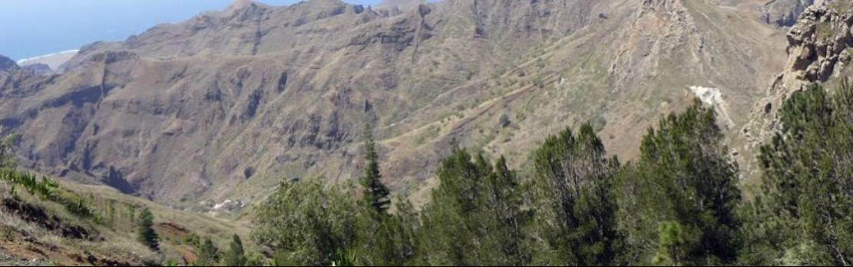
Fig. 2: Monte Gordo Natural Park. (source: www.areasprotegidas.cv)
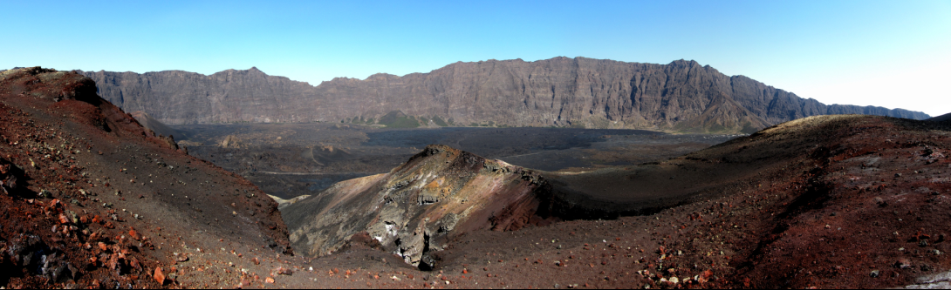
Fig. 3: Fogo Natural Park. (source: Christian Muller)

Description and background
Cape Verde is an archipelago nation composed of ten islands of volcanic origin and is located approximately 500 km west of the West African coast. Cape Verde’s biodiversity is globally significant. It is threatened, however, by a variety of anthropogenic pressures. In coastal and marine ecosystems, rapid tourism development, exacerbated by unsustainable fishing, lead to a continuous loss of habitats. In terrestrial ecosystems, overgrazing and land degradation aggravated by invasive plant species, are the reason for the loss of ecological equilibrium.
The National Biodiversity Strategy and Action Plan (1999) defined priority habitats for conservation in Cape Verde. This priority-setting exercise served as the basis for the legal establishment of the National Protected Area (PA) Network in 2003, counting on 47 sites consisting of both terrestrial and coastal/marine protected areas.

Governance types
Currently, in Cape Verde, the only governance type that exists is the government-managed. The General Directorate of Environment is the entity responsible for the management of the protected areas.

Key threats
Invasive species; Pollution; Unsustainable activities (sand mining, mass tourism); Vulnerability to climate change.

Barriers for effective implementation
The main barriers for effective implementation are Lack of funding and Lack of integration into spatial plans and some relevant sectors (fisheries, tourism, etc).
Since the legal establishment of the national PA network (with 47 AP) in 2003, the Government has been leading efforts towards operationalizing the sites.
Only 3 PA have approved a management plan (SMNP, MGNP and FNP): Regulatory Decree No. 19/2007 approving the boundaries of SMNP, Regulatory Decree No. 10/2007 approving the boundaries of MGNP, Resolution No. 40/2008 approving the management plan of SMNP and Resolution No. 41/2008 approving the management plan of MGNP, Regulatory Decree No. 3/2008 approving the boundaries of FNP and Resolution 20/2010 approving the management plan of FNP.
In 2010, began a Consolidation of Cape Verde’s Protected Areas System Project funded by the GEF. This project will operationalize 14 sites.
And there are also other initiatives that will operationalize 10 sites.

Status, priority and timeline for key actions of the Programme of Work on Protected Areas

Status of key actions of the Programme of Work on Protected Areas
Status of key actions of the Programme of Work on Protected Areas | Status
- Progress on assessing gaps in the protected area network (1.1) | 0 (However, in some PA - Fogo, MG and SM- was made a preliminary gap analyses.)
- Progress in assessing protected area integration (1.2) | 0 (The integration of protected areas into some spatial plans just started.)
- Progress in establishing transboundary protected areas and regional networks (1.3) | 0 (There are no transboundary protected areas.)
- Progress in developing site-level management plans (1.4) | 1 (There are 3 approved management plans and there are 24 protected areas which management plans are being developed.)
- Progress in assessing threats and opportunities for restoration (1.5) | 1 (In the 3 protected areas with approved management plans are known threats as well as opportunities for restoration (was made a preliminary assessment). However, the progress in assessing threats and opportunities for restoration is slow in the protected area network.)
- Progress in assessing equitable sharing of benefits (2.1)  - Progress in assessing protected area governance (2.1) | 0 (No equitable formula for benefit sharing has been developed.)  0
- Progress in assessing the participation of indigenous and local communities in key protected area decisions (2.2) | 0 (The local communities participate in the protected areas decisions, but we have to improve the mechanisms for their participation.)
- Progress in assessing the policy environment for establishing and managing protected areas (3.1)  - Progress in assessing the values of protected areas (3.1) | 0  0
- Progress in assessing protected area capacity needs (3.2) | 1 (A preliminary assessment has been done.)
- Progress in assessing the appropriate technology needs (3.3) | 0
- Progress in assessing protected area sustainable finance needs (3.4) | 1
- Progress in conducting public awareness campaigns (3.5) | On-going
- Progress in developing best practices and minimum standards (4.1) | 1
- Progress in assessing management effectiveness (4.2) | 0 (In the 3 protected areas with approved management plans was made a preliminary assessment using WWF’s RAPPAM methodology.)
- Progress in establishing an effective PA monitoring system (4.3) | 1
- Progress in developing a research program for protected areas (4.4) | 0 (But, there are some independent research activities.)
- Progress in assessing opportunities for marine protection | 1
- Progress in incorporating climate change aspects into protected areas | 0 (There is no incorporation of climate change aspects into protected area management. However, the incorporation of climate change aspects was made in some relevant sectoral plans.)
Status: 0 = no work, 1 = just started, 2 = partially complete, 3 = nearly complete, 4 = complete
(Insert notes as appropriate)

Priority actions for fully implementing the Programme of Work on Protected Areas:

• Form the multi-stakeholder advisory committee
• Assess gaps in the protected area network (1.1)
• Assess protected area integration (1.2)
• Assess threats and opportunities for restoration (1.5)
• Assess the policy environment for establishing and managing protected areas (3.1)
• Assess the values of protected areas (3.1)
• Assess protected area capacity needs? (3.2)
• Assess protected area sustainable finance needs (3.4)
• Conduct public awareness campaigns (3.5)
• Establish an effective PA monitoring system (4.3)
• Assess opportunities for marine protection

Timeline for completion of key actions
2012 - 2016

Action Plans for completing priority actions of the Programme of Work on Protected Areas

Action 1: Assess gaps in the protected area network (1.1)
Key steps | Timeline | Responsible parties | Indicative budget
Consultancy (recruit consultants and draft report development) | 2012 | Ministry of Environment | 24.000 €
Presentation and validation of the report | 2012 | Ministry of Environment | 6.000 €
Dissemination | 2012 | Ministry of Environment | 10.000 €

Action 2: Assess protected area integration (1.2)
Key steps | Timeline | Responsible parties | Indicative budget
Consultancy (recruit consultants and draft report development) | 2012 | Ministry of Environment | 40.000 €
Presentation and validation of the report | 2012 | Ministry of Environment | 10.000 €
Dissemination | 2012 | Ministry of Environment | 10.000 €

Action 3: Assess protected area sustainable finance needs (3.4)
Key steps | Timeline | Responsible parties | Indicative budget
Consultancy (recruit consultants and draft report development) | 2012 | Ministry of Environment | 120.000 €
Presentation and validation of the report | 2012 | Ministry of Environment | 10.000 €
Dissemination | 2012 | Ministry of Environment | 10.000 €

Action 4: Conduct public awareness campaigns (3.5)
Key steps | Timeline | Responsible parties | Indicative budget
Consultancy (recruit consultants and draft report development) | 2012 | Ministry of Environment | 50.000 €
Presentation and validation of the report | 2012 | Ministry of Environment | 10.000 €
Dissemination | 2012 | Ministry of Environment | 10.000 €
Implementation of the national protected area communication, education and public awareness strategy | 2012 - 2014 |  | 80.000 €

Action 4: Conduct public awareness campaigns
Key steps | Timeline | Responsible parties | Indicative budget
Consultancy (recruit consultants, oceanographic studies and preparation of the draft report) | 2012-2014 | Ministry of Environment | 500.000 €
Presentation and validation of the report | 2012-2014 | Ministry of Environment | 10.000 €
Dissemination | 2012-2014 | Ministry of Environment | 5.000 €
Implementation of priority recommendations | 2012-2014 | Ministry of Environment | 15.000 €

Key assessment results
Ecological gap assessment (insert summary findings if available)

Management effectiveness assessment (Insert summary findings if available)

Sustainable finance assessment (Insert summary findings if available)

Capacity needs assessment (Insert summary findings if available)

Policy environment assessment (Insert summary findings if available)

Protected area integration and mainstreaming assessment (Insert summary findings if available)

Protected area valuation assessment (Insert summary findings if available)

Climate change resilience and adaptation assessment (Insert summary findings if available)

(Insert other assessment results if available)

