Action Plan for Implementing the Programme of Work on Protected Areas
of the Convention on Biological Diversity
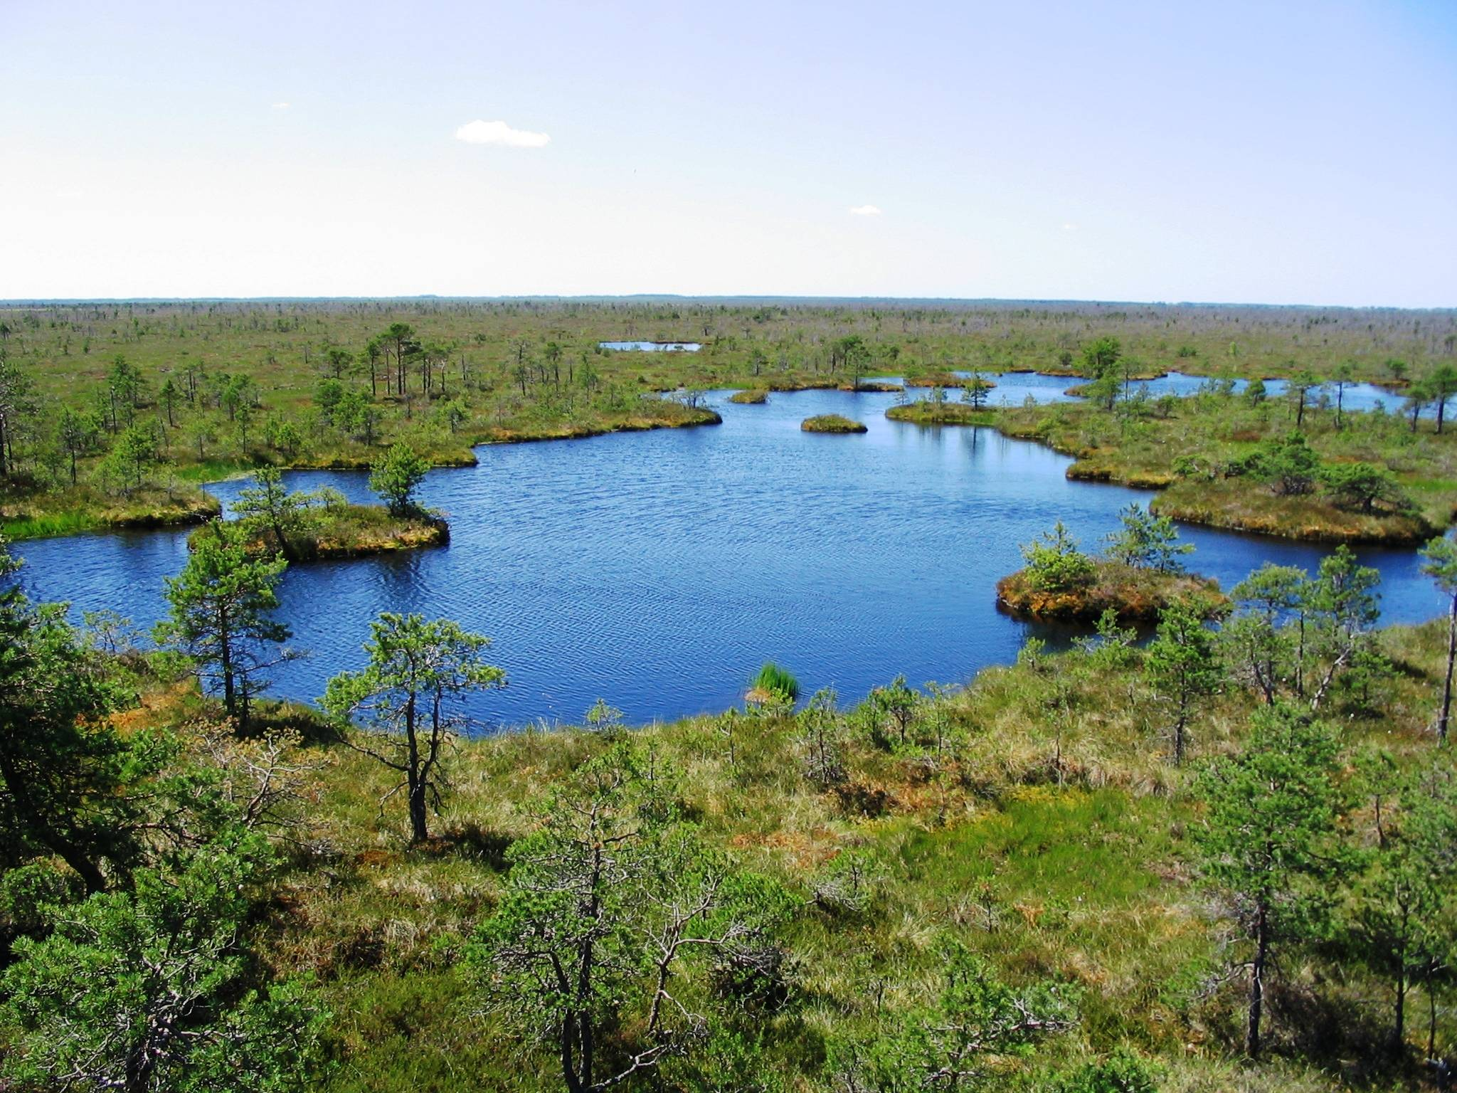

REPUBLIC OF BELARUS

Submitted to the Secretariat of the Convention on Biological Diversity [ ]
Protected area information:
PoWPA Focal Point:
Natalya Minchenko, Head of Biological and Landscape Diversity Department of the Ministry of Natural Resources and Environmental Protection of the Republic of Belarus
tel/fax +375 17 200 53 34, n_minchenko@tut.by

Lead implementing agency:
Ministry of Natural Resources and Environmental Protection of the Republic of Belarus
Multi-stakeholder committee: (Add description)
There is an interagency council for implementing the Convention on biological diversity which include the representative of the Ministry of forestry , National academy of science of Belarus, Administration of the President of the Republic of Belarus and other stakeholders.
Description of protected area system
Coverage (Amount and % protected for terrestrial and marine; maps of protected area system)
1302 protected areas
7,7 % overall coverage (terrestrial surface only)

Description and background (Summary description)
Areas that are subject to special protection, according to the Law of the Republic of Belarus dated October 20, 1994 "On Specially Protected Areas" in the statutory wording of the Law of the Republic of Belarus dated May 20, 2000 (Bulletin of the Supreme Council of the Republic of Belarus, 1994, No. 35, p. 570; National Register of Legal Acts of the Republic of Belarus, 2000, No. 52, 2/171), include specially protected areas (biosphere reserves, national parks, reserves (zakazniks) and natural monuments). Areas are declared specially protected if they bear special environmental, scientific, recreational or aesthetic significance. The majority of specially protected areas perform the functions of the nuclei of the National Environmental Network that ensure the maintenance of the region’s ecological balance. Specially protected areas that are considered to be promising and important for forming the National Environmental Network are indicated in Presidential Edict No. 19 dated January 12, 2007.
The system of specially protected areas includes:
- The Berezinsky Biosphere Reserve;
- 4 national parks – Belovezhskaya Pushcha, Braslav Lakes, Pripyatsky and Narochansky;
- 85 reserves of republican significance and 332 reserves of local significance;
- 306 natural monuments of republican significance and 574 natural monuments of local significance.

Governance types (Summary matrix of governance types)
The Berezinsky Biosphere Reserve and 4 national parks – state (Administration of the President of the Republic of Belarus);
reserves - state (Ministry of Forestry of the Republic of Belarus, Administration of the President of the Republic of Belarus) or local authorities (district, Minsk city executive committees)
natural monuments - local authorities (district, Minsk city executive committees)

Key threats (Description of key threats, and maps, if available)
specially protected areas are separated, which is a serious obstacle to free migration of wildlife species of animals and plants as the continuity of their habitat is not ensured;
degradation of ameliorated peat soils;
aggressive invasive species;
fires;
land acquisition for the mining of peat;
recreational pressure

Barriers for effective implementation (Description of key barrier s for effective implementation)
insufficient human and financial resources to management and protect most areas;
departmental interests of individual sectors of the economy (energy, forestry)

National Targets and Vision for Protected Areas
(Insert national targets for protected areas/Target 11 of the Aichi Targets. Include rationale from protected area gap assessment, if completed, along with any additional information about the vision for the protected area system, including statements about the value of the protected area system to the country)
8% protected areas to 2015;
improvement of the regulatory and legal framework for the development and management of the protected area system;
optimization of the protected area management system;
territorial development of the system of specially protected areas;
provision of efficient protection in protected areas;
optimization of economic and other types of activity in protected areas to the end of ensuring sustainable use of their natural resources;
creation of pre-conditions for the development of tourism-related activities in specially protected;
scientific and methodological support and enhancement of scientific activity efficiency;
assurance of operation of the system of environmental monitoring and ecosystem monitoring in specially protected natural areas;
improvement of the mechanism of operation, protection and use of specially protected areas;
increase in the level of education and awareness of the public and local residents in the sphere of protected areas and assurance of participation of the public and local residents in the management of specially protected areas;
promotion and strengthening of international cooperation in the sphere of specially protected areas
integrated protected areas into the wider landscapes and seascapes

Progress in and plans for achieving the goals of the Programme of Work on Protected Areas
Progress: 0 = no work, 1 = just started, 2 = partially complete, 3 = nearly complete, 4 = complete
Goals of the Programme of Work on Protected Areas | Progress 0-4
- Progress in establishing and strengthening national and regional systems of protected areas (1.1) | 2
- Progress in integrating protected areas into broader land- and seascapes and sectors so as to maintain ecological structure and function (1.2) | 2
- Progress in establishing and strengthening regional networks, transboundary protected areas (TBPAs) and collaboration between neighbouring protected areas across national boundaries (1.3) | 2
- Progress in substantially improving site-based protected area planning and management (1.4) | 2
- Progress in preventing and mitigating the negative impacts of key threats to protected areas (1.5) | 2
- Progress in promoting equity and benefit-sharing (2.1)  - Progress in assessing and implementing diverse protected area governance types (2.1) | 2
- Progress in enhancing and securing involvement of indigenous and local communities and relevant stakeholders (2.2) | 2
- Progress in providing an enabling policy, institutional and socio-economic environment for protected areas (3.1)  - Progress in assessing the contribution of protected areas to local and national economies (3.1) | 2
- Progress in building capacity for the planning, establishment and management of protected areas (3.2) | 2
- Progress in developing, applying and transferring appropriate technologies for protected areas (3.3) | 2
- Progress in ensuring financial sustainability of protected areas and national and regional systems of protected areas (3.4) | 2
- Progress in strengthening communication, education and public awareness (3.5) | 3
- Progress in developing and adopting minimum standards and best practices for national and regional protected area systems (4.1) | 2
- Progress in evaluating and improving the effectiveness of protected areas management (4.2) | 2
- Progress in assessing and monitoring protected area status and trends (4.3) | 2
- Progress in ensuring that scientific knowledge contributes to the establishment and effectiveness of protected areas and protected area systems (4.4) | 3
- Progress in marine protected areas | -
- Progress in incorporating climate change aspects into protected areas | 1

Priority activities for fully implementing the Programme of Work on Protected Areas:
Activities | Timeline
1. Assess equitable sharing of benefits | 1
2. Implement sustainable finance mechanism | 1
3. Establish effective PA monitoring system and research programme | 3
4. Strengthen nature protection through harmonizing sectoral policies | 3
5. Incorporate climate change aspects into PAs | 3
6. Integrate PA values and ecological services into the national economy | 2

Action Plans (detailed steps) for completing priority activities for fully implementing the Programme of Work on Protected Areas:

Activity 1: Creation of environment for а Program Work on Protected Areas
Key steps | Timeline | Responsible agencies | Indicative budget ($ USA)
Analysis and integration of the international standards in management of PA with legislative mechanisms | 2014-2015 | Ministry of natural resources and environment protection, NASB | -
The ratification of Bern convention and harmonization of national legislation | 2013-2014 | Ministry of natural resources and environment protection, NASB | -
Developing and approving methods of cost estimate of ecosystems services and cost estimate of biological diversity | 2012-2013 | Ministry of natural resources and environment protection | 4000

Activity 2: Development of the PA system and management
Key steps | Timeline | Responsible agencies | Indicative budget ($ USA)
Implementing the Scheme of rational placement of specially protected natural sites of the republican importance up to January 1, 2015 | 2012-2014 | Ministry of natural resources and environment protection, NASB | 120000
Developing a draft scheme of the National Environmental Network with due consideration of the Common European Environmental Network | 2012-2015 | Ministry of natural resources and environment protection | 50000
Working out a draft National strategy of the development of the specially protected natural sites system | 2014 | Ministry of natural resources and environment protection, NASB | 5000
Creating an efficient system of protected areas that is representatively inclusive of all types of standard ecological systems in the Republic of Belarus and that takes into account the areas of socio-economic development of the regions and developing a draft scheme of rational placement of specially protected natural sites of the republican importance, | 2013-2014 | Ministry of natural resources and environment protection, NASB | 10 000
Providing of inventory of PA for identification of modern status and valuable for items of them creation | 2013 | Ministry of natural resources and environment protection, NASB | 100 000
Working out the scheme of wild animals migration routes | 2013 | Ministry of natural resources and environment protection, National Academy of Sciences of Belarus | 10 000
Working and carrying out plans of controlling specially protected natural sites of international importance | 2012-2020 | Ministry of natural resources and environment protection, National Academy of Sciences of Belarus | -
Forming a list of typical and rare biotopes in the territory of the Republic of Belarus | 2012-2013 | Ministry of natural resources and environment protection, National Academy of Sciences of Belarus | 20 000
Optimizing the system of state authorities and other agencies, including state nature protection institutions that carry out management in the sphere of specially protected areas | 2012-2015 | Ministry of natural resources and environment protection, state nature protection authorities controlling specially protected natural sites | -
Training professionals in the sphere of specially protected areas, as well as upgrading the skills of employees working for state institutions who carry out public administration in protected areas, and state nature protection institutions | 2012-2014 | Ministry of natural resources and environment protection | 20 000
Ensuring management of protected areas on the basis of management plans, action plans for preserving rare and endangered wild animals and wild-growing plants | 2012-2015 | Ministry of natural resources and environment protection, state nature protection authorities controlling specially protected natural sites | In accordance with management and action plans

Activity 3: Developing the monitoring system and control of implementation legislation
Key steps | Timeline | Responsible agencies | Indicative budget ($ USA)
Growth of the experience of management authorities in sphere of control implementation ecological legislation | 2012-2020 | Ministry of natural resources and environment protection, National Academy of Sciences of the Republic of Belarus | -
Development of the monitoring system and research methodology on PA in accordance with international standards | 2012-2020 | Ministry of natural resources and environment protection, National Academy of Sciences of Belarus | 200 000
Working out express methods of indicating changes in the condition and stability of species and ecosystems in case of man-made changes in habitat | 2012-2020 | National Academy of Sciences of Belarus, Ministry natural resources and environment protection, Ministry of Education | 50 000

