BOTSWANA FOURTH NATIONAL REPORT TO THE CONVENTION OF BIOLOGICAL DIVERSITY

May 2009

BOTSWANA GOVERNMENT

Contents
Contents i
EXECUTIVE SUMMARY vi
CHAPTER 1 – OVERVIEW OF BIODIVERSITY STATUS, TRENDS AND THREATS 1
1.1 Introduction 1
1.2 The overall picture 2
1.2.1 Botswana’s unique biodiversity 2
1.2.1.1 Unique areas 2
1.2.1.2 Important Bird Areas (IBAs) 5
1.2.1.3 Species diversity 6
1.2.1.4 Agrobiodiversity 7
1.2.2 Biodiversity conservation status 8
1.2.2.1 Protected area network and other areas of high biodiversity conservation value 8
1.2.2.2 Red Data Lists 13
1.2.2.3 Pressures on Botswana’s biodiversity 24
1.3 Terrestrial biodiversity 26
1.3.1 Kalahari Acacia Baikiaea woodlands 26
1.3.1.1 Characteristics: 27
1.3.1.2 Status and trends of biodiversity: 27
1.3.1.3 Threats 28
1.3.1.4 Conservation activities: 29
1.3.2 Southern African bushveld 29
1.3.2.1 Characteristics: 29
1.3.2.2 Status and trends of biodiversity: 29
1.3.2.3 Threats 30
1.3.2.4 Conservation activities: 31
1.3.3 Zambezian Baikiaea woodlands 32
1.3.3.1 Characteristics: 32
1.3.3.2 Status and trends of biodiversity: 32
1.3.3.3 Threats 33
1.3.3.4 Conservation activities: 34
1.3.4 Zambezian halophytics 34
1.3.4.1 Characteristics: 34
1.3.4.2 Status and trends of biodiversity: 34
1.3.4.3 Threats 36
1.3.4.4 Conservation activities 36
1.3.5 Zambezian and Mopane woodlands 37
1.3.5.1 Characteristics: 37
1.3.5.2 Status and trends of biodiversity: 37
1.3.5.3 Threats 38
1.3.5.4 Conservation activities: 39
1.3.6 Zambezian flooded grassland 39
1.3.6.1 Characteristics: 39
1.3.6.2 Status and trends of biodiversity: 39
1.3.6.3 Threats 41
1.3.6.4 Conservation activities: 42
1.3.7 Kalahari xeric savanna 45
1.3.7.1 Characteristics: 45
1.3.7.2 Status and trends of biodiversity: 45
1.3.7.3 Threats 46
1.3.7.4 Conservation activities: 47
1.4 Biodiversity and People 47
1.5 Freshwater biodiversity 49
1.5.1 Wetlands 49
1.5.1.1 Important wetland areas 49
1.5.1.2 Status and trends of wetlands 49
1.5.1.3 Threats 50
1.5.1.4 Conservation activities 51
1.5.2 Rivers 53
1.5.2.1 Status and trends of Botswana’s rivers 53
1.5.2.2 Threats 53
1.5.2.3 Conservation activities 53
Chapter 2 - Implementation of Botswana National Biodiversity Strategy and Action Plan 55
2.1 Introduction 55
2.2 Biodiversity Strategy and Action Plan 55
2 2.1 Background 55
2.2.2 Summary of objectives (targets) 56
2.3 Progress towards strategy objectives 57
2.3.1 Better understanding of biodiversity and ecological processes 58
2.3.2 Long-term conservation of Botswana's biological diversity, genetic resources and related knowledge 58
2.3.3 Sustainable utilisation of all components of biodiversity in Botswana through appropriate land and resource use practices and management 59
2.3.4 An institutional environment, including financial and human capacity, conducive to effective biodiversity conservation, sustainable use and management 60
2.3.5 Coping with environmental change and threats to biodiversity 61
2.3.6 Raised public awareness and appreciation of biodiversity together with active public participation in biodiversity related activities and decision-making processes 62
2.3.7 Objective 7: Fair access to biological resources and equitable sharing of benefits arising from the use of biological resources 63
2.3.8 Safe industrial and technological development based on national biodiversity resources for future prosperity 63
2.3.9 Improved availability and access to biodiversity data and information, and promotion of exchange of information 64
2.3.10 Recognition of Botswana's international and regional role with regards to biodiversity 64
2.3.11 Implementation of this Biodiversity Strategy and Action Plan 65
2.4 Domestic and International Funding for Priority Activities 66
2.5 Effectiveness of National Biodiversity Strategy and Action Plan 66
2.5.1 Direct contributions 66
2.5.2 Implementation obstacles 66
2.5.2.1 Coordination 66
2.5.2.2 Information 67
2.5.2.3 Institutional Capacity 68
2.5.2.4 Awareness 68
2.5.2.5 Funding 69
2.5.3 How to improve implementation and overcome obstacles 69
2.6 Compliance with COP 8 requirements 69
2.6.1 Progress in achieving national participation of indigenous and local communities (VIII/5 (Article 8(j)) 70
2.6.2 Biodiversity funding made available for work in protected areas (VIII/24) 70
2.6.3 Environmental Impact Assessment (VIII/28) 71
2.6.4 Clearing House Mechanism 72
Chapter 3 - Biodiversity mainstreaming – Sectoral and cross-sectoral integration or mainsteaming of biodiversity considerations 73
3.1 Level of integration of biodiversity into sectoral and cross-sectoral strategies and plans 73
3.1.1 Biodiversity Policy 73
3.1.2 Status of the National Biosafety Framework (NBF) 74
3.1.3 Biosafety Capacity in Botswana 76
3.2 Description of process used to integrate biodiversity into sectoral and cross-sectoral strategies and plans 77
3.3 Adoption of ecosystems approach 77
Chapter 4 - Conclusions: PROGRESS towards the 2010 target and implementaiton of the strategic Plan 80
4.1 progress towards 2010 National targets 80
4.1.1 Indicators to measure progress 80
4.1.2 Obstacles 80
4.2 National progress toward the strategic plan of the CBD 80
4.2.1 National goals 80
4.2.2 Progress towards goals 81
4.2.3 Obstacles 90
4.3 Conclusions 90
4.3.1 Effect of CBD on biodiversity management in Botswana 90
4.3.2 Lessons learned 90
4.3.3 Priorities for the future 91
4.3.3.1 National priorities 91
Appendix 1 – Information concerning reporting Party and preparation of national report 93
Appendix II – Progress towards Targets of the Global Strategy for Plant Conservation and the Programme of Work on Protected Areas 96
REFERENCES 102

List of Tables
Table 1: Ecoregions in Botswana and their global conservation status 4
Table 2: Species richness within Botswana taxa 6
Table 3: Types of Protected Areas in Botswana 8
Table 4: Botswana's Forest Reserves 11
Table 5: Botanical monuments in Botswana 11
Table 6: List of globally threatened bird species in Botswana 14
Table 7: List of globally threatened fish in Botswana 16
Table 8: List of globally threatened mammals in Botswana 16
Table 9: List of plant species protected under Forest Act, 1968 18
Table 10: Flora species listed in the SABONET Plant Red Data List 18
Table 11: Endemic, near endemic and potentially endemic plant species in Botswana 20
Table 12: Percentage of threatened species distribution within each ecoregion (Plants and birds are a percentage of recorded sittings, mammals is a percent of the known range) 24
Table 13: Major wetlands in Botswana and their status 50
Table 14: Progress towards CBD goals since 3rd National Report 82
Table 15: Progress towards CBD Programme of Work on Protected Areas in Botswana 97

List of Figures
Figure 1: Map of ecoregions represented in Botswana 3
Figure 2: Map of Important Bird Areas in Botswana Source: Kootsosite et al (2008) 5
Figure 3: Map showing Species Richness Index in Botswana (BSAP 2005) 7
Figure 4: Protected areas in Botswana 10
Figure 5: Distribution of threatened and vulnerable bird species in Botswana 15
Figure 6: Distribution of threatened and vulnerable mammal species in Botswana 17
Figure 7: Distribution of threatened and vulnerable plant species in Botswana 22
Figure 8: Distribution of threatened and vulnerable species in Botswana (plants, birds and wildlife) 24
Figure 9: Threats to biodiversity in Botswana (BSAP, 2005) 26
Figure 10: Steps in Applying Ecosystem Approach to a Planning Issue (DEA, 2009) 78

List of Boxes
Box 1: Walking on the Makgadikgadi Pans 53
Box 2: The Okavango Delta Management Plan 78

List of Case Studies
Case study 1: Rare and endangered plant species in the Okavango Delta 23
Case Study 2: Building Local Capacity for Conservation and Sustainable Use of Biodiversity in the Okavango Delta 44
Case Study 3: Okavango Delta Management Plan 54

List of Abbreviations and Acronyms
BCH | Biosafety Clearing House
BSAP | Biodiversity Strategy and Action Plan
BTB | Botswana Tourism Board
BTSP | Botswana Threatened Species Policy
CBD | Convention on Biological Diversity
CBNRM | Community Based Natural Resource Management
CHA | Controlled Hunting Area
CHM | Clearing House Mechanism
CKGR | Central Kalahari Game Reserve
COP | Conference of Parties
CPB | Cartagena Protocol on Biosafety
DEA | Department of Environmental Affairs
DWNP | Department of Wildlife and National Parks
EIA | Environmental Impact Assessment
ESP | Environment Support Programme
GDN | Government Data Network
GEF | Global Environment Facility
GMO | Genetically Modified Organism
HOORC | Harry Oppenheimer Okavango Research Centre
IAS | Invasive Alien Species
IBA | Important Bird Area
IUCN | International Union on Conservation of Nature and Natural Resources
KAZA | Kavango- Zambezi
LMO | Living Modified Organism
MOU | Memorandum of Understanding
MSB | Millennium Seed Bank
NBF | National Biosafety Framework
NAU | National Authorised Users
NDP | National Development Plan
NFP | National Focal Point
NMMAG | National Museum, Monuments and Art Gallery
ODMP | Okavango Delta Management Plan
ODRS | Okavango Delta Ramsar Site
OKACOM | Okavango River Basin Water Commission
RDL | Red Data List
SABONET | Southern African Biodiversity Network
SADC | Southern African Development Community
TFCA | Transfrontier Conservation Area
UK | United Kingdom
WKCC | Western Kgalagadi Conservation Corridor
WMA | Wildlife Management Area
WWF | World Wildlife Fund

EXECUTIVE SUMMARY
The handbook of the Convention on Biological Diversity including its Cartagena Protocol on Biosafety states that Biodiversity is the term given to the variety of life on Earth including plants, animals, and micro-organisms, as well as the ecosystems of which they are part. Biodiversity includes genetic differences within species, the diversity of species and the variety ecosystems. It is the result of the interaction of species including humans, with one another and with the air, water and soil around them. This combination of life forms-ecosystems, species and genetic varieties- has made Earth a uniquely habitable place and provides the goods and services that sustain our lives, such as clean air and water, food and medicine, fuel, fiber and material for construction. Our cultures are founded upon the different environments in which they have developed (CBD Handbook, 2005). In addition to its intrinsic value, biodiversity provides goods and services that underpin sustainable development in many important ways, thus contributing to poverty alleviation. The rate of biodiversity loss is increasing at an unprecedented rate, threatening the very existence of life as it is currently understood.

The maintenance of biodiversity is a necessary condition for sustainable development, and as such constitutes one of the great challenges of the modern era. Addressing the threats to biodiversity requires immediate and long-term fundamental changes in the way resources are used and benefits are distributed. The Conference of the Parties at its sixth meeting endorsed the 2010 targets, putting in action the need to pursue sustainable development and alleviate poverty. A provisional framework for goals and targets and a provisional list of indicators for assessing progress towards achievement of 2010 targets was developed. In addition, a strategic plan was established to review the impacts and effectiveness of the existing process under the convention and identifying ways of overcoming the obstacles.

Botswana ratified to the Convention on Biological Diversity in 1995. This means that Botswana is bound by the provisions of the CBD. Countries which are party to the CBD, in adopting a Strategic Plan, have committed themselves to achieving, by 2010, a significant reduction in the rate of biodiversity loss at the global, national and regional levels, as a contribution to poverty alleviation and to the benefit of all life on earth. The fourth national report provides an important opportunity to assess progress towards the 2010 target, drawing upon an analysis of the current status and trends in biodiversity and actions taken to implement the Convention at the national level, as well as to consider what further efforts are needed.

In order to demonstrate implementation of the activities of the convention Botswana is required to report on the progress of the biodiversity status and trends by way of producing CBD fourth national report which will play an important role in highlighting this. Prior to this Botswana produced the first, second and third national reports. All these reports provided an overview of the biodiversity status of the country and the implementation measures of the convention. National reports provide an important source of information for review and decision-making processes under the Convention. The fourth national report aims to assess progress towards the 2010 target, drawing upon an analysis of the current status and trends in biodiversity and actions taken to implement the Convention at the national level, as well as to consider what further efforts are needed.

Status and trends in biodiversity, and major threats in Botswana
For purposes of this report, Botswana was divided into 7 internationally recognised eco-regions. Two of these eco-regions form part of the Global 200 eco-regions, i.e. the central and eastern Miombo woodlands and the Zambezian flooded savanna (Okavango system) which are ecoregions of global conservation priority. Both ecoregions have had their conservation status classified as Vulnerable.

Status of terrestrial biodiversity in Botswana
Fauna
Botswana is a large country with low human population densities. Extensive wilderness areas support high densities of mammals making Botswana one of the last refuges of species requiring open range. As a result Botswana still remains a stronghold for some of the world’s globally threatened mammal species, such as the African elephant and wild dog. While the mammal, bird and fish distribution is fairly well documented there are still gaps in our knowledge of reptiles, amphibians and invertebrates.
Based on the internationally agreed criteria established by BirdLife International for key sites for conservation of birds, 12 sites in Botswana have been identified as Important Bird Areas (IBAs). They include; Chobe National Park, Linyanti Swamps, Okavango Delta, Lake Ngami, Central Kalahari Game Reserve, Makgadikgadi Pans, Gemsbok National Parks, Tswapong Hills, Mannyelanong Hill, Phakalane Sewage, and Bokaa Dam. The Chobe and Okavango Delta IBAs have the richest avifauna with 433 and 464 species respectively. None of the avifauna species in Botswana are endemic and there are only two near-endemics, the Slaty Egret, which has approximately 85 % of its global population in the Okavango Delta, and the Short-clawed Lark, which has more than 90 % of its global population in South-eastern Botswana.
Only two globally threatened fish species occur in Botswana, namely; Oreochromis andersonii (Threespot Tilapia) and Oreochromis macrochir (Greenhead Tilapia). Both species have been classified as vulnerable and are threatened by the occurrence of the invasive alien species Oreochromis niloticus (Nile Tilapia), which is now widely distributed in the Zambezi, Kafue and Limpopo systems.
Population trends and conservation status of reptiles and amphibians is not known. Two internationally protected species of reptiles, the Nile crocodile (Crocodylus niloticus) and the African rock python occur in Botswana, and are protected by the Wildlife Conservation and National Parks Act of 1992. The overall status of Botswana’s fauna remains satisfactory.

Flora
The Botswana flora consists of around 2,150-3,000 species. A comprehensive distribution list of threatened or endemic species in Botswana is still missing, but the majority of the known rare species currently exist mainly in unprotected areas. The Forest Act of 1968, as amended by Act No.8 of 2005, allows for the declaration of certain protected species and lists ten tree species to be protected. According to the Southern African Plant Red Data Lists, there are officially 43 Red Data listed plant species in Botswana. The SABONET 2002 Database lists 13 endemic, 10 potentially endemic and 7 near endemic plant species in Botswana. The Royal Botanic Gardens, Kew list an additional 14 species as endemic and near endemic. The overall status of Botswana’s flora is currently believed to be relatively good, but over harvesting is threatening some economically or medicinally important plant species.

Agro-biodiversity
Although availability of data on distribution of species, breeds, varieties and especially genetic diversity is still limited, agro-biodiversity in Botswana is still thought to be relatively rich. Botswana is important as it is believed to be a centre of diversity for Vigna (Cowpea) species and a secondary centre of diversity for Citrullus species (wild melon), and many wild types of these species can be found in Botswana (Matlhodi, 1992). The number of varieties currently grown in the country compared to what is stored in the National Plant Genetic Resources Centre’s collection is known to be declining and the use of exotic species for cross breeding is threatening indigenous species of cattle. Ex situ conservation facilities and programmes are in place for crops and wild crop relatives.

Conservation of biological diversity in Botswana
Botswana has set aside 45% of its land area as protected areas. This includes national parks, game reserves, private wildlife and nature reserves, Wildlife Management Areas (WMAs), Controlled Hunting Areas (CHAs), forest reserves and national monuments. The national parks, game reserves, WMAs (see Table 3) and CHAs are governed by the provisions in the Wildlife Conservation and National Parks Act, 1992. The Ministry of Youth, Sport and Culture through the National Museum, Monuments and Art Gallery are responsible for a number of botanical monuments. Botswana has one designated Ramsar site, covering the Okavango Delta, and one World Heritage Site, the Tsodilo Hills, which are protected through the management standards attached to Ramsar and World Heritage Site listings respectively.
The protected area network in Botswana provides good in situ conservation for most of the ecoregions and many wildlife species, except in the north eastern part of Botswana. While the vegetation in national parks and game reserves is protected and the forest reserves offer protection of certain tree species, the protected area network offer less protection for Botswana’s rare and endangered plants as most of these occur outside the protected area network.
The ex situ conservation facilities for wildlife is limited for all organisms. However, through the Millennium Seed Bank Project, over 500 collections of plant seeds, herbarium vouchers and live specimens have been obtained so far for ex situ conservation. It is difficult to determine population trends for most taxonomic groups, except for the big mammals and some of the birds, as there is not enough data available. For most other groups baseline data has not been established and survey and monitoring is not taking place on a regular basis. Institutional responsibilities for survey and for building up national reference collections have not yet been established. A contributing factor to the lack of survey data is the general lack of taxonomic expertise.

Threats
The level of threats to biodiversity in Botswana will vary depending on location. In general habitat destruction and reduction and barriers to movement are the main threats. Threats to biodiversity by invasive alien species (IAS) are still relatively low on a national scale and are confined to specific areas. In the southwest of the country Prosopis glandulosa is starting to become a problem, while in the Okavango Delta Salvinia molesta poses the greatest threat to the aquatic environment. An invasive bird species, the Indian Myna (Acridotheres tristis), has established itself in Gaborone however little is known about its impacts within Botswana.
The highest pressures on overall biodiversity are in the eastern parts of the country (Southern African bushveld and Kalahari Acacia- Baikiaea woodlands ecoregions), and in and around the Okavango Delta (Zambezian flooded grasslands), with smaller pockets in other parts of the country.
In general the Zambezian and Mopane Woodland and the Zambezian Flooded grasslands show a high distribution of vulnerable and threatened species. This is an indication that continued protection of these ecoregions is paramount for conservation of vulnerable and threatened species. However, a high distribution of threatened plant species is found in the Kalahari Acacia-Baikiaea savanna, while the Zambezian flooded grasslands is important for threatened species of avifauna and mammals.
The effects of climate change on biodiversity are yet to be verified and confirmed but with Botswana being a dry land country any changes in the rainfall distribution will have effects on biodiversity and people.

Status of freshwater biodiversity in Botswana
A wide variety of organisms inhabit Botswana’s freshwater ecosystems, including invertebrates, molluscs, fish and others. Currently very little is known about the status of rivers in Botswana. Besides studies on the Okavango river system, no studies or reports on the status and trends of biodiversity in rivers were identified. The main threats to rivers are changes to river ecology due to abstraction of river sand, loss of riparian vegetation, and the drying out of rivers downstream of the major dams. Aquatic weeds and other invasive alien species are mainly a problem in the rivers in the north of the country. The fish disease Epizootic Ulcerative Syndrome (EUS) has recently been detected in the Zambezi River.
The wetland ecosystems have however been better studied, in particular, the Okavango Delta. The Okavango Delta is a Ramsar site and the core of the Delta is protected through the Moremi Game Reserve. The Harry Oppenheimer Okavango Research Centre has been set up specifically to monitor the health of the Delta and guide research on various aspects of the functioning of the Delta. A specific integrated planning framework, the Okavango Delta Management Plan is in place since 2006.
The Makgadikgadi Pans, unique salt pans, are on the other hand largely unprotected, but plans are advanced to begin the process leading to the development of an integrated management plan and potentially apply for Ramsar status.

Implementation of the Botswana National Biodiversity Strategy and Action Plan
The goal of the BSAP is to contribute to the long-term health of Botswana’s ecosystems and related species, and to encourage sustainable and wise use of resources through the provision of a framework of specific activities designed to improve the way biodiversity is perceived, utilized and conserved.
The BSAP has been designed based on the CBD’s three main objectives, and implementation of the BSAP will therefore contribute to the 2010 goals.
In Botswana, responsibilities for implementation of the Action Plan are divided across sectors and ministries. Implementation of the strategy is gradually taking place but many of the deadlines have not yet been met. Even though it has been adopted as a national strategy, institutions which fall under the Ministry of the Environment, Wildlife and Tourism and environmental NGOs are the most pro-active implementers.

Obstacles of implementation
Coordination of the implementation of the BSAP has been charged to the Department of Environmental Affairs, a ministry department with limited administrative jurisdiction over other implementing Ministries/sectors. The status of the Department coupled with the weak technical capacity has constrained coordination of the implementation of the BSAP. Within local authorities and regulatory bodies the number of staff technically qualified to collect, analyse, interpret and act on biodiversity data is often insufficient; and the absence of dedicated staff at implementing institutions has compromised the level of efforts to implement the BSAP.
At present there are no formalised mechanisms for exchange of biodiversity information between the institutions. Ecological research is mostly conducted by academic institutions and interaction between researchers, users, managers and communities is limited therefore scientific findings are rarely used to inform management decisions, particularly in relation to biodiversity. Baseline biodiversity data are limited and not integrated into management procedures, which inhibits the ability to understand land use impacts and detect resource and biodiversity trends.
The current BSAP might also be too detailed to be practical to implement. Public awareness about biodiversity and the BSAP is generally low in all sectors. Low outputs on implementation can also be attributed to lack of funding for activities outlined in the strategy.

Future priorities
Reporting on the status and trends in biological diversity in Botswana is problematic due to the fact that there are no ecological baselines against which change is measured. There is an urgent need for establishment of ecological baselines. After ecological baselines have been established, there is need for standardized monitoring of biodiversity populations.
Capacity building and raising awareness at institutional and community level is crucial to enhance understanding and create opportunities for conservation of biological resources and sustainable use of its components.
At a global level, freshwater ecosystems are the most threatened of all natural habitats, yet little information is available on the status of freshwater ecosystems in Botswana. There is an urgent need for assessment of freshwater habitats, their status and threat in Botswana.
The establishment of an overarching policy or legislation on conservation of biodiversity is necessary in order that biodiversity conservation activities in Botswana are guided and coordinated, including fair and equitable sharing of benefits arising from sustainable use of genetic resources.

CHAPTER 1 – OVERVIEW OF BIODIVERSITY STATUS, TRENDS AND THREATS
1.1 Introduction
This chapter provides an overview of Botswana’s biodiversity status and trends, and threats to biodiversity. The information is grouped according to internationally recognised ecoregions, rather than by sector, aiming towards a more biome oriented view. However, these ecoregions roughly coincide with the administrative districts of Botswana.
Although there are some information gaps where supporting data does not exist, it is nevertheless hoped that the report will assist in future regional, national and district planning processes and guide environmental survey and monitoring activities in the country.
The objectives of this chapter are to:
- Give a brief overall picture of biodiversity status, trends and threats in Botswana
- Discuss the status, trends and threats of biodiversity in the terrestrial environment and freshwater environment
- Discuss the implications for human wellbeing

Botswana published its National Biodiversity Strategy and Action Plan in 2004. The timing of activities was revised in 2007. A recurring feature in the Action Plan is the need for reliable biodiversity information in the form of baselines and regular monitoring data for all biodiversity groups. It was proposed to establish focal institutions for each taxonomic group with responsibility for data collection and monitoring. This has not yet happened and as a result availability of survey and monitoring data is still patchy and not consistent, which makes it difficult to establish trends.

1.2 The overall picture
1.2.1 Botswana’s unique biodiversity
1.2.1.1 Unique areas
For the purpose of this report Botswana has been divided into 7 terrestrial ecoregions - See Figure 1 and Table 1. The WWF eco-region map was used as a base map but the boundaries have been slightly modified, using local data on soils and climate conditions in order to make it more accurate.
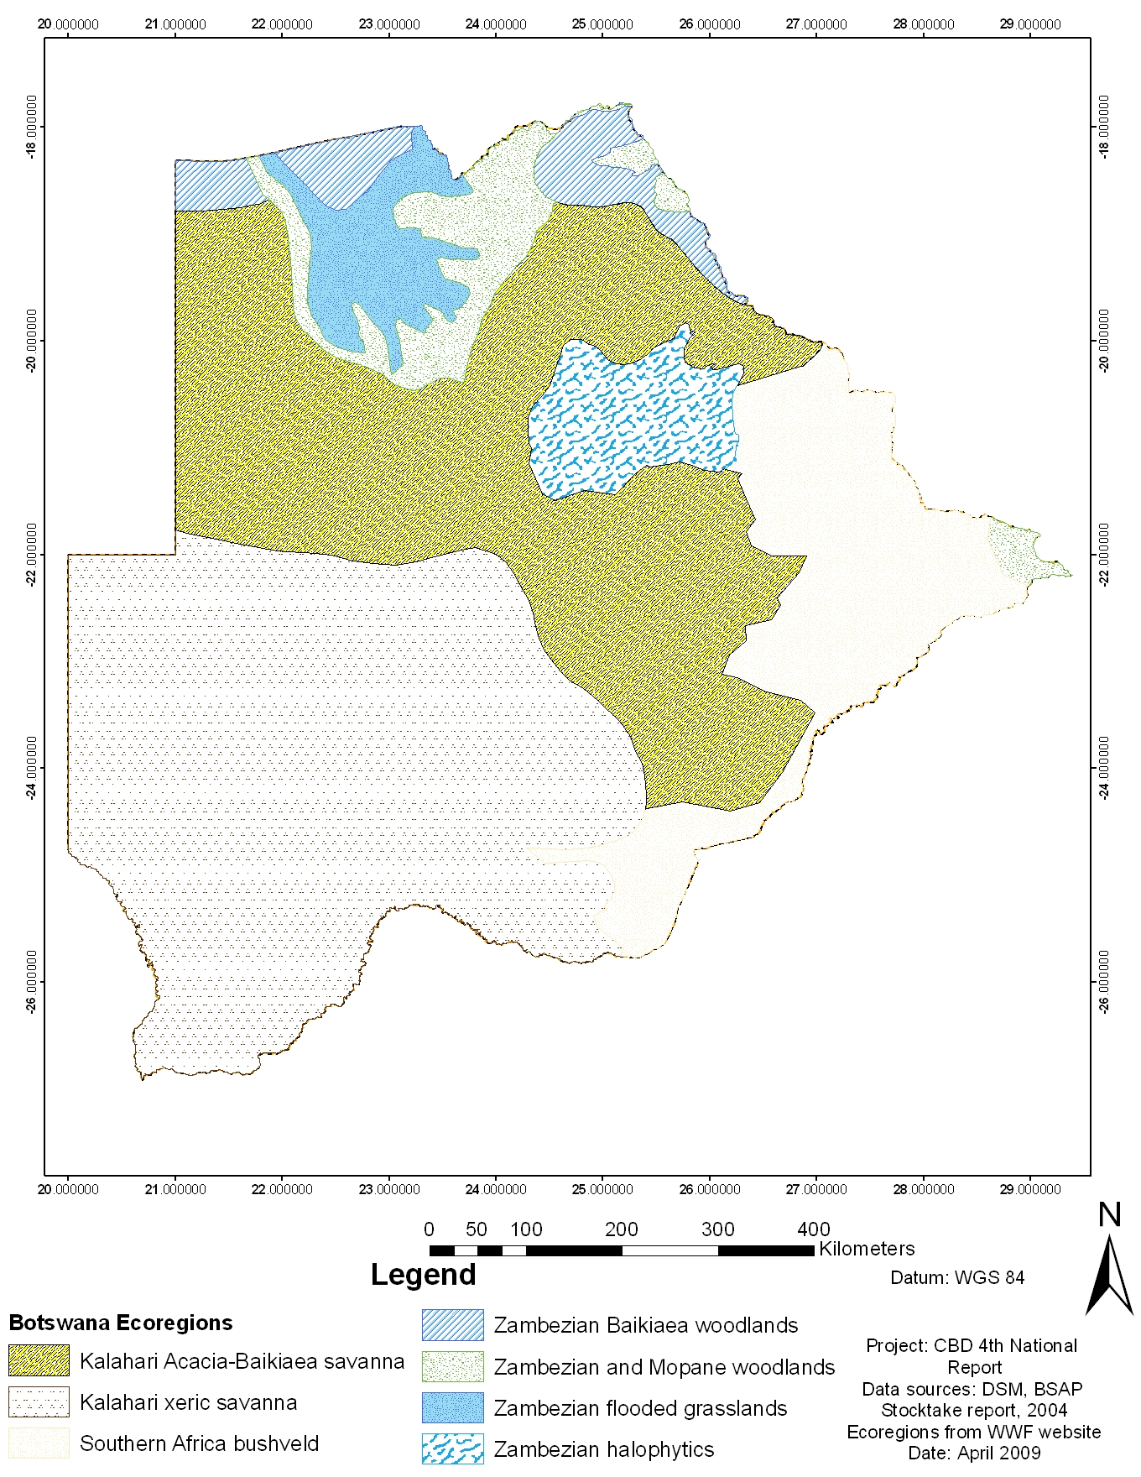
Figure 1: Map of ecoregions represented in Botswana

Table 1: Ecoregions in Botswana and their global conservation status
No | Ecoregion | Global Conservation status
AT0709 | Kalahari Acacia Baikiaea woodlands | Vulnerable
AT0717 | Southern African bushveld | Vulnerable
AT0726 | Zambezian Baikiaea woodlands | Vulnerable
AT0908 | Zambezian halophytics | Vulnerable
AT0725 | Zambezian and Mopane woodlands | Stable/intact
AT0907 | Zambezian flooded grassland | Relatively stable/intact
AT1309 | Kalahari xeric savanna | Relatively stable/intact
Source: www.worldwildlife.org
A finer national ecological zoning delineation exists, although there is a lack of an agreed national ecosystem map and criteria for identification of areas of ecological importance. The use of the ecoregion boundaries puts the report in a regional and global context. Two of these ecoregions form part of the Global 200 ecoregions, i.e. the central and eastern Miombo woodlands and the Zambezian flooded savanna (Okavango system) which are ecoregions of global conservation priority. Both ecoregions have had their conservation status classified as Vulnerable (www.worldwildlife.org).
Within these ecoregions, areas of special ecological uniqueness and/or concern to Botswana include:
- Okavango Delta – Unique inland delta and a Ramsar site.
- Makgadikgadi pans – Unique halophytic seasonally flooded pan system. Breeding site for flamingos
- Chobe forest reserves (Miombo woodlands) – Very limited area in northern Botswana, but high in biodiversity.
- Molapo farming system in the northwest – unique dryland farming system based on receding moisture in seasonal riverbeds. Important for agro-biodiversity

1.2.1.2 Important Bird Areas (IBAs)
Twelve (12) sites have been identified as Important Bird Areas in Botswana, based on the internationally agreed criteria established by BirdLife International (see Figure 2 below). These sites are; Chobe National Park, Linyanti Swamps, Okavango Delta, Lake Ngami, Central Kalahari Game Reserve, Makgadikgadi Pans, Gemsbok National Parks, Tswapong Hills, Mannyelanong Hill, Phakalane Sewage, and Bokaa Dam. IBAs are key sites for conservation of birds and seven of them in Botswana are already part of protected area network. Of the twelve, the Chobe and Okavango Delta IBAs have the richest avifauna with 433 and 464 species respectively (Kootsositse et al, in press).

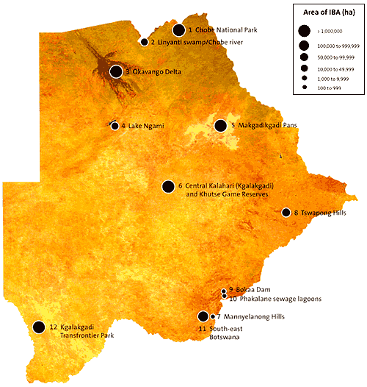
Figure 2: Map of Important Bird Areas in Botswana Source: Kootsosite et al (2008)

Kootsositse noted that monitoring efforts in these areas lack adequate coordination due to insufficient funding that would otherwise enable design and implementation of active participatory exercise, reporting and evaluation programmes involving local communities and other stakeholders.
1.2.1.3 Species diversity
Botswana is a large country with low human population densities. Vast wilderness areas support high densities of mammals making Botswana one of the last refuges of species requiring large areas e.g. elephant and wild dog. While the mammal, bird and fish distribution is fairly well documented there are still gaps in our knowledge of plants, reptiles, amphibians and invertebrates in particular. The number of recorded species is indicated in Table 2, with Map 3 showing species richness index for Botswana according to available national datasets (BSAP, 2007).

Table 2: Species richness within Botswana taxa
Taxon | Number of described species in Botswana | Remarks
Mammals | 147
Birds | 587
Amphibians | 34
Reptiles | 131
Freshwater fish | 99 | Mostly found in the large permanent river ways of the Limpopo, Chobe-Linyanti-Kwando system and the Okavango Delta.
Invertebrate |  | Largely undescribed
Plants | 2,150-3,000
Source: DWNP, NMMAG

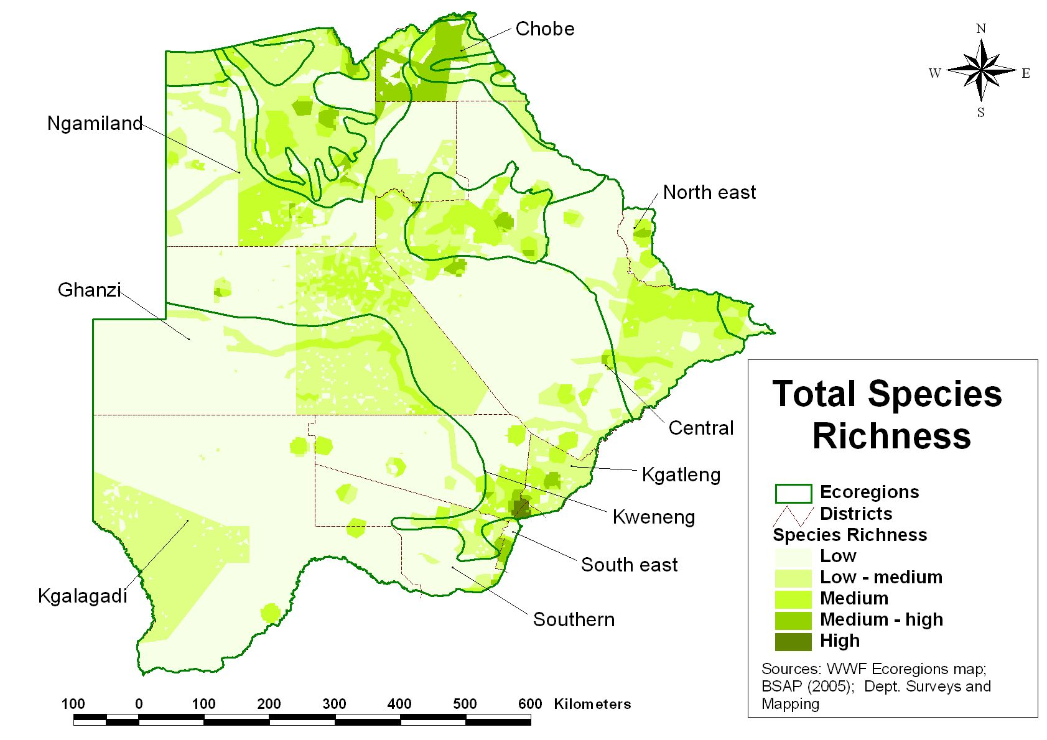
Figure 3: Map showing Species Richness Index in Botswana (BSAP 2005)

1.2.1.4 Agrobiodiversity
Agrobiodiversity in Botswana is still believed to be relatively rich in species at traditional farm level, and there is a definite demand for local breeds and varieties in the local markets. However maize and sorghum normally make up to 70% of area planted, while cattle and goats are the most important livestock species. A trend towards more intensive farming systems continues to put pressure on local breeds and varieties.
Availability of data on distribution of species, breeds and varieties and especially genetic diversity is still limited, although the number of varieties currently grown in the country compared to what is in the National Plant Genetic Resources Centre’s collection is known to be declining and the use of exotic species for cross breeding is threatening indigenous species of cattle.
From a crop perspective, Botswana is important as it is believed to be a centre of diversity for Vigna (Cowpea) species and a secondary centre for of diversity for Citrullus species (wild melon) (Matlhodi, 1992), and many wild types of these species can be found in Botswana.
Ex situ conservation facilities and programmes are in place for crops and wild crop relatives. The National Plant Genetic Resource Centre holds seed collections of most of the major crops. These are then duplicated at the regional Plant Genetic Resource Centre in Zambia. Lately there have been attempts to collect minor crops and wild crop relatives as well, but the collecting programme is still not comprehensive (BSAP, 2007).

1.2.2 Biodiversity conservation status
1.2.2.1 Protected area network and other areas of high biodiversity conservation value
The Botswana Biodiversity Strategy and Action Plan (BSAP) adopted the definition of protected areas from that of the workshop on categories of Protected Area held at the Fourth World Congress on National Parks and Protected Areas:
An area of land and/or sea especially dedicated to the protection and maintenance of biological diversity, and of natural and associated cultural resources, and managed through legal or other effective means.
According to this definition, Botswana has set aside 45% of its land area as protected areas. This includes national parks, game reserves, private wildlife and nature reserves, wildlife management areas (WMAs), controlled hunting areas (CHAs), forest reserves and national monuments. National parks, game reserves, WMAs (see Table 3) and CHAs are governed by the provisions in the Wildlife Conservation and National Parks Act, 1992.
Table 3: Types of Protected Areas in Botswana
Type of area | Km² | % of total land area | Legal constitution | Level of protectionª
National Parks | 44,420 | 8 | Wildlife Conservation and National Parks Act No 28 0f 1992 | Ib  No hunting
Game Reserves | 59,590 | 10 | Wildlife Conservation and National Parks Act No 28 0f 1992 | Ib  No hunting
Private Wildlife & Nature Reserves | Not known | <1 | No act deals with this | IV  No hunting
Wildlife Management Areas (WMA) | 75,160 | 24 | Wildlife Conservation and National Parks Act No 28 of 1992 | V  Controlled hunting
Forest Reserves | 4,191 | 1 | Forest Act, 1968 | II -Protection of Trees
National Monuments | <100 | <1 | Monuments and Relics Act 2001 | III – Botanical monuments
World Heritage Sites | 48 + buffer zone 704 | <1 | Monuments and Relics Act 2001 | World Heritage listing standards
Ramsar Sites | 55, 374 | 9.53 | Wildlife Conservation and National Parks Act No. 28 of 1992  Aquatic Weeds Control Act Cap: 34:04 | Ramsar management standards
Source: BSAP, 2007
a: According to IUCN guidelines on protected areas
Ia Strict Nature Reserve: protected area managed mainly for science
Ib Wilderness Area: protected area managed mainly for wilderness protection
II Ecosystem conservation and recreation (i.e. National Park)
III Conservation of natural features (i.e. Natural Monument)
IV Conservation through active management (i.e. Habitat/Species Management Area
V Landscape/seascape conservation and recreation (i.e. Protected Landscape/Seascape)
VI Sustainable use of natural ecosystems (i.e. Managed Resource Protected Area)

In addition, the Forest Act of 1976 has designated 5 areas in the north of Botswana as Forest Reserves (See Figure 4 and Table 4). Approximately 4190 km² of Zambezian Baikiaea and Zambezian & Mopane Woodlands is protected. WMAs are buffer zones between incompatible land-uses particularly livestock and wildlife and in some cases they also serve as migratory corridors for wildlife. These buffer zones are often designated adjacent to national parks and game reserves for purposes of sustainable management of wildlife usually through CBNRM activities (see Figure 5). Within these both consumptive (trophy hunting) and non-consumptive (photographic) based commercial wildlife operations are executed.

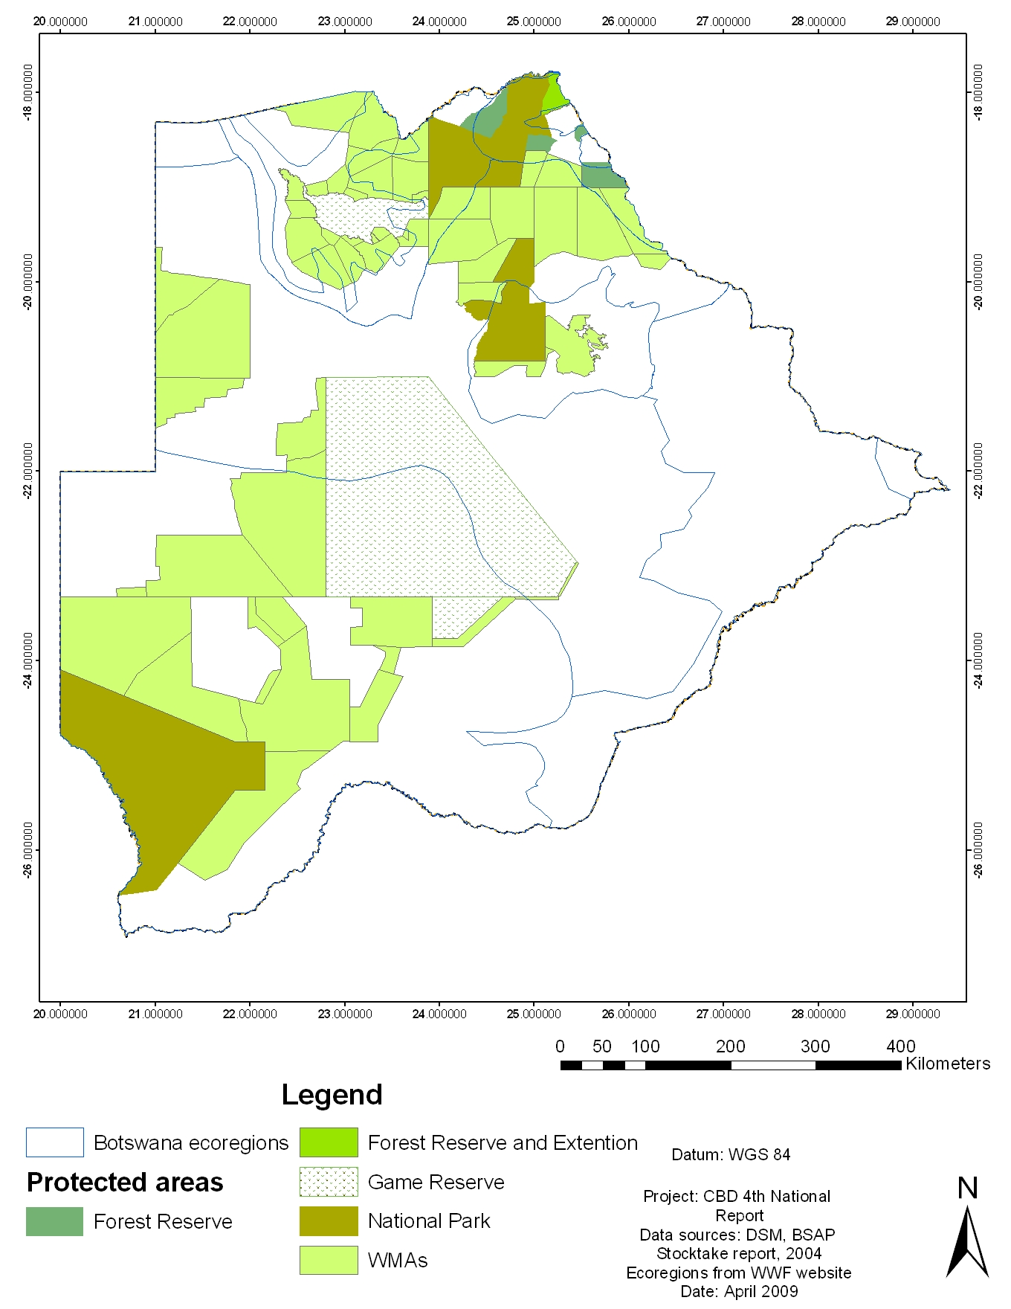
Figure 4: Protected areas in Botswana

Table 4: Botswana's Forest Reserves
Forest Reserve | Ecoregion Protected | Area (km²)
Chobe Forest Reserve | Zambezian Baikiaea and Zambezian & Mopane Woodlands | 1432
Kasane Forest Reserve and Extension | Zambezian Baikiaea and Zambezian & Mopane Woodlands | 837
Kazuma Forest Reserve | Zambezian Baikiaea Woodlands | 195
Sibuyu Forest Reserve | Zambezian Baikiaea Woodlands | 1194
Maikaelelo Forest Reserve | Zambezian Baikiaea Woodlands | 532

The Ministry of Youth, Sport and Culture through the National Museum, Monuments and Art Gallery are responsible for a number of botanical monuments (See Table 5). Botswana has one designated Ramsar site, covering the Okavango Delta, and one World Heritage Site, the Tsodilo Hills. These areas are protected through the management standards attached to Ramsar and World Heritage Site listings. The Makgadikgadi pans have been proposed for Ramsar listing. In addition, there are a number of private game farms of which many effectively work as conservation areas.

Table 5: Botanical monuments in Botswana
Name of Monument | District and Location | Remarks
Molepolole Aloe Forest Reserve | Kweneng (Molepolole) | Preserved because Bakwena believe that they saved them from the Boers
Mahalapye Baobab | Central (Mahalapye) | Southern most occurring and eye catching
Pelotshetlha Lithops | Southern (Pelotshetlha) | Occurs on a small hill-size of football pitch. Only located area so far
Makosho trees | Central (Lecheng) | Known to occur in riverine areas but in this place not close to any river. They have a limited distribution of 42 in this area
Sesamothamnus lugardii (Thobega) Trees | Central (Boteti sub District) | Limited distribution, threatened and occur in a quarried area
Baines Baobabs | Ngamiland (Nxai Pan) | Spectacular for their unusual clusterings
Mamuno Aloe Forest Reserves | Gantsi (Mamuno) | Attractive forest of Aloe marlothii
Sowa Morula | Central (Sowa) | Stand of Morula trees
Maitengwe Mopane Forest Reserve | Central (Maitengwe) | This area is secured as an in-situ area for protection of and research on vegetation
Sokwe forest reserve | Central (Serowe) | Area rich in botanical diversity
Mowana Prison Tree | Chobe (Kasane) | Tree historically used as a prison cell
Mazilibgwa’s Mowana | Central (Mosu) | Historic huge baobab tree
Green’s Gutsaa Baobab | Central (Gweta) | Historic huge baobab tree
Marula-mantsi Tree Trail | Central (Gweta) | Morula is now being harvested for commercial projects. This area has been secured or protected for research purposes.
Source: Botswana National Herbarium and Botanical Gardens

The protected area network in Botswana provides good in situ conservation for most of the ecoregions and many wildlife species, except in the north eastern part of Botswana. While the vegetation in national parks and game reserves is protected and the forest reserves offer protection of certain species, the protected area network offer less protection for Botswana’s rare and endangered plants as most of these occur outside the protected area network (BSAP, 2007). The recently adopted Botswana Threatened Species Policy compensates for this limitation by establishing a complete scheme for the protection and recovery of threatened species and for the inventorying of endemic species for the purpose of protecting them when they are threatened or data deficient (BTSP, 2007). Comprehensive legal support for the policy is however still lacking.

The ex situ conservation facilities for wildlife is limited for all organisms. However, through the Millennium Seed Bank Project, over 500 collections of plant seeds, herbarium vouchers and live specimens have been obtained so far for ex situ conservation, and the project is on track of reaching the Global Plant Conservation Strategy target no 8 of 60 % of threatened plant species in accessible ex situ conservation by the end of the year.

The Millennium Seed Bank (MSB) Project is an international collaborative plant conservation initiative managed by the Royal Botanic Gardens, Kew in the United Kingdom (UK). The global project acts as an umbrella for a number of national MSB programmes. The MSB Project is the largest ex situ conservation project in the world. By the end of this decade the MSB partners in over 20 countries will have banked seed from 10% of the world's wild plant species, and thus secured these species against possible extinction. The long-term goal is to have 40 % of the world' flowering wild plant species in ex situ conservation by 2040.

The purpose of the specific Botswana project, which started in 2003, is “To contribute to the health and survival of Botswana’s wild plant species, through seed conservation and strengthening of Botswana’s seed conservation capacity”. The project is focusing on collections and ex situ storage of the rare and endangered plant species as well as those wild species with economic potential. Genetic diversity for most organisms, including animals is unknown (BSAP, 2007).

1.2.2.2 Red Data Lists
Red Data Lists are intended to be comprehensive and authoritative accounts of the global, regional and national conservation status of plants and animals. They help to convey the urgency and scale of conservation problems to the public and policy-makers, and are used to motivate the global community to take appropriate actions to reduce the loss of species (Setshogo & Hargreaves, 2002). The most common globally accepted standard of extinction risk assessment is the World Conservation Union’s IUCN Red Listing of Threatened Species. However the IUCN’s Global Red List of Threatened Species is not a comprehensive list of all species in Botswana and may not reflect the national status of species in Botswana (Botswana Threatened Species Management Policy, Implementation Strategy and Action Plan, 2007).

FAUNA
Avifauna
In 2008, there were 25 globally threatened bird species in Botswana (see Table 6), and a further eight species regarded as nationally threatened, or Birds of Conservation Concern in Botswana. These species include the Bateleur, Hooded Vulture, Martial Eagle, Grey crowned Crane, Kori Bustard, Southern Ground Hornbill and Lesser Kestrel. Six species listed in the IUCN Red List for Botswana have not been listed by BirdLife Botswana as species of conservation concern. These include the Egyptian vulture, Basra Reed Warbler, Black Harrier, Blue Crane, Corn Crake and Denham’s Bustard. It is significant to note that Botswana has no Critically Endangered bird species. On the whole, the status of birds throughout the country is relatively good (Kootsositse et al, in press).
Table 6: List of globally threatened bird species in Botswana
No | Scientific Name | English Name | Conservation Status
1 | Neophron percnopterus | Egyptian Vulture | Endangered
2 | Acrocephalus griseldis | Basra Reed Warbler | Endangered
3 | Egretta vinaceigula | Slaty Egret | Vulnerable
4 | Falco naumanni | Lesser Kestrel | Vulnerable
5 | Torgos tracheliotos | Lappet-faced Vulture | Vulnerable
6 | Circus maurus | Black Harrier | Vulnerable
7 | Anthropoides paradiseus | Blue Crane | Vulnerable
8 | Grus carunculatus | Wattled Crane | Vulnerable
9 | Gyps coprotheres | Cape Vulture | Vulnerable
10 | Crex crex | Corn Crake | Vulnerable
11 | Trigonoceps occipitalis | White-headed Vulture | Vulnerable
12 | Phoenicopterus minor | Lesser Flamingo | Near Threatened
13 | Circus macrourus | Pallid Harrier | Near Threatened
14 | Neotis denhami | Denham’s Bustard | Near Threatened
15 | Gyps africanus | White-backed Vulture | Near Threatened
16 | Rhynchops flavirostris | African Skimmer | Near Threatened
17 | Glareola nordmanni | Black-winged Pratincole | Near Threatened
18 | Gallinago media | Great Snipe | Near Threatened
19 | Mirafra cheniana | Latakoo (Melodious) Lark | Near Threatened
20 | Oxyura maccoa | Maccoa Duck | Near Threatened
21 | Charadrius pallidus | Chestnut-banded Plover | Near Threatened
22 | Coracias garrulous | European Roller | Near Threatened
23 | Falco vespertinus | Red-footed Falcon | Near Threatened
24 | Limosa limosa | Black-tailed Godwit | Near Threatened
25 | Numenius arquata | Eurasian Curlew | Near Threatened
Source: Hancock, 2008 in press
None of the avifauna species in Botswana are endemic and there are only two near-endemics, viz the Slaty Egret, which has approximately 85% of its global population in the Okavango Delta, and the Short-clawed Lark, which has more than 90% of its global population in South-eastern Botswana. Figure 5 shows the distribution of threatened bird species in Botswana.

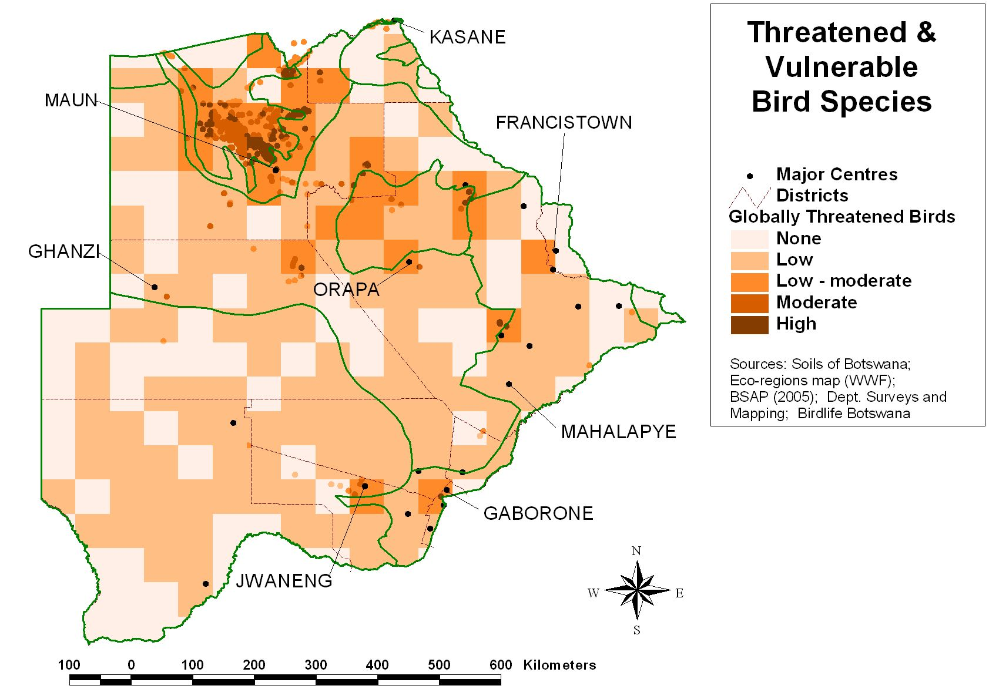
Figure 5: Distribution of threatened and vulnerable bird species in Botswana

Fish
Only two globally threatened fish species occur in Botswana (see Table 7). Both species are threatened by the occurrence of the alien and invasive species Oreochromis niloticus (Nile Tilapia), which is now widely distributed in the Zambezi, Kafue and Limpopo systems. At present, the Okavango population is not immediately threatened, but this system is intermittently linked to the Zambezi and thus it is inevitable that O. niloticus will invade the system (Tweddle & Marshall, 2008).

Table 7: List of globally threatened fish in Botswana
No | Scientific Name | Common Name | Conservation Status
1 | Oreochromis andersonii | Threespot Tilapia | Vulnerable
2 | Oreochromis macrochir | Greenhead Tilapia | Vulnerable

Mammals
Botswana’s rangelands support a variety and abundance of mammals which are globally threatened, although currently, the remaining wildlife resources are concentrated in northern Botswana (Darkho & Rwomire, 2003). It harbours many threatened large mammal species and contains one of the largest remaining populations of the African wild dog Lycaon pictus (See Table 8). The distribution of globally threatened mammal species found in Botswana is shown by Figure 6.
Table 8: List of globally threatened mammals in Botswana
No | Scientific Name | Common Name | Conservation Status | Population Trend
1 | Acinonyx jubatus | Cheetah | Vulnerable | Declining
2 | Ceratotherium simum | White Rhinoceros | Near Threatened | Increasing
3 | Diceros bicornis | Black Rhinoceros | Critically endangered | Increasing
4 | Eidolon helvum | Straw-coloured Fruit Bat | Near Threatened | Declining
5 | Felis nigripes | Black-footed Cat | Vulnerable | Declining
6 | Hippopotamus amphibius | Hippopotamus | Vulnerable | Declining
7 | Hippotragus equines | Roan Antelope | Least Concern | Declining
8 | Hyaena brunnea | Brown Hyaena | Near Threatened | Declining
9 | Kobus vardonii | Puku | Near Threatened | Declining
10 | Laephotis botswanae | Botswana Long-eared Bat | Least Concern | Unknown
11 | Loxodonta Africana | African Elephant | Near Threatened | Increasing
12 | Mastomys coucha | Southern African Mastomys | Least Concern | Stable
13 | Panthera leo | Lion, African Lion | Vulnerable | Declining
14 | Panthera pardus | Leopard | Near Threatened | Declining
Source: IUCN Red Data List

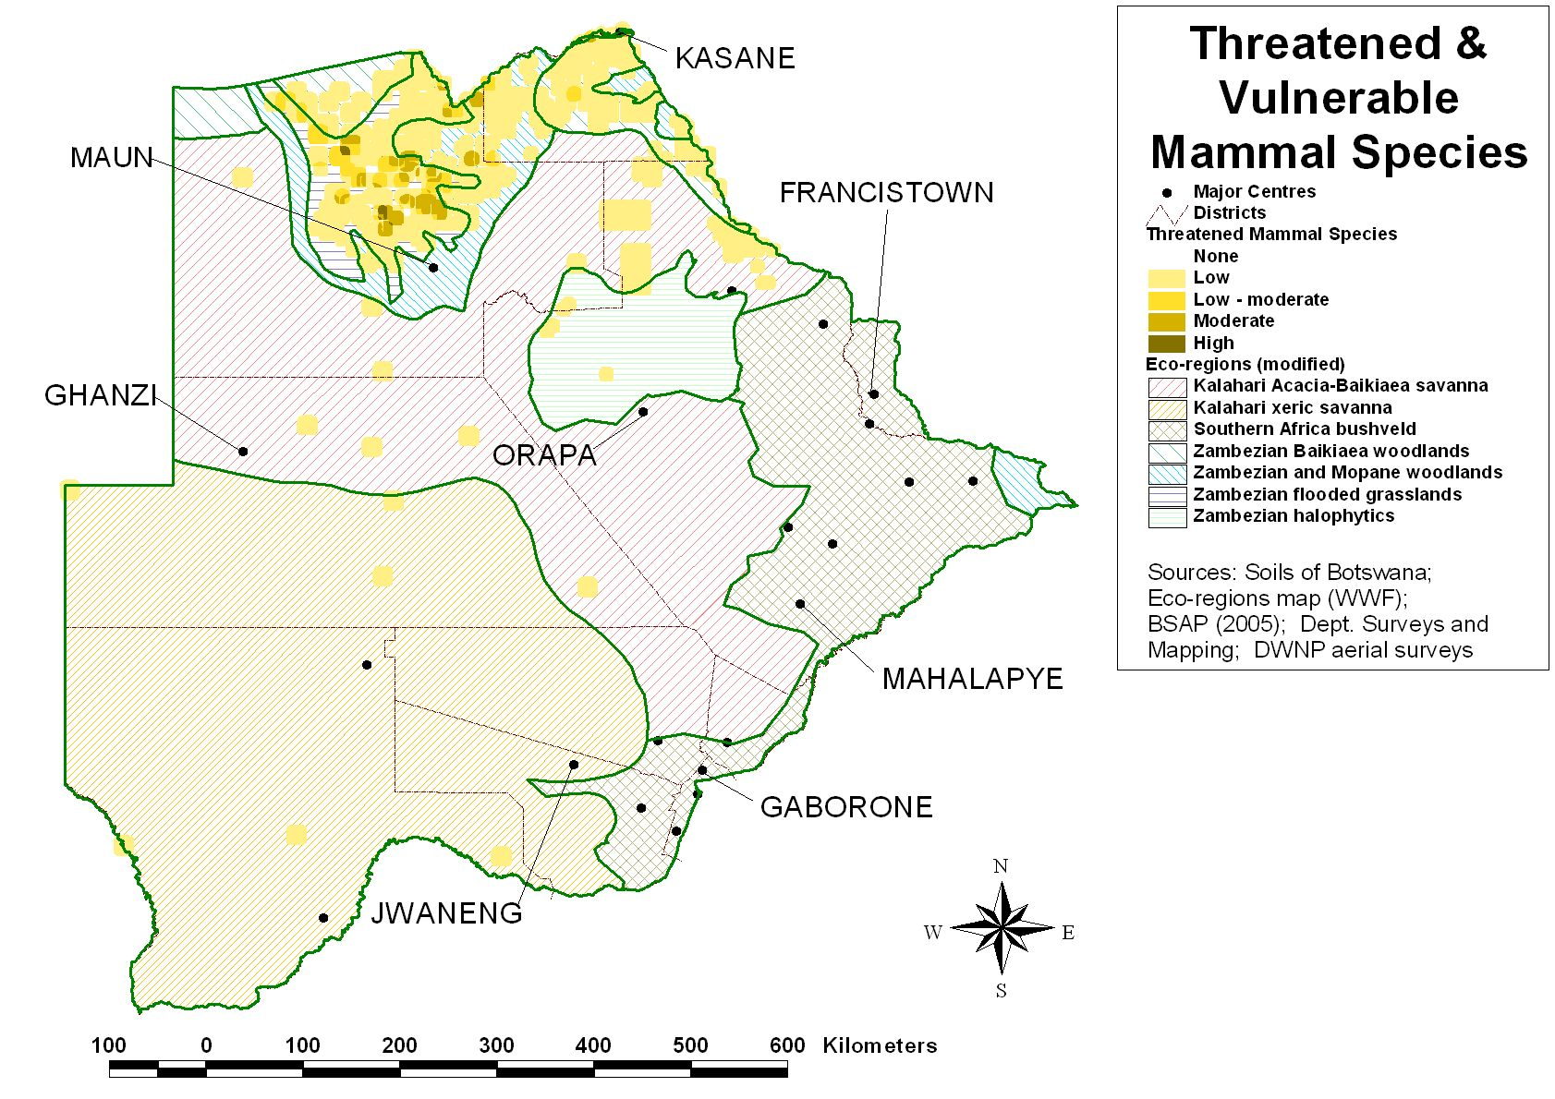
Figure 6: Distribution of threatened and vulnerable mammal species in Botswana
Reptiles and Amphibians
The list on trends and conservation status of reptiles and amphibians is not yet available. No threats assessments have been conducted either. Two of internationally protected species of reptiles, the Nile crocodile (Crocodylus niloticus) and the African rock python occur in Botswana and are protected by the Wildlife Conservation and National Parks Act of 1992. The Nile crocodile was classified as vulnerable from 1982-1990. Although it has now been listed as least concern, the species may still be threatened in some parts of its range.

FLORA
There is no single comprehensive list of threatened or endemic species in Botswana and little protection is given to flora. The Forest Act of 1968, as amended by Act No.8 of 2005, allows for the declaration of certain protected species and lists ten tree species (Table 9) to be protected. However none of these species are listed in the Southern African Biodiversity Network (SABONET) 2002 Database of Southern African Plant Red Data Lists, which contains approximately 43 species (Table 10). The SABONET 2002 Database lists 13 endemic, and 10 potentially endemic and 7 near endemic plant species in Botswana (see Table 11). The Royal Botanic Gardens, Kew lists an additional 14 species as endemic and near endemic. Figure 8 shows the distribution of Botswana’s threatened and vulnerable plant species.
Table 9: List of plant species protected under Forest Act, 1968
Family | Botanical Name | Status
Bombaceae | Adansonia digitata L. | Protected
Ebenaceae | Diospyros mespiliformis Hochst ex A.D.C. | Protected
Euphorbiaceae | Spirostachys africana | Protected
Fabaceae | Afzelia quanzensis Welw. | Protected
Fabaceae | Baikiae plurijuga Harms. | Protected
Fabaceae | Brachystegia spp. | Protected
Fabaceae | Guibourtia coleosperma (Benth) J. Leon | Protected
Fabaceae | Pterocarpus angolensis D.C. | Protected
Meliaceae | Entandrophragma caudatum Sprague | Protected
Rhamnaceae | Berchemia discolor (Klotzsch) Mensley | Protected

Table 10: Flora species listed in the SABONET Plant Red Data List
Family | Species name | Status
Acanthaceae | Barleria matopensis S. Moore | Least concern
Acanthaceae | Blepharis bainesii S.Moore ex C.B.Clarke | Least concern
Apocynaceae | Adenium boehmianum Schniz | Endangered
Apocynaceae | Adenium oleifolium Stapf | Vulnerable
Asclepiadaceae | Ceropegia floribunda | Data deficient
Asclepiadaceae | Hoodia lugardi (N.E. Br.) Bruyns | Vulnerable
Asclepiadaceae | Huernia levyi Oberm. | Vulnerable
Asclepiadaceae | Orbea tapscottii (I.Verd.) L.C.Leach | Endangered
Asclepiadaceae | Orbea knobelii (E.Phillips) L.C.Leach | Vulnerable
Asteraceae | Arctotis rogersii (Benson) M.C.Johnst. | Data deficient
Asteraceae | Arctotis serpens (S.Moore) Lewin | Data deficient
Asteraceae | Erlangea remifolia Wild & G.V.Pope | Data deficient
Asteraceae | Rennera laxa (Bremek. & Oberm.) Källersjö | Data deficient
Aizoaceae | Nananthus aloides (Haw.) Schwantes | Data deficient
Aizoaceae | Nananthus margaritiferus L.Bolus | Data deficient
Capparaceae | Boscia foetida Schinz subsp. minima Toelken | Least concern
Cyperaceae | Eleocharis cubangensis H.E. Hess | Data deficient
Cyperaceae | Pycreus okavangensis Podlech | Least concern
Eriospermaceae | Eriospermum linearifolium Baker | Data deficient
Eriospermaceae | Eriospermum seineri Engl. & K.Krause | Data deficient
Euphorbiaceae | Euphorbia venteri L.C.Leach ex R.H.Archer & S.Carter | Endangered
Euphorbiaceae | Jatropha botswanica Radcl.-Sm. | Least concern
Fabaceae | Acacia hebeclada subsp. chobiensis (O.B.Mill.) A.Schreib. | Least concern
Fabaceae | Acacia hebeclada DC. subsp. tristis A.Schreiber | Rare
Lythraceae | Nesaea minima Immelman | Vulnerable
Orchidaceae | Ansellia africana Lindl. | Vulnerable
Orchidaceae | Eulophia angolensis (Rchb.f.) Summerh. | Vulnerable
Orchidaceae | Eulophia latilabris Summerh. | Vulnerable
Orchidaceae | Habenaria pasmithii G.Will. | Data deficient
Orchidaceae | Zeuxine africana Rchb.f. | Rare and threatened
Pedaliaceae | Harpagophytum procumbens DC. | Vulnerable
Pedaliaceae | Harpagophytum zeyheri Decne. | Least concern
Poaceae | Aristida wildii Melderis | Data deficient
Poaceae | Panicum coloratum var. makarikariense Goosens | Data deficient
Poaceae | Panicum gilvum Launert | Data deficient
Poaceae | Panicum pilgerianum Schweickerdt Clayton | Data deficient
Poaceae | Sporobolus bechuanicus Gooss. | Data deficient
Portulacaceae | Avonia rhodesica (N.E.Br.) G.D.Rowley (formerly Anacampseros rhodesica) | Vulnerable
Rosaceae | Grielum cuneifolium Schinz. | Data deficient
Santalaceae | Thesium dissitum N.E.Br. | Data deficient
Sapindaceae | Erythrophysa transvaalensis I.Verd. | Vulnerable
Scrophulariaceae | Jamesbrittenia integerrima (Benth. ) Hilliard | Data deficient
Scrophulariaceae | Jamesbrittenia concinna (Hiern) Hilliard | Data deficient
Source: Setshogo & Hargreaves, 2002

Table 11: Endemic, near endemic and potentially endemic plant species in Botswana
Family | Botanical Name | Status
Acanthaceae | Blepharis bainesii S.Moore ex C.B.Cl. | Potentially Endemic
Amaranthaceae | Amaranthus dinteri subsp. dinteri | Endemic
Anacardiaceae | Rhus magalismontana subsp. Magalismontana Burch x Rhus pyroides var. pyroides | Endemic
Asclepiadaceae | Orbea knobelii (Phill.) Leach | Endemic
Asteraceae | Arctotis rogersii S.Moore | Potentially Endemic
 | Arctotis serpens S.Moore | Potentially Endemic
 | Erlangea remifola Wild & Pope | Endemic
 | Rennera laxa (Brem. & Oberm.) Kallersjo | Endemic
Capparaceae | Boscia matabelensis Pest | Near Endemic
 | Cleome kalachariensis (Schinz) Gilg & Ben | Endemic
Convolvulaceae | Ipomoea fanshawei Verdc. | Near Endemic
Eriospermaceae | Eriospermum linearifolium Bak. | Potentially Endemic
 | Eriospermum seineri Engl. & Krause | Potentially Endemic
Euphorbiaceae | Euphorbia rubriflora N.E.Br. | Near Endemic
 | Jatropha botswanica Radcliff-Sm. | Endemic
 | Tragia gardneri Prain | Near Endemic
Iridaceae | Gladiolus rubellus Goldblatt | Endemic
Lythraceae | Nesaea minima Immelman | Endemic
Neuradaceae | Grielum cuneifolium Schinz | Potentially Endemic
 | Neuradopsis bechuanensis Bremek. & Oberm | Endemic
Poaceae | Aristida stipitata subsp. spicata (De Winter) Meldeis apud Launert | Endemic
 | Aristida wildii Meld. | Potentially Endemic
 | Eragrostis leptotricha Cope | Near Endemic
 | Eragrostis phyllacantha Cope | Near Endemic
 | Eragrostis subglandulosa Cope | Endemic
 | Sporobolus bechuanicus Goossens | Endemic
Rutaceae | Thamnosma rhodesica (Baker f.) Mendonca | Near Endemic
Santalaceae | Thesium dissitum N.E.Br. | Potentially Endemic
Scrophulariaceae | Jamesbrittenia integerrima (Benth.) Hilliard | Potentially Endemic
Scrophulariaceae | Jamesbrittenia concinna Hiern | Potentially Endemic
Source: Setshogo & Hargreaves, 2002, RBG Kew 2003

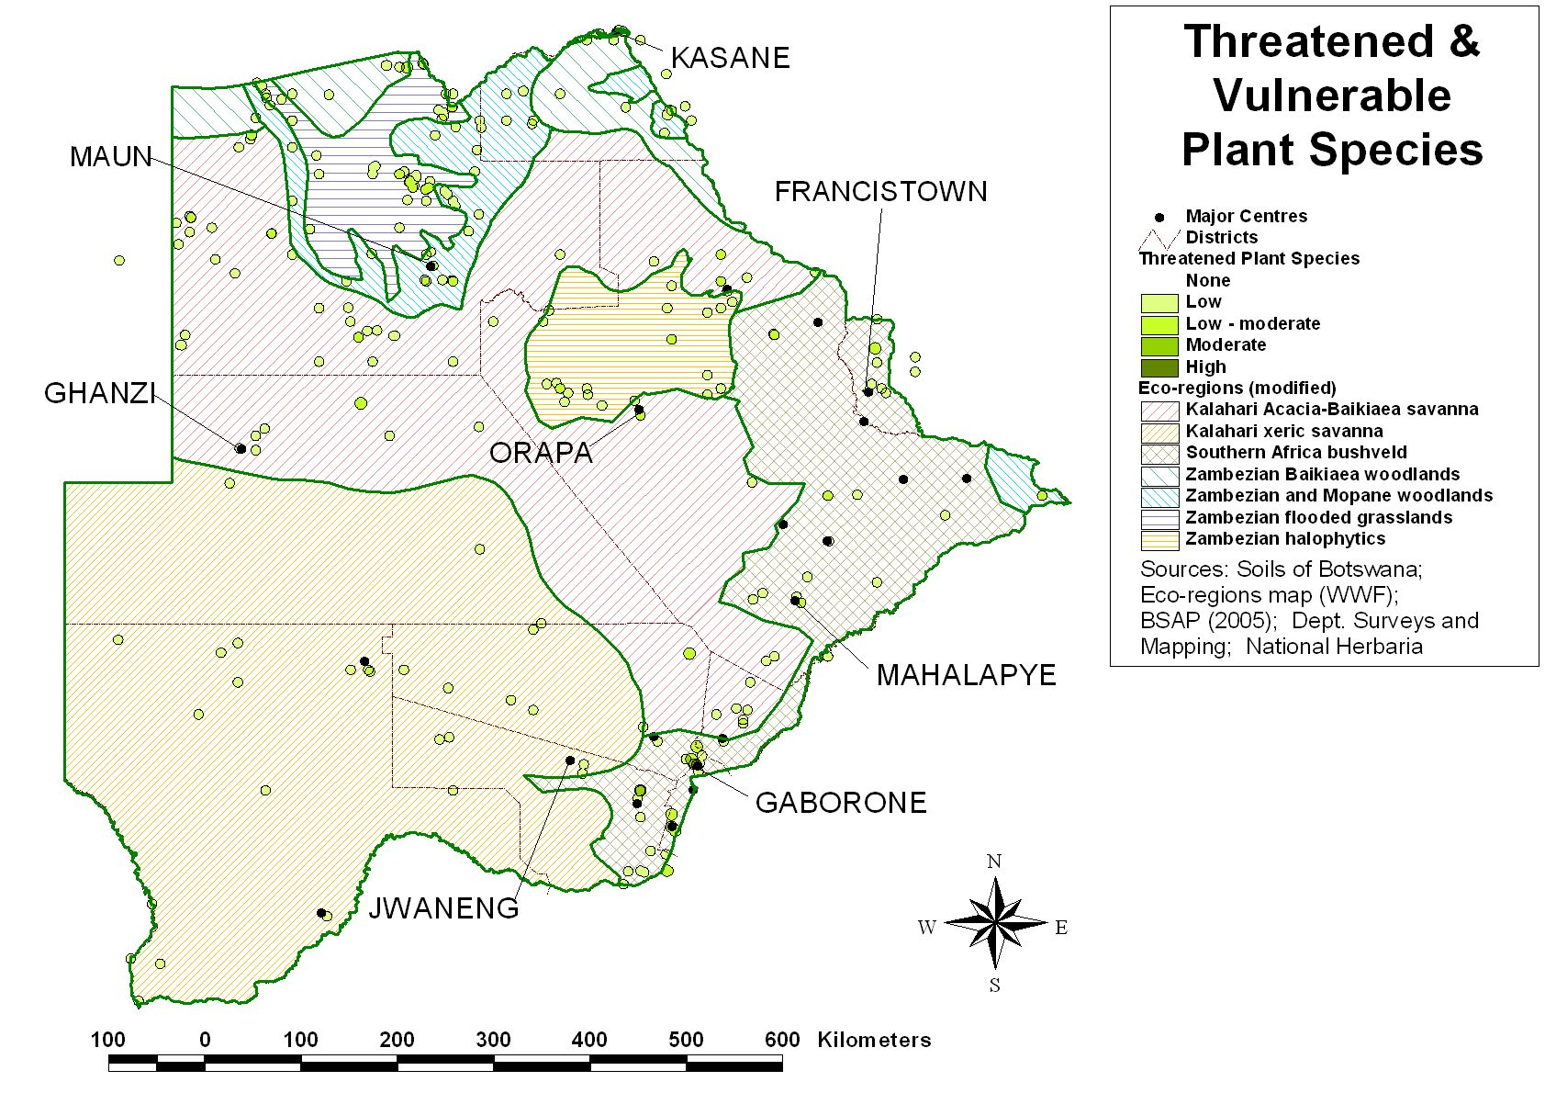
Figure 7: Distribution of threatened and vulnerable plant species in Botswana

Case study 1: Rare and endangered plant species in the Okavango Delta
Rare and Endangered Plant Species in the Okavango Delta Ramsar Site
The Okavango Delta Ramsar Site (ODRS) encompasses the Okavango Delta, Tsodilo Hills, the Kwando-Linyanti River system and Lake Ngami. The ODRS is an important economic feature of the country as a whole. Ensuring sustainable use and management of the biological components, including the rare and endangered plant species, which occur within the ODRS boundary, is therefore critical to the future of the Delta from an ecological perspective, but also to the local and the national economies.
An assessment of the rare and endangered plant species was carried out during the Okavango Delta Management Plan project in 2006 and conservation assessments were carried out at global/regional and local scales. The survey resulted in a total of 20 plant species having been selected for local Red Data List status using recognised IUCN Red Data List criteria. Some of these species, such as Erlangea remifolia are endemic to the area and the local assessment therefore coincides with the global level assessment. Of these 20 species, six species have had their status upgraded and one, the orchid Habenaria pasmithii has been proposed as possibly locally extinct. Six new species have also been added to the local RDL.
In the short term, the main threat to the Red Data Listed species occurring within the boundaries of the Okavango Delta Ramsar Site are habitat conversion and destruction, mainly affecting those species which occur outside of the protected areas but including elephant impacts both inside and outside the protected areas. In the long term, the complex processes of climate change and hydrological changes are potentially more serious and more difficult to mitigate.
In general the Zambezian and Mopane Woodland and the Zambezian Flooded grasslands show a high distribution of vulnerable and threatened species (see Figure 8). This is an indication that continued protection of these ecoregions is paramount for conservation of vulnerable and threatened species. However, Table 12 shows a high distribution of threatened plant species in the Kalahari Acacia-Baikiaea savanna, while the Zambezian flooded grasslands is important for threatened species of avifauna and mammals.

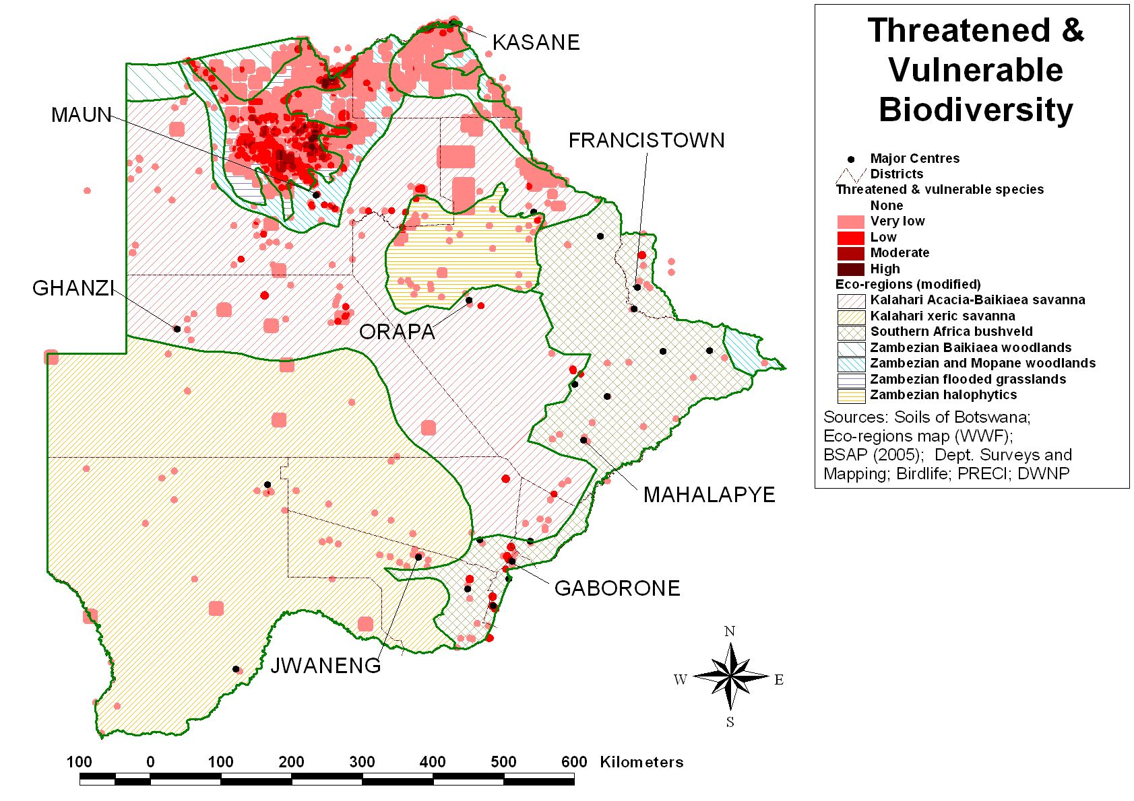
Figure 8: Distribution of threatened and vulnerable species in Botswana (plants, birds and wildlife)

Table 12: Percentage of threatened species distribution within each ecoregion (Plants and birds are a percentage of recorded sittings, mammals is a percent of the known range)
Ecoregion | Threatened Plants (%) | Threatened Birds (%) | Threatened Mammals (%)
Zambezian and Mopane Woodland | 18.30 | 17.86 | 22.5
Southern African Bushveld | 16.18 | 0.87 | 0
Kalahari Xeric Savanna | 9.28 | 1.84 | 3.4
Zambezian Halophytics | 9.02 | 1.62 | 2.1
Zambezian Baikiea woodland | 4.77 | 0.22 | 22.5
Zambezian Flooded grasslands | 19.63 | 70.67 | 32.4
Kalahari Acacia-Baikiaea savanna | 22.81 | 6.93 | 16.9

1.2.2.3 Pressures on Botswana’s biodiversity
Threats and level of threats to biodiversity in Botswana will vary depending on location. In general habitat destruction and reduction and barriers to movement are the main threats. In parts of Botswana the high populations of elephants are threatening certain tree species and forest habitats, while in the more arid parts of the country hydrological changes is affecting biodiversity. Fire is often noted as a threat, but while it is a threat to some biodiversity, it is also an important component of the ecosystem, for example the slaty egret prefers feeding within recently burnt vegetation. The real threat is high frequency of uncontrolled bushfires in some areas. Overuse and over collection of wild species is only a problem in small areas of the country where the population pressure is higher and for certain valuable or medicinal species. Threats to biodiversity by invasive alien species (IAS) are still relatively low on a national scale and here again confined to specific areas. In the southwest of the country Prosopis glandulosa is starting to become a problem, while in the Okavango Delta Salvinia molesta poses the greatest threat to the aquatic environment. An invasive bird species, the Indian Myna (Acridotheres tristis), has established itself in Gaborone (IBAs Manager, focus group discussions) however little is known about its impacts within Botswana. For avifauna the three most important threats are tourism activities, fires and disturbance to the habitat. Scarcity of surface water can locally be a serious threat to water dependent ungulates.

The map in Figure 9 indicates that the highest pressures on overall biodiversity are in the eastern parts of the country (Southern African bushveld and Kalahari Acacia- Baikiaea woodlands ecoregions), and in and around the Okavango Delta (Zambezian flooded grasslands), with smaller pockets in other parts of the country. This is mainly a result of population pressure and hydrological changes (BSAP, 2007).

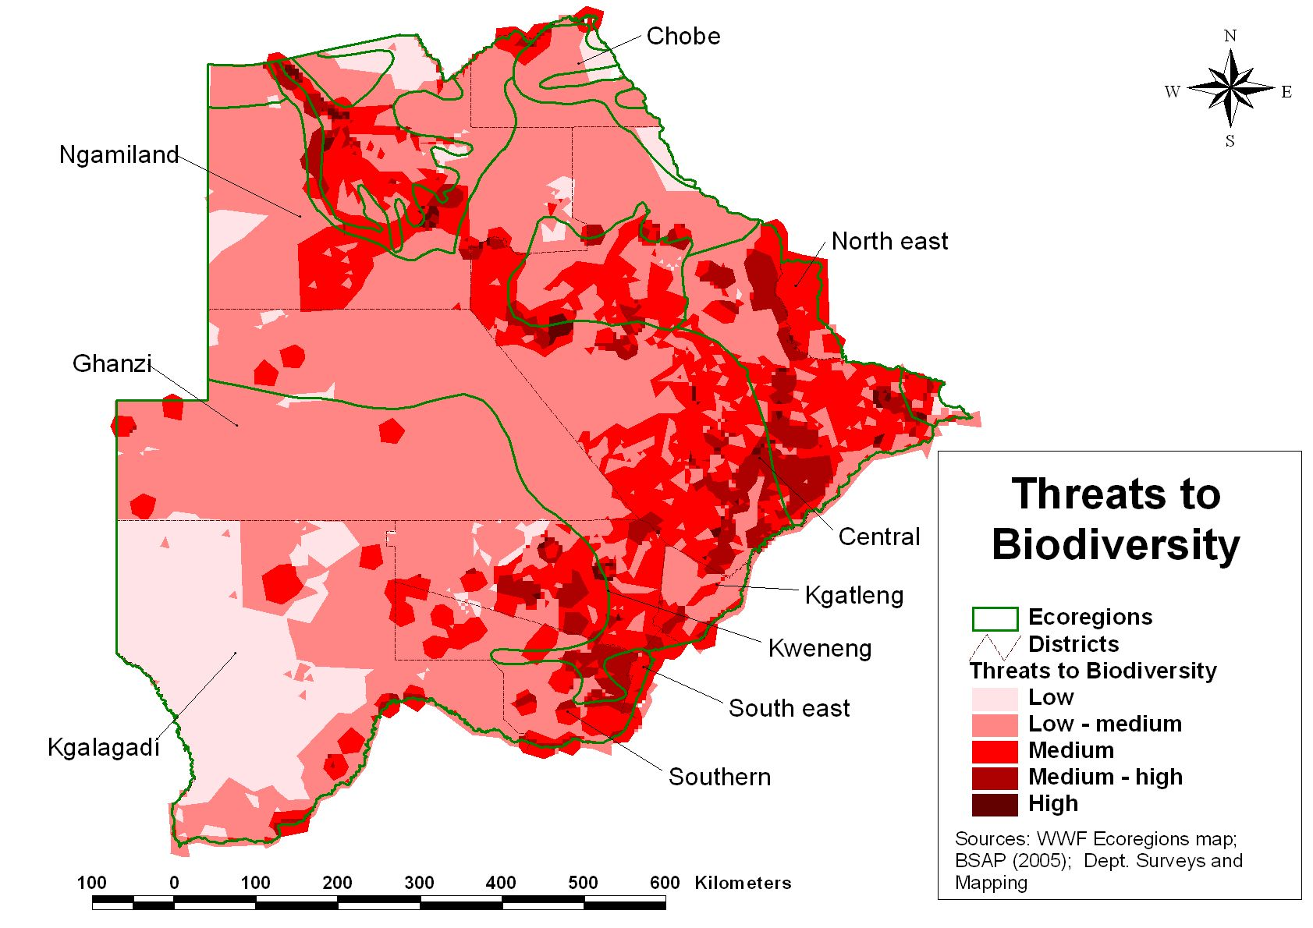
Figure 9: Threats to biodiversity in Botswana (BSAP, 2005)

1.3 Terrestrial biodiversity
1.3.1 Kalahari Acacia Baikiaea woodlands
Area (Ha and % of total): 185521.80 km² and 32.03%
Global Conservation status: Vulnerable
Percentage protected area: 38.45%

1.3.1.1 Characteristics:
This ecoregion runs diagonally across Botswana, ending in the southeast near the border with South Africa. Within Botswana, a smaller area extends northwards between the Okavango Delta and the Makgadikgadi Pans towards the border of the Chobe National Park and then moves east, just crossing the border into Zimbabwe.
Surface water is scarce here and droughts occur roughly once every seven years. As a result, the human population is fairly low, especially on the sandveld that covers most of the ecoregion (www.worldwildlife.org).

1.3.1.2 Status and trends of biodiversity:
Generally, much of the ecoregion’s natural vegetation remains intact. Although large areas of the sandveld are protected by the Central Kalahari Game Reserve, there is little protection of the hardveld in the southeast of the ecoregion, which is the most densely populated area of the ecoregion. The sandveld, on the other hand, (which makes up most of the ecoregion) is very sparsely populated, with fewer than 5 persons per km².
- Fauna
There is a relatively high level of total species richness but a low per unit area richness and low local endemism. The ecoregion supports many of the charismatic large mammals associated with African savannas. While these species are not endemic, several are listed as threatened by the IUCN, including the critically endangered black rhinoceros (Diceros bicornis), and two species listed as vulnerable, the cheetah (Acinonyx jubatus) and the brown hyena (Hyaena brunnea). Predators found in this ecoregion include the African civet (Civettictis civetta), serval (Felis serval), lion (Panthera leo), leopard (Panthera pardus), African wild dog (Lycaon pictus) and both brown and spotted hyena (Crocuta crocuta).
The lappet-faced vulture (Torgos tracheliotus), which is considered vulnerable by BirdLife International is also found throughout the ecoregion. There are 31 amphibian and 92 reptile species found within the ecoregion. None of the amphibian species is endemic or near-endemic, but six of the reptile species are near-endemic, and one, the Tsodilo gecko (Pachydactylus tsodiloensis), is a strict endemic. It is found only on the Tsodilo hills in the northwest of the ecoregion. Near-endemics include Kalahari purple-glossed snake (Amblyodipsas ventrimaculata), Kalahari ground gecko (Colopus wahlbergii), and Leonard’s spade-snouted worm lizard (Monopeltis leonhardi).
Many of the large herbivores found in the ecoregion undertake seasonal migrations, especially during droughts. Blue wildebeest (Connochaetes taurinus), eland (Taurotragus oryx), zebra (Equus burchelli), buffalo (Syncerus caffer), and red hartebeest (Alcelaphus buselaphus) all migrate within this ecoregion.

- Flora
Although this is the largest phytogeographical region in southern Africa, the ecoregion is relatively poor in species and has few endemics, exemplifying its transitional nature. Deciduous tree and bush savanna covers most of the ecoregion in the sandveld area. The grass cover includes Stipagrostis uniplumis, Aristida meridionalis, A. congesta, Eragrostis pallens, E. superba, Heteropogon contortus, Cymbopogon excavatus, and Digitaria eriantha. The vegetation of the sandveld is largely determined by climate. To the south of the ecoregion, where the climate becomes more arid, the sandveld vegetation grades into the sparse and shrubby. To the north, the climate becomes moist and the vegetation grades into a mesic savanna or woodland dominated by Baikiaea plurijuga.
1.3.1.3 Threats
The development of livestock industry and its expansion into wildlife areas and subsequent wildlife conflicts is threatening wildlife populations (Lebotse, 2008 unpublished thesis). The decline of wildlife populations is caused by competition with livestock for grazing, hunting of wild animals, and the removal of species considered problem animals, such as predators. Veterinary cordon fences erected to control the spread of foot and mouth disease to cattle and the expansion of livestock ranches (allocated by land boards to be fenced ranches under the accelerated fencing policy pose a major threat to wildlife populations (www.worldwildlife.org). These fences have been strongly criticized by conservationists, because they caused the mass die-off of migratory herbivores during the droughts of the 1990’s.
1.3.1.4 Conservation activities:
Part of this ecoregion is protected by the Central Kalahari Game Reserve, through Wildlife and National Parks Act of 1992. In addition, the establishment of the Khama Rhino Sanctuary within the ecoregion has facilitated re-introduction of white rhinos in Botswana. The Khama Rhino Sanctuary covers approximately 4 300 hectares of the Kalahari sandveld, including several natural waterholes. The sanctuary provides prime habitat for white and black rhinos as well as over 30 other species of animals and over 230 species of birds.

1.3.2 Southern African bushveld
Area (Ha and % of total): 76650.29 km² and 13.23%
Global Conservation status: Vulnerable
Percentage protected area: < 1% all in private or community nature reserves such as Mokolodi Nature Reserve
1.3.2.1 Characteristics:
The Southern African bushveld covers the South Eastern corner of Botswana. It belongs to the vast savanna biome, the dominant vegetation of Africa.

1.3.2.2 Status and trends of biodiversity:
Although there are no formally protected areas in the Botswana portion of the ecoregion, there are still large areas of continuous habitat remaining. The zone contains some of the largest urban centres in Botswana such as Gaborone and Francistown, and a number of smaller urbanised villages.
- Fauna
Species in this ecoregion include large mammals such as wildebeest, jackal, kudu, duiker and impala. Small mammals found in this ecoregion include rock rabbit and porcupine. Avifauna species of the region include guinea fowl and martial eagle. The BSAP Stocktake report shows that, this ecoregion has the highest level of species richness of insectivora.
- Flora
This ecoregion is one of the most important areas in Botswana for plant diversity (BSAP Stocktake Report, 2004). Species of flora found in this region include Cussonia natalensis, Aloe excelsa (Zimbabwe aloe), Mystroxylon aethiopicum (Kooboo-berry), Salsola aphylla, Lye ganna, Combretum collinum subsp, gazense (Hairy bushwillow,) and Combretum collinum subsp ondongense (Variable combretum).
1.3.2.3 Threats
The major threat in this ecoregion is overharvesting of resources. Plants are heavily exploited for medicinal use in this region particularly the orchid Ansellia africana because it is believed to have aphrodisiac properties. Some street vendors harvest and sell it as an ornamental plant (Samways & Associates, 2007). The multiple use of the Colophospermum mopane vegetation adds another factor to the already complex milieu of issues surrounding the harvesting, management and conservation of mopane woodland mopane worms (Gonimbrasia belina) in Botswana. Despite expressed concern over the likely impact of trade on its populations, very few studies have been undertaken on it (Sekhwela et al, 2007).
Arable clearing and wood cutting reduce the habitat necessary for increased population and production and leads to loss of habitat for Ansellia species. Areas of bush encroachment indicated by presence of thorny bushes such as Dichrostachys cineria and Acacia erubescens that are normally associated with overgrazed areas were observed by Sekhwela et al (2007) indicating that land degradation is prevalent.
Mopane woodland does not support a dense grass cover, and this reduces availability of flammable material to start fire and burn quickly. It is partly due to this reason and the presence of livestock that fire does not pose as a major threat to this ecoregion. However, a change in mopane woodland structure to shrub mopane for instance, increases the vulnerability to fires as shrubs are likely to catch fire more quickly than woodlands. Fires of high intensity and areas of high fire frequency are likely to be detrimental to Phane productivity (Dube, 2005).
Expansion of mining operations in this region is a well known factor. Open pit mining and other infrastructure causes major habitat loss.
1.3.2.4 Conservation activities:
Although this region is the most populated it has few conservation areas. The DWNP has one area near Otse (Otse Vulture Reserve). There are a number of private and community protected areas such as Mokolodi Nature Reserve (Gaborone) and Tachila Nature Reserve in Francistown. The area around water supply reservoirs is also protected from formal settlement and agricultural land use.

1.3.3 Zambezian Baikiaea woodlands
Area (Ha and % of total): 21598.01 km² and 3.73%
Global Conservation status: Vulnerable
Percentage protected area: 60.27%

1.3.3.1 Characteristics:
This ecoregion represents a transition from moist southern savanna woodlands to dry southwestern deserts. It is a mosaic of dry deciduous Baikiaea plurijuga-dominated forest, thicket, and secondary grassland. The area falls within the Zambezian centre of endemism and coincides largely with Zambezian dry deciduous forest and scrub forest. The hot, semi-arid climate and nutrient-poor soils mean that this region is not suitable for farming, and thus it has retained some of its natural vegetation.

1.3.3.2 Status and trends of biodiversity:
This ecoregion is an area of moderate species richness for most taxonomic groups. While floristically it falls within its own centre of endemism, the fauna of the area has low levels of endemism as it largely represents a merging of elements from the southern savannas, the arid southwest and the miombo woodlands
- Fauna
There is a relatively high level of total species richness but a low per unit area richness and low local endemism. The ecoregion supports many of the charismatic large mammals associated with African savannas. Some of these species include Loxodanta Africana (African elephant), Panthera Leo (lion), Hippopotamus amphibius (hippopotamus) and Hippotragus equines (roan antelope). With more than 400 recorded bird species, this ecoregion’s avifauna is characterized by moderately high species richness but low endemism. Some of important bird species found in the ecoregion include the Rynchops flavirostris (African skimmer), Balearica regulorum (grey-crowned crane) and Gorsachius leuconotus (white-backed night heron).
- Flora
This ecoregion is important to Botswana due to the miombo forest areas, which host many of the protected tree species in Botswana. As a result most of Botswana’s forest reserves are located here. Some of the species found in the ecoregion are Lannea schweinfurthii var. stuhlmannii (False marula, Tree grape) Lannea schweinfurthii var. tomentosa (Hairy false marula) Ozoroa insignis subsp. reticulata (Currant resin tree, Tropical resin tree) Ozoroa longipes (Round-leaved resin tree) Friesodielsia obovata (Bastard dwaba-berry) Diplorhynchus condylocarpon (Horn-pod tree, Wild rubber) and Baikiaea plurijuga (Zambezi teak, Zambezi redwood, Pod mahogany). With its closeness to the Chobe and Zambezi rivers, which can be used for irrigation, there is continued pressure to de-gazette forest reserves for agricultural purposes.

1.3.3.3 Threats
On the whole, this ecoregion is fairly sparsely settled with fewer than 5 people per km² in most areas. In the least populated areas, population densities are probably less than one person per km². As a result of the scattered human population within the environment, much of the habitat has not been modified or fragmented.
Cattle fences (e.g. those erected in Botswana between the Caprivi Strip and the Okavango Delta in 1995 to control the spread of cattle lung disease) can cause increased rates of mortality when animals are cut off from grazing and water resources. Uncontrolled bushfires are common and frequent in the ecoregion.
Competition for land for agricultural purposes is a potential threat to the natural vegetation and will affect both flora and fauna. Poaching is posing some threat to the flagship wildlife species in the area, but anti-poaching control measures are in place.
While the distribution of the forest, woodland, savanna and grassland elements is partly determined by edaphic and climatic factors, disturbance factors such as fire, logging, and agriculture play an increasing role in the spread of secondary savanna and grassland. More recently there has been an increasing interest in the agricultural potential of the area linked to use of irrigation water from the Zambezi River.
The Chobe and the Zambezi rivers are used for tourism activities and fishing. Water extraction for human consumption and agricultural purposes, over fishing and pollution from excessive boat traffic will potentially affect aquatic diversity in the rivers.

1.3.3.4 Conservation activities:
Linkages between Botswana and surrounding countries particularly Zimbabwe, link the conservation and wildlife utilisation networks into a single ecosystem. This has lead to the first stages in a trans-frontier conservation area (TFCA linking Botswana with Zimbabwe, Namibia, Zambia and Angola (KAZA TFCA). The TFCA has an agreed Memorandum of Understanding (MOU) in place while ratification is still required. The TFCA could be threatened due to expansion of arable agricultural projects in the region.

1.3.4 Zambezian halophytics
Area (Ha and % of total): 25087.76 km² and 4.33%
Global Conservation status: Vulnerable
Percentage protected area: 37.91%

1.3.4.1 Characteristics:
This ecoregion covers the Makgadikgadi Pan Complex in Botswana, which consists of two major saline pans, Ntwetwe Pan (106 x 96 km) and Sua Pan (112 x 72 km), surrounded by a number of smaller pans. There are a number of rivers that are important to the Makgadikgadi Pans complex. To the west is the Boteti River, which flows sporadically out of the Okavango Delta and empties into the southern portion of Ntwetwe Pan. The Nata River, a seasonal river which originates in Zimbabwe, is the most important river in the complex and flows into the north of Sowa Pan while the Mosetse provides seasonal water into the southern and central sections of Sowa Pan.
1.3.4.2 Status and trends of biodiversity:
The uniqueness of this ecoregion and varied ecological habitats provides for a diversity of flora and fauna despite the arid conditions in the area (Makgadikgadi Inventory Report). The Zambezian Halophytics are relatively undisturbed, and large blocks of habitat remain intact. The human population in the Makgadikgadi Pans area is low, and large expanses of this area are uninhabited. Most of the ecoregion is, however, not formally protected.
- Fauna,
This ecoregion provides a unique and important habitat for wildlife including a vast diversity of bird species with both migrant and resident populations occurring in the area. Temporal and spatial patterns of use are poorly understood, limiting potential conservation planning for the region. Many water bird populations are found in excess of the Ramsar 1% criteria, for example, the Lesser and Greater Flamingo, White Pelican, Pied Avocet, Chestnut banded Plover and Blackwinged Pranticole (Tyler, 2001) underscoring the wetland’s importance at the national, regional and international level. No inventory of mammals for this ecoregion or the basin has been conducted and data therefore on distribution and status is lacking. The status and trend of predators within the region is poorly understood. However, water dependent ungulate wildlife populations are known to move in response to seasonal rainfall and the presence of surface water during the dry season. There have been no fish studies carried out in the area either, although a there has been a record of fish species caught in the Boteti River, when in flood. All species found in the Okavango Delta, due to flooding regime, have been caught in the Boteti.
This ecoregion supports over 405 species of birds. Water bird counts indicate that Boteti River is an important “wintering” site for Palearctic and intra-African migrants particularly pelicans, herons and storks (fish and mollusc eating species), rails, waders, terns and skimmers. Although all crane species are listed as endangered, and Botswana is considered to have one of the largest Wattled Crane populations left in Africa, information on cranes in the Makgadikgadi is poor, with no systematic surveys for the area to date.
- Flora
Plant communities in this region are dominated by mopane (Colophospermum mopane). Apart from the Ecosurv Impact Assessment on Botanical Diversity by the proposed small scale Diamond Mining operation for Debswana Mining Company, according to the National Herbarium, there has been no site specific plant studies undertaken in the area. However there have been a number of species specific studies undertaken in the area, with emphasis on Euphorbia species. Of the known endemic plant species in Botswana Hoodia lugardii and the grasses Sporobolus bechuanicus, and Panicum coloratum subsp. makarikariense are found here (Makgadikgadi Inventory Report).

1.3.4.3 Threats
Domestic animals are distributed in this ecoregion in large numbers and therefore compete for grazing along the Boteti with migrating herds of zebra and wildebeest. The encroachment of livestock in the Makgadikgadi National Park and the incursion of predators into grazing areas are a significant source of conflict. The response of the government has been the ban on killing lion and the erection of a game proof fence along the Boteti River. There is major soda ash and salt extraction mine and process facility on the edges of Sua Pan, which is not seen as a major threat to the pan. The size of the plant is relatively small, although the abstraction area covers the northern third of Sua Pan. The threat that this plant poses to the area is associated with its infrastructure; roads, a railway, power lines and a township have already been established around the plant. The mining company has shown some level of environmental commitment by burying their power lines to prevent injury to flying flamingos at night as the plant is located directly between flamingo feeding and nesting grounds. Water extraction for the mining activities in the area is affecting hydrological levels.

Uncontrolled tourism, particularly motorbike tours, is a major threat to the fauna of the Makgadikgadi Pans. Sightseeing parties and vehicles disturb breeding waterbirds, particularly flamingos and pelicans, causing them to become apprehensive and even to desert their eggs and young.

1.3.4.4 Conservation activities
The western areas of the region fall into the Makgadikgadi Pans – Nxai Pan conservation complex. The area has received support from the EU and has improved its park planning and infrastructure. On Sowa pan, the soda ash mine maintains a protected area which has ecological linkages to the Nata Sanctuary (a community managed protected area). Debswana operates a small sanctuary on their Orapa Mine lease area. Of major significance to biodiversity conservation is the establishment of a management programme by DEA to prepare the Makgadikgadi for Ramsar status.

1.3.5 Zambezian and Mopane woodlands
Area (Ha and % of total): 29912.54 km² and 5.16%
Global Conservation status: Stable
Percentage protected area: 47.94%

1.3.5.1 Characteristics:
The Zambezian and Mopane Woodlands are significant from an evolutionary perspective, because the Trans-Botswana transition belt – the changeover zone between the tropical and subtropical biomes – broadly corresponds to the mopane vegetation in the southern part of the ecoregion. This belt has played an important role in faunal evolution, as various taxa representative of one biome or the other have dispersed through this zone to speciate on the other side.

1.3.5.2 Status and trends of biodiversity:
The Zambezian and Mopane Woodlands are split into the areas surrounding the Okavango Delta and the smaller units to the east adjacent to Zimbabwe. The ecozone generally enjoys a healthy conservation status. The poor agricultural potential of the Okavango region means that the majority of habitats are still relatively intact although, due to the potential supply of irrigation water, the eastern areas with their black cotton soils are being developed for arable agriculture. The large attendant mammal populations have encouraged the establishment of an extensive protected area network in the ecoregion.
- Fauna,
This ecoregion is one of the most important areas for vertebrate diversity in southern Africa, particularly for mammals. Some of these species include Loxodanta Africana (African elephant), Panthera Leo (lion), and impala. The biota and associated natural processes remain largely intact as a result of the extensive and well-maintained system of national parks and reserves in the ecoregion. Although the Zambezian and Mopane Woodlands are rich in vertebrate species, they tend to be poor in endemics. A survey conducted in the Chobe River found 69 species (excluding Synodontis species) in 14 families, with the Cichlidae and Cyprinidae families most strongly represented. Similar species composition were identified a study of the Okavango River (Hay et al 2000).
- Flora
The floral diversity in this area is not that great but some of the red data listed plant species such as Harpagophytum species and the endemic and near endemic Pycreus okavangensis, Acacia hebeclada subspecies chobiensis, Boscia matabelensis and various orchids are found here.
1.3.5.3 Threats
The key process that drives the functions and biodiversity of this ecoregion is water inflow. The current below-average flood levels and extent is a factor of major importance influencing habitats and abundance of species, and exacerbates many of the human-induced biodiversity threats in this region. For example low water levels increases the number of anthropogenic fires, which pose the highest ranking threat to biodiversity. Uncontrollable fires have caused far-reaching effects on phragmites reedbeds and hyphaene petersiana. The burning of phragmites reedbeds has disastrous consequences for reed nesting species such as egrets, Burchell’s Starlings and Chirping Cisticolas, while burning of Hyphaene petersiana affects nesting for white backed vulture. Additionally, fire has impacted heavily on populations of Sitatunga.
Another concern is the potential habitat destruction caused by uncontrolled elephant populations in some parts of the ecoregion. The large elephant population impacts heavily on mopane woodland which is habitat for other species, which include birds. Elephant population in northern Botswana currently stands at 152 000 with 38 614 of these occurring in Linyanti area, giving it the highest density in Botswana, of 4.2 elephants per square kilometre. Elephants also exert a heavy impact on the Phragmites reedbeds that are favoured by herons and egrets for nesting (BirdLife Botswana, 2007).
The eastern portion of this ecoregion adjacent to Zimbabwe is under serious threat. The southern plain (Pandamatenga) has been totally cleared and converted to rain-fed arable agriculture while plans to convert the northern plain to become an integrated agro-commercial development based on supply of irrigation water from the Zambezi are advanced and clearing of about 20,000ha of woodland will occur.
1.3.5.4 Conservation activities:
The western portion of the ecoregion falls within the Okavango Delta Management Plan area (Ramsar site) and is protected by Chobe National Park, Moremi Game Reserve and WMAs. There are a number of community managed areas within the ecoregion such as Sankuyo and Khwai. These communities have management plans in place outlining how they manage the concession and how they distribute the benefits accruing from tourism activities such as quota based hunting, game viewing and photographing.

1.3.6 Zambezian flooded grassland
Area (Ha and % of total): 22744.70 km² and 3.93%
Global Conservation status: Relatively Stable
Percentage protected area: 71.4%

1.3.6.1 Characteristics:
This ecoregion is a mosaic of dry deciduous Baikiaea plurijuga-dominated forest, thicket, mopane and riverine woodlands and secondary grassland. The area falls within the Zambezian centre of endemism and coincide largely with Zambezian dry deciduous forest and scrub forest. The diversity of the habitats over relatively small areas in the Delta should enhance the number of species (Ramberg et al, 2006).

1.3.6.2 Status and trends of biodiversity:
The Okavango is one of the few remaining large wetland systems in the world without notable man made developments and that has so far remained relatively pristine. The rivers which feed the wetland are unregulated and therefore its natural hydrological regime is intact. The Delta provides important habitat for a variety of resident wildlife and a number of migratory species especially avifauna hence the maintenance of the Delta is crucial for conservation of these species (Lebotse, 2008).

- Flora
The currently known flora of the Okavango Delta comprises about 1300 on the species and lower levels, of which 1 260 taxa are on the species level. The most diverse are the grasses Poaceae, sedges Cyperaceae, followed by the Asteraceae and Fabaceae, each of which have more than 20 genera and 50 taxa of species and lower ranks. Of the total number of taxa present in the Okavango Delta, a significant proportion of about 60% occur in dryland settings on islands or sandveld tongues. However, despite their terrestrial character many of these taxa are absent in the surrounding savanna habitats as they require a different air humidity or soil moisture regime or higher ground water table. No taxonomic study of algae in the Okavango Delta has been published (Ramberg et al, 2006).
- Fauna
Invertebrates
The data on invertebrate species in this ecoregion is far from comprehensive, and many taxonomic groups are too difficult to collect, or nobody has tried to sample them, while some are taxonomically not well known or there are no taxonomists able to identify them (Ramberg et al, 2006).
In the Okavango Delta, the butterflies most at risk are the myrmecophilous (ant associated) Lycaenids. As larvae these species require both the host ant and the host plant, as well as optimal climatic conditions to thrive. Due to the paucity of information on the Delta’s butterflies, no Lycaenids have yet been identified as threatened, although it is possible that some species are at risk. There are no documented endangered or vulnerable butterfly species in the Okavango. The following species are rare: Anthene minima, Colotis doubledayi angolanus, Pseudonympha swanepoeli and Tuxentius malaena (Ramberg et al, 2006).There are no endemic snail species and many of them occupy seasonal waters scattered over huge areas of the African savanna.
Fish
There are no endemic fish species restricted to the Okavango Delta and so far no alien introductions or translocated fish have been found in the Okavango River and Delta (Ramberg et al, 2006).
Reptiles and Amphibians
In total 33 amphibians and 64 reptiles have been recorded in the Okavango Delta. Out of the 33 species in Botswana twelve (36%) have a distribution restricted to the Okavango and the Chobe and eight (24%) are confined to the Okavango Delta only (DEA, 2008; Ramberg et al, 2006).
Birds
The number and variety of birds in the Okavango Delta is well documented, due largely to the efforts of amateur birdwatchers who contributed substantial data to the Bird Atlas of Botswana between 1980 and 1990. This database, where birds have been recorded in a standardized way for the whole country, has subsequently been kept updated by the Records Sub-committee of Bird Life Botswana. There are 444 confirmed bird species occurring in the Okavango Delta. This makes the Delta together with the Chobe River, the most species-rich area in Botswana. The Okavango Delta has the largest single population of Wattled Crane remaining in the world, and aerial surveys conducted by BirdLife Botswana, in conjunction with the Department of Wildlife and National Parks in 2001, 2002 and 2003 show that this population is stable (Kootsosite et al, in press). About 85% of the global population of the threatened Slaty Egret is found within this ecoregion.
Mammals
Some 122 mammal species of 12 orders and 34 families live in the Okavango Delta. All the larger species are wide spread across the African Savanna region. The distributional ranges of some of the larger mammals are marginally within the Delta. One of these, the Sable Antelope (Hippotragus niger), is common in the broad-leaved woodlands and the grasslands close to the delta. The White Rhino (Ceratotherium simum) was recently introduced after their local extinction (Ramberg et al, 2006).

1.3.6.3 Threats
While the ecological integrity of this wetland remains largely intact, there are signs it is being slowly eroded in the face of gradually rising anthropogenic pressures. The Delta is threatened by a rapid population growth, and tourism expansion. As a result of the rapidly increasing population and expanding tourism, there is an increasing process of commoditization and privatization of the land and its natural resources, leading to pressure on these resources and scarcity (Kgathi et al, 2005).

Climate change is emerging as a major threat to biodiversity in this ecoregion. An integrated hydrological model developed to assess the Okavango Delta hydrological response to various natural and anthropogenic scenarios projected that climate change has potentially the greatest impacts on the Kalahari basin and the delta reducing both in-flow from upstream and rainfall over the delta, and increasing temperature and the rate of evapotranspiration. The lower envelope of flooding is expected to be reduced by 68% (DEA, 2008). Considerable uncertainty concerning the direction and extent of change still remains, and this poses significant challenges for ecosystem management in general (Lebotse, 2008 Unpublished thesis).

Parts of the open waterbodies have become infested with the alien waterweed, Salvinia molesta. Salvinia molesta weed is an invasive alien species, and poses threat to the Okavango Delta’s biodiversity. Extensive weed spread could be detrimental to the ecological, hydrological and biochemical processes of the wetland system, the same processes that are key fabric livelihoods of rural communities and operations of tourism private entrepreneurs. When the Salvinia molesta infests and covers the water body this negatively affects the feeding success of the Slaty Egret (and possibly other waterbirds) which hunts by sight.

1.3.6.4 Conservation activities:
Approximately 7% of the area falls within the Moremi Game Reserve and is protected under the 1992 National Parks Act. A further 65% is protected under the same Act as a Wildlife Management Area and activities are controlled through the (Draft) WMA Regulations (2000), which allow for both consumptive and non-consumptive use of wildlife. The rest of the area (28%) is zoned for agricultural and residential development (Jansen, 2003).
In 1997, the Government of Botswana ratified the Convention on Wetlands of International Importance and listed the Okavango Delta as a Ramsar site. The convention advocates for wise use of wetlands and their sustainable utilisation for the benefit of mankind in a way compatible with the maintenance of the natural properties of the ecosystem (www.ramsar.org). The obligations of Botswana under this convention coupled with national interest necessitated the development and preparation of a management plan for the Okavango Delta, the Okavango Delta Management Plan (ODMP).

Despite the fact that the Okavango Delta, in Botswana has been designated a wetland of international importance, there is no systematic delta-wide long term monitoring carried out in the delta and its component ecosystem except for annual aerial surveys of larger herbivores by the Department of Wildlife and National Parks, and small monitoring of on rare and endangered species and limited bird surveys by BirdLife Botswana (DEA, 2008).

The establishment of the Harry Oppenheimer Okavango Research Centre (HOORC) of the University of Botswana in 1994 to research on the conservation of natural resource systems in Northern Botswana particularly, the Okavango Delta is one of the major steps towards conservation of this system. Research at HOORC is aimed at enhancing the understanding of the natural systems of the Okavango Delta (and indeed the Basin) and its relationship between human activities as well as its functioning, and providing technical support for the management of the delta.

Through the Permanent Okavango River Basin Water Commission (OKACOM), the governments of Angola, Botswana and Namibia promote coordinated and sustainable water resource management for the Okavango river basin while addressing social and economic needs of riparian states. The role of OKACOM is to anticipate and reduce impacts that occur due to uncoordinated resource development. In order to achieve this, it has developed a coherent approach to manage the river basin and the approach is based on equitable allocation, sustainable utilization, sound management and sharing of benefits.
Case Study 2: Building Local Capacity for Conservation and Sustainable Use of Biodiversity in the Okavango Delta
The Biokavango Project
The BIOKAVANGO Project focuses on three production sectors that dominate resource uses within the Okavango Delta: water harvesting, tourism and artisanal and recreational fisheries, all potential threats to biodiversity, but which also provide good opportunities for the successful integration of biodiversity objectives within production systems. Project design is founded on the recognition that command-and-control approaches alone are inadequate to ensure effective and sustainable mainstreaming of biodiversity management objectives in these sectors. A two-pronged strategy to mainstreaming biodiversity in these sectors has been established, namely:
- transferring certain key responsibilities for biodiversity management to land users ensuring that land use activities are undertaken with due diligence to conservation objectives, and
- building capacity within the regulatory authorities responsible for resource use allocation and management to assimilate and apply biodiversity management objectives in decision-making.
The strategy is being achieved by developing and implementing user-friendly conservation management models, decentralising and making data accessible for decision making and providing technical assistance to users to understand the data and make informed management decisions.
At Government level, biodiversity conservation objectives is being mainstreamed into District land use planning and management decision making systems and accompanying regulations (such as lease holds); ensuring that biodiversity is fully addressed within the Okavango Delta Management Plan including water harvest plans; building the capacity of government agencies, particularly Land Boards, to address biodiversity conservation issues within their activities and to improve management and enforcement as a driver for transforming production practices.
At Land resource user level, the aim is to empower land users in the target sectors to manage resources sustainably, measuring the impacts of their activities on biodiversity and associated ecosystem processes, and introducing new management approaches that assure the simultaneous attainment of conservation objectives in the regular course of doing business.
This has provided a testing ground for new conservation approaches. While the ecological landscape of the Okavango Delta is unique, and the Project is designed to address the specific threats facing the area, the planned approaches to integrating conservation objectives into the production sectors may be adapted for replication elsewhere in Botswana and will be applicable to other wetlands within Southern Africa.

1.3.7 Kalahari xeric savanna
Area (Ha and % of total): 216946.72 km² and 37.46%
Global Conservation status: Relatively Stable
Percentage protected area: 56.16 %

1.3.7.1 Characteristics:
The Kalahari xeric ecoregion stretches in the south western region of Botswana and is arguably the largest in the country. The Kalahari sands are generally nutrient poor and temperature fluctuations are extreme. These harsh conditions perhaps explain the reason why plant species richness per unit area in the xeric savanna is among the lowest of all in Southern Africa. Relatively, little is known about this particular region (Taolo (DWNP), Focus group discussions)
1.3.7.2 Status and trends of biodiversity:
- Flora,
This ecoregion has the lowest species richness per unit area in Southern Africa. Endemism is estimated at less than 3% for plants. Some of the species in the ecoregion include Cadaba natalensis (Mauve cadaba, Natal wormbush) Albizia anthelmintica (Worm-cure false-thorn) Montinia caryophyllacea (Wild clover bush), and Acacia erioloba (camelthorn tree).
- Fauna,
Despite the low levels of endemism, the diversity of large mammals at all levels of the food chain is remarkable. Some fauna are almost synonymous with the region. These include the gemsbok (Oryx gazella) and sociable weaver (Philetairus socius).

1.3.7.3 Threats
Increase in cattle farming, particularly fenced ranches, in this region is a major threat to biodiversity. This is mainly because the region is mainly grassland and that there are no prospects of any other form of agriculture (Taolo, Focus group discussions).
The single largest threat to animal biodiversity is the loss of wildlife movement corridors which allow the animal populations to respond to the highly variable rainfall regime and the scattered distribution of resources. The integrity of the Kalahari wildlife system of Botswana has today reached unprecedented levels of threat (Perkins et al, draft article). Significant declines of some of the key wild ungulate populations, development pressure and livestock expansion into critical wildlife resource areas over the last three decades threaten to irreversibly separate the Central Kalahari Game Reserve wildlife populations from those of the Trans Frontier Kgalagadi Park. This would result in the loss of wildlife’s mobility to and across the Schwelle, an area rich in shallow depressions or pans, which separates the two protected areas and is of critical importance to Kalahari ungulates and the integrity of the ecosystem as a whole. Developments along the trans-Kalahari (transport) corridor, attempts to fence the road and long term interest to establish rail links will subdivide the ecoregion, and these are all serious threats to fauna diversity.

Some target species Hoodia species, Harpagophytum (Devil’s claw) species and Tylosema esculentum (Marama bean) are victims of unsustainable harvesting. Hoodia species in this region generally are threatened by the increased interest in the species as an appetite suppressant and the commercialisation of the plant. This is an area that needs more investigation as commercialisation could deplete the resource. Various alien Prosopis species (glandulosa, pallida & velutina) have been found to be invading the ecoregion. Another potential invasive species is Sancrus biflora, especially in protected areas (Focus group discussions). The Central Kalahari Game Reserve (CKGR) burns almost every year. However, the effects of these fires are not well researched. This poses a threat to biodiversity in the CKGR and to the ecoregion in general (Focus group discussions).

1.3.7.4 Conservation activities:
The Kalahari Gemsbok National Park has increased in tourism value and stature with its change into a trans-frontier national park linking it to South Africa. Conservation International and Department of Wildlife and National Parks are currently implementing a four year project called the Western Kgalagadi Conservation Corridor (WKCC). One of the outputs is to establish conservation corridors between the Kalahari Transfrontier Park and the Central Kalahari Game Reserve and thus restore ecosystem integrity.
1.4 Biodiversity and People

Biodiversity contributes to livelihoods in several ways. Firstly, biodiversity utilisation can contribute to cash and in-kind incomes. Secondly, access to biological resources can strengthen the capacity of rural households to meet their future livelihood requirements and make those livelihoods more secure. There is strong relationship between rural communities and the species of animals and plants that conservationists wish to protect. Such rural populations are the recipients of both the benefits and the costs of maintaining biodiversity and their participation in decision making around policy and action is essential for the long-term success of any conservation strategies (BSAP Stocktake Report, 2004).
Even though from a national economic and statistical point of view the use of biodiversity appears to be declining, it is clear that biodiversity is still very important to some groups, and that many other groups rely on biodiversity to compliment their other livelihood activities. Biodiversity is particularly central to the livelihoods of communities in Kalahari xeric savanna, Zambezian Baikiaea Woodlands, Zambezian and Mopane Woodlands ecoregions, while in the Southern African Bushveld it is less important due to urbanization.

Kalahari xeric savanna: Vegetarian veld foods play a more important role in local people’s diet than game meat, as hunting is strictly limited by current legislation and policies. Only around 10% of people in Kgalagadi District hunt animals such as gemsbok, eland, springbok, steenbok, hartebeest, duiker and ostrich (Amusa 2000; Velempini 2006 in IUCN, 2007).

Zambezian Baikiaea Woodlands: The Department of Forestry and Range Resources has developed a new Forest Policy (2007) which makes allowance for communities to participate in the conservation and benefits in forestry areas. This approach is largely due to the loss of the commercial timber resources in forestry areas through bush fires and elephant activities and the need to identify new roles for forestry areas. There has been a ban on commercial logging since 1994, but people living in and around the forest reserves are allowed to collect fallen firewood, fruit and berries in the forest reserves. The reserves are also used more and more for community based tourism activities as many of the area’s wildlife can be found here as well.
Zambezian and Mopane Woodlands: Harvesting of mopane worms is an important supplementary source of income in the northern part of the ecoregion. There is concern that with climate change the mopane belt will move, which would affect the communities in the area.

Southern African Bushveld: Pastoralism and hunting and gathering have been the traditionally livelihoods options in this dryland area. Veld products, such as wild fruits and vegetables, particularly Terfezia pseilii (truffles), Citrullus lanatus (wild melons), Grewia flava (bush raisins) as well as Mopane worms and honey, still represent regular supplementary sources of food for rural people in Botswana’s dryland areas.

Zambezian Flooded Grasslands: Biodiversity plays a very important role for the people who live in and around the Okavango Delta, as it provides the basis for the tourism industry in the area, and thus a major source of income. Wildlife Management Areas around the Okavango Delta are used by local communities for hunting and photographic safaris. Communities obtain income from leasing out hunting concessions and by running various tourism enterprises. Natural resource based tourism activities are on the increase, but it is still secondary to the benefits received from the use and sell of veldproducts. Reeds and other local plants are used in the basket making industry which the area is famous for.

Zambezian Halophytics The Nata Sanctuary has, recently upgraded its management plan and entered into bird conservation and tourism developments with Birdlife Botswana. They are currently being assisted by Botswana Tourism Board (BTB) to enhance its marketing strategy and envisage going into Joint Venture Partnerships with prospective tour operators. It has received funding from CTF to construct a 28km fence to deter cattle. The project is currently underway. Lekhubu Island is run by Gaing-O Community Trust and has received funding support from GEF Small Grant Programme (GEF/SGP) to develop a gate house that would include an office, curio shop, and restaurant. It has received support from Y Care Charitable Trust to relocate camping sites from the foot of the hill to avoid environmental degradation.

1.5 Freshwater biodiversity

A wide variety of organisms inhabit Botswana’s freshwater ecosystems, including aquatic vegetation, invertebrates, molluscs, fish and others.
1.5.1 Wetlands

1.5.1.1 Important wetland areas
Wetlands are areas that are transitional between terrestrial and aquatic ecosystems and are generally characterised by vegetation that can survive in saturated soil conditions. An initial survey of SADC wetlands was conducted in 1997 providing information regarding the biological, ecological and socio-economic attributes of these areas (see Table 12).
1.5.1.2 Status and trends of wetlands
There was an inventory of wetlands of Botswana prepared in 1998 (Masundire et al, 1998). They identified 9 major wetlands as shown in Table 13.

Table 13: Major wetlands in Botswana and their status
Name | Type | Area (km²) | Conservation Status
Okavango | Swamp | 16000 | Partially protected for wildlife
Ngami | Shallow lake | 790 | Unprotected
Xau | Shallow lake | 100 | Unprotected
Makgadikgadi | Pans | 10000 | Partially protected for wildlife
Linyanti-Chobe | Floodplain, swamp | 200 | Partially protected for wildlife
Liambezi | Shallow lake (now dry) | 150 | Unprotected
Savuti Marsh | Swamp | 30 | Protected
Nogatsau | Pans | NA | Partially protected for wildlife
Nxai and Kgamakgama | Pans | 230 | Unprotected
Source: Masundire et al (1998)

1.5.1.3 Threats
There are a number of possible and actual degrading factors that might jeopardise the ecological integrity of the wetlands in the country. Processes driving the functions and biodiversity of the wetlands, that is water flow, sedimentation and nutrients, are potentially affected by both natural and anthropogenic factors. Anthropogenic factors mainly entail large scale water abstractions and obstructions, and eutrophication, while the natural impacts include climate change, tectonic activities (in the Okavango Delta) (DEA, 2008). Some of the major factors leading to the degradation and the loss of habitat and biodiversity of Botswana’s wetlands were identified in the Draft Wetlands Policy and include the following (Ecosurv, 2000):
- Changes in land use due to urbanisation, canalisation of rivers and channels, settlement within wetlands, increasing molapo farming, clearing of riparian vegetation for arable lands and uncontrolled fire;
- Changes in water quality and availability through diversion of water for other activities (such as dams, irrigable agriculture) and unsustainable ground and surface water abstraction;
- Pollution originating from fuels and lubricants, mismanagement of pesticides, dumping in river courses and from sewerage disposal;
- Invasive species as manifested by the spread of plants such as Salvinia molesta, currently causing problems in the wetlands of northern Botswana and tree species such as Melia azedarach and Jacaranda mimosifolia invading riparian woodlands in eastern Botswana;
- Sedimentation of wetlands due to upstream habitat change and destruction, e.g. deforestation and desertification through overgrazing within river catchments and erosion of arable land.
- Uncontrolled exploitation of wetland resources through commercial exploitation of communal resources (such as sand extraction), overgrazing and commercialisation of livestock production, lack of regulations, particularly fisheries regulations, and limited enforcement of existing natural resource management related legislation;
- Alienation of communities living in or near wetlands due to reduced (rights of) access and resource use and lack of empowerment of communities;
- Regional threats, such as upstream water abstraction, dams, pollution and conflicting land uses; and
- Global threats such as global warming and its potential impact on climatic processes, with subsequent local effects on wetlands

1.5.1.4 Conservation activities
It has been long appreciated that waterbirds might function as indicators of ecosystems; particularly wetland health since they often respond very quickly to changes in their environment, their status can be a powerful indicator of changes in other organisms in the ecosystem which are more often difficult to measure. Waterbirds are monitored in many parts of the world, both for their intrinsic conservation interest and because they can act as indicators of ecological status (Owino et al, 2001). Similarly, systematic waterbird counts have been conducted annually in the months of January and July at a variety of wetlands sites throughout Botswana, as part of the African Waterbird Census since 1991 (Tyler, 2001; BirdLife Botswana, 2007).

The current annual waterbird census carried out by BirdLife Botswana for the African Waterbird Census provides an important opportunity that provides a suitable tool for assessing the status of biological diversity in the Botswana’s wetlands (Lebotse, 2008 unpublished thesis). However these need to be conducted systematically in a standardised manner so that trends can be calculated.

A draft wetlands policy was prepared in 2001. The approval has been withheld but recently the draft policy was revised by the UNDP funded Environmental Support Programme and progress may occur.

Box 1: Walking on the Makgadikgadi Pans
1.5.2 Rivers
1.5.2.1 Status and trends of Botswana’s rivers
Currently very little is known about the status of rivers in Botswana. No studies or reports on the status and trends of biodiversity in rivers, besides what has already been discussed on the Okavango River System, were identified at the time of writing this report.

1.5.2.2 Threats
The main threats to rivers are changes to river ecology due to abstraction of river sand, loss of riparian vegetation, and the drying out of rivers downstream of the major dams. Aquatic weeds and other alien and invasive species are a problem in the rivers in the north of the country while alien invasive plants are of concern in eastern Botswana rivers. The fish disease Epizootic Ulcerative Syndrome (EUS) has recently been detected in the Zambezi River. The syndrome will have a negative effect on the fish populations if it spreads into Botswana’s rivers.

1.5.2.3 Conservation activities
Department of Mines has become more aware of the threat posed by sand abstraction from rivers and the DEA has been far more vigorous in ensuring these impacts are incorporated into EIAs. With water being such a valuable resource in Botswana it is unlikely that there will be planned release of water from reservoirs to downstream users and to maintain ecosystem processes.

Case Study 3: Okavango Delta Management Plan
The Okavango Delta Management Plan
The Ministry of Environment, Wildlife and Tourism in collaboration with the rest of government, local authorities and organizations outside government joined efforts in formulating an initiative which evolved into a programme which culminated in the development of a Management Plan for the Okavango Delta.
The ODMP is largely based on the Government of Botswana planning system and complemented by elements from the New Guidelines for Management Planning for Ramsar Sites and the Ecosystem Approach.
The ODMP provides a contextual framework within which all other sector plans should operate within the North West District. It strives for sustainable utilisation of the Okavango Delta’s natural resources. The overall objective of the ODMP is to:
“To integrate resource management for the Okavango Delta that will ensure its long-term conservation and that will provide benefits for the present and future well-being of the people, through sustainable use of its natural resources”

The Overall Goal further translates to three Strategic Goals, each with several Strategic Objectives for the ODMP. The three strategic goals are:
- To establish viable institutional arrangements to support integrated resource management in the Okavango Delta
- To ensure the long-term conservation of the Okavango Delta and the provision of existing ecosystem services
- To sustainably use the natural resources of the Okavango Delta in an equitable way and support the livelihoods of all stakeholders

Through the ODMP the Ministry of Environment, Wildlife and Tourism demonstrated the possibility for integrated natural resource management and actual testing of the principles of ecosystem management of a key wetland system. The participatory planning and consultation principles embraced during the development of the ODMP have brought the broad environmental planning into some appreciable level and has enhanced cross-sectoral planning.

Chapter 2 - Implementation of Botswana National Biodiversity Strategy and Action Plan
2.1 Introduction
This chapter provides an overview of the implementation of Botswana’s National Biodiversity Strategy and Action Plan (BSAP), which was published in 2004 and revised in 2007. The main objective of this Chapter is to:
- Assess effectiveness of the strategy
- Identify obstacles encountered in implementation and how to overcome them
2.2 Biodiversity Strategy and Action Plan
2 2.1 Background
In accordance with the Convention of Biological Diversity (CBD), Botswana developed a National Biodiversity Strategy and Action Plan (BSAP) during 2002-2004. The BSAP was revised in 2007. The BSAP is based on the following vision:
A nation in balance with nature, with fair access to biological resources, where the benefits deriving from the use of these resources are shared equitably for the benefit and livelihoods of current and future generations, and where all citizens recognize and understand the importance of maintaining Botswana’s biological heritage and related knowledge and their role in the conservation and sustainable use of Botswana’s biodiversity.

The goal of this Biodiversity Strategy and Action Plan is therefore to contribute to the long-term health of Botswana’s ecosystems and related species, and to encourage sustainable and wise use of resources through the provision of a framework of specific activities designed to improve the way biodiversity is perceived, utilised and conserved. The Strategy builds on and complements the National Conservation Strategy, and forms part of the Government’s effort to achieve Vision 2016.
2.2.2 Summary of objectives (targets)
The BSAP contains 11 objectives, which are broken down into strategic targets and activities. The objectives are:
- Better understanding of biodiversity and ecological processes
- Long-term conservation and management of Botswana’s biological diversity and genetic resources
- Efficient and sustainable utilisation of all components of biodiversity in Botswana through appropriate land and resource use practices and management
- An institutional environment, including human capacity, which is conducive to effective biodiversity conservation, sustainable use and management.
- Coping with environmental change and threats to biodiversity
- Appropriate valuation/appreciation of biological diversity, and raised public awareness on the role of biodiversity in sustainable development and public participation in biodiversity related activities and decision making
- Fair access to biological resources and equitable sharing of benefits arising from the use of biological resources
- Safe industrial and technological development and other services based on national biodiversity resources for future prosperity
- Improved availability and access to biodiversity data and information, and promotion of exchange of information
- Recognition of Botswana’s and the Southern African Region’s roles with regards to Biodiversity
- Implementation of this Biodiversity Strategy and Action Plan
2.3 Progress towards strategy objectives
Progress towards the 11 strategic objectives is presented in table format below. Red, amber and green lights indicate the level of progress with Red representing none, amber – some and green – target reached.
2.3.1 Better understanding of biodiversity and ecological processes
No | Strategic target | Status
1.1 | National inventories of components of biodiversity (species and ecosystems) established | Some inventories have been undertaken since 2005, but there are still major gaps.
1.2 | National biodiversity reference collections established for key groups | Comprehensive reference collections are still missing for most groups.
1.3 | A focused biodiversity research programme aimed at establishing biodiversity trends, understanding ecological processes and finding suitable biodiversity management solutions | Biodiversity baseline data and consistent monitoring and survey is still lacking for most groups and areas, except for most protected areas
1.4 | Better understanding of the effects of socio-economic issues on biodiversity, including demographic change and HIV/AIDS | There are some regional initiatives that look at the effects of HIV/AIDS on the environment. The main effect noticed so far is the effect on biodiversity management capacity

2.3.2 Long-term conservation of Botswana's biological diversity, genetic resources and related knowledge
No | Strategic target | Status
2.1 | Conservation efforts prioritised at national and district levels | Not yet in a consistent manner. District State of the Environment Reporting, to guide planning is not yet being implemented.
2.2 | Comprehensive protected area network to conserve ecosystems and species | Botswana has a fairly good protected area network with 45 % of land being formally protected. However, there are gaps in the protected area especially with regard to important plant areas and in some of the eco-regions.
2.3 | Effective ecosystems management practices in place | Ongoing in protected areas and important ecosystems such as the Okavango Delta and the Makgadikgadi pans. Ecosystem management guidelines for land use planning in Botswana have been drafted.
2.4 | Needs of species, in particular threatened and endemic species addressed | Ex situ seed collection of rare and endangered plant species is being built up. A Threatened Species Policy has been drafted.
2.5 | Effective management systems for economically important non-domesticated species in place | The National Forest Policy is now in draft form. This is a very comprehensive policy which places emphasis on integrated conservation, development, management and sustainable utilisation of forest resources. The CBNRM policy has been passed.
2.6 | Conservation of agricultural biodiversity | The National Plant Genetic Resource Centre holds seed collections of most of the major crops and wild crop relatives.
2.7 | Development and implementation of methods for appropriate rehabilitation and restoration of degraded ecosystems | Initiatives have been made through the Indigenous Vegetation project, Desert Margin programme and Sand dune stabilisation in the Kgalagadi region.
2.8 | Indigenous knowledge recorded and conserved | The National Museum and Art Gallery has been preserving medicinal plants. The Centre of Scientific Research on Indigenous Knowledge and Innovation (CESRIKI), set up at University of Botswana

2.3.3 Sustainable utilisation of all components of biodiversity in Botswana through appropriate land and resource use practices and management
No | Strategic target | Status
3.1 | Biodiversity consideration and essential ecological processes adequately incorporated into national land use and resource planning processes. | A district State of the Environment Reporting system coupled with district planning processes has been developed but not implemented.
3.2 | Identification and promotion of biodiversity compatible land and resource uses, including tourism | WMAs have been designated throughout the country as buffer zones adjacent to national parks and game reserves for purposes of sustainable management of wildlife
3.3 | Increased levels of community participation and use of indigenous knowledge systems in land use and sustainable management processes | The approval of the CBNRM Policy (2008) and commencement of CBNRM Policy Implementation Planning in the Okavango (KCS 2009) are ongoing.
3.4 | Sustainable use of fuelwood and forest resources | The approval of the National Forest Policy (2007) which makes provision for CBNRM, ecotourism and social benefits has greatly enhanced community participation in natural resource and biodiversity management in forest areas.
3.5 | Rangeland/dryland biodiversity maintained through promotion of sustainable use of natural rangelands for economic growth and ecological balance | Projects for improving rangeland management through community participation and monitoring (MOMS) have been awarded by DFRR for community areas in eastern Botswana.
3.6 | Sustainable use of wetlands ecosystems, biodiversity and ecological processes | Okavango Delta Management Plan developed and Makgadikgadi Integrated Management Plan under development.
3.7 | Sustainable use of wildlife resources and wild plants | Regulations for Veld product export exist, but are not effective. Wildlife quotas are in place
3.8 | Sustainable use of agricultural biodiversity | Seed are collected and duplicated at the regional National Plant Genetic Resource Centre in Zambia
3.9 | Sustainable and efficient use and trade in veldproducts for maximum economic and livelihoods benefits | Review of the national legislations of the agriculture sector with focus on the Agricultural Resources Act which covers veld species

2.3.4 An institutional environment, including financial and human capacity, conducive to effective biodiversity conservation, sustainable use and management
No | Strategic target | Status
4.1 | Cross sectoral coordinated approach to national biodiversity conservation and use with roles and responsibilities clearly defined and mechanisms in place to facilitate coordination | The ODMP has been the first schema for Botswana, although it is only for the Ngamiland District. Efforts are visible in cross sectoral coordination and planning. Makgadikgadi Integrated Management Plan currently under development
4.2 | Comprehensive legal framework for the protection of species and ecosystems with appropriate mechanisms in place for implementation and enforcement | Formulation and development of a composite Biodiversity Policy has been scheduled
4.3 | Enhanced institutional biodiversity capacity at all levels for effective planning, research, monitoring and legal enforcement, as identified in the biodiversity training needs assessment | DEA District offices as regional centres have been established
4.4 | National in situ and ex situ conservation capacity strengthened | Capacity building has taken place in national parks (in situ) but very little has been done for ex situ conservation.
4.5 | Financial mechanisms and finance in place for biodiversity related activities | Tropical Forest Conservation Fund, Community Conservation Fund, Community Trust Fund and Non-government Organisations Fund have been put in place to support conservation activities. However these have been criticized for low disbursement rate.
4.6 | Economic value of ecosystems and other relevant environmental values and cost established and incorporated into national accounts | Direct use valuation of the Okavango Delta has been carried out. Water, livestock and mineral accounts have been developed and yet to be incorporated into national accounts

2.3.5 Coping with environmental change and threats to biodiversity
No | Strategic target | Status)
5.1 | Early warning mechanisms and mitigation plans in place to minimise effects of natural disasters on biodiversity | National and district disaster management committees established and functional.
5.2 | Conservation strategies and facilities in place to address identified threats. | Anti-poaching mechanisms and hunting quotas are in place.
5.3 | Effects of climate change on vegetation, fauna and livelihoods investigated to allow for appropriate responses | Investigations on climate change adaptation have been carried out by the University of Botswana
5.4 | Reduced levels of habitat destruction and degradation | This is unknown as there are no baselines to measure change against
5.5 | Sustainable water use and management with the objective to maintain biodiversity levels | Efforts evident in the Okavango Delta through the ODMP and Biokavango Project
5.6 | Effective management of invasive species | Aquatic Weed (Control) Act 1986 regulates the inspection, movement and importation of boats and aquatic apparatus, such as fishing gear, to prevent the importation and spread of aquatic weeds. The Aquatic Vegetation Control Unit undertakes public awareness programs on annual basis.
5.7 | Water and air pollution levels reduced to reduce biodiversity loss | There is continual monitoring of algae and bacterial levels in effluent discharged back into in the natural system
5.8 | Improved understanding of threats to biodiversity | The full effect of some of the threats such as climate change, fire and alien invasive species is poorly understood. Conservation assessments have been done for the rare and endangered plant species of the Okavango Delta and management plans have been drawn up subsequently.  There has also been a study on the effect of fires in the Okavango Delta as part of the Okavango Delta Management Plan project/  The threat of AIS plants is still to be assessed.

2.3.6 Raised public awareness and appreciation of biodiversity together with active public participation in biodiversity related activities and decision-making processes
No | Strategic target | Status
6.1 | Raised public awareness about the value and need to conserve Botswana’s biodiversity, related indigenous knowledge and traditional practices, and related policies | Public awareness about biodiversity and the BSAP is generally low in all sectors. This lack of awareness is apparent at all levels of society, from government through to individuals
6.2 | Promotion and priority given to use of indigenous species in public places and in habitat restoration programmes | Department of Forestry and Range Resources are in the process of propagating indigenous species in their tree nurseries which will eventually be distributed across the country
6.3 | Quality of life and appreciation of biodiversity enhanced through increased access to green recreational areas | Botswana Tourism Board is actively promoting the development of recreational and tourism areas throughout Botswana.
6.4 | Enhanced participation by community, civil society, including youth in biodiversity related activities | The new CBNRM policy has been adopted.
6.5 | Gender issues mainstreamed into the biodiversity planning framework to enhance participation | There is some consideration in the Forest Policy to mainstream women in forest conservation.

2.3.7 Objective 7: Fair access to biological resources and equitable sharing of benefits arising from the use of biological resources
No | Strategic target | Status
7.1 | Fair access to biological resources and benefit sharing | Intellectual Property Bill is still a draft and has components that address indigenous knowledge issues of obligations under Agreement on Trade Related Aspects of Intellectual Property and Patent Cooperation Treaty
7.2 | Access to biodiversity linked to responsibility for sustainable management | Intellectual Property Bill is still a draft and has components that address indigenous knowledge issues of obligations under Agreement on Trade Related Aspects of Intellectual Property and Patent Cooperation Treaty. Indirectly through CBNRM
7.3 | Legal protection of innovations associated with genetic resources, local knowledge and skills improved | Intellectual Property Bill is still a draft and has components that address indigenous knowledge issues of obligations under Agreement on Trade Related Aspects of Intellectual Property and Patent Cooperation Treaty. The establishment of CESRIKI by the University of Botswana

2.3.8 Safe industrial and technological development based on national biodiversity resources for future prosperity
No | Strategic target | Status
8.1 | Increased capacity in dealing with biotechnology and biosafety | Three national workshops on Biosafety Clearing House were conducted between May and October 2008. The main objective of the workshops was to introduce the Biosafety Clearing House to relevant stakeholders, particularly those that will become National Authorized Users (NAU) with the procedure of registering information into the BCH.
8.2 | Safe use of biotechnologies ensured in Botswana | The Botswana National Biosafety Framework is currently at a draft stage
8.3 | Raised biosafety and biotechnology awareness | A national awareness workshop was conducted in June 2008.
8.4 | Bio-prospecting and citizen-based innovation encouraged through creation of an enabling environment | Nothing has been done yet to achieve this target

2.3.9 Improved availability and access to biodiversity data and information, and promotion of exchange of information
No | Strategic target | Status
9.1 | National standards established and disseminated to relevant groups for biodiversity data collection, including for metadata | No national standards developed yet
9.2 | Key inventories computerised and meta data established | Meta data has been established but need to be updated before it can be uploaded into the Botswana Government Data Network
9.3 | Easy access to environmental, biodiversity, social and economic data | An environmental Information System has been developed but availability of data is still limited.
9.4 | Botswana biodiversity research data safe-guarded | Intellectual Property Bill is still a draft

2.3.10 Recognition of Botswana's international and regional role with regards to biodiversity
No | Strategic target | Status
10.1 | Active participation in international biodiversity meetings and relevant biodiversity related agreements and protocols continually reviewed and signed if appropriate | Capacity building is taking place for negotiating officers. Financial constraints impede participation
10.2 | Compliance with and efficient implementation of relevant biodiversity related conventions, agreements and treaties | Communication with the secretariat to other conventions such as UNCCD, RAMSAR, CITES and UNFCCC
10.3 | Regional and transboundary collaborations enhanced (expertise, markets, resources) and active participation in regional biodiversity networking programmes | Programmes at regional level include the SADC Biodiversity Strategy, Trasfrontier conservation areas (Kavango Zambezi Transfrontier Park) and participation in Regional Workshops (Trade and Environment)
10.4 | Establishment of Botswana at the forefront of biodiversity management and conservation in the region | High percentage of Protected areas and Policies and programmes in place positions Botswana at the forefront of biodiversity management and conservation in the SADC region
10.5 | Pro-active role in globalisation including bio trade and biotechnology | Not yet

2.3.11 Implementation of this Biodiversity Strategy and Action Plan
No | Strategic target | Status
11.1 | Political will and coherent government approach to implementation of BSAP established | There is political will towards environmental protection but little towards implementation of BSAP in particular
11.2 | Institutional resources for the coordination of the implementation of the BSAP enhanced | Coordination of the BSAP still lies with DEA
11.3 | Components of BSAP streamlined into national development planning and budgeting processes | Some into National Development Plan 10
11.4 | Sustainable financial provisions for implementation of the BSAP ensured | There is a fund that is disbursed by DEA for NGO assistance. This indirectly targets activities for the BSAP because criterion used is informed by departmental mandate

2.4 Domestic and International Funding for Priority Activities
Funds used in the implementation of the BSAP are not readily available because of the diverse implementing partners; government institutions, NGOs and other organisations. Botswana has recently been re-classified as a middle income country. This means that international funding from donors has become much more difficult to access. This has particularly affected the environmental NGO sector, which has almost collapsed, and with it a lot of community based natural resource projects.
2.5 Effectiveness of National Biodiversity Strategy and Action Plan

2.5.1 Direct contributions

The BSAP has largely worked as a support document for organisations working in the environmental and biodiversity conservation field. Through the BSAP they have been able to justify funding requests as national priorities. The BSAP has also provided direction for the Department of Environmental Affairs, within the Ministry of Environment, Wildlife and Tourism, but it has not really had much impact on other government departments.
2.5.2 Implementation obstacles

2.5.2.1 Coordination
Botswana is diverse with complex ecosystem and a wide range of resources and users, which are governed by multiple managers following an array of national laws, policies and guidelines, as well as regional and international conventions, agreements and protocols. Responsibilities for biodiversity conservation are dispersed across sectors and not coherently articulated. Land use management strategies exist within the various governing institutions, from the local to national levels, but these are parochial and do not specifically address biodiversity conservation. Guiding/policy instruments are spread amongst numerous implementing government bodies, which often do so without considering the implications for BSAP. The instruments themselves may also conflict with one another and with the principles of sustainable development and resource use.
The intricacy of this situation indicates that a strong coordinating body is necessary to ensure integrated management planning. Coordination of the implementation of the BSAP has been charged to the Department of Environmental Affairs. This is a ministry department without any jurisdiction over other Ministries, i.e. they are not able to instruct other ministries to implement BSAP actions even though it is a national strategy. Implementation of the strategy has therefore happened more by chance in those areas where other ministries are responsible for implementation of activities. Responsibilities within governmental ministries have also changed since the BSAP was created. Coordination of the BSAP within DEA has also been given to junior staff, and with a high staff turnover, partly due to government promotion structures, there is limited institutional memory in addition to limited authority.

2.5.2.2 Information
Knowledge management system that ensures information flow between researchers, resource users and managers is long overdue. At present there are no formalised mechanisms for exchange of biodiversity information between the institutions. For example, the enforcement of regulations controlling the movement of boats (Aquatic Weeds (Control) Act) requires cooperation between the Department of Customs and Excise (access through borders), the Department of Animal Health (access through Veterinary Cordon Fence gates) and DWA-AVCU. But the personnel manning borders and veterinary fences have no training nor perceived authority to check for boat movement permits.
Local Authorities also lack a coherent formal outreach mechanism for imparting information to resource user groups. This is a barrier to the resolution of present conflicts; it prevents the necessary clarity over resource user rights, and decreases the credibility of the local authorities as effective land managers. In addition, it will prevent the effective dissemination of feedback and management decision information from future monitoring of biodiversity, and the engagement of resource users in the management process.

2.5.2.3 Institutional Capacity
Within local authorities and regulatory bodies the number of staff technically qualified to collect, analyse, interpret and act on biodiversity data is often insufficient; and existing staff are frequently needed to fulfill other critical duties. Institutions where this capacity exists are not currently well-incorporated into the planning and policy process. Ecological research is mostly conducted by academic institutions and interaction between researchers, users, managers and communities is limited. Scientific findings are therefore rarely used to inform management decisions, particularly in relation to biodiversity. Baseline biodiversity data are limited and not integrated into management procedures, which inhibits the ability to understand land use impacts and detect resource and biodiversity trends.

There is limited know-how at the enterprise level and within local user groups to incorporate biodiversity management objectives into production practices. This barrier is relevant to most landscape production sectors in the country. For instance, carrying capacities for tourism in different areas have yet to be conclusively established. There is limited capacity amongst tourism businesses to monitor and take steps to mitigate direct and indirect impacts on biodiversity, posing the risk that development can have unintended consequences. This is pertinent to waste management, infrastructure development and wildlife watching operations. For fisheries, management practices have tended to employ traditional methods, such as gear restrictions. Spatially demarcated sections administered by user groups would provide a means both of increasing fishery productivity while maintaining biodiversity. However, this requires information and skills not readily accessible. In retrospection, the BSAP might be too detailed to be practical to implement.

2.5.2.4 Awareness
Public awareness about biodiversity and the BSAP is generally low in all sectors. For example, during focus groups in preparation for this report, in one of the groups, all participants claimed to have been seeing the BSAP for the first time. Discussion on implementation was therefore problematic as the participants did not know what the strategy entails and what the responsibilities of their respective sectors were in the implementation of the BSAP. Public awareness of the extrinsic value of tourism is high, but there is little awareness of the relationship between human activities and biodiversity, and the concept of limiting natural resource use and growth in the agricultural sectors is not understood. This lack of awareness is apparent at all levels of society, from government through to individuals.

2.5.2.5 Funding
The biggest challenge to implementation is however availability of funding, especially for those parts of the action plan which were envisaged to be implemented by environmental NGOs. Even when funding is available it is often difficult to get donors to invest in basic taxonomic research or long-term biodiversity monitoring schemes, which are priority areas within the BSAP, as without baselines and trend data there is no way to really tell if the biodiversity status is getting better or worse.

2.5.3 How to improve implementation and overcome obstacles

There is need to integrate the BSAP or biodiversity management objectives into the government planning cycle and structures need to be found to get all ministries to consistently work towards the implementation of the BSAP.
- Coordination mechanisms with DEA need to be reviewed.
- The BSAP should be properly reviewed and simplified to facilitate dissemination.
- Components of the BSAP which are envisaged to be implemented by environmental NGOs may need to be revised or Government need to consider funding mechanisms for NGOs. Donors should also be made aware that environmental issues are a priority area for Botswana.
- Government institutions need to be properly tasked with biodiversity survey and monitoring responsibilities.
- There is need to promote business interest in biodiversity conservation and ethics and to promote interest in re-investment into biodiversity conservation.
2.6 Compliance with COP 8 requirements
2.6.1 Progress in achieving national participation of indigenous and local communities (VIII/5 (Article 8(j))
Since the third National Report to the CBD the Community Based Natural Resource Management Policy has been passed. The main features of the policy are community management of natural resources, and in particular wildlife and their habitats, community based tourism and the promotion of environmental education and education for sustainable development to ensure that Batswana become aware of the need for sustainable resource utilization and environmental management.

With development has followed urbanization and a general lack of interest in traditional methods and knowledge among the younger generation. This poses a great threat to indigenous knowledge, as it will only take a few generations for this type of knowledge to disappear completely (BSAP, 2007). The establishment of the University of Botswana’s CESRIKI, however, is expected to ensure that indigenous knowledge is preserved for present and future incorporation of indigenous knowledge and innovation into scientific research as well as use of indigenous knowledge in conservation planning.

2.6.2 Biodiversity funding made available for work in protected areas (VIII/24)

The European Commission has funded several projects within the Department of Wildlife and National Parks during the past 10 years. The bulk of the funding has been allocated for infrastructure improvements. In 2007, the European Commission co-funded a taxonomic survey study for five protected areas in Botswana with the government of Botswana. The data set of the presence and location of species is an important starting point for eventual systematic conservation planning (Samways & Associates, 2007).
Some regional TransFrontier Conservation Area initiatives such as the Limpopo/Shashe TFCA and the Kavango–Zambezi (KAZA) TFCA (the largest in the world) have attracted donor interest, of which some is directed towards strengthening protected area management.
The Limpopo/Shashe transfrontier initiative involves Botswana, South Africa and Zimbabwe. The TFCA straddles the borders of the three countries around the confluence of the Limpopo and Shashe rivers. A memorandum of understanding has been signed between the three countries in June 2006 and currently work is underway to prepare the treaties.

2.6.3 Environmental Impact Assessment (VIII/28)

Since the BSAP was developed new legislation regarding Environmental Impact Assessments have been introduced in Botswana (EIA Act 2005) and guidelines have been finalised (2009) and awaiting approval. The EIA Act of 2005 and the draft EIA Regulations are explicit in making provisions to ensure that biodiversity issues are addressed in EIA.

The Act is systematically implemented through the requirement that all new developments seek screening approval prior to commencement. Screening indicates whether projects require an EIA assessment or not. Scoping is a stage during which public participation is undertaken as per the legal requirements and as outlined in the guidelines. The outcome of the scoping is a report outlining public concerns and background environmental information together with details of the terms of reference for the EIA. There is also the Environmental Impact Statement which contains the baseline studies, impact identification, assessment and alternatives. The preparation of mitigations and the drafting of environmental management plans and monitoring tools are prerequisites for EIA. According to the guidelines the following biodiversity issues, among others, should be considered in environmental impact assessments:
- ecological considerations particularly biological diversity including effect of proposed activity on number, diversity, breeding habits, etc. of wild animals and vegetation;
- gene pool of domesticated plants and animals e.g. monoculture as opposed to wild types;
- sustainable use including effect of proposal on soil fertility;
- breeding populations of fish and game or wild animals, natural regeneration of woodland and sustainable yield, wetland resource degradation or wise use of wetlands;
- ecosystem maintenance including effect of proposal on food chains, nutrient cycles, aquifer recharge, water run-off rates, areal extent of habitants, fragile ecosystems.

The EIA process is strongly consultative with stakeholders participating throughout and allows for a public review period before the EIA is approved. Due to the formal approval steps and the need for public involvement EIAs take between 6 months and a year to complete and are relatively expensive.

Although biodiversity issues should be included in EIAs, the sections on impacts on biodiversity tend to be very brief, while the bulk of the reports focus on socio-economic impacts. This can be attributed to lack of expertise in biodiversity management in the country and the limited biodiversity information available.

2.6.4 Clearing House Mechanism

A proposal for a Clearing House Mechanism was developed as part of the BSAP process. The main discussions concerned data ownership and data provision. The Botswana Biodiversity Clearing House Mechanism (CHM) was subsequently established through a consultancy commissioned in 2007 and one of the officers from the Department of Environmental Affairs was trained as the CHM administrator. The CHM has been seriously affected by technical problems within the Botswana Government Data Network (GDN), which resulted in some delays in getting it online. The technical difficulties have since been partially overcome as the CHM can now be accessed within the GDN. The Department of Environmental Affairs is still working in consultation with the Department of Information Technology at the Ministry of Communications, Science and Technology to restore connectivity to the World Wide Web.
Upon resolution of the technical problems and when all the available metadata and graphics are uploaded, a proposal for the CHM to be registered with the Secretariat of the Convention on Biological Diversity (CBD) will be submitted. Meanwhile, another officer has been trained to take over the administration of the CHM following the redeployment of the original officer. It is necessary to make arrangements to refresh the trained node administrators on metadata creation and provision. The nodes would also have to be assisted with getting their computers set up to allow access to searches from the Gateway Administrator computer.
Chapter 3 - Biodiversity mainstreaming – Sectoral and cross-sectoral integration or mainsteaming of biodiversity considerations
3.1 Level of integration of biodiversity into sectoral and cross-sectoral strategies and plans
3.1.1 Biodiversity Policy

Integration of biodiversity into sectoral and cross-sectoral strategies and plans is taking place but not in a consistent manner, as there is no over-arching policy or legislation to say that this should be done. The policies and strategies relating to fields under the jurisdiction of the Ministry of Environment, Wildlife and Tourism are more likely to include biodiversity considerations in their strategies and plans. The Department of Tourism, for example has made it its mission to ensure and promote sustainable tourism. This goal is now clearly outlined in the recently reviewed Tourism Act, and measures have been put in place to promote sustainable tourism (Modukanele, 2009)

Environmental legal structures can only be effective instruments for the conservation and protection of natural resources when political will and the necessary resources for implementation support them. This makes it extremely difficult to coordinate and enforce the requirements for the protection of habitat areas of biodiversity resources. This therefore calls for a more coordinated and single composite Biodiversity Policy.

Issues of biotechnology, GMOs and indigenous knowledge, require specific and detailed legislation to regulate them. There is need for a strong legislative framework to regulate access and ownership of biodiversity resources and the associated issues of ex-situ collections and bio piracy. An Access and Benefit Sharing strategy is needed to guide the use of biodiversity resources. In particular, there is need for precise definition and guidelines respecting biodiversity resources, identification of the various kinds and components of biodiversity that are to be protected, definition of the scope of coverage of biodiversity, and most significantly, the harmonization of Botswana national laws on environment generally and biodiversity in particular with international environmental normative standards. Thus there is need for provision of strong and effective institutional framework for the conservation, management and protection of biodiversity resources and a need to make sure that environmental legislation is not lagging behind that of other countries in the region.

It is in this aspect that the Department of Environmental Affairs (DEA) in collaboration with the Environmental Support Programme (ESP) has scheduled formulation and development of a composite Biodiversity Policy for the 2009-2010 financial year. Todate, an issues paper has been developed and the modalities on how this will be executed are still being worked out.

The CBNRM policy, which also falls under the Ministry of Environment, Wildlife and Tourism, was approved in 2007. The policy covers all natural resources including wildlife, forests and veld products. The CBNRM Policy is intended to guide and facilitate the strengthening of, and support to, existing and future CBNRM activities (DWNP, 2009). There are however some good examples of where cross-sectoral integration that have been practiced at project level. The development of the Okavango Delta Management Plan is probably the best example (See Box 3).

3.1.2 Status of the National Biosafety Framework (NBF)

Although biotechnology in general is a powerful tool towards sustainable development, with great potential benefits, there are uncertainties and possible risks associated particularly with the application of modern biotechnology. Issues of concern that have been associated with the application of modern biotechnology are on the safety of its products for human consumption, and the impact on the environment, as well as non-safety or social possible effects.

CBD refers to the regulation of Biotechnology in Articles 8(g) and 19. Article 19(3) calls for parties to consider modalities of a protocol setting out appropriate procedures including advance informed agreement in the field of safe transfer, handling and use of any Living Modified Organisms (LMOs) resulting from modern biotechnology. In response to Article 19(3) a decision was made during the fifth COP in 1995 to develop a protocol on biosafety. CBP was therefore a direct international legal response to the CBD, contributing towards the conservation and sustainable use of biological resources. The protocol was to specifically on transboundary movement of any biotechnology products resulting from modern biotechnology that may have adverse impact on the environment and human health.

The Botswana National Biosafety Framework is currently at a draft stage. The goal of the policy is to regulate and monitor the application; and promote the development of biotechnology by ensuring the application of biosafety measures to guarantee the protection of biological resources, to ensure sustainable use of biological resources, protection of human health, and to minimize the adverse socio-economic impacts of biotechnology. Objectives have been set to achieve the goal and strategic target set to contribute to the realization of the set of objectives.

The framework consists of three components; the first component being an overview of the background that went into developing the NBF, the second being the Biosafety & Biotechnology Policy for Botswana and the third being the Biosafety Draft Bill. The policy articulates the position of Botswana regarding the different areas that can be impacted by biotechnology and biosafety activities, and these include the areas of agriculture, commerce and industry, education, environment, health and ethics.

The Biosafety Draft Bill expounds both the policy and the Cartagena Protocol on Biosafety (CPB) to practical measures and activities that can be implemented to achieve intended objectives of the policy and CPB. It contains all essential elements for biosafety legislation such as the objective, the subject matter of regulation, the measures to be taken for modern biotechnology application, risk assessment and management, monitoring and evaluation and the relevant institutional framework.

The framework recognizes and emphasizes the Precautionary Principle in the regulation of any undertaking for the import, contained use, release or placing in the market of Genetically Modified Organisms (GMOs) and their products.

3.1.3 Biosafety Capacity in Botswana

Three national workshops on Biosafety Clearing House were conducted between May and October 2008. The main objective of the three day workshops was to introduce the Biosafety Clearing House to relevant stakeholders, particularly those that will become National Authorized Users (NAU) with the procedure of registering information into the BCH. Institutions that participated in the workshops include Ministry of Health, Department of Plant Protection, Department of Environmental Affairs, Botswana Unified Revenue Services and the Department of Agricultural Research. About forty people from the above mentioned institutions participated in the workshops.
Through hands-on exercises and guidance by the facilitators to register information in Biosafety Clearing House website as National Authorized Users (NAU) and publish information as National Focal Point (NFP), participants were able to familiarize themselves with proper usage of the BCH mechanism so that they could implement it in their work related to biosafety.
A national awareness workshop was conducted in June 2008. The main objective of the one day workshop was to raise awareness at national level about biosafety information issues and to publicize the BCH. A total of about fifty people attended the workshop and included participants from media, university lecturers, scientists and researchers as well as delegates from non-governmental organizations.

3.2 Description of process used to integrate biodiversity into sectoral and cross-sectoral strategies and plans

There is currently no process in place to integrate biodiversity into sectoral and cross-sectoral strategies and plans apart from the National Development Planning framework, which include chapters on environmental concerns, but not specifically biodiversity concerns. A district State of the Environment Reporting system to link with local planning processes by providing specific indicator data and environmental trends has recently been developed, but it is not being implemented as of yet.

3.3 Adoption of ecosystems approach
The Ecosystem Approach has been adopted in theory in Botswana through Strategic Target number 2.3 of Botswana’s Biodiversity Strategy an Action Plan, which clearly states that measures should be taken to put “effective ecosystem management practices in place”.
In line with this, ecosystem management guidelines for land use planning in Botswana have been drafted. These operational guidelines focus on the following:
- Functional relationships and processes within ecosystems
- Enhanced benefit-sharing
- Use of adaptive management practices
- Scale appropriate management practices, with decentralization to lowest level as appropriate
- Intersectoral cooperation

The proposed steps to be included into the into the formal land use planning process in Botswana are shown in Figure 10.
Figure 10: Steps in Applying Ecosystem Approach to a Planning Issue (DEA, 2009)

The guidelines should be used in accordance with relevant legislation such the EIA Act, Tribal Land Act, Agriculture Resources (Conservation) Act and others and in accordance with the Revised District Planning Handbook 2008. In order to effectively and rapidly mainstream the Ecosystem Approach into district land use planning there is urgent need to build and enhance knowledge, awareness and understanding of the ecosystem approach concept and how to apply it in terms of planning.
The coordination role will be taken by the Department of Environmental Affairs (DEA). Concrete examples of major conservation initiatives practicing the ecosystems approach include the recent development of the Okavango Delta Management Plan (See Box 3), the Biokavango Project and the ongoing development of the Makgadikgadi Management Plan.
Box 2: The Okavango Delta Management Plan
The Okavango Delta Management Plan
The Okavango Delta Management Plan (ODMP) was published in 2008. It is the result of a 5 year project aiming to “to integrate resource management for the Okavango Delta that will ensure its long-term conservation and that will provide benefits for the present and future well-being of the people, through sustainable use of its natural resources”
The ecosystem approach provided guidance in categorizing management interventions into three thematic areas or subsystems. This enables an integrated resource management planning approach in implementing management interventions.

Through the ODMP the Ministry of Environment, Wildlife and Tourism has demonstrated the possibility for integrated natural resource management and actual testing of the principles of ecosystem management of a key wetland system. The participatory planning and consultation principles embraced during the development of the ODMP have brought the broad environmental planning into some appreciable level and has enhanced cross-sectoral planning.

Chapter 4 - Conclusions: PROGRESS towards the 2010 target and implementaiton of the strategic Plan
This chapter provides an overview of Botswana’s contribution towards the 2010 target and implementation of the strategic plan. Botswana has incorporated many/most of the CBD 2010 targets in its national Biodiversity Strategy and Action Plan.
4.1 progress towards 2010 National targets
4.1.1 Indicators to measure progress
Botswana has not yet developed any specific national indicators to specifically measure progress towards the 2010 CBD targets. Though, many of the targets of the CBD are mirrored in the BSAP and the BSAP indicators can thus be used to measure CBD progress. However, the BSAP indicators have not been routinely monitored, so data is not easily available. For this report key institutions have been asked to provide trend data do measure progress. While some institutions have responded, others have not.
4.1.2 Obstacles
Biodiversity cuts across many sectors, and this makes decision-making more difficult. The CBD focal institution in Botswana is the Department of Environmental Affairs, which does not have jurisdiction over other ministry departments. Biodiversity is thus competing with other national priorities and constraints.
Since the BSAP was developed government structures have changed and Botswana has got a whole new Ministry of Environment, Wildlife and Tourism, with it changed ministerial responsibilities. This means that in some cases it is not entirely clear who has main responsibility for the implementation of certain action areas in the BSAP today.
4.2 National progress toward the strategic plan of the CBD
4.2.1 National goals
Apart from CBD goal No. 11, Parties have improved financial, human, technical and technological capacity to implement the Convention, all the other CBD goals are mirrored in the BSAP objectives and strategic targets.
4.2.2 Progress towards goals
To illustrate progress towards the CBD goals Table 14 below is highlights actions which have taken place since the last national report. The last column of the table is an attempt to show if there has been progress (+), no change (0) or negative development (-). Botswana has not yet developed indicators specifically to measure progress towards the CBD 2010 target hence reporting on progress towards the target is a challenge.

Table 14: Progress towards CBD goals since 3rd National Report
CBD Goals | No | CBD goals and targets | Global 2010 indicator | Progress | Trend  +, 0, -
1. Promote the conservation of the biological diversity of ecosystems, habitats and biomes | 1.1 | At least 10 % of each of the world’s ecological regions effectively conserved | Coverage of protected areas | There has been no further progress on establishing additional protection for the eco-regions in the east of the country. | 0
 | 1.1 |  | Trends in extent of selected biomes, ecosystems and habitats | There has been no progress on developing a national eco-region map. A rapid inventory of biodiversity has been done for some of the national parks, but these surveys were not comprehensive. | 0
 | 1.1 |  | Trends in abundance and distribution of selected species | The number of threatened plant species and their threat levels within the Okavango Delta Ramsar site has increased. | -
 | 1.2 | Areas of particular importance to biodiversity protected | Trends in extent of selected biomes, ecosystems and habitats | Not possible to establish trends. Important Bird Areas have been established, but there are still no formal Important Plant Areas. | 0
 | 1.2 | Areas of particular importance to biodiversity protected | Trends in abundance and distribution of selected species | Not possible to establish trends. Important Bird Areas have been established, but there are still no formal Important Plant Areas. | 0
 | 1.2 | Areas of particular importance to biodiversity protected | Coverage of protected areas | The protected area coverage has not changed | 0
2.Promote the conservation of species diversity | 2.1 | Restore, maintain, or reduce the decline of populations of species of selected taxonomic groups | Trends in abundance and distribution of selected species
2.Promote the conservation of species diversity | 2.1 |  | Change in status of threatened species
2.Promote the conservation of species diversity | 2.2 | Status of threatened species improved | Change in status of threatened species
2.Promote the conservation of species diversity | 2.2 | Status of threatened species improved | Trends in abundance and distribution of selected species
2.Promote the conservation of species diversity | 2.2 | Status of threatened species improved | Coverage of protected areas
3. Promote the conservation of genetic diversity | 3.1 | Genetic diversity of crops, livestock, and of harvested species of trees, fish and wildlife and other valuable species conserved, and associated indigenous and local knowledge maintained. | Trends in genetic diversity of domesticated animals, cultivated plants, and fish species of major socio-economic importance | The trend is perceived to be negative, with increasing monocultivation and use of exotic breeds, but there is not enough information available to support this. | -
3. Promote the conservation of genetic diversity | 3.1 |  | Biodiversity used in food and medicine (indicator under development) | Veldt products are being used as livelihoods options for some rural areas. There is currently no information to show whether or not the use and related knowledge is being maintained. There are however new initiatives, such as the Centre for Scientific Research on Indigenous Knowledge & Innovation (CESRIKI) set up to ensure that indigenous knowledge is being preserved. | +
3. Promote the conservation of genetic diversity | 3.1 |  | Trends in abundance and distribution of selected species
4. Promote sustainable use and consumption | 4.1 | Biodiversity-based products derived from sources that are sustainably managed, and production areas managed consistent with the conservation of biodiversity | Area of forest, agricultural and aquaculture ecosystems under sustainable management | Commercial logging is still not allowed in Botswana’s forest reserves.  There are indications of over harvesting of mopane worms. | 0  -
4. Promote sustainable use and consumption | 4.1 |  | Proportion of products derived from sustainable sources
4. Promote sustainable use and consumption | 4.1 |  | Trends in abundance and distribution of selected species
4. Promote sustainable use and consumption | 4.1 |  | Nitrogen deposition
4. Promote sustainable use and consumption | 4.1 |  | Water quality in aquatic ecosystems | In general, the wetland systems in the country are pristine and the waters in the Okavango Delta are clear, with low nutrients. Kwando-Linyanti-Chobe Rivers have marginally high nutrients. The lower reaches of these systems exhibit slightly higher nutrients of nitrogen, phosphorus and potassium. | +
4. Promote sustainable use and consumption | 4.2 | Unsustainable consumption of biological resources, or that impacts upon biodiversity reduced | Ecological footprint and related concepts
 | 4.3 | No species of wild flora or fauna endangered by international trade | Change in status of threatened species
5. Pressure from habitat loss, land use change and degradation, and unsustainable water use, reduced | 5.1 | Rate of loss and degradation of natural habitats decreased | Trends in extent of selected biomes, ecosystems and habitats
 | 5.1 | Rate of loss and degradation of natural habitats decreased | Trends in abundance and distribution of selected species
6. Control threats from invasive alien species | 6.1 | Pathways for major potential invasive alien species controlled | Trends in invasive alien species | Botswana still does not have an official list of IAS or legislation to support it. Selected species such as Prosopis glandulosa and aquatic weeds such as Salvinia molesta and others are being monitored. | +
6. Control threats from invasive alien species | 6.1 | Management plans in place for major alien species that threatened ecosystems, habitats or species | Trends in alien species | Management plans only exist for the aquatic species. These are implemented successfully by Department of Water Affairs. | 0
7. Address challenges to biodiversity from climate change, and pollution | 7.1 | Maintain and enhance resilience of the components of biodiversity to adapt to climate change | Connectivity/fragmentation of ecosystems | A wildlife corridor is being established between the Central Kalahari Game Reserve and the Kgalagadi TransFrontier Park. There are also two major transfrontier park initiatives underway, KAZA and Limpopo-Shashe which will contribute to connectivity. | +
 | 7.2 | Reduce pollution and its impacts on biodiversity | Nitrogen deposition
 | 7.2 | Reduce pollution and its impacts on biodiversity | Water quality in aquatic ecosystem | In general, the wetland systems in the country are pristine and the waters in the Okavango Delta are clear, with low nutrients. Kwando-Linyanti-Chobe Rivers have marginally high nutrients. The lower reaches of these systems exhibit slightly higher nutrients of nitrogen, phosphorus and potassium. | +
8. Maintain capacity of ecosystems to deliver goods and services and support livelihoods | 8.1 | Capacity of ecosystems to deliver goods and services maintained | Biodiversity used in food and medicine (indicator under development)
 | 8.1 |  | Water quality in aquatic ecosystems | In general, the wetland systems in the country are pristine and the waters in the Okavango Delta are clear, with low nutrients. Kwando-Linyanti-Chobe Rivers have marginally high nutrients. The lower reaches of these systems exhibit slightly higher nutrients of nitrogen, phosphorus and potassium. | +
 | 8.1 |  | Incidence of human-induced ecosystem failure | No ecosystem in Botswana known to have failed to due to human impact | +
 | 8.2 | Biological resources that support sustainable livelihoods, local food security and health care, especially of poor peopled maintained | Health and well-being of communities who depend directly on local ecosystem goods and services | Even though communities harvest and use biodiversity for ailments, linkages between health and Biodiversity have not yet been established; studies are still underway | 0
 | 8.2 |  | Biodiversity used in food and medicine | Even though communities harvest and use biodiversity for ailments and food source, linkages between health and Biodiversity have not yet been established; studies are still underway | 0
9. Maintain socio-cultural diversity of indigenous and local communities | 9.1 | Protect traditional knowledge, innovations and practices | Status and trends of linguistic diversity and numbers of speakers of indigenous languages
 | 9.1 | Protect traditional knowledge, innovations and practices | Additional indicators to be developed
 | 9.2 | Protect the rights of indigenous and local communities over their traditional knowledge, innovations and practices, including their rights to benefit sharing | Indicator to be developed | Draft on Intellectual Property Bill | +
10. Ensure the fair and equitable sharing of benefits arising out of the use of genetic resources | 10.1 | All access to genetic resources is in line with the Convention on Biological Diversity and its relevant provisions | Indicator to be developed | There is still no formal system or legislation in place to regulate access and benefit sharing and only limited legislation concerning import and export of genetic resources. | 0
 | 10.2 | Benefits arising from the commercial and other utilization of genetic resources shared in a fair and equitable way with the countries providing such resources in line with the Convention on Biological Diversity and its relevant provisions | Indicator to be developed
11. Parties have improved financial, human, technical and technological capacity to implement the Convention | 11.1 | Official development assistance provided in support of the Convention | Official development assistance provided in support of the Conventions | A national environmental fund is about to be set up. | +
 | 11.2 | Technology is transferred to developing country Parties, to allow for the effective implementation of their commitments under the Convention, in accordance with its article 20, paragraph 4. | Indicator to be developed

4.2.3 Obstacles

Lack of consistent trend data is the main obstacle to reporting on the progress towards the CBD goals and implementation of the BSAP. The BSAP includes actions to establish focal institutions for each taxonomic group which would be responsible for surveying and monitoring, but this has not yet come into effect. Monitoring is also not done routinely for most taxonomic groups except for birds and wildlife within the National Parks. For IAS it is only the aquatic weeds which are regularly monitored. The lack of institutional responsibility and accountability for biodiversity survey and monitoring makes it very difficult to establish and verify trends with regards to biodiversity.

Another obstacle concerns issues around data ownership and this affects data availability. In many cases unsolved ownership rights limits access to biodiversity related information. Management of data is also a common problem. Many government institutions do not have data management structures in place and data and information is often person bound instead of institution bound. This becomes a particular problem in institutions where there is high staff turn-over.
4.3 Conclusions
4.3.1 Effect of CBD on biodiversity management in Botswana

The CBD has had a positive effect on biodiversity management in Botswana. The main outcome has been the development of the BSAP, which is guiding the country’s biodiversity management decisions, even though it has not yet effectively penetrated all of government due to poor inter ministerial communication.
4.3.2 Lessons learned
- In order to measure progress it is important to that the indicators are well designed and easily measurable. It is also important to allocate specific responsibilities for survey and monitoring linked to indicators for specific institutions, and that these institutions agree to their responsibility.
- The BSAP needs to be regularly updated to reflect new policy and institutional arrangements to be effective.
- A lot of resources have gone into establishing a biodiversity Clearing House Mechanism / Environmental Monitoring System. These systems are not yet operational due to technical (computer) and data ownership issues. It is becoming clear that data management must stay with the data provider, while the Clearing House Mechanism can provide links to the provider.
- Botswana has not yet developed national biodiversity indicators or set up a system for collection of indicator data. This is a priority for the Department of Environmental Affairs.

4.3.3 Priorities for the future
4.3.3.1 National priorities
- Reporting on the status and trends in biological diversity in Botswana is problematic due to the fact that there are no ecological baselines against which change is measured. There is an urgent need for establishment of ecological baselines. After ecological baselines have been established, there is need for standardized monitoring of biodiversity.
- Capacity building in key thematic areas such as Biosafety, agrobiodiversity and others so as to ensure compliance with our international obligations.
- Raising awareness at institutional and community level is crucial to enhance understanding and create opportunities for conservation of biological resources and sustainable use of its components. Community based approach to biodiversity management should be intensified. The current CBNRM programme tends to emphasize financial benefits over biodiversity benefits.
- At a global level, freshwater ecosystems are the most threatened of all natural habitats, yet little information is available on the status of freshwater ecosystems in Botswana. There is an urgent need for assessment of freshwater habitats, their status and threat in Botswana.
- The establishment of an overarching policy or legislation on conservation of biodiversity is a necessity for guiding and coordination of biodiversity conservation activities in Botswana, including fair and equitable sharing of benefits arising from sustainable use of genetic resources.
- Synergies with other biodiversity related conventions and international agreements need to be established, particularly with the UNFCCC. Climate change is one of the major threats to biodiversity, yet in Botswana little or no research has been conducted to quantify the impacts. Funding for creating these synergies should be made accessible especially for developing countries.

Appendix 1 – Information concerning reporting Party and preparation of national report
A. Reporting Party
Contracting Party | BOTSWANA
NATIONAL FOCAL POINT
Full name of the institution | Department of Environmental Affairs
Name and title of contact officer | MR. S. C. MONNA ( Director)
Mailing address | Private Bag 0068 Gaborone, Botswana
Telephone | (267) 3902050 / 3902055
Fax | (267) 3902051/ 3914687
E-mail | smonna@gov.bw
CONTACT OFFICER FOR NATIONAL REPORT
Contracting Party | BOTSWANA
Full name of the institution | Department of Environmental Affairs
Name and title of contact officer | MISS D. D. OITSILE (Natural resource officer)
Mailing address | Private Bag 0068 Gaborone, Botswana
Telephone | (267) 3902050
Fax | (267) 3902051/ 3914687
E-mail | ddoitsile@gov.bw
SUBMISSION
Signature of officer responsible for submitting national report
Date of submission | 19/ 05/ 09

B. Process of preparation of national report
A consultancy company assisted in the preparation of the 4th National Report due to a lack of manpower at the Department of Environmental Affairs. The company prepared a report outline based on the CBD guidelines, which was presented to the National Biodiversity Authority (NBDA).

The process of collecting data for the report included stakeholder consultations through the following focus groups:
Group | Department | Proposed Date of Meeting
Group 1 | Harry Oppenheimer Okavango Research Center | 23-March
Group 1 | Department of Water Affairs | 23-March
Group 1 | Department of Environmental Affairs | 23-March
Group 1 | Department of Mines | 23-March
Group 1 | Department of Meteorological Services | 23-March
Group 1 | Department of Multilateral Affairs | 23-March
Group 1 | Department of Research Science & Technology | 23-March
Group 2 (Sustainable utilisation) | Rural Development | 24-March
Group 2 (Sustainable utilisation) | Community Based Natural Resource Management Forum | 24-March
Group 2 (Sustainable utilisation) | Thusano Lefatsheng | 24-March
Group 2 (Sustainable utilisation) | Khama Rhino Sanctuary | 24-March
Group 2 (Sustainable utilisation) | Botswana Community Based Organisations Network (BOCOBONET) | 24-March
Group 2 (Sustainable utilisation) | Centre for Scientific Research Indigenous Knowledge and Innovation (CESRIKI) | 24-March
Group 3 (Plant conservation) | Department of Forestry & Range Resources-National tree seed Center Botswana | 25-March
Group 3 (Plant conservation) | Plant Protection | 25-March
Group 3 (Plant conservation) | Veld Products Research & Development | 25-March
Group 3 (Plant conservation) | National Herbarium | 25-March
Group 3 (Plant conservation) | University of Botswana Herbarium | 25-March
Group 4 (Tourism for conservation) | Tourism | 26-March
Group 4 (Tourism for conservation) | Mokolodi | 26-March
Group 4 (Tourism for conservation) | Debswana (Jwaneng & Orapa) | 26-March
Group 4 (Tourism for conservation) | Tachila | 26-March
Group 4 (Tourism for conservation) | Mashatu | 26-March
Group 5 (Wildlife conservation) | Department of Wildlife & National Parks | 27-March
Group 5 (Wildlife conservation) | International Trade | 27-March
Group 5 (Wildlife conservation) | Kalahari Conservation Society | 27-March
Group 5 (Wildlife conservation) | African Wildlife Foundation | 27-March
Group 5 (Wildlife conservation) | Conservation International | 27-March
Group 5 (Wildlife conservation) | Chobe Wildlife Trust | 27-March
Group 5 (Wildlife conservation) | Birdlife | 27-March
Group 5 (Wildlife conservation) | Caracal | 27-March
Group 5 (Wildlife conservation) | Natural History | 27-March
Group 6 (Agro biodiversity) | Livestock Production | 30-March
Group 6 (Agro biodiversity) | Department of Agricultural Research | 30-March
Group 6 (Agro biodiversity) | Forum on sustainable Agriculture | 30-March
Group 6 (Agro biodiversity) | Permaculture | 30-March

Key institutions were also contacted directly with custom made questionnaires.
The draft report was presented to the National Biodiversity Authority who provided comments. The final report was submitted to Department of Environmental Affairs who finalised the report.

Appendix II – Progress towards Targets of the Global Strategy for Plant Conservation and the Programme of Work on Protected Areas
A. Progress towards Targets of the Global Strategy for Plant Conservation

1. National targets
Ex situ conservation of all threatened plant species.

2. Progress towards targets
  - Incorporation or targets in relevant strategies plans and programmes
This target is part of the Millennium Seed Bank Project and also features in the BSAP.
  - Actions taken to achieve the target
A seed collecting programme has been in place since 2003.
  - Obstacles encountered
Curation of collections requires resources.
Many of the rare and endangered plant species are data deficient and therefore difficult to locate. Botswana is a large country and getting to the species at the right time for seed collection is sometimes a problem. Botanical identification skills is a limiting factor in the field.
  - Needs and future priorities identified.
Botanical and taxonomic identification skills need to be built and sustained.
Survey and monitoring need to continue and funds need to be made available for this purpose.

B. Progress toward Target of the Programme of Work on Protected Areas

Progress towards targets
Progress towards the CBD programme of Work on Protected Areas can be found in Table 15 below.

Table 15: Progress towards CBD Programme of Work on Protected Areas in Botswana
No | Goals | Target | PROGRESS in BOTSWANA
1.1 | To establish and strengthen national and regional systems of protected areas integrated into a global network as a contribution to globally agreed goals. | By 2010, terrestrially / and 2012 in the marine area, a global network of comprehensive, representative and effectively managed national and regional protected area system is established as a contribution to (i) the goal of the Strategic Plan of the Convention and the World Summit on Sustainable Development of achieving a significant reduction in the rate of biodiversity loss by 2010; (ii) the Millennium Development Goals – particularly goal 7 on ensuring environmental sustainability; and (iii) the Global Strategy for Plant Conservation | Much is not done for this target. However a gap analysis (activity 1.1.5) has been initiated in 2008. The analysis is expected to address most of the activities that address this target. Preliminary results suggest that Botswana land surface that covered by Protected areas is more than the 10% recommended by IUCN. The analysis further suggests that 45% of wildlife biomass in Botswana has good conservation status. However about 60% of wildlife biomass was outside protected areas (IUCN categories II and IV).
1.2 | To integrate protected areas into broader land- and seascapes and sectors so as to maintain ecological structure and function. | By 2015, all protected areas and protected area systems are integrated into the wider land- and seascape, and relevant sectors, by applying the ecosystem approach and taking into account ecological connectivity 5/ and the concept, where appropriate, of ecological networks. | Protected areas in Botswana are connected through the establishment of wildlife management areas. However, due to animal disease control programs in Botswana, veterinary cordon fences have divided protected areas in Botswana into two systems, the northern systems comprising of Chobe national park, Moremi game reserve, Nxai/Makgadikgadi National Park and northern WMAs.
1.3 | To establish and strengthen regional networks, transboundary protected areas (TBPAs) and collaboration between neighbouring protected areas across national boundaries. | Establish and strengthen by 2010/2012 6/ transboundary protected areas, other forms of collaboration between neighbouring protected areas across national boundaries and regional networks, to enhance the conservation and sustainable use of biological diversity, implementing the ecosystem approach, and improving international cooperation | Three transboundary protected areas have been established. These are the Kalahari Transfrontier Park between South Africa and Botswana, Kavango-Zambezi Transfrontier Conservation Area among Angola, Botswana, Namibia, Zambia and Zimbabwe, and the Shashe-Limpopo Transfrontier Conservation Area among Botswana, South Africa and Zimbabwe.
1.4 | To substantially improve site-based protected area planning and management. | All protected areas to have effective management in existence by 2012, using participatory and science-based site planning processes that incorporate clear biodiversity objectives, targets, management strategies and monitoring programmes, drawing upon existing methodologies and a long-term management plan with active stakeholder involvement | Each protected areas in Botswana have either a management plans or draft that outline management strategies and monitoring programmes that addresses sustainable conservation of natural resources. The management plans for Moremi and Nxai/Makgadikgadi have been approved, the management plan for CKGR/Khutse is in a draft form (a cabinet memorandum has been drafted) and Kalahari Transfrontier Park has an old memorandum that need to be reviewed.
1.5 | To prevent and mitigate the negative impacts of key threats to protected areas. | By 2008, effective mechanisms for identifying and preventing, and/or mitigating the negative impacts of key threats to protected areas are in place. | Two major threats to protected areas in Botswana are fire and human encroachment. No mitigation strategies to address the impacts of fire are in place. To address the impacts of human encroachment, the national landuse map is being revised.
2.1 | To promote equity and benefit sharing. | Establish by 2008 mechanisms for the equitable sharing of both costs and benefits arising from the establishment and management of protected areas | The Community based natural resource management of 2007 outlines activities that will ensure that there is equitable sharing of cost and benefits from protected areas.
2.2 | To enhance and secure involvement of indigenous and local communities and relevant stakeholders. | Full and effective participation by 2008, of indigenous and local communities, in full respect of their rights and recognition of their responsibilities, consistent with national law and applicable international obligations, and the participation of relevant stakeholders, in the management of existing, and the establishment and management of new, protected areas | The Community based natural resource management of 2007 outlines activities that will ensure that there is participation of local communities in protected area management.
3.1 | To provide an enabling policy, institutional and socio-economic environment for protected areas. | By 2008 review and revise policies as appropriate, including use of social and economic valuation and incentives, to provide a supportive enabling environment for more effective establishment and management of protected areas and protected areas systems. | The Wildlife policy and acts are being reviewed to accommodate any recent developments in protected area management.
3.2 | To build capacity for the planning, establishment and management of protected areas. | By 2010, comprehensive capacity-building programmes and initiatives are implemented to develop knowledge and skills at individual, community and institutional levels, and raise professional standards. | At least 50 officers are trained every year in Wildlife management, including protected area management. Furthermore, short courses are conducted to equip officer and communities with knowledge on natural resource management.
3.3 | To develop, apply and transfer appropriate technologies for protected areas. | By 2010 the development, validation, and transfer of appropriate technologies and innovative approaches for the effective management of protected areas is substantially improved, taking into account decisions of the Conference of the Parties on technology transfer and cooperation. | This target will be informed by the results of the gap analysis and assessment of effective management of protected areas studies.
3.4 | To ensure financial sustainability of protected areas and national and regional systems of protected areas. | By 2008, sufficient financial, technical and other resources to meet the costs to effectively implement and manage national and regional systems of protected areas are secured, including both from national and international sources, particularly to support the needs of developing countries and countries with economies in transition and small island developing States. | Funds for the management of protected areas are secured through the normal government allocations. However, some funds have been obtained from donors (e.g. EU).
3.5 | To strengthen communication, education and public awareness. | By 2008 public awareness, understanding and appreciation of the importance and benefits of protected areas is significantly increased | Public awareness is done through radio and television programs and newsletters. At times workshops are also conducted. The department is in process of developing and integrating all its functions databases. This will enable the public and stakeholder to electronically view the department progress.
4.1 | To develop and adopt minimum standards and best practices for national and regional protected area systems. | By 2008, standards, criteria, and best practices for planning, selecting, establishing, managing and governance of national and regional systems of protected areas are developed and adopted.
4.2 | To evaluate and improve the effectiveness of protected areas management. | By 2010, frameworks for monitoring, evaluating and reporting protected areas management effectiveness at sites, national and regional systems, and transboundary protected area levels adopted and implemented by Parties | A study is being initiated to evaluate the effectiveness of protected area management in Botswana.
4.3 | To assess and monitor protected area status and trends. | By 2010, national and regional systems are established to enable effective monitoring of protected-area coverage, status and trends at national, regional and global scales, and to assist in evaluating progress in meeting global biodiversity targets | The result of the gap analysis and effective management of protected areas studies will inform this target.
4.4 | To ensure that scientific knowledge contributes to the establishment and effectiveness of protected areas and protected area systems. | Scientific knowledge relevant to protected areas is further developed as a contribution to their establishment, effectiveness, and management | The result of the gap analysis and effective management of protected areas studies will inform this target.

REFERENCES
BirdLife Botswana (2007). Important Bird Areas of Botswana Monitoring Report. BirdLife Botswana. Gaborone
Caracal (2002). Site Survey for the Development of an Integrated Wetland Management Plan for the Makgadikgadi Palustrine Wetland System
Darkho, K. & Rwomire, A. (2003). Human Impact on Environment and Sustainable Development in Africa. Ashgate Publishing. UK
DEA (2007). Revised Botswana Biodiversity Strategy and Action Plan. Ministry of Environment, Wildlife and Tourism
DEA (2009) Draft Ecosystem management guidelines for land use planning in Botswana
Department of Environmental Affairs (2008) Okavango Delta Management Plan. Ministry of Environment, Wildlife and Tourism.
Department of Tourism. (2009). Summary report for DEA. Mmamodukanele/ Department Of Tourism /Research & Statistics Division/Bio-Diversity Report/30:01:09/
Department of Wildlife, Tourism and National Parks. (2009) Summary report for DEA.
Ecosurv (2002) Draft Final Wetland Policy. Prepared for NCSA (DEA)
Golding, J (2002). Setshogo, M.P & Hargreaves. Southern African Plant Red Data Lists. Southern African Botanical Diversity Network Report No. 14
Hay, C.J. (2002), Naesje, T.F., Kapirika, S., Koekemoer, J.H., Strand, R. Thorstand, E.B. and Harsaker, K. “Fish populations, gillnet catches and gillnet selectivity in the Zambezi and Chobe Rivers, Namibia”, from 1997-2000- NINA Project Report 17; 1-88.
IUCN (2007) The Real Jewels of the Kalahari - Drylands Ecosystem Goods and Services in Kgalagadi South District, Botswana. Report prepared by Masego Madzwamuse, Brigitte Schuster and Bertha Nherera
Jansen, R. (2003) How integral is wetland monitoring to integrated wetland management? The case of the Okavango Delta Management Plan. http://www.ees.ufl.edu/homepp/brown/hoorc/contents.htm (accessed 27/03/09)
Kgathi, D. L, Mmopelwa, G & Mosepele, K (2005) Natural resource assessment in the Okavango Delta: case studies of some key resources, Natural Resource Forum, 29: 70-81
Kootsositse V. M., Hancock, P. & L. Rutina. (2008) 2008 Status Report for Protected Important Bird Areas in Botswana. Prepared with Funding from the European Commission EuropeAid/ENV/2007/132-278 (Not yet published).
Lebotse, L (2008). Trends and Patterns in waterbird abundance in the Okavango Delta, 1998-2008. Unpublished thesis
Mathodi, S. M. (1992). Proceedings of the First National Workshop on PLANT GENETIC RESOURCES held at the Gaborone Sun Hotel, Gaborone 24-26 June: ed:Mathodi, S.; Mazhani, L. M.; Dipholo, D. K.; Mbewe, M. N. and B. J. Hargreaves
Ministry of Agriculture. (2008). Botswana Biodiversity Strategy and Action Plant Progress Report – Department of Crop Production, MOA; A submission to the Department of Environmental Affairs – 16 October 2008
Owino, A.O. et al (2001) Patterns of variation in waterbird numbers on four Rift Valley lakes in Kenya, 1991-1999, Hydrobiologia, 458:45-53
Ramberg, L. et al (2006). Species diversity of the Okavango Delta, Botswana, Aquatic Science, 68, 310-337
Royal Botanci Gardens, Kew (2003) Botswana Collection Guide – Endemic and near endemic species. Not published.
Secretariat of the Convention on Biological Diversity (2005). Handbook of the Convention on Biological Diversity including its Cartagena Protocol on Biosafety, 3rd edition, (Montreal, Canada)
Sekhwela M.B.M. et al (2007). Towards an Integrated Sustainable Harvesting, Management and Conservation of Phane & Mophane Woodland
Samways & Associates (2007). Taxanomic Survey Data for Five Protected Areas in Botswana. DWNP. Gaborone
Tweddle, D & Marshall, B.E. (2007). Oreochromis andersonii. In: IUCN 2008. 2008 IUCN Red List of Threatened Species. <www.iucnredlist.org>. Downloaded on 15 April 2009
Tyler, S. (2001). A review of waterbird counts in Botswana, 1991-2000. Babbler Special Supplement No. 1. BirdLife Botswana. Gaborone
Velempini, K. 2006. The role of indigenous technical knowledge (ITK) and community based management in dryland ecosystem of Kgalagadi South, Botswana. Unpublished dissertation for Master of Science Degree, University of Botswana.
www.okacom.org (accessed 28/03/09)
www.orc.ub.bw (accessed 28/03/09)
http://www.birdlife.org/action/science/sites (accessed 27/03/09)
http://www.worldwildlife.org/wildworld/profiles/terrestrial/at/at1309_full.html (accessed 30/03/09)
www.worldwildlife.org.org (accessed 30/03/09)

/ Terrestrial includes inland water ecosystems.
5/ The concept of connectivity may not be applicable to all Parties.
6/ References to marine protected area networks to be consistent with the target in the WSSD plan of implementation.

