Action Plan for Implementing the Convention on Biological Diversity’s
Programme of Work on Protected Areas

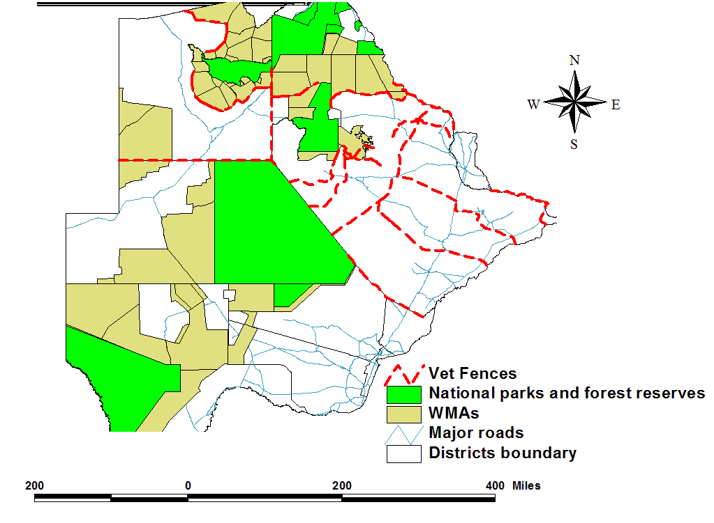

BOTSWANA

Submitted to the Secretariat of the Convention on Biological Diversity [date]

Protected area information:
PoWPA Focal Point:

Mr. Botshabelo Othusitse
Chief Wildlife Officer, Wildlife Estate Management
Department of Wildlife and National Parks
Ministry of Environment, Wildlife & Tourism
Gaborone, Botswana
E-Mail: bothusitse@ gov.bw

Lead implementing agency: DEPARTMENT OF ENVIRONMENTAL AFFAIRS, is the CBD focal point and the Implementing agency is UNDP.
Multi-stakeholder committee:
There is currently no committee that deals directly with the implementation of PoWPA issues.
however there is a UN Convention for Combating Desertification and Drought (UNCCDD) national taskforce for combating desertification and drought that has been established that is faced with issues of drought and desertification, thus aiming at engaging in projects that sensitive the public on issue of desertification as well as engage in projects that aims at mitigating desertification and drought.

Description of protected area system

National Targets and Vision for Protected Areas
(Insert national targets for protected areas/Target 11 of the Aichi Targets. Include rationale from protected area gap assessment, if completed, along with any additional information about the vision for the protected area system, including statements about the value of the protected area system to the country)
Though Botswana has viable populations of wildlife and is renowned for its commitment to conservation and successful conservation programmes, Botswana’s wildlife populations have not been spared by challenges of wildlife population decline and human population encroachment into wildlife areas. Human population increase is often associated with an increase in demand for more land for infrastructural development, agricultural activities, and residential places. This demand often expands into wildlife areas resulting in wildlife population declines, isolated small populations, and displacement of wildlife populations from their original habitats. This population increase often results in wildlife habitat fragmentation, habitat degradation, illegal off-take, and human wildlife conflict. However Botswana still harbor relatively healthy wildlife populations in a wide range of wilderness habitats which include part of the five high biodiversity areas in the world, the Miombo-Mopane woodlands of southern African, and the Kalahari dessert.
With the negative effects of climate change which has been manifesting itself especially in the Okavango delta, it has become more and more evident that there is an agent need to integrate protected areas into a wide landscape that can allow mitigation measure for the unforeseen effects that may be brought along by climate change.
Protected areas in Botswana have been divided into two systems which are protected areas in the northern part of the country where the environmental conditions are slightly wetter than the southern system where the environmental conditions are the typical semi arid conditions. These systems have been further separated by veterinary disease control fences which have cut-off historical wildlife migratory routes. Infrastructure Developments between the protected areas have also increased the difficulty of easy movement of wildlife between the protected areas thus greatly reducing connectivity between the protected areas. With the recent population declines of wildlife numbers in the northern part of the country where a number of floodplain species have been on the decrease there is a need to improve connectivity between protected areas as well as to secure some critical areas that can be used as refuge in the times when conditions are not favourable.
Coverage
(Amount and % protected for terrestrial and marine; maps of protected area system)
Wildlife resources in Botswana offer a wide range of opportunities for economic diversification at national and local level. About 40% of the Botswana’s land area has been devoted to protected areas, with 17% being national parks and game reserves, where there is zero utilization by communities (fig 1.). The remaining percentage is wildlife management areas and forest reserves which allow some form of utilization by the communities and concessioners.
Figure 1. Map of Botswana showing National Parks and Wildlife management areas.
Description and background
About 40% of the Botswana’s land area has been devoted to protected areas, with 17% being national parks and game reserves, where there is zero utilization by communities. The remaining percentage is wildlife management areas and forest reserves, which allow some form of utilization by the communities. It should be noted that the 40% that is mentioned here is only accounting to national parks and game reserves, wildlife management areas, and forest reserves. There are however privately owned game reserves, and educational parks who’s areas have not been included here.
All protected areas in the country have been legally established and are fully supported by a range of legally frame work that has been satisfactorily enforced. These legal documents range from the Wildlife and National Parks act, regulations and management plans. Management of the protected areas is solely the responsibility of the government of Botswana. With all revenues accrued from the national parks and game reserves going into the government coffers. None is directly planted back into the management of these protected areas.

Over the years Botswana has experienced increasing wildlife habitat loss and threat to biodiversity due to human activity. This has confined wildlife population and biodiversity into protected areas but the question is how much can the protected areas harbour as they are continually threatened by human population encroachment and unsound management activities. Some Wildlife populations throughout Botswana have continued to decline since the inception of veterinary cordon fences. There barriers as well as many other infrastructure developments have affected migratory routes of many ungulates in Botswana. This has resulted in massive die off of some water depended species such as wildebeest in the 1980s and the populations of these species have never recovered in many parts of the country. Climatic conditions have also change to much drier years in many parts of the country. This has affected even the less water dependent species of the Kalahari ecosystem. These species usually supplement water requirements by feeding on tubers and water supplements plants, such as Tsama melons and wild cucumbers, but these plants as well have been greatly affected by the reduced amount of precipitation throughout the country.

Infrastructure development and the growing demand for land by the pastoralist have increased competition for resources between wildlife and livestock. This pressure continues to grow and has impacted negatively on the wildlife populations in many parts of the country.

Botswana’s comparative advantage in terms of tourism has been its wilderness state in most of its protected areas that offer tranquillity and relaxation that most of the SADC regions lack. It is the wish of the Botswana to maintain such a comparative advantage however there are challenges of keeping some of the protected areas attractive to tourism activities so that these areas can become profitable to that land authorities. Resource as a limiting factor in many of the protected areas in Botswana has determined the abundance as well as distribution of wildlife populations in many parts of the protected areas. The sporadic nature of the rainfall in areas such as in the South Western region of the country means that resource are scattered and become determining factors of animal movement. These movements may result in animals moving into human inhabited areas there by falling victims of illegal off take. This may also render the protected areas less attractive to tourism as animals may move out of the protected areas in search of resource such as water and mineral licks. Some of the protected areas have good resources to hold some water depended species but since surface water is very limited in those areas it is not possible to have water depended species all year round in protected areas such as the Central Kgalagadi Game Reserve, Makgadikgadi/Nxai Pan National park, and Kgalagadi Transfrontier Park. Thus water provision in these areas could result in a more suitable habitat for some declining species of wildlife.
Governance types
All major protected areas (i.e National parks, game reserves, wildlife management areas, educational parks) are governmened by the state government.

Forest Reserve | Ecoregion Protected | Area (km²)
Chobe Forest Reserve | Zambezian Baikiaea and Zambezian & Mopane Woodlands | 1432
Kasane Forest Reserve and Extension | Zambezian Baikiaea and Zambezian & Mopane Woodlands | 837
Kazuma Forest Reserve | Zambezian Baikiaea Woodlands | 195
Sibuyu Forest Reserve | Zambezian Baikiaea Woodlands | 1194
Maikaelelo Forest Reserve | Zambezian Baikiaea Woodlands | 532

Terrestrial Sites | Institutional Arrangement | IUCN Category | Year of Establ-ishment | Area (km²)
Protected Areas - legally established - regarded as secure
Chobe National Park | National park (department of wildlife and national parks, (DWNP)) |  | 1960s | 10, 590
Makgakgadi/Nxai Pans national Park | National park (DWNP) |  | 1995 | 7, 520
Moremi game reserve | game reserve (DWNP) |  | 1963 | 4, 4871
Central Kalahari Game Reserve | game reserve (DWNP) |  | 1961 | 52, 245
Khutse Game Reserve | game reserve (DWNP) |  | 1971 | 2, 600
Kalahari Transfrontier Park | National park (DWNP |  | 1938 | 26, 310
Gaborone educational park | Educational park (DWNP)
Maun education Park | Educational park (DWNP)
Francistown educational park | Educational park (DWNP)
Mokolodi nature reserve | Educational park (Private)
Khama Rhino sanctuary
Nata sanctuary | Bird sanctuary (Community)
Sowa flamingo sanctuary | Bird sanctuary (Community)
Mashato private game reserve | game reserve (Private)
Game ranges | Private
Wildlife management areas |  |  |  | 140, 000

Key threats
(Description of key threats, and maps, if available)
- Habitat fragmentation due to disease control fences.
These have negatively affected free movement of wildlife in the country. Water depended wildlife species cannot access the resources that are needed during times of drought.
- Settlement within wildlife migratory corridors.
Due to increasing demands for more land for cattle farming there has been continued settlements within the wildlife migratory corridors. Human activities have resulted in the constriction of migratory corridors and the final loss of the corridors in most section of the country.
- Poaching.
Poaching has a negative impact on the populations of wildlife as it tends to affect the population in many ways not just the physical removal of the individuals that are killed. Some wildlife species populations are declining and poaching is a contributing factor to the declining populations.
- Land use conflict
Land use conflict tends to displace animals form their habitats, and restrict them from accessing critical habitats as these are also sort after by the cattle farmers. It also brings along conflict and activities such as illegal off-take.
- Climate change
Climatic conditions have change to much drier years in many parts of the country. This has affected even the less water dependent species of the Kalahari ecosystem. These species usually supplement water requirements by feeding on tubers and water supplements plants, such as Tsama melons and wild cucumbers, but these plants as well have been greatly affected by the reduced amount of precipitation throughout the country.
Barriers for effective implementation
(Description of key barrier s for effective implementation)
- Lack of qualified human capital and adequate financial resources
Protected areas in Botswana are management by officer that do not necessarily have training in protected areas management and there is limited budget that is provided for proper protected area management. There is therefore a need to train protected area managers in many aspect of protected area management in order to ensure that protected areas are managed accordingly and do contribute positively to conservation as well as the economic well being of the immediate stakeholders (communities) and the country at large. Furthermore, there is need for separate budgeting for protected areas so that all resource that are needed for protected areas management can be sourced. Currently protected areas do not receive a budget that is specifically for protected areas, thus dividing the allocated budget among the different requirements of the department of wildlife and national parks ends up resulting in very little resources being channeled to protected areas management.
- Issues of Governance also need to be evaluated to identify the best governance that would ensure that protected areas meet their objectives.

Status, priority and timeline for key actions of the Programme of Work on Protected Areas

Status of key actions of the Programme of Work on Protected Areas
Status of key actions of the Programme of Work on Protected Areas | Status | priority | Time line
- Progress on assessing gaps in the protected area network (1.1) | 0 | VH
- Progress in assessing protected area integration (1.2) |  | VH
- Progress in establishing transboundary protected areas and regional networks (1.3) | 3 | H
- Progress in developing site-level management plans (1.4) | 4 | H
- Progress in assessing threats and opportunities for restoration (1.5) | 0 | M
- Progress in assessing equitable sharing of benefits (2.1)  - Progress in assessing protected area governance (2.1) | 1  0 | M  M
- Progress in assessing the participation of indigenous and local communities in key protected area decisions (2.2) | 0 | L
- Progress in assessing the policy environment for establishing and managing protected areas (3.1)  - Progress in assessing the values of protected areas (3.1) | 4  1 | H
- Progress in assessing protected area capacity needs (3.2) | 0 | VH
- Progress in assessing the appropriate technology needs (3.3) | 0 | H
- Progress in assessing protected area sustainable finance needs (3.4) | 2 | H
- Progress in conducting public awareness campaigns (3.5) | 4 | H
- Progress in developing best practices and minimum standards (4.1) | 2 | H
- Progress in assessing management effectiveness (4.2) | 0 | VH
- Progress in establishing an effective PA monitoring system (4.3) | 0 | VH
- Progress in developing a research program for protected areas (4.4) | 0 | H
- Progress in assessing opportunities for marine protection
- Progress in incorporating climate change aspects into protected areas | 0 | VH
Status: 0 = no work, 1 = just started, 2 = partially complete, 3 = nearly complete, 4 = complete
(Insert notes as appropriate)

Priority actions for fully implementing the Programme of Work on Protected Areas:
(Insert priority actions)
Action | Priority
Undertake gap analysis for all protected areas in the country. | Identify deficiencies in protected area management imperatives, i.e human capital (staffing and skills), finances and governance
Protected area Integration into wider landscape and mainstreaming of biodiversity with other sectors and ecosystem | - Integrate protected areas through Corridor establishment, security, and management
Empower Protected area managers to undertake management effectiveness assessment of all protected areas in the country. | - Secure resources for Capacity building for conducting assessments, and assessment.  - Development of a schedule for assessment of the protected areas.  - Implement the assessment schedule.  - PoWPA focal point reports to CBD secretariat on all completed activities,
Undertake protected area capacity needs assessment. | - Review and finalize protected areas legislations to incorporate climate change mitigation and adaptation.  - Asses human capital and resource needs for each protected area for effective implementation of PoWPA.
Establishing an effective PA monitoring system | - Develop tools and skills for monitoring Protected area management effectiveness for all the PAs in Botswana
Incorporating climate change aspects into protected areas | - Incorporate into management plans of all protected areas
Assessing the values and contribution of protected areas to the national and local economies and to achieving MDGs | - Develop economic valuation for protected areas for each category.  - Develop communication strategies for protected areas.

Timeline for completion of key actions

Action Plans for completing priority actions of the Programme of Work on Protected Areas

Action 1: GAP ANALYSIS
Key steps | Timeline | Responsible parties | Indicative budget
Gap analysis in Staffing requirement, resources requirement, and skills inventory and requirement, for effective protected areas management for all protected areas in the country. | 2013-2014 | DWNP, | U$20K
Gap analysis of Legal framework and sector policies to ensure mainstreaming | 2013-2014 | DWNP, DEA, DFRR, LANDS, AGRIC | U$25K
Reviewing and updating appropriate sectorial policies and legislation, including strengthening of community involvement in conservation. | 2014-2015 | DWNP, DEA, DFRR, LANDS, AGRIC | U$300K

Action 2: PROTECTED AREA INTEGRATION
Key steps | Timelines | Responsible Parties | Indicative Budget
Consultation workshops on land use issues and wildlife corridors | 2013-2014 | DWNP, DEA, DFRR, LNDAS, NGOs | U$100K
Identify and engage a consultant, to do land use analysis and conflict resolution | 2014-2015 | DWNP, DEA, DFRR, LNDAS, NGOs | U$200K
Implementation of corridor management plans | 2016 | DWNP, DEA, DFRR, LNDAS, NGOs | U$200K

Action 3: MANAGEMENT EFFECTIVENESS
Key steps | Timeline | Responsible parties | Indicative budget
Assessment of the management effectiveness of all the PAs in Botswana | 2013 | DWNP | U$600K

Action 4: EFFECTIVE PA MONITORING SYSTEM
Key steps | Timeline | Responsible parties | Indicative budget
Development of the PA Monitoring System | 2013 - 2014 | DWNP | U$100K
Training of PA staff to implement the system | 2013 -2014 | DWNP

Action 5: INCORPORATING CLIMATE CHANGE ASPECTS INTO PROTECTED AREAS
Key steps | Timeline | Responsible parties | Indicative budget
This will be done under the Climate Change |  |  | ????????

Key assessment results
Ecological gap assessment
Botswana has a series of veterinary fences that have divided the country into two major blocks, hence cutting on the connectivity of the between the parks to the north and those to the south of the country. The Western Kalahari Conservation Corridor Project, which came to a close in 2010, under Conservation International mapped major wildlife habitats within the Kalahari ecosystem as well as major corridors that are necessary to link the Kalahari Transfrontier Park and the Central Kalahari Game Reserve. The project further attempted to determine and support community projects that would support corridor maintenance to ensure their effectiveness. Unfortunate the WKCC project came to a close before the full mobilization of the communities to run such projects due to financial reasons.
There is therefore a need to further determine major wildlife habitats in the northern system as well as other important links between the protected areas.

Management effectiveness assessment
There is an ongoing assess entitled “Appraisal on Optimizing Financial and Management Effectiveness of Protected Areas in Botswana. The findings will be communicated once the assessment has been completed.
Sustainable finance assessment
Sustainable financing for protected areas in Botswana was covered under the performance audit of the Department of Wildlife and National Parks by Atos Origin (See capacity needs assessment below)

Capacity needs assessment
Several assessment have been conducted on the capacity needs of the department of Wildlife and Strategic Options to Improve the Performance of the Botswana Department of Wildlife and national Parks “ by Rowan B. Martin of Atos Origin, march 2008. The assessment concluded that the department is grossly under staff and under resourced. It further gave guidance ideal staffing requirement for the various protected areas. The only area that needs to be looked into is the skills inventory and requirement. There is general lack of skills to manage protected areas in Botswana and lot training needs to undertaken to ensure that parks achieve their objectives.

Policy environment assessment
The Department of Wildlife and National Parks engaged a consulting company to review the Wildlife Conservation Policy with the view to take on board the new and emerging challenges of wildlife conservation and management. The policy document has been completed and has been presented to cabinet and given a green light. The revised wildlife conservation policy will be tabled before parliament in July 2012 for consideration. The approval of the policy will be followed by the review of the wildlife conservation and national parks act and its subsidiary regulations.

Protected area integration and mainstreaming assessment
Botswana has a series of veterinary fences that have divided the country into two major blocks, hence cutting on the connectivity of the between the parks to the north and those to the south of the country. The Western Kalahari Conservation Corridor Project, which came to a close in 2010, under Conservation International mapped major wildlife habitats with the Kalahari ecosystem as well as major corridors that are necessary to link the Kalahari Trans-Frontier Park and the Central Kalahari Game Reserve. The project further attempted to determine and support community projects that would support corridor maintenance to ensure their effectiveness. Unfortunate the WKCC project came to a close before the full mobilization of the communities to run such projects due to financial reasons.
There is therefore a need to further determine other important links between the protected areas to ensure connectivity and as well as facilitate community projects that would support protected area integration throughout Botswana.
Furthermore, Birdlife Botswana, a Non-Governmental Organization, has mapped several Important Bird Areas throughout the country to take on board bird conservation, an area which given less priority compared to mammal conservation. Along these lines, the Department of Wildlife and National Parks declared the Sowa Flamingo Sanctuary to protect important flamingo habitats in the Sowa Pan and is in the process of declaring Lake Ngami, a very important habit for Waterfowls a bird sanctuary. Other areas for future consideration include Lake Xao which has started filling up following the flooding of Boteti River after more than 20 years since it dried up.
The commitment of the Botswana Government to the mainstreaming issues of environment and climate change into development process is as evidenced by the inclusion under the Sustainable Environment chapter of the National Development Plan 10 (2009 – 2016). The plan advocates for systematic approach towards the integration of resource management and development, cutting across economic sectors and recognizing the linkages between natural resources. During the plan period, the Government of Botswana aims to increase forest cover by 5%. This will have a positive impact on the reduction of the ozone depleting substances hence the performance of the environment.

Protected area valuation assessment
Protected area valuation assessment was conducted for the Makgadikgadi Nxai Pans National Park. The report on the findings is attached for your information. There is need to engage consultant to conduct protected area valuation assessment for all the protected areas in Botswana.

Climate change resilience and adaptation assessment
To be dealt with under climate change

