Action Plan for Implementing the Convention on Biological Diversity’s
Programme of Work on Protected Areas

(BHUTAN)

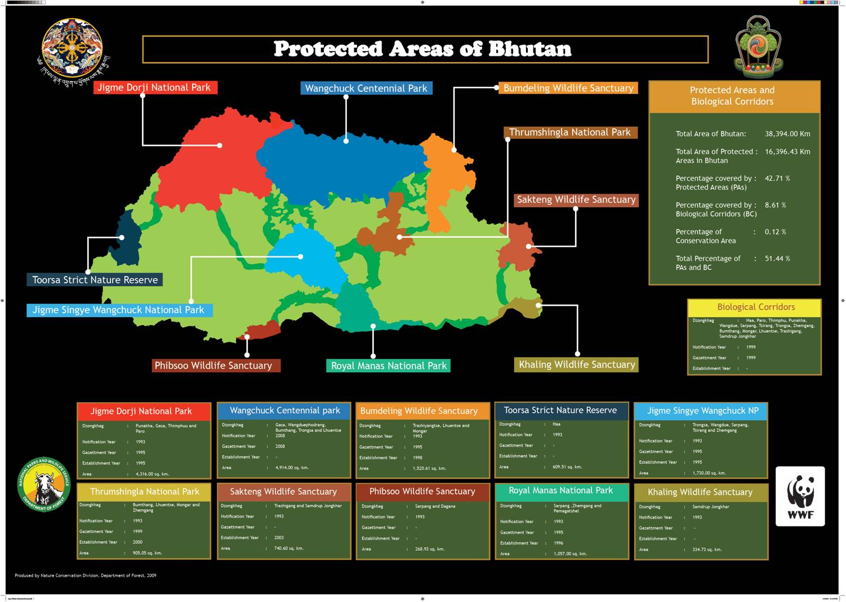

Submitted on 19 June 2012

Protected area information:

PoWPA Focal Point:

National Environment Commission

Mr. Karma C. Nyedrup, Dy. Director

NEC, Thimphu, Bhutan, P. Box 466

Phone £ +975-2-324323/+975-2-323385

kc@nec.gov.bt
Lead implementing agency:
Ministry of Agriculture and Forests.
Multi-stakeholder committee:
National Environment Commission
Description of protected area system

National Targets and Vision for Protected Areas
(Insert national targets for protected areas/Target 11 of the Aichi Targets. Include rationale from protected area gap assessment, if completed, along with any additional information about the vision for the protected area system, including statements about the value of the protected area system to the country)
National Targets and Vision for PoWPA inside protected areas is not yet developed. Gap analysis not yet conducted.
In the Vision and strategy 2003 of Nature Conservation Division,Department Of Forests and Park Services, four strategic components were chosen with time horizon of ten years (2003-2013):
- Management of protected areas, buffer zones and biological corridors
- Integrated conservation development projects, Ecotourism program.
- Environment education
- Research, survey and monitoring.

Coverage
The protected areas system, which is made up of five national parks, four wildlife sanctuaries, and a strict nature reserve, covers altogether an area of 15,192 km² (exclusive of botanical park with 47km²) or 39.6 percent of the country’s total area. This puts Bhutan at the top of the list of countries in the world with the highest proportion of area under protected areas. . In addition to 39.5 % of the country land under Protected Areas, 9.5 % set aside as biological corridors totaling to 51.4% of country’s areas. Currently there are 10 PAs of which 7 are operational and the rest will be brought under operation by 2013. Besides, there are about 13 conservation areas of which 2 are under effective management and the rest under some form of interventions.

Description and background
The Royal Government has a policy that ensures at least 60 % forest cover in perpetuity which also has become a constitutional mandate of the country
The protected areas system in Bhutan is one of the most comprehensive in the world not only in terms of area coverage but also in terms of the balance and contiguity in distribution across the country. The system encompasses a continuum of representational samples of all major ecosystems found in the country ranging from the tropical/ sub-tropical grasslands and forests in the southern foothills through temperate forests in the central mountains and valleys to alpine meadows and scree in the northern mountains. In 2006, the area of Thrumshingla National Park was increased from 768 km² to 905 km² and that of Bumdeling Wildlife Sanctuary from 1,400 km² to 1,521 km² to bring additional areas of potential tiger and snow leopard habitats under the protected areas system. In June 2008, Wangchuck Centennial Park was inuguarated to commomerate 100 years of Monarchy in Bhutan.

Of the ten protected areas, seven are functional at present with conservation management plans, personnel and basic conservation management infrastructure in place.The remaining protected areas – Torsa Strict Nature Reserve, Phipsoo Wildlife Sanctuary and Khaling Wildlife Sanctuary – are expected to become functional in the Tenth Five Year Plan period (2009-2013).

The conservation management plans of the operational protected areas essentially include conservation research and monitoring, patrolling and law-enforcement, public awareness and education, integrated conservation and development programmes, and nature tourism. In Bhutan, irrespective of the conservation category (strict nature reserve, national park, wildlife sanctuary) the protected areas are not managed as a homogeneous territory but, rather, as a mosaic of conservation zones permitting varying levels of human intervention and use. For instance, the core zone is fully protected, allowing only for regulated research and scientific monitoring. On the other hand, the multiple-use zone is an area which might well support local communities, their agricultural needs and practices, including grazing, and access to forest resources. This is in contrast to many other countries which follow exclusionary policies for protected area management, involving relocation of local communities to areas outside the protected areas.

Table 1: Operational Status of Protected Areas in Bhutan

Protected Area | Area km² | Operational Status
Torsa Strict Nature Reserve | 610 | Not yet operational
Jigme Dorji National Park | 4,316 | Operational since 1997. Conservation management plan being revised.
Jigme Singye Wangchuck National Park | 1,730 | Operational since 2002. Conservation management plan being revised.
Royal Manas National Park | 1,029 | Operational since 1994. Prior to 1994, patrolling and some limited research activities were being implemented as well as basic park infrastructure existed in Manas.
Thrumshingla National Park | 905 | Operational since 2002. Conservation management plan being revised.
Bumdeling Wildlife  Sanctuary | 1,521 | Operational since 2001. Conservation management plan being revised.
Wangchuck Centenniel Park | 3,736 | inuarauagted in June 2008
Phipsoo Wildlife Sanctuary | 269 | Not operational but patrolling and preliminary surveys ongoing under the management of Sarpang Forest Division
Sakten Wildlife Sanctuary | 741 | Operational with its first conservation management plan in place in 2006.
Khaling Wildlife Sanctuary | 335 | Not yet operational

Establishment and Management of Biological Corridors

Declared in 1999, the 12 biological corridors, collectively encompassing an area of 3,660 km², connect all the nine protected areas. The primary purpose of the biological corridors is to maintain gene-flow through uninterrupted wildlife movements and succession of habitats. The longest corridor is the North Corridor with a length of 76 km, connecting Jigme Dorji National Park to the corridors of Thrumshingla National Park and Bumdeling Wildlife Sanctuary. The shortest corridor is the one connecting Thrumshingla National Park to the North Corridor with a length of 16 km. The width of the corridors ranges from 500 m to 3 km. The corridors were identified based on field assessment of the following criteria: abundance of target wildlife; slope of terrain; occurrence of forest fires; condition of canopy and undergrowth; level of human disturbance; and width of narrowest constriction.

Conservation management interventions have been piloted since 2003 in the biological corridors adjacent to Thrumshingla National Park in order to draw lessons from and establish the basis for defining the conservation management status of and administrative framework for the biological corridors in general. Consequently, NCD has promulgated Biological Corridor Rules 2007 as an addendum to the Forest and Nature Conservation Rules 2006. The Rules describe the conservation management status of biological corridors as lower than that of a protected area but higher than that of government reserved forests. The field-level implementation of the Biological Corridor Rules 2007 and management of the biological corridors are mandated to the territorial forest divisions with the Nature Conservation Division providing coordination and backstopping to the territorial forestry staff.

Table 2: Biological Corridors and their Areas

Biological Corridor | Area km²
Torsa SNR – Jigme Dorji NP Corridor | 147
Jigme Dorji NP – Jigme Singye Wangchuck NP Corridor | 275
Jigme Singye Wangchuk NP – Jigme Dorji NP Corridor | 600
Jigme Singye Wangchuk NP – North Corridor | 525
North Corridor | 640
Thrumshingla NP – North Corridor | 142
Bomdeling WS – North Corridor | 119
Thrumshingla NP – Bumdeling WS Corridor | 79
Jigme Singye Wangchuck NP – Thrumshingla NP Corridor | 385
Phipsoo WS – Royal Manas NP Corridor | 376
Khaling WS – Sakten WS Corridor | 160
Royal Manas NP – Khaling WS Corridor | 212
Total | 3,660
Source: Nature Conservation Division, DoF, 2006

Governance types
“Types” of governance of natural resources can be distinguished on the basis of “who holds management authority and responsibility and is expected to be held accountable according to legal, customary or otherwise legitimate rights”. In this sense, four broad types have been identified and mentioned in the CBD PoW.In Bhutan the PAs management is governed by two broad types of governance.
A.Government protected areas; All protected areas managed by government.
B. Some of protected areas are managed on the shared basis. Wangchuck Centenniel Park is co-managed by Government of Bhutan and WWF-Bhutan.Conservatin area in Phobjikha is managed Environment NGO called Royal Society of Protection for Nature .Some of the community managed forests is co-managed by community and Government.

Key threats
Some of the key identified threats in the National Biodiversity Action Plan 2009 are; human wildlife conflict, poaching, forest fire habitat loss, land use change and degradation, and unsustainable water use.
The government is implementing programs and developed legislations to reduce the rate of deforestation, minimize loss of land for development (urbanization, roads, and industries) and reduction of land for mining and quarry.

Through afforestation, reforestation and plantation programs, many degraded land are reforested. The principle of Environmental Friendly Road Construction is being implemented. The sustainable land management programs are instituted to reduce land and water degradation.

The government has developed plantation strategy, Land Act, and revised mine and minerals management regulations. The water Act is under preparation.

Barriers for effective implementation

For the Kanchenjunga Landscape (KL) program, Bhutan, India and Nepal are implementing various conservation program , national level strategic plans for Toorsa SNR –JDNP corridor development have been developed, and in some cases have already been integrated into national strategies. The framework for regional cooperation for implementation of the Convention on Biological Diversity has been published and the framework for a regional strategy for the management of biodiversity is underway
Obstacle encountered: political commitment (among participating countries); information sharing (networking) among the countries.
Declared in 1999, the 12 biological corridors(BC), collectively encompassing an area of 3,660 km², connect all the nine protected areas. The primary purpose of the biological corridors is to maintain gene-flow through uninterrupted wildlife movements and succession of habitats.
Obstacle encountered: many settlements are inside the biological corridor; BC management will require involvement of many partner agencies which is expected to delay the process of implementation. Development activities involving numerous sectors for negotiation.

Limited staff for patrolling (lack of trasboundary agreement), people’s participation and perception of conservation.

Multi stakeholder participation in PA management, issues are complex with various stakeholders, new ideas /concept –difficult for people to accept.

Community Forestry is established, Private forestry, formation of groups in weaving, ecotourism etc Problems in implementation due to different perception of people towards PA, implementing agencies perception.

Lack of communication facilities in some of the PAs hampered in dissemination of information.

No mechanism in place to revive new technologies, innovations, and further application hampered, no decentralization for parks.

lack of funding and capacity of human resource.

Status, priority and timeline for key actions of the Programme of Work on Protected Areas

Status of key actions of the Programme of Work on Protected Areas
Status of key actions of the Programme of Work on Protected Areas | Status
- Progress on assessing gaps in the protected area network (1.1) | 0
- Progress in assessing protected area integration (1.2) | 1
- Progress in establishing transboundary protected areas and regional networks (1.3) | 1
- Progress in developing site-level management plans (1.4) | 2
- Progress in assessing threats and opportunities for restoration (1.5) | 0
- Progress in assessing equitable sharing of benefits (2.1)  - Progress in assessing protected area governance (2.1) | 1
- Progress in assessing the participation of indigenous and local communities in key protected area decisions (2.2) | 1
- Progress in assessing the policy environment for establishing and managing protected areas (3.1)  - Progress in assessing the values of protected areas (3.1) | 1
- Progress in assessing protected area capacity needs (3.2) | 1
- Progress in assessing the appropriate technology needs (3.3) | 0
- Progress in assessing protected area sustainable finance needs (3.4) | 1
- Progress in conducting public awareness campaigns (3.5) | 1
- Progress in developing best practices and minimum standards (4.1) | 1
- Progress in assessing management effectiveness (4.2) | 1
- Progress in establishing an effective PA monitoring system (4.3) | 1
- Progress in developing a research program for protected areas (4.4) | 1
- Progress in assessing opportunities for marine protection | 0
- Progress in incorporating climate change aspects into protected areas | 1
Status: 0 = no work, 1 = just started, 2 = partially complete, 3 = nearly complete, 4 = complete
(Insert notes as appropriate)

Priority actions for fully implementing the Programme of Work on Protected Areas:
Sl.No | Actions | Priority ranking
1 | Assessing gaps in the protected area network | M
2 | Site level management plan | H
 | Protected area integration | H
3 | Valuation of Protected areas | M
4 | Assessing appropriate technology needs | M
5 | Public awareness campaign | M
6 | Research programs | M
7 | Incorporating climate change aspects into PAs | H
8 | Assessing equitable sharing of benefits | l/M

Timeline for completion of key actions
By 2020

Action Plans for completing priority actions of the Programme of Work on Protected Areas

Action 1: Gap assessment in in the Protected Areas
Key steps | Timeline | Responsible parties | Indicative budget
Task force | 1mm | MoAF, NEC
Recruitment of consultant | 3 mm | $ 50,000
Capacity building of survey team and task force | 1 mm | $ 2,00,000
Preparation of report | 1 mm | $ 50,000
Stakeholder consultant ions | 3 mm | $ 1,00,000
National level consultations | 3 mm | $ 1,00,000
Finalization of report | 3 mm
Endorsement and printing | 5mm

Action 2: Development of site level management plan for effective management and implementation of PoW CBD and others.
Key steps | Timeline | Responsible parties | Indicative budget
Task force | 1 mm | MoAF, DoFPs
Recruitment of consultant | 3 mm
Capacity building of survey team and task force | 1 mm
Preparation of report | 1 mm
Stakeholder consultant ions | 3 mm
National level consultations | 3 mm
Finalization of report | 3 mm
Endorsement and printing | 5 mm

Action 3: Valuation of PAs for obtaining fund for effective management and sustainable financing.
Key steps | Timeline | Responsible parties | Indicative budget
Task force | 1 mm | DoFPs, MoAF, NEC
Recruitment of consultant | 3 mm
Capacity building of survey team and task force | 1 mm
Awareness campaign | 2 mm
Preparation of report | 1 mm
Stakeholder consultantions | 3 mm
National level consultations | 3 mm
Finalization of report | 3 mm
Endorsement and printing | 3 mm

Key assessment results
Ecological gap assessment (insert summary findings if available)
Not yet conducted. Micro level planning and assessment conducted.
www.moa.gov.bt
Management effectiveness assessment (Insert summary findings if available)
Sustainable finance assessment (Insert summary findings if available)
Capacity needs assessment (Insert summary findings if available)
www.moa.gov.bt
Policy environment assessment (Insert summary findings if available)
www.moa.gov.bt
www.nbc.gov.bt
www.nec.gov.bt
Protected area integration and mainstreaming assessment

Establishment and Management of Conservation Areas outside the Protected Areas System

www.moa.gov.bt
Protected area valuation assessment (Insert summary findings if available)
www.moa.gov.bt
Climate change resilience and adaptation assessment
www.moa.gov.bt
www.ddm.gov.bt
www.nec.gov.bt

