Draft of Action Plan for Implementing the Convention on Biological Diversity’s
Programme of Work on Protected Areas

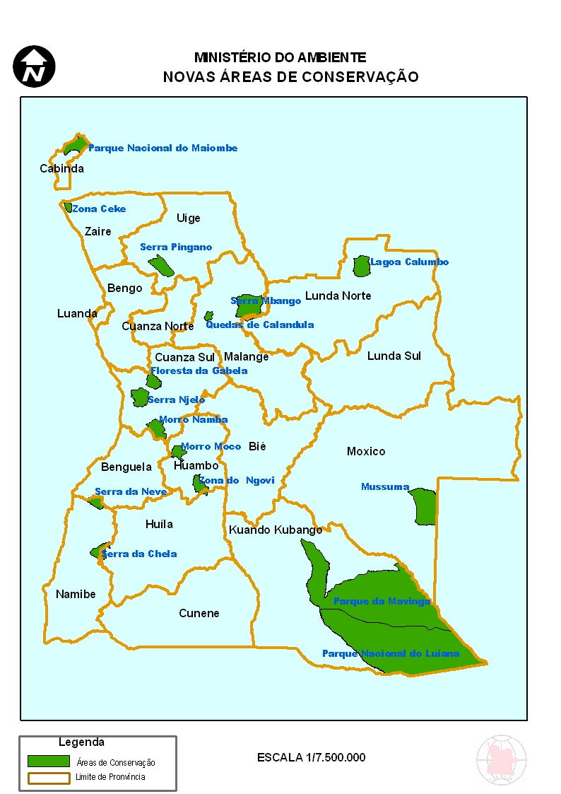
(ANGOLA)

Submitted to the Secretariat of the Convention on Biological Diversity [date]
Protected area information:

PoWPA Focal Point:
Joaquim Lourenco Manuel
Head of Protected Area Department
National Direction of Biodiversity
Ministry of Environment
Luanda Angola
Cell phone: 244 912 226938/928 551381
Email: mjicky1@gmail.com /mjicky@yahoo.com.br

Lead implementing agency:
Protected Area Department
National Institute of Biodiversity and Conservation Areas
National Direction of Biodiversity
Ministry of Environment
Luanda Angola

Multi-stakeholder committee:
National Multi sartorial Committee of Environment in Luanda Angola (The Ministry of the Agriculture, Rural Development and Fish, Ministry of Energy and water, Ministry of Planning, Ministry of Hostelry and Tourism, Ministry of Administration of Territory and Ministry of the Defense)

Description of protected area system

National Targets and Vision for Protected Areas
The global objective of this Work Action Plan are to implant a system of conservation of the national biodiversity that it is capable to lead to the ecological stability, to the resilience to the climatic change and to the human well-being.
Coverage
(Amount and % protected for terrestrial and marine; maps of protected area system)
- Terrestrial protected 6,6%
- Marine protected 0%
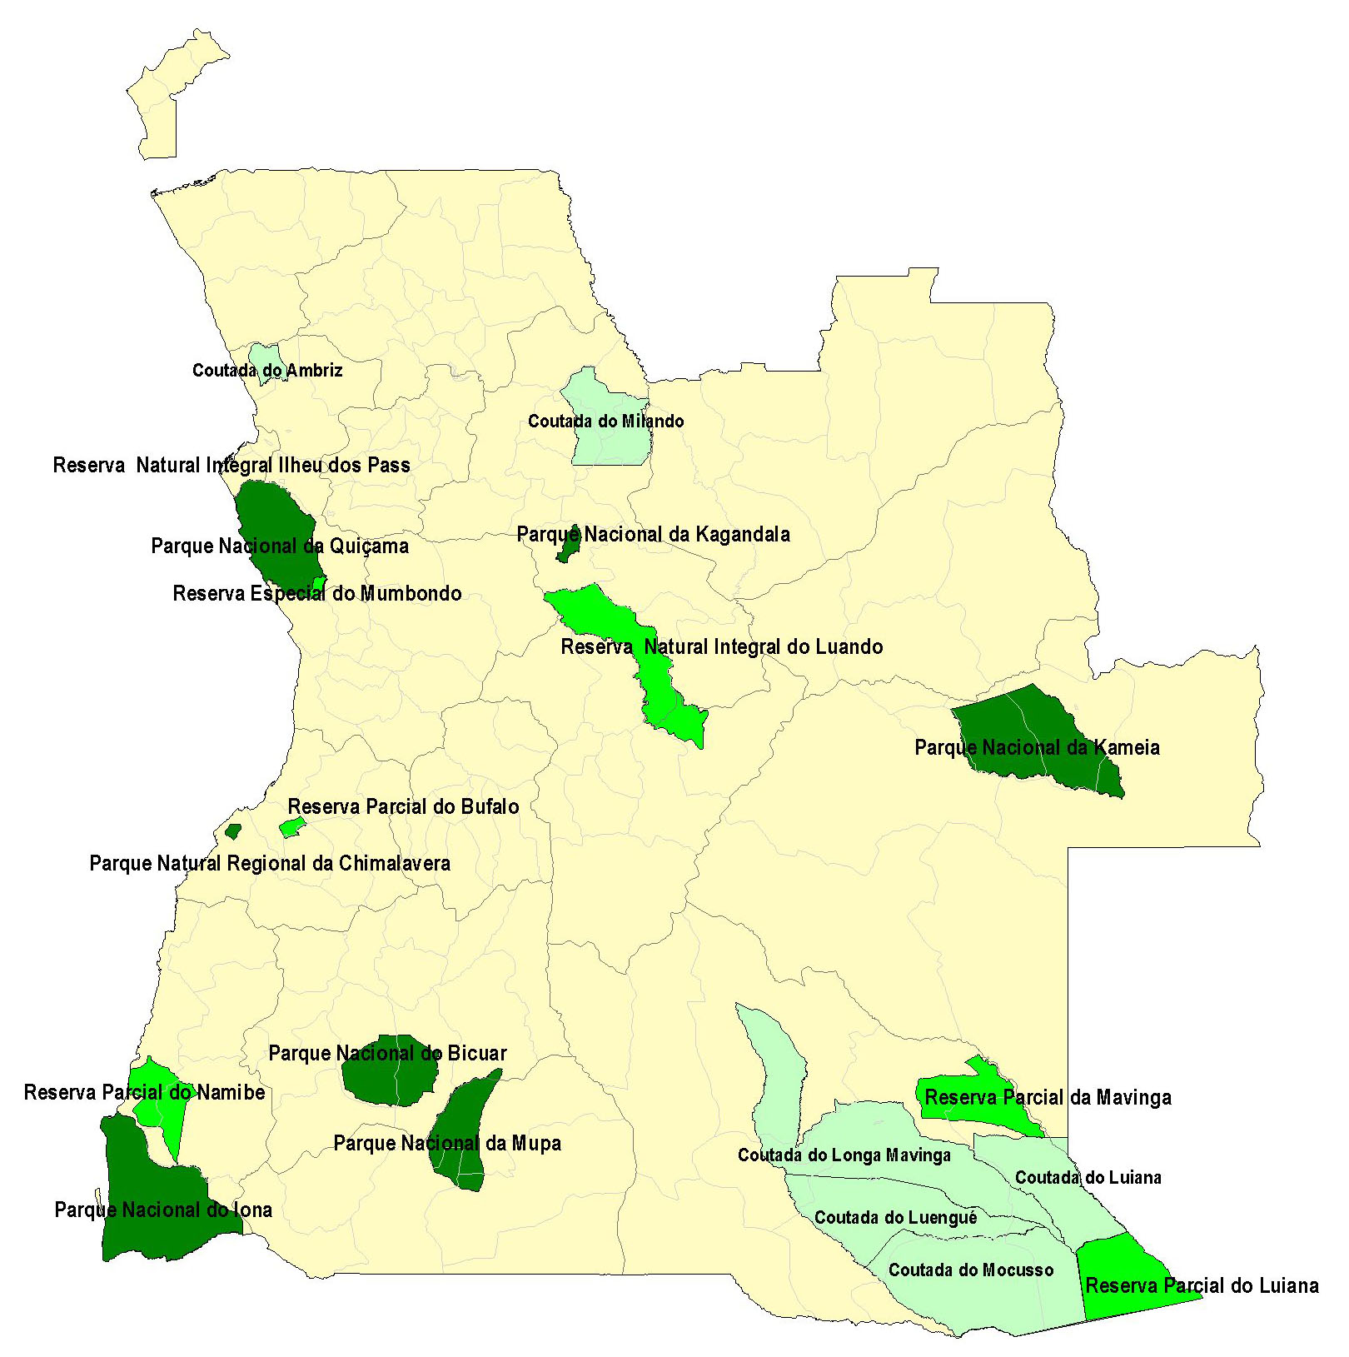
Protected area existing protected area to increases until 2017

Description and background
- 6,6% of the protected area in Angola 4% are effectively protected;
- Starting from 2012 we will increase the protected areas of 6,6% for 15% of the Angolan territory;
- Along the sea coast of the protected areas exists some protection of the sea, river mouth, coast of the National Parks of Quiçama and Iona.
Governance types
We didn't still specify, we will do in the revision of NBSAP on this year of 2012
Key threats
- Loss and fragmentation of ecosystems and natural habitats;
- Development no maintainable
- Pressures on the natural resources
- Degradation of flora
- Climatic changes
- Pollution
- Hunts illegal
- Forest fire
- Aliens Species
Barriers for effective implementation
- Deficient financing of the protected areas by the government and for the private organizations or philanthropic NGOs.
- Puddle technical capacity of administration and investigation

Status, priority and timeline for key actions of the Programme of Work on Protected Areas

Status of key actions of the Programme of Work on Protected Areas
Status of key actions of the Programme of Work on Protected Areas | Status
- Progress on assessing gaps in the protected area network (1.1) | 1
- Progress in assessing protected area integration (1.2) | 1
- Progress in establishing transboundary protected areas and regional networks (1.3) | 2
- Progress in developing site-level management plans (1.4) | 1
- Progress in assessing threats and opportunities for restoration (1.5) | 1
- Progress in assessing equitable sharing of benefits (2.1)  - Progress in assessing protected area governance (2.1) | 1  1
- Progress in assessing the participation of indigenous and local communities in key protected area decisions (2.2) | 2  2
- Progress in assessing the policy environment for establishing and managing protected areas (3.1)  - Progress in assessing the values of protected areas (3.1) | 3  1
- Progress in assessing protected area capacity needs (3.2) | 1
- Progress in assessing the appropriate technology needs (3.3) | 2
- Progress in assessing protected area sustainable finance needs (3.4) | 1
- Progress in conducting public awareness campaigns (3.5) | 3
- Progress in developing best practices and minimum standards (4.1) | 2
- Progress in assessing management effectiveness (4.2) | 2
- Progress in establishing an effective PA monitoring system (4.3) | 1
- Progress in developing a research program for protected areas (4.4) | 1
- Progress in assessing opportunities for marine protection | 0
- Progress in incorporating climate change aspects into protected areas | 1
Status: 0 = no work, 1 = just started, 2 = partially complete, 3 = nearly complete, 4 = complete
(Insert notes as appropriate)

Priority actions for fully implementing the Programme of Work on Protected Areas:

N. | Activity | Timeline
1 | To reach the goal-base of 10% for each vegetation type or habitat type in Angola, considering your characteristics of fauna and flora | 2015
2 | To maintain the functionality of the processes of the ecosystem inside the areas of proposed protection | 2015
3 | To contributed for the resiliency of the ecosystem to the climatic changes and gender. | 2015

Action Plans for completing priority actions of the Programme of Work on Protected Areas
(Insert detailed action plans)

Action 1: (To reach the goal-base of 10% for each vegetation type or habitat type in Angola, considering your characteristics of fauna and flora)
Key steps | Timeline | Responsible parties | Indicative budget
To identify Biomas to be included in the National Net of Protected Areas | 2012 | INBAC | 10.000 USD
To identify the percentage to include | 2012 | INBAC | 5.000 USD
To trace the corrector between the new areas and the old ones | 2012 | INBAC | 15.000 USD
Effetely creation of the 14 protected Areas | 2017 | INBAC | 200 000 000 USD
Elaboration of the administration plan | 2020 | INBAC | 20.000 USD
INBAC – National Institute of Biodiversity and Conservation Areas
Action 2: (To maintain the functionality of the processes of the ecosystem inside the areas of proposed protection)

Key steps | Timeline | Responsible parties | Indicative budget
Ranger’s formation and personal administrative | 2015 | INBAC | 15.000.000 USD
Acquisition of equipment in means and legal instruments | 2011 - 2015 | INBAC | 45.000 000 USD
To include the local communities in the administration | 2010 - 2017 | INBAC | 1.000.000 USD
INBAC – National Institute of Biodiversity and Conservation Areas
Action 3: (To contributed for the resiliency of the ecosystem to the climatic changes and gender.)
Key steps | Timeline | Responsible parties | Indicative budget
Inclusion of new ecosystems in the national net of conservation areas | 2017 | INBAC | 200.000.000 USD
Recovery of the degraded zones and beds of rivers | 2020 | INBAC | 50.000.000 USD
concentration of all resident communities in the protected areas and specification of the survival activities | 2010 -2020 | INBAC | 250.000.000 USD
INBAC – National Institute of Biodiversity and Conservation Areas

Key assessment results
Obs. The program of assessment and monitoring of protected areas will be on 2012 with the revision and implementation of NBSAP. We don't have scientific information about assessment or monitoring.
Ecological gap assessment (insert summary findings if available)
Not yet
Management effectiveness assessment (Insert summary findings if available)
Not yet
Sustainable finance assessment (Insert summary findings if available)
Not yet
Capacity needs assessment (Insert summary findings if available)
Not yet
Policy environment assessment (Insert summary findings if available)
Not yet
Protected area integration and mainstreaming assessment (Insert summary findings if available)
Not yet
Protected area valuation assessment (Insert summary findings if available)
Not yet

Climate change resilience and adaptation assessment (Insert summary findings if available)
Not yet

