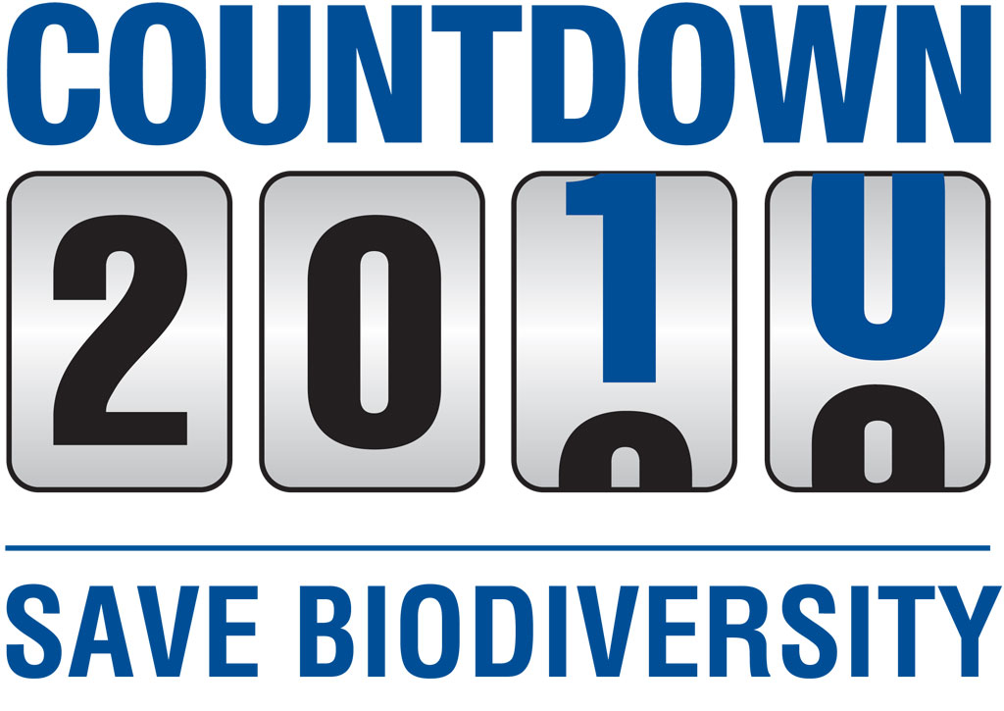

Pan-European Consultation Meeting
28-29 April 2009, Athens

Co-chaired by Sebastian Winkler, Head of Countdown 2010 Secretariat and Ines Verleye, Biodiversity Expert Belgium

Report

Introduction

The Conference of the Parties (COP) of the Convention on Biological Diversity (CBD) at its sixth regular session in the Hague, the Netherlands, adopted the CBD Strategic Plan (SP) which contains in its mission the target of significantly reducing the current rate of biodiversity loss by 2010. During the next CBD COP which will take place in 2010, a new Strategic Plan and a biodiversity related target beyond 2010 will need to be developed in order for COP10 to adopt a follow-up process of the current 2010 target.

The COP at its ninth regular session in Bonn 2008, in adopting decision IX/9 on the revision of the Strategic Plan of the Convention after 2010, therefore invited Parties and observers to submit further views on the revision and updating of the Strategic Plan. Those views will be compiled, together with other relevant information, by the Executive Secretary of the CBD to prepare a synthesis/analysis of issues relevant to the revision and updating of the Strategic Plan. As suggested by the COP, in preparing their submissions Parties are encouraged to facilitate dialogue not only among different sectors of government but also involve the UN major groups, including scientific and academic bodies, indigenous and local communities, and stakeholders.

Objectives
The discussion on the CBD SP and in particular its 2010 target is of high importance to Europe. Not only does the region support the global target, at European level, a more stringent biodiversity target was adopted to “halt the loss" of biodiversity by 2010. It is therefore important that the region can reflect thoroughly on the future of the CBD Strategic Plan, in particular with regards to its own processes and the European biodiversity target.

In order to facilitate this regional reflection as well as to stimulate the input by countries of the Pan European region to the revision of the Strategic Plan, IUCN ROfE / Countdown 2010 Secretariat organized a consultation meeting with relevant Parties and observers. This consultation meeting:
- collected the views of the region on progress towards the global 2010 target and the implementation of the CBD SP,
- facilitated exchange of views on what should be considered in the next CBD SP,
- discussed what kind of CBD target beyond 2010 would be most suitable for the region, and
- discussed what would be the relation to the pan-European processes and in particular the Kyiv target of 2010

The meeting was held in Athens, Greece, back-to-back with the conference organized by DG Environment of the European Commission: "BIODIVERSITY PROTECTION - BEYOND 2010 - Priorities and options for future EU Policy". This provided the opportunity to capitalize on the outcomes of the EC Conference and channel the results of the discussion back to the pan-European Consultation.

Participants
In order to achieve a good and balanced discussion, participants were invited both from EU and non-EU countries as well as representatives of the NGO community and the CBD Secretariat. (Annex)

During the initial round of introduction participants expressed their expectations for the consultation. The main themes were to exchange views and discuss how the regional process can feed into the revision of the SP. Furthermore NGOs provided their views regarding elements needed for the new SP, including the translation of the post 2010 discussions from the EU level to the global level.

What has been the importance of the CBD Strategic Plan?

Before discussing the revision of the Strategic Plan, participants expressed their views on what role the current Strategic Plan has played at national level in particular with regards to the NBSAPs. During the discussion, it became apparent that while the SP is an important guiding document at global and even regional level, it did not directly guide the development and application of national instruments.

Serbia
Serbia indicated that the implementation of Multilateral Environmental Agreements (MEAs) has been an important national issue and that the country ratified several conventions (Bern, Bonn, Carpathian, Kyoto, Aarhus) before the Environment for Europe (EfE) meeting in Kyiv, 2003. Moreover, Serbia is CBD Bureau Member and chair of UNEP GC.
The Serbian National Biodiversity Strategy and Action Plan (NBSAP) was supported by the Global Environment Facility (GEF). A National Strategy on Sustainable Development, Agriculture was adopted, as well as action plans on IAS, Carnivores and ‘Monitoring the impact of climate change on biodiversity’.

Georgia
The Georgian NBSAP was adopted in 2005. It has 10 strategic goals with action plans under each goal of the NBSAP. However the implementation of the NBSAP is limited because there is no adequate monitoring system in place, due to a lack of experience and resources. Currently, Georgia is waiting to finalize its NBSAP until after the new SP. Georgia aims to have an ecological strategy on a eco-regional level, e.g. strategy for marine, strategy for forest, etc.
(put under elements of new SP)

Finland
A NBSAP was designed to be implemented until 2016. Thus, Finland would not renew its current NBSAP with the new Strategic Plan before that time.
With regards to the revision of the SP, it was highlighted that the set of indicators is incomplete (ABS, TK missing) and that the new SP needs to look at that.

Germany
Germany indicated that its NBSAP is linked to the EC strategy but that for the implementation, it is quite a challenge to work in a country with a federal structure.

Denmark
In Denmark, the link between the NBSAP and the SP is limited. With regards to the CBD PoWs, the connection between the “global agenda” and its national adaptation is often missing, e.g.: no references to Addis Ababa principles & guidelines, etc. The CBD therefore influences the national biodiversity policy but rather on general level.

Sweden
The list of obstacles in the current SP was a useful exercise for Sweden when implementing its NBSAP, as it has turned out that the obstacles are mainly at higher – policy – level. This is an issue that the new SP could address and it should be used when discussing the new SP. The value of the SP on the general level was to take the guidance coming from the COP decisions and making that into a more streamlined strategic document.

Switzerland:
The current SP is not used enough – one reason might be that it is too difficult to translate to national level, the overall goals that were established at global level. Furthermore, the SP never got enough public support and it was not shared beyond the CBD community. It would therefore be very useful to have sectoral, as well as policy-level targets that are more relevant and concrete to a larger public.
Having targets on the Pan-European scale as at the EfE meeting in 2003 – resulting in the Kyiv Declaration – was very useful.

Russia
The NBSAP is considered a strategic document, it is used for long term planning. The Action Plans under the Strategy are not time-bound and they are also not quantitative. The NBSAP is integrating the targets of the SP, but does not follow its structure.

Norway
NBSAP puts great emphasis on sectoral integration. After the adoption of the SP and the Kyiv resolution, the NBSAP was amended and now includes the 2010 target as a political target for Norway. The NBSAP has been used by NGOs. However, it was also useful on a policy level to start discussing the 2010 target among politicians.

The difficulty is that the level of knowledge regarding biodiversity is low quality which makes it hard to reach the biodiversity target. Often NGOs – supported with international organizations, projects - have better information and knowledge than governments.

Furthermore public opinion and awareness is also very limited. More resources should be used for increasing awareness and campaigning for biodiversity.

Finally it was stressed that horizontal connections across experts are also very important: as the national CBD Focal Points have limited capacity, their efforts should be supported by other experts both from other conventions and other sectors. The lack of sectoral integration and mainstreaming of biodiversity was generally considered one of the main problems to reach the 2010 target and will need to get sufficient attention in any revised SP.

Moving towards a new Strategic Plan

It was highlighted that the current SP has been a key element in the preparation and implementation of the national biodiversity programs. The new SP therefore should also support the national programs as implementation happens on the ground and financial support should go to the national and/or sub-national programs (ecological network, etc.).

In order to structure the discussions to best contribute to the ongoing developments regarding the revision of the new Strategic Plan, the discussions were concentrated around three sets of questions raised by the CBD Secretariat:

- Content of the Strategic Plan: a) Vision/Target(s) and b) key elements/goals/objectives (including role of sectors, link to existing targets under CBD but also elsewhere (MDGs, etc), the necessary elements, etc.)
- How to deliver this target (means, processes)
- How to monitor progress, problems etc.

All three elements need to be integrated into the new Strategic Plan so that it can provide strategic guidance towards reaching a new target while at the same time offering the tools to do so and monitor the process along the way.

Content of the strategic Plan
- Vision/Target
The most important element of the Strategic Plan as adopted by COP decision VI/26 is the target, which has had the most impact on global and national level. This target has further triggered work on and development of other sub-targets as well as related indicators. In order to structure the work and allow monitoring of progress, it is important to have both shorter and longer term targets with specific (sub)targets besides the overall vision or political long term target.

One of the ways in which the climate change process under the UNFCCC has been successful is in identifying communicable targets. For example the “2 degrees threshold” (2 degrees: avoid dangerous situation: was translated into ‘2 degrees change’) catches the imagination and generates both public and political attention.
The new CBD target should aim at identifying the “2 degrees” for Biodiversity – the threshold beyond which there is no return. The new target should showcase what must be reached in order to avoid the tipping point.

Possibilities mentioned for longer term vision/targets were 2020 – 2050 (to strengthen synergy with the UNFCCC process). In order not to lose the political momentum, the overall vision for the target(s) must be at least as ambitious as the current one (significantly reduce the current rate of loss of biodiversity) and convey a degree of urgency. Restoration should be an important element of the new target(s). Biodiversity and ecosystems should be restored in certain areas, while in others they need to be protected.

Besides the overall political target, specific, measurable sub-targets are needed with interim dates and milestones to take stock of the progress towards the overall target. Those short and middle long term targets should preferably be measurable and of a more scientific nature than the longer term one. The concrete milestones could be identified from the current CBD Programs of Work or could be linked to other processes (e.g. UNFCCC (2015), MDGs (2015), WSSD (2012)).

It is also crucial to consider other conventions and use their targets / objectives as well in order to avoid duplication of work and to streamline resources. Linking the SP to other high level initiatives while integrating medium and short term targets will allow to keep the political momentum and to monitor progress as well.

The new target(s) should address the drivers of biodiversity loss. It has been discussed many times, and was picked up by many fora, This should be an integral part of the new SP – providing a more cross-sectoral approach.

- Objectives/elements
The four objectives of the current SP remain relevant (leadership role of the CBD, NBSAPs & sectoral integration, resources and Capacity building and outreach/integration). However they are too general to provide guidance for national implementation and must be reformulated in a more strategic context. Nevertheless the SP should not replace the Convention. The new SP should also identify how to reach these objectives.

Leadership role of the CBD
There is a global “convention fatigue”, thus emphasis should be given to improving synergies between conventions. This needs to be highlighted in the revised SP although the focus should be towards supporting national action.

NBSAPs & sectoral integration
The main drivers of biodiversity loss are of major importance although it is still a challenge to identify the best methodology to do so. While information will never be complete, the NBSAPs already contain a high level of knowledge even when there’s limited capacity. There is enough information available to analyze losses, drivers, etc. Therefore the precautionary principle should be used based on this information to identify the necessary targets and actions.

Sectoral integration and mainstreaming of biodiversity must be a central element of the new SP. There are several issues for which the new SP could set targets – sustainable use, IAS, GMOs, use of biomass for energy, etc. – and for most of these targets the buy-in from the sectors is crucial. The targets should therefore be formulated in such a way that sectors could work with them. It should be done by involving them already in the development of the targets. The EMG (Environmental Management Group of UNEP) which facilitates cooperation between 44 IGO’s, was asked to engage the global organizations in the reflections regarding the revision of the SP and in particular the new target. By consulting the relevant actors when identifying targets and sub targets that are directly relevant to specific sectors, it will be easier to reach out to the sectors and facilitate cooperation afterwards.

Besides these international sectoral discussions, the same efforts can be undertaken to engage sectors at regional and national levels. The success of involving the sectors in achieving the new targets, will depend on how well it is explained (positive messages need to be identified) and why it is important for them. The “Kyiv” model could be used – the biodiversity community develops the targets but the sectors themselves are quantifying them.

Increased financial, human, scientific, technical, and technological capacity
There are a number of countries which need further support for implementing the Convention. The most appropriate means of support need to be identified, should it be rather pure financial, providing expertise, know-how, training, etc. One possible way could be to turn harmful subsidies to sustainable ones instead of allocating more resources.

Outreach & communication
It is important to communicate well to the public and to have a message that can be understood beyond the biodiversity community. Implementation is only possible if there is a large buy-in from a broad base – “friends” need to be identified and this needs a strong message.
The TEEB report will help to broaden the message beyond the intrinsic value of biodiversity to include the element of ecosystem services.

Climate change can be used as arguments – as ecosystems could easily and quickly go over the “tipping point”. If the Amazon goes over a certain tipping point we know there’s a huge risk of Latin America drying out and the rest of world will suffer severe climate changes. This with TEEB and other info would show clearly why concerted efforts are needed. The TEEB report could further be used for engaging the ministries of finance

Means
Once the targets are established, the identification of the time frame (roadmap) is important. For this, the identification of the means are needed as well – therefore it is important that it is an integral part of the SP. Effective - and new - provisions are needed for achieving the new targets.
It was stressed that the new SP should integrate more actions on ABS, GMOs and highlight the role of the ecosystem approach.

Closer links with UNDP would support implementation of activities at national and regional level. .

A third level of targets to consider is at national level since it is important to have a mechanism to translate a global framework into national targets and later in national strategies. COP7 gave a flexible framework and Parties were invited to include national targets in this framework. By having national targets, it will aid countries to have more ownership. (Long term spatial planning as well as agriculture are crucial, thus they should consider biodiversity objectives. One of the means to reach the objectives of the revised SP is to ensure that sectoral processes at national level integrate biodiversity considerations.

There is further need to improve cooperation on national, regional and international levels, but first of all support at regional level was considered necessary. A “Biodiversity Service Mechanism“ at Pan European level could be quite useful.

Monitoring and indicator framework
The current SP did not have any provisions for monitoring, and this has been identified as a weakness. The inclusion of an adequate monitoring framework in the revision of the SP is therefore crucial. Although the detailed methodology should not be necessarily part of the new SP, the basis and the guiding principles should be part of it.
The framework for the monitoring could be adopted in 2010, with a clear timeline to establish national targets by 2012 and to produce the first progress report in 2015. There should rather be short term reporting cycles (e.g. 3 year) to ensure close monitoring of progress. Moreover, the monitoring needs to cover different levels - from local to global - as it is a challenge to bring the international level to the national level. Very few countries included monitoring in their NBSAPs although more and more countries are working with indicators. Monitoring is also important to quantify biodiversity change for the other sectors, but the data must come from reliable and unbiased sources to increase acceptability by the sectors. (e.g. Norwegian biodiversity data comes from the Science Department, and not the Environment Department). Monitoring activities linked to the CBD SP should be connected to any national, regional and global biodiversity observation networks (e.g. linked to GEOSS: GEOBON).
Indicators will be important in order to measure progress. Many countries already developed indicators based on the relevant CBD decisions. Most of these indicators will remain valid for the coming years and should support the revised SP. However the link between indicator and SP target has been rather weak and the revision needs to strengthen this. Also the use of the CHM (Clearing House Mechanism) for this purpose must be strengthened to support the further development / maintenance of the work on indicators as well as their application.

Way forward

The CBD Secretariat informed the meeting about the process towards the development of a draft revised SP.

Currently a document is being prepared by the SCBD which contains all views expressed by interested parties among others, the December 2008 submissions and the online consultations. Furthermore, the CBD Secretariat will be taking into account elements from the various discussion and consultation processes as well as the outcomes of the Syracuse G8+5 meeting, the “Athens Conference” of the Commission and the regional consultations. Also the outcome of this consultation was taken on board by the SCBD.

Some expert groups will work on specific details of the SP and there are further consultations planned: SADC (Oct09), ASIA (Nov09). In parallel the GBO review will take place. After a second consultation period in autumn of 2009, the SCBD will develop a draft revised SP for consideration by the SBSTTA14 as well as the WGRI3 in May 2010.

The meeting provided for a rich exchange of views which allowed looking at the ongoing process from different angles. The ideas generated by the meeting will be used to support the further thinking about the new SP and can be taken up by other interested parties in the region when preparing their input to the CBD Secretariat on this issue.

Resources
www.biodiversity.fi
www.trondheimconference.org
www.cbd.int/sp/
www.iucn.org
http://www.countdown2010.org
http://ec.europa.eu/environment/nature/biodiversity/conference/index_en.htm
http://www.bmu.de/english/nature/downloads/doc/41253.php

