Ref.: SCBD/SPS/CG/JSH/86109 24 November 2016

N O T I F I C A T I O N
Data on Invasive Alien Species available on the Clearing-House Mechanism of the Convention on Biological Diversity
Dear Madam/Sir,
I am pleased to inform you that the Clearing-House Mechanism of the Convention on Biological Diversity (https://www.cbd.int/countries) now links each country profile webpage to the Global Invasive Alien Species Information Partnership (GIASI Partnership) website, which contains a registry of invasive alien species occurrences. The relevant information can be accessed via the “Invasive alien species” tab on the country profile webpage. Please note that the invasive alien species data is under a Creative Commons licence and is accessible for use by Parties and other experts. I would like to take this opportunity to thank the GIASI Partnership for compiling the data as well as the European Commission for its generous financial support to this partnership.

I encourage Parties, other Governments and relevant organizations to make use of this feature, and welcome any comments you may have on the layout of the webpage to enable the Secretariat, in collaboration with GIASI Partnership, to improve the presentation of the data. Comments on the layout should be sent to secretariat@cbd.int using the attached form as soon as possible but no later than
31 January 2017.

Finally, I would like to take this opportunity to inform you that the Secretariat is organizing a side-event entitled “Facilitation for finding the right information on invasive alien species” to be held on Tuesday, 6 December 2016 at 6.15 p.m. in the margins of the UN Biodiversity Conference in Cancun, Mexico.

Please accept, Madam/Sir, the assurances of my highest consideration.

Braulio Ferreira de Souza Dias
Executive Secretary

Attachment
COMMENT SUBMISSION FORM

Invasive Alien Species on Country Profile Page

Fields with * are mandatory.
Name _______________________________________________________________________
E-mail _______________________________________________________________________
Affiliation ____________________________________________________________________
Occupation* Select your primary occupation from the list below:
- National Government officer; 2. Sub-national Government officer; 3. Research specialist; 4. Other __________________________________________________________________________
Country* ______________________________________________________________________

Q 1.: Did you find your country’s invasive alien species occurrence information easily?

A.1* Yes / No If your answer was No, please explain what problem you encountered.

Q 2.: Is the presentation of the species list in your country (see example below) useful for you to know the status of invasive alien species in your country?

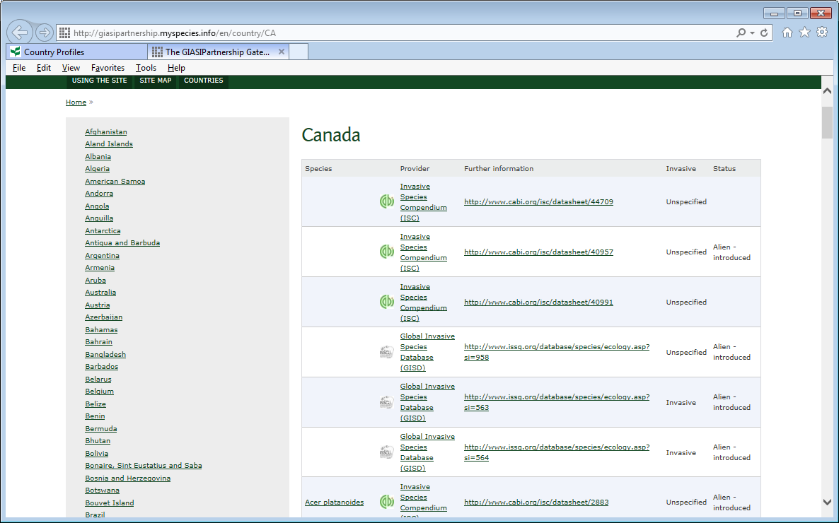

A.2* Yes / No If your answer was No, please explain what was a problem.

_____________________________________________________________________________________

Q 3.: Is the linked information from the species name (see example below) useful for the national planning or reporting? Please specify for what planning or reporting purpose it is relevant to be used.

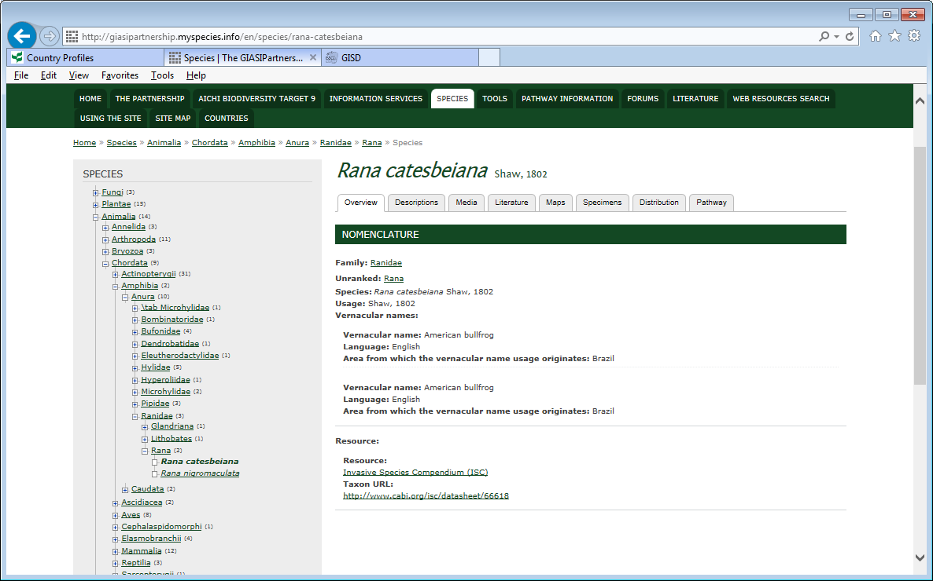

A.3* Yes / No If your answer was No, please explain what was a problem.

Q 4.: If you suggest a different style or form of presentation of the data, please explain. For example, invasive species distribution on a map; pathway of the introduction; risk reduction measures; relevant national regulations (For example, permission from the authority to import or export).

A.4 *_______________________________________________________________________________

Q 5.: If you recommend other data resources to be incorporated in the GIASI Partnership information to be shown on the CBD Clearing-House Mechanism, please indicate its URL and contact point.

A.5*

_ _ _ _ _

