 |  |  | CBD
 |  | CONVENTION ON BIOLOGICAL DIVERSITY |  |  | Distr.  GENERAL  UNEP/CBD/AHTEG-TTSTC/INF/1  23 July 2007  ORIGINAL: ENGLISH AND  SPANISH
Ad Hoc Technical Expert Group on Technology Transfer and Scientific and Technological Cooperation
Geneva, 10 – 12 September 2007
Item 4 of the provisional agenda∗

COMPILATION OF VIEWS ON PROPOSALS AND OPTIONS TO APPLY MEASURES AND MECHANISMS TO TECHNOLOGY TRANSFER AND COOPERATION provided by parties, governments and relevant conventions and international organizations and initiatives
Note by the Executive Secretary
INTRODUCTION
- In paragraph 4 of decision VIII/12, the Conference of the Parties decided to establish an Ad hoc Technical Expert Group on Technology Transfer and Scientific and Technological Cooperation with a view to collect, analyse and identify ongoing tools, mechanisms, systems and initiatives to promote the implementation of Articles 16 to 19 of the Convention, and to propose strategies for practical implementation of the programme of work on technology transfer and scientific and technical cooperation. In paragraph 5 of the same decision, the Conference of the Parties invited ”Parties to make submissions to the Executive Secretary on the proposals and options to apply measures and mechanisms to technology transfer and cooperation (UNEP/CBD/COP/8/19/Add.2) no later than four months prior to the meeting of the Ad Hoc Technical Expert Group” and, in paragraph 6, requested the Executive Secretary “to analyse the views submitted and to forward the results together with the proposals and the views of the Parties to the expert group for its work.” By paragraph 8 of the same decision, the Executive Secretary was requested to invite relevant conventions and international organizations and initiatives to contribute to the work of the Expert Group.
- In order to convey this invitation, notifications 2006-056 and 2006-057 were sent in June 2006 to Parties and Governments as well as relevant conventions and international organizations and initiatives. Reminders were sent in December 2006 (notifications 2006-127 and 2006-128) and in March 2007 (2007-028 and 2006-129).
- The present note presents a compilation of the views submitted. As requested by paragraph 7 of decision VIII/12, the compilation will also be annexed to the report of the meeting of the Expert Group for consideration by the ninth meeting of the Conference of the Parties, to be held in May 2008 in Bonn, Germany.
- The contributions have been reproduced in the form and language in which they were received.

COMPILATION OF VIEWS ON PROPOSALS AND OPTIONS TO APPLY MEASURES AND MECHANISMS TO TECHNOLOGY TRANSFER AND COOPERATION provided by parties, governments and relevant conventions and international organizations
CONTENTS
Page
I SUBMISSIONS FROM PARTIES
Colombia………………………………………………………………………………………..3
Cuba…………………………………………………………………………………………….7
Germany………………………………………………………………………………………...9
II SUBMISSIONS FROM RELEVANT CONVENTIONS AND
INTERNATIONAL ORGANIZATIONS
The International Chamber of Commerce (ICC)………………………………………….........12
United Nations Environment Programme (UNEP)……………………………………………..15

I SUBMISSIONS FROM PARTIES

COLOMBIA
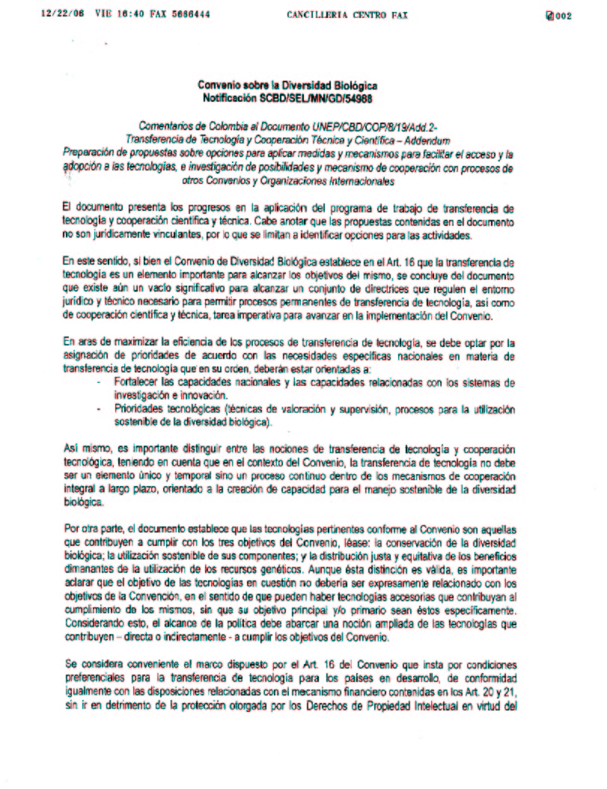
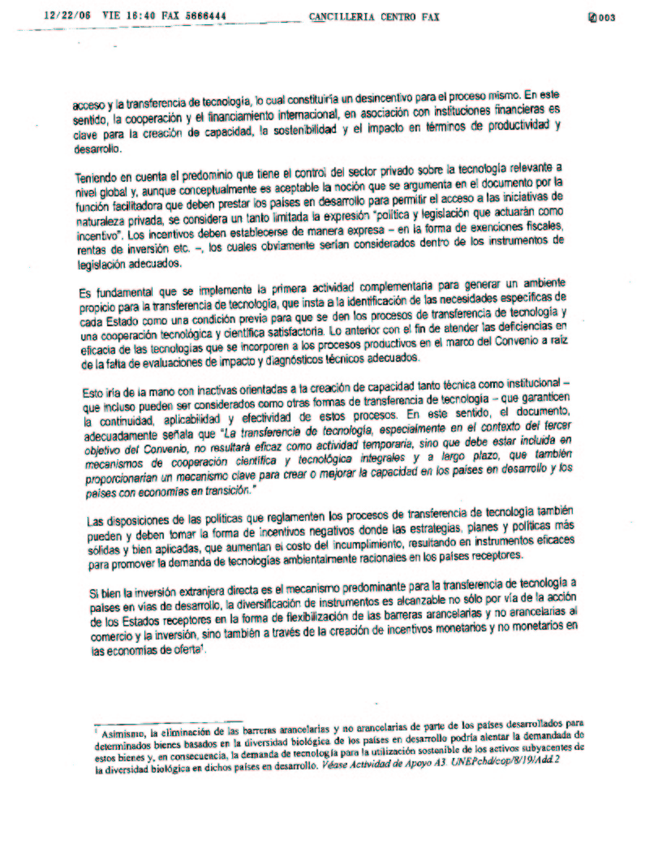

CUBA

Observaciones al documento sobre Transferencia de Tecnología Cooperación Técnica y Científica en el Marco del Convenio de Diversidad Biológica
Como resultado del análisis del documento UNEP/CBD/COP/8/19/Add.2 hemos arribado a las siguientes observaciones:
- En el párrafo 14 consideramos importante explicitar lo referente a la capacidad de absorción de las transferencia de tecnología que deben poseer los países receptores, los que deben contar con determinados conocimientos y aptitudes para poder adoptar con éxito los conocimientos tecnológicos foráneos.
La capacidad de absorción abarca las fases de aprendizaje y adaptación de la transferencia de tecnología y la misma está determinada por los siguientes factores:
- El nivel y la naturaleza del sistema de enseñanza;
- La aplicación de los resultados de la investigación básica a usos concretos y el desarrollo de nuevos productos;
- Régimen de propiedad intelectual empleado en el país receptor;
- El desnivel tecnológico entre la tecnología usada en el mercado nacional y el de la tecnología que se importa;
- Capacidad de los empresarios locales de hacer inversiones arriesgo, y a sus aptitudes en materia de gestión y organización empresarial.
- En el párrafo 17 proponemos adicionar al final: En ocasiones ocurre que durante el proceso de cooperación científica y tecnológica entre países desarrollados y países en desarrollo se produce transferencia de conocimientos y tecnología como resultado del éxodo de profesionales universitarios y tecnólogos hacia los países desarrollados, por diversos motivos vinculados con vías mas expeditas para alcanzar niveles superiores de especialización, mejoras económicas, etc. En general, en este éxodo el capital humano que se traslada hacia los países desarrollados es el de mas alta calificación.

Estos problemas provocan que se produzcan desequilibrios en la equidad de los procesos de cooperación y como consecuencia de ello se profundizan y ensanchan las diferencias entre los países en desarrollo y los desarrollados.

GERMANY

View submitted by Germany

Notification 2006-057 und 2006-127
Decision VIII/12: technology transfer and cooperation

1. Germany appreciates the information on the proposals and options to apply measures and mechanisms to technology transfer and cooperation contained in document UNEP/CBD/COP/8/19/Add.2

2. In general we believe that it is urgently needed to make a real effort in translating the today academic theories and our commitments presented in the decisions on TT into action. This may be done in small steps in a well designed step-by-step approach and by learning by doing but it could also, if the framework allows such development, done in an ambitious broader and visionary approach.

3. Any effective implementation and development of TT relevant to the Convention depends on a clear commitment by all Parties. We fully agree with para 14 (a) that biodiversity TT needs to be driven by demand/the recipient country needs. This requires as a crucial precondition that the host country must assess what knowledge and technologies are needed. This further requires that this shall be part of a national implementation plan which indicates the national actors and who needs which technology.

4. Only a clear understanding of the concrete TT needs relevant to the Convention by Parties will allow a focussed commitment and strategic support in implementing the PoW TT and any related activities in support.

5. We also believe that it will be necessary to adopt a general understanding of the term “technology transfer”. The EG TT CBD has started to reflect on “technology transfer” and “technology cooperation”. We should find a definition which reflects both concepts. To facilitate this discussion we have attached in Annex (a) two definitions of “technology transfer”. One is presented in our publication “TT via the German CHM” and the other stems from the IEA/CTI document “Technology without Borders”.

6. Before starting the development and implementation of an extensive work programme with heavy work load on TT it will be also important to clearly “screen” the existing initiatives actually facilitating TT relevant to the Convention. The document contains two good examples of such initiatives: the ISAAA and the CGIAR.

7. It may be a result of the national analysis of the concrete needs of technologies relevant to the Convention that new initiatives like ISAAA may be created by “pooling patents” and technologies for developing countries and countries in transition facilitating an easier access to and the transfer of those technologies, including long-term partnerships and capacity building.

8. We should avoid duplication of efforts and make maximum use of synergistic work between the different TT-Expert Groups of the CBD and UNFCCC as well of the joint liaison group of the three Rio conventions. In bundling efforts the private sector may become more interested in mobilizing financial and technological resources that match the TT needs relevant to the Convention. This could also help to broaden the base of financing for TT.

9. Information systems are supportive elements to the development of the PoW on TT. But they can not replace personnel contacts. The Clearing-House Mechanism (CHM) of the CBD should be developed and promoted as the relevant mechanism to disseminate information on technologies and best practices in technology transfer relevant to the Convention. It will be an important task to design the role and functionality of the information system facilitating TT. Any development in this direction needs to be based on concrete needs and also expectations presented by Parties and future users. The role and niche of the CHM in this respect should be clear. Any development should be demand-driven and not contain all and any area of technology. This development should be discussed in conjunction with the IAC CHM.

10. It will be also of importance to introduce new concepts on “facilitating TT” at CBD meetings like COP and SBSTTA. As we stated before the predominant majority of any TT is based on former personnel contacts – meetings. These meetings allow the exchange of ideas and facilitate contact building between future partners. We should discuss how we could make practical use of future COP and SBSTTA meetings for “TT match making” and contact building purposes. One option could be to organise special and TT-focussed “TT Fairs” or workshops “To Meet the Need” (see para 56). This could be for example done by identifying the needs of a sub-region/country and bring relevant technology supplier to this meeting.

11. It will be crucial of successful TT to promote policies and institutional changes that lead to the removal of barriers and increased market penetration of biodiversity friendly technologies.

12. We generally support the idea to identify if appropriate a central national consulting point on technology access and transfer (section D. page 8). This central consulting point could be the CHM NFP itself who might organise the relevant activities related to the use of the CHM as the information mechanism of the CBD to facilitate access to and transfer of information on CBD relevant technologies.

13. We also support the idea of the AHTEG on TT exploring the value of a Biodiversity Technology Initiative (BTI) as a central initiative for the implementation of an overall Biodiv-TT-Strategy. One major role of a BTI could be Capacity Building through workshops and training seminars but also a facilitator in preparing project proposals for Technology cooperation.

14. The Equator-Initiative should be much more promoted and disseminated as important initiative offering a basket of practical TT experiences relevant to Developing countries.

15. In any TT or T. cooperation activity it will be important to carefully consider the adaptation and impact assessment (risk assessments) of the transferred technology.

16. We also see a need to analyse the existing materials as guidelines, hand-books (UNDP-GEF Handbook on Tech. Needs Assessment) etc. relevant to technology transfer and explore the potential and practical applicability of these materials for the purpose of the Convention.

17. In support of the first implementing steps of the PoW of TT Germany is undertaking a concrete national survey on existing, biodiversity relevant technologies. The result will be a “catalogue of biodiversity related technologies/technology suppliers” which is the basis for any future contribution to TT.

Annex (a) Two descriptions of Technology Transfer

1) Source: BfN Skript 160 “Technology Transfer via the Clearing-House Mechanism (CHM), 2005, DE-CHM.
The real value of any TT lies in the local adaptation and integration of the technology on community or national level. The whole process integrates transfer of knowledge and hardware as well as capacity building, training and financial support. TT should enable the recipient to control and further develop the technology according to his needs so that it contributes in a sustainable way to strengthen local economies, to generate additional income and to reduce poverty. This should be realised in long-term technology cooperation partnerships.
2) Source: Technology without Borders – International Energy Agency / CTI 2001
What do we Mean by Technology Transfer?
The Report defines the term “technology transfer” as a broad set of processes covering the flows of know-how, experience and equipment for mitigating and adapting to climate change amongst different stakeholders such as governments, private sector entities, financial institutions, non-governmental organisations (NGOs) and research/education institutions.
Therefore, the treatment of technology transfer in this Report is much broader than that in the UNFCCC or of any particular Article of that Convention. The broad and inclusive term “transfer” encompasses diffusion of technologies and technology co-operation across and within countries. It covers technology transfer processes between developed countries, developing countries and countries with economies in transition, amongst developed countries, amongst developing countries and amongst countries with economies in transition. It comprises the process of learning to understand, utilise and replicate the technology, including the capacity to choose it and adapt it to local conditions and integrate it with indigenous technologies.
The Report generally makes a distinction between developed and developing countries. Although economies in transition are included as developed countries under the UNFCCC, they may have characteristics in common with both developed and developing countries.

II SUBMISSIONS FROM RELEVANT CONVENTIONS AND
INTERNATIONAL ORGANIZATIONS

INTERNATIONAL CHAMBER OF COMMERCE (ICC)

ICC Contribution to Preparation Work of the CBD Ad Hoc Technical Expert Group on Technology Transfer and Scientific and Technological Cooperation

Comments on document UNEP/CBD/COP/8/19/Add.2 per the notification dated 5 June 2006, concerning the proposals and options to apply measures and mechanisms to technology transfer and cooperation

The ICC is grateful for the opportunity to provide comments on the proposals and options to apply measures and mechanisms to technology transfer and cooperation, and welcomes the intensified work envisioned in the coming months on this subject. Given the private sector’s critical role in effecting technology transfer and scientific and technological cooperation, the ICC also looks forward to being a partner in work aimed at eliminating obstacles and facilitating both access to and adaptation of technologies with the necessary accompanying know-how.

General Comments
The ICC places high priority on development of effective technology transfer policies that promote the capacity of people to benefit economically and/or socially from innovation. More specifically, technology transfer is the process of developing practical applications from the results of scientific research.

There is an important role for governments in funding basic research and promoting science literacy. However, technology transfer policies need to rely on the marketplace for commercialization of basic science if society is to benefit from the strength of the market in distributing resources, as shown through examination of national experiences. An effective and successful technology transfer system incorporates both government support and private sector incentives and is based on three pillars:

- A durable government commitment to science in education, research, regulation and related infrastructure. There is no substitute for a national commitment to science literacy in education and research, and also in enforcing systematic science-based regulation. Without commenting on funding options, it is vital for the government to create an enabling environment for science and technology by investing in education and training, supporting basic and early applied research, and improving technology-related physical infrastructure. Clear and consistent processes for meeting legal requirements underpin science-based regulation.

- Broad rule-of-law protections, including strong intellectual property protections (IPP), in a just and consistent court system. The assurance of a rule-of-law culture (enforceable contracts, accurate and fair court systems, etc.) justifies investment and enables innovation for all commercial actors, both local and foreign. Among these rule-of-law protections, effective IPP protects commercially valuable, proprietary materials and/or information, and is essential to promote technology transfer. This is particularly true in innovative industries using new technologies, where patents are the primary assets for generating investment in innovative but risky endeavors. It is important that strong, predictable protections are afforded for all inventions.

- Legal means for private actors to benefit from investment in technology transfer. ICC recognises that countries operate under a range of political systems. Market-oriented policies encourage risk taking and increase private sector investment because the market can provide rewards commensurate with risks taken by entrepreneurs. Moreover, cross-border investment generates technology spill-over effects including through the transfer of proprietary technologies, know-how and management techniques. Private sector engagement in technology transfer is driven by a potential opportunity to realise financial benefits from the investment

Specific Comments

- The ICC agrees that prioritization is necessary to ensure the success of work on this topic and recommends that efforts focus on the following:

- Making full use of information systems (programme element 2) to increase access to information about new technologies, their uses, potential, and case studies about the transfer of technologies and adaptations made to date;
- Conducting a review of national trade policies, investment regimes and export controls to ensure that they support technology transfer (options iii, iv, and xi).
- Providing guidance to countries on programmes to enhance access to capital, guarantees, etc for small and medium-sized companies (option viii) and to public institutions on options for working in consortia, etc. (option xiii); creating twinning arrangements (option xiv); and public-private partnerships (option xv);
- Creating incentives for the private sector and foreign actors to engage in technology transfer (options xvii and xviii).

- The ICC is particularly supportive of the proposal (see item S6) to hold international technology fairs and workshops in connection with Convention meetings to bring together technology providers and users but also to build awareness among delegates of the important role of technology in achieving the Convention’s objectives.

- The ICC believes that a separate body or group to serve as a “consulting point” on technology access and transfer (see option xii) is not necessary under the Convention but that the Convention could serve a central role in providing information (both about available technologies and needs) through the Clearing House and other information systems.

- We do not see as a priority and, in fact, have concerns about undue focus on technology assessment (programme element 1) as a means of contributing to enabling environments. Any efforts to harmonize or guide or dictate such assessments may well result in administrative requirements or other filters that serve to block governments, organisations, companies or institutes from obtaining necessary new technologies rather than facilitate timely access.

- We also are concerned about the terminology found in Document 8/19/Add.2 and its predecessor documents that suggests the need for impact assessments and risk analysis to “ensure that transferred technologies are economically viable, socially acceptable and environmentally friendly.” Countries, and their citizens, should be free to evaluate and seek access to new technologies without screening or steering from the international community because what is economically viable or socially acceptable will vary widely among countries but also within countries. Under Article 16 of the Convention, the technologies for which we must create enabling environments are those “that are relevant to the conservation and sustainable use of biological diversity or make use of genetic resources and do not cause significant damage to the environment,” not a subset of this which some - but not others - may consider to be “socially acceptable” or “environmentally friendly.” Relevant impact or risk assessments by regulatory authorities should be made available, along with information about the technologies, via the information systems discussed above.

In short, many of the options already identified can be expected to contribute to the shared goal of increased access to and transfer of technologies as well as enhanced scientific and technical cooperation and the ICC is ready and willing to work as a partner in the Convention process to realize these goals. Great care must be taken, however, that the very effort aimed at creating enabling environments does not itself create barriers or administrative burdens that undermine our objective. Similarly, expert and working groups established under the Convention for other purposes, should be informed of the work being undertaken to facilitate technology transfer and cooperation and ensure that their own work does not frustrate these efforts by creating new barriers.

UNEP DTIE International Environmental Technology Centre (IETC)
United Nations Environment Programme
Division of Technology, Industry, and Economics

IETC is active in the four areas relevant to document UNEP/CBD/COP/8/19/Add.2: technology assessment, information systems, creating enabling environments and capacity-building and enhancement. It should be noted, however, that most IETC activities are focused on industry and pollution control technologies rather than biodiversity-related technologies.

Regarding technology assessments: IETC has developed a Sustainability Assessment Tool (SAT), which guides a potential buyer through the process of assessing various technologies according to economic, environmental and social criteria. The methodology is still in the testing stage, and IETC is planning to test it in several projects in order to verify the relevance and usefulness of the methodology in selection processes. The goal is to have a final version ready within 6 months to 1 year.

Regarding information systems: IETC has decided to discontinue its technology database, Maestro, which was a internet-based information system where technology producers were encouraged to provide basic information about their technologies. Maestro was discontinued for a number of reasons, including the fact that the number of new technologies listed in the database was relatively low as compared to the technologies actually available and being developed. Moreover, the database was not up-to-date, and therefore risked becoming misleading in some cases. Ensuring the database was kept up-to-date would have required significant financial resources to, among other things, actively search for new technologies. IETC did not have the resources required to maintain such an up-to-date and comprehensive database.

As an alternative, IETC developed an internet-based information system (ESTIS) for technology networks to be able to share experiences and lessons learned. This system, which is free of charge, can also be used to share experiences within specific networks. UNEP is currently using this system for network management, and the World Health Organization and the United Nations Department of Economic and Social Affairs have also started using this tool. IETC establishes and maintains servers around the world so the users do not have to maintain their own servers. Please see http://www.estis.net/ and/or contact Mr. Robert Rodriguez (ietc@unep.or.jp) for more details.

The same internet-based system could also serve as an enabling environment, where specific, targeted networks linked with specific issues could operate and share information and best practices. The network may also be a useful tool in the promotion of South-South cooperation.

Regarding capacity building: IETC almost always includes a capacity building component as a part of any project, but, as stated earlier, IETC is mainly focused on pollution control/industrial technologies. However, a few of the capacity building activities aimed at Government ministries, local authorities, local communities and universities, under the UNEP Iraqi Marshlands project, included elements of biodiversity management as their focus.

In addition to these comments, IETC has the following general observations on the document:

- The document appears as more as a “wish list” of possible activities and would benefit from prioritisation. For example, there are no cost estimates included, which adds to the impression that this is just a first attempt to put all possible ideas on the table. Although this may be a good point of departure for discussion, it will be important at some point for specific activities to be prioritized and linked to costs.
- The document appears more delivery-driven rather than demand-driven. Although it is useful for various UN agencies, and other international groups, linked with this issue to provide information on what they are doing and/or where they can deliver support, it will be essential that this be met by real needs, expressed by the potential users.
- Best practices and various techniques are not really covered in the document. One would assume that there is significant knowledge at the national and local level that can be utilized by other countries.
- The document says little about the experiences gained through scientific research and how these results can be widely disseminated. In a field like integrated pest management, for example, there have been a number of interesting field experiences that could be replicated by others depending on the information provided in research journals.
- The document tends to focus on legal, trade and finance-related issues, which may not be a priority in the short run. Again, the more practical approaches and needs should be covered in order to balance out the delivery approach.

Finally, it should be noted that neither UNEP nor most international organizations are involved in technology transfer per se. Rather, technology transfer is normally conducted through business-to-business arrangements. The document does make clear, however, that current national import tax system, particularly in some developing countries, may represent a barrier for the import of cutting-edge technologies.

-----

 UNEP/CBD/AHTEG-TTSTC/1.
Finston SK. 2007. “Technology Transfer Snapshots from Middle-Income Countries: Creating Socio-Economic Benefits through Innovation”. In Intellectual Property Management in Health and Agricultural Innovation: A Handbook of Best Practices (eds. A. Krattiger, RT Mahoney, L Nelsen, et al.). MIHR: Oxford, U.K., and PIPRA: Davis, U.S.A. Available online at www.ipHandbook.org.
OECD, 2006, “Economic and Other Impacts of foreign Corporate Takeovers in OECD Countries”, p10

