 |  | CBD
 |  |  |  | Distr.  GENERAL  UNEP/CBD/SBSTTA/15/INF/7  6 September 2011  ENGLISH ONLY
SUBSIDIARY BODY ON SCIENTIFIC, TECHNICAL AND TECHNOLOGICAL ADVICE
Fifteenth meeting
Montreal, 7-11 November 2011
Item 4.3 of the provisional agenda*

Livelihood alternatives for the unsustainable use of bushmeat
Note by the Executive Secretary
- The Executive Secretary is please to circulate herewith, for the information of participants in the fifteenth meeting of the Subsidiary Body on Scientific, Technical and Technological Advice, an information document on livelihood alternatives for the unsustainable use of bushmeat of the Convention on Biological Diversity, prepared by a consultant in preparation for the joint meeting of the Liaison Group on Bushmeat and the Central Africa Bushmeat Working Group of the Convention on International Trade in Endangered Species of Wild Fauna and Flora (CITES), held in Nairobi from 7 to 10 June 2011.

Livelihood Alternatives for the Unsustainable Use of Bushmeat
- Report prepared for the CBD Bushmeat Liaison Group -
Nathalie van Vliet, May 2011
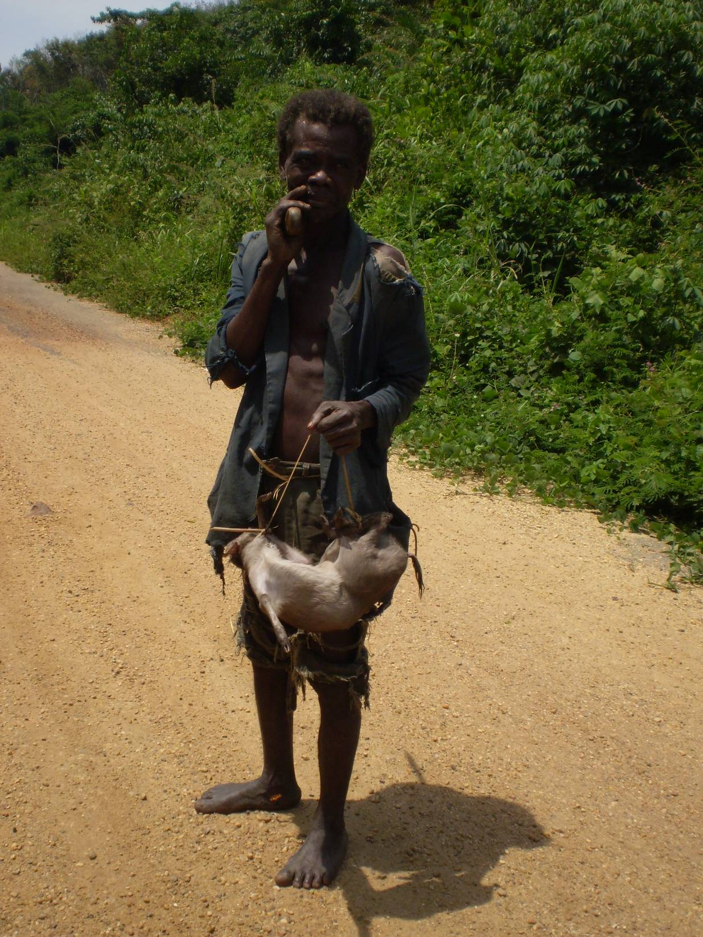

Table of contents
Table of contents 3
List of Figures 4
Introduction 5
1. Context 5
2. Justification, objectives and approach 6
2.1. Justification of the study 6
2.2. Objectives 6
2.3. Approach 6
3. Geographical focus 6
4. Definitions 7
Role of bushmeat in people´s livelihoods 8
5. Bushmeat consumption 8
5.1. Levels of bushmeat consumption 8
5.2. Reasons for bushmeat consumption 10
6. Bushmeat as a source of income 12
6.1. Subsistence and commercial hunting 12
6.2. Importance of bushmeat in household´s economy 12
6.3. Income generated all along the bushmeat market chain 13
Small scale livelihood alternatives to the unsustainable use of bushmeat 14
1. Diversification of income sources 14
1.1. Principle 14
1.2. Examples 15
1.3. Difficulties and risks 17
2. Production of domesticated sources of meat 19
2.1. Principle 19
2.2. Examples 19
2.3. Difficulties and risks 20
3. Mini-livestock breeding with indigenous species 21
3.1. Principle 21
3.2. Examples 21
3.3. Difficulties and risks 22
4. Community based Wildlife Management 24
4.1. Principle 24
4.2. Examples 24
4.3. Difficulties and risks 26
5. Game ranching 26
5.1. Principle 26
5.2. Examples 27
5.3. Difficulties and risks 28
6. Payments for environmental services and Certification 29
6.1. Principle 29
6.2. Examples 30
6.3. Difficulties and risks 32
Requirements and recommendations for scaling up successful approaches 33
1. Local specificities versus global patterns 33
2. Alternatives “where”, “to what” and “for whom” 34
3. Likelihood for substitution 34
4. Monitoring the social, economic and environmental impacts 35
5. More supportive legal frameworks and policies 35
6. Beyond boundaries: multi stakeholder interactions at the landscape level 36
Acknowledgements 36
References 37
List of persons contacted 44

List of Figures

Figure 1: Geographical distribution of tropical and subtropical dry and moist forests (source:www.ecoworld.com/) 7
Figure 2: Tortoises sold in a Chinese market (© TRAFFIC, Ling Xu) 8
Figure 3: Young kid showing a hunted hornbill near Kisangani, DRC (©Nathalie van Vliet) 10
Figure 4: Meat of red brocket deer in a community neighbouring the Calakmul Reserve (Mexico) (©Nathalie van Vliet) 12
Figure 5: Smoked bushmeat sold in Mamfe, South West Cameroon (©Nathalie van Vliet) 14
Figure 6: Hive construction during a training workshop in Lebialem, Cameroon (© Julie Wright) 16
Figure 7: Huaorani women preparing bushmeat in Ecuador (© UICN- TRAFFIC. Nicolás Kingman) 17
Figure 8: Cocoa seedlings introduced in communities around Takamanda National Park (Cameroon) as an alternative income generating activity (©Nathalie van Vliet) 18
Figure 9: Pig farms developed by Community Action for Development in the Southern Bakundu Reserve area (© CAD) 20
Figure 10: Grasscutter farm at the Faculty of Agronomy, University of Kisangani (Democratic Republic of Congo) (©Nathalie van Vliet) 24
Figure 11: Young men showing a Sykes monkey in Tanzania (© Martin R. Nielsen) 33

Introduction

Context
In tropical areas worldwide, the use of wildlife has important livelihood aspects and serves multiple roles. Wildlife products are often major items of consumption or display and have high medicinal and spiritual values in many human cultures (Scoones et al., 1992). The meat of wild animals has long been a part of the staple diet of forest-dwelling peoples (Elliott et al., 2002). Bushmeat remains a primary source of animal protein for the majority of forest families (Wilkie et al., 2005), and can also constitute a significant source of revenue (Milner-Gulland et al., 2003), particularly where the trade is driven by increased bushmeat consumption in urban areas. Besides, bushmeat also plays a special role in the cultural and spiritual identity of indigenous peoples. Acquisition of animal parts as cultural artefacts, for personal adornment or for hunting trophies is still a widespread practice throughout tropical forest regions and the rest of the world (Nasi et al., 2008).

Estimates of bushmeat harvest across the Congo Basin range between one (Wilkie & Carpenter, 1999) and five million tonnes per year (Fa et al., 2003) with harvest rates appraised at between 23 and 897 kg/km²/year (Nasi et al., 2008). In the Brazilian Amazon, subsistence hunters have been estimated to harvest some 23.5 million individual animals annually for food (Bennett & Robinson, 2000) with the yearly market value of wild game meat harvested by rural population estimated at US$ 191 million, second only to timber as a forest product (Peres 2000a; Peres 2000b). In Asia, the true scale and value of the wildlife trade are unknown, as much of the trade is carried out through informal networks, and not documented in government statistics (TRAFFIC, 2008). Many countries in the region including, Cambodia, Indonesia, Lao People’s Democratic Republic (Lao PDR) and Vietnam, act as major sources of wildlife that is traded and consumed.

There is compelling evidence that the scale of current hunting is a serious threat to many forest species and ecosystems. Local extirpation of hunted species is widespread, with West and Central Africa particularly affected (Milner-Gulland et al., 2003). Many large animals have already gone ecologically extinct in vast areas of neotropical forest areas (Redford, 1992). Hunting is (like other human extractive activities in tropical forests), depending on the scale, a disruptive process. It can and does trigger numerous indirect effects, which in turn alter both (i) the hunted populations and (ii) the functioning, structure and composition of the ecosystem (Nasi et al., 2010). The loss of wildlife from forest ecosystems can lead to the disruption of ecological and evolutionary processes, through changes in species composition within ecosystems and a general reduction in biological diversity (Emmons, 1989; Redford, 1992) creating “Empty Forests”.

In 2008, the Conference of the Parties to the Convention on Biological Diversity (CBD) identified the unsustainable hunting of bushmeat, and its effect on non-target species, as a priority to be addressed by Parties (Decision IX/5). Based on articles 10 (c) on customary sustainable use rights, and 8(j) on traditional ecological knowledge, the CBD seeks to incorporate the cultural, nutritional, medicinal and economic values of bushmeat for indigenous people in any strategy to reduce the ecological impact of hunting. In October 2009, the CBD Liaison Group on Bushmeat held its first meeting and elaborated National and International Recommendations towards the Sustainable Use of Bushmeat, based on information contained in CBD Technical Series No. 33, “Conservation and Use of Wildlife-Based Resources: The Bushmeat Crisis”. The meeting was convened in collaboration with the Food and Agriculture Organization of the United Nations (FAO) as well as the Center for International Forestry Research (CIFOR) and the International Council for Game and Wildlife Conservation (CIC).

Justification, objectives and approach

Justification of the study
Because bushmeat plays a crucial role in the diets and livelihoods of people, options to reduce harvest levels, other than “blind banning”, have been investigated both by conservation and development planners. More particularly, the development of small scale alternatives to the unsustainable bushmeat harvest and trade is one of the options that has received most attention as a solution to mitigate the impacts of hunting on biodiversity and the functioning of forest ecosystems. However, the diversity of activities and approaches implemented as “alternatives to bushmeat”, the diversity of institutions involved and scales of intervention, and the absence of an adaptive management approach based on the internal evaluation of projects, translates into a lack of a global synthesis with regionally or globally relevant recommendations for the implementation of small scale alternatives to unsustainable bushmeat use.

This document addresses small-scale food and income alternatives to bushmeat in tropical and sub-tropical countries based on the sustainable use of biodiversity. It was prepared for the Secretariat of the Convention on Biological Diversity (CBD), in response to the request from the Conference of the Parties, at its tenth meeting in October 2010, to ‘In order to support current and future livelihood needs and to reduce unsustainable use of bushmeat, develop, through the Liaison Group on Bushmeat and in cooperation with the Food and Agriculture Organization of the United Nations, the United Nations Development Programme, the Center for International Forestry Research and other relevant organizations and based on available case-studies, options for small-scale food and income alternatives in tropical and sub-tropical countries based on the sustainable use of biodiversity, and submit a report for the consideration by the Subsidiary Body on Scientific, Technical and Technological Advice at a meeting prior to the eleventh meeting of the Conference of the Parties, and to submit to that meeting a revised version of the recommendations of the Liaison Group on Bushmeat’ (Decision X/32).

Objectives
The objectives of this report are to list possible options for small-scale alternatives to the unsustainable use of bushmeat, describe examples of success stories and/or failed approaches in Africa, Latin America and Asia/Pacific, and provide recommendations relevant at regional or global levels. The first section of this report provides a general background and a regional comparison of the role that bushmeat plays both for food and as a source of income. It is indeed essential to know who depends on bushmeat, how dependant they are and for what reason, before searching for possible alternatives. The second section describes different types of alternatives with examples of application and a description of the main difficulties and risks associated with each of the alternatives. The third section describes the requirements for successful policies and measures to establish livelihood and income alternatives and provides recommendations for scaling up successful approaches.

Approach
The information described in this report was obtained through a combination of approaches:
- a review of the existing scientific literature and project reports on small scale alternatives to the unsustainable use of bushmeat (using Isi Web of Science and Google scholar)
- a review of websites from projects and institutions involved in development of small scale alternatives to the unsustainable use of bushmeat
- interviews with experts with experience in the implementation of small scale alternatives to the unsustainable use of bushmeat.

Geographical focus

The geographical focus of this study comprises the tropical and sub-tropical moist and dry forests as defined by Olson et al. (2001). Tropical and Subtropical Moist Forests are generally found in large, discontinuous patches centered on the equatorial belt and between the Tropics of Cancer and Capricorn. They are characterized by low variability in annual temperature and high levels of rainfall (>2000 mm annually). Forest composition is dominated by semi-evergreen and evergreen deciduous tree species.

Tropical and Subtropical Dry Forests are found in southern Mexico, south-eastern Africa, the Lesser Sundas, central India, Indochina, Madagascar, New Caledonia, eastern Bolivia and central Brazil, the Caribbean, valleys of the northern Andes, and along the coasts of Ecuador and Peru. Though these forests occur in climates that are warm year-round, and may receive several hundred centimetres of rain per year, they deal with long dry seasons which last several months and vary with geographic location. Deciduous trees dominate these forests, and during the dry season a leafless period occurs, which varies with species type. Because trees lose moisture though their leaves, the shedding of leaves allows trees such as teak and mountain ebony to conserve water during dry periods.

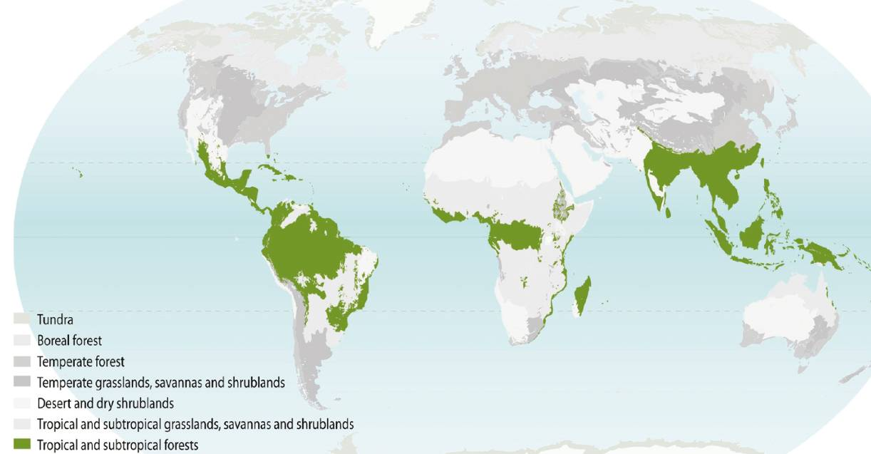

Figure 1: Geographical distribution of tropical and subtropical dry and moist forests (source: www.ecoworld.com/)

Definitions

Bushmeat
The CBD Bushmeat Liaison Group defines bushmeat (or wild meat) hunting as the harvesting of wild animals in tropical and sub-tropical forests for food and for non-food purposes, including for medicinal use (CBD, 2009). The main focus of this paper is on use for food, which is, by far, the largest use and includes any non-domesticated terrestrial mammals, birds, reptiles and amphibians harvested for food or other purposes. While invertebrates can be locally important dietary items, it is the larger vertebrates which constitute the majority of the terrestrial wild animal biomass consumed by humans. Insects, crustaceans, grubs, molluscs and fish are excluded from this definition and will not be addressed in depth. However the links between bushmeat, fish and invertebrate harvesting will be explored.

Alternatives to the unsustainable use of bushmeat
In this document, alternatives to the unsustainable use of bushmeat are analysed both in rural and urban settings and include alternatives for both consumption and trade. Alternatives to unsustainable bushmeat consumption include bushmeat from sustainable sources (sustainable hunting or domestication of wild animals) or the provision of other sources of protein that are considered substitutes by bushmeat consumers. Alternatives to bushmeat trade are those that provide other sources of income that effectively reduce wildlife trade and reduce pressure on natural resources to sustainable levels.

Sustainable use of natural resources
Article 2 of the Convention on Biological Diversity defines sustainable use as: The use of components of biological diversity in a way and at a rate that does not lead to the long-term decline of biological diversity, thereby maintaining its potential to meet the needs and aspirations of present and future generations. In practical terms, a sustainable use is one which is perpetuated over the long term. Often local interest in the resource is an important factor in maintaining its quality. Obviously as one cannot sustainably use a resource that has vanished, the statement that sustainable use is a form of conservation has some merit. It should be clear that all uses, consumptive or non-consumptive, will impact ecosystems in some way. These impacts will translate into more or less dramatic effects on the local environment depending on what is harvested and how. Ultimately, for bushmeat use and alternatives to be sustainable, they must be so from social, ecological and economic viewpoints.

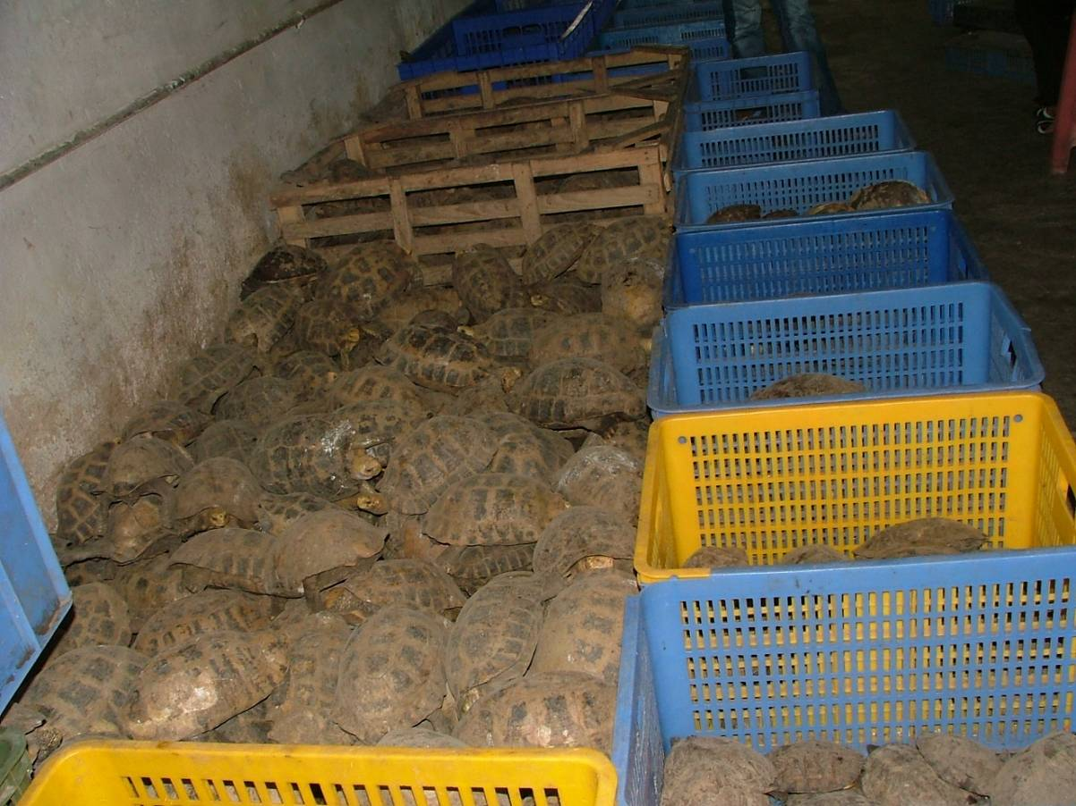
Figure 2: Tortoises sold in a Chinese market (© TRAFFIC, Ling Xu)

Role of bushmeat in people´s livelihoods

Bushmeat consumption

Levels of bushmeat consumption

Bushmeat consumption in rural areas
The reality in rural Africa is that for the greater majority of people, bushmeat represents a vital dietary item, but high variations across the continent exist. In the Congo Basin, rural bushmeat consumption ranges from 14.6 to 97.6 kg/capita/year (Fargeot and Dieval, 2000; Starkey, 2004). Hunting provides between 30 to 80% of the overall protein intake of rural households in Central Africa and nearly 100% of animal proteins (Koppert et al., 1996). In Southern and Eastern Africa, rural communities also rely on wild animals for their nutrition. In the period of food shortage, forest game, caterpillars and grasshoppers are highly exploited for food. A recent study in Tanzania shows that bushmeat consumption in communities around Serengeti National Park range from 10.95 to 32.4 kg/capita/year depending on the location and the ethnical group (Ndibalema and Songorwa, 2008). In those cattle ranching communities, livestock meat and fish also showed a reasonable contribution in the daily protein intake (6.9 to 39 kg/capita/year of domesticated meat and 4.38 to 73.3 kg/capita/year of fish). In West African countries, several studies have documented bushmeat consumption but most of them already date from before the nineties. Although marine and freshwater fish are the primary source of animal protein consumed in West Africa, bushmeat consumption figures range from 20% of the animal protein among rural people living in Nigeria's rain forest areas, to 75 % in rural Ghana, and to as much as 80-90 % in Liberia (Ntiamoa-Baidu, 1997).

In Latin America, the main studies on bushmeat consumption have focussed on the Amazon region, particularly in indigenous communities. Indigenous people, who represent 5% of the Amazonian population and in total approximately a million people, maintain a traditional lifestyle and rely on hunting and consumption of bushmeat as an important part of their livelihood strategy. In South America, as household wealth has increased in some remote communities, wild game consumption has increased, in part due to greater availability of firearms (Espinosa, 2008; Godoy et al., 2009). In indigenous communities, consumption levels range between 35.8 and 191.6 kg/capita/year. Small scale farmers with mixed origins (European, African and indigenous), usually raise domestic animals as part of their diversified production system and only rely on forest fauna in times of hardship. Bushmeat tends to be relied on more by community members who practise seasonal migrant labour (e.g. to participate in agribusiness harvests) and forest workers from mining or logging concessions, who have less time to plant family gardens or for livestock husbandry (Rushton et al., 2005).

In South East Asia, bushmeat consumption remains high in remote forest areas where it's less than half the price of domesticated animal meat. In Lao PDR, for example, wild foods contribute between 61-79% of non-rice food consumption by weight, and provide an average of 4% of energy intake, 40% of calcium, 25% of iron and 40% of vitamins A and C (TRAFFIC, 2008). However, as forests shrink and population increases, people shift to domestic sources of meat. Bushmeat is still consumed in large quantities, but now as a luxury by a few wealthy city dwellers rather than a general staple (Bennett and Rao, 2002).

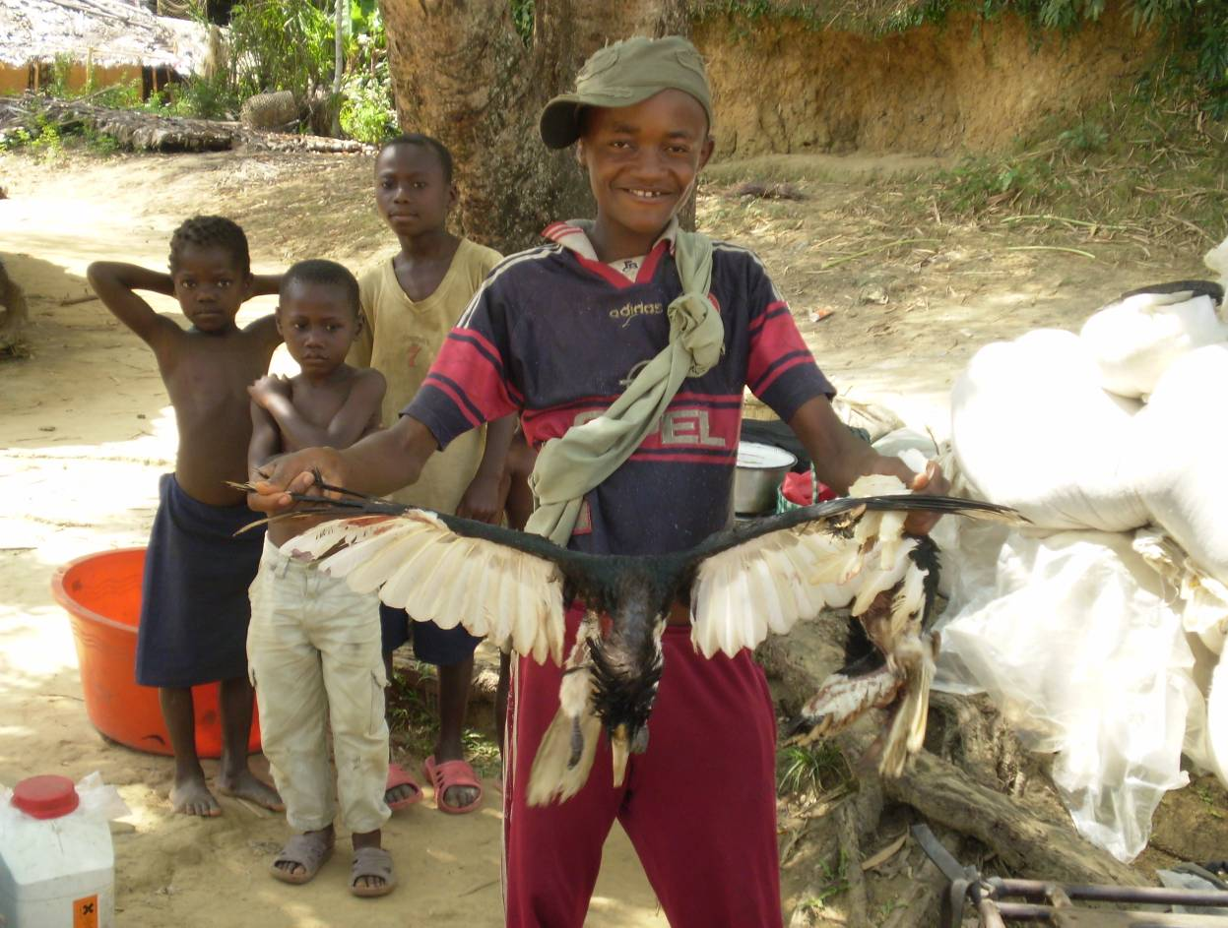
Figure 3: Young kid showing a hunted hornbill near Kisangani, DRC (©Nathalie van Vliet)

Bushmeat consumption in urban areas

In most tropical and sub-tropical regions of the world, urban consumption of bushmeat occurs in hidden markets and is often not a staple food.

In Eastern Africa, bushmeat hunting has long been regarded as a subsistence activity. The commercial portion of the bushmeat trade was thought to be negligible, but recent reports have indicated that the bushmeat industry is growing in countries like Kenya (Born Free, 2004). The level of consumption in urban areas is however very difficult to assess given that most of the bushmeat consumed in urban areas is sold using door to door house sales. With increasing urbanisation, a key trend within East African Countries is a continuing reliance on affordable sources of bushmeat protein. For example, in the urban area of the Maputo Province in Mozambique, a substantial trade of more than 50 tons per month of bushmeat exists, with the supply emanating from numerous, often distant, source areas (TRAFFIC, 2000).

In the Amazon Basin, data on bushmeat consumption by urban dwellers is particularly scarce. Although, bushmeat trade to urban areas occurs in hidden markets, Rushton et al. (2005) do consider the urban bushmeat consumption in South America as negligible. One of the rare examples of bushmeat markets in Latin America is in Iquitos Peru where the lack of cattle ranching in this part of the lowland Amazon gave birth to a very lucrative bushmeat trade. As South America has some of the most important livestock production systems in the world and is an aggressive exporter of beef, pork and poultry, Rushton et al. (2005) suggest that bushmeat consumption in urban areas is likely to be slowly replaced by domestic sources of protein.

In South East Asia, increasing affluence in major consumer markets, particularly in China, coupled with improvements in transport infrastructure is leading to spiralling demand for many wild animal species. Pangolins and turtles used for meat and in traditional Chinese medicine are the most frequently encountered mammals seized from illegal traders in the region (TRAFFIC, 2008) with major markets in
China, including its Special Administrative Region, Singapore and Malaysia.

The Congo Basin presents an exemption to the general rule: the trade occurs in open markets together with other agricultural products and bushmeat is a common meal for most households no matter the social and cultural background. Consumption in Libreville (Gabon) is estimated at 7.2 kg/capita/year (Wilkie et al., 2005), in Bangui (Central African Republic) at 14.6kg/capita/year (Fargeot and Dieval, 2000), in Mbanjock (Cameroon) at 2 kg/capita/year. Although urban bushmeat consumption per capita appears significantly lower than in rural areas according to most available studies, the contribution of urban areas to the overall bushmeat consumption is high and likely to become higher as the population of Central African countries grows and becomes more urbanised. Starkey (2004) estimated that a total of 161 tonnes of bushmeat was sold per year in five markets in Gabon. Similarly, Fa et al. (1995) suggested that the volume of bushmeat traded annually in Equatorial Guinea’s two main markets is of the order of 178 tons. An inventory in 1995-96 of the four main markets in the Cameroon capital, Yaoundé, estimated sales of 840–1080 tons of bushmeat per year (Bahuchet & Ioveva, 1999). In Yaoundé, Edderai & Dame (2006) identified 15 markets and 145 restaurants and cafeterias selling bushmeat and providing an occupation for 249 people, of whom 84.3% were women. Fargeot and Dieval (2000) estimate annual consumption in Bangui, Central African Republic, to be of the order of 9,500 tons per year, of which at least half passes through formal markets.

Reasons for bushmeat consumption

The role of wealth in bushmeat consumption
Household wealth has been identified as a key factor explaining bushmeat consumption (Rao et al., 2010). However, overall, available results show contradicting pictures about the way wealth influences bushmeat consumption and trade. In Gabon, wealthier households consume higher levels of bushmeat and a small increase in the wealth of the poor rural families may result in a correspondingly large increase of the consumption of wildlife (Wilkie et al., 2005). In Equatorial Guinea, wealthier households in Bata, consume a greater diversity of bushmeats and wealthier families are less constrained than poorer ones in what they can purchase to eat (Fa et al., 2009). On the contrary, in Central and Latin America, as wealth increases, bushmeat represents a lower proportion of the proteins consumed (Godoy et al., 2009). Data from different regions of the continent actually suggest that an increase in income causes consumption of bushmeat to fall (Rushton et al., 2005). The microeconomic logic that gives rise to livelihood strategies and determines bushmeat consumption among forest and urban peoples is still very little understood.

Influence of availability, prices and taste or cultural preference
In remote forest areas around tropical and subtropical forests of the world, bushmeat is often the main source of animal protein available and plays an essential role in people’s diets especially where livestock husbandry is not a feasible option and wild fish not available. Wild animals constitute a valuable food resource which cannot be easily withdrawn or replaced without causing wide-ranging socio-economic imbalances.

In rural and urban areas where other sources of protein are available, bushmeat is consumed because of a complex combination of prices, taste and tradition that varies across regions.

In several African cities, bushmeat is still the cheapest source of protein and represents a crucial source of meat for the poorest urban households. In Kisangani, Democratic Republic of Congo (DRC) and Bangui, Central African Republic (CAR), bushmeat is cheaper than many other alternative sources of protein (Fargeot, 2010; van Vliet et al., in press) or essentially perceived as ‘free’ protein as it can be captured rather than purchased (Kümpel, 2006). In many Southern and East African rural areas, although livestock meat is available, preference for bushmeat is driven by its affordability (Linsey et al., 2011). In North Myanmar, Rao et al., (2010) found that the average cost of livestock meat was significantly more expensive than the average cost of fish and bushmeat with fish being slightly more expensive than bushmeat. Bushmeat consumption levels often vary according to variations in prices of alternative foods, such as fish (Wilkie et al., 2005).

Bushmeat is also preferred because of its taste. In large cities of Equatorial Guinea, Gabon and Cameroon, despite higher prices in comparison to domestic meat, bushmeat is preferred for its taste (Kümpel et al., 2007; Abernethy & Ndong Obiang, 2010). Analysis of taste choices in Gabon indicate, not only that consumers differentiate bushmeat species from domestic meat, but also that they differentiate among different bushmeat species (Knights, 2008, Schenck et al., 2006). In Nigeria, using a combination of taste tests and questionnaires, cane rat (Cricetomys emini) was rated higher than mutton and beef according to sensory quality (Ladele et al., 1996). In Equatorial Guinea, the top three tastiest foods were all fresh fish or bushmeat species followed by frozen mackerel, frozen chicken and frozen pork (Kümpel, 2006).

The preference for bushmeat is also dictated by cultural reasons, particularly for traditional indigenous peoples. Many cultures still employ traditional medicine that includes animal-derived remedies (Alves and Alves, 2011) and animals often fulfil both a nutritional and a medicinal role. Probably the most famous of these are the Chinese, who use animals for a variety of ailments. Many vertebrates, including tigers, bears, rhinos, turtles, snakes, tokay geckos, pangolins, monkeys and swiftlets are traded as raw materials of traditional Chinese medicine. Lesser known and studied, though just as varied and rich is Latin America’s long tradition of animal-remedies for all kinds of ailments. In Africa, bushmeat consumption is also associated with tradition. In some rituals and ceremonies, such as men’s circumcision ceremonies in Gabon or burials in South East Cameroon, large quantities of bushmeat must be served to the participants (Angoué et al., 2000; van Vliet & Nasi, 2008). The traditional role of bushmeat has also been shown in Equatorial Guinea, where some species are considered to have magical or medicinal properties that increase their value (Kümpel, 2006).

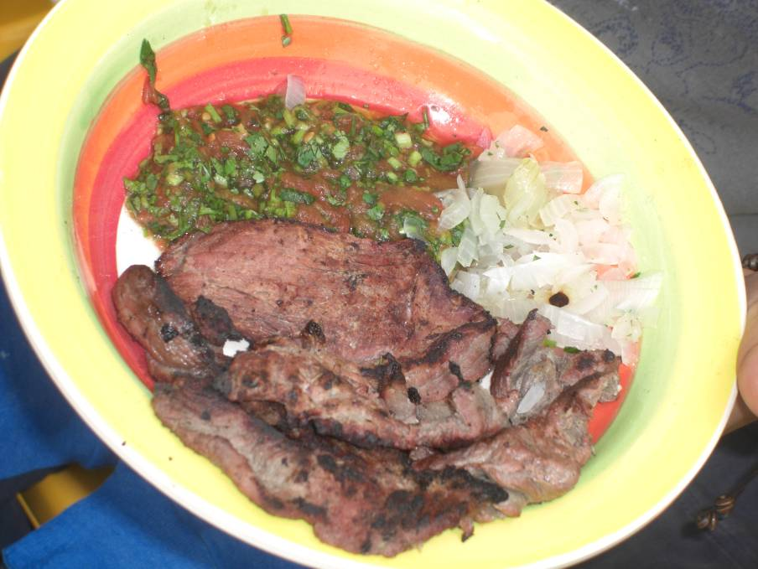
Figure 4: Meat of red brocket deer in a community neighbouring the Calakmul Reserve (Mexico) (©Nathalie van Vliet)

Bushmeat as a source of income

Subsistence and commercial hunting
The distinction between subsistence and commercial use of wildlife for food is blurred, with meat from the forest supplementing both diets and incomes. Bushmeat often represents both the primary source of animal protein and a main cash-earning commodity for the inhabitants of the humid forest regions of the tropics. Income alternatives to hunting are scarce in rural villages (Elliott, 2002, de Merode et al., 2004) and, where available, can be short term and unpredictable, which can lead young men to hunt rather than engaging in potentially more profitable activities (e.g. cocoa farming) (Solly, 2001). For the majority of the hunters, as hunting offtakes for a household increase, the percentage of the offtake sold also increases, reflecting the fact that hunters sell the remaining meat only after the household’s requirement for a certain level of protein are satisfied. In Serengeti, the majority of respondents hunt in order to fulfil their protein demands (75.2% of the respondents) compared to a few who are motivated by both protein and income (24.8%) (Mfunda and Røskaft, 2010). On occasions, men do hunt for commercial purposes to fulfil household’s short-term cash needs, such as school fees, ceremonies or medical care (Starkey, 2004; Solly, 2004, van Vliet & Nasi, 2008).

Specialised commercial hunting, defined as hunting driven solely by commercial purposes, also exists to different extents in different settings. Hunters specialised in commercial hunting often target specific species (e.g. bush pig hunters and elephant hunters in Gabon (Okouyi, 2006)) and often work in agreement with traders or directly with the consumers who provide guns and ammunition. Little is known about the income generated by specialised commercial hunters as their activity is most often illegal and sometimes associated with the illegal trade of other wild products (furs, horns, pets, etc.) where meat sales are only secondary. Specialized commercial hunting is also sometimes practiced by armed militia. In the Ituri region (Democratic Republic of Congo), for example, the forest has been heavily hunted in an open-access system exploited by a large number of lower-ranking soldiers that relied on bushmeat for their subsistence (de Merode and Cowlishaw, 2006). Loucks et al. (2009) also showed that the armed conflict in Cambodia had detrimental effects on wildlife due to the proliferation of guns, the emergence of wildlife trade for external markets, and government policies mandating hunting by local villagers.

Importance of bushmeat in household´s economy

In many rural settings hunting provides a very important source of income, often more important than the income generated by the trade of agricultural products. In villages from South East Gabon, Starkey (2004) showed that household income from hunting was 15–72% of total household income, and this percentage was higher in more remote communities. Richer households, who were able to own a gun, were more dependent on bushmeat as a source of income than poorer households (Starkey, 2004). In Lebialem, Cameroon, Wright and Priston (2010) showed that income generation was the reason for harvesting that was stated most frequently during interviews (46% of the hunters interviewed) and bushmeat harvesting was mentioned as the major source of income by 33% of respondents. A typical response was: “hunting is the only way of getting immediate cash”. Similarly, in North Myanmar hunting was reported to be the highest source of income by 24% of the respondents, just behind non-timber forest product collection (31%) and farming (45%) (Rao et al., 2010). In Equatorial Guinea, Kumpel et al. (2010) showed that hunting was a major income-generating activity at the village level, only eclipsed by waged employment. At the individual level, hunting earned an average of 597 USD per year and 60% of the men interviewed earned income from hunting. The vast majority (66%) of hunters chose ‘because there is no other way of making money’ as their reason for hunting.

As a result, where jobs are not available locally and catch per unit effort is profitable, hunting serves as a reliable fall-back in times of financial need and can be differentially important during times of stress for local people, such as when crops fail. Whilst hunting has the potential to provide a substantial income, households do not tend to accumulate wealth through hunting, because income from hunting is rather unpredictable, and it is rather spent as it is earned. Hunting income is spent in part on items that do not contribute significantly to household food security, such as on alcohol and cigarettes (Coad et al., 2010), but this pattern is not specific to income from hunting as the same is also observed for income generated by other activities (salaries from agriculture, mining etc.).
As rural communities get access to markets and invest in other cash generating activities (e.g. commercial agriculture, livestock raising, timber exploitation etc), hunting contributes to a lesser proportion of the total income. In the Peruvian Amazon, Coomes et al. (2004) showed that only about 17% of households reported participating in hunting and hunting contributed the smallest value behind farming, fishing, and other resource extraction activities. In Phnom Kok community forest, Cambodia, Kim et al. (2008) showed that honey and beeswax production provides a much better source of revenue than hunting, and bushmeat is therefore mainly for family consumption.

Income generated all along the bushmeat market chain
Hunting households are not the only beneficiaries of the bushmeat trade. Throughout tropical forest countries, bushmeat generates income for a variety of stakeholders including those who transport it at all points along different supply chains and those who trade it in roadside locations, in established markets, door to door, or in restaurants and shop halls. From first harvest to final sale, the trade in bushmeat for local, national or regional trade now forms an important part of the informal sector’s “hidden economy”. Access to markets is a key factor in realizing economic values of wild products, including bushmeat. If prices and profits are high enough, local traders will make use of any transport networks, over considerable distances to get perishable goods to market. As a result hunting and the bushmeat trade, although largely ignored in official trade and national statistics, play a crucial role in the economies of numerous countries, but being part of the hidden economy, are not tapped as a source of government revenues (Fargeot, 2009).
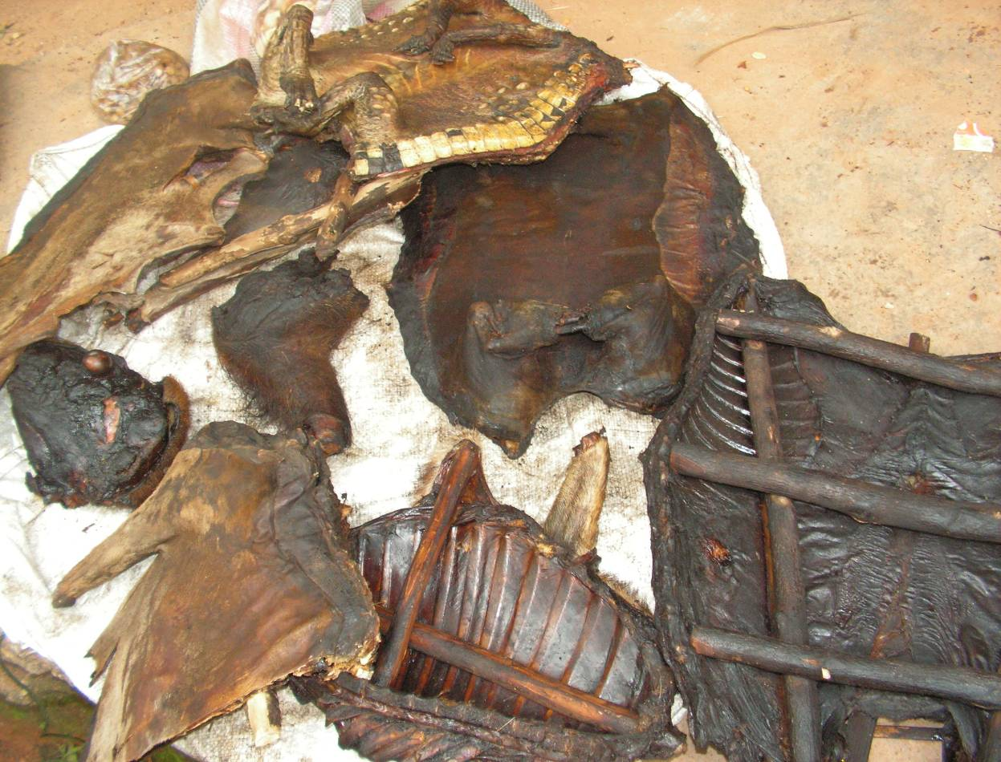
Figure 5: Smoked bushmeat sold in Mamfe, South West Cameroon (©Nathalie van Vliet)

Small scale livelihood alternatives to the unsustainable use of bushmeat
This section examines different types of small scale alternatives to the unsustainable use of bushmeat around tropical and sub-tropical forest areas of the world. All types of alternatives described in section 1 represent diversified ways of acquiring income while those presented in the following sections are also implemented as alternative sources of protein for self consumption. For each type of alternative, this section provides a description of the general principle, 2-3 case studies describing examples from different regions and the main difficulties or risks associated with each type of alternative. The examples provided in this section are at different stages of implementation. Some have already evaluated their success and failures (in terms of technical feasibility, economic benefits, appropriation and conservation outcomes), while others are at an early stage of implementation and provide no measure of success. These examples are not necessarily success stories but provide a picture of the diversity of alternatives that have been tested in the field. The majority of examples are from Africa and South America. Indeed, based on our consultation with several experts, it seems that most of the activities implemented in Asia aim at enforcing the law rather than on finding alternatives.

Diversification of income sources

Principle
The diversification of sources of income for small holders is seen as an alternative to the commercial use of bushmeat, under the hypothesis that hunters will invest their time on a more lucrative activity and abandon hunting if alternative sources of income are provided to them. The range of alternative sources of income is extremely wide, but comprises the development of other small scale productions systems, eco-tourism, craft work etc.

Examples

Example 1: Maasai beaders in Kenya
Anne Kent Taylor Fund (AKTF) (www.aktaylor.com) assists individuals, communities and corporations to conserve, protect and restore biodiversity in Kenya through economic activities that are ecologically sustainable. AKTF is a non-profit entity that works in cooperation with the various stakeholders in the Masai Mara region including government representatives, senior council members, wardens and rangers, tourist companies and operators, community elders and school committees, and other NGOs. The goal of the work of AKTF is to create economic opportunities for the Maasai around Kilgoris and link this to conservation of wildlife.

AKTF loans the women’s groups start-up funds to buy beads and supplies. The women produce items for the market, which Anne Kent sells in the U.S. and in local tourist markets. On the other hand, AKTF supports de-snaring/anti-poaching teams comprised of young Maasai men from the nearby communities. These men patrol on foot through thick forests and across the open plains removing wire snares which have been illegally set by poachers. The involvement of both women (as beaders) and the men (in the de-snaring/anti-poaching patrols) provides broad based financial incentives for Maasai communities to conserve wildlife, reinforcing community/government law enforcement efforts. The Maasai beaders, with profits from the bracelets, have installed a grain mill that they run as a business. The fees charged for milling ensure them a steady income and with that income they have built a small shop for the sale of their beaded goods. As these communities gain financial stability and pride they exert influence on others to practice conservation behaviour.

Example 2: Lebialem Hunters’ Beekeeping initiative (LHBI) in Cameroon
Several projects and small-scale beekeeping introduction initiatives have been implemented across Africa and appear to be successful. Beekeeping is a good income-generating activity for resource-poor people and is completely environmentally friendly and sustainable with no outside resources required. Besides, in most African countries there is already a market for honey.

The LHBI initiative (www.bee4bushmeat.org/) was launched in Lebialem in south-west Cameroon in November 2007 to investigate the potential of beekeeping as an alternative to bushmeat hunting. The general objectives for the project were (1) to train bushmeat hunters in beekeeping and supply them with the equipment and necessary technical support; (2) to set up a beekeeping association in Lebialem; (3) to implement a conservation education programme; and finally (4) to evaluate the effectiveness of beekeeping as a bushmeat hunting reduction strategy. The first phase of the project trained two hunters in beekeeping. During that time market opportunities for selling honey and beeswax were also explored. The second phase of the project, in 2008, resulted in the training of 33 hunters from two villages. Participants were provided with the materials, equipment and instructions necessary to construct a top-bar hive. The hives were manufactured locally to reduce cost; all other construction material was sourced within the communities. Start-up packages of equipment were lent to the trainees for a nominal fee. It takes 2-3 years for beekeepers to become established, so most of the trainees are not gaining significant financial benefits for the moment. A positive example however, is that one of the assistant trainers for LHBI, who has 5 colonised hives and is also employed to manage other hives, has made enough income to stop bushmeat hunting. Another benefit is the conservation education that the hunters received in parallel with the training, which allowed then to directly connect the external assistance received as part of the project with the reduced hunting of primates. All the hunters that were part of LHBI were required to sign a pledge to promote the reduction of primate hunting.

Figure 6: Hive construction during a training workshop in Lebialem, Cameroon (© Julie Wright)

Example 3: Diversifying agricultural production and fair trade commercialization in Yasuní, Ecuador

The “Diminishing Illegal Wildlife Trade in Yasuní” project is funded by the Spanish Development Cooperation Agency, led by IUCN/TRAFFIC, and implemented jointly by two strategic members of IUCN: Fundación Natura and the Randi Randi Group Corporation (Puyol et al., 2010). The aim of the project is to provide alternatives of income to indigenous communities through diversification of agricultural products. The principal sustainable production activities relate to the planting and fair trade commercialisation of fine aroma cocoa, a native species that is one of Ecuador’s “star” export products because of its superior quality and texture. The project has promoted the integration of cocoa production with that of fruit production from citrus and avocado trees and traditional foods such as cassava and plantain. These foodstuffs, together with meat from wild animals, which the Huaorani have the right to hunt, enrich their diet. Thus, the food sovereignty of these families is strengthened at the same time as their income is increased in a sustainable manner over the medium term.
The project also supports the Association of Huaorani Women of the Ecuadorian Amazon (AMWAE). AMWAE, has undertaken dialogues and ongoing community training on governance and land management, which are necessary groundwork to establish hunting rules, regulations, and ecosystem management. An agreement was also signed between AMWAE and Fundación Natura where communities agreed not to trade wildlife and not to hunt tapirs (even for subsistence purposes).

Currently, the project is working with nine strategically selected communities in two areas of the Yasuni Biosphere Reserve BR, with more than 70 Huaorani families and an impact on approximately 200,000 ha of tropical forests. The various communities are still discussing their own regulations for exercising social control over these agreements, and this process is itself making a very positive contribution to improving local governance.

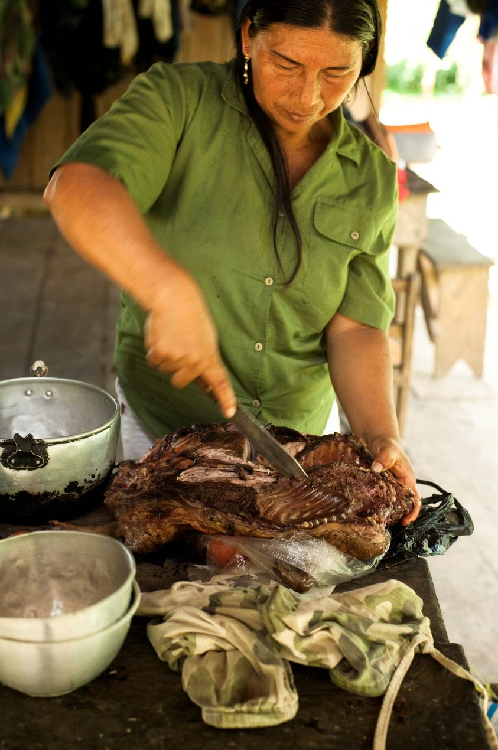
Figure 7: Huaorani women preparing bushmeat in Ecuador (© UICN- TRAFFIC. Nicolás Kingman)

Difficulties and risks

Profitability
At the hunter’s level, the capacity of an income generating activity to substitute for bushmeat trade is linked to its profitability compared to hunting. Profitability depends on production costs, but also on markets and prices. In areas where wildlife is abundant, bushmeat “production costs” are likely to be lower than any other production system (agriculture, livestock raising…etc). On the contrary, where wildlife is becoming scarce, several alternative sources of income might offer lower production costs compared to hunting. The challenge is also to ensure that there is a market for these new products to recover investment and production costs. Many projects have invested time and resources on the technical aspects related to production but have not sufficiently addressed the potential for commercialisation and the alternative activities developed were soon abandoned at the end of the project.

Compliance with conservation measures
In many cases, alternatives might be successfully adopted without implying substitution of bushmeat use, which means that bushmeat consumers, hunters or traders engage in additional activities but keep their “business as usual” when it comes to bushmeat use. Imposing conditions to the provision of alternatives is necessary in those specific cases. Unlike alternatives of income developed through Payments for Environmental Services or certification schemes, standard income generating activities offer less guarantee that improved income is linked to conservation outcomes.

Gender distribution in livelihood activities is important when developing alternative sources of income to increase the chances of compliance with conservation measures. Some activities are usually male dominated or female dominated. As a result, alternative sources of income that engage women will not necessarily prevent the men from hunting. Similarly, some sources of income can be attractive to ethnical groups or age groups that are not necessarily those involved in hunting.

Socio-economic characteristic of alternative sources of income
Wildlife trade interventions focusing on poverty alleviation and/or livelihood diversification need to be designed according to the nature and motivation for people’s engagement in wildlife trade, and according to the particular species or product being targeted. At similar levels of profitability, hunting might still be preferred as it may offer a wider range of characteristics that make it attractive for forest dwellers (Brown, 2003). These include: 1. High returns to discontinuous labour inputs, with low risk and minimal capital outlay; 2. Excellent storage properties and a high value/weight ratio; it is easily transported and is thus an attractive commodity for producers in isolated areas who have few alternatives; 3. A commodity chain characterised by high social inclusivity, in both wealth and gender terms; 4. Labour inputs that are easily reconciled with the agricultural cycle, and with diversified income-earning strategies; 5. Unlike many high-value marketed commodities, usage can readily be switched between consumption and trade. This range of socio-economic characteristics should be considered when developing alternative sources of income. Furthermore, livelihood interventions targeted solely at subsistence activities, or on poorer households who harvest wild products primarily for their own consumption, seem likely to have little impact on the harvesting of wildlife for trade in order to generate cash income.

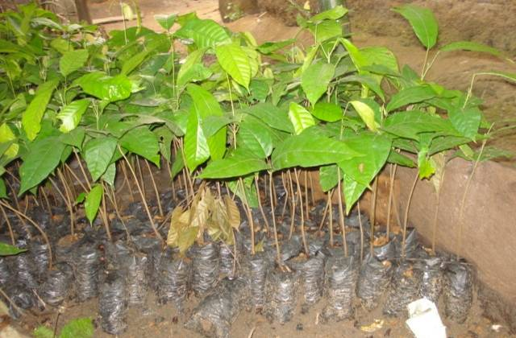
Figure 8: Cocoa seedlings introduced in communities around Takamanda National Park (Cameroon) as an alternative income generating activity (©Nathalie van Vliet)
- Production of domesticated sources of meat

Principle
Livestock rearing cattle, sheep, goat, poultry and aquaculture are all options that could decrease the harvest of bushmeat by replacing it with domestic meat as a protein source and a complement to farmer’s income. South America probably offers the best example of how the development of diversified domestic sources of meat has helped to reduce the dependency on bushmeat (Rushton et al., 2005). In the eastern part of South America for example, the livestock and fishery sectors have been able to respond positively to increasing demands for protein and the role of bushmeat is likely to become marginal in the future. In the western and northern zones, where the livestock sectors are less able to supply protein, the response has been to encourage intensive pig and poultry systems and fish production.

Examples

Example 1: Improving Poultry Production for Sustainability in the Ruaha Landscape, Tanzania.
The Iringa District Development Plan identifies poultry production as a livelihood improvement strategy in villages bordering Ruaha National Park. Poultry production was chosen because it has the potential to: 1. provide greater animal-source protein for nutritionally-stressed households; 2. generate income for women who usually manage household expenditures such as children’s health care and education; 3. increase protein and cash availability throughout the year, most importantly outside the times when grains are harvested and cash is scarce; 4. accomplish the objectives outlined above without excessive labour burdens or financial barriers to entry (Knueppel et al., 2009).

The development plan for the Iringa District was the starting point for a project coordinated by the Wildlife Conservation Society (WCS), the Iringa District Council (IDC) and Sokoine University of Agriculture (SUA) to develop poultry production and vaccinate chickens in communities living around the Ruaha National Park. The results of the project suggest the following preliminary conclusions: 1. preference for bushmeat does not appear to drive consumption, but the roles of demand for bushmeat and suppliers’ need for cash in driving exploitation remain unclear; 2. vaccination programs for chickens can improve households’ incomes and food security while increasing children’s and adults’ consumption of animal source protein; 3. increases in protein consumption are achieved through purchased domestic meat, rather than bushmeat or direct consumption of chickens; 4. but it appears that improvements in poultry production do not immediately reduce bushmeat consumption when households’ basic food security needs are not met.

Example 2: Poultry and pig farm in the Southern Bakundu Forest Reserve Area, Cameroon
An integrated conservation and development project was implemented in the Southern Bakundu Forest Reserve by Community Action for development – CAD, a non-government organization (http://sgp.undp.org/web/projects/14202/promoting_community_wildlife_management_in_the_southern_bakundu_forest_reserve_area.html.) Among other aims, the project sought to promote wildlife conservation through the promotion of alternatives to hunting to alleviate poverty among forest-dwelling people. Among those alternatives that people agreed to implement was pig farming and poultry. Twenty seven pig farms were established with 49 pigs. Over 30 people (14 men, 9 women and 7 youths) engaged in pig farming with successful production levels. However, at the end of the project, farmers were not yet gaining any financial benefit from pig farming. Small-scale poultry was also introduced as an alternative enterprise, using the local breeds that are relatively resistant to disease. 55 fowls were purchased and distributed to 15 people including 10 women and 5 men. Local people are generating significant income from the sale of fowls as they serve as suppliers to CAD.
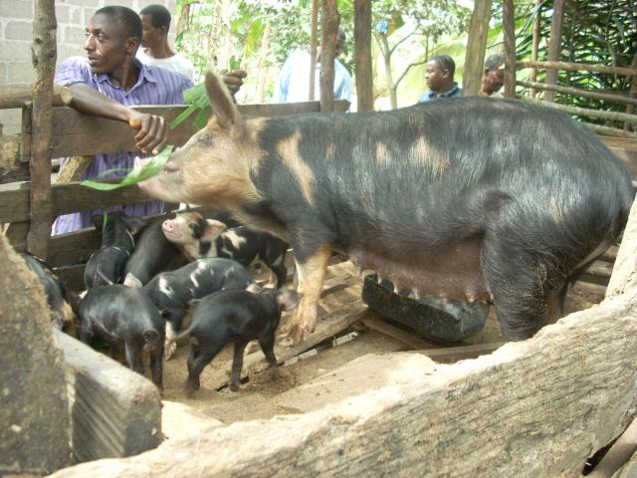
Figure 9: Pig farms developed by Community Action for Development in the Southern Bakundu Reserve area (© CAD)

Difficulties and risks
For domesticated sources of meat generated as a source of income, please refer to section on diversification of sources of income, as the same difficulties and risks apply here.

For domesticated sources of meat generated as a source of protein, the potential for substitution is determined by availability, prices and cultural preferences. Availability of cheap alternative proteins can certainly help reduce bushmeat consumption in given local contexts. However the availability and prices of alternatives should be measured relatively to the availability of bushmeat. In areas where bushmeat is still available at lower efforts and costs, bushmeat is likely to be preferred to any other source of protein. More over, the incentives for bushmeat consumption are often complex and do not only depend on availability and prices. Cheaper sources of alternatives (such as poultry or pigs) are not always seen as acceptable substitutes by consumers. The capacity of certain types of protein to become a substitute for bushmeat should be carefully studied on a case-by-case basis (vanVliet and Mbazza, 2011). A clear understanding of consumer preferences (stated and actual) in terms of habit, taste, cultural attachment and symbolic value for both wildlife and alternatives is needed before any efforts in supplying alternative protein sources are provided.

Besides, the ecological risks associated with the spread of domesticated animals need to be further investigated as those species can become invasive to surrounding ecosystems. The spread of domesticated animals reared in open areas can lead to several environmental problems to local wildlife, such as those described in the section on game ranching (see page 28). When domesticated animals escape, their high reproductive potential, together with their omnivorous habits in the case of pigs, allows their populations to grow and spread rapidly with subsequent negative impacts on the environment they inhabit. These impacts include changes in vegetation and soil characteristics, disease propagation, genetic pollution (Nogueira-Filho et al., 2009). In the Brazilian Amazon region the spread of domestic pigs, which are generally reared in open areas around human dwellings, has led to continuous escapes from captivity and increased feral pig populations.

Mini-livestock breeding with indigenous species

Principle
Mini-livestock encompasses small indigenous vertebrates and invertebrates which can be produced on a sustainable basis for food, animal feed and as a source of income. It includes bush rodents, guinea-pigs, frogs, giant snails, manure worms, insects and many other small species. Mini-livestock production is suitable for backyard family production and can contribute to increased food security (Hardouin et al., 2003). ‘Mini-livestock’ has also been referred to as ‘micro-livestock’ or ‘unconventional livestock’. Amongst the vertebrates an important actual and potential source of meat are the edible bush rodents: in Africa Thryonomys (cane rat), Cricetomys (giant rat), Atherurus (brush-tailed porcupine); in the Mascareignes Tenrec (tangue); in Latin America Hydrochoerus (capybara), Dasyprocta (agoutis), Myocastor (coypu), Agouti (pacas) and Cavia porcellus (guinea-pig) which is widely bred and eaten in South America. Some invertebrates can also be considered as mini-livestock. Giant snails like Archachatina and Achatina are certainly in high demand in Africa and many snail farms exist. Caterpillars are produced for food in some countries with the best quality caterpillars being exported all over the world.

Mini-livestock can represent a successful solution for both wildlife and households for the following main reasons:
  - Most mini-livestock breeding normally takes place in the area of endemicity, which means that appropriate feed is available, or can be produced locally.
  - The small size of mini-livestock animals means a small amount of input per unit, which in turn means more flexible production.
  - Mini-livestock can make an important contribution to increased food security because of its small scale, indigenous and flexible nature. It also offers the prospect of a regular income source once the volume of production exceeds what the producer wishes to consume.
  - Mini-livestock production is also appropriate for the involvement of women who are likely to be very much involved in the routine management of the animals.
  - Mini-livestock can also be easily raised in an urban setting.

Examples

Example 1: Grasscutter (greater cane rat) farms in Central Africa
The DABAC (Développement d'Alternatives au Braconnage en Afrique Centrale) project was active for 10 years in Gabon, Cameroon and Congo, with the aim of farming game species to reduce pressure on wildlife. The results of this project show that grasscutters are well adapted for farming in this regional context for both technical and consumer preference reasons. However, experiences in Central Africa show that grasscutter farms are not viable were farming is more time consuming and costly than hunting (Chardonnet, 2004). In most forest areas in Central Africa, grasscutters are responsible for damaging crops and are far too common in rural areas for hunters to be motivated to farm them.

It is probably in Cameroon that the experience is most successful as the work started by DABAC is now continued by national NGOs, like Community Action for Development and APRONATURE with support from TRAFFIC. These local NGOs have developed grasscutter pilot farms around the Bakungu and Dja reserves. The results from these projects show once again that grasscutter farming is technically possible but not viable as long as grasscutters are abundant in farms and home gardens.

Example 2: Peccary farming in Latin America (adapted from Nogueira, pers.comm. and Young et al., 2010)
One animal viewed as threatened by over-hunting in the Neotropics is the Collared Peccary, which is found from as North as New Mexico to northern Argentina.

In Brazil, The Breeders Association for Wild Animals (Associação de Criadores de Animais Silvestres- ACASCO, http://www.acasco.com.br) was founded in 2005 by request from the farmers of the Centro-Oeste Region suffering from the lack of institutional support for the development of their peccary farms. Today, ACASCO is a union between breeders and partners of the Wild and Exotic Animals Project in progress since 2004. The cooperative started with peccary farms but has now expanded its activities to the breeding of many other species. In 2011, ACASCO has reached 50 members who breed about 147 species. The production system developed is competitive, sustainable and respects the preservation of nature and wildlife.

In French Guiana, Collared peccaries (Tayassu tajacu) are part of the menu of several restaurants serving local French Guyanese cuisine. The problem of frequency of supply to the restaurants of this popular meat, coupled with a demand by some local farmers to farm this animal as part of their farm diversification, thrust the Agriculture Chamber of Guyana and the Regional Council of Guyana to develop a project with the University of the West Indies, entitled ‘‘Knowledge of the wild fauna of Guyana : Management and Domestication Possibilities’’. The project’s objectives are the following: (1) respond to the increasing farmers’ demand for novel production; (2) develop complementary revenue for the farmers; (3) respond to the increasing demand by restaurants to obtain a regular, legal supply of meat; (4) limit hunting pressure. Small experimental production units of Collared Peccary are transferred to farms and monitored over time. Peccaries are bred in 1 ha forested plots on the farmer’s holdings to derive the maximum nutrition from existing natural foods, supplemented with rations produced from locally-available feedstuffs. The results of the pilot farms show that there is a very good potential for the system to be sustainable and low cost to the farmer.

Example 3: Palm worm domestication in Alto Orinoco, Venezuela (adapted from Cerda et al., 2001)
Many different small animals have been traditionally used as food in the Amazon, and some are in different stages of domestication like the large rodents (e.g. Agouti paca, Dasyprocta sp.) and Guinea pig (Cavia aperea). Field and experimental work, still in its early stages, is being implemented to assess the traditional mode of palm worm (Rhynchophorus palmarum) gathering and consuming by the Jivi communities and to develop a low technology, small-scale "controlled" production system. Traditionally, the Jivi gather the palm worms from damaged or fallen moriche palm (Mauritia flexuosa) stems and eat them raw or roasted. An innovative process is now being developed to grow palm worms on alternative plant substrates. The high nutritional value and the rich level of vitamins, makes palm worms a very important source of food that should be of increased interest. Palatability tests organized in Puerto Ayacucho demonstrate that this food is appreciated both by the Amerindians and by non-Amerindians. The development of local, small-scale invertebrate breeding systems can contribute to the development of sustainable, renewable resources and could provide cash to the local Jivi communities.

Difficulties and risks

Legal requirements
Wildlife legislations in subtropical and tropical regions do not always have a provision for mini livestock farming. In most Central African countries, the law forbids the commercialisation of wild species without distinguishing their origin: from the wild or from captive breeding. The situation in Brazil and other Latin American countries is different as the law forbids hunting, but allows the commercial use of captive bred animals (Nogueira and Nogueira-Filho, 2011).

Profitability compared to hunting
The lack of economic viability is often cited as the reason why wildlife farming is often unsuccessful (Mockrin et al., 2005). Many of the mini-livestock species (particularly rodents) are serious pests of food crops cultivated on the edges of forests and are found in high densities around villages. Trapping or hunting those animals is still profitable enough in many regions and mini-livestock farming is not a competitive alternative to hunting. For the successful development of mini livestock farms, it is essential to encourage the involvement of governmental and/or non-governmental agencies that could be able to provide subsidies for establishing wildlife farms and support services such as technical assistance to captive breeders (Santos et al., 2009).

Zoonotic diseases
Mini-livestock can be an important source of zoonotic diseases, and further research into this area is required. Mini-livestock can facilitate the emergence of diseases of sanitary importance for animal keepers and meat manipulators or can also have decimating effects on the captive breeding stock. Rodents are often hosts of diseases such as leptospirosis and salmonellosis which affect humans. More specifically, the South American rodent, Agouti paca, can harbour leishmaniasis and trypanosomiasis. Outbreaks of rat-transmitted diseases have occurred in cane rat farms in Gabon causing high mortality rates among captive stock (Jori et al., 2005).

Ecological considerations
Wildlife farming on a significant scale almost inevitably results in animals eventually escaping (Mockrin et al., 2005). In this case, the main concern is genetic mixing with wild populations and the potential for genetic homogenization. This ecological process is defined as an increase in the genetic similarity of gene pools over time due to intra- and inter-specific hybridization (Olden, 2006). Another relevant conservation issue to be considered is that mini livestock farms often rely on the wild either as a source of genetic diversity for the genitors or as a source of food for the nutrition of the animals. The development of mini livestock farms can create a market for live animals used as “genitors” in mini livestock farms with potential side effect on wildlife. The dramatic decline in the wild population of porcupines (Hystrix brachyura) across the northwest Vietnamese region is an example of such concern. Although the porcupine farmers are obliged by law to propagate stock solely from farm-bred animals, almost 60% of these farmers obtained their founder stock from the wild (Brooks et al., 2010). The establishment of captive breeding centres by governmental and non-governmental development agencies could supply founder stock which may reduce harvesting rates from the wild. In addition, genetic selection programs aimed at developing higher reproduction indexes could be pursued. The improvement and selection processes adopted for guinea pigs (Cavia porcelus) in Peru can be used as a model.

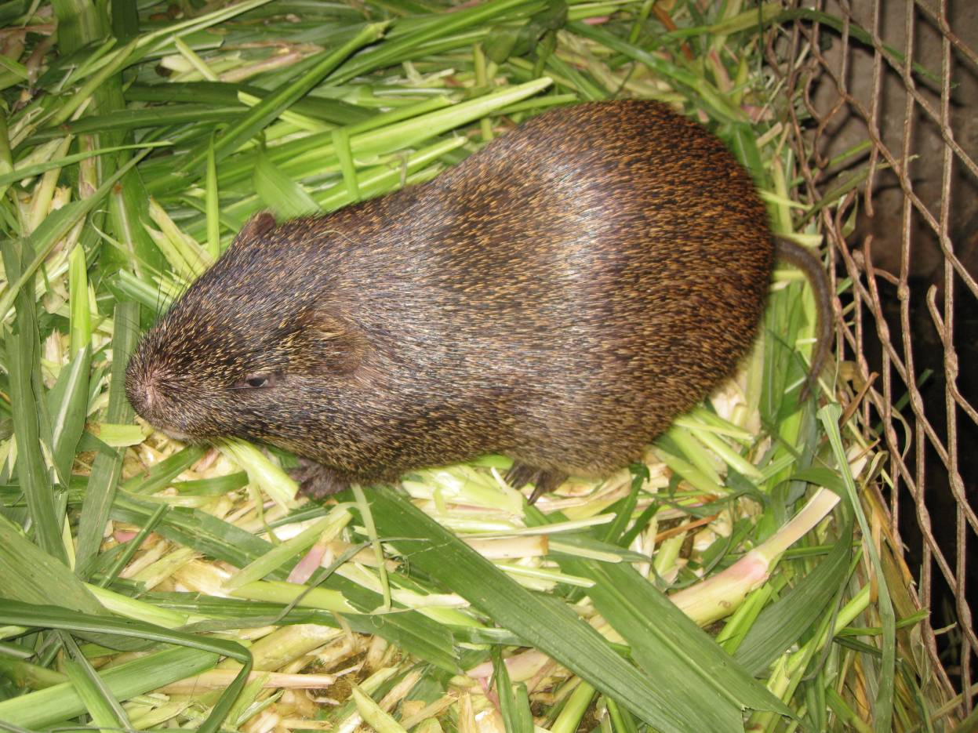
Figure 10: Grasscutter farm at the Faculty of Agronomy, University of Kisangani (Democratic Republic of Congo) (©Nathalie van Vliet)

Community based Wildlife Management

Principle
The underlying theory of Community-based Wildlife Management (CWM) is that the rural communities have been alienated from a resource they should rightfully control, manage and benefit from. The main objective for CWM is to create, through the bottom-up, participatory approach, conditions whereby a maximum number of community members stand to benefit from a sustainable management and utilization of wildlife (Roe et al., 2009). The concept of community conservation rests on the premise that there is a common interest between conservationists and local people: a desire to limit uncontrolled exploitation by outsiders and safeguard the natural resource base for the future. The approach is based on the idea that the communities will protect and conserve wildlife only if it is in their own (economic) interest to do so. Two general outcomes are expected from CWM. They include maintenance of wildlife habitats and preservation of species, and improved social and economic well-being of the communities. The following two conditions are seen as important for the success of CWM programs: revenues from wildlife must offset all costs associated with a program, and the “target” communities must be interested and willing to participate.

Examples

Example 1: The Tamshiyacu Tahuayo Communal Reserve (TTCR) in Peruvian Amazon (adapted from Newing and Bodmer, 2003).
The Tamshiyacu Tahuayo Communal Reserve (TTCR) in northeast Amazonian Peru was created through a coalition of local communities and researchers in response to large-scale hunting, fishing and logging by outside commercial interests. It is unusual in two respects: first, the extent to which communities have retained control over management in a government-created protected area; and secondly, the way in which communities’ decisions about their own natural resource use have been informed by collaborative biological research.

The TTCR covers an area of 322,500 hectares of uninhabited lowland Amazonian forest 100 km south of the state capital of Iquitos in Loreto, Peru. The surrounding area has a low population density, with a total of about 6,000 local residents in the Tahuayo, Tamshiyacu, Yarapa and upper Yavari Miri river basins. The people of this region are mostly ribereños, – detribalised riverside dwellers. Many ribereño families have historically highly mobile lifestyles, moving from place to place in order to meet changing demand for forest products from national and international markets. In some cases this history stretches back to early colonial times; others have only recently left their indigenous communities.

The TTCR has been largely successful in implementing CWM. It has changed resource rights from open access to communally controlled, and has maintained healthy populations of the full complement of game species (Bodmer and Puertas, 2000). It demonstrates a collaborative approach to natural resource management in which community decisions are informed both by individual experience and by the results of technical studies of sustainability across different areas of the reserve. It has now been in operation for almost 20 years. The TTCR was created as the result of a strong alliance between local people and conservationists.

Key factors in its creation were:
- a strong sense among the local community of natural resource crisis;
- the jurisdiction of regional rather than national authorities over the creation of a protected area, which allowed direct negotiations between communities and the appropriate authorities;
- the presence of researchers in an established position of mutual trust with community members, who were able to facilitate the negotiation process.

Example 2: Sustainable use of wildlife by indigenous populations from Brazil
Extractive reserves constitute an innovative approach to match conservation and development objectives, which were originally envisaged as part of a land struggle by forest dwellers in Brazil (Ruiz Peres et al., 2005). Based on a progressive socio-economic concept that was developed by Chico Mendes and the National Council of Rubber Tappers, Brazil’s Extractive Reserves are lands owned by the Federal Government which are set aside for the exclusive use of the rubber tappers or other traditional residents of the area. The first extractive reserve was Alto Juruá, in the westernmost part of the Brazilian Amazon, was created in January 1990.

Extractive Reserves have significant potential for demonstrating the feasibility of sustainable development in tropical rainforests and other threatened ecosystems. As a result, over the last decade, several institutions have developed projects of sustainable wildlife management in extractive reserves. Among others, is the Núcleo de Pesquisa e Conservação da Fauna e Flora Silvestre (NPC, http://www.npcfauna.org.br), founded in 1997, a non-profit institution with expertise on conservation and sustainable wildlife hunting in Brazil. NPC is pioneer in the development of sustainable management plans for wildlife hunting by traditional populations. The objective of NPC is to eradicate poverty of forest dwelling people and promote the sustainable use of wildlife based on technical criteria, economic viability and social justice. NPC works in collaboration with several key partners for the implementation of pilot projects, awareness raising and training.

Based on more than 20 years of experience, extractive reserves in Brazil have shown to be a success both for wildlife conservation and development as long as management includes the following: a source-sink system (areas with no hunting (source) should be set up near hunted areas (sink)), an adequate monitoring program, satisfactory community involvement, commercial trade focused initially on the Brazilian market and on the MERCOSUL region and supervision of the state government by the federal government and NGOs (Da Silveira, 2011).

Difficulties and risks

Legal provision for land and resource rights
Key to the successful implementation of community wildlife management is the establishment of secure and exclusive land and resource rights for the local people. In many forest legislations, resource user rights are not clearly defined and there is no provision for a legal status of land managed by local communities. Where a legal status for community land exists, the applicability of this model is ambiguous, particularly to people who use dispersed resources over extensive geographical areas, with a semi nomadic livelihood style (Twyman, 2001).

The most critical provisions of the legal framework for participatory wildlife management are the following: 1. It must provide for the empowerment of communities to have exclusive rights to the lands and the wildlife that they are to manage; 2. It must be possible to legally market the bushmeat and other wildlife products from permitted species that are harvested from these lands.

Bottom-up, participatory approach
In principle, community wildlife management relies heavily on active community participation not only in wildlife utilization but also in problem identification, planning, implementation, monitoring and evaluation. The approach requires programs to involve their ``target'' communities in all wildlife- related decisions. The experience with community wildlife management over the past decades demonstrates that devolving authority over valuable resources remains a political challenge. Emphasis should be placed on supporting local communities and civic organizations by building their capacity to engage in collective action that builds stronger political constituencies for resource governance reforms.

Community expectations
Communities’ decision to accept and join the program is largely influenced by promises of socioeconomic benefits. As a result, the initiative is likely to fail if communities’ expectations are not fulfilled and the target communities find themselves with little stake in implementing those programs/projects. To date, community wildlife management has been too focused on ‘conservation’ and a rather simplistic understanding of approaches to integrating conservation and development. Community wildlife management must become a response as to how best to harness local resource exploitation to enhance sustainable economic and social development (Roe et al., 2009). Another condition for the success of community wildlife management is that equitable amounts of wildlife revenues must remain in the hands of the community. The revenues must reach the majority of community members in an open and easily understood manner so that they can create and/or increase community members' interest in conserving wildlife. However, the ideal of the community capturing benefits can be negated by the reality of elite capture of benefits. Examples demonstrate that the application of the model of devolved natural resource governance triggers important power contestations whose results shape access to and control of wildlife benefits by local political elites (Mombesha and Le Bel, 2010). Important for local communities is also the way in which wildlife management provides adequate responses to human-wildlife conflicts. The wildlife management system in place should reduce wildlife related problems encountered by the communities (damage to crops and/or lives), rather than the opposite.

Game ranching

Principle
Game ranching comprises the maintenance of wild animals in defined areas delineated by fences. It is a form of husbandry similar to cattle ranching, the animals are managed on natural vegetation although the habitat may be manipulated to improve production efficiency (Ntiamoa-Baidu, 1997). Animals on ranches may be exploited for meat, but most ranches aim for the added value of sport/trophy hunting, live animal sales and ecotourism. The rationale behind advocating game ranching is that indigenous wild animal species are better adapted to the prevailing conditions than domesticated species and are therefore more resistant to diseases and more productive. Game ranching is currently most developed in southern Africa where it has played a significant role in the conservation and increase in populations of several species. These include previously critically endangered species such as the Cape mountain zebra and bontebok in South Africa and the red hartebeest and black faced impala in Namibia.

Examples

Example 1: Chivaraidze Game Ranch in Zimbabwe
Inspired by CAMPFIRE’s (Communal Areas Management Programme for Indigenous Resources) philosophical insights, CIRAD supported the establishment of Chivaraidze Game Ranch (CGR) in Chiriwo Ward from 1996 to 2004 (Le Bel et al., 2004). From 1999 to 2002, 509 impalas and a mixed population of 200 head of zebras, wildebeests, sables, tsessebes, waterbucks and elands were translocated. Three boreholes were sunk and infrastructure such as butchery, office and storerooms constructed. A tractor, trailer and basic ranch equipment, and horses were bought and game guards equipped with rifles and portable VHF radios to ensure security. The institutional framework of the ranch was established in phases with the assistance of a capacity building NGO, the Zimbabwe Trust (ZIMTRUST) and the district council.

In October 2000, the CGR became a CAMPFIRE company and this enabled it to open a bank account. A new constitution defined the company’s mandate in five clauses, that is, (1) the provision of game meat at reduced prices, (2) the reduction of poaching, (3) job creation, (4) the creation of wealth and (5) the search for financial viability and ecological sustainability. In January 2002, a wildlife exploitation contract was signed with a private safari operator and this was followed in June 2003 by the first trophy sport hunting and cropping of wild animals. In November 2003, the ranch transformed itself into a cooperative company.

In April 2004, CIRAD handed over the ranch and between 2005 and 2007 the cooperative company experienced internal instability arising from power struggles between itself and the ward leadership. Most of the trained workers left the ranch and politically loyal but inexperienced staff was recruited. The performance of the ranch declined amidst increased poaching of wildlife. This was compounded by the general economic and political crisis in the country (Le Bel et al., 2004). Six years after CIRAD handed over Chivaraidze Game Ranch to the community, the project is revealing a schism between the aforesaid principles and actual practice. First, the ideal of devolving authority over wildlife to the community has come up against powerful local sectional interests. Second, the ideal of benefits of management exceeding costs is being contradicted by the reality of costs exceeding benefits. Third, the ideal of the community capturing benefits is being negated by the reality of elite capture of benefits. Fourth, the ideal of community cohesion is being neutralised by local leaders’ divisive use of kinship and party political ties to gain access to and control the ranch and its wildlife (Mombeshora and Le Bel, 2010).

Example 2: The PARSEL project in Zimbabwe (adapted from Perroton et al., 2011)
Promotion of legal bushmeat production through game ranching has been advocated by several scholars as a way to conciliate wildlife conservation, rural food security and community livelihood improvement in Zimbabwe. Whereas most of the current examples implemented in Zimbabwe produce wildlife on communal land, the PARSEL project (with funding from the European Union) has developed game ranching on private land (within the Save Valley Conservancy-SVC) and benefits communities living in and around the conservancy. Around the Save Valley Conservancy (SVC), communities live in relative food insecurity and protein deficiency and face low agricultural production due to crops raiding and predation by wildlife coming out of the SVC. On the other hand, ranchers of the SVC complain about land invasion and poaching by the surrounding communities.
The project is based on a collaboration among several stakeholders: governmental structures (National Parks and Wildlife Management Authority, Rural District Councils), non governmental local and international partners (WWF, TRAFFIC, IUCN, IGF and Cirad) and private partners (safari operators). The project structure is as follows: The Save Valley Conservancy operates sport hunting within its properties. The project is given hunting quotas to be used within the SCV by the National Parks and Wildlife Management Authority. The SVC organizes and operates the culling. The project then distributes the meat to beneficiary communities. The Malilangwe trust, a local NGO, is involved as a partner to provide local coordination, implement community outreach programs and assist with logistical support. Another local NGO, the Tunza – trust, serves as a link between the project staff and local communities and organizes the distribution of meat.

The preliminary results of this on-going project show that, although tons of meat have been produced, the quantities provided do no cover the local demand (only 0,5 kg/household/year) (Perrotton et al, 2011). Although the project is innovative in that it is based on a multi-sectoral partnership, real community participation is not achieved. In fact, communities act as passive actors, benefiting from the meat. Local political leaders also strongly influence the implementation of the project, as project staff and members of the SCV trust are also involved in the ruling political party. Recurrent capture of the benefits by individuals and patronage networks for personal interests are once again observed.

Example 3: Game ranching in Namibia
Shortly after gaining independence in 1990, Namibia turned ownership of its wildlife back to the people. Starting from nothing in 1998, Namibia now has 64 community conservancies, covering about 17 percent of the national land area, slightly more land than is in national parks or other forms of state protection.

Conservancies in Namibia are run by local community groups, often livestock farmers. The conservancies aren’t parks; most residents continue to work herding livestock. But they set aside a portion of their common land exclusively for wildlife. The objective is to give benefits and create jobs through consumptive and non-consumptive uses of wildlife. It has worked so well that the Ministry of Environment and Tourism now often translocates animals, including critically endangered black rhinos, out of overcrowded national parks onto unfenced conservancy land, where they have room to recover to their former numbers. Overall, conservancies earned about $5.3 million in direct income and generated about $40 million for the Namibian economy in 2009.

The community conservancy idea works in Namibia for several reasons (Connif, 2011):
  - low population density: six people per square mile, as compared to 158 in Kenya, or 94 in neighbouring South Africa.
  - favourable rains: Namibia has also enjoyed a run of favourable rains since the mid-1990s, helping prey species like springbok and gemsbok, and thus lions and other predators, too.
  - full ownership of wildlife to people: the national government turned ownership of the wildlife back to the people in 1990. ‘
  - income generated from a mix of uses including trophy hunting and safari lodges for camera tourists.
  - benefits are visible “overnight”: communities benefit from wildlife soon after the creation of a conservancy and perceive the tangible value of using wildlife in a sustainable manner.

Difficulties and risks
The difficulties and risks mentioned in the section on community wildlife management also apply to game ranching in communal land. In addition, specific difficulties to game ranching are described bellow.

Legal aspects
Game ranching can be implemented where national wildlife legislations provide ownership of wildlife to the “owners” of land (community or private land). For example in Southern Africa, during 1960–1970s, legislative changes occurred, granting varying degrees of user rights over wildlife to landowners. These changes (occurring in Namibia in 1967, Zimbabwe in 1960 and 1975 and South Africa at varying times depending on the province) enabled landowners to utilize wildlife occurring on their land for hunting, live capture and trade. The animals on the ranch are the property of the ranch owner (private or community) for as long as they remain on his ranch. In South Africa, Namibia and Botswana, it is a legal requirement for ranches to be surrounded by perimeter game fencing for landowners to acquire the right to utilize wildlife consumptively (Lindsey et al., 2009).

Costs involved with game ranching
Game ranching involves high levels of investment. Game fencing material (especially when electric fencing is necessary), specific infrastructure (such as offloading ramp and holding pens for new game arriving to the ranch) and out building expenses (such as the erection of stores, carports, garages, cold rooms, abattoir facilities), imply very high investment costs. Water has to be provided to the animals and involves boreholes, dams, pipes and watering points. Vehicles and equipment are also necessary. Besides, some game might have to be bought when starting a game ranch.

Access to land for game ranching
The basic requirement for game ranching is an adequate quantity of suitable land. Location is very important and the land should be in an area that has been designated by the authorities for this type of land use. The size and shape of the parcel of land, and access to it are also important. The ecological classification, availability of water, variety of habitat types and neighbouring land uses also have a significant bearing on the chances of success (The Bostwana wildlife producer’s association, 2005).

Ecological risks (Adapted from Lindsey et al., 2009)
- Poaching: Once a market for venison and other wildlife products is established, increased poaching is inevitable and it becomes more premeditated and organized.
- Genetic pollution: With game ranching it is a fact that, with time, escapes occur. Even with the ranching of native species, genetic pollution is still a problem as the ranched animals are selected for large antlers, large body size, lean meat, and over time become maladapted to the natural environment.
- Disease: Translocation of wildlife is an integral part of game ranching. As disease agents are often specific to certain species or locations, the possibility of introducing a biologically or economically devastating disease into susceptible wild or domestic populations must be considered.
- Movements of local wildlife: Game ranching requires that large tracts of land be fenced off. There are cases where this has interfered with the migration and other movements of local wildlife.
- Predator control: Game ranching is incompatible with predators. This may result in further lobbying for predator control, eroding efforts to manage wildlife for biodiversity.

Payments for environmental services and Certification

Principle
Payments for Environmental Services (PES) are systems designed to provide economic compensation for the services ecosystems supply to society, including carbon sequestration, biodiversity, wildlife conservation, scenic beauty, and watershed protection, among others. Payments are normally given to landholders (individuals or communities) who protect desired land uses or resources, which are thought to provide the ecosystem services of interest.
There are different types of Payments for Environmental Services schemes: direct payment schemes and product based schemes. In direct payment schemes the government pays landowners on behalf of civil society to adopt improved land management options and thus address a particular environmental problem. Although direct payment schemes are the most common type of PES (mainly for carbon stocks and watershed protection), there are no such examples (to our knowledge) where such schemes have been implemented with the spesific aim of reducing the unsustainable use of bushmeat. In product-based schemes, consumers pay a "green premium" in addition to the market price of a product or service, in order to ensure an environmentally friendly production process, which is verified through independent certification. When consumers choose to pay this price-premium they are also choosing to pay for the protection of environmental services. Three types of wildlife-friendly eco-labels are distinguished by how they certify products and what steps are taken to verify that wild animals were conserved (Treves and Jones, 2010). The most credible but costly are “Protective” labels that must verify wildlife conservation in the vicinity of certified businesses. “Persuasive” eco-labels certify manufacturing/collection practices, under the assumption that wildlife will benefit as a result. “Supportive” eco-labels donate revenues to conservation organizations and are, at best, indirect interventions, opaque to consumer scrutiny

Ecolabelling certification programmes, as alternatives to the unsustainable use of wildlife, have been developed for a variety of non-wildlife based products including shade-grown coffee, organic farming, certified timber (etc…). Standard, labelling or certification scheme are set so as to promote sustainable management while at the same time generating better returns for poor producers. The additional payment that consumers pay for an eco-certified product is used to compensate the producer from his contribution to wildlife conservation (e.g. no hunting, maintaining critical habitats for wildlife species) .

Eco-certification is also used for wildlife based products and the labelling is given to producers that trade wildlife based products from sustainably managed areas. The theory behind certification of wildlife products is that well-managed wildlife trade can reverse the declines in threatened species as well as open up new opportunities for income generation and secure subsistence resources for food, health and other needs. Under the appropriate conditions, sustainable and well-managed wildlife trade can contribute significantly to securing sustainable livelihoods at the local level.

Examples

Example 1: Community Markets for Conservation (COMACO) in Zambia
Community Markets for Conservation (COMACO, http://www.itswild.org) is a model for rural development that offers sustainable livelihoods to people of the Luangwa Valley region. It operates through a community-owned, for profit trading centre, called the Conservation Farmer Wildlife Producer Trading Centre. Structurally, COMACO consists of a network of rural trading depots linked to regional trading centers, called Community Trading Centres or CTCs, where commodities are consolidated, processed, packaged and marketed. Members benefit from the trading centers by receiving high market value for goods they produce and by having access to affordable inputs and improved agricultural skills training and support. These benefits are provided on the condition that farmers adopt land use practices that help conserve natural resources and wildlife. These required land-use practices include conservation farming to maintain soil fertility, production of crops that reduce demand for new land and limit conflict with wildlife, and commitment to stop wildlife snaring or illegal hunting. The approach not only improves food security and household incomes, but helps people to remain in the same place, farming the same fields over the long term, thus reducing incentives to clear forest for new farmland.

Example 2: Elephant Pepper in Africa
Elephant pepper (http://www.elephantpepper.org/) aims to promote the livelihood of farmers living in elephant range through training, the deployment of appropriate conflict mitigation methods and development of agricultural techniques which promote elephant conservation. Established in Zimbabwe in November 1997, the organization utilizes research, education, and dissemination of community-based problem animal control methods that are safe, low-cost, and effective.
Elephant Pepper products grew out of field research focused on methods to address human wildlife conflict in southern Africa. It is widely accepted that rural farmers bear the costs of living with elephants and receive little of the benefits. Even where community-based conservation initiatives exist, and elephants generate large revenues, little of the money filters down to the rural household level. Resolving conflict between humans and elephants is one of the most pressing wildlife management issues in Africa. The problem of elephant-human conflict is severe and rises from the fact that elephants destroy the crops of small-scale farmers. These crops are often the only food available to these rural communities.
Research discovered the effectiveness of chillies to keep elephants away from crops. Application of simple techniques using chillies is sufficient to keep elephants away from farmers’ fields. In addition, chillies are an important cash crop. By motivating farmers to plant chillies, Elephant Pepper ensured production of the raw materials necessary to repel elephants from local farms. Moreover two market opportunities were created. One involved larger scale planting of chillies for chilli mash that goes into Tabasco sauce and is purchased by a large international market buyer, the other was the development of sauces and spice grinders carrying the Elephant Pepper brand and Certified Wildlife Friendly™, thus linking the products directly to efforts to reduce conflict and ensure protection of elephant populations. Elephant Pepper PTY Ltd. brings financial, social and environmental benefits to its stakeholders; linking farmers to a global market and by raising awareness around successful approaches to wildlife conflict mitigation.

Example 3: The Peccary Pelt Certification project in Peru (adapted from Fang et al., 2008)

The Peccary Pelt Certification Project, an initiative of the Durrell Institute for Conservation and Ecology (DICE) and the Wildlife Conservation Society (WCS), is aimed at increasing benefits to communities by “certifying” or labelling pelts that come from sustainably managed populations, thus increasing their market value. Major stakeholders involved with the peccary pelt trade include rural communities that hunt the peccaries, middlemen who collect peccary pelts and the tanneries that process the pelts. Peccary pelts are used in the European leather industry for the manufacture of fine quality products, especially gloves.

Certified communities would receive added benefits directly through an increased value of peccary pelts and indirectly through recognition of their conservation activities. This added value would act as an incentive for communities to convert unsustainable bushmeat hunting practices to more sustainable hunting. Thus, the leather certification programme would bring economic benefits to rural families, improving their living standards, and at the same time help to conserve wildlife and Amazon forests. The added value would not increase hunting pressure, but would guarantee that bushmeat hunting is sustainable, since any unsustainable increase in hunting would deem a community unfit for certification.

The project will set up "green labelling" for certified peccary pelt products that respect the following rules:
- Rural communities should have community-based wildlife management plans that set limits on harvested species that are not vulnerable to over-hunting and halt or greatly reduce hunting of species vulnerable to over-harvesting.
- Hunting limits should be within sustainable levels. These plans should include all hunted species, not just peccaries.
- Rural communities will need to monitor and evaluate their hunting in the form of hunting registers that include information on the species, number of individuals, date, and location hunted and catch-per-unit-effort (CPUE).
- Rural communities will need to manage their wildlife habitats. This will require sound forestry management and sustainable use of non-timber plant products, since these plants provide food and shelter for wildlife.
- Rural communities will need to set up source-sink areas as part of their management plans.

Example 2: Traditional Chinese Medicine Endangered Species Certification Scheme (Adapted from James, 2009)
The purposes of the Traditional Chinese Medicine Endangered Species Certification Scheme are:
- to raise the level of awareness, education and compliance with the legal requirements associated with the international wildlife trade
- to recognise professionals and traders involved in the ethical research, recommendation, prescription, supply, export or import of traditional Chinese medicines (TCM), and
- to provide a credible mechanism to acknowledge and support professionals and traders to publicly promote that they do not use or support the use of Chinese medicinal products containing illegally traded wildlife ingredients.

Participation in the ESCS is a positive announcement to the community that the individual or organisation trades only in legally acquired wildlife parts or products. The chief benefit of certification for participants is the acquisition of a certificate advertising that the certified person or organisation trades only in legally acquired wildlife parts and products. Participants are also issued with a public identification sticker (window decal or door sticker) and two wall posters. Applicants are required to sign a declaration to trade only in legally acquired wildlife parts and products and pay the application fee (if applicable). Once accepted, a certificate of participation; a window decal or door/window sticker; and two posters, each with the ESCS logo, are issued for display at the applicant’s business premises. Certification is on an annual basis, with a declaration as to compliance in order to maintain certification.

Although involvement in the scheme has been initially slow, it is expected to increase over time as the benefits of participation become more recognised and valued. Categories of participants from the TCM sector so far are: individual TCM practitioners, group TCM practices, educational and research organisations, importers/wholesalers. While work will continue to increase participation from the above sectors, ESCS needs to focus on the retailers of Chinese medicine products such as Chinese herb shops and dispensaries.

Difficulties and risks

Consumer value and calibration of marketing messages to reduce confusion
Eco-labels face several challenges that are common to many environmentally preferable, product-marketing efforts (Treves and Jones, 2010). Consumers face several competing claims about products, without the time or ability to evaluate the labels. Producers and distributors must therefore communicate the benefits of their goods quickly and easily to their target consumers. Most people buy products based on perceived quality or convenience, not on the nebulous benefits of positive environmental outcomes. Environmentally preferable products must therefore also surpass the competition in one or more other dimensions. Eco-labels may enjoy an advantage, if they can credibly certify producers or clearly show evidence of wildlife conservation. This advantage might give producers access to dedicated markets and insulate them from competition with more mainstream producers.

Technical challenges to verify compliance with conservation goals
Wildlife creates particular challenges for producers who wish to use eco-labels, because verifying conservation successes and failures is complex, technical, and costly. First, verifying whether a business has been instrumental in conserving wildlife is particularly challenging, because wildlife ignore jurisdictional property boundaries. Second, wild animal populations experience complex, stochastic, long-term demographic changes that obscure the putative influences of humans. Third, many species of conservation concern are wary of humans, due to past persecution, which makes monitoring them expensive and difficult. Fourth, a number of wildlife species do damage property or pose a threat to people, so incentives must at least offset losses, to prevent retaliatory killing. Finally, wild animals share complex ecosystems with other, interdependent organisms that may be adversely affected by human activities, making efforts for one focal species dependent on the conservation of others as well.

Costs and benefits of wildlife certification
For many, the costs of certification itself may be prohibitive. Examples from the field highlight the need for significant donor investment at least in the initial stages. Unless subsidised by donor funding, the initial costs of certification to the communities will be high. Direct costs will vary depending on the number of communities applying for certification and the distance that certifiers have to travel. In the case of wildlife certified products, indirect costs will include the investment needed to ensure that local communities set up sustainable wildlife management schemes that meet certification standards (training in sustainable hunting practices, development of community-based management plans and no-hunting zones, establishment of hunting registers) and the transport of certified products. What is not always clear from existing certification initiatives is whether certification does indeed generate higher prices than non-certified products, which is indeed the only guarantee that beneficiaries will comply with conservation goals. In order to ensure conservation benefits, certified products should guarantee higher benefits than non-certified products, not only on the short term but also over the long term. For wildlife certified products, any drop in prices of certified products would indeed lead to a shift towards unsustainable hunting practices with dramatic effects on wildlife, in order to respond to the existing demand for wildlife products.

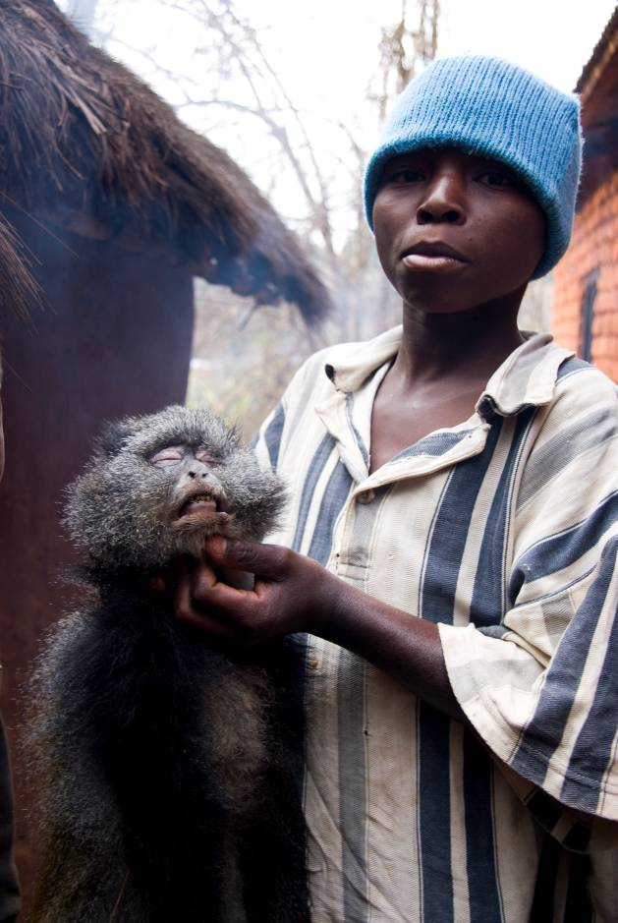
Figure 11: Young man showing a Sykes monkey in Tanzania (© Martin R. Nielsen)

Requirements and recommendations for scaling up successful approaches

The previous section showed that alternatives to the unsustainable use of wildlife do exist and described the diversity of approaches that can be implemented. It further showed the range of difficulties and risks associated with each of the approaches. Many of the examples described above were successful at different levels and in different ways in reducing pressure on wildlife locally. However, up scaling to national or regional contexts, approaches that were successful locally, remains a real challenge. In this section we discuss some considerations that need to be taken into account by policy makers and managers who wish to up-scale successful small scale alternatives to the unsustainable use of bushmeat.

Local specificities versus global patterns
General patterns concerning the importance of bushmeat for consumption and income can be drawn at a national, regional or global scale but, for the purpose of developing small scale alternatives to bushmeat use, the diversity of case specific situations needs to be taken into account. Each site is characterised by a different local social, natural, economic and cultural context that explains the differences among sites in terms of drivers of bushmeat demand, users of bushmeat for both consumption and income, level of dependence to bushmeat and determinants of consumption behaviour. This implies that the same alternatives will not necessarily be equally successful in every place and the outcome of replicating approaches that were locally successful will not necessarily be a global success. Nevertheless, the following sections provide general requirements and recommendations for scaling up successful approaches.

Alternatives “where”, “to what” and “for whom”

In order to determine the place, the type of alternative and the target for the intervention, the following considerations need to be addressed:

For each purpose a different approach:
If the project seeks to reduce bushmeat consumption, it should provide alternative sources of protein, whereas if the project seeks to reduce bushmeat trade, then it needs to develop sources of income. If alternatives to bushmeat consumption are to be developed, should they be provided to rural consumers or to urban consumers? If alternatives for bushmeat trade are to be developed, should alternative sources of income be provided for hunters only? or also to all those that depend on the bushmeat trade for their livelihoods (including transporters, wholesalers, market retailers, shop hall and bushmeat restaurant owners etc)?

For each target a different alternative:
Different user groups have different criteria for behavioural change: 1. For urban consumers who consume bushmeat on a daily basis as the most cheaply available protein source, economic and nutritional alternatives are likely to change consumption behaviour. However, urban consumers for whom bushmeat is rather a luxury good are not economically or nutritionally dependent upon bushmeat for their livelihood. Thus neither economic nor nutritional alternatives will necessarily curb their consumption or behaviour. However, increased awareness of the ecological and livelihood impacts of the unsustainable use of bushmeat can generate demand for eco-certified wildlife-friendly products among wealthier consumers. 2. Bushmeat traders provide an important link between the hunter and urban markets. The trading of bushmeat is not necessarily seen as the most desirable occupation as it implies high risks (fines, taxes, waste with perished products etc) and thus might be abandoned if other opportunities were made available. 3. Hunters might be sensitive to different types of alternatives depending on whether they are primarily hunting for subsistence or commercial purposes. Commercial hunters primarily derive economic benefits from bushmeat exploitation. Consequently, alternatives developed to change a commercial hunter’s behaviour must consider their economic needs and provide sufficient incentives to switch occupations. This switch may be facilitated by technical and financial support as well as by institutional and infrastructural changes. Subsistence hunters are likely to change behaviour if socially accepted alternative proteins are available at similar prices. Subsistence hunters also depend on bushmeat to cover basic household needs (medicine, school fees, clothing, etc.) and economic alternatives for the provision of such basic expenses are also needed.

Likelihood for substitution

…for alternatives to bushmeat as a source of protein
Depending on the level of taste and cultural preference, bushmeat can be difficult to substitute with domestic meat. Where people have a high preference (whether stated or actual) for bushmeat, meat from sustainable hunting areas, ranching or domesticated wildlife farms is likely to be more socially accepted by consumers than domesticated sources of meat. In some other cases, alternative wild products are easily considered as appropriate substitutes. Overall, people who depend on wild protein will substitute wild fish and bushmeat for one another, depending on the price and availability of each. The other possible wild substitute, invertebrates (e.g. caterpillars, snails, worms), represents an important traditional habit, but is generally seasonal and cannot fully substitute for meat and fish. In many other cases, domestic sources of protein will be regarded as a possible substitute, but the ways in which they are provided can determine the likelihood for adoption. The place (market, door to door, etc), the state (fresh, smoked, frozen), the way they are sold (in small piles, per kg, whole animal etc) are all factors that can influence the likelihood for substitution.

…for alternatives to bushmeat as a source of income
In order to increase the likelihood for substitution, alternatives to bushmeat as a source of income need to:
- Ensure that the alternatives target those effectively involved in bushmeat trade;
- Consider the traditional gender distribution of income generating activities;
- Have a commercialisation plan for the newly introduced products or services;
- Provide equal or higher profits with similar socio-economic characteristics (high returns to discontinuous labour inputs, low risk, minimal investment, excellent storage properties, high social inclusivity, easily reconciled with the agricultural cycle and with diversified income-earning strategies).

Monitoring the social, economic and environmental impacts

Improved indicators and better monitoring processes are needed in order to capitalize lessons learned from field experiences (Roe et al., 2009). A major deficiency of many projects is the absence or paucity of quantitative and/or qualitative data on their social, economic and environmental impacts. There is a real need for good monitoring protocols to be in place and for measurements against baselines established at the outset of the project or programme. Most projects are good at reporting on activities and to an extent the project deliverables. Lacking are more meaningful outcomes, such as technical feasibility, economic sustainability, social appropriation, and conservation outcomes. Part of the solution lies with the engagement of several stakeholders (communities, governmental institutions, national research centres) in monitoring project successes (and failures). Imparting skills and knowledge in establishing baselines and subsequent monitoring is empowering for all stakeholders and instructive for project implementers. Properly designed and structured projects will provide for quantitative and qualitative self-assessments of project impacts long after the project has departed.
Beyond the project level, a monitoring tools that can inform about the status of wildlife, the levels and the drivers of bushmeat use and the responses from stakeholders (based on new projects, new policies…etc…) at national or regional levels, is also needed. A good example of a regional bushmeat monitoring system currently being developed for Central Africa is the SYVBAC (Système de Suivi de la Filière Viande de Brousse). Since 2008, TRAFFIC has been supporting a participatory process with selected key stakeholders for the development of a Central African bushmeat monitoring system that will gather all available survey information and provide a regular overview of the trends in bushmeat harvest and trade at the regional level through proxy indicators. Stakeholders involved in the development of SYVBAC represent the working expertise from six central African countries in the region including representatives of the COMIFAC (Comission des Forêts d’Afrique Centrale), Ministries of Forest and/or Wildlife Conservation (Cameroon, Central African Republic, Democratic Republic of Congo, Gabon, Republic of Congo ), technical and scientific institutes, NGOs, intergovernmental organizations, development agencies, representatives of the private forest sector and other specialists. The general objective of SYVBAC is to generate the information needed to support the development of policies and strategies that aim at bringing the bushmeat trade to sustainable levels. The specific objectives are to monitor: the levels and the evolution of bushmeat use and trade in the region; the factors that influence bushmeat use and trade; the impacts of bushmeat trade on endemic/rare/protected species and the importance of bushmeat trade in national economies, poverty reduction, nutrition and health of human populations. In the absence of such a mornitor system, Food Balance Sheets from FAO can be used to monitor the overall food security situation at national level (Ziegler, 2010).

More supportive legal frameworks and policies
The existing examples show that legal frameworks are not always supportive for the development of small scale alternatives to the unsustainable use of bushmeat. In many regions (e.g. Central Africa, South East Asia), wildlife trade is illegal and there is no provision for wildlife trade from sustainably managed areas, game ranches or mini-livestock farms. Dickson (2003) argues that bushmeat trade regulation should be developed to include a legitimate channel for the sustainable trade. He states that deeming bushmeat categorically illegal does not offer the possibility of developing “participatory management models or to broaden the governance reform”, and is also likely to render the trade inconspicuous and encourage the bribery of monitoring officials (Egbe, 2000). A way of creating a legitimate channel for bushmeat would be to allow restricted hunting and/or trade through quotas.

Where legislations allow the trade from sustainably managed areas, game ranching or mini-livestock farms, the numerous ecological problems associated with those alternatives are not carefully taken into account. In the case of game ranching, Lindsey et al. (2009) suggest that most of the ecological problems could be overcome through allowing the formation of conservancies, where adjacent ranches remove internal fencing to form larger collaborative wildlife areas.

Land tenure regulations and rights to access forest resources are un-clearly defined. Whereas an open access resource offers opportunities for people with limited resources, the same lack of “exclusivity” often prevents producers from adopting sustainable practices and making a good living. Particularly in areas with limited alternative opportunities, new entrants quickly dissipate profits if, for example, prices for a product rise.

Technical difficulties and investment costs for the development of alternatives should be supported by governmental policies through research, extension services, and micro credits schemes. Nogueira et al. (2011), shows that the main constraint that limits the expansion of peccary production in Brazil includes the difficulties in acquiring breeding stock and the lack of state support for wildlife farming. For example, a major challenge is the ability to provide populations of manageable animals large enough to sustain captive breeding programs.

Beyond boundaries: multi stakeholder interactions at the landscape level

Landscape approaches
A landscape approach is one that recognizes the co-existence of various ecosystem services for multiple stakeholders pursuing different land/resource use objectives and recognizes the need to balance trade-offs between different land/resource uses. Landscape approaches are often necessary to ensure that successes in some landscape units do not lead to ecological catastrophes in others. The need for complementarity between the different land uses is exacerbated by the fact that efforts to conserve wildlife in one landscape unit can be undermined if the surrounding areas are not adequately managed. As a result, the success of the development of alternatives is intimately linked to the capacity of the alternative to substitute for bushmeat without implying higher pressure on other natural resources or on other locations. For example: 1. a reduction in bushmeat use might drive up unsustainable exploitation of fish; 2. a successful reduction of hunting inside a national park might increase hunting pressure in the buffer area. Ensuring that the adoption of the proposed alternative effectively leads to a reduction of pressure on wildlife in the project area without leakages (e.g. increasing pressure on wildlife elsewhere or on other natural resources) is key to the implementation of any alternative.

Multi stakeholder approaches
Landscape approaches also imply that different stakeholders work in coordination. Multi stakeholder partnerships between conservation organisations, development agencies, governmental bodies, extension services and the private sector, provide a robust framework for intervention. Several examples of effective partnerships between conservation organisations and some sections of the logging industry now exist in Central Africa (Poulsen et al., 2007). Among the most promising of these examples is the PROGEPP project, a partnership of the Congolese Ministry of Forestry Economy, the Congolaise Industrielle des Bois (CIB) and the Wildlife Conservation Society around the Nouabale-Nodki National Park in Congo. The project created a wildlife management system in the concessions based on four key principles: regulating access to wildlife resources through land-use planning; promoting selective hunting through law enforcement; involving communities in wildlife management; and developing economic and protein alternatives to hunting and bushmeat (Poulsen et al., 2010).

Acknowledgements
We would like to thank the contributions from different institutions and persons that provided us with general information and examples of small scale alternatives to the unsustainable use of bushmeat. Among others we thank Ana Puyol, Arthur Perrotton, Aurélie Binot, Chris Shepherd, Clare Fitzgibbon, Dale Lewis, David Edderai, Fang Tula, Ferran Jori, Germain Ngandjui, Guimaraes Diva, Jacques Hardouin, Juliet Wright, John.Fa, Patrick-Jacques Houben, , Machado Andrade, Martín R. Alvarez, Martin R. Nielsen, Maurizio G. Paoletti, Noelle Kumpel, Michel De Garine, Paulo Bezerra, Paulo Cesar, Pedro Mayor, Peter Lindsey, Richard Bodmer, Roland Melisch, Sebastien Le Bel, Selena Nogueira, Sergio Nogueira, , Stella Asaha, William Schaedla.

We are also particularly grateful to Julie Gray and Roland Melish from TRAFFIC who helped considerably with the editing of this report.

References
Abernethy, K., and A. M. Ndong Obiang. 2010. Bushmeat in Gabon/La viande de Brousse au Gabon. Technical Report to the Directeur Generale des Eaux et Forets, President de la Comite Inter-ministerielle de la Strategie Nationale de Gestion de la Viande de Brousse. Ministere des Eaux et Forets, Gabon.
Alves R.N., Alves H.N. 2011. The faunal drugstore: Animal-based remedies used in traditional medicines in Latin America. Journal of Ethnobiology and Ethnomedicine 2011, 7:9
Angoué, C., A. Assoko Ndong, A. Binot, S. Carette, P. de Maret, and T. Trefon. 2000. Gabon in S. Bahuchet, and P. d. Maret, editors. Les peuples des forêts tropicales aujhourd'hui: Volume III Région Afrique Central. Programme Avenir des Peuples des Forêts Tropicales (APFT), Université Libre de Bruxelles, Brussels, Belgium.
Bahuchet, S., and K. Ioveva. 1999. De la forêt au marché: le commerce du gibier au sud Cameroun in S. Bahuchet, D. Bley, H. Pagezy, and N. Vernazza-Licht, editors. L'homme et la forêt tropicale. Editions de Bergier.
Bennett, E. L., and J. G. Robinson. 2000. Hunting of Wildlife in Tropical Forests: Implications for Biodiversity and Forest Peoples. Page 42. Environment Department Papers: Biodiversity Series - Impact Studies. World Bank, Washington, D.C.
Bennett, E.L. and Rao, M. 2002. Bushmeat consumption in Asian tropical forest countries: is this a glimpse of the future for Africa? In Links between Biodiversity, Conservation, Livelihoods and Food Security: The Sustainable Use of Wild Species for Meat (Mainka, S. and Trivedi, M., eds) pp. 39–44, IUCN
Bennett, E.L., Nyaoi, A.J. and Sompud, J. 2000. Saving Borneo’s bacon: the sustainability of hunting in Sarawak and Sabah. In: Hunting for Sustainability in Tropical Forests (eds. J.G. Robinson and E.L. Bennett), pp. 305-324. Columbia University Press, New York.
Born Free. 2004. http://www.bornfree.org.uk/campaigns/further-activities/bushmeat/bushmeat-threats/. Accessed the 16/05/2011
Brooks E.G.E, Roberton S.I. and Bell D.J. 2010. The conservation impact of commercial wildlife farming of porcupines in Vietnam. Bioloical Conservation 143: 2808–2814.
Brown, D. 2003. Bushmeat and Poverty Alleviation: Implications for Development Policy. ODI Wildlife Policy Briefing 2.
Cerda H., Araujo Y., Glew R. H. and Paoletti M. G. 2009. Palm worm (Coleoptera, Curculionidae: Rhynchophorus palmarum) A Traditional Food: Examples from Alto Orinoco, Venezuela. In Ecological Implications of Minilivestock. Paoletti M.G. (ed.) 2005. Ecological Implications of Minilivestock. Potential of Insects, Rodents, Frogs and Snails Science Publishers, Enfield N.H.,USA 648 pp.
Chardonnet P. 2004. Projet régional DABAC, Evaluation externe. Fondation IGF, Avril 2004.
Coad L., Abernethy K., Balmford A.,MANICA A., AIREY L., and Milner-Gulland E.J. 2010. Distribution and Use of Income from Bushmeat in a Rural Village, Central Gabon. Conservation Biology, 24 (6), 1510-1518.
Connif R. 2011. An African Success: In Namibia, The People and Wildlife Coexist. http://e360.yale.edu/feature/an_african_success_in_namibia_the_people_and_wildlife_coexist/2403/
Coomes O.T., Barham B.L., Takasaki Y.2004.Targeting conservation–development initiatives in tropical forest insights from analyses of rain forest use and economic reliance among Amazonian peasants. Ecological Economics 51, 47– 64.
Da Silveira R. 2011. Management of Wildlife in the Floodplain: A Critical Look at Threats, Bottlenecks, and the Future in Amazonia. In M. Pinedo-Vasquez et al. (eds.), The Amazon Várzea: The Decade Past and the Decade Ahead, 137-144.
de Merode E & Cowlishaw G. 2006. Species protection, the changing informal economy, and the politics of access to the bushmeat trade in the Democratic Republic of Congo. Conservation Biology 20: 1262-1271.
de Merode, E., K. Homewood, and G. Cowlishaw. 2004. The value of bushmeat and other wild foods to rural households living in extreme poverty in Democratic Republic of Congo. Biological Conservation 118:573-581.
Dicskson B. 2003. ‘What is the goal of regulating wildlife trade? Is regulation a good way to achieve this goal?’ pp.2`-31 of Oldfield, S (ed) The Trade in Wildlife: Regulation for Conservation, Earthscan, London.

Edderai D. and Dame M. 2006. A census of the commercial bushmeat market in Yaoundé, Cameroon. Oryx, 40: 472-475
Egbe, S. 2000. Communities and Wildlife Management in Cameroon. Consultancy report presented to the DFID-Cameroon Community Forestry Development Project, Yaoundé, pp.20.
Elliott, J., Grahn, R., Sriskanthan, G. & Arnold, C. 2002. Wildlife and Poverty Study. Livestock and Wildlife Advisory Group, Department for International Development, London, UK.
Emmons, L. H. 1989. Jaguar Predation on Chelonians. Journal of Herpetology 23:311-314.
Espinosa, M. 2008. What has Globalization to do with Wildlife Use in the Remote Amazon? Exploring the Links between Macroeconomic Changes, Markets and Community Entitlements. Journal of Developing Societies 24:489.
Fa J. E., Albrechtsen L., Johnson P. J. and Macdonald D. W. 2009. Linkages between household wealth, bushmeat and other animal protein consumption are not invariant: evidence from Rio Muni, Equatorial Guinea. Animal Conservation 12 (2009) 599–610.
Fa, J. E., J. Juste, J. Perez del Val, and J. Castroviejo. 1995. Impact of market hunting on Mammalian species of Equatorial Guinea. Conservation Biology 9:1107-1115.
Fa, J., D. Currie, and J. Meeuwig. 2003. Bushmeat and food security in the Congo Basin: linkages between wildlife and people's future. Environmental Conservation 30:71-78.
Fang T.G., Bodmer R.E., Puertas P.E., Aparicio P.M., Peña P.P., Villanes R.A., Hayman D.T.S. 2008. Certificación de pieles de pecaríes en la Amazonía Peruana: una estrategia para la conservación y manejo de fauna silvestre en la Amazonía Peruana. Fundamazonía. Lima, julio de 2008.
Fargeot C. 2009. La viande de chasse en Afrique centrale : un PFNL essentiel. Le Flamboyant (65) : 13-18.
Fargeot, C. 2010. Bushmeat consumption in Central African Republic. XXIII IUFRO Congress, 23rd -28th of August 2010, Seoul, South Korea.
Fargeot, C., S. Dieval. 2000. La consommation de gibier à Bangui, quelques données économiques et biologiques. Canopée, 18 : 5-7
Godoy, R., E. Undurraga, D. Wilkie, V. Reyes-García, T. Huanca, W. Leonard, T. McDade, S. Tanner, and V. Vadez. 2009. The effect of wealth and real income on wildlife consumption among native Amazonians in Bolivia: estimates of annual trends with longitudinal household data (2002–2006). Animal Conservation 13 (2010) 265–274
Hardouin J., Thys É., Joiris V., and Fielding D. 2003. Mini-livestock breeding with indigenous species in the tropics. Livestock Research for Rural Development (15) 4
James B.J. 2009. TCM Endangered Species Certification Scheme. Australian Journal of Acupuncture and Chinese Medicine 4(2):29–31.
Jori F., Edderai D., Houben P. 2005. Potential of rodents for minilivestok in Africa. In : Paoletti Maurizio G. (ed.). Ecological implications of minilivestock : potential of insects, rodents, frogs, and snails. Enfield : Science Publishers, p. 25-45.

Kim S., Sasaki N. and Koike M. 2008. Assessment of non-timber forest products in Phnom Kok community forest, Cambodia. Asia Europe Journal, Volume 6, Number 2, 345-364.
Knights, K. 2008. Who ate all the crocodiles? An investigation of trends and patterns in trade and consumption of bushmeat in Gabon. Conservation Science. Imperial College, London.
Knueppel D. Coppolillo P., Msago A. O., Msoffe P. , Mutekanga D., Cardona C. 2009. Improving Poultry Production for Sustainability in the Ruaha Landscape, Tanzania. Report prepared for WCS TransLinks Program.
Koppert, G., Dounias, E., Froment, A. and Pasquet, P. 1996. Consommation alimentaire dans trois populations forestières de la région côtière du Cameroun : Yassa, Mvae et Bakola. Pp 477-496, In L’alimentation en forêt tropicale, interactions bioculturelles et perspectives de développement. Volume I, Les ressources alimentaires : production et consommation. C.M. Hladik, A. Hladik., H. Pagezy, O. F. Linares, G.J.A. Koppert et A. Froment (eds.), UNESCO. Paris.
Kümpel, N. F. 2006. Incentives for sustainable hunting of bushmeat in Río Muni, Equatorial Guinea. Institute of Zoology. University of London, London.
Kümpel, N. F., E. J. Milner-Gulland, G. Cowlishaw, and J. M. Rowcliffe. 2010. Incentives for hunting: the role of bushmeat in the household economy in rural Equatorial Guinea. Human Ecology 38:251-264.
Kümpel, N. F., T. East, N. Keylock, J. M. Rowcliffe, G. Cowlishaw, and E. J. Milner-Gulland. 2007. Determinants of bushmeat consumption and trade in Río Muni, Equatorial Guinea: an urban-rural comparison. Pages 73-91 in G. Davies, and D. Brown, editors. Bushmeat and livelihoods: wildlife management and poverty reduction. Blackwell Publishing, Oxford.
Ladele, A.A., Joseph, O.A., Omotesho, O.A., & Ijaiya T.O. 1996. Sensory quality ratings consumption pattern and preference for some selected meat types in Nigeria. International Journal of Food Sciences and Nutrition, 47, 141-145.
Le Bel S., Gaidet N., Mutaké S., Le Doze S., Nyamuguré T. 2004. Communal game ranching in Zimbabwe: Local empowerment and sustainable game meat production for rural communities, Game and Wildlife Sciences vol. 21, no 3, 275-290.
Lindsey P. A., Roman˜ Ach S. S., Matema S., Matema C., Mupamhadzi I. and Muvengwi J. 2011. Dynamics and underlying causes of illegal bushmeat trade in Zimbabwe. Oryx, 45(1), 84–95
Lindsey P. A., Romanãch S. S. and Davies-Mostert H. T. 2009. The importance of conservancies for enhancing the value of game ranch land for large mammal conservation in southern Africa. Journal of Zoology 277 (2009) 99–105.
Loucks C. , Mascia M.B., Maxwell A., Huy K., Duong K., Chea N., Long B.,Cox N., Seng T. 2009. Wildlife decline in Cambodia, 1953–2005: exploring the legacy of armed conflict. Conservation Letters, Volume 2, Issue 2, 82–92.
Mfunda I.M. and Røskaft E. 2010. Bushmeat hunting in Serengeti, Tanzania: An important economic activity to local people. International Journal of Biodiversity and Conservation Vol. 2(9), 263-272
Milner-Gulland, E. J., E. L. Bennett, and S. A. M. W. M. Group. 2003. Wild meat: the bigger picture. TRENDS in Ecology and Evolution 18:351-357.
Mockrin MH, Bennett EL, La Bruna DT. 2005. Wildlife farming: A viable alternative to hunting in tropical forests? New York, USA, Wildlife Conservation Society. WCS Working Paper p. 23.
Mombeshora S. and Le Bel S. 2010. Community based game ranching and politics in Chiriwo ward of Mbire District, Zimbabwe. ISDA 2010, Montpellier, June 28-30, 2010
Nasi, R., D. Brown, D. Wilkie, E. Bennett, C. Tutin, G. van Tol, and T. Christophersen. 2008. Conservation and use of wildlife-based resources: the bushmeat crisis. Secretariat of the Convention on Biological Diversity and Center for International Forestry Research (CIFOR), Bogor, Indonesia and Montreal, Canada.
Nasi, R., T. Christophersen, and C. Belair. 2010. Ending empty forests: Management and sustainable use of wildlife in tropical production forests. ITTO Tropical Forest Update 20:19-21.
Ndibalema V. G., and Songorwa A.N. 2008. Illegal meat hunting in serengeti: dynamics in consumption and preferences. African Journal of Ecology, Volume 46 (3), 311–319.
Nogueira S.S. C. and Nogueira-Filho S.L. G. 2011. Wildlife farming: an alternative to unsustainable hunting and deforestation in Neotropical forests? Biodiversity and Conservation. Online First™

Nogueira-Filho S.L.G., Nogueira S.S.C. and Fragoso J.M.V. 2009. Ecological impacts of feral pigs in the Hawaiian Islands. Biodiversity and Conservation. Volume 18, Number 14, 3677-3683.
Ntiamoa-Baidu, Y, 1997. Wildlife and food security in Africa. FAO Conservation Guide 33. Food and Agriculture Organisation of the United Nations, Rome.
Okouyi, J. 2006. Savoirs locaux et outils modernes cynégétiques : développement de la filière commerciale de viande de brousse à Makokou (Gabon). Université Orléan, France.
Olden J.D. 2006. Biotic homogenization: a new research agenda for conservation biogeography. Journal of Biogeography, Volume 33, Issue 12, 2027–2039.

Olson D. M. , Dinerstein E. , Wikramanayake E.D., Burgess N.D., Powell G.V.N., Underwood E.C., D'amico J.A., Itoua I., Strand H.E., Morrison J.C., Loucks C.J., Allnutt T.F., Ricketts T.H., Kura Y., Lamoreux J.F., Wettengel W.W., Hedao P., and Kassem K.R. 2001.Terrestrial Ecoregions of the World: A New Map of Life on Earth: A new global map of terrestrial ecoregions provides an innovative tool for conserving biodiversity. BioScience 51(11):933-938
Peres, C. 2000a. Effects of subsistence hunting on vertebrate community structure in Amazonian forests. Conservation Biology 14:240-253.
Peres, C. A. 2000b. Evaluating the impact and sustainability of subsistence hunting at multiple Amazonian forest sites. Pages 31-57 in J. Robinson, and E. Bennett, editors. Hunting for Sustainability in Tropical Forests. Columbia University Press, New York, USA.
Perrotton A., Binot A., Le Bel S., de Garine-Wichatitsky M..(2011). Providing and sharing legal bush meat to local communities in Southern Africa: case studies and lessons from Zimbabwe. 31st symposium I.C.A.F. (The International Commission on the Anthropology of Food and Nutrition), LASSEUBE March/April 2011
Poulsen, J.R., C.J. Clark and G. Mavah, 2007. Wildlife management in a logging concession in Northern Congo: Can livelihoods be maintained through sustainable hunting? In G. Davies and D. Brown (eds.). Bushmeat and Livelihoods. Blackwell Publishing, pp 140–157
Puertas, P. and Bodmer R. 2000. Conservation of a High Diversity Primate Assemblage. En: Felipe San Martín & Mario Podestá (eds.). La Primatología en el Perú, Vol II: 586-593. Proyecto Peruano de Primatología "Manuel Moro Sommo" & la Organización Panamericana de la Salud (OPS/OMS), Lima-Perú.
Puyol A., Ortiz B., Inchausty V.H., Yépez O. 2010. Gender, economic alternatives, and food sovereignty: Political strategies to bring about positive change to reduce commercial
hunting in Yasuní. TRAFFIC/IUCN.
Rao M., Htun S., Zaw T., Myint T. 2010. Hunting, Livelihoods and Declining Wildlife in the Hponkanrazi Wildlife Sanctuary, North Myanmar. Environmental Management 46:143–153
Redford, K. H. 1992. The empty forest. Bioscience 42:412-422.
Roe D., Nelson, F., Sandbrook, C. (eds.). 2009. Community management of natural resources in Africa: Impacts, experiences and future directions, Natural Resource Issues No. 18, International Institute for Environment and Development, London, UK.
Ruiz-Pérez M., Almeida M., Dewi S., Costa E.M.L., Ciavatta M., Puntodewo P.A., Postigo A.A. and de Andrade A.G. 2005. Conservation and Development in Amazonian Extractive Reserves: The Case of Alto Jurua. Royal Swedish Academy of Sciences 2005 Ambio Vol. 34, No. 3.
Rushton, J., R. Viscarra, C. Viscarra, F. Basset, R. Baptista, and D. Brown. 2005. How Important is Bushmeat Consumption in South America: Now and in the Future? ODI Wildlife Policy Briefing, Number 11, February 2005, ODI, United Kingdom.
Santos DO, Mendes A, Nogueira SSC, Nogueira Filho SLG. 2009. Captive breeding of the collared-peccary: an agribusiness alternative. Revista Brasileira da Saúde Producão Animal 10:1–10.
Schenck, M., E. Nsame Effa, M. Starkey, D. Wilkie, K. Abernethy, P. Telfer, R. Godoy, and A. Treves. 2006. Why people eat bushmeat: Results from two-choice, taste tests in Gabon, Central Africa. Human Ecology 34:433-445.
Scoones, I., Melnyk, M. and Pretty, J. 1992. The hidden harvest: wild foods and agricultural systems: a literature review and annotated bibliography. IIED, SIDA and WWF, London, UK and Gland, Switzerland.
Solly, H. 2001. Village hunters and city sellers: the bushmeat economy in the Dja reserve. Tropical Forest Bushmeat Working Group, London.
Solly, H. 2004. Bushmeat hunters and secondary traders: making the distinction for livelihood improvement. Wildlife Policy Briefing 7.Overseas Development Institute, London.
Starkey, M. 2004. Commerce and subsistence: the hunting, sale and consumption of bushmeat in Gabon. Fitzwilliam College. Cambridge University, Cambridge, United Kingdom.
The Botswana wildlife producer’s association. 2005. The Botswana game ranching handbook. Produced by The Botswana wildlife producer’s association, January 2005.
TRAFFIC, 2008. “What’s Driving the Wildlife Trade? A Review of Expert Opinion on Economic and Social Drivers of the Wildlife Trade and Trade Control Efforts in Cambodia, Indonesia, Lao PDR and Vietnam”. East Asia and Pacific Region Sustainable Development Discussion Papers. East Asia and Pacific Region Sustainable Development Department, World Bank, Washington, DC.
TRAFFIC. 2000. Bushmeat utilisation depletes wildlife in East and Southern Africa. TRAFFIC dispatches, Number 14, June 2000.
Treves A. and Jones S.M. 2010. Strategic tradeoffs for wildlife-friendly eco-labels. Frontiers in the Ecology and the Environment 8(9): 491–498.
Twyman C. 2001. Natural resource use and livelihoods in Botswana’s Wildlife Management Areas. Applied Geography 21 (2001) 45–68.
van Vliet N., C. Nebesse, S. Gambalemoke, D. Akaibe, R. Nasi (in press). The bushmeat market in Kisangani, Democratic Republic of Congo: implications for conservation and food security. Oryx
van Vliet, N., and P. Mbazza. 2011. Recognizing the multiple reasons for Bushmeat consumption in urban areas: a necessary step towards the sustainable use of wildlife for food in Central Africa. . Human Dimensions of Wildlife 16, 45-54.
van Vliet, N., and R. Nasi. 2008. Hunting for Livelihood in Northeast Gabon: Patterns, Evolution, and Sustainability. Ecology and Society 13:33.
Wilkie D. and Godoy R.A. 2001. Income and Price Elasticities of Bushmeat Demand in Lowland Amerindian Societies. Conservation Biology, Volume 15, No. 3, 761–769.
Wilkie, D. S., and J. F. Carpenter. 1999. Bushmeat hunting in the Congo Basin: an assessment of impacts and options for mitigation. Biodiversity and Conservation 8:927-955.
Wilkie, D., M. Starkey, K. Abernethy, E. Nstame, P. Telfer, and R. Godoy. 2005. Role of prices and wealth in consumer demand for bushmeat in Gabon, Central Africa. Conservation Biology 19:268-274
Wright J.H., Priston N.E.C. 2010. Hunting and trapping in Lebialem Division, Cameroon: bushmeat harvesting practices and human reliance. Endangered species research, Vol. 11: 1–12.
Young G., Garcia G.W., Lallo C.H.O., Xandé C., Pindard L. and Steil A. 2010. Establishing sustainable collared peccary (tayassu tajacu; pecari tajacu) farming in French Guiana. Advances in Animal Biosciences (2010) 1: 397-397.
Ziegler S. (2010). Application of Food Balance Sheets to Assess the Scale of the Bushmeat Trade in Central Africa. TRAFFIC Bulletin Vol. 22(3):105-116.

List of persons contacted
Type of alternative | Contact person | E-mail | Country or region of expertise | Affiliation
General | Noelle Kumpel | Noelle.kumpel@zsl.org | Equatorial Guinea | ZSL
General | Chris Shepherd | cstsea@po.jaring.my | South East Asia | TRAFFIC
General | William Schaedla | williamschaedla@myjaring.net | South East Asia | TRAFFIC
General | Roland Melisch | Roland.Melisch@wwf.de | Global | TRAFFIC
General | Germain Ngandjui | germain.ngandjui@traffic | Central Africa | TRAFFIC
General | Aurélie Binot | aurelie.binot@cirad.fr | East Africa | CIRAD
Certification of wildlife products | Dale Lewis | dlewis@itswild.org | East Africa | COMACO
Certification of wildlife products | Richard Bodmer | R.Bodmer@ukc.ac.uk | Peru | Durrell Institute for Conservation and Ecology
Certification of wildlife products | Fang Tula | tulafang@hotmail.com | Peru | Peccari Pelt Certification Project
Diversification of income alternatives | Stella Asaha | stellaasaha@yahoo.com | Cameroun | FOREP
Diversification of income alternatives | Ana Puyol | ana.puyol@sur.iucn.org | Ecuador | TRAFFIC
Diversification of income alternatives | Wright Juliet | juliet@bee4bushmeat.org | Cameroon | Oxford Brookes University
Game ranching, community wildlife management | Martin R. Nielsen | nielsenmr@gmail.com | East Africa | Life, University of Copenhagen
Game ranching, community wildlife management | Peter Lindsey | palindsey@gmail.com | East Africa | University of Pretoria
Game ranching, community wildlife management | De Garine Michel | michel.de_garine-wichatitsky@cirad.fr | Zimbabwe | CIRAD
Game ranching, community wildlife management | Le Bel Sebastien | sebastien.le_bel@cirad.fr | Zimbabwe | CIRAD
Game ranching, community wildlife management | Arthur Perrotton | arthurperrotton@hotmail.fr | Zimbabwe | CIRAD
Game ranching, community wildlife management | Clare Fitzgibbon | Clare.Fitzgibbon@naturalengland.org.uk | Kenya | Natural England
Game ranching, community wildlife management | John.Fanshawe@birdlife.org | John.Fanshawe@birdlife.org | Kenya | Birdlife
Mini livestock | Stella Asaha | stellaasaha@yahoo.com | Cameroun | FOREP
Mini livestock | Ferran Jori | ferran.jori@cirad.fr | Central Africa | CIRAD
Mini livestock | Edderai David | davidedderai@hotmail.fr | Gabon | CIRAD
Mini livestock | Hardouin Jacques | bedim@fsagx.ac.be | Ecuador | Université Libre de Bruxelles
Mini livestock | Houben Patrick-Jacques | patrick-jacques.houben@ec.europa.eu | Ecuador | DABAC
Mini livestock | Guimaraes Diva | diva@ufpa.br | Amerique du Sud | Universidade Federal de Pará
Mini livestock | Nogueira Selena | selene@jacaranaa .uescba.com.br | Brasil | Universidade Estadual de Santa Cruz
Mini livestock | Nogueira Sergio | slgnogue@uesc.br | Brasil | Universidade Estadual de Santa Cruz
Mini livestock | Paulo Bezerra | paulobezerra@npcfauna.org.br | Brasil | Núcleo de Pesquisa e Conservação da Fauna e Flora Silvestre
Mini livestock | Martín R. Alvarez | malva@uesc.br | Argentina, Venzuela | Universidade Estadual de Santa Cruz
Mini livestock | Pedro Mayor | mayorpedro@hotmail.com | Peru | Universidade Estadual de Santa Cruz
Mini livestock | Maurizio G. Paoletti | paoletti@bio.unipd.it | South America | Università di Padova
Mini livestock | Paulo Cesar Machado Andrade | pcmandra@yahoo.com.br | Brasil | Universidade Federal do Amazonas
-----

* UNEP/CBD/SBSTTA/15/1/Rev.1.
The full report of the Bushmeat Liaison Group meeting is available at www.cbd.int/doc/?meeting=LGB-01
CBD Technical Series Nr. 33 “Conservation and Sustainable Use of Wildlife-based Resources: The Bushmeat Crisis” (2008) is available in Spanish, French, and English at www.cbd.int/ts
There are very few examples of game ranching in tropical and subtropical areas. Example 3 is NOT from a tropical or subtropical forest area but presents an example of a successful approach and provides lessons that can be useful for other regions

