 |  |  | CBD
  CONVENTION ON  BIOLOGICAL DIVERSITY |  | Distr.  GENERAL  13 Jun 2003  ENGLISH ONLY

__________________________________________________________
Ad Hoc Technical Expert Group on Mountain Biodiversity.
Rome, Italy 1-4 July 2003.

Information for Participants

Venue
The Meeting of the Ad Hoc Technical Expert Group on Mountain Biodiversity will be held in Rome, Italy from Tuesday, 1 July to Friday, 4 July 2003 at:

STARHOTEL METROPOLE
Via Principe Amedeo, 3
00185 Roma
Tel. + 39 06 4774 - Fax + 39 06 4740413

Opening and registration
The Meeting will be opened at 9:00 a.m. on Tuesday, 1 July 2003. Registration will take place at the venue of the Meeting from 8:30 to 9:00 a.m. the same day.

Working language of the Meeting
The meeting will be held in English only.

Hotel information
Participants are kindly reminded that they are responsible for making their own hotel bookings. A list of hotels located in the vicinity of the Meeting venue with indicative prices is attached as annex I. Also attached, as Annex II, is a map showing the exact location of the hotels.

More information on hotels can be found on the web site www.romaturismo.it by using the following search engine:
http://alberghi.romaturismo.it/romatiaccoglie/langIndep/RicercaH.asp?lingua=EN&area=OP

Time zone
In July, the time in Rome is GMT + 1 hour.

Weather
The average daytime temperature in the month of July is about 30/35ºC

Electricity
220 volts, 50 Hertz.

Visas
Participants are advised to check with the nearest Italian diplomatic or consular mission regarding visa and vaccination requirements in order to secure an entry visa to Italy prior to departure.

Official language
The official language in Italy is Italian, but English and French are understood and spoken in hotels and restaurants.

Currency
The currency in Italy is the Euro. The current exchange rate against the US dollar stands at approximately 1 Euro = 1.18 US dollar.

Credit cards
Major credit cards are accepted in most hotels and restaurants in the city.

Field trip
At the registration, a form for the participation to the field trip will be distributed. The excursion, kindly offered by the National Park, will take place on 4 July to the Gran Sasso and Monti della Laga National Park for the whole day. Information on the Park can be found on: http://www.gransassolagapark.it

Further information
Other useful information on the city can also be found on: http://www.romaturismo.it/

Annex I

LIST OF HOTELS WITH INDICATIVE PRICES
(Numbers below refer to the ones on the map in the annex II below)

* Starhotel Metropole****
Address: Via Principe Amedeo, 3 – 00185 Roma
Telephone: + 39 06 4774
Fax: + 39 06 4740413
Email: meeting.metropole.rm@starhotels.it
Web Site: http://www.fastres.com/europe/it/rome/
Prices: Single room: 140 Euro
Double room: 170 Euro
Starhotel Metropole, the meeting venue, is offering a special room rate to all participants. To benefit from these rates, participants must send directly to Starhotel the form duly completed which is attached hereto as annex III.

1. Hotel Nord Nuova Roma***
Address: Via Giovanni Amendola, 3 – 00185 Roma
Telephone: + 39 06 4885441 Fax: + 39 06 48171630668307246
Email: nord@bettojahotels.it
Web Site: http://www.bettojahotels.it
Prices: Max Single room with bathroom 150 Euro
Max Double room with bathroom 200 Euro

2. Hotel Universo****
Address: Via Principe Amedeo,5B – 00185 Roma
Telephone: + 39 06 476811
Fax: + 39 06 4745125
Email: universo@venere.it
Web Site: http://www.hoteluniverso.com
Prices: Max Single room with bathroom 178 Euro
Max Double room with bathroom 263 Euro

3. Hotel Diana ****
Address: Via Principe Amedeo, 4 – 00185 Roma
Telephone: + 39 06 4827541
Fax: + 39 06 486998
Email: info@hoteldianaroma.com
Web Site: http://www.hoteldianaroma.com
Prices: Max Single room with bathroom 165.27 Euro
Max Double room with bathroom 155 Euro

- Hotel Valle ****
Address: Via Cavour, 134 – 00184 Roma
Telephone: + 39 06 4815736
Fax: + 39 06 4885837
Email: info@hotelvalle.it
Web Site: http://www.hotelvalle.it
Prices: Max Single room with bathroom 165 Euro
Max Double room with bathroom 220 Euro

Annex II

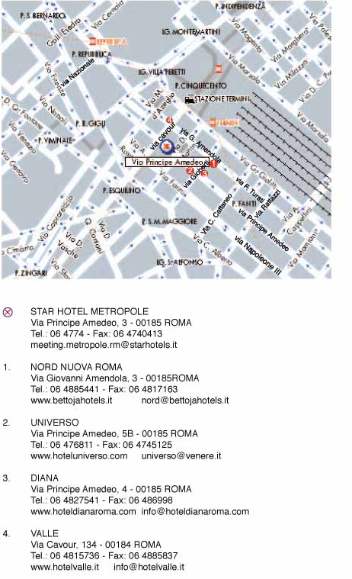
Meeting of the Ad Hoc Technical Export Group on
Mountain Biodiversity
Annex III
Roma, 1- 4 July 2003
Starhotel Metropole
ACCOMMODATION FORM

Family Name____________________________________________ First Name __________________________________________

Address ____________________________________________________________________________________________________

Code__________________ City_____________________________________________ Country_____________________________

Telephone |__________________| Fax |___________________| E-mail |________________________________________________|

HOTEL RATES (in Euro, per room, per night, breakfast and 10% VAT included)
Hotel | Single room | Double room
Starhotel Metropole - Roma  Via Principe Amedeo, 3  00185 Roma  Tel.+39 06 4774 Fax.+39 06 4741712  metropole.rm@starhotels.it | 140,00 | 170,00

ARRIVAL | DEPARTURE | sgl | dbl
___/___ | ___/___ | N°___ | N° ___

PAYMENT

- I enclose my credit card's details

VISA/MASTERCARD/CARTASI’ |__| DINERS CLUB |__| AMEX |__|

N° |__|__|__|__|__|__|__|__|__|__|__|__|__|__|__|__| Expiry Date |___/___|___/___|

Providing the above credit card details I authorise to:

use the card to secure the hotel reservation.
- debit the card in case of cancellation or no-show according to the policy stated here below.
The amount of the entire stay will be paid upon departure to the hotel.

CONFIRMATION - CANCELLATION POLICY

A confirmation will be sent by e-mail or fax by the hotel. Cancellations must be notified in writing to the hotel.
- For cancellations of hotel reservation notified within 48 hours before the arrival: no penalty fee
- For cancellation of hotel reservation or reduction of the length of stay notified less than 48 hours before the arrival and no-show: penalty fee: one night stay

Date |___|___| 2003 Signature |_________________________________________|

To be returned to: Starhotel Metropole - Roma
Via Principe Amedeo, 3 - 00185 Roma
Tel.+39 06 4774 Fax.+39 06 4741712 e-mail: metropole.rm@starhotels.it

Following the provision of law No. 675/96, please be informed that the personal data provided in this hotel reservation form will be used exclusively for information about the event mentioned in this form.

This is a short number

