 |  | CBD
 |  |  |  | Distr.  GENERAL  UNEP/CBD/COP/12/INF/29  29 September 2014  ORIGINAL: ENGLISH
CONFERENCE OF THE PARTIES TO THE CONVENTION ON BIOLOGICAL DIVERSITY
Twelfth meeting
Pyeongchang, Republic of Korea, 6-17 October 2014
Item 25 of the provisional agenda*
Promoting synergies in addressing biodiversity and climate change
adaptation issues: Linking national adaptation plans and national
biodiversity strategies and action plans
Note by the Executive Secretary

Introduction

- In decision XI/21, the Conference of the Parties reiterated the importance of activities to integrate biodiversity into relevant climate change activities and to ensure coherence in national implementation of both the United Nations Framework Convention on Climate Change and the Convention on Biological Diversity.
- The Executive Secretary is circulating herewith, for the information of participants in the twelfth meeting of the Conference of the Parties, the document “Promoting synergies in addressing biodiversity and climate change adaptation issues: linking national adaption plans and national biodiversity strategies and action plans”.
- The document was prepared by a consultant in collaboration with the Secretariat. The note aims to assist national focal points of the Convention on Biological Diversity to collaborate with their United Nations Framework Convention on Climate Change counterparts to strengthen synergies between the conservation and sustainable use of biodiversity and climate change adaptation at the national level through design, review and implementation of National adaptation plans and national biodiversity strategies and action plans.

Promoting synergies in addressing biodiversity and climate change adaptation issues:

Linking national adaptation plans and national biodiversity
strategies and action plans

1. Introduction
National adaptation plans (NAPs) and national biodiversity strategies and action plans (NBSAPs) are key planning tools for the implementation of the United Nations Framework Convention on Climate Change (UNFCCC) and the Convention on Biological Diversity (CBD) respectively.
The NAP and NBSAP processes contain many common approaches, such as stakeholder engagement, knowledge management, assessments of status and trends, and the prioritization of actions. Furthermore, NAPs and NBSAPs overlap in many ways with regard to assessing and addressing the impacts of climate change on ecosystem services, livelihoods and development.
The following document has been prepared in order to assist national focal points of the CBD to collaborate with their UNFCCC counterparts to strengthen synergies between the conservation and sustainable use of biodiversity and climate change adaptation at the national level through NAP and NBSAP design, review and implementation.

1.1 Overview of links between biodiversity and climate change
Observed changes in climate have already affected biodiversity at the species and ecosystem levels, including by changing the timing of key life events, increasing vulnerability to pests and natural disasters, and changing habitat conditions. Climate change will also have a negative impact on the ability of biodiversity to deliver ecosystem services – benefits that ecosystems provide to humanity – that the agriculture, water and other development sectors rely on.
Furthermore, climate change will have a negative impact on local economies and livelihoods. Due to the reliance of the poor and other vulnerable groups such as women and local and indigenous groups on biodiversity and ecosystem services, these negative impacts are likely to have a negative impact on their well-being and will compromise many development objectives.
The findings of the Fifth Assessment Report (AR5) of the Intergovernmental Panel on Climate Change (IPCC) Working Group II (WGII) on Impacts, Adaptation and Vulnerability are that recent changes in climate have caused impacts on natural and human systems on all continents and in all oceans. It found that evidence of climate change impacts is strongest and most comprehensive for natural systems.
Examples of specific projected impacts on species and ecosystems are presented in Box 1 below.
Box 1: Examples of projected impacts of climate change on biodiversity
- Many terrestrial species of plant and animal have shifted their ranges, altered their seasonal activities and experienced changes in abundance
- A large proportion of terrestrial and freshwater species will face increased extinction risk
- Coastal ecosystems are susceptible to increased submergence, flooding and erosion due to sea level rise
- Ocean temperature increases have resulted in large-scale distribution shifts of species, and have caused changes in ecosystem composition
Source: AR5 WGII report
Biodiversity has a potentially significant role to play in both climate change mitigation and adaptation. This paper, however, focuses on the contribution of biodiversity and ecosystem services to climate change adaptation.
In particular, the conservation and sustainable use of biodiversity may contribute to adaptation by increasing resistance to natural disasters through, for example, flood control and coastal protection and maintaining ecosystem goods and services, such as the provision of food, clean water and raw materials. As one concrete example, adaptation linked to agricultural biodiversity is expected to avoid 10-15% of the projected reductions in yield under changing climatic conditions. In fact, protecting biodiversity and ecosystem services from climate change is not a luxury but a necessity, because if they are destroyed or degraded, climate adaptation efforts will likely be more expensive and less sustainable.
Although there are many links between climate change and biodiversity, a very important one is through ecosystem-based approaches for adaptation to climate change (EBA), which link the conservation, restoration and sustainable use of biodiversity and ecosystem services with climate change adaptation. As stated by the Second Ad Hoc Technical Expert Group (AHTEG) on Biodiversity and Climate Change:
“Ecosystem-based adaptation, which integrates the use of biodiversity and ecosystem services into an overall adaptation strategy, can be cost-effective and generate social, economic and cultural co-benefits and contribute to the conservation of biodiversity”.
The UNFCCC Secretariat, in collaboration with partners of the Nairobi work programme (NWP) on impacts, vulnerability and adaptation to climate change, convened a technical workshop on EBA, which identified a number of broad principles for EBA, acknowledging the complexity of ecosystems and their natural adaptive capacity and focusing on:
- The maintenance of ecosystem services through conserving ecosystem structure and function and managing ecosystems at the appropriate spatial and temporal scales;
- Participatory and adaptive decision-making that is decentralized to the lowest accountable level; and
- Appropriately using information and knowledge from all sources, including traditional knowledge, innovations and practices.
EBA is discussed in more detail in section 2.3.1 below.
The many links between climate change and biodiversity provide countries with a strong incentive, among others, to promote and strengthen synergies between NBSAPs and NAPs.

1.2 Advantages of promoting and strengthening synergies between NBSAPs and NAPs
There are several reasons why a country might wish to promote synergies between NBSAPs and NAPs. These include (i) meeting international obligations, (ii) reducing vulnerability to the impacts of climate change by building adaptive capacity and resilience through biodiversity conservation, and (iii) facilitating the integration of climate change adaptation concerns into biodiversity policies, programmes and activities. These are discussed in turn below.

1.2.1 Meeting international obligations
Strengthening synergies between biodiversity conservation, management and sustainable use and climate change adaptation, in addition to facilitating the efficient use of human, technical and financial resources, also contributes to the achievement of international obligations.
Table 1, below, provides brief examples of relevant decisions made at the international level that encourage or highlight the importance of synergies between the CBD and UNFCCC. It is important to bear in mind that synergies should respect the independence and distinct mandates of the Rio Conventions, and that actions should be implemented in accordance with national circumstances.
Table 1: International calls for synergies
UN General Assembly | UNFCCC | CBD
There is a need for enhanced cooperation among the Rio Convention Secretariats | Enhanced action on adaptation should consider vulnerable ecosystems | EBA should be integrated into relevant strategies
Expresses concern over the negative impacts that climate change, biodiversity loss and land degradation have on each other | Adaptation should be integrated into relevant environmental policies and action | The impacts of adaptation actions on biodiversity and ecosystem services should be considered
Complementarities may be achieved when addressing climate change and biodiversity loss | Enhanced coordination among the Rio Conventions should be encouraged through the involvement of national experts and the sharing of relevant information | Suggests a list of activities to enhance cooperation and coordination between the three Rio conventions

1.2.2 Reducing vulnerability to the impacts of climate change by building adaptive capacity and resilience through biodiversity conservation and sustainable use
In planning for the conservation and sustainable use of biodiversity, NBSAPs promote increases in the protective function of ecosystems. The conservation and restoration of wetlands, for example, has been identified as an important hazard management strategy in the face of climate change. Intact ecosystems, with high levels of biodiversity, are expected to be more capable of adapting to climate change than systems that are fragmented or have a reduced level of diversity.
Those NBSAPs that recognize and value the natural adaptive capacity of species and ecosystems can also contribute to building adaptive capacity, including at the societal level. For example, some corals are more resilient to bleaching and, as such, will be less impacted by changes in sea temperatures and chemistry. Likewise, in the face of sea-level rise, mangroves can move inland while maintaining a functioning coastal ecosystem so long as the inland route is not blocked by development.
Promoting and strengthening synergies will ensure that NAPs do not select activities that will negatively impact biodiversity and ecosystems, thus reducing resilience and adaptive capacity. It will also ensure that, where relevant, cost-effective and sustainable adaptation strategies will make full use of biodiversity and ecosystem services.
In Tanzania, a study on vulnerability to climate change attributed reduced river flow and increased flooding to deforestation in the mountains. The study suggested that effective management of soil, forests and water resources are needed as adaptation measures, along with improved social capacity.

1.2.3 Facilitating the integration of climate change adaptation, in a coherent manner, into relevant new and existing biodiversity policies, programmes and activities
There is a great deal of scope for integrating climate change adaptation within NBSAPs and, in doing so, to better reflect climate change adaptation within biodiversity-related sectors.
In particular, in spite of the natural adaptive capacity of biodiversity, many species and ecosystems are not able to adapt to the impacts of climate change. For example, species in a region of southern Africa unique for its diversity of succulent flora, and with exceptionally high endemism, are unable to shift further south beyond the tip of Africa, while species restricted to lakes or high mountains have no migration avenues to follow. Such species may require more active interventions in the face of climate change, including:
- Identifying and protecting climate refugia;
- Increasing connectivity of habitats;
- Protecting environmental gradients;
- Reducing other threats that may be exacerbated by climate change;
- Designing resilient networks of conservation areas; and
- Habitat restoration.
Understanding observed and projected climate change impacts on species and ecosystems can contribute to long-term management plans that are sustainable, and that are resistant to the multiple pressures of change.
The national adaptation programme of action (NAPA) of the Republic of the Maldives contains a complete vulnerability assessment of coral reef biodiversity assessing, among other factors, susceptibility to bleaching. Activities within the NAPA to promote the adaptation of reef biodiversity include the establishment of marine protected areas, enforcement of the coral mining ban, and enhanced capacity for sewage treatment. These actions are completely compatible with Aichi Biodiversity Targets 10, 14 and 15 (please see below for more details on the Aichi Targets).

1.2.4 Reducing duplication and redundancy
Both biodiversity conservation and sustainable use and climate change adaptation require the management of immediate impacts or pressures and long-term risks. In order to achieve this, climate change adaptation and the management of biodiversity both seek to build resilient communities, support food security and livelihoods, and achieve a transition towards a green economy and sustainable development.
Furthermore, climate change threats and threats to biodiversity can overlap. This is the case with threats such as droughts and floods as well as sea level rise and extreme weather events.
Combining NBSAP and NAP approaches can therefore reduce duplication and avoid redundancy. Coordination can make more efficient use of limited financial resources, reduce the development of conflicting policy, and enhance the targeting of positive incentives.
In South Africa, to avoid overlap and ensure consistency in policy development and project implementation, the NBSAP is linked to the Climate Change Response Strategy as well as the National Action Programme to Combat Land Degradation and Alleviate Rural Poverty.

1.2.5 Successful mainstreaming of biodiversity and climate change issues in national development planning processes
The successful implementation of both NAPs and NBSAPs requires mainstreaming into other development or sectoral planning. Such mainstreaming is seen as important since climate change adaptation and biodiversity conservation and sustainable use are issues that both are impacted by development and can impact development pathways.
Although the timing of mainstreaming activities may not be completely compatible, there are a number of advantages to linking NBSAP and NAP mainstreaming processes. These include sharing experiences and connections, identifying common entry points for mainstreaming, and establishing sustainable mechanisms and processes for mainstreaming.
In France, implementation of the NBSAP is comprised of a series of ten sectoral biodiversity action plans. These cover everything from natural heritage to urban planning and transport. A technical committee coordinates implementation although each ministry is responsible for the implementation of its action plan.

1.3 The Strategic Plan for Biodiversity 2011-2020, the Aichi Biodiversity Targets, NBSAPs, and adaptation to climate change
The Strategic Plan for Biodiversity serves as the overarching framework on biodiversity for the entire UN system. It seeks to halt the loss of biodiversity, secure the Earth’s variety of life, and contribute to human well-being and poverty eradication. Implementation of the Strategic Plan is driven by national and subnational actions, with supporting activities at the regional and global levels.
Of the Strategic Plan’s 20 Aichi Targets, the following are of particular relevance when considering synergies between NBSAPs and NAPs:
- Target 10: By 2015, the multiple anthropogenic pressures on coral reefs, and other vulnerable ecosystems impacted by climate change or ocean acidification are minimized, so as to maintain their integrity and functioning.
- Target 14: By 2020, ecosystems that provide essential services, including services related to water, and contribute to health, livelihoods and well-being, are restored and safeguarded, taking into account the needs of women, indigenous and local communities and the poor and vulnerable.
- Target 15: By 2020, ecosystem resilience and the contribution of biodiversity to carbon stocks has been enhanced, through conservation and restoration, including restoration of at least 15 per cent of degraded ecosystems, thereby contributing to climate change mitigation and adaptation and to combating desertification.
The Strategic Plan for Biodiversity can be used as a vehicle for achieving synergies at national level because actions to achieve Aichi Targets 10, 14 and 15 will contribute to climate change adaptation as well as biodiversity objectives.

2. Ways and means to link NBSAP and NAP processes
The following section considers ways and means through which NBSAP and NAP processes can be better aligned. Throughout the section, suggested steps are presented based on the stage of the NAP process, noting that NAP and NBSAP processes are loosely aligned as outlined in Figure 1 below.
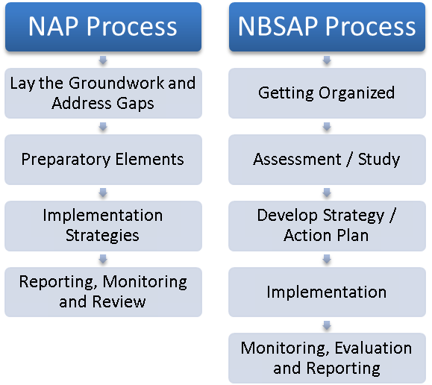
Figure 1: Comparison of NAP and NBSAP processes
There are a number of similarities in the above steps – for example the process of laying the groundwork and addressing gaps in NAPs and the getting organized step in the NBSAP process both include the identification of institutional needs and the establishment of organizational structures. Likewise, the monitoring, reporting and review phases under both processes are intended to be iterative steps that assess both the achievement of the planned activities and the effectiveness of the plans themselves.
Given the similarity in processes, there are significant opportunities for cross-learning and coordination as discussed in additional detail below. For ease of reference, the sections below are organized according to the steps in the NAP process.

2.1 Lay the groundwork and address gaps

2.1.1 Engaging biodiversity stakeholders
Given the links between biodiversity and climate change, it is important to engage biodiversity stakeholders in the NAP process, and climate change stakeholders should be involved in the NBSAP process. However, such a task can be challenging, as it is often difficult to identify the relevant persons within ministries, organizations and communities. Therefore, the CBD national focal point can be proactive in offering to assist the NAP process to integrate biodiversity and ecosystems, and to integrate climate change into the NBSAP process.

2.1.2 Making use of existing biodiversity-related information
The process of developing or revising an NBSAP requires the collection of information on the status and trends of biodiversity – and this usually includes an assessment of climate change threats. For example, the review of Tonga’s NBSAP contains a section on potential risks from climate change and its link to increased natural disasters overwhelming the resistance and resilience of coastal ecosystems.
Finally, in addition to conducting specific assessments for NBSAPs, many countries maintain a database of biodiversity information through the clearing-house mechanism (CHM) under the CBD. Currently both central and national CHMs are maintained with the objective of supporting the exchange of information and technology with regard to biodiversity. Currently, 160 Parties to the CBD have appointed a CHM focal point and 93 Parties have established national CHM websites.
Both central and national CHM websites contain information that may be useful in NBSAP development, in terms of threat and vulnerability studies and with regard to the identification of good practice examples and lessons learned. For example, the national CHM for Uganda contains details and background material related to the NBSAP revision as well as a special section on links between biodiversity and climate change. This information would also be useful for climate change adaptation planning.
Suggested steps:
- Consult the CBD website for the contact information for the national CHM focal point (http://www.cbd.int/chm/nfp.shtml);
- Consult CHM websites for biodiversity information;
- Share this information with the NAP team and stakeholders to assist in the development of the NAP.

2.1.3 Benefiting from traditional knowledge with regard to ecosystem management
The CBD has a long history of integrating traditional knowledge, innovations and practices into its work, including through NBSAPs. This reflects an acknowledgement of the importance of biodiversity to the livelihoods of many indigenous peoples, recognition of customary use rights over biodiversity resources, and valuation of traditional knowledge, innovations and practices with regard to the conservation and sustainable use of biodiversity.
With regard to NBSAPs, indigenous peoples are recognized as important rights holders who should be engaged. Such engagement extends beyond participation in meetings and consultations to also include capacity-building and knowledge and information sharing in order to ensure that engagement is effective. For example, Australia’s NBSAP includes a priority, action and target for the engagement of indigenous peoples as outlined in Box 2 below.
Box 2: Indigenous peoples and Australia’s NBSAP
Priority for action 1: Engaging all Australians
Action 5: Support long-term, two-way knowledge transfer and capacity building to enhance the role of traditional ecological knowledge in biodiversity conservation.
National target 2: By 2015, achieve a 25% increase in employment and participation of Indigenous peoples in biodiversity conservation.
Source: http://www.cbd.int/doc/world/au/au-nbsap-v2-en.pdf.
Most of the work on traditional knowledge under the CBD is coordinated through activities under Article 8(j) on traditional knowledge, innovations and practices and the accompanying Akwé: Kon guidelines on cultural, environmental and social impact assessments.
Local information on the status of traditional knowledge can be found through the regional reports on the status and trends concerning the knowledge, innovations and practices of indigenous and local communities relevant to the conservation and sustainable use of biological diversity prepared under the programme of work on Article 8(j) and related provisions of the CBD.
A great deal of work on climate change has already been conducted in relation to Article 8(j), including through the compilation of climate change impacts and vulnerabilities among indigenous peoples and local communities prepared for the fifth meeting of the working group on Article 8(j) and related provisions. Making use of this work in relevant sections of NBSAPs and NAPs can help to ensure the consistent engagement of indigenous peoples.
Suggested steps:
- Consider applying the Akwé: Kon guidelines to climate change adaptation projects (http://www.cbd.int/doc/publications/akwe-brochure-en.pdf);
- Identify and engage indigenous peoples representatives who are in involved in NBSAP development;
- Ensure that customary rights are recognized when designing and implementing NBSAPs and NAPs.

2.1.4 Mobilizing economic tools to assess contributions to development
Many countries carry out an economic valuation exercise as part of the NBSAP development and revision process, for the purpose of integrating the value of biodiversity into national accounts, and in national development planning. For example, the NBSAP for Pakistan includes the objective to “develop mechanisms to incorporate biodiversity values into national accounting and decision making at different levels”.
Within this, there are many methodologies available which can be used to assess the development contribution of biodiversity and ecosystem services that are threatened by climate change. Some countries have assessed the economic costs of climate change impacts, and the costs of mitigating and adapting to climate change.
Suggested steps:
- Review existing valuation studies (biodiversity and climate change) and identify any gaps relating to vulnerable ecosystems, or biodiversity-based livelihoods;
- Incorporate the projected impacts of climate change on biodiversity and ecosystem services into upcoming valuation studies.

2.2 Preparatory elements

2.2.1 Understanding observed climate change impacts on biodiversity and ecosystem services
The impacts of climate change on biodiversity are already being felt, especially in some of the most vulnerable ecosystems. At a global level, the second AHTEG on biodiversity and climate change examined available scientific literature, including reports from the Intergovernmental Panel on Climate Change (IPCC), in order to summarize how climate change is impacting biodiversity and ecosystem services. The latest report from the IPCC is the Fifth Assessment Report (AR5). The AR5 finds that climate change has impacted human and natural systems on all continents, and in all oceans, and that natural systems are most severely impacted. Examples of such changes are presented in Figure 2 below.
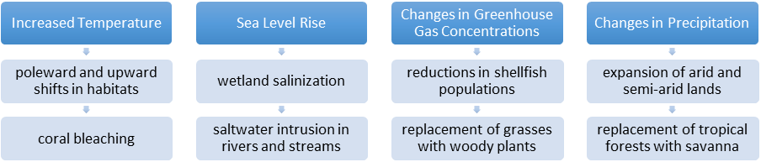
Figure 2: Observed impacts of climate change on ecosystems
Specific national-level assessments have also been conducted either as part of the NBSAP process or as a broader exercise integrated into the NBSAP threat assessment process. Other NBSAPs have identified understanding current climate change impacts on species and ecosystems as being an important activity within their NBSAP.
For example, in its NBSAP, Bosnia and Herzegovina includes a strategic target on monitoring global climate change effects. This strategic target includes a number of programme activities on monitoring climate change impacts on species diversity, monitoring climate change impacts on ecosystem diversity, and enhancing collaboration for the implementation of the CBD and UNFCCC at the local level.
In many cases the resources for assessing the observed impacts of climate change on species and ecosystems are limited. It may therefore be beneficial to consider the general issue of vulnerability in order to prioritize monitoring efforts. This is particularly true as some species and communities are extremely sensitive to even small changes in climate, whereas others will be able to tolerate large changes in climate with little apparent impact. As a general guide, vulnerable ecosystems identified in the fourth assessment report of the IPCC include the following:
- Wetlands in prairies;
- Wetlands in arid lands;
- Temperate grasslands and prairies
- Mediterranean forests, woodlands and scrub;
- Montane grasslands and shrublands;
- Mangroves;
- Tropical forests;
- Boreal forests / taiga;
- Small islands;
- Arctic islands;
- Peatlands;
- Mangroves; and
- Coral reefs.
Suggested steps:
- Examine the extent to which climate change threats have already been included in the NBSAP process;
- Assess the extent to which climate change impacts on biodiversity and ecosystem services have been assessed by national impact and vulnerability assessments prepared for the UNFCCC;
- Assess gaps and discuss with NAP counterparts steps that could be taken in order to address gaps;
- Establish a monitoring system to capture observed impacts, with a particular focus on vulnerable ecosystems;
- Identify other sources of information on linkages between biodiversity and climate change in the country and make arrangements for information sharing.

2.2.2 Benefiting from projections of future climate change impacts on biodiversity and ecosystem services
Various types of modelling tools exist for predicting impacts of climate change on biodiversity and/or ecosystem services. A number of such models have been run as a component of NBSAP threat analysis. Preparations for South Africa’s NBSAP, for example, modelled the projected impacts of climate change on 179 species. Such projections are based on combining climate models with biological models as outlined below.
When considering the climate portion of models, Coupled Atmosphere-Ocean General Circulation Models (AOGCMs), used for global and continental predictions, typically operate on coarse resolutions (150-300 km), whereas broad categories of downscaling tools include high-resolution “time-slice” Atmosphere General Circulation Models (AGCMs), variable resolution AOGCMs (VarGCMs), Nested Regional Climate Models (RCMs), and statistical downscaling (SD) methods.
Such climate models can be combined with biological or ecological information as bioclimatic models. The IPCC, in its Third Assessment Report, defines bioclimatic models as models “… used to determine the strength of association between suites of biotic and abiotic variables and species distributions. These associations can then be used to predict responses to environmental change, including climatic change.”
Integrative models have emerged in recent years and predict global climate change and social and environmental consequences, integrating climate science, technological change, economics, and policy. However, integrative models are at a relatively nascent stage and need to be validated and verified against observed data. Currently, ecosystem service data are scarce and on coarse scales.
Multi-model combinations are also emerging as more accurate predictors of climate change impacts on biodiversity. Specifically, by considering the weighted outputs of a number of models assessing the same process, multi-model combinations are able to minimize errors from both input data and the individual forecast models. This is particularly relevant when modelling interactions with high levels of uncertainty and high margins of error, for example, changes in hydrology and associated impacts on biodiversity.
As an example of the outcomes of such models applied at the national and subnational level, bioclimatic models project species extinction risks resulting from temperature increases, such as:
- In the Brazilian Cerrado: 38-45% of plants;
- In Mexico: 2-18% of mammals, 2-8% of birds and 1-11% of butterflies;
- In Australia: 7-14% of reptiles, 8-18% of frogs, 7-10% of birds and 10-15% of mammals as 47% of appropriate habitat in Queensland is lost.
With regard to modelling impacts on individual species or groups of species, a number of such assessments are integrated into NBSAPs, for example:
- In the Cape Floristic Region, 30 to 40% of South African Proteaceae, the plant family that includes South Africa’s national flower, the King Protea, are forecast to go extinct as a result of climate change between now and 2050;
- In the Amazon Basin, 30 of 69 tree species studied could face extinction;
- Many species of Arctic-breeding shorebirds and waterfowl are projected to undergo major population declines as tundra habitat shrinks; and
- Substantial changes in the location and areas of natural vegetation zones on the Tibetan Plateau are projected under climate scenarios.
Suggested steps:
- Refer to IPCC assessment reports for summaries of relevant projections and models;
- Review the examples of bioclimatic models compiled by the CBD Secretariat (http://www.cbd.int/doc/meetings/sbstta/sbstta-16/information/sbstta-16-inf-26-en.pdf);
- Identify how climate change impacts will be integrated into national targets and indicators within the framework of the Aichi Targets (especially Targets 10, 12, 14, and 15);
- Identify national and/or regional partners that can help the country to undertake bioclimatic modelling.

2.2.3 Assessing climate vulnerabilities within biodiversity-related sectors
Climate change is expected to have negative impacts on biodiversity-based livelihoods. In this regard, developing countries are predicted to be the most severely affected, as rural and poor people living in developing countries tend to have a more direct reliance on climate-sensitive natural resources such as forests, agricultural lands, and fisheries for subsistence or employment.
Assessments of the impacts of climate change on biodiversity-related sectors have already been carried out in many regions (see Box 3 for one example). The general approach to conducting such assessments is outlined in Figure 3 below.
Box 3: Vulnerable biodiversity-based livelihoods in Madagascar
Madagascar has completed a comprehensive assessment of climate change impacts on biodiversity, including a series of regional reports and a livelihood analysis.
With regard to biodiversity-based livelihoods, surveys in communities were combined with technical session discussions to identify vulnerable livelihoods as well as potential adaptation options. Specific recommendations were developed for the following biodiversity-related sectors: agriculture and husbandry, forestry and fishing.
Source: Conservation International and WWF (2008). Assessing the Impacts of Climate Change on Madagascar’s Biodiversity and Livelihoods
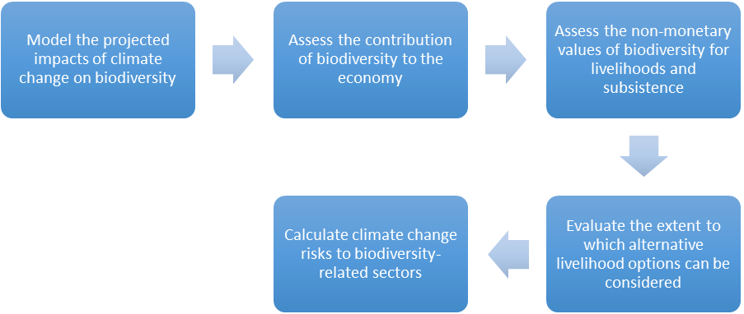Figure 3: Calculating climate change risks to biodiversity-related sectors
Examples of the outcomes of such assessments include:
- In Mongolia, a warming of 1-2°C is expected to lead to a 10-30 % reduction in productivity in steppe regions;
- In Uganda, an increase of 2°C would drastically cut back the land area suitable for coffee;
- If sea level rises by about one metre, the whole Mekong Delta, Vietnam's main rice growing region, will be submerged.
Small island developing States (SIDS) are highly vulnerable to the impacts of climate change on biodiversity-related sectors, in part because of the concentration of large settlements, and associated economic and social activities, at or near the coast. In small island developing States, arable land, water resources and biodiversity are already under pressure from sea level rise. They are further threatened by tropical storms and cyclones, coral bleaching, inundation of land, and coastal and soil erosion, resulting in high-cost damage to socio-economic and cultural infrastructure.
Suggested steps:
- Compile vulnerability assessments from forest, agriculture, fisheries and tourism sectors and use the assessments undertaken under the NBSAP process to guide adaptation choices, to ensure the actions are not detrimental to biodiversity and biodiversity-based livelihoods;
- Identify and consider any biodiversity-specific vulnerability assessments;
- Review any NBSAP actions focused on reducing vulnerability biodiversity-based livelihoods;
- Combine general vulnerability assessments with economic data, being sure to consider non-monetary sectors of the economy (if such data are available).

2.2.4 Understanding adaptive capacity and biodiversity
All species and ecosystems have some capacity to adjust to change; this “adaptive capacity” depends on the innate ability of a species or community to adapt or respond to changes in climate, and also on constraints that may be imposed by geography and topography. Highly mobile species like birds might be able to migrate to new habitats where climate conditions are more favourable, while trees and other sedentary species might be able to change their distribution only slowly over generations. Adaptability may be constrained if there is nowhere else to go as a result of natural continental or oceanic boundaries, or by altitudinal limits to migration. Figure 4 below, taken from the IPCC Working Group II Summary for Policymakers, illustrates the speeds at which different species will be able to move to suitable habitats within their climate.
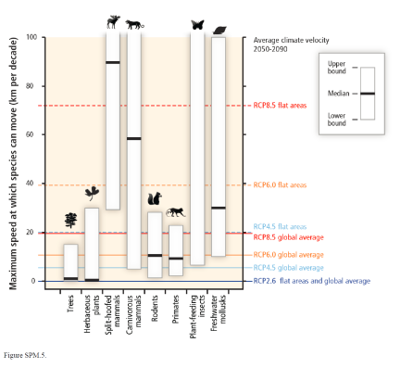
Figure 4: Maximum speed at which species can move in kilometres per decade
Source: IPCC WGII Fifth Assessment Report – Summary for Policymakers
It is also important to understand constraints to adaptive capacity that may result from human factors, such as land-use patterns or changes due to societal or sectoral responses to climate change. If climate change increases demand for limited resources such as water, species may find themselves in competition with humans for resources. Thus the adaptive capacity of species and ecosystems is also linked to the adaptive capacity of human communities.
Understanding the adaptive capacity of species and ecosystems can assist in adaptation planning in two ways. First, species or ecosystems with high adaptive capacity can be protected as a safeguard so that ecosystem functions can be preserved under changing climatic conditions even if specific species compositions cannot. For example, corals in the Poritidae family tend to be more resilient to bleaching events than corals with fine branches. Therefore, ensuring that such corals are protected from other threats to reef systems will increase the ability of the reef to adapt to climate change (see Box 4 below).
Box 4: Conservation of resilient corals in the Caribbean
An analysis of coral bleaching in the Caribbean carried out by the National Oceanic and Atmospheric Administration (NOAA) identified resilient corals and discusses how resilient species can be used to adapt to climate change.
In particular, individual history and genetic composition of the coral in combination with local environmental factors determines the extent to which corals can withstand bleaching events. Integrating corals with high resilience into reef systems can help to ensure the continued provision of ecosystem functions during and following bleaching events, thereby increasing the overall resilience of the reef.
Source: Marshall P.A. and Schuttenberg, H.Z. (2006). A Reef Manager’s Guide to Coral Bleaching. Great Barrier Reef Marine Park Authority, Australia – Chapter 1: Managing for Mass Coral Bleaching
Second, species or ecosystems with low adaptive capacity can be prioritized for particular adaptation options, as outlined in section 2.3.2 below.
Suggested steps:
- Review threat analyses of NBSAPs and NAPs to see if any assessments have been completed with regard to adaptive capacity;
- Identify factors that may reduce the natural adaptive capacity of species and ecosystems, including other anthropogenic threats or limits to mobility;
- Identify species and ecosystems with high adaptive capacity as a potential asset in climate change adaptation;
- Identify species and ecosystems with low adaptive capacity and consider including such species and ecosystems in climate change adaptation actions.

2.3 Implementation strategies

2.3.1 Plan for ecosystem-based approaches to adaptation
Ecosystem-based approaches to adaptation, as mentioned above, seek to maintain and restore ecosystem services in order to support climate change adaptation. Examples of EBA include:
- Restoration of wetlands to reduce flood risks;
- Establishment of diverse agricultural systems, including the conservation of indigenous crop and livestock varieties, to reduce weather-related food losses; and
- Sustainable management of grasslands and rangelands to enhance pastoral livelihoods in the face of increasing pressures.
Ecosystem-based approaches to adaptation complement other climate change responses in two ways. First, EBA helps to make ecosystems more resistant and resilient in the face of climate change, so that they can continue to provide the full suite of ecosystem goods and services that underlie human well-being. Such strategies are especially important for sustaining natural resources like water, timber and fisheries that many developing country economies and their people, especially the poor, depend on for their well-being and livelihoods. An example of ecosystem services provided by forests is presented in Box 5 below. Second, EBA protects and restores ecosystems that can provide cost-effective protection against some of the threats that result from climate change and, as such, can prevent direct loss and damage.
Box 5: Forest ecosystem services
Forests provide around 1.6 billion people with food, medicines, fuel and other basic necessities, and are the origin of about 5,000 different commercial products. These same forests play vital roles in water supply and purification, and account for a large portion of total above-ground terrestrial carbon.
Source: http://www.cbd.int/development/doc/cbd-good-practice-guide-forestry-booklet-web-en.pdf, http://www.cbd.int/forest/tools.shtml.
Ecosystem services and ecosystem resilience
The protection of ecosystem services as a contribution to climate change adaptation has already been taken up in a number of NBSAPs. As an example, in Samoa, the replanting of mangroves is an integral part of a large restoration project to enhance food security, which is expected to be threatened as a result of climate change.
Overall, EBA is based on the principle that the conservation and sustainable use of biodiversity can contribute to enhanced ecosystem resilience. This, in turn, can increase the adaptive capacity of ecosystems, including associated ecosystem services, which may be critical for food security and livelihoods.
Tanzania, for example, identified eight projects within its national adaptation programme of action (NAPA) that have a direct or indirect link to biodiversity and ecosystem services, including catchment conservation and sustainable use, forest-fire prevention and wildlife extension services. Complementing the NAPA, Tanzania’s NBSAP includes, in its actions on agricultural biodiversity, a priority action to “undertake adaptation measures to climate change with regard to agriculture, water, natural resources and coastal and marine resources”.
Intact ecosystems, with natural levels of genetic, species and functional diversity, are expected to be more capable of adapting to climate change than impoverished systems. Therefore, maintaining intact and connected systems (as opposed to impoverished systems in isolated remnants) will be important for the possibility of continued provision of ecosystem goods and services as the climate changes. Such “connectivity” is already an important component of a number of NBSAPs, as outlined in Box 6 below.
Box 6: NBSAP actions to maintain intact, connected ecosystems
Bhutan – Action 1.7: Identify priority biological corridors for conservation management based on tiger status surveys, snow leopard status surveys, and other biodiversity surveys that may be carried out from time to time.
Palau – 7.2.1: Establish spatially explicit management at correct spatial scales that are compatible with known patterns of “connectivity” of target populations (of corals).
Democratic Republic of the Congo – Project 1: Ensure that sustainable development and ecological management plans are in place in areas around and between protected areas.
Preventing loss and damage
The conservation and sustainable use of biodiversity can act as a buffer against hazards such as floods and drought (e.g., see Box 7 below). The conservation and restoration of wetlands, for example, has already been identified as an important hazard management strategy in the face of climate change. Not only can such actions be more cost-effective than traditional engineering responses but they can also provide substantial benefits in terms of fisheries, increased resilience and an improved aesthetic and cultural environment.
Box 7: Biodiversity and drought management
The conservation and sustainable use of biodiversity figure into drought management strategies including through actions such as maintaining the genetic diversity of indigenous livestock and crops and through the conservation of forests which act as micro-climates.
For example, maintaining the vegetative cover to protect soils from wind and water erosion is a key preventive measure against desertification, while also preventing the loss of ecosystem services during drought episodes.
Furthermore, conservation and restoration efforts which use local species can yield more positive results in terms of drought management while also improving biodiversity status and trends.
Suggested steps:
- Identify and consider any inventories or catalogues of ecosystem services available (note that such information is often assembled as part of the NBSAP preparation process);
- In collaboration with the NAP team and stakeholders, prioritize ecosystem services that (i) can address threats from climate change or (ii) may be threatened by climate change;
- Identify actions within the NBSAP and NAP that address the priority ecosystem services;
- Carry out an environmental impact assessment to ensure that prioritizing one ecosystem service over another doesn’t have unintended negative consequences;
- Design and implement EBA with the help of tools such as the UNEP EBA Decision Support Framework.

2.3.2 Integrate adaptation options for vulnerable biodiversity
Species or ecosystems with low adaptive capacity and high vulnerability to the negative impacts of climate change have already been identified in many countries through the NBSAP threat assessment process. A number of adaptation actions for biodiversity are included in NBSAPs. For example, in the NBSAP from Cambodia, one of the goals is to identify response measures to mitigate the impact of climate change on biological resources. The NBSAP from South Africa includes a similar goal as well as a number of specific activities, as outlined in Figure 5 below.
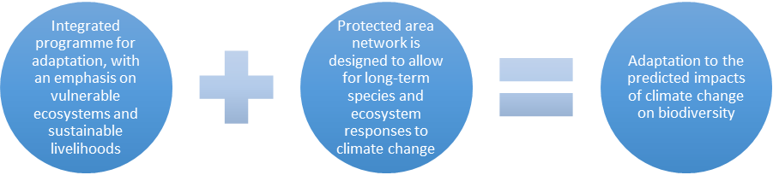Figure 5: Facilitating adaptation in South Africa
NBSAPs can include various climate change adaptation options for vulnerable biodiversity, for instance focusing on the following:
- Ensuring that ecosystems remain intact and interconnected to allow for biodiversity and people to adjust to changing environmental conditions;
- Restoration of fragmented or degraded ecosystems;
- The use of natural infrastructure such as wetlands or fringing mangrove communities to buffer human settlements from floods or storms; and
- Ensuring that resource managers adjust management practices or human use of ecosystems in appropriate ways.
In some cases, the above adaptation options may be insufficient and additional steps must be taken. These may include assisted migration (relocation) or ex situ conservation. The second AHTEG on biodiversity and climate change noted, however, that interventions such as relocation may present significant risks both to the species being managed for adaptation and to surrounding species and ecosystems. Assisted migration and ex situ conservation also tend to be very costly and may be beyond the capacity of many countries, especially those with a large number of competing adaptation needs.
Suggested steps:
- Identify any species or ecosystems that are particularly vulnerable to the negative impacts of climate change;
- Where such information is missing from the NBSAP, collaborate with the NAP team to fill information gaps;
- In collaboration with the NAP team and stakeholders, design a specific adaptation plan for vulnerable species and ecosystems, bearing in mind the precautionary approach / principle;
- Be sure to conduct a complete impact assessment for any assisted migration action.

2.3.3 Coordinate NBSAP and NAP mainstreaming processes
Mainstreaming is a core component of the CBD, as outlined in Box 8 below. NBSAP development includes a particular focus on mainstreaming biodiversity into sectoral policies, strategies and action plans, as well as into cross-sectoral plans such as poverty reduction and/or rural development strategies. There is also increasing awareness of the need to link NBSAPs to gender mainstreaming efforts.
Box 8: Mainstreaming in the CBD
Article 6 (b): Integrate, as far as possible and as appropriate, the conservation and sustainable use of biological diversity into relevant sectoral or cross-sectoral plans, programmes and policies.
Aichi Target 2: By 2020, at the latest, biodiversity values have been integrated into national and local development and poverty reduction strategies and planning processes and are being incorporated into national accounting, as appropriate, and reporting systems.
As NBSAPs address the sustainable use of biodiversity, they engage those sectors that make regular use of biodiversity, including forestry, fisheries, agriculture, tourism, etc. In some cases, NBSAPs include sectoral action plans, as in the case of France where NBSAP implementation is achieved through ten sectoral biodiversity action plans: natural heritage, agriculture, international, urban planning, transport infrastructure, the sea, overseas territories, forests, research, and tourism.
Furthermore, integrated, multi-sector approaches such as those employed by many NBSAPs provide management frameworks that may be well positioned to incorporate EBA and adaptation for biodiversity into broader risk reduction strategies. For example, the conservation or restoration of river floodplains in Europe has been adopted as an important response to increasing flooding events or droughts.
Suggested steps:
- Collaborate with the NAP team and stakeholders to identify common areas for mainstreaming climate change adaptation and biodiversity conservation and sustainable use into development planning processes.

2.3.4 Promote coordination and synergy with other multilateral environmental agreements
In some cases, the process of developing and implementing the NBSAP may have already established synergies between the CBD and UNFCCC. For example, many countries have NBSAP or biodiversity task forces or steering committees. These usually include some representatives of the departments or ministries responsible for matters related to climate change. These representatives are good starting points for collaboration with the NAP process.
Going beyond the CBD and the UNFCCC, there are also opportunities to take advantage of links with other biodiversity-related conventions through the NBSAP process. Perhaps the best tool within the CBD process to promote synergies among multilateral environmental agreements is the Strategic Plan for Biodiversity 2011-2020 and its Aichi Biodiversity Targets. Linking these to NAPs will enhance synergies with NBSAPs; they can also be used to enhance synergies with the other biodiversity-related conventions.
The CBD and the Biodiversity Indicator Partnership have developed a series of factsheets and potential indicators to assist with national implementation of activities. Examples of indicators are presented in Figure 6 below.
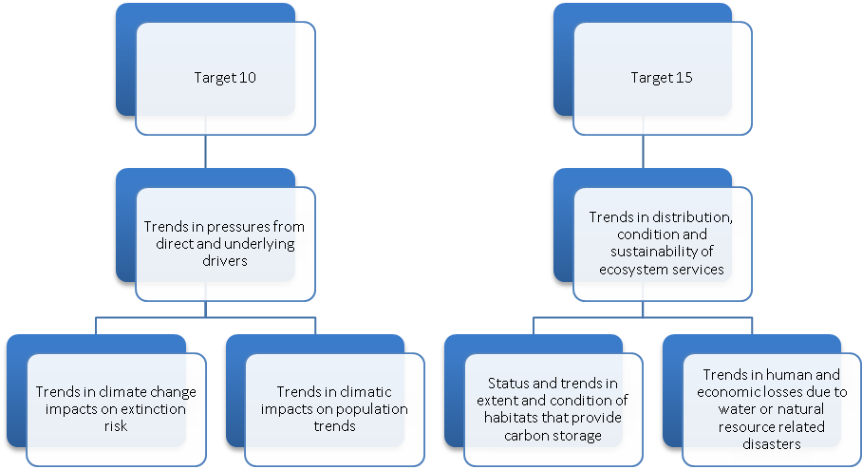
Figure 6: Examples of indicators proposed under the Aichi Targets
Suggested steps:
- Refer to the Strategic Plan Indicator factsheets for information on proposed indicators and potential sources of information (via searchable database at http://www.cbd.int/sp/indicators/);
- Contact and engage a biodiversity indicators development facilitator in your region (http://www.bipnational.net/GetInvolved/FindaFacilitator).

3. Conclusion
There are a number of significant opportunities to benefit from enhanced synergies between NBSAP and NAP processes. Key processes and issues such as mainstreaming, ecosystem-based approaches to adaptation, vulnerability and impact assessments as they apply to species and ecosystems, and monitoring and reporting form natural entry points for synergies.

3.1 Gaps, needs and opportunities
In spite of the many examples of existing and potential synergies,, a number of gaps and needs remain to be addressed if greater synergies between NBSAP and NAP processes are to be realized. Such gaps and needs occur at the global, national and local levels.

3.1.1 Global level
Funding: There is a need for closer alignment of funding for NBSAP and NAP processes so that common tasks such as biodiversity vulnerability assessments can be carried out using shared resources.
Reporting: Opportunities for synergies in national reporting should continue to be explored at the level of the conventions in order to promote efficiencies, for instance in the gathering, storing and dissemination of information on status and trends, as well as on implementation.

3.1.2 National level
Inter-agency collaboration: A review of National Capacity Self-Assessments reveals that many countries have prioritized the establishment or strengthening of collaboration between ministries and government agencies responsible for biodiversity and climate change as an important component of enhanced implementation. Examples of successful inter-agency collaboration drawn from national reports under the Rio Conventions include:
- Regular meetings among staff from different agencies;
- Shared office space between agencies;
- Establishment of issue-based working groups; and
- Assignment of shared responsibilities for overlapping issues.
Information: Although information on the links between biodiversity and climate change is increasing, there remain significant gaps. These include gaps with regard to downscaled bioclimatic models, understanding of hydrological impacts, and assessments of trade-offs associated with different ecosystem services and adaptation options. It is also important to address current gaps with regard to the use of traditional knowledge, noting that traditional knowledge should only be used with the full prior and informed consent of the holders of such knowledge.

3.1.3 Local level
Capacity-building: The links between biodiversity and climate change are complex. There is a need for local capacity-building to assist local communities with issues such as risks and risk assessments, and options for adaptation. Building such capacity is often an important first step in the effective engagement of local communities in the planning and implementation of activities that address climate change adaptation and biodiversity conservation and sustainable use.
Stakeholder engagement: Although most NBSAPs and NAPs have processes in place for stakeholder engagement, there is a need to increase the extent to which such processes are brought together. While the timing of NBSAP revision and NAP development may present challenges with regard to common stakeholder engagement processes, a number of opportunities remain. For instance NBSAP working groups and lists of stakeholders participating in relevant processes could be used to strengthen stakeholder engagement in addressing both biodiversity and climate-related concerns.

3.2 Additional resources
To support synergies between NBSAP and NAP processes, a number of tools related to each process may be useful to consult. These include:
- The CBD NBSAP Capacity Building Modules:
http://www.cbd.int/nbsap/training/default.shtml;
- The CBD Adaptation Website:
http://adaptation.cbd.int;
- The UNFCCC Guidelines for National Adaptation Plans:
http://unfccc.int/adaptation/workstreams/national_adaptation_programmes_of_action/items/7279.php;
- The UNFCCC Database on Ecosystem Based Approaches to Adaptation:
http://unfccc.int/adaptation/nairobi_work_programme/knowledge_resources_and_publications/items/6227.php.

__________

* UNEP/CBD/COP/12/1/Rev.1.
Ecosystem services (or ecosystem goods and services) can be described as follows: “Ecosystem services are the benefits people obtain from ecosystems. These include provisioning services such as food, water, timber, and fiber; regulating services that affect climate, floods, disease, wastes, and water quality; cultural services that provide recreational, aesthetic, and spiritual benefits; and supporting services such as soil formation, photosynthesis, and nutrient cycling.” Source: Millennium Ecosystem Assessment (2005), Ecosystems and Human Well-Being: Synthesis, http://www.unep.org/maweb/documents/document.356.aspx.pdf.
Intergovernmental Panel on Climate Change. Fourth Assessment Report: Working Group II Report. http://www.ipcc.ch/publications_and_data/ar4/wg2/en/contents.html.
CBD, UNFCCC, and the United Nations Convention to Combat Desertification.
United Nations General Assembly resolutions A/RES/57/257, A/RES/57/260, A/RES/58/243, and A/RES/58/212.
Decision 1/CP.16, decision 13/CP.8, and SBSTA 14 conclusions (FCCC/SBSTA/2001/2).
Decision IX/16, decision X/33.
European Water Directive. European Commission, 2000. http://eur-lex.europa.eu/LexUriServ/LexUriServ.do?uri=OJ:L:2000:327:0001:0072:EN:PDF.
In its decision X/2 adopting the Strategic Plan for Biodiversity 2011-2020, the Conference of the Parties (COP) to the CBD encouraged Parties to develop national and regional targets using the Aichi Targets as a flexible framework; to revise and update their NBSAPs and incorporate their national targets in these revised NBSAPs; and to use the revised NBSAPs as tools for effective mainstreaming of biodiversity into national development planning.
Links to information on both processes are provided at the end of this document. For brief overviews of NBSAP components and steps in the NAP process, see “Indicative Outline of an NBSAP” (http://www.cbd.int/doc/nbsap/indicative-outline-nbsap.docx) and “NAP poster” (http://unfccc.int/files/adaptation/application/pdf/nap_poster.pdf).
http://www.sprep.org/att/IRC/eCOPIES/Countries/Tonga/63.pdf.
http://chm.nema-ug.org/.
See for example CBD COP decision X/2 paragraphs 3 (a) and 6, and Aichi Target 18.
http://www.cbd.int/doc/publications/akwe-brochure-en.pdf.
http://www.cbd.int/doc/meetings/tk/emccilc-01/other/emccilc-01-wg8j-05-inf-18-en.pdf.
For an overview, see “An Exploration of Tools and Methodologies for Valuation of Biodiversity and Biodiversity Resources and Functions”, CBD Technical Series No. 28, Montreal.
http://www.cbd.int/doc/world/ba/ba-nbsap-01-en.pdf.
http://www.cbd.int/doc/world/za/za-nbsap-01-en.pdf.
IPCC Third Assessment Report - Climate Change 2001, Working Group II: Impacts, Adaptation and Vulnerability.
Target 12: By 2020 the extinction of known threatened species has been prevented and their conservation status, particularly of those most in decline, has been improved and sustained.
Community Based Adaptation: Samoa. UNDP, 2008. http://sdnhq.undp.org/gef-adaptation/projects/websites/index.php?option=com_content&task=view&id=252&sub=1.
National Adaptation Programme of Action for Tanzania. Division of Environment, 2006.
http://www.cbd.int/doc/world/pw/pw-nbsap-01-en.pdf.
European Water Directive. European Commission, 2000. http://eur-lex.europa.eu/LexUriServ/LexUriServ.do?uri=OJ:L:2000:327:0001:0072:EN:PDF.
Community Based Adaptation: Samoa. UNDP, 2008. http://sdnhq.undp.org/gef-adaptation/projects/websites/index.php?option=com_content&task=view&id=252&sub=1.
Millennium Ecosystem Assessment, 2005. Ecosystems and Human Well-being: Desertification Synthesis. World Resources Institute, Washington, DC.
Bainbridge, B. A Guide for Desert and Drylands Restoration: New Hope for Arid Lands. Society for Ecological Restoration International. 2007.

