 |  | CBD
 |  |  |  | Distr.  GENERAL  UNEP/CBD/COP/12/INF/18  22 September 2014  ORIGINAL: ENGLISH
CONFERENCE OF THE PARTIES TO THE CONVENTION ON BIOLOGICAL DIVERSITY
Twelfth meeting
Pyeongchang, Republic of Korea, 6-17 October 2014
Item 26 of the provisional agenda*
Review of Global Assessments of Land and Ecosystem Degradation and their Relevance in Achieving the Land-based Aichi Biodiversity Targets
Note by the Executive Secretary

Introduction
- The Executive Secretary is circulating herewith, for the information of participants in the twelfth meeting of the Conference of the Parties, a technical report prepared for the Secretariat of the Convention on Biological Diversity entitled “Review of Global Assessments of Land and Ecosystem Degradation and their Relevance in Achieving the Land-based Aichi Biodiversity Targets”.
- The Conference of Parties, in paragraph 5 of decision XI/16, requested the Executive Secretary to collaborate with partners to assist Parties in identifying ecosystems whose restoration would contribute most significantly to achieving the Aichi Biodiversity Targets; identify gaps in practical guidance and implementation tools for ecosystem restoration and suggest ways to fill those gaps; and develop clear terms and definitions of ecosystem rehabilitation and restoration and clarify the desired outcomes of implementation of restoration activities, taking into account the Aichi Biodiversity Targets 14 and 15, and other relevant targets.
- It is in this context that this document was commissioned by the Secretariat of the Convention on Biological Diversity and prepared by the World Resources Institute in collaboration with experts from World Resources Institute, Netherlands Environmental Assessment Agency (PBL), University of Western Australia, and ISRIC–World Soil Information.
- The document is being circulated in the form and language in which it was provided to the Secretariat. It will be edited and presented as a volume of the CBD Technical Series.

Working Title
Review of Global Assessments of Land and Ecosystem Degradation and their Relevance in Achieving the Land-based Aichi Biodiversity Targets
A technical report prepared for the Secretariat of the Convention on Biological Diversity (SCBD)

By:
Thomas Caspari
ISRIC–World Soil Information, Wageningen, The Netherlands
Sasha Alexander
University of Western Australia (UWA), Perth, Australia
Ben ten Brink
Netherlands Environmental Assessment Agency (PBL), The Hague, The Netherlands
Lars Laestadius
World Resources Institute (WRI), Washington, DC, USA

Ecological restoration provides a means
for partially offsetting the environmental surprises
of human society’s vast uncontrolled experiment
with the planet’s biosphere.
(Perrow & Davy 2002)

In 2008-9, the world’s governments rapidly mobilized hundreds of billions of dollars to prevent collapse of a financial system whose flimsy foundations took the markets by surprise. Now we have clear warnings of the potential breaking points towards which we are pushing the ecosystems that have shaped our civilizations. For a fraction of the money summoned up instantly to avoid economic meltdown, we can avoid a much more serious and fundamental breakdown in the Earth’s life support systems.
(Secretariat of the Convention on Biological Diversity 2010)

Draft key messages
Global figures on ecosystem conversion and degradation are available.
Our review shows that all major ecosystems and landscapes have been the subject of global assessments of degradation and loss, either directly or indirectly. While some biomes are monitored regularly (e.g. forests by FAO, wetlands by Ramsar), some others (e.g. grasslands) have no international organization responsible for the assessment and reporting on their global state.
Wetlands are the most degraded of all major ecosystems.
Globally, it has been estimated that half of the global wetlands has been converted with a quarter of the remainder being degraded. The world’s forests are close to these figures, whereas the planetary damage done to grasslands appears somewhat lower.
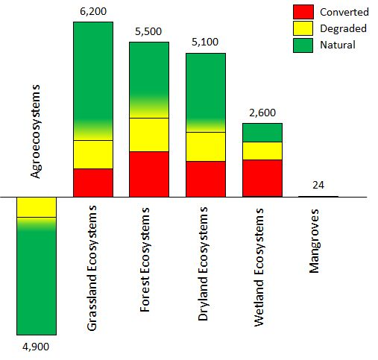
Findings from this technical report on the conversion and degradation of selected major ecosystem types. Numbers represent potential ecosystem extent under current climatic conditions. For exact numbers and data sources please see Table 12.
The results of available assessments vary widely.
This is due to conceptual differences (assumptions and definitions) as well as to data differences (techniques for collection and interpretation). Different assessments do not necessarily converge around a “true” magnitude of degradation. The information contained in the Millennium Ecosystem Assessment continues to be relevant.
Land degradation is a context-specific and value-laden concept.
A plantation forest may be a prime asset for the paper industry, but perceived as degraded by the ecologist or by native people of the area. Overall, the concept of ecosystem and landscape degradation, its causes and impacts, continues to be debated in part due to subjective perceptions and judgements of value. Thus, arriving at indisputable estimates of the global extent of degradation and the potential for restoration and rehabilitation is not possible, and even the best current scientific assessments contain a great deal of uncertainty.
Estimates of restoration potential are much less common than assessments of degradation. While global studies that quantify the benefits of restoration are rare, there are ecosystem- and site-specific assessments which could be used as indicators for decision-making however much more common are studies that quantify the negative impacts of degradation. These can also have similar utility.
The global restoration opportunity is substantial.
Notwithstanding the preceding points, the findings of this report indicate that the extent of degraded land with opportunities for restoration and rehabilitation is substantial. In addition to the subsequent adoption of sustainable agriculture and livestock practices on rehabilitated land, environmentally-sound intensification of food production, including through conservation agriculture and agroforestry practices, will likely needs to be part of a long-term strategy to meet the rising global demand for food without causing additional biodiversity loss and ecosystem degradation.
Restoration is an investment with high return.
Reliable global estimates for restoration benefits do not yet exist. Recent meta-analyses of dozens of large-scale efforts suggest that restoration efforts should be considered as high-yielding investments. Restoration of degraded ecosystems and rehabilitation of production landscapes promotes economic growth but also social cohesion for current and future generations, thus fostering a more healthy relationship between humans and the environment.

Table of Contents

Acknowledgements.........................................................................................10
List of abbreviations and acronyms...................................................................11
List of Tables.................................................................................................13
List of Figures................................................................................................15
1 Introduction 12
1.1 Motivation 12
1.2 Context of the technical report 12
1.3 Aim of the technical report 13
2 Terms and definitions in ecosystem restoration and rehabilitation 15
2.1 Conceptual framework 15
2.2 Terms and Definitions 17
3 A review of global estimates of the extent of ecosystem and landscape degradation 20
3.1 Methodological considerations 20
3.1.1 Geographical coverage and ecosystem classification 20
3.1.2 Sources of information 20
3.1.3 Presentation of results 21
3.2 Global estimates of ecosystem degradation 22
3.2.1 Overall global estimates 22
3.2.2 Agro-ecosystems 26
3.2.2.1 Extent of agro-ecosystems 27
3.2.2.2 Degradation in agro-ecosystems 28
3.2.3 Grassland ecosystems 34
3.2.3.1 Extent of grasslands 34
3.2.3.2 Degradation of grasslands 35
3.2.4 Forest ecosystems 36
3.2.4.1 Defining a forest 37
3.2.4.2 Deforestation or forest loss 39
3.2.4.3 Forest degradation 42
3.2.5 Dryland ecosystems 46
3.2.5.1 Extent of drylands 46
3.2.5.2 Degradation and desertification in drylands 47
3.2.6 Wetland ecosystems 53
3.2.6.1 Extent of wetlands 53
3.2.6.2 Conversion and degradation of wetlands 55
3.2.6.3 Conversion of peatlands 56
3.2.7 Coastal ecosystems 57
4 Deriving estimates for restoration and rehabilitation potential 61
4.1 Discussion of the findings 61
4.1.1 Conceptual changes over time 61
4.1.2 Ecosystem classification 62
4.1.3 Qualitative vs. quantitative assessments 63
4.1.4 Data gaps and perspectives 66
4.2 From degradation estimates to restoration potentials 68
4.2.1 Best estimate evaluation of existing global degradation assessments in light of ecosystem restoration and rehabilitation 68
4.2.2 Putting the findings in context of the Aichi Biodiversity Targets 71
5 The benefits of ecosystem restoration 74
5.1 Trade-offs and multiple benefits 74
5.2 Global estimates of benefits from ecosystem restoration 77
5.2.1 Overall global estimates 77
5.2.2 Agroecosystems 80
5.2.3 Grassland ecosystems 84
5.2.4 Forest ecosystems 86
5.2.5 Dryland ecosystems 90
5.2.6 Wetland ecosystems 93
5.2.7 Coastal ecosystems 96
5.3 Constraints and future challenges 99
6 Conclusions and Outlook 102
7 Literature cited 104
Appendices..................................................................................................143

Acknowledgements
The authors first wish to acknowledge the advice and guidance of the Secretariat of the Convention on Biological Diversity in preparing this technical report.
The authors are also most grateful to their colleagues at ISRIC, PBL, WRI, UNCCD, UWA and SER for their review and comments on the initial drafts of this report.
Finally, the authors would like to express their sincere appreciation for the work of the expert review panel.

List of abbreviations and acronyms
AFRP | Brazilian Atlantic Forest Restoration Pact
ASEAN | Association of Southeast Asian Nations
ASSOD | Soil Degradation in South and Southeast Asia
BCR | Benefit-Cost Ratio
CBD | United Nations Convention on Biological Diversity
CIESIN | Center for International Earth Science Information Network
C | Carbon
CH₄ | Methane
CITES | Convention on International Trade in Endangered Species
CKPP | Central Kalimantan Peatland Project
CCS | Carbon Capture and Storage
CO₂ | Carbon dioxide
COMSDAD | Compiled Map of Soil Degradation Assessments
COP | Conference of the Parties
CRI | Conservation Risk Index
DESIRE | Desertification Mitigation and Remediation of Land project
ES | Ecosystems Services
ESA | European Space Agency
FAO | Food and Agriculture Organization of the United Nations
FAOSTAT | FAO statistical database
FRA | FAO Forest Resources Assessment
GBO | Global Biodiversity Outlook report (CBD)
GEF | Global Environment Facility
GEO | Global Environmental Outlook report (UNEP)
GFCL | Global Forest Cover Loss
GIMMS | Global Inventory Modeling and Mapping Studies
GIS | Geographical Information System
GLADA | Global Assessment of Land Degradation and Improvement
GLADIS | Global Land Degradation Information System
GLASOD | Global Assessment of Human-Induced Soil Degradation
GLOBIO | Global Biodiversity Model
GLWD | Global Lakes and Wetlands Database
GPFLR | Global Partnership on Forest Landscape Restoration
GRoWI | Global Review of Wetland Resources and Priorities for Wetland Inventory
Gt | Gigaton (billion ton = Pg)
GVI | Global Vegetation Index
HANPP | Human Appropriation of Net Primary Production
ICASALS | International Centre for Arid and Semiarid Land Studies, Texas Tech University
ICTSD | International Centre for Trade and Sustainable Development
IFL | Intact Forest Landscapes
IFPRI | International Food Policy Research Institute
IGBP | International Geosphere-Biosphere Programme
IMAGE | Integrated Model to Assess the Global Environment
IPCC | Intergovernmental Panel on Climate Change
ISRIC | International Soil Reference and Information Centre
ITTO | International Tropical Timber Organization
IUCN | International Union for Conservation of Nature
LADA | Land Degradation Assessment in Drylands
LEAD | Livestock, Environment and Development initiative (FAO)
LPI | Living Planet Index
LSD | Land and Soil Degradation
MA | Millennium Ecosystem Assessment
MDG | Millennium Development Goal
Mha | Megahectares (million hectares)
MSA | Mean Species Abundance
N₂O | Nitrous Oxide
NBSAP | National Biodiversity Strategies and Action Plan
NDVI | Normalized Difference Vegetation Index
NPP | Net Primary Production
OECD | Organization for Economic Co-operation and Development
PAGE | Pilot Analysis of Global Ecosystems
PBL | Planbureau voor de Leefomgeving (Netherlands Environmental Assessment Agency)
Pg | Petagram (10¹⁵ gram = Gt)
PoWPA | CBD Programme of Work on Protected Areas
REDD | Reducing Emissions from Deforestation and Forest Degradation
SBSTTA | Subsidiary Body on Scientific, Technical and Technological Advice (CBD subsidiary body of COP)
SER | Society for Ecological Restoration
SLM | Sustainable Land Management
SOC | Soil Organic Carbon
SOLAW | State of the World’s Land and Water Resources for Food and Agriculture
SOM | Soil Organic Matter
TEEB | The Economics of Ecosystems & Biodiversity
UN | United Nations
UNCCD | United Nations Convention to Combat Desertification
UNCOD | United Nations Conference on Desertification
UNEP | United Nations Environment Programme
UNSO | Bureau des Nations Unies pour la Lutte Contre la Désertification
WOCAT | World Overview of Conservation Approaches and Technologies
WRI | World Resources Institute
WWF | World Wide Fund for Nature
List of Tables
Table 1: Main causes of soil degradation by region in susceptible drylands and other areas (in Mha) 29
Table 2: Forest area changes 1990-2000 in tropical and non-tropical areas (Mha per year) 40
Table 3: Forest area extent and change for periods 1990-2005 41
Table 4: Estimated extent of degraded and secondary forests by category in tropical Asia, tropical America and tropical Africa in 2000 (Mha, rounded to nearest 5 million). Data are from 77 tropical countries in the year 2000 43
Table 5. Status of the world's potential forest landscapes (by 2010) 44
Table 6. Current status of potential forest lands, by potential density (million hectares) 44
Table 7: Soil degradation degree by region inside the drylands (“Susceptible”) and outside (“Others”); all data in Mha 49
Table 8: The extent of global drylands, and estimates of degradation by GLASOD vs. COMSDAD, all data in Mha 51
Table 9: Comparison of estimates of global wetland area according to the GRoWI (Finlayson et al. 1999), and GLWD (Lehner & Döll 2004) 55
Table 10: Current and past extent of mangroves by region (1980-2005). 59
Table 11: Comparison of forest area and forest area change estimates from the remote sensing survey with country data. 66
Table 12: Best estimates of the core team on extent and degradation parameters of major ecosystems, n/a = not available. 69
Table 13: Indicative trends in the distribution of costs and benefits of various technologies or practices 83
Table 14: Mitigation potential in agriculture and forestry in 2030 85
Table 15: Peatland uses and functions 95
Table 16: Value ranges of ecosystem services provided by mangrove ecosystems 98
Table 17: Costs and benefits of direct and indirect use values of mangrove restoration (adapted from Tri et al. 1998) 99

List of Figures
Figure 1: Strength of linkages between categories of ecosystem services and components of human well-being that are commonly encountered 15
Figure 2: Conceptual framework for ecosystem degradation, rehabilitation and restoration 16
Figure 3: Opportunities and trade-offs 18
Figure 4: Conversion of terrestrial biomes. 23
Figure 5: Habitat conversion and protection in the world’s 13 terrestrial biomes.. 24
Figure 6: Global assessment of the status of human-induced soil degradation (1990) 28
Figure 7: Status and trends in global land degradation 31
Figure 8: Status of the land (Capacity of ecosystems to provide services). 32
Figure 9: Degrading land (Trends in ecosystem services 1990-2005) 32
Figure 10: Land degradation classes 33
Figure 11: Estimated deforestation, by type of forest and time period (FAO 2012) 38
Figure 12: World population and cumulative deforestation, 1800-2010 39
Figure 13: Findings of FAO’s Global Forest Resource Assessment (FAO 2001): Major change processes in World’s forest area, 1990-2000 (in Mha).. 40
Figure 14: Change in forest area by region, 1990-2010 41
Figure 15: Historic developments and projections to 2050 of global mean species abundance (MSA) per biome 45
Figure 16: The relation between “peatland”, “wetland”, and “mire” 54
Figure 17: Conceptual relationship between Ecosystems & Biodiversity and Human Well-being 75
Figure 18: Trade-off analysis depicting major interventions and consequences on condition of ecosystems and development goals (MA 2005d). 76
Figure 19: The value of ecosystem services 78
Figure 20: Benefit-cost ratios of restoration 80
Figure 21: Enhancing agroecosystem goods and services 82
Figure 22: Linkages and feedback loops among desertification, global climate change, and biodiversity loss 92
Figure 24: Impact of conservation on ecosystem services (ES) in all DESIRE study sites. 100
Figure 25: Simplified conceptual model for ecosystem degradation and restoration.. 101

Introduction

Motivation
Everyone depends on the Earth’s ecosystems and the services they provide. Over the past 50 years, humans have transformed the landscape more rapidly and extensively than in any comparable period of time, largely to meet rapidly growing demands for the tangible necessities, such as food, water, timber, fiber, and fuel (MA2005b), but also as a result of an insatiable desire for luxury goods and capital accumulation among the political and economic elites.
Increases in the productive capacity for market goods and services derived from natural capital are often associated with unsustainable management practices that result in the degradation of natural resources, and the reduction of other essential ecosystem services, such as those that provide important supporting, regulating and cultural functions. Many terrestrial and aquatic ecosystems that still remain relatively intact are becoming increasingly vulnerable to degradation and loss in their productive capacity. Many ecosystems have been degraded to the extent that they are nearing critical thresholds or tipping points, beyond which their capacity to provide the desired services may be drastically reduced (TEEB 2010; MA 2005a).
These trends are fuelled by a variety of anthropogenic drivers such as population pressure, unsustainable agricultural and livestock practices, and extractive and water-intensive industries (SCBD 2010, FAO 2011a), and are now being magnified by the impacts of climate change and biodiversity loss. Even in those ecosystems that have been cleared and converted into cultivated systems and that now form part of the production landscape, there are significant declines in health that have led to productivity loss and abandonment. It is these agro-ecosystems that offer the greatest promise for rehabilitation and restoration, and on which we should focus our efforts in order to avoid the further transformation of our remaining natural ecosystems.
Recognizing the need to recover health and productivity in both natural and production landscapes, restoration and rehabilitation activities are increasingly being undertaken to enhance their integrity and resilience. Assessments of ecosystem health, the status and extent of degradation, and the potential for restoration and rehabilitation are useful tools that can assist countries and communities in prioritizing interventions and monitoring progress towards the Aichi Biodiversity Targets (hereafter “Aichi Targets”), in particular Target 15 which call for the restoration of at least 15% of the world degraded ecosystems.

Context of the technical report
In decision X/2, the 10th Conference of Parties (COP) to the Convention on Biological Diversity (CBD) adopted the Strategic Plan for Biodiversity 2011-2020 and a set of 20 Aichi Targets. Aichi Targets 5, 11 and 15 describe area-based global targets to reduce the conversion of natural habitats, improve protected area networks, and improve ecosystem resilience through conservation and restoration activities. These targets can be realized, inter alia, through: the effective implementation of the CBD programme of work on protected areas (PoWPA), the assessment of degraded lands and implementation of appropriate methods of restoration and rehabilitation, and the adoption ecosystem-based approaches to climate change mitigation and adaptation. For the necessary protection, sustainable use and restoration practices to be effective and sustained, an ecosystem approach should be employed involving a broad range of stakeholders with multi-sectoral integration across land- and seascapes.
The CBD’s COP 12, to be held in October 2014, is a point to review progress towards the Aichi Targets and put in place the enabling environment and mechanisms for their achievement by 2020. Prior to COP 12, Parties should have completed the revision of their national biodiversity strategies and action plans (NBSAPs) which are the main road maps for action on biodiversity. Systematic capacity development and facilitating implementation in a focussed way through continuous technical support holds the key for Parties to achieve the Aichi Targets.
In response to multiple COP decisions, the CBD Executive Secretary plans to provide capacity building to support Parties in achieving Targets 5, 11, and 15 by using an ecosystem approach, within the land- and sea-scape context, to restoration and rehabilitation, expanding and improving protected areas networks, and mitigating and adapting to climate change. This initiative will employ a variety of methods, namely: sub-regional capacity building workshops accompanied by e-learning modules, the provision of tools and technologies, and technical support networks to achieve these goals and outcomes. The institutional and technical capacity building and actions resulting from these workshops will contribute to progress in meeting all of the Aichi Targets, including fostering sustainable development, reducing poverty and enhancing human well-being, thereby contributing to the post-2015 development agenda. The results and conclusions of this technical report will likely become part of the documentation for SBSTTA 18 and COP 12.

Aim of the technical report
The aim of this technical report is fourfold:
- First, to provide a clear and simple conceptual framework, including terms and definitions for degradation and restoration of ecosystems and landscapes;
- Second, to review existing global and selected sub-global estimates of the extent of degraded ecosystems and landscapes, and to compare and summarize the methodologies used;
- Third, to assess the area of degraded ecosystems and landscapes and the area with potential for restoration, rehabilitation, and conversion to productive land; and
- Fourth, to identify, and where possible quantify in physical and/or economic terms, the expected benefits of restoration including climate change mitigation and adaptation, biodiversity conservation, combatting desertification and land degradation, and other benefits.

Given the limited time and resources available for the production of this technical report, the authors would clearly like to state that these finding represent the first step in a longer-term, iterative process of assessing the scope of land and ecosystem degradation and the potential for restoration and rehabilitation. It is hoped that this report will serve as the foundation for further work and assist with other relevant global processes that are addressing the rapid and unprecedented decline in biodiversity and ecosystem services at all scales.

Terms and definitions in ecosystem restoration and rehabilitation

Conceptual framework
In this report, a simple conceptual framework is employed to introduce and provide context for the key terms and definitions related to ecosystem degradation, restoration and rehabilitation. To the extent possible, existing frameworks have been considered and incorporated however a discussion of their differences and similarities is beyond the scope of this report. Due to the nature of global assessments and the wide range of ecosystems covered in this report, this conceptual framework solely aims to clarify the use of frequently used terms and develop a common language for decision-making in multi-stakeholder environments.
The ecosystem approach, championed by the Convention on Biological Diversity (CBD 2000), extends natural resource management beyond protected areas to the entire ecosystem within a land- and sea-scape context. It recognises that humans are an integral component of ecosystems, and that ecosystems can be best managed recognizing the numerous functions they perform and the multiple benefits they provide. All species, including humans, are dependent on the Earth’s ecosystems and the wide range of services they offer, such as food, water, disease management, climate regulation, spiritual fulfilment and aesthetic enjoyment (MA 2005b). Figure 1 provides an overview of the links between ecosystem services and human wellbeing.
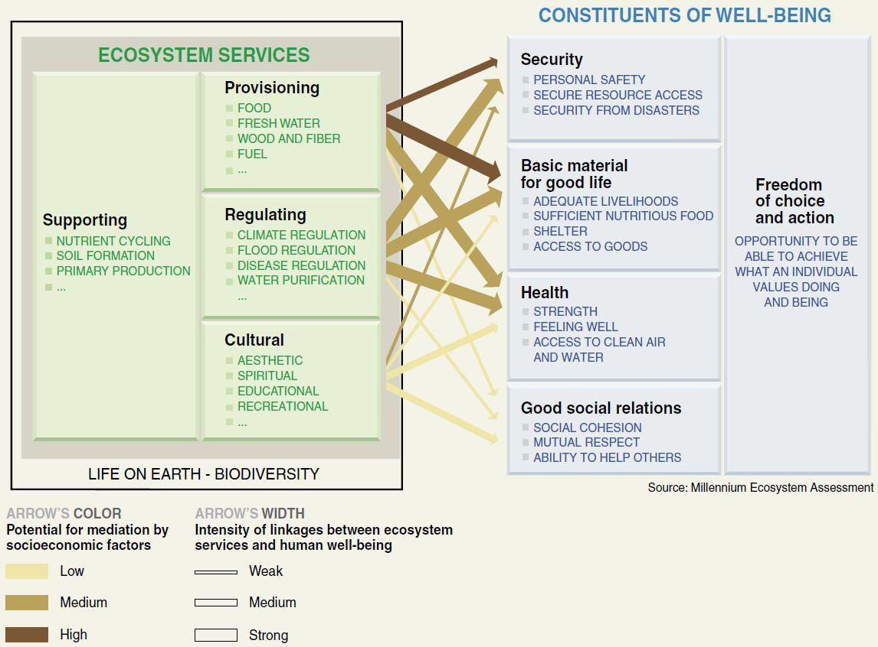
Figure 1: Strength of linkages between categories of ecosystem services and components of human well-being that are commonly encountered; includes indications of the extent to which it is possible for socio-economic factors to mediate the linkage (MA 2005b).
A landscape approach merely scales up the ecosystem approach. It accounts for the feedback loops and interdependencies among ecosystems to better understand how the various structural and functional components of a landscape interact (e.g. several types of ecosystems within a watershed) and how equity is fostered when conservation and restoration decisions recognize and capture these multiple functions and uses.
Over thousands of years, humanity has been driving functional changes in ecosystems and landscapes for its own benefit, converting land and replacing the original species with ones that produce greater benefits to humans (i.e. ecosystem services as defined by the MA). This narrow focus on the production function means that other ecosystem services and their underlying structures and processes were neglected or their impairment tolerated. In the past 50 years, humans have transformed ecosystems and landscapes more rapidly and extensively than in any comparable period of time. This has largely been driven by the conversion of primary type ecosystems (e.g. forests, grasslands, mangroves) into productive systems to meet the growing demands of increased population. These activities have contributed to the overall reduction in the complex array of ecosystem services essential to maintain human health and wellbeing, and the planet’s life-support systems.
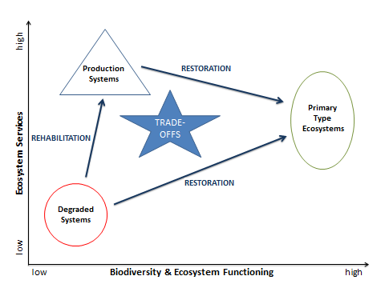
Figure 2: Conceptual framework for ecosystem degradation, rehabilitation and restoration (modified from Bradshaw 1987a)
Figure 2 summarizes the conceptual framework with the help of a simple diagram. It shows various types of managed and unmanaged systems plotted along the x-y axes: increasing biodiversity and ecosystem functioning (x-axis) and increasing ecosystem services (y-axis). The arrows indicate possible interventions for transitioning from one system to another.

Terms and Definitions
The term degradation, whether referring to habitat, land, ecosystems or landscapes, is context-specific and value-laden. Land degradation is considered both a state and process (Safriel 2013). It is characterized by a loss or reduction in ecological or economic productivity (Bai et al. 2008a) often with direct trade-offs between these two outputs. Thus, degradation for one stakeholder may be a source of income or livelihood for another.
The dimensions of land degradation include a persistent reduction in the productive capacity of land (e.g. loss of soil nutrients, vegetative cover, and productivity), a loss of biodiversity (e.g. species or ecosystem complexity), and decreased resilience (e.g. increased vulnerability of ecosystems and communities). The process of land degradation may ultimately lead to a state, such as desertification, where biodiversity and ecosystem functioning have been reduced to such an extent where few, if any, ecosystem services are being provided.
Given that all human societies and economies ultimately depend on natural capital, the highest priority must be to conserve and sustainably manage ecosystems and landscapes, rather than to condone or ignore their continued degradation. Where appropriate and feasible, the restoration of degraded ecosystems and the rehabilitation of production landscapes should be undertaken so as to avoid the further conversion of relatively intact or natural ecosystems solely for provisioning services like food and timber.
Ecosystem restoration is an activity that often involves a wide variety of disciplines and expertise including natural resource management, biodiversity conservation, ecological engineering, landscape design, just to name a few. In its strictest sense, restoration means to bring the ecosystem back to a former, unimpaired condition. This implies a very specific endpoint or desired outcome that is a close approximation of its intact or natural condition prior to disturbance (Bradshaw 2002). Restoration involves gradual changes in order to fulfil a long-term commitment and vision; it is not a one-time intervention, like planting trees on barren lands or removing dams from rivers.
More broadly, restoration is defined as the process of assisting the recovery of an ecosystem that has been degraded, damaged, or destroyed with respect to its health, integrity and sustainability (SER 2004). While the objective is the recovery of the structure, function and composition of a degraded ecosystem, it also suggests that restoration is an intentional activity that initiates ecological processes to return an ecosystem to its historic trajectory (SER 2004) or, when impractical, put it on a pathway towards a desired, self-sustaining ecological state (Hobbs et al., 2006).
The definition of rehabilitation is somewhat less specific, but yet still close to that of restoration according the Oxford English Dictionary: “the action of restoring a thing to a previous condition or status”. However, in common usage, rehabilitation activities aim to repair ecosystem functioning with less emphasis on the recovery of structure and composition and more on increasing productivity for the benefit of people (Aronson & Clewell 2013). Thus rehabilitation efforts are more relevant to production and multi-use landscapes with many proven approaches and technologies to progress from a less desired to a more desired ecosystem state (see Figure 3). Many of these activities are grouped under terms such as sustainable land management (SLM), soil and water conservation (SWC), conservation agriculture (CA), integrated water resources management (IWRM), agroforestry and silvopastoral practices, and many more.
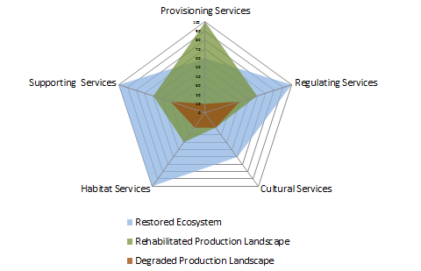
Figure 3: Opportunities and trade-offs: This radar diagram illustrates change in the status of ecosystem services associated with restoration and rehabilitation as defined above. In addition, to the four categories of ecosystem services (MA 2005), “habitat services” (de Groot 1992) has been added to highlight those services with no direct or indirect benefit to humans. Movement outward along the axis indicates improvement while movement inward depicts negative trends.
The above diagram also shows how rehabilitation and restoration help to minimize trade-offs between desired socio-economic benefits and the associated but undesired decrease in biodiversity, soil health, water quality etc. Even if the focus of rehabilitation is on maximizing the production function, e.g. provisioning services, most often the measures taken will positively contribute to the improvement of essential supporting and regulating services.
Finally, the terms remediation, re-vegetation and reclamation are often seen as the first steps or actions to be taken in rehabilitation or restoration projects and programmes, particularly in severely degraded or contaminated ecosystems. For these types of activities, the focus is on removing gray infrastructure or making an area safe for subsequent land uses with little or no regard for biodiversity and ecosystem functioning. When implemented in isolation or seen as ends in of themselves, these activities do not constitute restoration or rehabilitation.
Ecosystem restoration and rehabilitation activities are undertaken for a variety of reasons, but for the purposes of this report, the rationale is practical and focused on the long-term sustainability of biodiversity and ecosystem services. A recent meta-analysis has shown that restoration actions focused on enhancing biodiversity are correlated with the increased provision of ecosystem services (Benayas et al. 2009) while another meta-analysis shows that a “restored” wetland rarely provides the full range and magnitude of services delivered by a wetland that has not been degraded (Moreno-Mateos et al. 2012). Thus, the first priority should always be to conserve and sustainably use ecosystems rather than allow for their degradation.
Ecosystems are inherently complex while many production or mosaic landscapes include natural areas that evolved novel interactions and dependencies that are equally difficult to understand. Thus, best policies and practices in restoration and rehabilitation adhere to an adaptive management approach. It is a systematic process for continually improving management policies and practices by learning from the outcomes of previously employed policies and practices (MA 2005). In addition, implicit in this approach are (i) a clearly articulated vision, (ii) quantifiable objectives that offer clear milestones for measuring progress, and (iii) thorough scientific investigation of both the ecosystem’s natural dynamics and its response to disturbances (Lindenmayer et al. 2008). This is especially important for restoration because natural processes such as succession can often be construed as important methods for recovery known as assisted natural regeneration (Prach et al. 2001). An adaptive management approach forms an explicit link between research and management, and thus allows for the development of policies and practices within a structured framework.
Chapter 3 provides a review of global assessments of ecosystem conversion and degradation and a comparison of the different methodologies used. Taking into account these findings, Chapter 4 offers best estimates on the extent of ecosystem and landscape degradation as well as the potential for restoration and rehabilitation activities. Chapter 5 will identify, and quantify when possible, the benefits and co-benefits of these activities.

A review of global estimates of the extent of ecosystem and landscape degradation

Methodological considerations

Geographical coverage and ecosystem classification
The intent of this report was to review global assessments primarily covering terrestrial ecosystems. This excludes all tundra and marine ecosystems but does include mangroves and all types of inland wetlands. Thus, an ecosystem classification was selected so as to allow for sufficient findings per unit selected, and their comparison. The system developed for the Pilot Analysis of Global Ecosystems (PAGE) of the World Resources Institute (WRI) with its 5 units provided the most appropriate classification system. Because of their particular importance, we have added dryland ecosystems to yield the following 6 units in total:
- Agroecosystems: irrigated and rainfed cropland; pasture
- Grasslands ecosystems: natural grasslands incl. savannah, shrubland, and tundra; pasture
- Forest ecosystems: all ecosystems with a tree crown cover of >10%
- Dryland ecosystems: all areas under water stress, partly also deserts
- Wetland ecosystems: inland freshwater habitats, including peatlands
- Coastal ecosystems: terrestrial fraction only, mainly mangroves.
These units represent major ecosystem-based reporting units, and it is important to note that these units are not mutually exclusive allowing for overlap either spatially or conceptually. This is especially true for the dryland ecosystems (see related discussion in section 3.2.5).

Sources of information
The starting point for this report was the most relevant global assessments on the degradation status of soil, land and ecosystems. For a quick overview, they are listed in Appendix A, including their methodologies and main findings.
There are three significant aspects or dimensions that can be used to characterize the nature of the various global assessments reviewed.
- Data acquisition vs. data review: assessments generating authentic data through techniques such as field work, questionnaires, remote sensing or modelling, vs. those that exclusively review, interpret, and analyse existing data;
- Ecocentric vs. anthropocentric: assessments focussing on state and trends of the ecosystem(s) itself (e.g. GLASOD), vs. those also encompassing the benefits humans derive from natural systems (ecosystem services concept);
- Single vs. multiple: assessments focussing on one type of major ecosystem (e.g. FRA 2000), vs. those that assess several ecosystems (e.g. PAGE) or even encompass all biomes (MA).
Although these dimensions are not always explicitly stated in the report, they informed their consideration during the compilation and evaluation of the data. Where relevant references were found in the text, the original literature was traced, results verified, and respective findings integrated, where applicable. In addition to the literature review, experts from participating institutions were consulted on initial drafts of this report. A final review was conducted by an expert panel listed in Appendix D.

Presentation of results
The structure of chapter 3 is determined by the six major ecosystem-types selected and analysed. All estimates relating to the status or degradation of one of these units are cited, put into context, and, where possible, compared with other estimates of the same unit.
Generally, results are presented in the following order: Past/current extent of the ecosystem → Magnitude of loss/conversion → Rate of loss/conversion → Magnitude/rate of degradation → Future trends (where applicable). Within these groupings, a chronological order has been maintained to allow for a change analysis of similar data over time. In addition, estimates of land- or soil-based degradation obtained through expert opinion or remote sensing are mentioned prior to those that are derived from assessing ecosystems and landscapes.
For each ecosystem, a quick overview of the findings is provided in a short summary and corresponding figure or graph. The main text closely follows the sequence of the overview so that the reader can switch from overview to detail without difficulty. Any issues encountered during the review, such as lack of or inconsistencies in data, are presented in section 4.1. For an overall picture, Appendix B contains six ecosystem-specific tables that list the main findings regarding the status and trends of degradation and restoration.

Global estimates of ecosystem degradation

Overall global estimates
Global assessments largely agree that approximately one-quarter of the world’s terrestrial surface has by now been converted to human-dominated land uses. In this process, up to three-quarters may now actually be embedded in anthromes (biomes dominated by human activities), with 60% of the ecosystem services negatively affected to some degree.
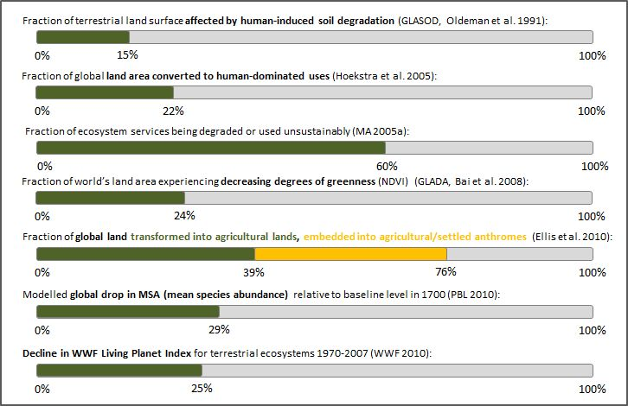
Some of the most ambitious Aichi Targets will remain unattainable and even appear implausible if progress made towards them cannot be measured. This report therefore endeavours to provide an overview of the state of the world’s major ecosystems as presented by the various assessments. While this information is valuable in itself, it also forms the quantitative basis for deriving estimates of restoration potentials and the multiple benefits that could be achieved. In terms of the accuracy of the data, it may appear problematic to consider degradation estimates that have been averaged over entire biomes, or even the whole planet, however this data could prove useful for:
- illustrating the overall order of magnitude of the ecosystem degradation,
- creating a context for singular assessments either at the ecosystem levell, national, or regional level), and thus constitute a wake-up call for policy-makers and other decision-makers.
This section will outline the various overall global degradation estimates while the following sections will address their equivalents on the biome or major ecosystem level.
In order to get a feeling for the magnitude of what is “degraded”, it is useful to look at the extent to which natural ecosystems have been converted into production landscapes. Based on the comparison of remotely sensed global land cover data with potential biome extents estimated by Olson et al. (2001), Hoekstra et al. (2005) proclaimed a “global-scale biome crisis” with habitat conversion exceeding habitat protection by a ratio of 10:1 in more than 140 eco-regions. Their analysis found that globally, 21.8% of land area had been converted to human-dominated uses or production landscapes. Habitat loss had been most extensive in tropical dry forests, temperate broadleaf and mixed forests, temperate grasslands and savannas, and Mediterranean forests, woodlands and scrub. Tundra and boreal forest biomes remained almost entirely intact (Figure 5). As this assessment focused on ecosystem loss and did not account for land degradation in areas that were not converted, these figures represented minimum estimates.
The Millennium Ecosystem Assessment showed that more than two-thirds of the area of two of the world’s 14 major terrestrial biomes and more than half of the area of four other biomes had been converted by 1990, primarily to agriculture and livestock production systems (Figure 4).
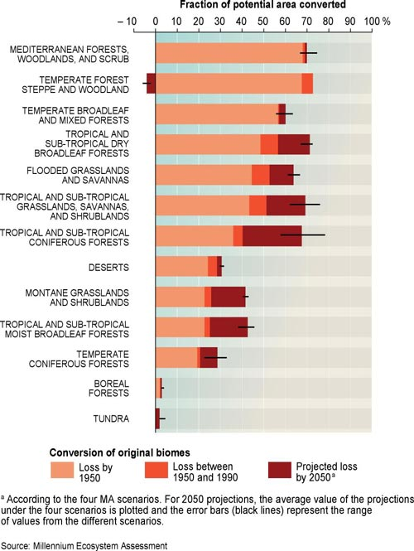
Figure 4: Conversion of terrestrial biomes; from: MA (2005b).
Using a modelling approach to map and characterize the anthropogenic transformation of the terrestrial biosphere before and during the Industrial Revolution, from 1700 to 2000, Ellis et al. (2010) found that in 1700, about 95% of earth’s ice-free land was in wildlands and semi-natural anthromes. By 2000, 55% of earth’s ice-free land had been transformed into rangelands, croplands, villages and densely settled or urban centres, leaving less than 45% of the terrestrial biosphere wild and semi-natural.
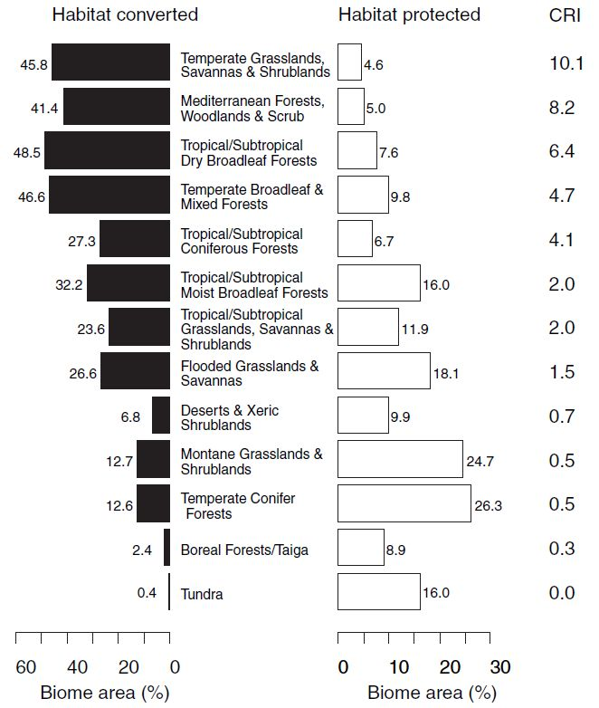
Figure 5: Habitat conversion and protection in the world’s 13 terrestrial biomes. Biomes are ordered by their Conservation Risk Index (CRI). CRI was calculated as the ratio of % area converted to % area protected as an index of relative risk of biome-wide biodiversity loss; from: Hoekstra et al. 2005.
In the process of transforming almost 39% of earth’s total ice-free surface into agricultural land and settlements, an additional 37% of global land without such use has become embedded within production landscapes. The findings of Ellis et al. (2010) indicated that in total as much as 75% of the terrestrial surface may be influenced by humans to some extent. To interpret these findings in terms of degradation is a challenge, as “degradation” lies in the eye of the beholder. Conversion of a natural forest into agricultural land can lead to degradation in terms of biodiversity, watershed protection or carbon sequestration, but not necessarily in terms of crop production or soil fertility. These trade-offs between the various ecosystem services often shift the costs of degradation from one group of stakeholders to another or defer costs to future generations (MA 2005b). These trade-offs are at the core of understanding the complexity of degradation estimates (see Figure 3).
Whereas percentages in Figure 5 represent the maximum values of global degradation estimates, expert-based assessments that are restricted to managed landscapes tend to be more conservative. The first truly global, land-based assessment was that of GLASOD (Global Assessment of Human-Induced Soil Degradation) for the period 1987-1990. This expert-based approach found that 1,964 Mha, that is, roughly 15% of the terrestrial land surface, or about one-third of the land used for agriculture, were affected by some form of soil degradation. The degrees of degradation identified were:
- light: 38% (749 Mha), restoration by modification of management system
- moderate: 46% (910 Mha), structural alterations needed
- strong: 15% (296 Mha), major engineering required
- extreme: 0.5% (9 Mha), beyond restoration
Of the area experiencing soil degradation, 55.6% was reported as damaged by water erosion, 27.9% by wind erosion, 12.2% by chemical, and 4.2% by physical deterioration (Middleton & Thomas 1997). The above findings represent the cumulative effect of all previous soil degradation damage “since 1950” but probably since much earlier (Hurni et al. 2008). It is important to note that these estimates reflect human-induced changes only and are thus primarily related to managed land rather than the entire terrestrial surface.
Making the step from soil to land degradation, Bai et al (2008a) analysed a time series of remotely sensed global trends in “greenness”, thereby taking the production function of vegetation – or net primary productivity (NPP) – as a proxy for land degradation. According to their analysis, nearly one quarter (24%) of the world’s land area was undergoing degradation in the period 1981-2006. This is equivalent to 3,510 Mha of terrestrial land surface. The results indicated that the decline in greenness was evident in a total area with a human population of some 1 billion and contributed to a net loss of about 35 million tonnes of carbon per year. The areas most affected were tropical Africa south of the Equator, Southeast Asia, South China, North-central Australia, drylands and sloping-lands of Central America and the Caribbean, Southeast Brazil, the Pampas and the boreal forests (FAO 2013).
Assessments based on remotely sensed greenness focus solely on the production function, while decreases in some provisioning and most supporting, regulating and cultural services are not taken into account. Thus, NPP as a proxy for land degradation is likely to be on the conservative end of estimates on global ecosystem degradation. In recognition of this, the Millennium Ecosystem Assessment (MA) analysed a set of 24 ecosystem services and concluded that approximately 60% (15 out of 24) of the services examined were found to be degraded or were being used unsustainably, including freshwater, capture fisheries, air and water purification, and the regulation of regional and local climate, natural hazards, and pests. The MA pointed out that the full costs of the degradation of these ecosystem services are difficult to measure, but that the available evidence demonstrates that they are substantial and growing (MA 2005b).
There are a number of assessments that focus on biodiversity loss to estimate the degree and extent of ecosystem degradation. The Living Planet Index (LPI) is based on the occurrence of thousands of animal species from around the globe and is one of the longest-running measures to assess the trends in the state of global biodiversity (WWF 2010). In 2010, the LPI showed a 25% global decline in biodiversity in terrestrial ecosystems during the period 1970-2007. However, trends regarding tropical and temperate species’ populations were starkly divergent: the tropical terrestrial LPI had declined by 46% while the temperate LPI had increased by 5%. This variance likely reflected the differences in the rates and timing of land-use changes, and hence habitat loss, occurring in the tropical and temperate zones (WWF 2010). As part of its contribution to the TEEB study, the Netherlands Environmental Assessment Agency (PBL) modelled the mean species abundance (MSA) as an indicator of “naturalness” of ecosystems using the year 1700 as a baseline. By 2000, the MSA had dropped to 71.4%, and projections for 2050 indicated a further decrease to 62.5% (Figure 15). Whereas MSA loss in earlier centuries occurred mostly in temperate biomes, the impact on subtropical and tropical biomes has accelerated from 1900.

Agro-ecosystems
The conversion of forest and grassland ecosystems to agriculture (agro-ecosystems) has had significant impacts on the provision of all ecosystem services. It is estimated that more than one-third of the word’s surface is now covered by actively managed systems, and in this process at least the same amount has been embedded into managed landscapes. The degradation of agro-ecosystems , in the form of nutrient mining, soil erosion or salinization, affects an estimated 20% of the total managed area and contributes to productivity losses, hunger, and poverty.
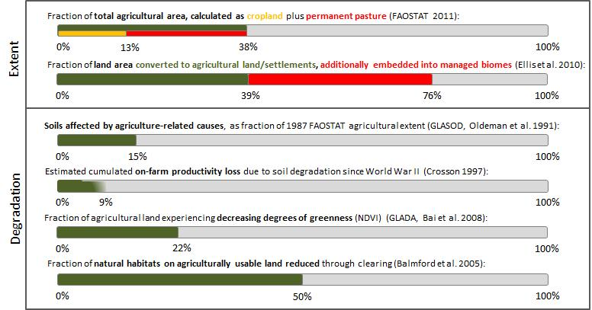

Extent of agro-ecosystems
Of all ecosystems analysed in this report, agro-ecosystems are unique in that their global extent has been increasing – at the expense of other types of ecosystems. Since the onset of the Neolithic revolution, forests have been in decline. Wood et al (2000) estimate that about 30% of the potential area of temperate, subtropical, and tropical forests has been converted to agriculture. Analogous estimates exist for grassland ecosystems, of which around 20% are thought to have been converted to cultivated crops (Lal et al. 2012). The MA (2005a) makes special mention of drylands because they contain about 44% of all cultivated systems worldwide, primarily in the dry sub-humid areas. Between 1900 and 1950, approximately 15% of dryland rangelands were converted to cultivated systems to better capitalize on the food provisioning service with a somewhat faster conversion rate during the last five decades as a result of the Green Revolution.
As would be expected, the rates of ecosystem conversion vary greatly according to region. In countries with high levels of productivity and low population growth, the extent and distribution of land under cultivation is stabilizing or even contracting (e.g. Australia, Japan, United States, Italy). The area under agricultural production has also recently stabilized and begun to contract in China. However, some countries with relatively low levels of productivity, such as those found in sub-Saharan Africa, continue to rely mainly on the expansion of cultivated area to meet the increasing demand for food (MA 2005a).
Globally, about one-third of the total land area has been converted to agricultural land, including permanent pastures. Actual estimates range from 27 to 39%, with the MA (2005a) estimate of 27% (3,360 Mha) for cultivated systems and the Wood et al. (2010) figure of 27.8% (or 3,623 Mha) being the most conservative. On the other end of the spectrum, Ellis et al. (2010) state that at the beginning of the twenty-first century, 39% of the earth’s total ice-free surface – or approx. 5,000 Mha – had been converted into agricultural land and settlements, and an additional 37% has been embedded within managed biomes. The most recent FAOSTAT data for 2011 estimate the total agricultural area (cropland and permanent meadows & pastures) at 4,911 Mha.
Assessments largely agree on the fraction of agricultural land currently devoted to crop production: Schneider et al. (2009) pointed out that the area of global cropland has dramatically increased to about 11% of earth’s total land surface (1,431 Mha) supported by estimates of Lal et al. (2012) with 1,420 Mha, and FAOSTAT (2013) data with 1,552 Mha. Grazing land is estimated to cover approximately 3,500 Mha (e.g. Lal et al. 2012), or 25% of earth’s total ice-free land surface (Schneider et al. 2009). The approximate ratio of 30:70 for cropland: pasture is confirmed by Wood et al. (2000), i.e. for every 3 ha of cropland there are 7 ha of pasture. In addition, they state that 17.5% (270 Mha) of all cropland is irrigated (i.e. 5.4% of global agricultural land); 38% of the area within the satellite-derived global extent of agriculture is found in temperate regions, another 38% in tropical regions, and some 23% in subtropical regions.

Degradation in agro-ecosystems
It is far more difficult to estimate the amount of agricultural land that is currently degraded or undergoing degradation. It is generally understood that the positive current trends in food production may mask the negative trends in the underlying biophysical capacity of agro-ecosystems that result from nutrient mining, soil erosion, and the depletion of groundwater resources. In general, environmental problems often associated with high-input, intensive agro-ecosystems include salinization of irrigated areas, nutrient and pesticide leaching, and pesticide resistance while those more associated with low-input and extensive agro-ecosystems are soil erosion and loss of soil fertility (Wood et al 2000). In agro-ecosystems more than in all other major ecosystems analysed, the specific mix of inputs and production technology has a direct bearing on their long-term capacity to provide goods and services. Management practices can change rapidly in response to market signals and new technological opportunities which can compensate for some aspects of resource degradation. However, where resource degradation occurs, it often increases the reliance on the use of external, capital-intensive inputs to maintain production levels.
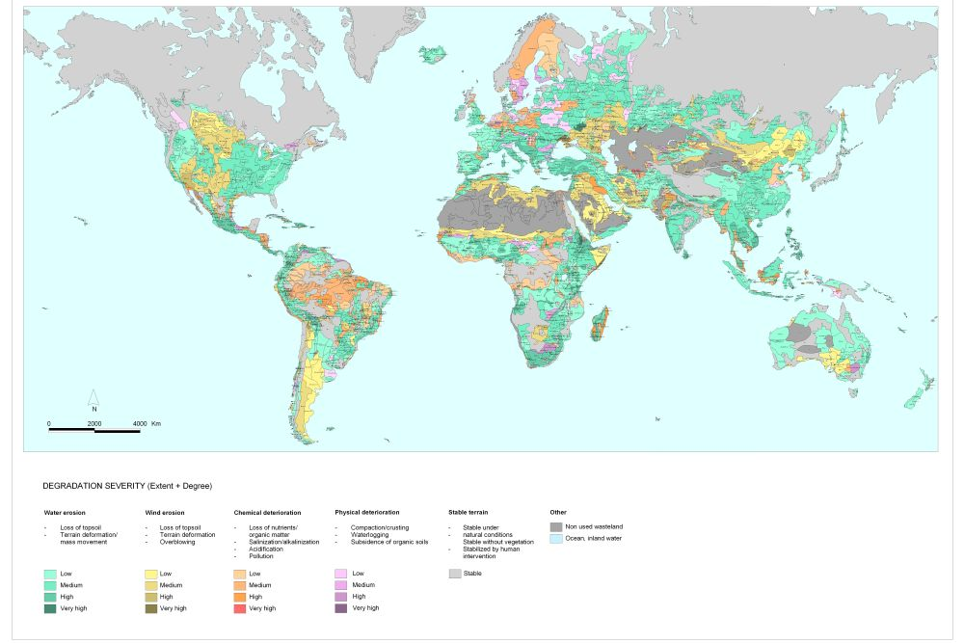
Figure 6: Global assessment of the status of human-induced soil degradation (1990); from: http://www.isric.org/projects/global-assessment-human-induced-soil-degradation-glasod
Based on expert analyses, the first global estimate of degradation in agro-ecosystems was made in the mid-1970s. It found that about 80% of the world's agricultural land suffers from moderate to severe erosion and 10% from slight to moderate erosion (Pimentel et al. 1976). These findings have subsequently been criticised as unreliable and too high (e.g. by Crosson et al. 1995). To meet the urgent need for reliable data on global land degradation, the UNEP-funded project GLASOD (Global Assessment of Human-induced Soil Degradation) was set up in 1987 and produced a world map at the scale of 1:10 million within a time frame of 28 months (Oldeman & van Lynden 1996). The global estimate of land degradation, including all terrestrial biomes, was 1,964 Mha (Table 1). Although GLASOD made no distinction for different land use types or ecosystem classifications, but some indication can be derived from the causes of land degradation mentioned: “Agricultural” yields 551.6 Mha (approx. 11.5% of 1987 agricultural extent as taken from FAOSTAT), “Overexploitation” 132.8 (2.8%), and “Bioindustrial” 22.7 Mha (0.5%).
GLASOD also provided estimates of the degree of soil degradation: Out of the total degraded land worldwide (1,964 Mha), a light degree, implying a somewhat reduced productivity of the terrain but manageable in local farming systems, was identified for 38% of all the globally degraded soils (749 Mha). A somewhat larger percentage (46%) had a moderate degree of soil degradation. This portion of the earth surface – 910 Mha – was considered as having a greatly reduced productivity, and major improvements often beyond the means of local farmers in developing countries required to restore productivity. More than 340 Mha of this moderately degraded terrain was found in Asia and over 190 Mha in Africa. Strongly degraded soils were found to cover an area of 296 Mha worldwide, of which 124 Mha in Africa and 108 Mha in Asia. These soils were estimated to be not any more reclaimable at farm level and only restorable through major engineering work or international assistance. Extremely degraded soils – considered “irreclaimable and beyond restoration” covered approx. 9 Mha worldwide, of which over 5 Mha was located in Africa.
Table 1: Main causes of soil degradation by region in susceptible drylands and other areas (in Mha); from: Middleton & Thomas (1997)
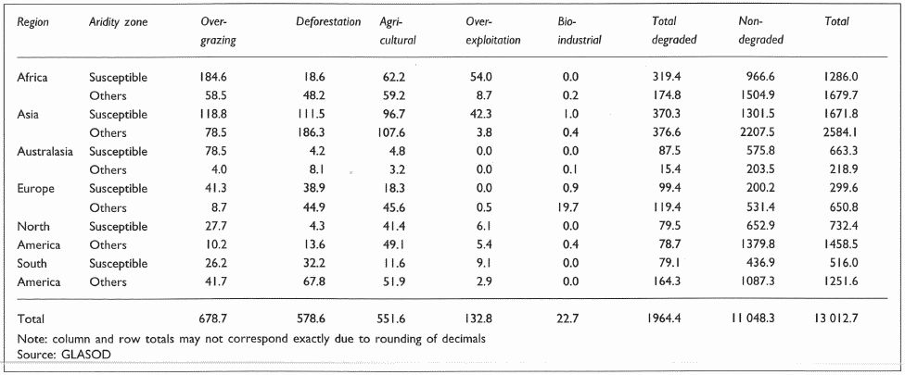
Using data derived from the GLASOD assessment, Crosson (1997) calculated the cumulative on-farm productivity loss due to soil degradation since World War II at the global level. Average productivity losses on the total area of land in crops and permanent pastures were between 4.8% and 8.9%. Based on the worst case scenario, Oldeman (1998) later singled out the data for cropland alone (12.7% productivity lost), and for pasture land (3.8%).
The Pilot Assessment of Global Ecosystems (PAGE) used the GLASOD data as a foundation and combined them with a newly calculated global area of agriculture (IFPRI calculation using CIESIN 2000). The PAGE results suggested that human-induced degradation since the mid-1900s is more severe than estimated by the GLASOD. Over 40% of the PAGE agricultural extent coincided with the GLASOD mapping units that contained moderately degraded areas, and 9% coincided with mapping units that contained strongly or extremely degraded areas (Wood et al. 2000). These figures are likely too high – please see section 3.2.5 for an explanation how GLASOD maps overestimate soil degradation. The PAGE further hypothesises that a state of strong or extreme degradation implies that soils would be very costly or infeasible to rehabilitate to their original (mid-1900s) state. And that degradation is estimated to have reduced overall crop productivity by around 13%. They also mentioned that no global estimates of improving soil quality are known to exist.
The PAGE also quantified particular soil constraints where over three quarters of their estimated agricultural extent were found to contain soils predominantly constrained, primarily soil fertility constraints. Just over half the agricultural extent was in lands with ≤ 8% slope with only 6% of this land relatively free of soil constraints, mostly in temperate regions. The depletion of soil organic matter (SOM) was found to be widespread, reducing fertility, moisture retention, and soil workability, and increasing CO₂ emissions. Salinization data were found to be poor, and rough estimates indicated about 20% of irrigated land suffered from salinization. Around 1.5 Mha of irrigated land per year were estimated to be lost to salinization and about US$11 billion per year in reduced productivity, just under 1% of both the global irrigated area and annual value of production.
Estimating soil or land degradation by assessing changes in the production function of soils has also been used in the FAO-inspired LADA (Land Degradation Assessment for Dryland Areas) project and its global component, the GLADA. For the total land surface, trends in net primary productivity (NPP) were estimated for the period 1981-2006 by analysing changes in remotely sensed “greenness”. This produced a globally consistent dataset that can then be intersected with land use and/or land cover data to estimate changes for each major ecosystem type. For agricultural land, the GLADA found that 22.2% were degrading, equal to 17.6% of total land degradation observed. Thus it concludes that land degradation is not primarily associated with farming.
A global land information system (GLADIS) is being developed as part of the LADA project. Global datasets covering environmental, economic and social dimensions were used in models which produced indices that reflect the current status (i.e. “baseline” condition) of ecosystem benefits as well as trends (i.e. overall long-term tendency of changes in the flow of such benefits). Status and trends were determined for eleven globally important land-use classes, as defined in GLADIS, which then allowed the identification of four different typologies of degradation (Figure 7). These typologies can be used to facilitate geographic targeting and priority-setting of ecosystem management strategies and interventions.
The most challenging aspect of the GLADIS is the reliance on existing data sources of varying scope, coverage, scale and accuracy which may explain why most results are not yet available. Some preliminary GLADIS results on status and trends in global land degradation have been published through FAO’s State of Land and Water Report (SOLAW, FAO 2011). As would be expected, the relative extents of the different typologies of degradation vary depending on land use. Highest values for Type 1 were associated with sparsely vegetated areas and moderate or high livestock density (68% of the global extent of this land use class). The highest percentage of improving lands (i.e. Type 4) are mostly associated with cropping and little to no livestock (24%). Globally, approximately 25% of all land is experiencing high levels of degradation while about 46% are stable (neither significantly increasing nor decreasing trends) but slightly to moderately degraded (Type 3). Only 10% is associated with improving conditions.
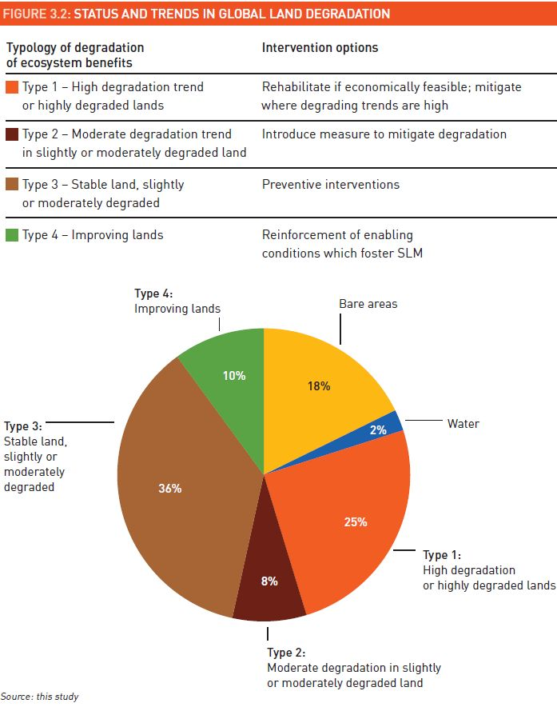
Figure 7: Status and trends in global land degradation (from: FAO 2011a)
In an additional SOLAW thematic report, Nachtergaele et al. (2010a) present preliminary findings from GLADIS modelling on the status and trends of each of the major ecosystem goods and services (biomass, soil health, water quantity and quality, biodiversity, economics, social and cultural). One outcome is a global map showing the “status of the land”. The first conclusion of this report is that most developing countries, particularly in dryland Africa, have a particularly fragile resource base as far as ecosystem provisioning services are concerned (Figure 8) but that: “Land degradation processes are on-going over large part of the Earth land surface”. Most of the degradation is due to soil erosion and biodiversity loss in the less populated areas, while water shortage, soil depletion and soil pollution are common in the most agricultural areas (Figure 9). Biophysical land degradation classes were identified by the combination of the overall status in provisioning biophysical ecosystem services and the trends in these services (Biomass, Soil, Water and Biodiversity) as described above (Figure 10).
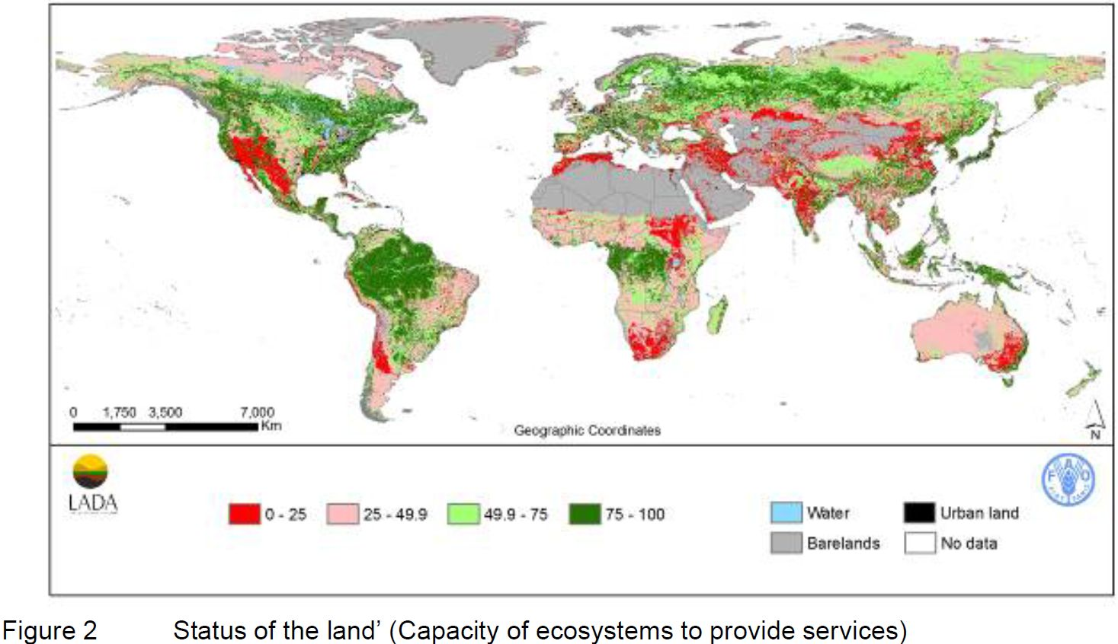
Figure 8: Status of the land (Capacity of ecosystems to provide services).
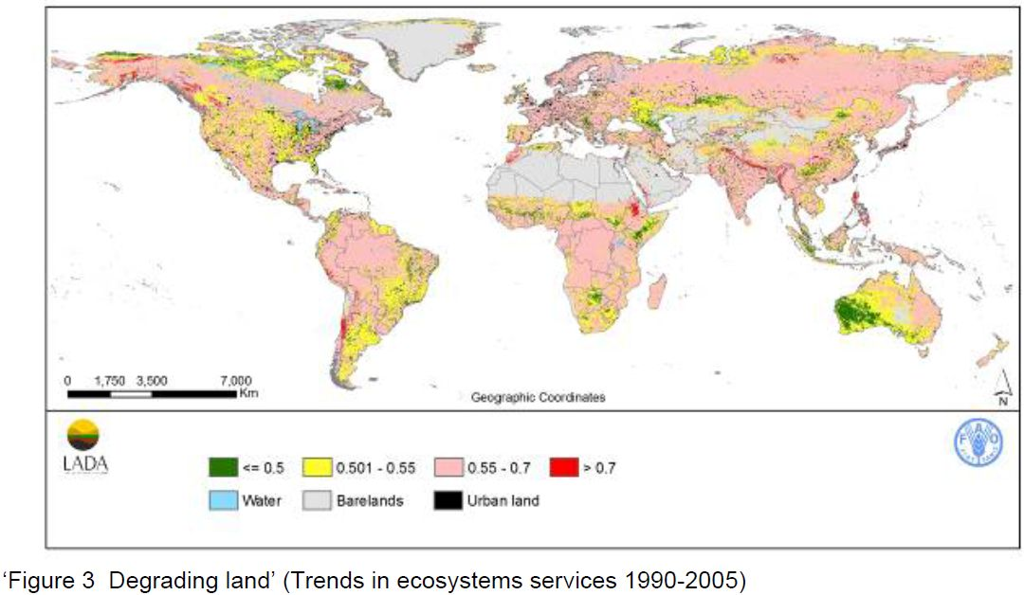
Figure 9: Degrading land (Trends in ecosystem services 1990-2005)
Although assessing the degradation of agricultural lands through changes in the production function – estimated via expert knowledge, remote sensing, modelling, or a combination of these – covers the majority of approaches and methodologies, some authors have also looked into the habitat function. UNEP (2002) showed that farmland bird populations in Europe have declined on average 50% since 1980. And Balmford et al. (2005) found that ecosystem conversion to cropland or permanent pasture has already reduced the extent of natural habitats on agriculturally usable land by more than 50%, with much of the rest altered by temporary grazing.
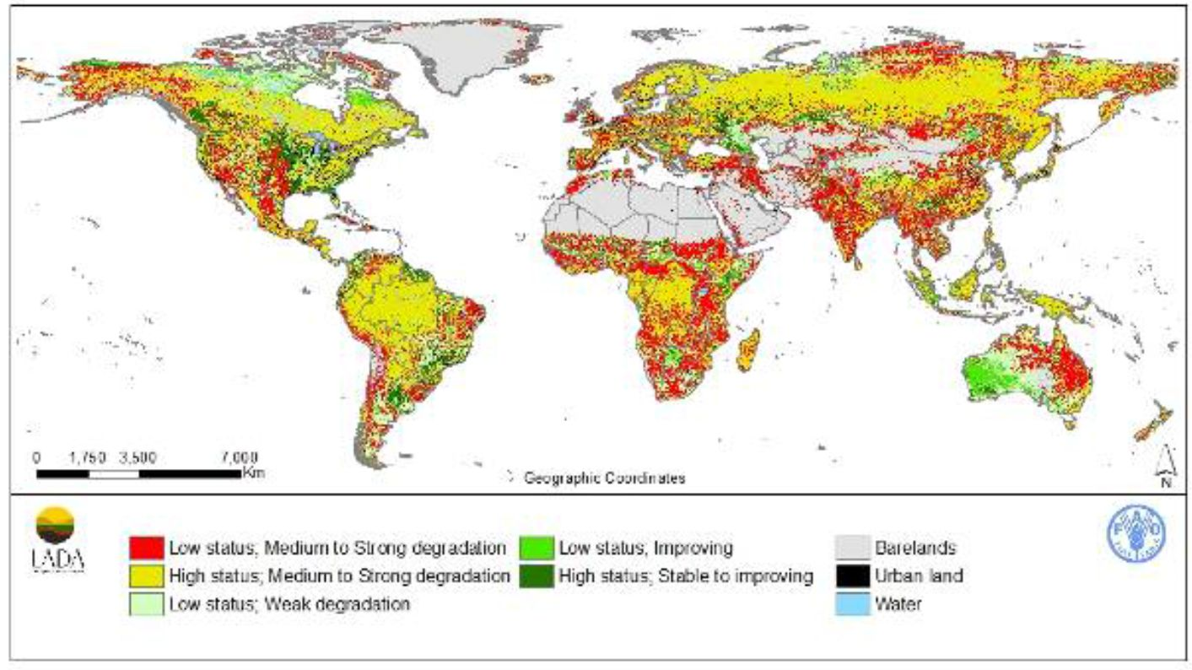
Figure 10: Land degradation classes
In continuously cultivated, low-input agricultural systems, rapid declines in soil fertility and crop yields, together with commodity price fluctuations, continue to impact human wellbeing in agricultural communities (Koning & Smaling 2005). In high-input agro-ecosystems, the rate of soil erosion has greatly increased with the widespread adoption of intensive, mechanized, agricultural practices (UNEP 2012). Erosion in industrial agricultural systems is now over three times higher than in systems practising conservation agriculture, and over 75 times higher than in systems with natural vegetation (Montgomery 2007). Globally, soil erosion is contributing to the decline in agricultural land available per capita (Boardman 2006) as degraded land is increasingly being abandoned (Bakker et al. 2005; Lal 1996).
Approaches towards improving soil fertility and yields in some situations while avoiding some of the problems of industrial agriculture on the other hand will be discussed in section 5.2.2, along with the co-benefits associated.

Grassland ecosystems
One-fifth of the world’s grasslands have been converted to cropland, and more than two thirds are currently being used for grazing. Up to half of the existing grassland area appears to be at least lightly degraded with 5% strongly degraded.
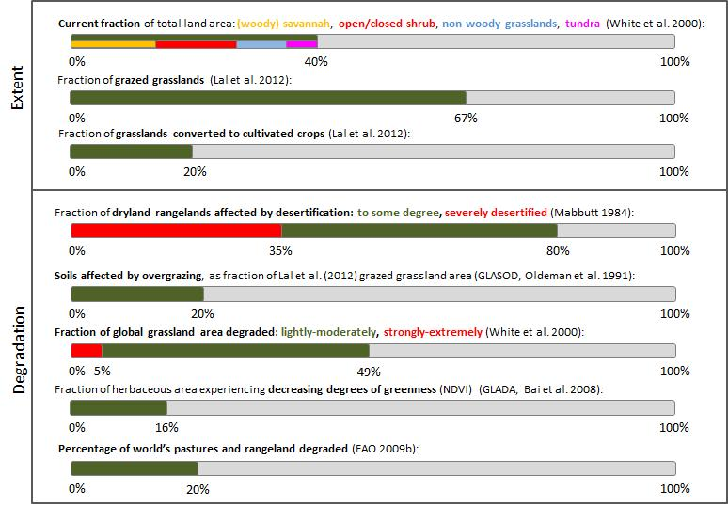

Extent of grasslands
There is a wide variety of definitions for “grasslands”, and special care must be taken when comparing data on the extent or degradation of grassland ecosystems. Some studies classify grasslands by the type of vegetation while others characterize them by climate, soils, and human use. A basic definition of the grassland biome is that of regions where moderate annual average precipitation is enough to support the growth of grass and small plants, but not enough to support large stands of trees. Woody plants, shrubs or trees, may occur on some grasslands – forming savannas – and generally do not cover more than 10% of the ground.
FAO (2009b) identified three major trends relating to pasturelands:
- valuable ecosystems are being converted to pastureland (e.g. clearing of forest),
- pastureland is being converted to other uses (cropland, urban areas and forest), and
- pastureland is degrading.
There are no global datasets on the first trend. However, using estimates of current forest cover (3,900 Mha; FAOSTAT), original forest cover (5,500 Mha; Lal 2012), and a forest conversion ratio into cropland/grassland of 3/1 (FAO 2006), a total historic conversion of forests into pastures of approximately 400 Mha can be inferred.
Lal et al. (2012) estimate that 20% of the world’s native grasslands have been converted to cultivated crops with significant portions of milk and beef production occurring on grasslands managed solely for those purposes. A large fraction of this conversion appears to have happened rather recently, considering that some 15% and 14% of the natural habitats in the semi-arid and dry sub-humid areas were reported to have been transformed between 1950 and 1990 (MA 2005d). The same study also provides a future outlook by estimating that roughly 10–20% (with low to medium certainty) of current grassland and forestland is projected to be converted to other uses between 2005 and 2050, mainly due to the expansion of agriculture, industry and urban areas.
Sub-regional assessments can further illustrate the substantial conversion of grasslands to production landscapes. White et al. (2000), based on IGBP data, cited in FAO (2009b) estimated that more than 90% of the North American tallgrass prairie and almost 80% of the South America cerrado have been converted to cropland and urban uses. UNEP’s (2010) estimate of 95% for the conversion of North American grasslands is even higher. In contrast, the Asian Daurien steppe and the Eastern and Southern Mopane and Miombo woodlands in sub-Saharan Africa are relatively intact, with less than 30% converted to other uses.
It is generally acknowledged that grasslands currently cover some 40% (approx. 5,200 Mha) of the earth’s surface excluding Greenland and Antarctica (e.g. White et al. 2000) of which 13.8% is woody savannah and savannah, 12.7% is open and closed shrub, 8.3% is non-woody grasslands, and 5.7% is tundra. Grasslands most commonly occur in semi-arid zones (28% of the world’s grasslands), followed by humid (23%), cold (20%), and arid zones (19%). According to Lal et al. (2012) the present area of grazed grasslands is 3,500 Mha, of which 2,250 Mha are tropical savannahs and grasslands, and 1,250 Mha are temperate grasslands and shrublands. These figures show the large fraction of the grasslands ecosystems subjected to human use in one way or another. Dryland rangelands alone support approximately 50% of the world’s livestock (MA 2005d) which conveys the magnitude of pressure exerted on this biome, and the degradation potential associated.

Degradation of grasslands
As rangelands cover approximately 65% of all land use in the global drylands (MA 2005d) it is not surprising that the first estimate of degradation was published by the UN Conference on Desertification (UNCOD). Based on expert statements from around the world, an annual rate of land degradation in dryland rangelands of 3.6 Mha per year was published (UNCOD 1977). Following UNCOD’s call for compiling more data on the subject, Mabbutt (1984) established that 80% of dryland rangelands (or 3,100 Mha) are affected by desertification, and 35% (1,300 Mha) are severely desertified.
The GLASOD project has identified that out of the 1,964 Mha land globally that are considered degraded, 678.7 Mha were due to overgrazing with 69% of these lands in susceptible drylands (Middleton & Thomas 1997). Assuming 5,169.1 Mha as the area of susceptible drylands, and 48% as the land use fraction of grazing in susceptible drylands, just below 20% of grazing land in susceptible drylands were degraded due to overgrazing.
During a technical expert consultation at FAO in 1991, it was determined that 2,600 Mha of degraded rangelands are affected by vegetation degradation without associated soil degradation (Oldeman & van Lynden 1996). One year later, as part of a UNEP-sponsored study, the GLASOD data were intersected with an ICASALS (International Centre for Arid and Semiarid Land Studies, Texas Tech University) map of major land uses. It found that 3,333 Mha of rangeland or nearly 73% of its dryland total are affected by degradation, mainly by degradation of vegetation which on some 757 Mha is accompanied by soil degradation, mainly erosion (UNEP 1991, Dregne & Chou 1992). However, these findings have been widely criticised as they are based on poor information and involved double counting.
Subsequent estimates have been significantly lower. For example, the thorough assessment by White et al. (2000) under the World Resource Institute (WRI) series of Pilot Analysis of Global Ecosystems (PAGE), reported that nearly 49% of the global grassland area is lightly to moderately degraded while only 5% is considered strongly to extremely degraded. Estimates based on remotely sensed greenness in the GLADA project have been even lower with only 15.8% of grasslands experiencing degradation. This amounted to 25.3% of total degradation observed, meaning that grasslands are over-represented in global degradation terms (Bai et al. 2008b). It was also found that – as would probably be expected – natural and protected areas seemed to be faring better than grazed areas.
The FAO State of Food and Agriculture report (FAO 2009b) shows the great variability in estimates of the extent of grassland degradation stating that “about 20 per cent of the world’s pastures and rangeland have been degraded to some extent, and the proportion may be as high as 73 per cent in dry areas.” Lund (2007a) pointed out that there is no international organization responsible for the assessment and reporting on the world's grasslands as there is for the periodic global forest assessments by FAO.

Forest ecosystems
Forest ecosystems could currently potentially cover around 50% of the earth’s surface. Deforestation has reduced forest cover by about one-third while another third is considered to be degraded. Annual rates of conversion and loss are currently 0.4% in tropical forests, only slightly balanced by increases in forest cover in temperate and boreal areas.
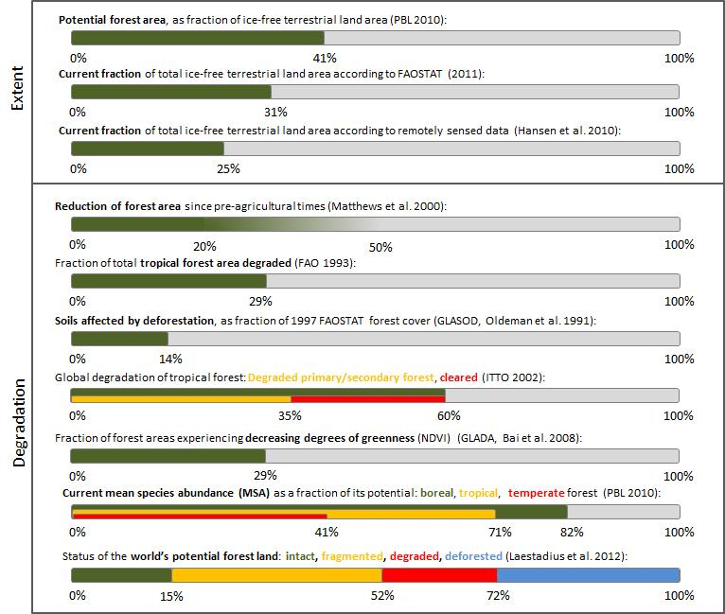

Defining a forest
There is no single, agreed upon definition of ‘‘forest,’’ due in large part to varying climatic, social, economic, and historical conditions. Lund (2007b) identified 720 different definitions of forest, with thresholds for tree cover ranging from 0% to 80%. The situation is complicated by the fact that for many governments, ‘‘forest’’ denotes a legal classification of areas that may or may not actually have tree cover (MA 2005d). The most widely accepted definition is that of forests as terrestrial ecosystems dominated by trees, where the tree canopy covers at least 10% of the ground area (as used in Matthews et al. 2000, MA 2005d, FAO2010b).
The many definitions of a “forest” is the primary reason why estimates of forest extent vary considerably. Williams (1994) stated that between 1923 and 1985, at least 26 calculations of closed forest land were made which ranged from 2,400 to 6,500 Mha. FAO provides an overall picture of the world’s forests in their Global Forest Resources Assessments and State of the Worlds Forest reports. Their assessments are the most widely cited despite the acknowledged problems of poor inventory quality and national data comparability (Matthews et al. 2000). The latest global forest resources assessment indicates a forest cover of 4,033 Mha or about 31% of the earth’s land surface (FAO 2011b), while the FAOSTAT database produced an estimate of 4,027 Mha for 2011. Lal et al. 2012 are in the same range with 4,160 Mha: 1,750 Mha of these were tropical forests, 1,040 Mha temperate forests, and 1,370 Mha boreal forests (taiga). Relying solely on remote sensing approaches, estimates tend to be considerably lower: Matthews et al. (2000), using reinterpreted results of high resolution satellite imagery (IGBP 1998) estimated a total forest cover of 2,896 Mha, while Hansen et al. (2010) proposed 3,269 Mha.
Estimates of potential forest cover under current climatic conditions are 5,392 Mha (considering the cool/temperate/tropical forests and woodland biomes of the PBL 2010 report), and 5,530 Mha (Lal 2012 based on data from Ramankutty & Foley 1999). These estimates would imply total historic forest conversion to be in the range of 20-30%. In their PAGE report, Matthews et al. (2000) concluded that “at least 20%” but possibly up to 50% of global forest cover has been lost since pre-agricultural times. They also pointed out that while forest area has increased slightly since 1980 in the developed countries, it has declined by at least 10% in developing countries. They further estimated that about 40% of forests were relatively undisturbed by human activity, though nearly half of these would likely be impacted soon. Williams (2002) calculated the cumulative conversion of forest land worldwide over a period of 5,000 years at 1,800 Mha.
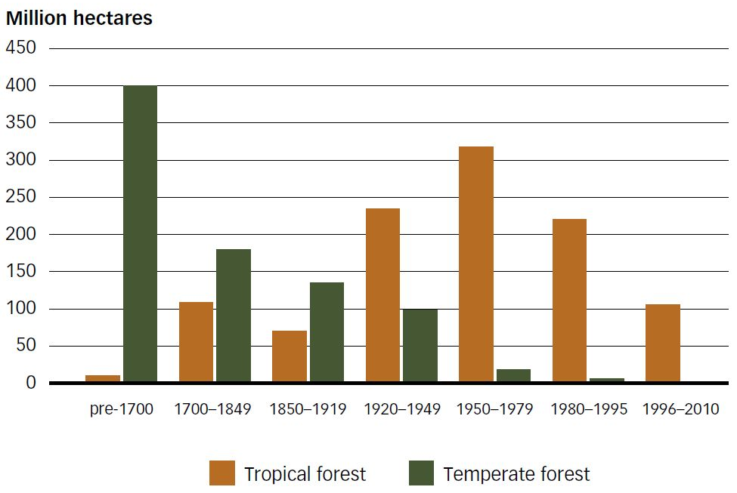
Figure 11: Estimated deforestation, by type of forest and time period (FAO 2012)
Laestadius et al. (2012) used the Intact Forest Landscapes (IFL) approach to calculate the actual as well as potential extent of forest landscapes. According to Potapov et al. (2008) an intact forest landscape is an unbroken extension of natural ecosystem within areas of current forest extent, without signs of significant human activity, and having an area of at least 500 km². The forest landscape zone is different from what FAO calls the forest zone in that it includes treeless areas (such as lakes, wetlands, and rivers) that occur naturally within a forest landscape. According to their calculation, if undisturbed, forests landscapes would cover 7,474 Mha under current bioclimatic conditions or approximately 57% of the word’s land surface. Current forest extent is estimated at 5,386 Mha, including 3,348 Mha of closed forest (canopy cover > 45%), 1,045 Mha of open forest (canopy cover between 25-45%), and 993 Mha of woodlands (canopy cover between 10-25%). Only 15% of this current extent were identified as remaining intact with 37% fragmented, 20% degraded, and 28% deforested.

Deforestation or forest loss
FAO (2012) have elucidated that the trajectory of global deforestation has more or less followed the global growth rate of the human population, although the pace of deforestation was more rapid than population growth prior to 1950, and has been slower since then (Figure 12). Most temperate forest was lost prior to and during the industrial revolution. In recent decades, deforestation has slowed or been reversed in the temperate zone while increasing rapidly in the world’s tropical forests, largely because of the heavy dependence on land-based economic activities (FAO 2012).
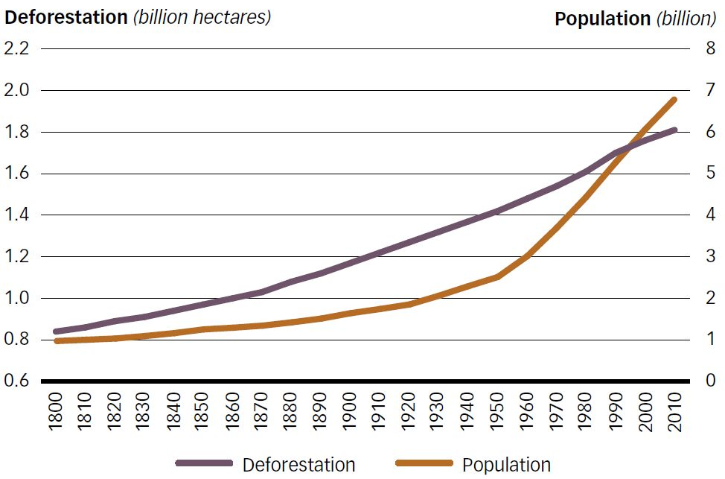
Figure 12: World population and cumulative deforestation, 1800-2010 (from: FAO 2012)
FAO’s 2000 Global Forest Resource Assessment (FAO 2001) has been a milestone in assessing the current status and trends in the world’s forest ecosystems. It has documented significant deforestation, especially in tropical forests, for the period of 1990–2000. The total conversion of natural tropical forests is estimated at 15.2 Mha per year (Table 2). Taking into account the relatively small natural regeneration of tropical forests (1.0 Mha annually) and establishment of plantations (1.9 Mha annually), the net change in tropical forest area was estimated to have decreased by12.3 Mha. In contrast, during this same period, a net increase of forest area was observed in temperate and boreal zones (2.9 Mha annually, of which 1.2 Mha were forest plantations and 1.7 Mha were due to the change in area of natural forests). In total, the net change in global forest area is estimated to decrease by 9.4 Mha or 0.20% per year (Table 2).
Table 2: Forest area changes 1990-2000 in tropical and non-tropical areas (Mha per year); from: FAO (2001)
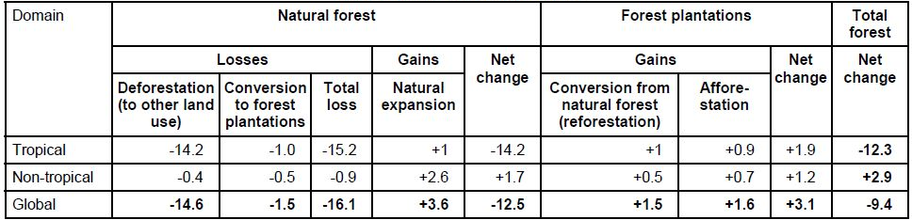
The Millennium Ecosystem Assessment mainly relates to these data (MA2005d) and has visualised the findings in a flow chart (Figure 13).
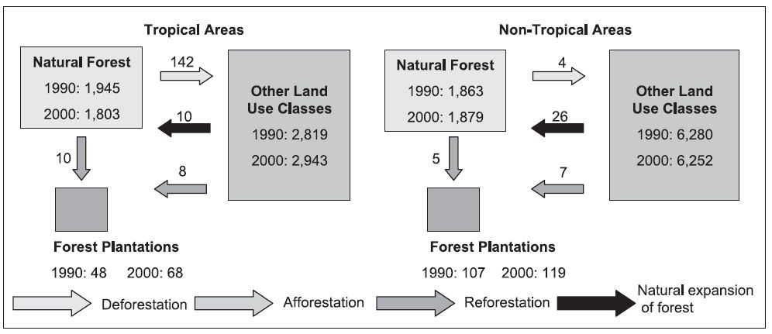
Figure 13: Findings of FAO’s Global Forest Resource Assessment (FAO 2001): Major change processes in World’s forest area, 1990-2000 (in Mha). From: MA (2005d).
In combination with these figures, the authors of the Millennium Ecosystem Assessment pointed out that the net annual change in (natural!) forest area for 1980–90 was estimated to be -13 Mha (FAO 1995) (including conversion of 6.1 million hectares per year in tropical moist forests and 3.8 million hectares per year in tropical dry forests), and -11.3 Mha for 1990–95 (FAO 1997). This would indicate that net global forest conversion has slowed down since the 1980s. However, they also pointed out that much of this is due to increases in plantation forestry, and although the global net change in forest area was lower in the 1990s than in the 1980s, the conversion rate of natural forests remained at approximately the same level. They furthermore stated that it appeared likely that deforestation in developing countries has continued since 2000 at practically the same rate as during the 1990s, about 16 Mha per year, corresponding to 0.84% for the 1990s and 0.80% since 2000. The difference in these estimates was considered to definitely be within the uncertainty limits of the techniques used (MA 2005d).
FAO publishes updates on global forest data on a biannual basis in its State of the World’s Forests reports. Table 3 summarises the findings of their 2009 report.
Table 3: Forest area extent and change for periods 1990-2005. From: FAO (2009a)
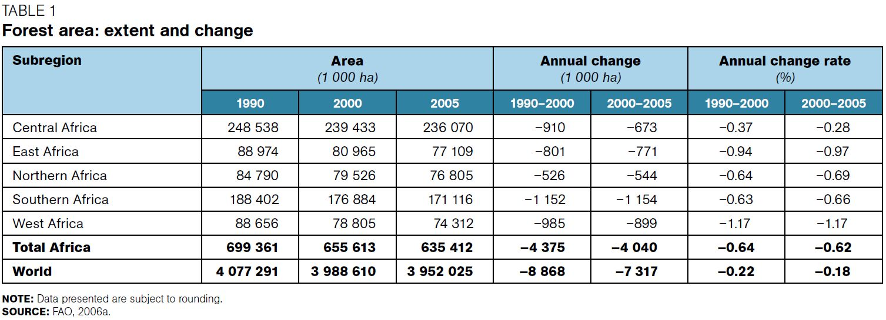
By 2005, global forest area had dropped just below 4,000 Mha, while the overall annual decrease in total forest area was at approximately 7-8 Mha (0.12%). The 2011 sequel, covering the period of 2000-2010, showed a global forest extent just above 4,000 Mha, and an annual decrease of approximately -5 Mha. This is mainly due to large-scale planting of forests in temperate regions and to the natural regeneration of forests. Figure 14 provides an overview of the FAO findings from 1990-2010.
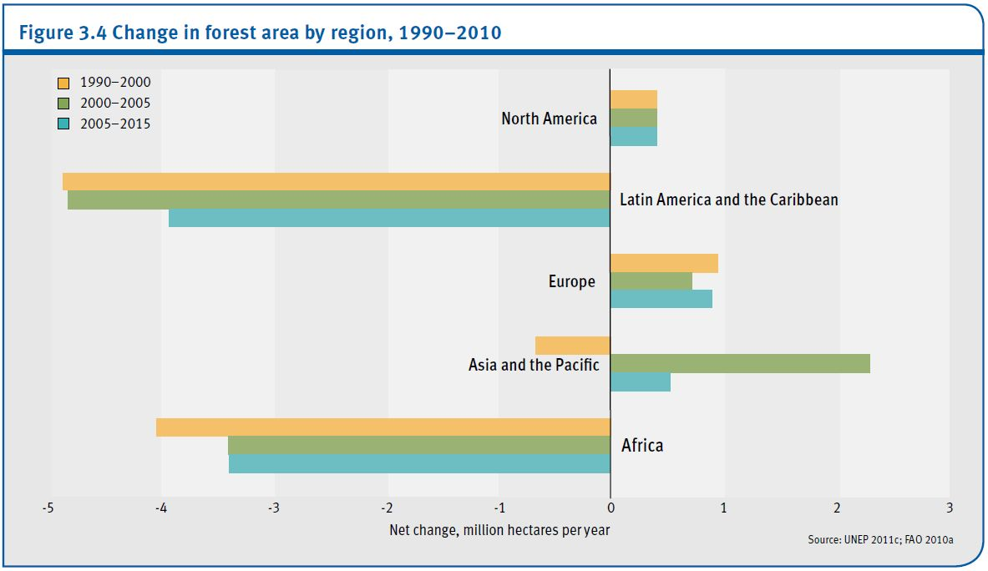
Figure 14: Change in forest area by region, 1990-2010 (from: UNEP 2012)
At current rates of deforestation, it will take 775 years to lose all of the world’s forests. With tongue in cheek, FAO (2012) only recently pointed out that this would seem to provide enough time for actions to slow or stop global deforestation.
On a positive note, many countries seem have been able to stabilize the extent of their forest areas. During the period 2005–2010, about 80 countries reported either an increase or no change in forest area (FAO 2012).
Forest data mentioned in UNEP’s Global Environmental Outlook (GEO) reports as well as CBD’s Global Biodiversity Outlook (GBO) generally come from FAO sources. Although widely used, the data are not beyond criticism. Hansen et al. (2010) question the utility of the FAO data for a global forest change assessment, mainly because:
- the methods used to quantify forest change are not consistent among all countries, thus hindering the ability to synthesize results;
- the definition of “forest” is based on land use instead of land cover and the land use definition obscures the biophysical reality of whether tree cover is present;
- forest area changes are reported only as net values; and
- forest definitions used in successive reports have changed over time
They advocate for a remote sensing-based approach which would allow for an internally consistent global quantification of forest cover change. Their assessment estimated global forest cover loss (GFCL) at 101.1 Mha between 2000-2005, and a deforestation rate of 0.6% per year. Forest cover loss was highest in the boreal forest biome with nearly 60% of the cover lost due to fire. The remaining 40% of boreal GFCL was attributed to logging, mining and other change dynamics such as insect and disease-related forest mortality. The biome with the second highest area of GFCL was the humid tropics. The majority of this loss was attributable to large-scale agro-industrial clearing in Brazil, resulting in non-forest agricultural land uses, and in western Indonesia and Malaysia, resulting in agro-forestry land uses. When GFCL was expressed in terms of the proportion of year 2000 forest, the humid tropical biome was the least disturbed. The authors stressed that large regions of forest absent of large-scale forest disturbance still exist in the humid tropics, and to a lesser extent also in the interior Congo Basin. The dry tropics biome with main areas occurring in Australia and South America had the third highest estimated area of GFCL. Finally, the temperate biome had the lowest total area of forest cover of all biomes, as the majority of this biome had long been converted to agricultural and settlement land uses (Hansen et al. 2010).

Forest degradation
Whereas assessments on the state of global forests readily provide numbers on deforestation and its rates, i.e. the sudden, complete and often wide-scale conversion of forests, estimates of forest degradation through forest use intensification (e.g. through increased small-scale logging or forest pasture), are less tangible and more difficult to assess. The ITTO (2002) mentioned that due partly to differing definitions of the terms degraded and secondary forest, it is difficult to establish the extent of degraded and secondary forests even in the three tropical regions in which it works (Asia/Africa/America). The FAO is working toward a resolution of this issue and has recently published globally applicable guidelines for assessing forest degradation (FAO 2011c).
In 1993, FAO estimated that 532 Mha, or 29% of the total tropical forest area was considered degraded in 1990 (FAO 1993). Wadsworth (1997) estimated that, worldwide, 494 Mha were “cutover tropical forests, and 402 million hectares tropical forest fallow”. An indication of forest degradation on the global scale was also provided through the GLASOD project, where 578.6 Mha of land were found to be “affected by deforestation” (Middleton & Thomas 1997), representing roughly 14% of the 1997 FAOSTAT forest cover (4,110 Mha).
In 2002, the International Tropical Timber Organization (ITTO) compiled and extrapolated country data on the degradation of tropical forests worldwide. They arrived at a total area of degraded and secondary tropical forests of 850 Mha, corresponding to roughly 60% of the total area that is statistically classified as forest in the tropics (Table 4). Degraded primary forests and secondary forests cover about 500 Mha, while 350 Mha of formerly forested land was deforested between 1950 -2000 (ITTO 2002).
Table 4: Estimated extent of degraded and secondary forests by category in tropical Asia, tropical America and tropical Africa in 2000 (Mha, rounded to nearest 5 million). Data are from 77 tropical countries in the year 2000; from: ITTO (2002)
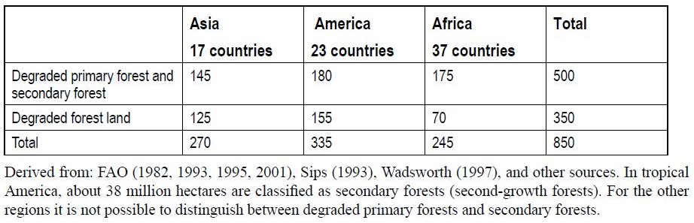
The GLADA project found that between 1981-2003, on a global scale, degradation was over-represented in forests: integrating remotely sensed degrading areas with FAO global land use systems (FAO 2008) showed 46.7% of degrading land as forest, although broadleaved and needle-leaved forest together occupied only 29.3% of the land. The GLADA also noted that, counter-intuitively, the proportion of degradation in the various forest categories was very similar: declining net primary production (NPP) was seen across 30% of natural forest and supposedly protected forest, across 25-33% of grazed forests, and 33% of plantations. To explain these findings, the authors assumed that “some of the recorded degradation” reflected clearance for cropland and grazing. They further noted that apart from land degradation as it is commonly understood, high-latitude taiga is subject to catastrophic fires and pest outbreaks that affect huge areas and, since the rate of recovery is slow, the 23-year Global Inventory Modeling and Mapping Studies (GIMMS) NDVI data may encompass a whole cycle (Bai et al. 2008b).
Preliminary results from a recent study by Laestadius et al. (2012) suggested that 27% (1,459 Mha) of current forest landscapes were degraded to some degree, and as much as 52% (2,814 Mha) could be considered fragmented, leaving only 21% (1,112 Mha) as intact forest (Table 5). This follows closely the estimates of an earlier study that had found 23.5% of forest landscapes remain intact (Potapov et al. 2008).
Table 5. Status of the world's potential forest landscapes (by 2010)
Forest type | Area  (million ha) | Proportion (%)
Forest type | Area  (million ha) | Of current forest extent | Of potential forest extent
Intact forest | 1,112 | 21 | 15
Fragmented forest | 2,814 | 52 | 37
Degraded forest | 1,459 | 27 | 20
Current forest extent, total | 5,386 | 100
Deforested | 2,089 |  | 28
Potential forest extent, total | 7,474 |  | 100
Results also suggest that some forest types were more diminished than others, with closed forests having sustained the most substantial conversion in terms of area, followed by woodlands (Table 6). In relative terms, however, the open forest is the most transformed.
Table 6. Current status of potential forest lands, by potential density (million hectares)
Potential forest type | Current status |  |  |  | Total
Potential forest type | Intact | Fragmented | Degraded | Deforested | Total
Closed forest | 762 | 1,437 | 1,150 | 887 | 4,236
Open forest | 131 | 604 | 310 | 404 | 1,448
Woodlands | 219 | 774 |  | 797 | 1,790
TOTAL | 1,112 | 2,814 | 1,459 | 2,089 | 7,474
As for most major ecosystems, degradation has not only been assessed in terms of land area extent, but also in terms of biodiversity-related indicators. Using the forest cover loss data of Hansen et al. (2010), the UNEP (2012) pointed at the fact that more than 100 Mha of forest habitat have been lost during 2000–2005. The Living Planet Index (LPI) for forests, based on 319 populations of temperate and tropical species (mostly birds), shows a decline of about 12% during 1970–1999. Analogous to the difference in deforestation rates between temperate and tropical forests, the index for temperate species shows little change over the period (most deforestation here having taken place before the 20th century), whereas the tropical sample shows a downward trend, consistent with the continuing deforestation in many tropical areas (UNEP 2002).
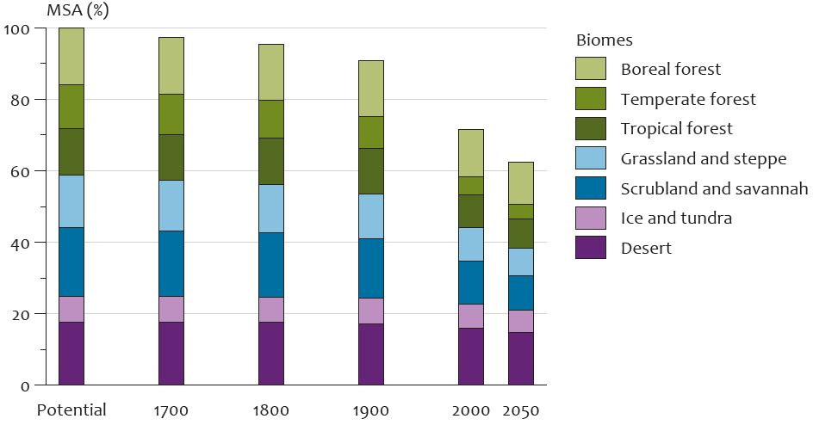
Figure 15: Historic developments and projections to 2050 of global mean species abundance (MSA) per biome; from: PBL (2010)
In their 2010 report on rethinking global biodiversity strategies, PBL applied the GLOBIO3 model to assess the compound effects of direct and indirect drivers on biodiversity in terrestrial ecosystems. The analysis yielded estimates for mean species abundance (MSA) values as percentage of undisturbed systems, from 1700 with projected changes until 2050 (Figure 15). The results confirm the deforestation trends as discussed above, namely that MSA loss in earlier centuries occurred mostly in temperate biomes, while impact on subtropical and tropical biomes accelerated only from 1900. By 2000, the boreal forest MSA had dropped to 82.4%, the temperate forest MSA to 40.7%, and the tropical forest MSA to 71.2% of its potential.
The projected development of global MSA per biome in the baseline scenario shows a loss between 2000 and 2050 at a similar rate as over the 20th century. According to the report, future biodiversity loss is not evenly distributed worldwide but rather concentrated in regions such as Central and South America, Sub-Saharan Africa and Asia. It also pointed out that biomes most affected are temperate and tropical grassland and forests that are most suitable for human settlement. Projected figures by 2050 are 75.1% for boreal forest MSA, 33.2% for temperate forest MSA, and 62.8% for tropical forest MSA.

Dryland ecosystems
More than two billion people depend on the world’s arid, semi-arid and dry sub-humid lands for their livelihoods. Despite the implications for food security, climate change and human settlement, only a few exploratory global assessments of the extent of dryland degradation are available. While most assessments agree that between 15-25% of drylands are degraded, the harmonization of results is difficult due to the different methodologies employed.
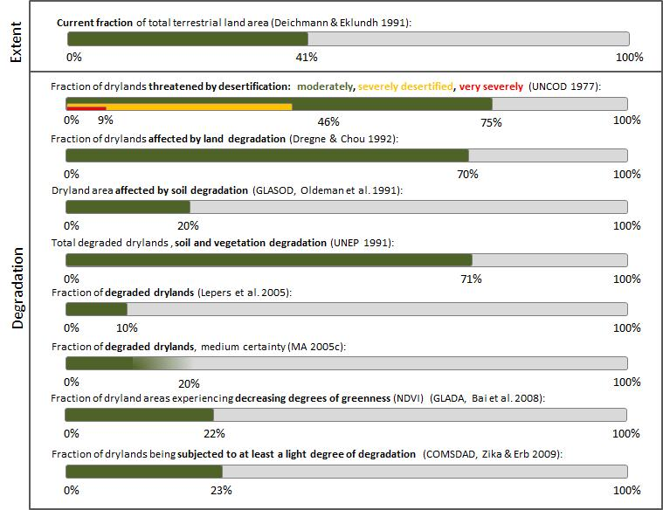

Extent of drylands
Technically, “drylands” are defined as the climatic region of the world with an aridity index value (annual precipitation/evaporation ratio) of 0.65 or less (UNEP 1992, UNCCD 1994), or in other words: areas in which annual mean potential evapotranspiration is at least ~1.5 times greater than annual mean precipitation. This comprises all arid, semi-arid and dry subhumid lands. As Safriel (2007) has pointed out, the relevant literature is not explicit regarding why a value of 0.65 has been selected for demarcating drylands from non-drylands. Though the classification of an area as a dryland subtype is determined by its low aridity index, it is important to remember that these areas do experience large between-year variability in precipitation (Safriel et al. 2005).
Drylands are characterized by a gradient of increasing primary productivity from hyper-arid, through arid and semi-arid, to dry sub-humid areas where the major constraint is (insufficient) soil moisture due to low rainfall and high evaporation. Deserts, grasslands, and woodlands are the natural expression of this gradient (MA 2005d) which illustrates the substantial overlap with other major ecosystem types in this report. Cultivated areas (section 3.2.2) constitute 25% of global drylands while 44% of all cultivated systems worldwide are actually located within drylands (MA 2005a). With another 65%, grasslands (section 3.2.3) constitute the main ecosystem type in drylands. This fraction is decreasing, with approximately 15% of dryland grasslands, the most valuable dryland range, having been converted between 1950 and 2000 (Safriel et al. 2005).
There is sufficient justification, however, to treat dryland ecosystems as a separate unit within the terrestrial ecosystems classification. As per the climatic definition above, drylands cover 41.3% (approximately 5,310 Mha, excluding hyper-arid deserts with another 1,000 Mha) of Earth’s land surface and are inhabited by more than 2 billion people – one third of the world’s population. Furthermore, dryland rangelands support approximately half of the world’s livestock.

Degradation and desertification in drylands
These facts, combined with a perception that a) droughts and land degradation – termed “desertification” in drylands – in the Sahel and other dryland areas was worsening in the 1970s and 1980s, and b) these phenomena are of a transboundary nature, resulted in the first global assessment of dryland degradation initiated through the 1977 United Nations Conference on Desertification (UNCOD). The total area of drylands was estimated at 5,550 Mha (37% of total global land), plus an area of man-made deserts accounting for 900 Mha (6%). Based on expert judgements, the area threatened, at least moderately, by desertification was found to be 3,970 Mha or 75.1% of the total drylands, excluding hyperarid areas (deserts). Of those, 350 Mha (9%) were considered very severely, 1,840 Mha (46%) severely, and 1,780 Mha (45%) moderately affected by desertification hazard. UNCOD also made estimates on annual rates of land degradation (arid and semiarid areas only): 0.125 Mha/yr in irrigated lands, 2.5 Mha/yr in rainfed croplands, and 3.2 Mha/yr in rangelands, yielding a total of 5.825 Mha/yr (UNCOD 1977).
As a follow-up to the UNCOD, Mabbutt (1984) in collaboration with UNEP launched another assessment of desertification status and trends. It was based on desertification questionnaires sent to all countries affected, and subsequent regional aggregation of results with the help of UN regional commissions and updated UNCOD documents. It was noted that the information provided was “patchy and often unsatisfactory” and attributable to the general failure of countries to conduct the required assessments, but also to the lack of simple methodologies for desertification assessments over larger areas. Overall, Mabbutt (1984) arrived at global desertification status figures that were similar to the desertification risk figures proposed by UNCOD (1977): The area found to be at least moderately desertified was 3,475 Mha, which in comparison is lower in area (as compared to 3,970 Mha), but higher % (77.2% as compared to 75.1%), due to a lower estimate of global dryland area of 4,500 Mha (35% of land surface area). This overall estimate was composed of degraded rangelands (3,100 Mha, 80% of their dryland total), rain-fed croplands (335 Mha, 60%), and irrigated lands (40 Mha, 30%). With this, the area of significantly desertified land constituted 75% of all productive land in the world’s drylands. In a second phase, an estimate of severely or very severely desertified land – defined as land that has lost >25% of its productivity and where substantial reclamation would be needed – was made: 1,300 Mha of rangelands (or 35% of their dryland total), 170 Mha (30%) of rain-fed croplands, and 13 Mha (10%) of irrigated lands fell into this category, an area constituting about 30% of the productive drylands in the world. Projections to the year 2000 indicated that desertification in rangelands would continue to increase at existing rates; in rainfed croplands it would accelerate into a critical situation; in irrigated lands, the status of desertification would likely remain largely as it was, with gains balancing losses and with possible local improvements.
Mabbutt’s findings have later been regarded as too pessimistic. Nelson (1988) surveyed the evidence for the rate and extent of land degradation, including Mabbutt's study. Nelson pointed out that the meanings of moderately, severely, and very severely degraded, as used in Mabbutt's survey, are subject to varying interpretations. Moreover, the time (1982) of the survey was at the end of a severe and prolonged drought in Africa, which could have affected the judgment of African officials about the rate, extent, and severity of land degradation. After reviewing other studies in the land degradation literature, Nelson concluded that the evidence with respect to the rate, extent, and severity of land degradation around the world is "extraordinarily skimpy".
Dregne & Chou (1992) used anecdotal evidence, research reports, expert opinion and local experience to derive estimates of degraded lands in the dryland zones of the world. Their estimate of 3,600 Mha of land degradation, representing 70% of total dryland area, has subsequently also been questioned as being too high (Reynolds & Stafford-Smith 2002).
Using the “provisional methodology” for the assessment and mapping of desertification originally developed for the UNCOD, the GLASOD (Global Assessment of Human-induced Soil Degradation) project set out to compile a soil degradation database for the period 1987-1990, prepared by leading experts (Oldeman et al. 1991, Oldeman & van Lynden 1996). It found that soil degradation occurred on 1035.2 Mha within the drylands (Table 7). Assuming 5,169 Mha as the dryland total area (Middleton & Thomas 1997), this represented 20% of the global terrestrial surface. Of this, 427.3 Mha were considered lightly, 470.3 Mha moderately, 130.1 Mha strongly, and 7.5 Mha extremely degraded. While outside the drylands, a total area of 929.2 Mha was assessed as being degraded. Causative factors of soil degradation were identified, and of the total degradation (1,964.4 Mha) observed, the main causes were identified as overgrazing (34.5%), deforestation (29.5%), agricultural (28.1%), overexploitation (6.8%), and bio-industrial (1.1%).
There has been some confusion on GLASOD results, with significantly higher UNCOD-style degradation values of up to 74% of dryland area circulating in the literature. This is because during the production of the GLASOD world map of global soil degradation, the mismatch between ground sampling scale and map unit scale had to be bridged. For cartographic reasons, a certain class of degradation degree would be displayed as an entire map unit, although only part of that unit is actually affected on the ground. Looking at the map only would therefore give an exaggerated impression of the extent of degradation (Safriel 1997). An improved GLASOD methodology was subsequently developed (ASSOD approach, van Lynden & Oldeman 1997), but solely applied to the South and South-east Asia region, rather than globally.
In order to go beyond the “soil-centred” approach of GLASOD, UNEP (1991) intersected GLASOD data with an ICASALS (International Centre for Arid and Semiarid Land Studies, Texas Tech University) map of major land uses and derived the following degradation estimates for drylands:
- Degraded irrigated lands: 43 Mha (30% of their dryland total)
- Degraded rainfed croplands: 216 Mha
- Degraded rangelands (soil degradation only): 757 Mha
- Degraded rangelands (soil and vegetation degradation): 3,333 Mha (73% of their dryland total, 64% of total drylands)
- Degraded rangelands (vegetation degradation without recorded soil degradation): 2,576 Mha
- Total degraded drylands (2,576 Mha + GLASOD): 3,592 Mha (69.5% of total drylands excluding hyperarid deserts)
- Non-degraded lands: 1,580 Mha
Table 7: Soil degradation degree by region inside the drylands (“Susceptible”) and outside (“Others”); all data in Mha; from: Middleton & Thomas (1997)
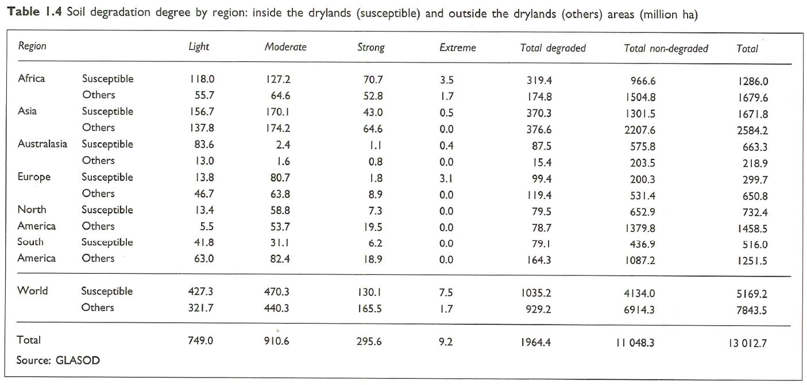
The UNEP (1991) study concluded that some 2,600 Mha, mainly in rangelands, are impacted by vegetation degradation not recorded in GLASOD, bringing the total extent of drylands experiencing some kind of degradation up to nearly 70%.
These results are problematic as soil is closely interlinked with vegetation cover and the ecosystem service of primary productivity (Safriel 2007), making it difficult to keep them separate during degradation assessments. In fact, soil degradation is of concern as it leads to reduced productivity. This example shows how important the definition of degradation is in assessing land degradation. An elegant way to overcome this problem as well as the inconsistencies in national data sets is to assess land degradation through remote sensing. Taking vegetative cover as a proxy for the state of the soil, remotely sensed reflectance from live vegetation – measured as a Normalized Difference Vegetation Index (NDVI) or Global Vegetation Index (GVI) – have been increasingly used as a proxy for indicators of land degradation.
For example, in a partial-coverage assessment of desertification prepared for the MA in 2003, Lepers et al. (2005) combined partially overlapping regional data sets with remote sensing data covering the period 1981-2000 to show that 10% of global drylands (including hyper-arid areas) were degraded (MA 2005c). Having reviewed the available data on dryland degradation, the MA drylands section underscored the need for better assessment given the limitations and problems with each of the underlying data sets. They concluded that the actual extent of desertified area may lie somewhere between the figures reported by GLASOD and the 2003 MA study. That is, some 10–20% of drylands were already degraded (with medium certainty). Based on these estimates, the total area affected by desertification was estimated between 600 and 1,200 Mha (MA 2005c).
The same report also pointed out that among the various dryland subtypes, ecosystems and populations in the semi-arid areas are the most vulnerable to the loss of ecosystem services (medium certainty). This is because population density within drylands decreases with increasing aridity from 10 persons per km² in the hyper-arid lands to 71 persons in dry sub-humid areas; conversely, the sensitivity of dryland ecosystems to human impacts that contributes to land degradation also increase with increasing aridity. Therefore, the risk of land degradation was found to be greatest in the median section of the aridity gradient (mostly the semi-arid areas), where both sensitivity to degradation and population pressure (expressed by population density) are of intermediate values (MA 2005d).
In a remote sensing-based study, the Land Degradation Assessment in Drylands (GLADA) project aimed at providing an up-to-date, quantitative and reproducible land degradation assessment. Based on the evaluation of NDVI trends during 1981-2006, Bai et al. (2008b) found that 8% degradation by area is in the dry sub-humid, 9% in the semi-arid, and 5% in arid and hyper-arid regions, yielding a total of 22% degrading land in the drylands, including the hyper-arid areas.
The most recent approach to quantify soil degradation is by Zika & Erb (2009) who compiled a world map of the extent and degree of desertification based on existing regional and global maps. The metric “human appropriation of net primary production” (HANPP) model was used as it was considered capable of identifying and monitoring key interlinkages between biophysical forces and human drivers. Their overall finding was that approximately 2% of the global terrestrial NPP are lost each year due to dryland degradation, or between 4-10% of the potential NPP in drylands. NPP losses amounted to 20-40% of the potential NPP on degraded agricultural areas in the global average and above 55% in some regions. Their Compiled Map of Soil Degradation Assessments (COMSDAD) identified a global total of 1,180 Mha – or 23.2% of the world’s drylands – as being subjected to at least a light degree of degradation (Table 8). The semi-arid zone shows the largest extent with 480 Mha, followed by the arid zone (450 Mha) and the dry sub-humid zone (250 Mha).
The compilation of this new world map resulted in an increase in degradation in all dryland zones as compared to the GLASOD map by 15% on average.
Table 8: The extent of global drylands, and estimates of degradation by GLASOD vs. COMSDAD, all data in Mha; from: Zika & Erb (2009)
 | Total dryland area | GLASOD | COMSDAD
 |  |  | Brackets: fractions of GLASOD
Dry subhumid | 1,280 | 220 | 250 (114%)
Semi-arid | 2,250 | 410 | 480 (117%)
Arid | 1,550 | 390 | 450 (115%)
World | 5,080 | 1,030 | 1,180 (115%)
NPP losses due to human-induced desertification ranged between 799 and 1973 Tg C/yr (0.8 and 2.0 Pg C/yr). A loss of 1 Pg C/yr would mean that about 5% (4–10%) of the potential production in drylands is lost every year due to human-induced soil degradation.
Besides soil and vegetation data, biodiversity indicators have also been used to assess global dryland degradation, although to a much lesser extent. MA (2005c) noted that – depending on the level of aridity – dryland biodiversity is relatively rich, still relatively secure, and critical for the provision of dryland services:
- Of 25 global ‘‘biodiversity hotspots’’ identified by Conservation International, 8 were in drylands;
- The proportion of drylands designated as protected areas was close to the global average, but the proportion of dryland threatened species was lower than average;
- At least 30% of the world’s cultivated plants originated in drylands and have progenitors and relatives in these areas;
- A high species diversity of large mammals in semi-arid drylands supports cultural services (mainly tourism);
- A high functional diversity of invertebrate decomposers in arid drylands supports nutrient cycling contributing to most arid primary production;
- A high structural diversity of plant cover (including microphyte diversity of soil biological crusts in arid and semi-arid areas) contributes to rainfall water regulation and soil conservation, hence to primary production and the genetic diversity of wild and cultivated plants.
Despite the importance of desertification, still only a few exploratory assessments of the global extent of land degradation are available and they all have major weaknesses (see discussion in MA 2005c). Probably because of the inherent shortcomings of the different approaches, it has not been possible to harmonize the results of expert opinion-based assessments with those derived by remote sensing technologies (Conijn et al. 2013). Research initiated by the PBL Netherlands Environmental Assessment Agency is currently looking into new, modelling-based approaches to this issue, however results are not available at this stage (PBL pers. comms. 2013).
Although various suggestions have been made for improving the expert-based approach (e.g. in the framework of the DESIRE project, see methodology in Liniger et al. 2008, and results in Schwilch et al. 2012), it appears that the future of degradation assessment in drylands will have to involve a mix of expert-based and remotely sensed information as well as modelling (see also section 4.1.4). During the Millennium Ecosystem Assessment, the need for a systematic global monitoring program, leading to the development of a scientifically credible and consistent baseline for the state of desertification was again stressed, and an “integrated use of satellite-based remote sensing or aerial photographs with ground-based observations” delineated a possible way forward to gain consistent, repeatable, cost-effective data on vegetation cover. In addition, long-term monitoring will be needed to distinguish between the role of human activities and climate variability in vegetative productivity. But the quest for better information on dryland status and trends does not stop here. Understanding the impacts of desertification on human well-being requires that we improve our knowledge of the interactions between socio-economic factors and ecosystem conditions. It follows that the gathering of information about socio-economic factors related to desertification needs to be carried out at sub-national levels (MA 2005c).
Land degradation in dryland ecosystems provides an example where the lack of capacity – scientific, technical and institutional – limits our success in addressing environmental problems. Degradation in dryland systems is driven by multiple causes and characterized by complex feedbacks that are made worse by global climate change (Ravi et al. 2010; Verstraete et al. 2009). Despite concerted efforts and a wide array of initiatives, drylands continue to be threatened in part because of lack of agreement on the underlying drivers, characteristics and consequences of degradation (Reynolds et al. 2007). Long-term harmonized data are necessary not only to understand the root causes of observed changes, but also to forecast and disentangle those possibly irrevocable impacts of global change from the often more temporary or local variability induced by other human activities. These data gaps, and the subsequent lack of capacity and effective strategies among dryland nations, can severely hamper progress towards internationally agreed goals on dryland conservation and restoration (UNEP 2012), the Aichi Targets and the Rio+20 commitment to strive to achieve a land-degradation-neutral world within the context of sustainable development.

Wetland ecosystems
Wetlands cover 10% of the terrestrial land surface, nearly one-third being peatlands. Assessments point to the substantial conversion of wetlands of up to 50%, with approximately 25% of peat-producing mires destroyed. Up to 85% of internationally important wetlands have undergone or are currently undergoing ecological change. In this process, agriculture is the biggest driver.
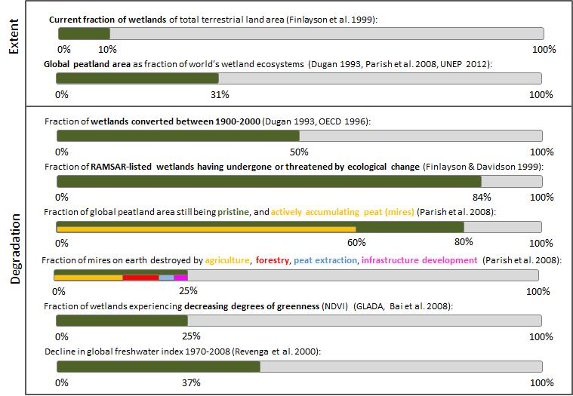

Extent of wetlands
This section addresses freshwater wetlands (peatlands etc.), whereas mangroves are discussed separately in section 3.2.7. For a definition of the most important wetland terms, see Figure 16.
Like all other major ecosystems in this report, estimates of the global extent of wetlands are highly dependent on the definition of wetlands used in each inventory, the type of source material available, the methodologies and objectives of the investigation (MA 2005d). Great care should therefore be taken when comparing data from different sources. The Ramsar Convention adopted a wetland definition which includes areas of marsh, fen, peatland or water, whether natural or artificial, permanent or temporary, with water that is static or flowing, fresh, brackish, or saline including areas of marine water, the depth of which at low tide does not exceed 6 meters (Navid 1989).
In the Global Review of Wetland Resources and Priorities for Wetland Inventory (GRoWI) that estimated the global extent of wetlands from national inventories, Finlayson & Davidson (1999) concluded that little is known about the extent and condition of the global wetland resource. On a regional basis, only parts of North America and Western Europe had adequate past and current inventories. GRoWI nevertheless produced a range of estimates, e.g. Spiers (1999), which provided the “best” minimum estimates for natural freshwater wetlands (570 Mha), rice paddy (130 Mha), mangroves (18.1 Mha), and coral reefs (30-60 Mha). Also provided were figures for global area of lakes (12 Mha) and marshes (27 Mha) – which combined made up approximately 9% of the total wetland area (Aselmann & Crutzen 1989). Although this assessment excluded many wetland types, such as saltmarshes and coastal flats, seagrass meadows, karsts and caves, and reservoirs, the estimate of a total of 748–778 Mha was higher than most previously published global estimates which ranged from 560–970 Mha (Spiers 1999). After additional inputs to the GRoWI, a follow-up estimate produced a much larger area for global wetlands, stating at 1,280 Mha, still considered to represent a minimum figure (Finlayson et al. 1999).
Although the data sources used for GRoWI to provide an extensive resource for addressing the project’s fundamental questions of the size of the wetland resource and the adequacy of existing inventories, it was recognized that, given the time-frame of the work, it was not possible to identify and access all inventory material worldwide (Finlayson et al. 1999).
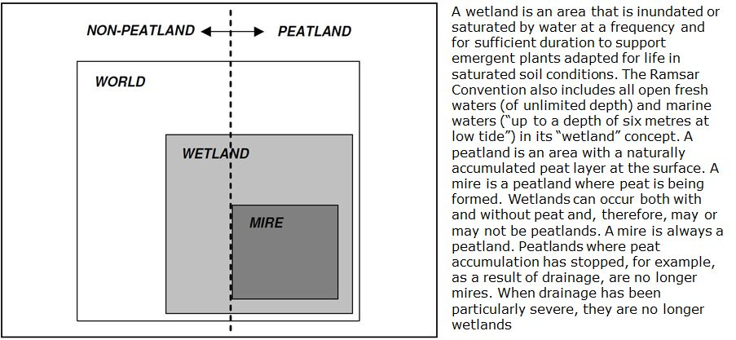
Figure 16: The relation between “peatland”, “wetland”, and “mire”; from: Parish et al. (2008), adopted from Joosten & Clarke (2002).
Analogous to developments for assessing land degradation in drylands – remote sensing techniques were considered to be quick, inexpensive, consistent, and reproducible means of data generation. In 2003, the European Space Agency (ESA) in collaboration with the Ramsar Secretariat launched the ‘‘GlobWetland’’ project in order to demonstrate the current capabilities of Earth Observation technology to support inventorying, monitoring, and assessment of wetland ecosystems (Jones et al. 2009). Responding to the need for a comprehensive and complete global database of wetlands, Lehner & Döll (2004) established a new Global Lakes and Wetlands Database (GLWD) by drawing upon a variety of existing maps, data and information. Level 3 of this database represents lakes, reservoirs, rivers, and different wetland types with a total global area of 916.7 Mha. A comparison of their findings with those of the GRoWI assessment is provided in Table 9.
Although considerably lower estimates are circulating in the current literature – Lal et al. 2012, e.g., showed the area of wetlands as 350 Mha – the GRoWI estimate seems to represent a consensus, (MA 2005e).

Conversion and degradation of wetlands
The conversion and degradation of wetlands through human activities has been substantial. Data provided by Ramsar Contracting Parties indicated that 84% of Ramsar-listed wetlands had undergone or were threatened by ecological change. The most 5 widespread threats were from pollution, drainage for agriculture, settlements and urbanisation, and hunting (Finlayson & Davidson 1999). For both inland and coastal wetlands, the most salient drivers of change are population growth and increasing economic development, which in turn promote infrastructure development and land conversion including agricultural expansion (Wood & van Halsema 2008). Other direct drivers affecting wetlands are deforestation, increased withdrawal of freshwater, diversion of freshwater flows, disruption and fragmentation of the landscape, nitrogen loading, overharvesting, siltation, changes in water temperatures and invasion by alien species (Fraser & Keddy 2005).
Table 9: Comparison of estimates of global wetland area according to the GRoWI (Finlayson et al. 1999), and GLWD (Lehner & Döll 2004); from: UNEP (2012)
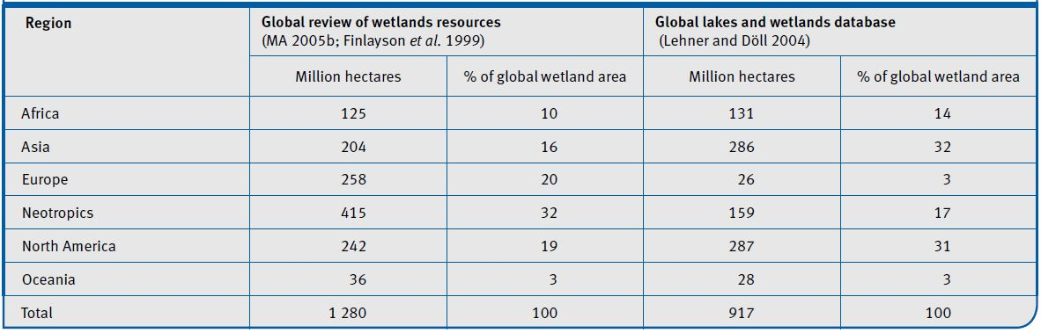
On a global scale, some have speculated that approximately 50% of those wetlands that existed in 1900 had been completely lost by 2000 (Dugan 1993, OECD 1996). This figure included inland wetlands and possibly mangroves, but not large estuaries and marine wetlands such as coral reefs and seagrasses. Much of this conversion is thought to have occurred in the northern temperate zone during the first half of the 20th century. However, since the 1950s tropical and sub-tropical wetlands, particularly swamp forests and mangroves, have increasingly been lost. Agriculture was and is considered the principal cause for wetland conversion worldwide. By 1985, it is estimated that between 56-65% of intact wetlands had been drained for intensive agriculture in Europe and North America, 27% in Asia, 6% in South America and 2% in Africa (Finlayson & Davidson 1999).
The 50% conversion “best guess” estimate was repeated by Revenga et al. (2000) in their PAGE report, but treated rather carefully during the Millennium Ecosystem Assessment due to the lack of supporting evidence MA (2005a). It concluded that since reliable estimates of the extent of wetlands (and particularly of intermittently inundated wetlands in semi-arid lands) are lacking, it is not possible to ascertain the extent of wetland conversion with any degree of certainty. This conclusion was the same 5 years later, when UNEP (2010) stated that “verifiable global data for loss of inland water habitats as a whole are not available”. They gave some additional facts, though, that are listed for completeness:
- Continental estimates for fractions of inland water systems suitable for use in intensive agriculture drained by 1985: Europe 56%, North America 65%, Asia 27%, and South America 6%
- More than 40% of the global river discharge is now intercepted by large dams and one-third of sediment destined for the coastal zones no longer arrives
- The condition of the 1,880 wetlands of international importance covered by the Ramsar Convention continues to deteriorate, with the majority of governments reporting an increased need to address adverse ecological changes in 2005-2008, compared with the previous three-year period. The countries reporting the greatest concern about the condition of wetlands were in the Americas and Africa.
During the GLADA project (2006-2009), land degradation was assessed in terms of remotely sensed changes in “greenness” in the period of 1981-2006. NDVI analyses showed that 25% of “wetlands” were degrading during that time (23.1% when mangroves are excluded).
Degradation of wetland ecosystems has also been expressed in terms of changes in biodiversity and habitat quality. Revenga et al. (2000) pointed out that more than 20% of the world’s freshwater fish have become extinct or been threatened or endangered in recent decades. In their latest Living Planet Report, WWF (2012) pointed out that the freshwater Living Planet Index declined more than for any other biome. The index included 2,849 populations of 737 species of fish, birds, reptiles, amphibians and mammals found in temperate and tropical freshwater lakes, rivers and wetlands. Overall, the global freshwater index was found to have declined by 37% between 1970-2008; this reflected the combined trends of a drastically decreased tropical freshwater index (-70% and thus the largest fall of any of the biome-based indices) and a positive trend in the temperate freshwater index (+35%).

Conversion of peatlands
Due to their particular significance in carbon sequestration, the world’s peatlands are increasingly the subject of attention. Most sources seem to agree that the total extent of peatlands is 400 Mha or 3% of the world’s land surface (Dugan 1993, Parish et al. 2008, UNEP 2012), constituting roughly one-third of the global wetland resource.. In their thorough global review on peatland areas, Parish et al. (2008) lamented that the general inventory status of peatlands is (largely) inadequate and that almost nothing seemed to be known about the peatlands in large parts of Africa, South America, and for the mountain areas of central Asia. Major problems mentioned for preventing a consistent global overview included a lack of awareness and capacity, typological differences between countries and disciplines, different inventory scales and the use of outdated data. Nevertheless, the review ventured to estimate that 80% of the global peatland area was still in a pristine condition (i.e. not severely modified by human activities), and 60% still actively accumulated peat. Human exploitation had destroyed almost 25% of the mires on Earth: of this destruction, 50% was for agriculture, 30% for forestry, 10% for peat extraction, and 10% for infrastructure development (Joosten & Clarke 2002). The review also estimated the annual global destruction rate of intact peatlands at 0.4 Mha or 1‰ per year, and the associated annual global decrease in peat volume at 20 km³. These losses (Immirzi et al. 1992, Joosten & Clarke 2002) largely occurred (and still occur) in the temperate and tropical zones. In some regions (southern Africa, Southeast Asia, Central Asia) the current annual conversion rates of peatlands can be counted in whole percentages and may result in the annihilation of their peatland habitat in this century (Silvius & Giesen 1992, Hooijer et al. 2006). Most future mire and peatland conversion are expected to result from drainage and infrastructure development.
Compared to other continents, Europe has suffered the greatest reduction in mires, both in absolute and relative terms. Peat formation has stopped in over 50% of the original mire area, of which possibly 10-20% does not even exist anymore as peatland. In Western Europe, many countries have lost over 90% of their peatland heritage, with the Netherlands leading with almost 100% of its peatlands being destroyed. Asia and North America, including the vast extent of Siberian and sub-arctic peatlands, have incurred the least amount of conversion. Large-scale reclamation of tropical peat swamp forests in Southeast Asia which started only in the 1960s has destroyed over 12 Mha of this habitat. Large areas have been left without peat soil as a result of oxidation and fires. Over 90% of peat swamp forests in Southeast Asia have been impacted by deforestation, conversion, drainage and legal or illegal logging to the extent that they are significantly degraded and have turned from being carbon sinks into net sources of carbon (Hooijer et al. 2006).

Coastal ecosystems
Nearly one-third of humanity lives within 100 km of a coast, and one-third of coastal lands are considered semi-altered or altered. At least one-fourth of mangrove ecosystems have been converted globally, and an equally high percentage appears to be degrading. Similar figures exist for seagrass habitats and coastal marshes.
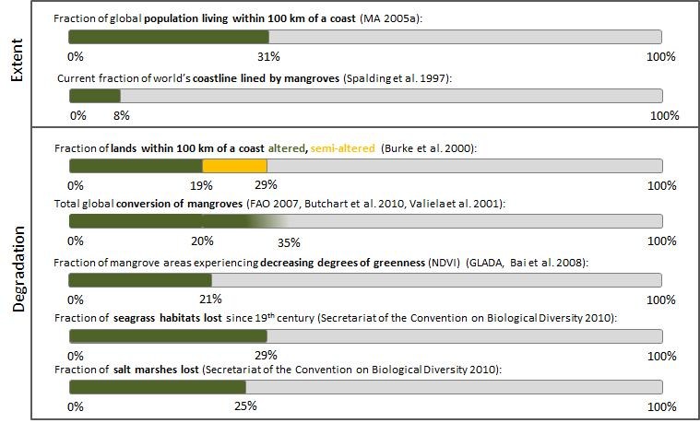
Coastal ecosystems are among the most productive yet highly threatened systems in the world (MA 2005d). Although they comprise all coastal lands where fresh water and salt water meet plus near-shore marine areas, this section focuses on mangroves because of: a) the multitude of ecosystem services they provide, b) their recognition as bulkhead in climate change mitigation and adaptation (UNEP 2013), and c) mangroves are better mapped and assessed than other coastal and marine wetlands (Finlayson & Davidson 1999).
Mangroves are trees and shrubs found in intertidal zones and estuarine margins that have adapted to living in saline water, either continually or during high tides (Duke 1992). The World Mangrove Atlas, the product of the first global mapping exercise, concluded that mangroves lined approximately 8% of the world’s coastline and covered a surface area of 18.1 Mha (Spalding et al. 1997). It also stressed that estimates of current mangrove extent vary significantly from one source to another, possibly because of the difference in definition, methodology and land cover information used. Subsequent estimates have not substantially deviated from the original including 17 Mha (Saenger et al. 1983), 16.6 Mha (Valiela et al. 2001), and 15.7 Mha (FAO 2007).
Despite their value to humans, coastal ecosystems and the services they provide are becoming increasingly vulnerable (MA 2005a) due to growing population and exploitation pressures in most parts of the world. Though the thin strip of coastal land at the continental margins and within islands accounts for less than 5% of Earth’s total area, 17% of the global population lives within these coastal ecosystems, and 39% of global population lives within the area that is within 100 kilometres of a coast (MA 2005a).
The leading human activities that contribute to mangrove conversion are classified as follows: 52% for aquaculture (38% shrimp plus 14% fish), 26% for forest use, and 11% for freshwater diversion (Valiela et al. 2001). Restoration has been successful in some places but has not kept pace with wholesale destruction in most areas.
During the PAGE assessment, Burke et al. (2000) estimated that 19% of all lands within 100 km of the coast (excluding Antarctica and water bodies) are classified as altered, meaning they are in agricultural or urban uses; 10% are semi-altered, involving a mosaic of natural and altered vegetation; and 71% fall within the least modified category. Among the coastal ecosystems, mangroves appear to be the most degraded and under constant threat. For all continents, present-day mangrove forest area is substantially smaller than the original area. Anywhere from 5 to 80% of original mangrove area in various countries, where such data are available, is believed to have been converted or lost (Burke et al. 2000), with estimates for a world average conversion ranging from 20% (FAO 2007, Butchart et al. 2010) to 35% (Valiela et al. 2001). According to FAO (2007), an alarming 20%, or 3.6 Mha of mangroves, have been converted since 1980 alone. To put this figure into context, it should be noted that although mangroves constitute less than 0.4% of the world’s forests (Spalding et al. 2010), their losses exceed those for tropical rain forests and coral reefs (Valiela et al. 2001). In less than 100 years, the world’s mangrove forests may become so degraded and reduced in area that they would be considered to have “functionally disappeared” (Duke et al., 2007).
Generally, mangrove ecosystems are being lost at the rate of about 1% per year (Table 10). In some areas, the rate may be as high as 2 to 8% per year (Miththapala 2008). The rates of conversion are highest in developing countries where mangroves are cleared for coastal development, aquaculture, timber and fuel production (Polidoro et al. 2010). More recently, the rate of net conversion appears to have slowed down, although it is still disturbingly high. About 0.187 Mha were lost every year in the 1980s; this figure dropped to some 0.118 Mha per year in the 1990s and to 0.102 Mha per year (–0.66%) during the 2000–2005 period, reflecting an increased awareness of the value of mangrove ecosystems (FAO 2007).
Table 10: Current and past extent of mangroves by region (1980-2005); from: FAO (2007).
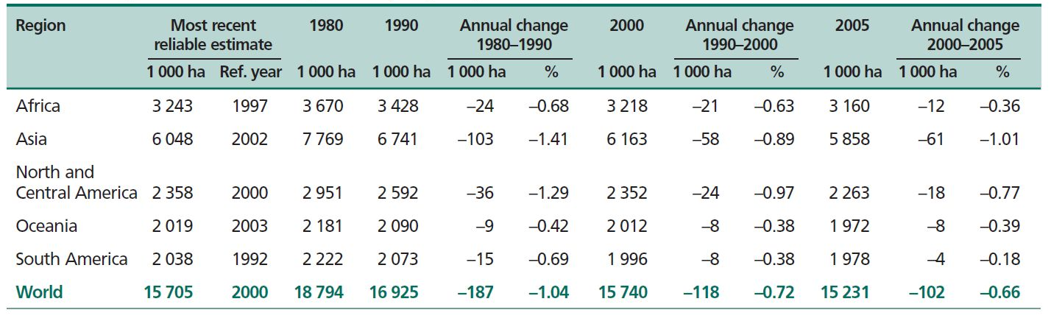
The FAO have emphasized that their conversion rate is situated at the conservative end of current estimates. Duke et al (2007) calculated a rate of 1-2% per year, and Valiela et al. (2001) estimated it at 2.07% or 0,283 Mha per year. The FAO data are being updated regularly, with the latest estimate for the total extent of mangroves at 15.6 Mha (FAO 2010b). These estimates are cited in the 3rd Global Biodiversity Outlook report (Secretariat of the Convention on Biological Diversity 2010) and the GEO5 report (UNEP 2012).
Reliable data on mangrove forest degradation rather than conversion are rare. The GLADA project estimate was that 21.2% of mangroves were experiencing degradation in the period 1981-2006. (Bai et al. 2008b). And Laestadius et al. (2012) recently estimated that from the overall potential mangrove area only 3% were still intact, whereas 46% were fragmented, 30% degraded, and 21% deforested or converted.
The only reliable data on coastal ecosystems other than mangroves are provided by the Secretariat of the Convention on Biological Diversity (2010): It is estimated that some 29% of seagrass habitats have disappeared since the 19th century, with a sharp acceleration in recent decades. Since 1980, the loss of seagrass beds has averaged approximately 110 km² per year, a rate of loss comparable to mangroves, coral reefs and tropical forests. Salt marshes, important as natural storm barriers and as habitats for shorebirds, have lost some 25% of the area they originally covered globally, and current rates of loss are estimated to be between one and two per cent per year.
Although the trends in degradation and conversion is clearly negative, it has been noted that, during the 1990s in some regions, mangrove area is actually increasing as a result of plantation forestry and small amounts of natural regeneration (Spalding et al. 1997). UNEP (2013) called attention to the fact that since the 2004 Indian Ocean tsunami, there has been a general increase in the awareness of the importance of mangrove ecosystems. Efforts to conserve, protect and restore them can currently be seen in Bangladesh, India, Indonesia, Myanmar, Seychelles, Sri Lanka, Pakistan, Thailand and Vietnam (Macintosh et al., 2012).

Deriving estimates for restoration and rehabilitation potential

Discussion of the findings

Conceptual changes over time
One of the main tasks of this report is to not only reproduce the available data on ecosystem extents and degradation, but also to elucidate how they were derived. Understanding the changing concepts of “degradation” over time, and investigating the motivation of the various assessments, understanding the references used and technologies applied, helps to put data into context and forms the basis for their comparison across various assessments. The comment of Verón et al. (2006) that “much of the confusion surrounding the spatial extent of desertification would be reduced if estimates were interpreted according to the conceptual and methodological framework under which they were produced” holds true for all global assessments.
The concept of “degradation” in particular has been evolving over time. In the 1970’s, the FAO defined land degradation as “a process which lowers the current or potential capability of soils to produce” (FAO 1979). Over the last thirty years, the object of land degradation has expanded from a focus on the soil to a focus on the ecosystem as a whole and from the narrow concept of production to the more encompassing one of the range of goods and services provided. When the LADA project defined degradation as “The reduction in the capacity of the land to provide ecosystem goods and services and to assure its functions over a period of time for its beneficiaries” it drew attention to the fact that it is essential to define the time period over which land degradation processes should be considered, and consequently the need to agree on a baseline against which the present state of the land should be evaluated (Nachtergaele et al. 2010b). The authors also pointed out that timelines in the not so distant path may help people to better understand the drivers of change and formulate action plans accordingly.
The assessments analysed in this study very greatly in terms of baseline used. Some do not provide baselines at all (e.g. all expert-based ones such as GLASOD), others depend on the availability of datasets (e.g. the Living Planet Index starting from 1970), and others imagine a garden of Eden scenario (e.g. the GPFLR 2011 study). Understanding the various baselines is therefore a pre-requisite to comparing degradation figures from different studies. This is especially important for ecosystems such as forests that have been used and modified by humans since Neolithic times.
Today more than ever, “degradation” remains a blurred entity: it is multi-dimensional, multi-scale, transitional, multi-perspective, multi-actor, and above all value-laden. A global authoritative effort to define the various dimensions of ecosystem degradation, thereby clearly defining the terms used and standardising efforts to quantify it, is still badly needed.

Ecosystem classification
Another pre-requisite is recognizing the various ways that the world’s land surface can be divided into a finite number of units and their delineation from each other. The main foundation of “cookie cutting” can be climatological (e.g. the definition of drylands), biogeographical (e.g. 1976 “Bailey system”), or ecological (e.g. the WWF biomes, Olson et al. 2001).
It was found that global degradation assessments rarely follow an existing classification scheme, probably indicating that there is no scheme currently existing that appears suitable for that purpose. Rather, a definition of what has been assessed is provided, and more often than not it is stressed that even an agreed definition of the unit assessed (“wetlands”, “forests”, etc.) does not exist. As a consequence, findings of degradation assessments are mostly comparable within a series of assessments of one originator (e.g. CBD Global Biodiversity Outlook report, FAO State of the World’s Forests reports, FAO Global Forest Resource Assessment report, UNEP Global Environmental Outlook reports), but not between different sources.
Some of the issues encountered during this review were:
- No agreed total terrestrial surface area. Estimates ranged from 13,013 Mha (GLASOD), over 13,048 Mha (current FAOSTAT) and 13,200 Mha (FAO SOLAW report) to 13,500 Mha (WRI and GPFLR studies).
- Agroecosystems: We used this synonymous to agricultural land. This latter term is problematic as some assessments use this for croplands only, whereas most assessments follow the FAO systematic that adds Cropland and Permanent pasture to “total agriculture”. The delineation of agroecosystems to “cultivated systems” as using during the MA is not fully clear: The ‘‘cultivated system’’ considered a landscape where crop farming is a primary activity but that probably includes, as an integral part of that system, patches of rangeland, forest, water, and human settlements (MA 2005a).
- Grassland ecosystems: This reporting unit has been the most fuzzy one. For most assessments it was especially unclear if grasslands included rangelands and permanent pasture which sometimes formed part of the agricultural systems. Similarly, tundra is frequently counted as part of the polar systems rather than grassland ecosystems. Most assessments also included shrublands and forested grasslands such as savannas. It is hoped that future assessments may adopt a comprehensive view, such as used by White et al. (2000) who went beyond arbitrary land cover distinctions and defined grasslands as “terrestrial ecosystems dominated by herbaceous and shrub vegetation and maintained by fire, grazing, drought and/or freezing temperatures”.
- Forest ecosystems: As long as there is no international agreement on what constitutes a forest, expert assessments of field findings as well as remotely sensed data will remain separate efforts producing incomparable data sets. The fact that remotely sensed forest extents currently vary from 2,896 Mha (Matthews et al. 2000) to 5,386 Mha (GPFLR 2011). Also, there is an apparent mismatch between remotely sensed forest area and the forest biome extents of the WWF ecoregions, with a larger part of actual forest/woodland falling outside the forest biomes (22% in case of the MA).
- Dryland ecosystems: A major issue is that some assessments include the hyperarid regime (approx. 1,000 Mha) in their calculations, while others don’t. A minor issues is that - even though drylands were defined on basis of the Global Humidity Index (mean annual potential moisture availability for the period 1951-1980), their extent is not constant in the literature: from 4,500 Mha (Mabbutt 1984), over e.g. 5,080 Mha (Zika & Erb 2009), 5,169 Mha (Middleton & Thomas 1997), 5,310 Mha (FAO 2004), 5,356 Mha (UNSO/UNDP 1997), through to 5,550 Mha (UNCOD 1977).
The Millennium Ecosystem Assessment as the most extensive effort yet, has defined “systems” rather than ecosystems to consequently show the linkages between ecosystems and human well-being and, in particular, the ecosystem services. The 10 selected systems assessed cover much larger areas than most ecosystems in the strict sense and include areas of system type that are far apart (even isolated) and that thus interact only weakly (MA 2005a).
Nevertheless, for assessments that are not “just” reviews or interpretations of existing data, the definition of biomes is important for accounting purposes, as how one classifies lands could dictate who will administer the lands and how they will be managed (Lund 2007).

Qualitative vs. quantitative assessments
When the idea of a global-scale assessment of land degradation was born during 2nd half of the 20th century, the most straight-forward approach involved the compilation of national datasets, and the consultation of experts. National data as an information source can be tricky in a global context, mainly because they do not exist equally everywhere (reliable quantitative data are generally rare in most developing countries), and are not necessarily comparable where they exist. This is because sampling, handling, analysing and interpreting may be biased.
Degradation assessments relying on the perception of experts are potentially subjective, and therefore also termed qualitative assessments. They are having a number of advantages over purely quantitative, data-driven assessments (van Lynden et al. 2004):
- They represent “accumulated” knowledge on an expert that ideally reaches over several decades, rather than just a snapshot in time;
- A wide range of different degradation types can be addressed simultaneously, at multiple scales;
- They can provide a relatively quick overview for national and regional planning;
- They enable identification of hot spots and bright spots (problem areas and examples of effective responses) for further study;
- They constitute a good tool for awareness raising;
- The data requirements are limited: adequate expert knowledge, though preferably supported by hard data, is sufficient.
Qualitative indicators have the advantage of providing richness and intuitive understanding that numerical data cannot convey. However, their assessment may be even more demanding than the assessment of quantitative indicators. In addition they are more difficult to present and therefore tend to appear less accurate. The biggest disadvantage is the potentially subjective character of qualitative assessments. Against this - it can be argued that by its very nature, degradation assessment is qualitative, since the term “degradation” in itself implies a loss of value. In this sense, the assessment of degradation is a value judgement. Perception of that value is also depending on the user of the land: the land qualities important for a farmer are very different from those of importance for a construction engineer (van Lynden et al. 2004).
Further disadvantages of qualitative assessments are:
- a general lack of hard supporting data;
- the information being based on expert knowledge and existing data, may not always be up to date;
- expert judgement cannot be tested for consistency;
- findings cannot be reproduced for unvisited sites, so that temporal or spatial comparisons are more difficult;
- Social and economic impact of degradation remains unclear.
In an effort to evaluate the GLASOD findings with the help of new GIS data to delineate and define the characteristics of GLASOD map units, Sonneveld & Dent (2009) tested the consistency and reproducibility of the expert judgements at the time. Although acknowledging what has been achieved on a global level in short time, they concluded that the expert assessments were not very reliable. Experts were found to be only moderately consistent in assigning soil degradation classes to similar sites and the authors speculated that the different conceptualization of the degrees of degradation among experts might be one of the main reasons for this. They also delineated improvements for future expert-based GLASOD-style assessments:
- Reduce subjective interpretations: give a quantitative interpretation to the qualitative assessments by relating their ordered classes to a quantitative measure of land degradation;
- Make qualitative assessments more consistent and more operational by discussing them in plenary sessions with the experts involved;
- Establish a common procedure for establishing physiographic mapping units by using a detailed global digital elevation model (in GLASOD, the experts were given a free hand with this)
- Reduce the impact of outliers generated by “special sites” unknown to the entire group by including specific factors that account for those particular locations.
As has been shown in sections 3.2.2 to 3.2.7, environmental monitoring has since the turn of the millennium been increasingly relying on remote sensing, i.e. the use of aerial sensor technologies to detect and classify objects on Earth by means of propagated signals from aircrafts and satellites. The main incentives for their use in land evaluation are:
- Relatively cheap and rapid method of acquiring up-to-date information over a large geographical area in a homogeneous way;
- It is the only practical way to obtain data from inaccessible regions, e.g. Antarctica, Amazonia;
- At small scales, regional phenomena which are invisible from the ground are clearly visible, e.g. faults and other geological structures. A classic example of seeing the forest instead of the trees;
- Cheap and rapid method of constructing base maps in the absence of detailed land surveys.
- Easy to manipulate with a PC, and combine with other geographic layers in a GIS.
However, they also come with a range of challenges:
- They are not direct samples of the phenomenon, so must be calibrated against reality. This calibration is never exact, a classification error of 10% is excellent;
- They must be corrected geometrically and georeferenced in order to be useful as maps, not only as pictures;
- Distinct phenomena can be confused if they look the same to the sensor, leading to classification error;
- Phenomena which were not meant to be measured can interfere with the image and must be accounted for. Examples for land cover classification: atmospheric water vapour, sun vs. shadow etc.
- Resolution of satellite imagery is too coarse for detailed mapping (e.g. tunnel erosion features) and for distinguishing small contrasting areas. Rule of thumb: a land use must occupy at least 16 pixels (picture elements, cells) to be reliably identified by automatic methods.
It also has to be noted that a remote sensing measurement – just as the one-off analysis of a soil parameter – just represents a “snapshot” in time in the assessment of an ecosystem. Furthermore, although remote sensing has advanced knowledge of land cover and land use, reliable information on changes is limited as data from different points in time are often not comparable because of changing sensor technology, insufficient ground truthing and a lack of agreement on ecosystem delineations (see section 4.1.2).
In the context of using remotely sensed Normalized Difference Vegetation Index (NDVI) data, e.g., von Braun & Gerber (2012) noted that although the NDVI and related indicators currently provide the only empirical tools for global assessments of land and soil degradation (LSD), they have clear shortcomings: In particular, their ground-truthing revealed many (and large) errors, their relationship with actual LSD was still debated (e.g. Vlek et al. 2010), and their application and treatment in parallel with socio-economic indicators and models hampered by a lack of compatibility in data format and nature. Further, a comprehensive methodology to overcome these issues, such as that outlined in Nkonya et al. (2011), had not yet been applied.
As a summary it can be said that the debate over "hard data" vs. "expert decision" can be softened when considering that derived “hard data” can be enhanced and upscaled by modelling them differently, and interpretation of remote sensing data is also driven by experts’ choice on methodology and data processing procedures. Rather than creating artificial conflicts between the two ways of collecting and assessing data, the aim should be to use the best data and the best opinion available for the global assessment of ecosystem state and degradation.
Table 11: Comparison of forest area and forest area change estimates from the remote sensing survey with country data; from: FAO (2001).
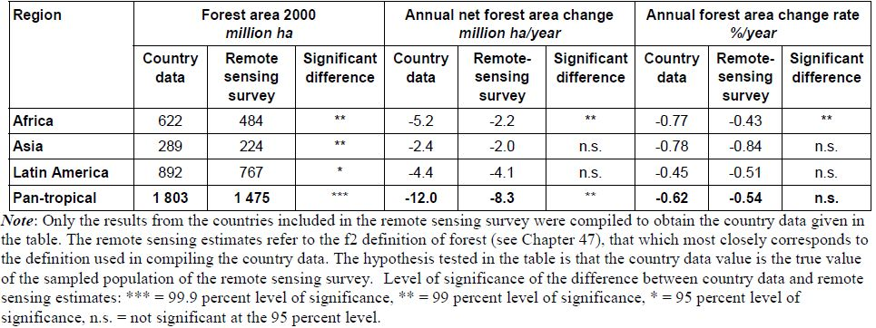

Data gaps and perspectives
Global appraisals of degradation and productivity remain relevant to support awareness raising in policy circles that are committed to action (Bindraban et al 2012). Progress towards agreed policy targets, including restoration of 15% of degraded ecosystems (CBD) or for a zero net degradation (UNCCD) cannot be measured without quantified information (Bindraban et al. 2013).
The sections above have highlighted some conceptual and technical restraints that exist beyond the always present lack of financial resources to conduct global assessments, and help to understand current data lacks. Our observation largely agree with those of UNEP (2012): Deficiencies in scientifically credible data on the environment remain a major handicap in developing evidence-based policies. Environment statistics, mostly collected or compiled by national statistical offices, are one of the most important sources of information for assessment reports like GEO-5, but global and regional reports from the United Nations and other agencies regularly show gaps, or use old data or estimates.
In particular, global data on land degradation have not been updated for a long time, although new estimates using satellite material are being developed. Datasets exist for land cover but do not always adequately represent areas that have experienced selective cutting or other types of modification. Forest cover losses in boreal and temperate forests are not as well studied as those in tropical forests, while evidence is still emerging of the significant carbon sequestration potential of rangelands and grasslands. Records of ecosystem change are improving, mainly through remote sensing, but reliable data on land-use change are still fragmented and often not comparable – the extent of drylands, for example, is uncertain because of the classifications and methodologies used by different programmes (see section 4.1.2 and ICTSD 2007). Similarly, there are discrepancies between a number of wetland inventories (Ramsar Convention Secretariat 2007) and there is no comprehensive global wetlands database.
Ellis et al. (2010) remarked that while existing global land-use and population data, vegetation models, remote sensing platforms and other data acquisition systems and models are certainly useful for investigating current, historical and future ecological patterns across the terrestrial biosphere, there remain tremendous uncertainties in our understanding and ability to model even current global patterns of ecosystem function and biodiversity across the anthropogenic biosphere.
Braun & Gerber (2012) confirmed that it will require a concerted effort by many parties to produce a global and integrated assessment of land degradation. One of the biggest challenges will probably be to match the findings of the various types of degradation assessments. Whereas ground and remotely sensed assessments often agree in the overall magnitude of an ecosystem converted or degraded (e.g. forest area assessments, Table 11), there are major disagreements as to where degradation or conversion exactly occur. With special regards to cultivated systems, Bindraban et al. (2012) noted that estimates of the intensity and extent of soil degradation give rather divergent views due to different methodologies, definitions applied and lack of on-the ground validation. Also, assessments of the impact of degradation on plant production were inaccurate, as they were made from reduction factors based on expert judgements, or on partial insight of adverse soil conditions on yield and statistical procedures that do not allow extrapolation in time nor space.
There can be no doubt that
- effective and long-term monitoring of environmental trends is indispensable as a data base, and key to avoiding environmental damage (UNEP 2012), and
- technically, global assessments on ecosystem state and change have to combine elements of ground measurement, remote sensing, and modelling, and
- conceptually, future assessments will have to consider both ecological and human systems, and their interlinkages.
Ellis et al. (2010) highlighted that solid theoretical and predictive global models of coupled human and ecological system dynamics are now indeed being developed. And they stressed that human systems models were needed that are as theoretically strong, predictive and useful as the best current biophysical models of natural biospheric pattern, process and dynamics, and that these models needed to be coupled together to produce useful predictions of global ecological patterns, processes and dynamics.
As a practical way forward, Bindraban et al. (2013) recently encouraged the development a comprehensive approach to better assess both extent and impact of soil degradation interlinking various scales. The increasing computational power, along with the availability of consistent long term remotely sensed information and increasing insights in production ecological processes provided a means to integrate and verify process-based approaches at ever higher spatial scale and resolution to more accurately assess both degradation and impact interlinking different scale levels. Interlinked with existing model-based environmental impact assessment models, such as IMAGE (Bouwman et al. 2006) and GLOBIO (Alkemade et al. 2009), this approach could result in powerful tools to assess: 1) ecosystem degradation per se and its direct in situ impacts, and 2) associated off-site and indirect impacts, for example on water basin hydrology.

From degradation estimates to restoration potentials

Best estimate evaluation of existing global degradation assessments in light of ecosystem restoration and rehabilitation
Based on the review as presented in chapter 3, and considering the data limitations as outlined in section 4.1, we (the authors) have used our expert knowledge to derive at estimates for the conversion and degradation of the world’s major ecosystems (Table 12).
Estimates of extent
Methods and assumptions used to derive at current and former ecosystem extents are provided in the footnotes. As noted in section 3.1.1, the major ecosystems chosen as reporting units substantially overlap and their total extent exceeds 100% of total terrestrial land surface. The sum of current extents (3rd column in Figure 12), e.g., is 20,418 Mha, approx. 1.5 times the terrestrial surface area.
It is interesting to note that the total of former extent estimates is 19,424 Mha, approx. 1,000 Mha (5%) lower than the sum of current extents. This can be mainly – but not exclusively – due to:
- The ways derived at “former” extents are not the same for all ecosystems. For forest ecosystems, the value is a modelling result and reflects potential forest cover under present climatic conditions, not “former” ones. For grasslands and wetlands, the former extent was derived by multiplying the current extent with the inverse of respective conversion estimates. This approach is problematic as two uncertain estimates are multiplied with each other.
- The conversion estimates for grasslands and/or wetlands might be too low.
- The time dimension of what is “former” might vary between ecosystems. Most estimates refer to a “pre-Neolithic stage”; people began altering plant and animal communities for their own benefit earlier than that, so that a value other than “0” is imaginable for the “former” extent of agroecosystems.
It is most probably the sum of the above that creates the observed deviation. As the extent figures as well as conversion estimates were derived from our review and thus are all plausible to a similar degree, not “artificial” adjustments were undertaken to make the sums of columns 1 and 2 match.
Estimates of conversion
Ecosystem conversion has been calculated as the differences between modelled or calculated former extents and associated current extents. In case of agroecosystems conversion does not apply, and in case of dryland ecosystems no conversion rates can be determined because of their static extent.

Table 12: Best estimates of the core team on extent and degradation parameters of major ecosystems, n/a = not available.
Major ecosystem type | Extent |  | Converted |  | Degraded |  | Wilderness
Major ecosystem type | former  [Mha] | current  [Mha] | [Mha] | [%]* | current rate [%] | fraction  [%] | [Mha] | [%]
Agro-ecosystems | 0 | 4,900 ^{a)} | -4,900 | - | n/a | 15-25 b⁾ | - | -
Grasslands | 6,200 c⁾ | 5,200 d) | +1,000 | 16% | n/a | 20-35 ^{e)} | 3,400-4,200 | 55-67
Forests | 5,500 ^{f)} | 3,900 ^{g)} | +1,600 | 29% | -0.2 ^{h)} | 30-60 ^{i)} | 1,600-2,700 | 28-50
Drylands | 5,100 ^{j)} | 5,100 | - k⁾ | - | n/a | 15-25 ^{l)} | - | -
Wetlands | 2,600 m)  peat: 500 ^{o)} | 1,300 ^{n)}  400 ^{p)} | 1,300  100 | 50%  25% | n/a  -0.1 | 25 ^{q)}  20-25 | 1000  280-300 | 38  56-60
Coastal ecosystems ^{r)} | 24 ^{s)} | 18 ^{t)} | 6 | 33% | -1.0 ^{v)} | 21 ^{w)} | 13 | 53
Total | 19,424 | 20,418
* of former extent
a) Following FAOSTAT; b) With GLASOD at the lower and preliminary GLADIS data at the higher end; c) Calculated from current extent and conversion estimates; d) Following White et al. (2000); e) With FAO 2009b at the lower end, and a compromise between GLASOD and White et al. (2000) at the higher end; this is supported by FAO (2010c); f) Following PBL (2010) and Lal (2012); g) Following FAOSTAT; this is for forest ecosystems, not forest landscapes; h) FAO (2001), calculating with a total forest net change of -9.4 Mha/yr; rates of gross tropical losses are in the order of -0.4% per year; i) With GLADA at the lower and Matthews et al. (2000) at the higher end; j) Total dryland extent according to the aridity index (Deichmann & Eklundh 1991); k) The areal extent of the drylands remains constant over time; l) With consideration of Lepers et al. (2005) on the lower end, and GLADA & COMSDAD at the higher end; m) Calculated from current extent and conversion estimates; n) Following Finlayson et al. (1999); o) Calculated from current extent and a conversion estimate of 25% (Parish et al. 2008); p) Following Dugan (1993), Parish et al. (2008), UNEP (2012); q) Solely relying on GLADA; r) Mangroves only; s) Calculated from current extent and a conversion estimate of one third (Valiela et al. 2001); t) Following Spalding et al. (1997); v) Following FAO (2007); w) Solely relying on GLADA.
Estimates of degradation
The review has shown that most of the existing data on degradation refer to the extent and rate of ecosystem conversion, rather than degradation in terms of deterioration within an existing system. In combination with the absence of an agreement on what constitutes a “degraded ecosystem”, the current state of knowledge does not allow to derive a single degradation figure for any of the ecosystems. Our best estimates are therefore provided in the form of ranges which try to capture the various existing estimates as summarised in the progress bar graphs for each ecosystem.
Even more difficult than assessing degradation itself is to assess the speed of change. To our knowledge, current rates of change in ecosystem extent only exist for forest ecosystems, peatlands, and mangroves.
Estimates of wilderness
The amount of primary-type areas currently remaining in each major ecosystem type (Mha) has been calculated by multiplying the fraction remaining after conversion (%) with the non-degraded fraction (%), and subsequently with the original extent (Mha).
As tempting as it may appear, all data in Table 12 should be handled with caution for the many reasons stated in section 4.1. Where they are to be cited, authors should always include a note on their indicative nature and the inherent limitations that still exist for these estimates.

Putting the findings in context of the Aichi Biodiversity Targets
As part of the shared vision of a sustainable, healthy planet by 2050, the Aichi Biodiversity Target 15 aims at restoring 15% of degraded ecosystems by 2020. In this endeavour, identifying what has been degraded is an appropriate starting point because it directly relates to considerations on the areas available for restoration.
The most obvious way to estimate the global restoration potential of Target 15 would be to multiply the degradation estimates in the right-hand column of with a factor of 0.15. In combination with the total estimated area of the major ecosystem type in question, this would provide a range of areas per biome. In reality, it is not that easy and the following has to be considered:
- “Degraded” is a blurred entity and it is therefore unclear what the overall entity of restoration would be. In case of forest ecosystems, e.g., “degraded forest” could mean forest land that has been cleared and is now under crops or pasture; or it could mean standing but heavily used forest; or it could mean both at the same time.
- There is no simple baseline for restoration. Does it include both land that is currently degrading (e.g. tropical forests being converted for agriculture) and land that has been degraded long time ago (e.g. the Mediterranean forest or the Dutch peatlands)?
- There is “degraded” land that might not be suitable for ecological restoration or where restoration would come at a high cost only. Clear-cutting a forest, e.g., can lead to soil erosion and/or massive changes of the water balance at landscape scale that would impede restoration efforts.
Therefore, a straightforward and unambiguous estimation of the 100% from which 15% are to be restored does not exist. In fact, it is not a scientific or technical but rather a societal and political task to discuss the multiple trade-offs involved in re-converting certain landscapes under use (or abandoned) to more natural states. As a consequence, we will not be able to present unambiguous figures for restoration potentials as part of this report. However, we can illustrate the outcomes of a range of “if-then-scenarios” to enable a feeling for the magnitude and variability for restoration potentials, e.g. of forest ecosystems.
A forest example
The following assumptions have been made:
- Current forest cover: 3,900 Mha
- Fraction of historic forest cover converted: 30%
- Total historic forest cover: 5,500 Mha
- Fraction of primary forest: one third of current forest cover
- Forest conversion ratio into cropland/grassland: 3/1 (FAO 2006)
- Fraction of cropland degraded: 20%
- Fraction of grasslands degraded: 25%
This would allow to illustrate the areal representation of the world’s forest ecosystems as follows:
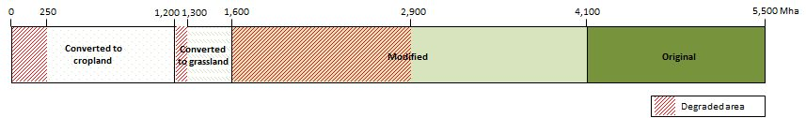
Based on this, various restoration scenarios can be developed and their respective restoration potentials derived. The following 4 scenarios are just examples, and depending on the societal and political context, many other scenarios are possible.
Scenario A considers the restoration of 15% of degraded forest ecosystems globally which yields a potential of 195 Mha. In addition to that, Scenario B adds the degraded fractions of converted forest land now under crops or pasture, bringing the potential to an estimated 246 Mha. About the same potential exists for Scenario C, restoring 15% of converted forest land only (240 Mha). Should the decision be to restore 15% of converted former forest land plus 15% of currently degraded or degrading forest area under Scenario D, the potential restoration area amounts to a total of 435 Mha.
The following graph illustrates the consequences of the various scenarios, with the areas to be restored highlighted in pink.
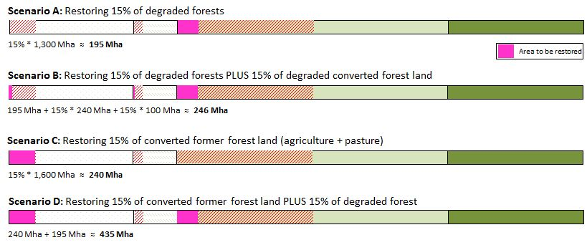
The continuing increase in the need for food will make competition for land for reforestation more intense. Designing new multi-functional landscape mosaics that provide food as well as forest-based goods and services has been identified as a way forward to accommodate these trade-offs. These new landscapes could include production forests as well as protection forests and might be established by government agencies, large industrial growers as well as smaller landholders. Based on a forest landscape restoration potential of an estimated global 2,000 Mha (Laestadius et al. 2012), the Aichi Target 15 would provide a restoration potential of 300 Mha.
The theoretical maximum global restoration potential for Aichi Target 15 across all biomes and including both rehabilitation and restoration potential might be in the area of 1,500 Mha.
The above approach using “if-then-scenarios” has several limitations. For example, it has to rely on numerous assumptions, and it expresses “degraded areas” in terms of extent of land alone, neglecting possible evaluations in terms of quality loss (biodiversity figures and calculations). Nevertheless, it might prove as valuable mechanism in a multiple stakeholder environment, where a quick overview of available options would be needed.

The benefits of ecosystem restoration

Trade-offs and multiple benefits
This report illustrates some of the challenges in assessing the extent and degree of ecosystem and landscape degradation. Even though there are varying degrees of uncertainty in the accuracy of these global estimates, they point to an undeniable magnitude of scale that calls for increased and concerted efforts to halt and reverse degradation trends. Recognizing that ecosystem functions and processes are closely linked with human well-being (Figure 17), it must now be our priority to maintain, and where necessary, restore the natural capital upon which we all depend on. For a given level of socio-economic development, policies that conserve more biodiversity will also promote higher aggregated human well-being through the preservation of regulating, cultural, and supporting services (MA 2005f).
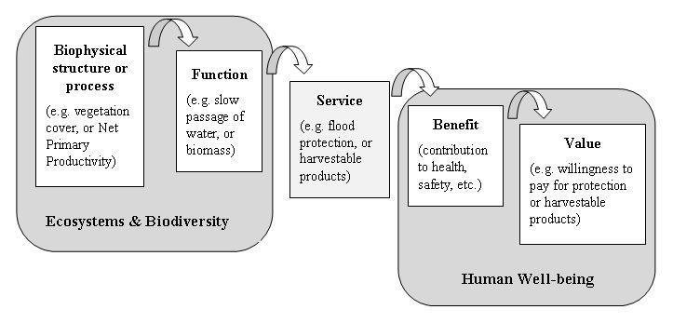
Figure 17: Conceptual relationship between Ecosystems & Biodiversity and Human Well-being; from: MA (2005a)
As with all ecosystem and land management practices, there are trade-offs in the delivery of services, in some cases with a reduced capacity to provide food and other provisioning services. Trade-off analyses are therefore vital to evaluate which services will be increased and which will be diminished when implementing a particular land use decision or ecosystem intervention. Limited resources, both in terms of expertise and finance, as well as capacities on the ground often narrow the range of natural solutions considered rather than broaden the opportunities to engage more widely considering multiple benefits and relevant stakeholders (SCBD 2013). Where multiple benefits have been identified and resources are limited, trade-offs must therefore be considered. For instance, the benefits associated with the restoration of soils and land cover in order to enhance water security need to be considered in terms of opportunity costs, such as the loss of access to crop and rangelands. In any scenario, cross-sectoral approaches that involve affected stakeholders will be necessary to resolve conflicts and address these trade-offs. The key issue is not the method adopted to manage trade-offs but the simple message that trade-offs often exist and will need to be considered early in the design and implementation of restoration and rehabilitation activities.
At the national level, mainstreaming restoration and rehabilitation efforts through policy reforms, such as increased or enforced regulation and provision of incentives, is vital in addressing the overlapping challenges of biodiversity loss, desertification, land degradation, drought and climate change. Schneiders et al. (2012) provide a pragmatic approach for national decision-makers by dividing ecosystem management and restoration into three discrete zones whereby (1) areas of high ecological status and with minimal pressures are effectively managed and restored, (2) rural areas or multifunctional production landscapes are sustainably managed, and where appropriate undergo mosaic restoration, and (3) built up or urban areas focus primarily on reducing their ecological footprint to avoid degradation elsewhere.
When coordinated and integrated at the landscape scale, appropriate management activities in each of the three zones would be mutually beneficial in furthering the overarching goals of ecological and socio-economic sustainability.
At the international level, trade-off analyses can help to illustrate the consequences of major development goals on the condition of ecosystems (Figure 18). An approach balancing ecosystem protection and economic development could yield an aggregate net benefit to the entire suit of objectives.
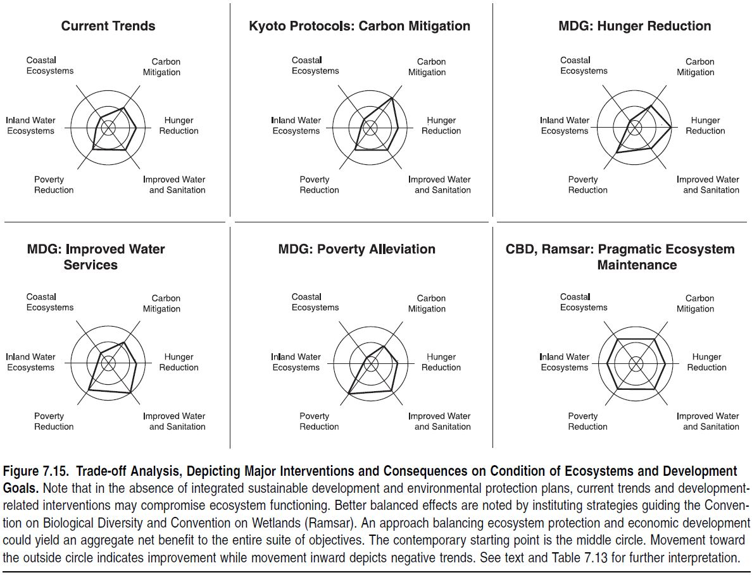
Figure 18: Trade-off analysis depicting major interventions and consequences on condition of ecosystems and development goals (MA 2005d).
The MA strongly supported the integration of ecological, economic and institutional perspectives from which Seppelt et al. (2011) posited four fundamental aspects of an integrated approach that are directly relevant to ecosystem management and restoration decision-making: (1) accuracy and realism of biophysical data and models, (2) accounting for local trade-offs or opportunity costs, (3) off-site or downstream impacts (e.g. externalities), and (4) stakeholder engagement and participation in the assessment process. The Ecosystem Approach, advocated by the CBD, is one such strategy for the integrated management of land, water, and biological resources that promotes conservation and sustainable use in an equitable way (Finlayson et al. 2011). The Ramsar Convention’s concept of “wise use” is perhaps the oldest example of the Ecosystem Approach among the intergovernmental processes concerned with sustainable development and the conservation of natural resources (Alexander and McInnes 2012). Balancing ecosystem protection and socio-economic development remains the core challenge; how can policies and practices yield an aggregate net benefit in terms these desired outcomes.
In this context, it is important to note that restoring natural systems within the landscape will improve the delivery of multiple services that serve to enhance productivity of crop and rangelands within the same unit. For example, mosaic restoration in which forests and trees are combined with other land uses, including agroforestry, smallholder agriculture, and settlements can improve microclimates and carbon sequestration, increase water retention in the watershed, restore pollination services, safeguard genetic diversity, etc.
The successful management of trade-offs and synergies is a key component of any strategy aimed at increasing the supply of ecosystem services for human well-being (MA 2005f). The sustainable use of natural capital underpins economic growth and development while at the same time ensuring the flow of essential non-market services which include:
- Combatting desertification through improved land management
- Mitigating climate change through increased carbon sequestration
- Enhancing the conservation status through restoring biodiversity
- Fostering equity and resilience for vulnerable communities through improved connectivity and planning across landscapes, and
- Safeguarding cultural heritage and related services through avoidance of further degradation.
By fostering a healthy relationship between humans and the environment, the restoration of degraded ecosystems and rehabilitation of production landscapes promotes both economic growth and social cohesion for current and future generations. An increasing number of ecological restoration projects and programmes are being undertaken around the world, and the following section provide some indications on how much can be gained from these pathways of action. Following the major ecosystem classification used in this report, estimates will be presented for the total global value of respective ecosystem services, the losses from degradation and unsustainable use as well as the benefits of restoration and rehabilitation.

Global estimates of benefits from ecosystem restoration

Overall global estimates
Within the context of the TEEB study (2008-2010) the authors of the global overview of the “Estimates of monetary values of ecosystem services”, developed a database on monetary values of ecosystem services which contains over 1350 data-points from over 300 case studies. The total economic value of global ecosystem services has been estimated at US$ 21–72 trillion in 2008 (Nelleman & Corcoran 2010), which is in the order of the estimated World Gross National Income in 2008 of US$ 58 trillion. The value added by soil biodiversity alone could be in the range of US$ 1.5 (Pimentel et al. 1997), excluding ecosystem goods such as crops and timber. Insects carrying pollen between crops, are estimated to be worth more than US$ 200 billion per year to the global food economy (UNEP 2002). Variations between ecosystems are considerable (Figure 19) and range between 490 int$/year for the total bundle of ecosystem services that can potentially be provided by an ‘average’ hectare of open oceans to almost 350,000 int$/year for the potential services of an ‘average’ hectare of coral reefs (de Groot et al. 2012).
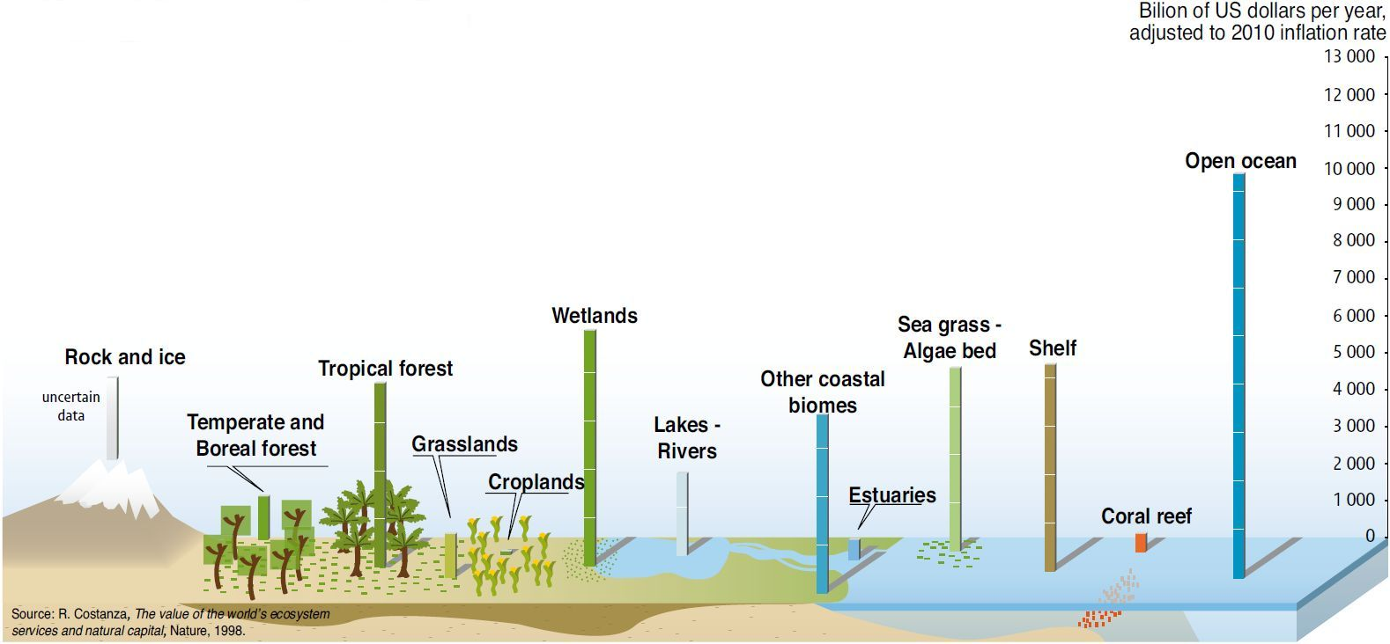
Figure 19: The value of ecosystem services; from: UNEP (2010)
It has to be noted that there is substantial uncertainty with regard to these numbers, and prominent knowledge gaps remain (TEEB 2010; UNEP-WCMC 2011; UNEP 2012): Firstly, because not all ecosystem services might easily be recognised and let alone be measured (most of the value is actually outside the market and best considered as non-tradable public benefits; this is why the continued over-exploitation of ecosystems thus comes at the expense of the livelihood of the poor and future generations). And secondly, because they represent estimates for the entire globe across all ecosystems. Even though this quantification can only be indicative, it may help to put a price tag on ecosystem conversion. The Millennium Ecosystem Assessment had estimated that approximately 60% (15 out of 24) of the ecosystem services examined are being degraded or used unsustainably. The authors noted that the full costs of the conversion and degradation of these ecosystem services are difficult to measure, but the available evidence demonstrated that they are substantial and growing (MA 2005b).
The global reduction of soil services resulting from improper management has been estimated to be in excess of US$1 trillion per year (Pimentel et al. 1997). Another example is the fight against Alien Invasive Species that costs the global economy in the order of US$1.4 trillion or more each year (UNEP 2002). An indication for value loss through degradation of ecosystems was also provided by the GLADA project (Bai et al. 2008b): Analysing remotely sensed trends in “greenness” of the earth’s surface, they found that degrading areas represented a net primary productivity (NPP) loss of approx. 1 GtC relative to the 1981-2003 mean; that is 1Gt not removed from the atmosphere - equivalent to 20% of the global CO₂ emissions for 1980. At the shadow price for carbon used by the British Treasury in February 2008 ($50/tonneC, Montbiot 2008) this amounts to US$ 48 billion in terms of lost C fixation. This is in agreement with the calculations of Lal et al (2012) that the technical potential of C sequestration through restoration of degraded lands is estimated at 0.5–1.4 GtC/year.
In the endeavour to reverse degradation, two considerations are essential:
- Sustainable, multi-functional use of an ecosystem is usually not only ecologically more sound, but also economically more beneficial, both to local communities and to society as a whole (Balmford et al. 2002).
→ To ensure more balanced decision-making (i.e., that multiple uses and values are considered), it is crucial that the full importance (value) of ecosystems should be recognized (de Groot et al. 2006).
- Ecosystems can exist in various states, but not all states provide the same level of ecosystem services. Human-induced losses of biological diversity can adversely affect the resilience of forest ecosystems, and hence the long-term provision of services.
→ To avoid catastrophic change, managers need to ensure that ecosystems remain within a ‘safe operating space’ (Parrotta et al. 2012).
Where these systems are converted systems – independent from the time of their conversion – sustainable land management (SLM) is the prime strategy for maintaining or improving ecosystem services. SLM has proven co-benefits (i.e. synergies, positive feedback loops or positive trade-offs) for biodiversity conservation, mitigation of (and adaptation to) climate change and the protection of international waters. It has even stronger potential synergies with enhanced rural livelihoods and human well-being where SLM is translated into greater biomass production and improved productivity. It may have negative consequences on other global environmental concerns, though: Land use impacts on natural biodiversity may contribute to climate change from release of carbon from the pool of soil organic carbon. It may generate issues of societal concern through change in land use and cover. It is therefore important to identify the likely negative consequences of a programme or project and set measures to mitigate the impact. Further, it is imperative to use a trade-off analysis to prioritise those projects that create co-benefits above those that have negative consequences (GEF 2006).
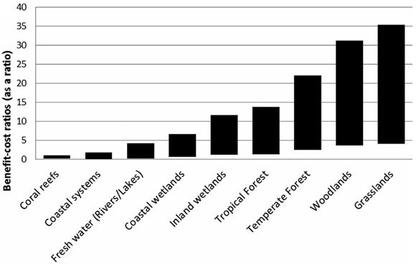
Figure 20: Benefit-cost ratios of restoration (bars, range of values: bottom of bars, worst-case scenario [analysis conducted at 100% of highest restoration cost reported, 30% of benefits, and social discount rate 8%]; top of bars, best-case scenario [analysis conducted at 75% of highest restoration cost reported and 75% at a social discount rate of −2%]) across 9 major biomes on the basis of 316 case studies over 20 years with a management cost component of up to 5% of the capital cost; from: de Groot et al. (2013)
Where systems are degraded, conversion of degraded ecosystems to restorative land may well emerge as the silver bullet. In their analysis of over 316 case studies reporting costs or benefits of ecological restoration across 9 major biomes, de Groot et al. (2013) found that the majority of the restoration projects provided net benefits and should be considered not only as profitable but also as high-yielding investments (Figure 20). A meta-analysis of 89 restoration assessments in a wide range of ecosystem types across the globe indicated that ecological restoration had increased provision of biodiversity and ecosystem services by 44 and 25%, respectively (Benayas et al. 2009). In a recent review screening 200 studies on costs and benefits of ecosystem restoration, de Groot et al. (2013) found that benefit-cost ratios ranged from about 0.05:1 (coral reefs and coastal systems, worst-case scenario) to as much as 35:1 (grasslands, best-case scenario)(Figure 20). These are conservative estimates, considering that both scarcity of and demand for ecosystem services is increasing and new benefits of natural ecosystems and biological diversity are being discovered.
Driven by rising awareness of ecosystems goods and services, and the multiple benefits that can be derived, thousands of ecological restoration projects are currently happening around the world. They are mainly local to regional scale, and the lack of data at the global level currently does not allow for plausible analyses. TEEB therefore recommends decision makers at all levels should take steps to assess and communicate the role of biodiversity and ecosystem services in economic activity, and for human well-being (TEEB 2010).
In an effort to provide data at the largest scale possible, the following sections of the report will review available information on benefits of restoration per major ecosystem type.

Agroecosystems
One of the main conclusions of the PAGE report on agroecosystems has been that pressures have mounted for agroecosystems to contribute a greater share of society’s environmental service needs (Wood et al. 2000). This is because agricultural systems are still being developed at the expense of global ecosystems, and because their fraction on total terrestrial surface area is now close to 40% (see section 3.2.2). Therefore the state of agroecosystems and their management will decisively determine whether the various global ecosystem and development goals can be reached. At the global level, conversion of natural habitat to agricultural uses is perhaps the single greatest threat to biodiversity. Hence, sustaining yield increases on existing farmland to meet growing human food needs will be essential for the conservation of existing biodiversity (MA 2005a).
The central challenge will be to meet the increasing demand for food while at the same time decreasing the on-site and off-site environmental impacts of agricultural systems. Difficult choices about ecosystem service trade-offs are faced when evaluating alternative cultivation strategies (MA 2005a). For example, intensification of production to gain more output per unit land area and time runs the risk of unintended negative impacts associated with greater use of external inputs such as fuel, irrigation, fertilizer, and pesticides. Likewise, area expansion of production reduces natural habitat and biodiversity through land use conversion and decreases the other environmental services that natural ecosystems provide.
There appears to be consensus that pursuing the necessary increases in global food output by emphasizing the development of more environmentally and ecologically sound intensification appears to be the preferred, and in many cases the only, long-term strategy. This has been a conclusion in the Millennium Ecosystem Assessment (MA 2005a), and it relates well with the recommendation of the PBL (2010) report of enhanced “eco-efficiency”, i.e. producing with lower ecological impact per unit output. Likewise, Lal et al. (2011) stated that “the strategy is to produce the essentials through sustainable intensification. Accordingly, the goal is to grow more produce from less land, more crop per drop of water, more yield per unit input of fertilizers and pesticides, more food per units of energy, and more biomass per unit of C and environmental foot print”. A general strategy could be to a) confine/ecologically intensify existing cultivated areas (IMPROVE) where food demand is growing, b) mosaic restoration where demand is approx. stable (IMPROVE-RESTORE), and c) re-convert no longer needed agricultural land back to primary type systems where economically feasible (RESTORE).
Ecological intensification is not a new concept as such, and a whole range of techniques is being practised under the overall concept of sustainable land management (SLM). As part of the SOLAW report, FAO has compiled a table of common measure and which benefits are associated with them in the short and long term both, on-site as well as off-site (Table 13). Improved cultivation practices can conserve biodiversity in several ways: sustaining adequate yield increases on existing cropland in order to limit expansion of cultivation, enlightened management of cultivation mosaics at the landscape scale, and increasing diversity within cropping systems. (MA 2005a). A combination of better policies, better technologies and better institutions will likely be needed to enhance environmental goods and services derived of agroecosystems (Figure 21).
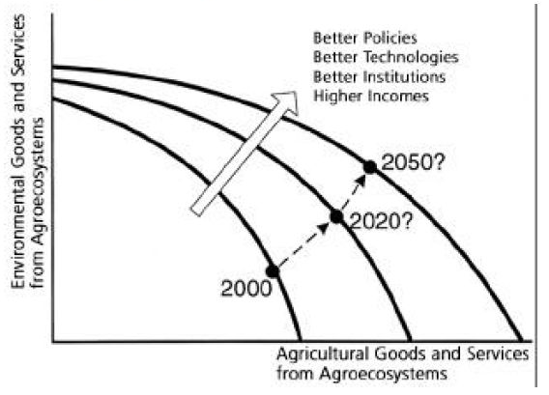
Figure 21: Enhancing agroecosystem goods and services; from: Wood et al. (2000)
Unsustainable management of agroecosystems has resulted and still is resulting in soil and landscape degradation worldwide. According to Eswaran et al. (2001), the productivity of some lands has declined by 50% due to soil erosion and desertification. On a global scale the annual loss of 75 billion tons of soil costs the world about US$400 billion per year, or approximately US$70 per person per year. Crosson (1997) calculated the on-farm economic costs of soil erosion on a global level. Using data derived from GLASOD on lightly, moderately, and strongly degraded land in crops and permanent pasture and assuming percentage losses of productivity for each degradation category (5%, 18%, 50% respectively) he arrived at an average productivity loss on the total area of land in crops and permanent pastures of 4.8%. Even if higher loss percentages are used (15%, 35%, 75%), the average world-wide productivity loss would not be higher than 8.9%. Besides erosion, salinization is a major form of soil degradation. Around 1.5 Mha of irrigated land per year were estimated to be lost to salinization and about US$11 billion per year in reduced productivity, or just under 1% of both the global irrigated area and annual value of production (Wood et al. 2000).

Table 13: Indicative trends in the distribution of costs and benefits of various technologies or practices; from: FAO (2011a)
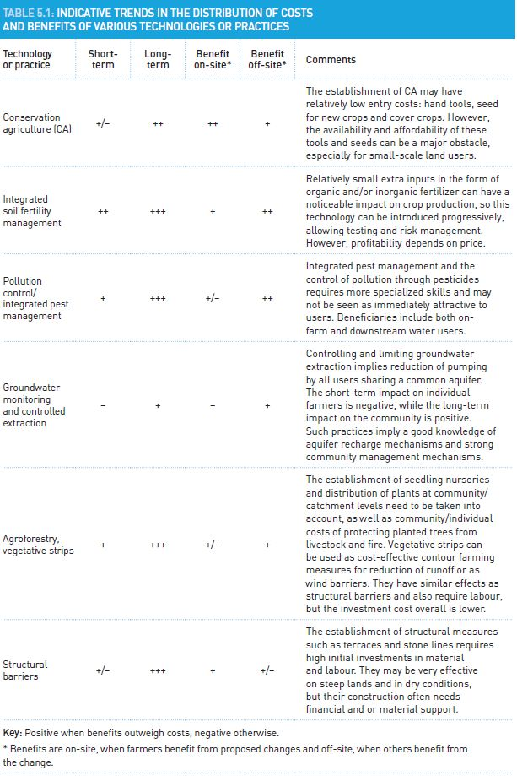
Soil degradation-derived cost estimates must be treated with care, though, as there is no clear methodology for measuring the actual cost of the productivity losses incurred, because of a lack of consistent empirically demonstrated relations between soil losses and productivity (Eswaran et al., 2001). And this is just looking at the production function. Current systems of economic valuation fail to reflect even the current monetary value to users or providers, e.g., increased costs of water purification resulting from agricultural pollution or subsidized provision of irrigation water (Wood et al. 2000).
There is no accepted costing of other ecosystem services, or there are widely varying estimates – carbon markets, for example, show differences in carbon prices at a ratio of 1:10 in different markets. Unless the environmental cost (loss of carbon, decline in water resources, loss of cultural services) is correctly valued, economic valuation results will largely underestimate the costs. What is needed are both more developed approaches to measuring the soil loss/productivity relationship, and agreed methodologies for valuation of ecosystem goods and services. Until that is achieved, no progress will be made in accurately estimating the real global or national cost of land degradation (FAO 2011a).
New institutional mechanisms are needed to develop effective markets in environmental goods and services. This includes mechanisms to internalize the costs of environmental damage and the benefits of environmental protection into agricultural production and marketing decisions (Wood et al. 2000).
Some data on benefits from restoring agroecosystems do exist. As early as 1977, UNCOD estimated the total net benefits of corrective measures against desertification in arid and semi-arid lands to be 119 million US$/yr in irrigated dryland agriculture, 26 million US$/yr in dryland rangelands, and 750 million US$/yr in rainfed dryland croplands.
Most recent estimates are related to the potential of agroecosystems to help mitigating climate change. This may surprise at first sight, as agriculture may be contributing about 20% of current annual greenhouse gas–forcing potential (MA 2005d). But while being the largest source of anthropogenic CH₄ and a significant contributor to increases in atmospheric N₂O concentration, cultivated systems play a relatively small role in total CO₂ emissions, and some systems have the potential to sequester carbon by use of improved crop and soil management practices, thus becoming a sink for carbon dioxide (MA 2005d). A study by McKinsey & Co. (2009) found that in comparison with the cost of carbon capture and storage (CCS) through geo-engineering, C sequestration in agroecosystems is the most cost effective option.
The main sequestration mechanism is through increasing soil organic matter (SOM) levels; in combination with the agroecosystems’ estimated 18-24% share of global total carbon storage (Wood et al. 2000), Lal (2004) estimated the current total technical potential of C sequestration in cropland soils at an overall 1.5-4.4 Pg CO₂-eq/yr (or 0.4–1.2 Pg C/yr). Smith et al. (2007) gave a maximum global mitigation potential of 6 Pg CO₂-eq/yr, but pointed out that not all of the technical potential can be realised. The economic potential was a maximum of 4.3 Pg CO₂-eq/yr at a carbon price of 100 US$ t CO₂-eq (Smith et al. 2008). Here, by far the greatest mitigation contribution originates from soil carbon sequestration (89%) and only some potential in mitigating methane (9%) and nitrous oxide (2%) emissions (Smith et al. 2008).
Projected mitigation potentials in agriculture in 2030 are in the same range with values between 1.5-5.0 Pg CO₂eq in 2030 (Table 14). Agroforestry has been predicted to provide the biggest share (0.5-2 Pg CO₂-eq/yr) followed by enhances soil C sequestration (0.5-1.5), and reduction of non-CO₂ gases (0.3-1.5).
Projections of agricultural mitigation potential to the year 2050 have yielded a net biosphere uptake (compared to the baseline) of up to 130 Pg CO₂ through closing the yield gap and reducing post-harvest losses alone (PBL 2010).
Table 14: Mitigation potential in agriculture and forestry in 2030; from: FAO (2011a)
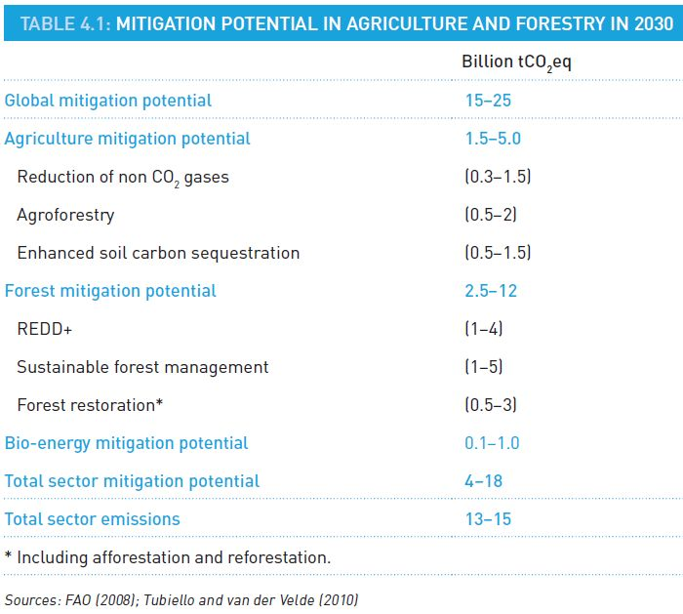

Grassland ecosystems
Fodder and grasslands are multipurpose: they provide essential ecosystem services and support livelihoods in a number of ways (e.g. as a genetic source for food production and sustainable production intensification; as a resource for energy production; as a raw material in industrial production; and for carbon sequestration). Many permanent fodder and grassland areas are used for watershed protection, polluted-land rehabilitation and bio-energy production (FAO 2011a). The total economic value of grassland ecosystem services has been estimated at 2,871 Int.$/ha/yr (de Groot et al. 2012).
However, land degradation from overgrazing is taking a heavy economic toll in lost livestock productivity. In the early stages of overgrazing, the costs show up as lower land productivity. But if the process continues, it destroys vegetation, leading to the erosion of soil and the eventual creation of wasteland. A 1991 UN assessment of the earth's dryland regions estimated that livestock production losses from rangeland degradation exceeded $23 billion. In Africa, the annual loss of rangeland productivity is estimated at $7 billion, more than the gross domestic product of Ethiopia. In Asia, livestock losses from rangeland degradation total over $8 billion. Together, Africa and Asia account for two thirds of the global loss (Brown 2002).
One of the main drivers of degradation is that current yields and economic returns can often be maximized by practices that boost forage harvest, but thereby deplete soil nutrients and reduce the long-term productive capacity of grassland systems. Indeed, economic pressures to “adopt unsustainable practices as yields drop” in response to a changing climate, “may increase land degradation and resource use” (IPCC 2007). This fact should further motivate support for policies and programmes that encourage the implementation of sustainable grassland management practices (FAO 2010c). Critical components in future grazing management and forage production services will be a) to implement grazing management systems that build soil carbon, enhance biological communities, re-establish effective water cycles, and manage livestock-based nutrients; and b) to promote soil cover of grasses, legumes and multipurpose trees to enhance livestock productivity (FAO 2010c).
Brown (2002) warned that it will take an enormous effort to stabilize livestock populations at a sustainable level and to restore the world's degraded rangelands. This would be costly, but failing to halt the desertification of rangelands would be even costlier as flocks and herds eventually shrink and as the resulting poverty will force large-scale migration from the affected areas. On the positive side, benefit cost ratios of grasslands restoration have been calculated in the range of 4:1 to 35:1 (Figure 20), with the best case scenarios offering the highest returns in comparison to all other ecosystems (de Groot at al. 2013). This may mainly be due to the fact that well-managed grasslands provide multiple co-benefits critical to adaptation (FAO 2010c): Risks associated with prolonged drought periods and unreliable rains can be offset by the increased water infiltration and retention associated with organic matter accumulation in the soil. Moreover, this will improve nutrient cycling and plant productivity and, at the same time, enhance the conservation and sustainable use of habitat and species diversity. Grassland management is thereby a key adaptation and mitigation strategy for addressing climate change and variability.
Technological options for improved management of grazing lands include: controlled grazing at low stocking rate and rotational grazing, choice of growing appropriate species adapted to specific ecoregions, fire management, nutrient management and soil and water conservation. Analogous to the discussion on “ecological intensification” of agroecosystems (section 5.2.2), a similar win-win strategy could also be possible in grassland ecosystems. In their SOLAW report, FAO (2011a) stated that the sustainable intensification of crop-livestock systems based on improved management of fodder, grasslands and rangelands could contribute significantly to the enhancement of sustainable development on a wide scale. FAO (2010c) explained the associated mechanism: improved grazing management could lead to greater forage production, more efficient use of land resources, and enhanced profitability and rehabilitation of degraded lands and restoration of ecosystem services.
Many management techniques intended to increase forage production have the potential to increase soil carbon stocks, thus sequestering atmospheric carbon in soils. This means that managing grasslands sustainably at the same time contributes towards mitigating climate change. Like in agroecosystems – but unlike e.g. in tropical forest ecosystems where vegetation is the primary source of carbon storage – most of the grassland carbon stocks are in the soil.
On the field scale, improved grazing management can lead to an increase in soil carbon stocks by an average of 0.35 tonnes C ha⁻¹ yr⁻¹ but under good climate and soil conditions improved pasture and silvopastoral systems can sequester 1–3 tonnes C ha⁻¹ yr⁻¹ (FAO 2010c). The co-benefits of carbon sequestration are manifold, one the main ones e.g. being that grassland cover can capture 50-80% more water, reducing risks of droughts and floods (FAO 2011a).
On a global scale, estimates of the grasslands total share in soil organic carbon stocks range from 20% (e.g. Conant 2012, considering managed grassland extent) up to 34% (White et al. 2000, also including unmanaged grassland biomes such as tundra). The high carbon contents explain why the cultivation and urbanization of grasslands, and other modifications of grasslands through desertification and livestock grazing can be a significant source of carbon emissions. Biomass burning, especially from tropical savannas, contributes over 40% of gross global carbon dioxide emissions (White et al. 2000). Improved management is therefore considered to make an equally big contribution: Depending on grazing and other management practices applied, grassland soils have the potential to sequester up to 0.8 Pg CO₂ per year by 2030 (FAO 2010c), with the technical potential being at around 0.3–0.5 Pg C/year (Lal 2010).
Besides technical constraints, feasibility will depend on a multitude of other factors. It is estimated that only 5–10% of global grazing lands could be placed under C sequestration management by 2020 (FAO 2010c). And the economic feasibility of carbon sequestration in grasslands will also depend on the price of carbon. IPCC (2007) noted that, at US$20 per tCO₂eq, grazing land management and restoration of degraded lands have potential to sequester around 300 Mt CO₂eq up to 2030; at US$100 per tCO₂eq they have the potential to sequester around 1,400 Mt CO₂eq over the same period (FAO 2011a).

Forest ecosystems
Whereas temperate forest areas have stabilised and are even growing, the destruction of tropical forests still continues (see section 3.2.4). Clear-cutting is often logical and profitable under the existing monetary regulations, land tenure and use rights (TEEB 2010). Tragically, the economic, social, cultural and aesthetic costs of deforestation far outweigh the benefits (Anderson 1990) and tend to fall on society or future generations. Accounting for all ecosystem services provided by forest ecosystems is therefore key. Their total economic value has been estimated at around 10,000 Int.$/ha/yr, with tropical forests contributing more than half, temperate forests about one third, and woodlands approximately 16% (de Groot et al. 2012). This allows for the calculation of total “real” losses from global deforestation and forest degradation. UNEP (2002) have indicated that annual losses may equate to between US$2 trillion and US$4.5 trillion alone. These could be secured by an annual investment of just US$45 billion: a 100:1 return (UNEP 2002, Kumar 2010).
Benefit-cost ratios (BCR) in forest restoration vary according to the scenario chosen, the options being passive restoration (relying on natural succession), active restoration, or a combination of both, e.g. passive restoration with protection measures. In case of passive restoration, BCR are higher, with values of up to 100 calculated for dryland forests in Latin America (Birch et al. 2010). Due to the costs spent in active restoration, BCR are several orders of magnitude lower and with values ranging between 0.2 and 0.62 the same study found that active restoration is not cost-effective in dryland forests.
De Groot et al. (2013) calculated benefit-cost ratios from screening over 200 restoration studies, and found values of 1:1 to 13:1 for tropical forest, 3:1 to 22:1 for temperate forests, and 4:1 to 31:1 for woodlands (Figure 20). With benefits in almost all cases outweighing costs, restoration is an attractive venture.
In a practical step towards forest restoration, the Bonn Challenge was launched in September 2011 at a ministerial roundtable hosted by Germany, IUCN and the Global Partnership on Forest Landscape Restoration (GPFLR) and pledged to restore 150 million hectares of deforested and degraded lands by 2020. At Rio+20, the US Forest Service, Rwanda, the Brazilian Atlantic Forest Restoration Pact (AFRP), and the Mesoamerican Alliance of Indigenous Peoples have committed to restoring a total of more than 18 million hectares of their forest landscape as an important contribution to the Bonn Challenge (Calmon et al. 2011, CBD 2012). A preliminary analysis around Aichi Target 15 indicated that the restoration of 150 Mha of forest and agroforestry landscapes could generate somewhere in the vicinity of US$ 85 billion per year (IUCN 2012b).
There is ample discussion on how much land is available globally for afforestation and reforestation. Nilsson & Schopfhauser (1995) undertook a global study and concluded there were only 345 Mha available for reforestation. This was based on aggregated regional estimates that potentially provide more realistic accounts of the land actual availability for reforestation. Campbell et al (2008) conducted a global analysis and estimated abandoned agricultural lands available for bioenergy agriculture. They identified 269 Mha of croplands and 479 Mha of pastures permanently abandoned across the globe at some point in the last 300 years. Allowing for forest regrowth and urbanization, they estimated there are now 385-472 Mha of abandoned agricultural land across the globe that could be suitable for bioenergy agriculture – or afforestation/reforestation.
The actual global potential for forest landscape restoration has been reported by GPFLR 2011. More than 2,000 Mha – about half of current global forest area extent – are considered to offer opportunities for restoration: 1,500 Mha for mosaic restoration (forests and trees are combined with other land uses, including agroforestry, smallholder agriculture, and settlements), and up to 500 Mha for wide-scale restoration of closed forests.
The GPFLR study has highlighted that although there is substantial potential for the restoration of degrading forests back to primary-type forests, the opportunities to rehabilitate degrading or degraded landscapes to include forest elements must not be neglected. It is widely acknowledged that on degraded and fragmented landscape with various constraints, restored forest ecosystem will develop along an altered trajectory and will not match the reference state, i.e. the original old-growth forest in species composition (Stanturf & Madsen 2005, Fagan et al. 2008). Beyond a ‘purist’ position it may be realised that as forest ecosystem processes decline in a stepwise manner with increasing anthropogenic or natural impacts, restoration approaches can lift up a degraded or fragmented or completely altered forest to a higher level of the restoration staircase (Ciccarese et al. 2012). Multi-purpose plantations, e.g., designed to meet a wide variety of social, economic, and environmental objectives, can provide key ecosystem services, help preserve the world’s remaining primary forests, and sequester and important proportion of the atmospheric carbon released by humans in the past 300 years (Paquette & Messier 2010).
Forest soils and vegetation store about half of all carbon in the terrestrial biosphere, i.e. more than any other ecosystem (IPCC 2007). The current C stock in the world’s forests is estimated to be 861±66 Pg C, with 383±30 Pg C (44%) in soil (to 1m depth), 363±28 Pg C (42%) in live biomass (above and below ground), 73±6Pg C (8%) in deadwood, and 43±3 Pg C (5%) in litter (Pan et al. 2011). This represents more than 40% of the global soil organic carbon stock, and more than 75% of the total terrestrial biomass carbon stock (Jandl et al. 2007). While boreal forests are especially rich in soil carbon, tropical forests probably store more carbon in their vegetation (Prentice et al. 2001). Generally, tropical forests store the most carbon, with current estimates suggesting the above-ground biomass stores of these forests is 247 Gt C (Chavez et al. 2008; Lewis et al. 2009; Mahli et al. 2006; UNEP, 2010), which is five times more than the current global carbon emissions of 47 Gt per year (UNEP, 2010). Almost half of this above-ground carbon is in the forests of Latin America, 26 per cent in Asia, and 25% in Africa (Saatchi et al., 2011).
It is important to understand that under steady-state conditions, natural forest ecosystems are neither carbon sinks nor sources. They only become sources when disturbed. And afforestation/reforestation creates carbon sinks. Under current conditions, land use change, primarily tropical deforestation, releases an estimated 2.9±0.5 Pg C year^{–1} of carbon to the atmosphere each year (Pan et al. 2011), contributing about 20% of annual anthropogenic CO₂ emissions (Achard 2002) and thereby making it the third-largest source after coal and oil (IPCC, 2007a). Historically, deforestation for agricultural expansion, mining, or other reasons as well as forest degradation have been responsible for about 600 Gt CO₂ emissions in the period 1850 to 2005, which is comparable to half of the historical fossil-fuel related CO₂ emissions (Houghton 2008).
Bonan (2008) estimated that in the 1990s, forest carbon sequestration was equivalent to approximately one-third of carbon emissions from fossil fuel combustion and land-use change. Pan et al. (2011) estimated that global forest systems constituted a net carbon sink of 1.1±0.8 billion tonnes of carbon (4 billion tCO₂eq) per year from 1990 to 2007. These are reliable data in so far as they have been generated through bottom-up estimates of C stocks and fluxes for the world’s forests based on recent inventory data and long-term field observations coupled to statistical or process models.
These impressive rates of carbon sequestration also explain why forest conservation is a vital strategy in global efforts to drastically cut greenhouse gas emissions. Large-scale forest restoration could help strengthen the forest ecosystems’ function as CO₂ sinks. As forests need decades if not centuries to develop, sequestration potentials are usually given for one certain point in the future. The 140 Gt CO₂eq by the year 2030 that GPFLR (2011) have calculated represent what could be sequestered if the entire restoration potential of 1,000 Mha of previously forested lands will have been realised through broad-scale or mosaic restoration. This surely represents a maximum value. On a more realistic scale, FAO estimated that the forestry mitigation potential will be in the order of 2.5-12 billion tCO₂eq in 2030. The latter included ranges of 1-5 billion tCO₂eq through sustainable forest management, 0.5-3 billion tCO₂eq through forest restoration (including afforestation and reforestation), and 1-4 billion tCO₂eq via the REDD+ mechanism (FAO 2011a). And the 15 Mha of forests to be restored by the AFRP project mentioned above are expected to sequester approximately 0.2 billion tons of CO₂ per year and store more than 2 billion tons of CO₂ by 2050 (Calmon et al. 2011).
However, even at this level there is a high degree of uncertainty surrounding these carbon estimates because they are based on general data, rather than estimates for specific forest types and their ability to reduce emissions (e.g. moist forests have the capacity to sequester more carbon than do dry forests) (Alexander et al. 2011). Further, the future of the global forest carbon sink is highly uncertain because the loss of biodiversity, linked to deforestation and forest degradation, could further diminish the ability of forests to effectively provide multiple ecosystem services, including carbon sequestration (Parrotta et al. 2012).
The United Nations Collaborative Programme on Reducing Emissions from Deforestation and Forest Degradation in Developing Countries (REDD) is the main intergovernmental initiative to counteract tropical deforestation. Under the newly created and not yet operational REDD+ mechanism, the view has expanded beyond a sole focus on activities that affect carbon budgets to also include those that enhance ecosystem services and deliver other co-benefits to biodiversity and communities, forest restoration could play an increasingly important role (Alexander et al. 2011).
However, REDD/REDD+ was/is facing a number of general challenges:
- It is contested by the powerful political forces that control logging, ranching, plantations and agricultural expansion in rainforests
- It may affect food supplies and employment and will increase prices of forest products.
- There is a lack of practical tools and guidance for implementing effective restoration projects and programs that will sequester carbon and at the same time improve the integrity and resilience of forest ecosystems.
It may therefore be premature to expect deforestation to be significantly reversed in the short term under REDD. As a way forward, Skutsch et al. (2009) recommended to focus on managing the politics and economics of emissions from degradation (that is, the thinning out rather than clearance of forest) in the world's dry forests and savanna woodlands. This type of degradation resulted primarily from the exploitation of forest by local communities as part of their livelihood, and strategies to successfully tackle it existed. Although the carbon content of dry forests was considerably lower per hectare, more of their area was degraded because they were more densely populated.
There seems to be consensus that REDD/REDD+ will need a number of social and environmental safeguards to successfully deliver co-benefits of forest restoration. For example, REDD+ will be more effective if it would insist on nations granting and enforcing land rights to local, indigenous, and forest-dependent communities (Skutsch et al. 2009, Alexander et al. 2011). For a more detailed discussion, see Parrotta at al. (2012). Knowledge gaps remain and Parrotta et al. (2012) voiced that further work is needed to understand:
- Relationships between plant species richness, functional diversity and biomass accumulation in diverse tropical forest systems;
- Relationships between species richness and ecosystem resistance (to disturbance);
- How the loss of forest biodiversity affects ecosystem processes;
- Long-term effects of forest ecosystem degradation on rates of recovery of forest ecosystems;
- Degradation/disturbance thresholds or tipping points beyond which recovery of ecosystem functions and provision of services may be severely constrained;
- The magnitude and dynamics of below-ground carbon stocks and fluxes in different forest types, as well as the time scales and the factors influencing the rates of recovery of biodiversity and carbon in disturbed, degraded, and secondary forests;
- The levels of ecosystem service provision from secondary forests, including increasingly widespread ‘novel’ forest ecosystems.
Protecting forests from degradation and deforestation is expected to generate synergies between forest carbon and biodiversity; but there may well be a trade-off as agricultural expansion shifts towards grasslands biomes (PBL 2010).

Dryland ecosystems
Up to one quarter of the world’s drylands has been estimated to be degraded (section 3.2.5). Fluctuation in the supply of ecosystem services is a normal phenomenon in drylands, but a persistent reduction in the levels of all services over an extended period constitutes desertification (MA 2005c).
Rough estimates of the annual impacts of degradation in irrigated areas, primarily through salinization, are losses of around 1.5 Mha of irrigated land in the world’s dry areas (Ghassemi et al. 1995 quoting Dregne et al. 1991). First global estimates of the economic costs of land degradation in drylands, or desertification, have been compiled in the 1990’s: Estimates for income forgone ranged from US$ 26 billion (UNEP 1991) to US$ 42 billion (Dregne & Chou 1992, Toulmin 1994). Annual farm income loss due to salinization in particular may be in the area of US$11 billion (Postel 1999, Wood et al. 2000). It is estimated that annual losses represent just under 1% of the global totals of both irrigated area and annual value of production, but are much more significant in affected areas (Wood et al. 2000, FAO 2011a). It is now widely accepted that dryland degradation costs developing countries an estimated 4–8% of their gross domestic product each year (UN 2011).
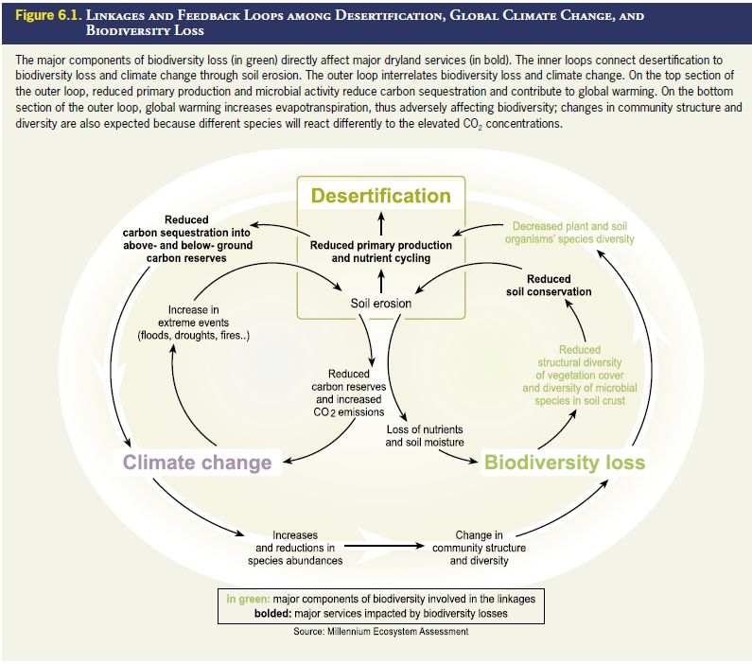
Figure 22: Linkages and feedback loops among desertification, global climate change, and biodiversity loss; from: MA (2005c).
Combating desertification will not only help to mitigate land degradation in dryland areas, but also yields multiple local and global benefits (MA 2005c). Figure 22 shows how fighting dryland soil erosion at the same time helps mitigate biodiversity loss and human-induced global climate change. Joint implementation of major environmental conventions can lead to increased synergy and effectiveness, benefiting dryland people. Addressing desertification is critical and essential for meeting the Millennium Development Goals successfully.
Ecological restoration is a particular valuable tool in drylands for restoring liveable conditions for plants, wildlife and people, as natural regeneration may take at least 50–300 years, and full restoration of ecosystem services as much as 3000 years (Lovich & Bainbridge, 1999). As early as 1991, UNEP has been promoting land reclamation measures in drylands and calculated that annual cost of US$ 388 million would be rewarded with annual benefits in the order of US$ 895 million (BCR of 2.3). In recent years, the “African Re-greening Initiatives” have shown how the improvement and expansion of tree-based production systems in Africa’s drylands successfully enabled both land rehabilitation and agricultural intensification to support a dense and growing population (IFPRI 2009).
UN (2011) have pointed at a whole range of investment opportunities in drylands; and the World Overview of Conservation Approaches and Technologies (WOCAT) database currently contains 190 sustainable land management technologies in areas with an annual precipitation <500 mm. UNEP (2012) have summarised the most promising management strategies for dryland ecosystems across the world, including afforestation to counteract chronic carbon loss due to land degradation, with successful examples in Israel (Tal & Gordon 2010), Iran (Amiraslani & Dragovich 2011) and eastern Uganda (Buyinza et al. 2010). Other progressive strategies for adaptively managing drylands include planting resilient nitrogen-fixing crops (Saxena et al. 2010), dune stabilization measures, runoff control, improved range management and integrated land management, for example Iran’s National Plan to Combat Desertification. Programmes that build community resilience through watershed restoration in drylands, such as the Watershed Organization Trusts in India, are also promising, as are models of polycentric adaptive governance increasingly adopted in Australia (Marshall & Smith 2010; Smith et al. 2010). Enhanced monitoring programmes based on vegetation indices and real-time climatic data are also important in allowing for early-warning and management interventions (Verón & Paruelo 2010).
All of the above measures are likely to contribute to the sequestration of carbon into drylands ecosystems, which is why changes in carbon fluxes and stocks have been suggested as the vital indicator to measure progress on the way to achieving Aichi Target 15.
Dryland carbon storage accounts for more than one third of the global stock, mainly due to the large surface area of drylands and long-term storage of the carbon belowground, rather than in the vegetation cover (UN 2011). Analogous to the forest ecosystems, drylands are currently are source of carbon emission, although they have the potential to function as a sink. Drylands ecosystems contribute carbon emissions to the atmosphere (0.23–0.29 billion tons of carbon a year) as a result of desertification and related vegetation destruction, through increased soil erosion and a reduced carbon sink (Lal 2001). This latter effect is expected to intensify with climate change.
Regarding the potential of carbon sequestration in drylands, the good news is that drylands have the potential to sequester more carbon than currently stored as they are far from saturated (FAO/LEAD 2006). On the other hand, because of low rainfall sequestration rates are also low and, depending on the carbon price, growing trees for carbon may not be viable (Flugge & Abadi 2006). Nevertheless, soil organic carbon (SOC) content can recover over time with restoration of degraded soil through revegetation and good management practices (Lal, 2004; 2008).
Lal (2001) estimated the potential of dryland ecosystems to sequester up to 0.4–0.6 GtC a year if eroded and degraded dryland soils were restored and their further degradation were arrested. Furthermore, Lal also pointed out that through active ecosystem management, such as reclamation of saline soils and formation of secondary carbonates, carbon sequestration can be further enhanced. This will add sequestration of 0.5–1.3 GtC a year; similar magnitudes of potential carbon sink capacity of dryland ecosystems have been estimated by Squires et al. (1995) on a global scale. Keller & Goldstein (1998) reached the slightly higher figure of 0.8 Gt of carbon per year using estimates of areas of land suitable for restoration in woodlands, grasslands, and deserts, combined with estimates of the rate at which restoration can proceed (UNEP 2008).
This restoration and enhancement of dryland condition, if undertaken at a global scale, could have a major impact on the global climate change patterns.

Wetland ecosystems
Because of the many services and multiple values of wetlands (Table 15), many different stakeholders are involved in wetland use, often leading to conflicting interests and the over-exploitation of some services, e.g. fisheries or waste disposal, at the expense of others such as biodiversity conservation and flood-control (de Groot et al. 2006). With up to 85% of Ramsar-listed wetlands of internationally importance having undergone or currently undergoing ecological change, the restoration of wetlands is becoming an increasingly important tool.
The total economic value of inland wetland ecosystem services has been estimated at 25,682 Int.$/ha/yr, and that of fresh water (river/lakes) at 4,267 Int.$/ha/yr (de Groot et al. 2012). Assuming a current global extent of more than 1,000 Mha, the global value of these services is estimated in the trillions of US dollars (Revenga et al. 2000), arguably as high as US$ 14 trillion annually (Ramsar Convention Secretariat 2007).
There are many examples of the local economic value of intact wetlands exceeding that of converted or otherwise altered wetlands. For example, in Canada intact freshwater marshes have a value of about US$ 8,800 per hectare compared to US$ 3,700 for drained marshes used for agriculture (Balmford et al. 2002). Benefit-cost ratios for inland wetland restoration have been calculated between 1:1.5 to 1:12, and for fresh water systems between below 1:1 (not cost-effective) to 4:1 (Figure 20).

Table 15: Peatland uses and functions; from: Parish et al. (2008)
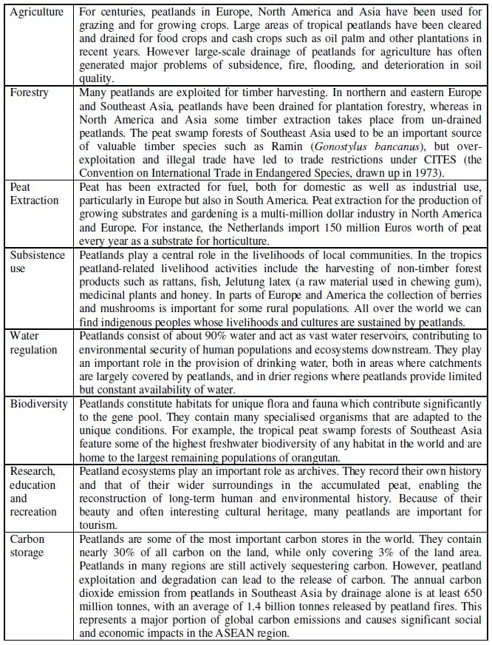
Wetlands and peatlands are rich in carbon (Nellemann & Corcoran 2010); they are the most efficient terrestrial carbon-storing ecosystems, with their peat containing twice as much carbon as all global forest biomass (Parish et al. 2008). Lal (2012) elucidated that the evaluation of the total global soil organic carbon (SOC) pool of peatlands is work in progress, with estimates being in the range of 350 Gt to more than 600 Gt. If the higher values were true, it would mean that peatlands, although forming only 3% of the world’s land surface, contain about 30% of all global soil carbon.
Analogous to all other terrestrial ecosystems, wetlands release CO₂ into the atmosphere when they are drained and disturbed, thus becoming carbon sources. Observed average C loss from drained forestry peatland in Finland, e.g., is 150 g C m⁻² yr⁻¹ (550g CO² m⁻² yr⁻¹) (Simola et al. 2012). CO₂ emission from peatland drainage in Southeast Asia is contributing the equivalent of 1.3% to 3.1% of current global CO₂ emissions from the combustion of fossil fuel (Hooijer et al., 2010). Total annual CO₂ emissions from the worldwide 50 Mha of degraded peatland may exceed 2 Gt (Joosten 2010), with some estimates being as high as 3 Gt CO₂eq (Parish et al. 2008), including emissions from peat fires. This is roughly an equivalent of 6% of all global CO₂ emissions (Crooks et al. 2011).
Restoration could reverse this process, increase carbon storage and prove to be a low-cost greenhouse gas mitigation strategy (IPCC 2007). Both in the context of reducing and sequestering emissions, the importance of peatlands cannot be over-emphasized (Lal 2012). In fact, in many countries, steps are currently being taken to restore wetlands, often involving reversals in land-use policies by re-wetting areas that were drained in the relatively recent past (Secretariat of the Convention on Biological Diversity 2010). A successful forest peatland restoration project in Indonesia, the Central Kalimantan Peatland Project (CKPP), restored approximately 60,000 ha of peatland, reducing emissions from the degraded peat of about 1.15 GtC per year (SER 2009). The project involved damming drainage canals to restore natural hydrologic conditions, revegetating denuded areas with commercially important native tree species, and introducing sustainable agricultural techniques. Most importantly, the CKPP partners worked closely with local communities and authorities to address emerging issues and solicit their expertise and experience to resolve them (Alexander et al. 2011).
Significant emission reductions can also be achieved through peatland conservation and restoration in other parts of the world such as in China, Russia and eastern Europe where large peatlands have been degraded through agriculture and other activities Parish et al. (2008). There are no reliable figures on how much carbon might be sequestered in peatland restoration globally. But Joosten (2010) indicated that peatland rewetting may globally reduce greenhouse gas emissions in the order of “several hundred Mt CO₂eq./yr”, taking into account that only part of the area is available for rewetting and that CO₂ reduction may be partly annihilated by re-installed CH₄ emissions. It has to be understood that restoration of very degraded wetland areas can be a slow process (Lal 2008).
Beyond carbon sequestration, a single freshwater ecosystem can often provide multiple benefits such as purification of water, protection from natural disasters, food and materials for local livelihoods and income from tourism. There is a growing recognition that restoring or maintaining the natural functions of freshwater systems can be a cost-effective alternative to building physical infrastructure for flood defenses or costly water treatment facilities (Secretariat of the Convention on Biological Diversity 2010). Also, restoring wetland, watershed and river ecosystems also indirectly contributes to climate change mitigation by protecting coastal vegetation and the ocean from excessive sediment and nutrient flows.

Coastal ecosystems
Coastal ecosystems provide an important service in maintaining water quality by filtering or degrading toxic pollutants, absorbing nutrient inputs, and helping to control pathogen populations. Coastal tourism is a major portion of the gross domestic product in many small island nations (Burke et al. 2001). The total economic value of coastal wetland ecosystem services has been estimated at 193,845 Int.$/ha/yr, and this is excluding mangroves (de Groot et al. 2012).
More than one third of the world’s original mangrove forests may have been converted (Valiela et al. 2001), and the annual global rate of mangrove loss continues to be between one to two per cent (Spalding et al. 2010). This is despite the multiple benefits they provide: Apart from their value as carbon sinks, mangroves provide many other socio-economic benefits including:
- Regulating services:
  - Protection of coastlines from erosion, floods, the action of tidal waves and cyclones. The value of mangroves as coastal protection may be as much as US$ 300,000 per kilometre of coastline (UNEP 2013).
  - Land stabilization by trapping sediments, and “sediment control” for other inshore habitats (e.g. seagrass beds and coral reefs) .
  - Water quality maintenance.
  - Carbon sequestration. Mangroves are among the most carbon-rich forests in the tropics (Cornforth et al. 2013): Average aboveground biomass in mangrove forests is 247.4 tons/ha, similar to that of tropical terrestrial forests (Alongi 2009).
Mangroves alone sequester up to 25.5 million tonnes of carbon per year and contribute more than 10% of essential organic carbon to the world’s oceans (Dittmar et al. 2006). The quantity of carbon buried each year by all vegetated coastal habitats such as mangroves, salt marshes and seagrass beds has been estimated at between 120 and 329 million tonnes. The higher estimate is almost equal to the annual greenhouse gas emissions of Japan (UNEP 2013). As much as 7% of the carbon dioxide reductions required to keep atmospheric concentrations below 450 ppm could be achieved simply by protecting and restoring mangroves, salt marshes and seagrass communities (Nellemann et al. 2009).
- Provisioning services:
  - Subsistence and commercial fisheries; for many communities living in their vicinity, mangroves provide a vital source of income and resources from natural products and as fishing grounds (Grimsditch 2011). Mangroves provide habitat for commercially valuable marine species (Walters et al. 2008): it is estimated that almost 80% of global fish catches are directly or indirectly dependent on mangroves (Ellison 2008, Sullivan 2005). Thus, the food security for many indigenous coastal communities is closely linked to the health of mangrove ecosystems (Horwitz et al. 2012).
The annual economic median value of fisheries supported by mangrove habitats in the Gulf of California, e.g., has been estimated at US$ 37,500 per hectare of mangrove fringe (UNEP 2013).
  - Fuelwood for coastal communities
  - Building materials
  - Honey and traditional medicines
- Cultural services
  - Tourism
  - Recreation
  - Spiritual appreciation
- Supporting services
  - Nutrient and organic matter processing.
  - Habitats for species.
This shows the importance of mangrove ecosystems as a bulkhead against climate change UNEP (2013). And it illustrates how ecosystem services from mangroves translate directly into economic benefits (Table 16).
Table 16: Value ranges of ecosystem services provided by mangrove ecosystems; from: Grimsditch (2011)
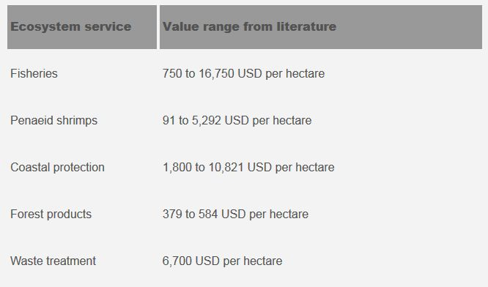
These ranges are admittedly huge, but Spalding et al. (2010) noted that overall, the summary value of US$ 2,000-9,000/ha/year estimated by Wells et al. (2006) appears to be a good estimate for mangroves over wide areas where they are extensive, close to human populations and already utilised.
UNEP (2010) provides some local examples: The Muthurajawela Marsh, a coastal wetland located in a densely populated area of Northern Sri Lanka, is estimated to be worth US$ 150 per hectare for its services related to agriculture, fishing and firewood; US$ 1,907 per hectare for preventing flood damage, and US$ 654 per hectare for industrial and domestic wastewater treatment.
The Okavango Delta in Southern Africa is estimated to generate US$ 32 million per year to local households in Botswana through use of its natural resources, sales and income from the tourism industry. The total economic output of activities associated with the delta is estimated at more than US$ 145 million, or some 2.6% of Botswana’s Gross National Product.
The substantial overall value of ecosystem services derived of mangrove forest is a strong incentive to protect existing mangrove forests, and to rehabilitate and restore these ecosystems where feasible. De Groot et al. (2006) highlighted that there are many examples of the local economic value of intact wetlands exceeding that of converted or otherwise altered wetlands. For example, services provided by intact mangroves in Thailand are worth about US$ 60,000 per hectare compared to about US$ 17,000 from shrimp farms (Balmford et al. 2002). As awareness of the services and benefits provided by mangroves is growing, conservation and restoration are being undertaken in many countries. For example, in 1990 a collaboration between the Government of Pakistan and the World Conservation Union (IUCN) facilitated the rehabilitation of 19,000 ha of Avicennia marina and Rhizophora mucronata. In 1999 about 17,000 ha were restored in the Indus delta thanks to the support of the World Bank (FAO 2007).
Benefit-cost ratios for coastal systems appear to be comparatively low and do not seem to exceed 2:1 (de Groot et al. 2013). For mangroves, however, figures are higher, and values of around 5:1 have been reported from Vietnam, where planting and protecting nearly 12,000 hectares of mangroves cost just over US$1 million but saved annual expenditures on dyke maintenance of well over US$7 million (Table 17).
Table 17: Costs and benefits of direct and indirect use values of mangrove restoration (adapted from Tri et al. 1998); from: Nellemann & Corcoran (2010)
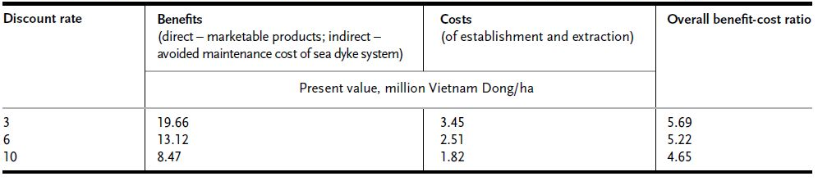
Alexander et al. (2011) have pointed out that the potential for significant long-term carbon storage (Cebrian 2002) suggests that REDD+ funding for restoration activities in these forested wetland ecosystems could lead to reductions in emissions and increases in global carbon storage, perhaps even more than in upland forests on a per hectare basis (Laffoley & Grimsditch 2009). In addition to carbon benefits, the tangible co-benefits of revitalized mangrove forests extend to local and indigenous communities that depend on their goods and services (e.g. timber, fisheries, water treatment, and storm/climate protection). It is important to note that, given high failure rates in past attempts to restore mangroves, there is a need to ensure that projects and programs are based on sound science, including the principles of Ecological Mangrove Restoration (Lewis 2009).

Constraints and future challenges
The previous section has highlighted the value of ecosystem services per major ecosystem type. Thanks to the Economics of Ecosystems and Biodiversity (TEEB) initiative that focused on drawing attention to the economic benefits of biodiversity, these data now exist on a global level (TEEB 2010). Of course these figures are indicative only, and it might prove impossible to put an overall figure on ecosystem services. More recently, ecological-economic efficiency (EEE) has been suggested as a more appropriate approach, in which the trade-offs and ethical choices between ecological protection, human health and obligation to future generations must be considered (Farley 2012).
Based on the TEEB work, efforts are also being undertaken to derive estimates for the growing cost of biodiversity loss and ecosystem degradation, and these figures have been included in section 5.2 where available. However, estimates for the potential global benefits from successful restoration are not (yet) as easily available. An exception to this are projections to 2020 or 2030 of carbon benefits that may be gained under certain forest or agricultural management regimes. Restoration projects are being realised at a local to regional scale, and this is naturally the level where benefits can reliably be quantified at present. How benefits from conservation could be captured at least qualitatively on national level, has been shown through the LADA-WOCAT-DESIRE approach (Schwilch et al. 2012). Positive and negative impacts of conservation measures (agronomic/vegetative/structural/management) on various ecosystem services were assessed through a combination of questionnaires completed by experts, and modelling (Figure 23).
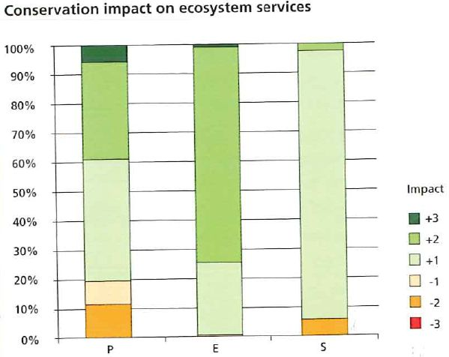
Figure 23: Impact of conservation on ecosystem services (ES) in all DESIRE study sites. P: Production services, E: Ecological services, S: socio-cultural services. Negative numbers: negative contributions to changes in ES; from: Schwilch et al. (2012).
Still, extrapolations of restoration benefit assessments to national or even global scale remain a task for the future.
The challenges in quantifying future benefits from restoring ecosystems are manifold, and some of the major considerations involved are summarized below:
- Areal extent
What is the total area that is going to be rehabilitated and/or restored? In case of the Aichi Biodiversity Target 15, what are the 100% that the 15% refer to? (see discussion in section 4.2.2). What is it that can be afforded, in terms of investments to be made (natural regeneration e.g. is cheap), and in terms of competing demand on land (opportunity costs).
- State of the land
What is the baseline for rehabilitation/restoration efforts? At which degradation level of an ecosystem does one intervene (Figure 24)? This is related to 1. because larger, often more costly barriers have to be overcome once the land is more heavily degraded. If degradation is long time back, it is difficult to unravel the structure, composition, dynamics and features of the primary type (pristine/near-natural) ecosystem. There might even be land that is either naturally unsuitable for restoration (problem soils), or has become practically unsuitable due to advanced degradation.
The state of the land will also partly determine the time scales of restoration involved. On heavily degraded land, rehabilitation might have to precede restorative efforts, and will require larger time spans. If investments are made, long time spans for return might prove problematic under the current economical framework.
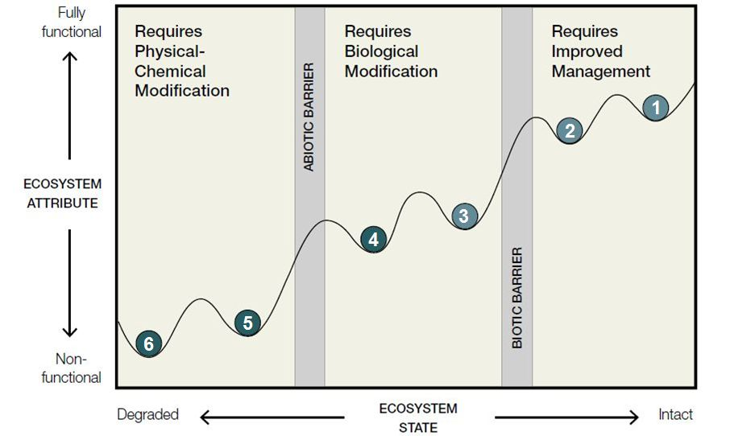
Figure 24: Simplified conceptual model for ecosystem degradation and restoration. The numbered balls represent alternative ecosystem states, with the resilience of the system being represented by the width and depth of the ‘cup’. Disturbance and stress cause transitions towards increasingly degraded states, with 6 being the most degraded. Barriers, or thresholds may also exist between some ecosystem states (e.g., between states 2 and 3) that prevent the system from returning to a less degraded state without management intervention. Restoration attempts to move the ecosystem back towards a more structurally ‘intact’, well-functioning state (e.g. state 2); from: Keenleyside et al. (2012).
- Desired outcomes
This is influenced by both 1. and 2.
Restoration is mostly considered as a process (“rehabilitation-restoration continuum”), with the degree of active intervention being determined by contextual circumstances (Parker & Picket 1997).
If the end of this process is supposed to be a primary-type ecosystem, the “ecological hysteresis” effect in restoration has to be considered. It describes how an ecosystem will not improvement along the same trajectory as it deteriorated, when either abiotic conditions are not appropriate any more or interaction with other species (dispersal, pollination etc.) have been lost. Perrow & Davy (2002), e.g., describe this effect from restoration projects in Costa Rica. It means that actual benefits might be lower than expected (Hobbs 2002). De Groot et al. (2013) calculated with benefits attaining 75% of the maximum value of the reference systems over 20 years, assuming restoration is always imperfect.
Instead of a primary-type ecosystem the desired outcome can also be a multifunctional landscape containing both conservation and production elements, achieved through mosaic restoration.
Even if the biodiversity and associated services of restored ecosystems usually remain below the levels of natural ecosystems, this should not discourage to walk the path of ecological restoration. Nellemann & Corcoran (2010) have suggested that while restoration-related definitions often focus on “original” habitat cover, it may be more appropriate in the future to focus on restoring resilient natural habitats, for example through paying attention to connectivity and dispersal, rather than assuming that all “original” species will persist under changed conditions. After all, unexpected co-benefits may occur besides the benefits envisaged. And economic analyses generally show that ecosystem restoration can give good economic rates of return.
An important message that the “ecological hysteresis” also carries is that restoration will not be able to replace conservation and that, where possible, avoiding degradation through conservation is preferable (and even more cost-effective) than restoration after the event (Secretariat of the Convention on Biological Diversity 2010).

Conclusions and Outlook
This report has demonstrated the challenges in determining the status and extent of ecosystem degradation while still providing an indication of its scope and magnitude. As mentioned in Chapter 1, it represents a first step and a possible foundation for further work of the CBD and other relevant global processes such as the IPBES and the UNCCD.
Preliminary conclusions
- Definition of reference units is a challenge:
  - Various assessments use various definitions for forest, grassland etc.
  - There are several ways to calculate “former extents”, e.g. using the current climatic conditions (current potential), or paleoclimatic evidence (historic potential at a certain point in time, e.g. pre-Neolithic)
Understanding the decisions made in the delineation of former and current units is the only way to enable the calculation of reliable conversion estimates.
- The various concepts of what constitutes degradation, is another challenge. Degradation always is a value-statement that might not be judged the same way by different stakeholders. Degradation estimates on major ecosystem level vary substantially on definitions used and assessment methodologies applied.
Examples: “Forest” can be an ecosystem, or a land use form; “Grasslands” may/may not include the tundra, forested savanna etc.
- Existing reviews, however, do provide estimates for the ecosystem change on the global scale, based on soil, vegetation or biodiversity parameters. These estimates show that all terrestrial ecosystems analysed are substantially affected by conversion and degradation. Wetlands are affected disproportionally high with an estimated 50% of global cover reduced by now. Assessment agree that on average, one quarter of the terrestrial land surface is converted to human-dominated land uses. Up to three quarters may by now be embedded in anthromes.
- Past/current rates of change (conversion and or degradation) are even more difficult to assess. Quantity: Except for positive extent trends in Agroecosystems and temperate forests, all other trends appear to be negative. Quality: same (improving lands in agroecosystems approx. 10%, temperate forests unknown but probably positive due to expansion of nature-near forestry).
- Because of the inherent nature of global degradation assessments – i.e. the many decisions that must be made in terms of which terminologies and ecosystem distinctions (“cookie-cutting”) to be used, which parameters to be assessed and technologies to be used, and the manifold ways to interpret the results – it appears that the added value of a synopsis of global assessments might not be sufficient to justify the effort.
- Rather, more effort should be invested in analysing and understanding the results of one existing global assessment (e.g. the MA), including the limitations it comes with; because other assessments have their own limitations, and “the truth” in terms of global conversion or degradation figures simply does not exist, and will also not exist in the future.
- Even if it there should be agreement on what constitutes degradation, there is a whole range of possibilities to assign the 15% to be restored: Reference could be the degraded extent, the converted extent, the degraded fraction of the converted extent, of a combination of those. The decision on what is going to be restored is not a technical or scientific one, but an economic & societal, and therefore political one!
- Outlook (technical): There is a mismatch between the demand for global degradation data, and the required investments available. Considering that GLASOD as the only land-based, ground-truthed global degradation assessment available, is now more than 20 years old, and given the still growing demand on land resources, it is high time for a repeated effort.

Literature cited

Achard F. 2002. Determination of deforestation rates of the world's humid tropical forests. Science 297: 999-1002.
Alexander S., Nelson C.R., Aronson J., Lamb D., Cliquet A., Erwin K.L., Finlayson C.M., de Groot R.S., Harris J.A., Higgs E.S., Hobbs R.J., Robin Lewis III R.R., Martinez D., Murcia C. 2011. Opportunities and Challenges for Ecological Restoration within REDD+. Restoration Ecology 19: 683–689.
Alexander S. & McInnes R. 2012. The benefits of wetland restoration. Ramsar Scientific and Technical Briefing Note no. 4. Gland, Switzerland: Ramsar Convention Secretariat.
Alkemade R., van Oorschot M., Miles L., Nellemann C., Bakkenes M., ten Brink B. 2009. GLOBIO3: A Framework to Investigate Options for Reducing Global Terrestrial Biodiversity Loss 2009. Ecosystems 12(3): 374–390.
Alongi D.M. 2009. The energetics of mangrove forests. Springer, New York.
Amiraslani F. & Dragovitch D. 2011. Combating desertification in Iran over the last 50 years: an overview of changing approaches. Journal of Environmental Management 92(1): 1–13.
Anderson A.B. (Ed.) 1990. Alternatives to deforestation: steps toward sustainable use of the Amazon rain forest. Columbia University Press, New York.
Anderson R.G., Canadell J.G., Randerson J.T., Jackson R.B., Hungate B.A., Baldocchi D.D., Ban-Weiss G.A., Bonan G.B., Caldeira K., Cao L., Diffenbaugh N.S., Gurney K.R., Kueppers L.M., Law B.E., Luyssaert S., O’Halloran T.L. 2011. Biophysical considerations in forestry for climate protection. Frontiers in Ecology and the Environment 9(3): 174–182. doi:10.1890/090179
Aronson J. & Alexander S. 2013. Ecosystem restoration is now a global priority: Time to roll up our sleeves. Restoration ecology 21(3): 293-296.
Aronson J., Milton S.J., Blignaut J.N. 2007. Restoring Natural Capital: Science, Business, and Practice. Island Press Washington, Covelo, London, 385 pp.
Aselmann I. & Crutzen P.J. 1989. Global distribution of natural freshwater wetlands and rice paddies, and their Net Primary Productivity, seasonality and possible methane emissions. Journal of Atmospheric Chemistry 8: 307–358.
Baartman J.E.M., van Lynden G.W.J., Reed M.S., Ritsema C.J., Hessel R. 2007. Desertification and land degradation: origins, processes and solutions. A literature review. Desire Report Series No. 4, ISRIC-World Soil Information, the Netherlands.
Bach H., Bakker M., Farrington J., Drillet Z., Duray B., Frederiksen P., Gyuró E.K., Henrichs T., Jansson K., Jensen T.S., Jombach S., Jones L., Kaae B., Lindner M., Lopatka A., Kohlheb N., Kuhlman T., Petit S., Paracchini M.L., Petersen L.K., Reid L., Rothman D., Scholefield P., Schulp N., Stuczynski T., van Eupen M., Verburg P., Verkerk H., Vogt J., Vinther F.P., Wilson C. 2009. Indicators – methodology and descriptions. In SENSOR Report Series 2008/09 (Eds. Helming K. & Wiggering H.). ZALF, Germany.
Bai Z.G., Dent D.L., Olsson L., Schaepmann M.E. 2008a. Proxy global assessment of land degradation. Soil Use and Management 24: 223–234.
Bai Z.G., Dent D.L., Olsson L., Schaepman M.E. 2008b. Global assessment of land degradation and improvement. 1. Identification by remote sensing. Report 2008/01, ISRIC – World Soil Information, Wageningen.
Bai Z.G., Conijn J.G., Bindraban P.S., Rutgers B. 2012. Global changes of remotely sensed greenness and simulated biomass production since 1981; Towards mapping global soil degradation. Wageningen, ISRIC, ISRIC Report 2012/02. 34 pp.
Bakker M.M., Govers G., Kosmas C., Vanacker V., van Oost K., Rounsevell M. 2005. Soil erosion as a driver of land-use change. Agriculture, Ecosystems and Environment 105(3): 467–481.
Balmford A., Bruner A., Cooper P., Costanza R., Farber S., Green R.E., Jenkins M., Jefferiss P., Jessamy V., Madden J., Munro K., Myers N., Naeem S., Paavola J., Rayment M., Rosendo S., Roughgarden J., Trumper K., Turner R.K. 2002. Economic reasons for conserving wild nature. Science 297(5583): 950-953.
Balmford A., Green R.E., Scharlemann J.P.W. 2005. Sparing land for nature: exploring the potential impact of changes in agricultural yield on the area needed for crop production. Global Change Biology 10 (11): 1594-1605.
Benayas J.M.R., Newton A.C., Diaz A., Bullock J.M. 2009. Enhancement of biodiversity and ecosystem services by ecological restoration: a meta-analysis. Science 325(5944): 1121-1124.
Bindraban P.S., Van del Velde M., Ye L., Van den Berg M., Materechera S., Kiba D.I., Tamene L., Vala Ragnarsdóttir K., Jongschaap R., Hoogmoed M., Hoogmoed W., Van Beek C., Van Lynden, G. 2012. Assessing the impact of soil degradation on food production. Current opinion in environmental sustainability 4 (5): 478-488.
Bindraban P.S., ten Brink B., Bai Z., Bakkenes M., van Beek R., van den Berg M., Conijn S., Janse J., Goldewijk K.K., Lastaedius L., van Lynden G., Minnemeyer S., Mϋller C., Schaphoff S., Sonneveld B., Stoorvogel J., Temme A. 2013. Mapping global ecosystem degradation and its impacts. Paper presented at the UNCCD 2nd Scientific Conference, 04 - 07 February 2013, Fortaleza, Brazil.
Birch J.C., Newton A.C., Aquino C.A., Cantarello E., Echeverría C., Kitzberger. T, Schiappacasse I., Garavito N.T. 2010. Cost-effectiveness of dryland forest restoration evaluated by spatial analysis of ecosystem services. Proceedings of the National Academy of Sciences (PNAS) 107(50): 21925-21930, doi: 10.1073/pnas.1003369107.
Boardman J. 2006. Soil erosion science: reflections on the limitations of current approaches. Catena 68: 73–86.
Bonan G. 2008. Forests and climate change: forcings, feedbacks, and the climate benefits of forests. Science 320: 1444–1449
Bouwman A.F., Kram T., Klein Goldewijk K. (Eds.) 2006. Integrated modelling of global environmental change. An overview of IMAGE 2.4. Netherlands Environmental Assessment Agency, Publication 500110002/2006, Bilthoven.
Box T.W. 1978. The significance and responsibility of rehabilitating drastically disturbed land. In: Reclamation of Drastically Disturbed Lands, Eds. Schaller F.W. & Sutton P. pp. 1-10. Madison, WI: American Society of Agronomy.
Bradshaw A.D. 1987. The reclamation of derelict land and the ecology of ecosystems. In: Jordan W.R., Gilpin M.E., Aber J.D. (Eds.) Restoration Ecology, pp. 53-74. Cambridge University Press, Cambridge.
Bradshaw, A.D., 2002. Introduction and philosophy. In: Davy, A.J., Perrow, M.R. (Eds.), Handbook of Ecological Restoration. Principles of Restoration, vol. 1. Cambridge University Press, Cambridge, pp. 3-9.
Brown L.R. 2002. World’s Rangelands Deteriorating Under Mounting Pressure. Earth Policy Institute Plan B Update.
http://www.earth-policy.org/plan_b_updates/2002/update6 [Accessed: 22-08-13]
Buyinza M., Senjonga M., Lusiba B. 2010. Economic valuation of a tamarind (Tamarindus indica L.) production system: green money from drylands of eastern Uganda. Small-Scale Forestry 9(3): 317–329.
Burke L., Kura Y., Kassem K., Revenga C., Spalding M., McAllister D. 2001. Pilot analysis of global ecosystems: Coastal ecosystems. World Resources Institute, Washington DC.
Butchart S.H.M., Walpole M., Collen B., van Strien A., Scharlemann J.P.W., Almond R.E.A., Baillie J.E.M., Bomhard B., Brown C., Bruno J., Carpenter K.E., Carr G.M., Chanson J., Chenery A.M., Csirke J., Davidson N.C., Dentener F., Foster M., Galli A., Galloway J.N., Genovesi P., Gregory R.D., Hockings M., Kapos V., Lamarque J.-F., Leverington F., Loh J., McGeoch M.A., McRae L., Minasyan A., Hernández Morcillo M., Oldfield T.E.E., Pauly D., Quader S., Revenga C., Sauer J.R., Skolnik B., Spear D., Stanwell-Smith D., Stuart S.N., Symes A., Tierney M., Tyrrell T.D., Vié J.-C., Watson R. 2010. Global biodiversity: indicators of recent declines. Science 328(5892): 1164–1168.
CA 2007. Water for Food, Water for Life: A Comprehensive Assessment of Water Management in Agriculture. Comprehensive Assessment of Water Management in Agriculture, Battaramulla.
Calmon M., Brancalion P.H.S., Paese A., Aronson J., Castro P., Costa da Silva S., Rodrigues R.R. 2011. Emerging threats and opportunities for biodiversity conservation and ecological restoration in the Atlantic Forest of Brazil. Restoration Ecology 19:154–158.
CBD 2000. COP 5 Decision V/6. Ecosystem approach. http://www.cbd.int/doc/decisions/cop-05/full/cop-05-dec-en.pdf [Accessed: 24-07-2013]
CBD 2012: Ecosystem Restoration. Note by the Executive Secretary. Meeting Documents, Eleventh meeting of the Conference of the Parties to the Convention on Biological Diversity (COP 11) in Hyderabad, India (8-19 October 2012).
http://www.cbd.int/doc/meetings/cop/cop-11/official/cop-11-21-en.pdf
[Accessed: 06-08-2013]
Cebrian J. 2002. Variability and control of carbon consumption, export, and accumulation in marine communities. Limnology and Oceanography 47:11–22.
Chavez J., Olivier J., Bongers F., Châtelet P., Forget P.M., van der Meer P., Norden N., Riéra B., Charles-Dominique P. 2008. Aboveground biomass and productivity in a rain forest of eastern South America. Journal of Tropical Ecology 24: 355-366.
Chazdon R.L. 2008. Beyond Deforestation: Restoring Forests and Ecosystem Services on Degraded Lands. Science 320 no. 5882: 1458-1460, DOI: 10.1126/science.1155365.
Ciccarese L., Mattsson A., Pettenella D. 2012. Ecosystem services from forest restoration: thinking ahead. New Forest 43(5-6): 543-560.
Clewell A.F. & Aronson J. 2013. Ecological restoration: principles, values, and structure of an emerging profession. Island Press Washington, Covelo, London, 314 pp.
Conant R.T. 2012. Grassland Soil Organic Carbon Stocks: Status, Opportunities, Vulnerability. Chapter 13 in: Lal R., Lorenz K., Hϋttl R.F., Schneider B.U., von Braun J. (Eds.) Recarbonization of the Biosphere: Ecosystems and the Global Carbon Cycle. Springer Netherlands, Dordrecht.
Conijn J.G., Bai Z.G., Bindraban P.S., Rutgers B. 2013. Global changes of net primary productivity affected by climate and abrupt land use changes since 1981. Towards mapping global soil degradation. ISRIC Report 2013/01, ISRIC - World Soil Information, Wageningen.
Cornforth A., Fatoyinbo E., Freemantle P., Pettorelli N. 2013. Advanced Land Observing Satellite Phased Array Type L-Band SAR (ALOS PALSAR) to Inform the Conservation of Mangroves: Sundarbans as a Case Study. Remote Sensing 5: 224-237.
Costanza R., d’Arge R., de Groot R.S., Farber S., Grasso M., Hannon B., Limburg K., Naeem S., O’Neill R.V., Paruelo J., Raskin R.G., Sutton P., van den Belt M. 1997. The value of the world’s ecosystem services and natural capital. Nature 387(6630): 253–260.
Crooks S., Herr D., Tamelander J., Laffoley D., Vandever J. 2011. Mitigating Climate Change through Restoration and Management of Coastal Wetlands and Near-shore Marine Ecosystems: Challenges and Opportunities. Environment Department Paper 121. World Bank, Washington DC.
Crosson P. 1997. The On-Farm Economic Costs of Soil Erosion. In: Lal R. et al. (Ed.) Methods for Assessment of Soil Degradation. Advances in Soil Science, CRC Press, Boca Raton NY, pp. 495-511.
Crosson P., Pimentel D., Harvey C., Resosudarmo P., Sinclair K., Kurz D., McNair M., Crist S., Shpritz L., Fitton L., Saffouri R., Blair R. 1995. Soil Erosion Estimates and Costs. Science 269 (5223): 461-465.
De Groot, R.S., 1992. Functions of Nature: Evaluation of Nature in Environmental Planning, Management and Decision Making. Wolters-Noordhoff, Groningen.
de Groot R.S., Stuip M.A.M., Finlayson C.M., Davidson N. 2006. Valuing wet-lands: guidance for valuing the benefits derived from wetland ecosystem services, Ramsar Technical Report No. 3/CBD Technical Series No. 27. Ramsar Convention Secretariat, Gland, Switzerland & Secretariat of the Convention on Biological Diversity, Montreal. ISBN 2-940073-31-7.
de Groot R.S., Brander L., van der Ploeg S., Costanza R., Bernard F., Braat L., Christie M., Crossman N., Ghermandi A., Hein L., Hussain S., Kumar P., McVittie A., Portela R., Rodriguez L.C., ten Brink P., van Beukering P. 2012. Global estimates of the value of ecosystems and their services in monetary units Ecosystem Services 1 (1): 50-61.
de Groot R.S., Blignaut J., van der Ploeg S., Aronson J., Elmqvist T., Farley J. 2012. Investing in Ecosystem Restoration Pays: Evidence from the Field (forthcoming) based on data from Neßhöver C., Aronson J., Blignaut J.N., Lehr D., Vakrou A., Wittmer H. 2011. Investing in Ecological Infrastructure. In: ten Brink P. (Ed.) The Economics of Ecosystems and Biodiversity in National and International Policy Making. Earthscan, London and Washington DC, pp. 401-448.
de Groot R.S., Blignaut J., van der Ploeg S., Aronson J., Elmqvist T., Farley J. 2013. Benefits of investing in ecosystem restoration. Conservation Biology. DOI 10.111/cobi.12158.
Deichmann U. & Eklundh L. 1991. Global Digital Datasets for Land Degradation Studies: A GIS Approach. GRID Case Study Series 4.
Dittmar T., Hertkorn N., Kattner G., Lara R. 2006. Mangroves, a major source of dissolved organic carbon to the oceans. Global Biogeochemical Cycles 20(1): DOI: 10.1029/2005GB002570.
Dregne H.E. 1983. Desertification of arid lands. Harwood Academic Publishers, Chur, Switzerland.
Dregne H.E. & Chou N.-T. 1992. Global desertification dimensions and costs. In: Degradation and restoration of arid lands. Lubbock: Texas Tech. University.
Dregne H.E., Kassas M., Razanov B. 1991. A New Assessment of the World Status of Desertification. Desertification Control Bulletin. United Nations Environment Programme 20: 6-18.
Dugan P. (Ed.). 1993. Wetlands in Danger – A World Conservation Atlas. Oxford University Press, New York.
Duke N.C. 1992. Mangrove Floristics and Biogeography. In: Robertson A.I. & Alongi D.M. (Eds.) Tropical Mangrove Ecosystems. American Geophysical Union, Washington D.C., pp. 63–100.
Duke N.C., Meynecke J.O., Dittmann S., Ellison A.M., Anger K., Berger U., Cannicci S., Diele K., Ewel K.C., Field C.D., Koedam N., Lee S.Y., Marchand C., Nordhaus I., Dahdouh-Guebas F. 2007. A World Without Mangroves? , Science, 317 (5834): 41-42. doi: 10.1126/science.317.5834.41b
Elliott M., Burdon D., Hemingway K.L., Apitz S.E. 2007: Estuarine, coastal and marine ecosystem restoration: Confusing management and science – A revision of concepts. Estuarine, Coastal and Shelf Science 74(3): 349–366.
Ellis E.C., Goldewiijk K.K., Siebert S., Lightman D., Ramankutty N. 2010. Anthropogenic transformation of the biomes, 1700 to 2000. Global Ecology and Biogeography 19(5): 589-606.
doi: 10.111/j.1466-8238.2010.00540.x
Ellison A. 2008. Managing mangroves with benthic biodiversity in mind: moving beyond roving banditry. Journal of Sea Research 59(1-2): 2-15.
Eswaran H., Lal R., Reich P.F. 2001. Land degradation: an overview. In: Bridges E.M., Hannam I.D., Oldeman L.R., Pening de Vries F.W.T., Scherr S.J., Sompatpanit S. (Eds.) Responses to Land Degradation. Proc. 2nd. International Conference on Land Degradation and Desertification, Khon Kaen, Thailand. New Delhi, India, Oxford Press.
EU 2013. Mapping and Assessment of Ecosystems and their Services: An analytical framework for ecosystem assessment under Action 5 of the EU Biodiversity Strategy to 2020. Discussion paper, final version (April 2013). Technical Report-2013–067. http://ec.europa.eu/environment/nature/knowledge/ecosystem_assessment/pdf/MAESWorkingPaper2013.pdf [Accessed: 24-07-2013]
Fagan K.C., Pywell R.F., Bullock J.M., Marrs H. 2008. Do restored calcareous grasslands on former arable fields resemble ancient targets? The effect of time, methods and environment on outcomes. Journal of Applied Ecology 4:1293–1303.
FAO 1979. Report on the second meeting of the working group on soil degradation assessment methodology. FAO, Rome.
FAO 1993. Forest Resources Assessment 1990: Tropical Countries. FAO Forestry Paper 112. Food and Agriculture Organization of the United Nations, Rome.
FAO 1995. Forest Resources Assessment 1990—Tropical Forest Plantation Resources, by D. Pandey. FAO Forestry Paper 128, Food and Agriculture Organization of the United Nations, Rome.
FAO 1997. State of the World’s Forests 1997. Food and Agricultural Organization of the United Nations, Rome.
FAO 2001. Global Forest Resource Assessment 2000 – Main Report. FAO Forestry Paper 140. Food and Agriculture Organization of the United Nations, Rome.
FAO 2004. Carbon sequestration in dryland soils. Food and Agriculture Organization of the United Nations, Rome. http://www.fao.org/docrep/007/y5738e/y5738e00.htm [Accessed: 10-09-2013]
FAO 2006. Global Land use area change matrix. Input to the fourth global environmental outlook (GEO-4), by Peter Holmgren. Working Paper 134, Food and Agriculture Organization of the United Nations, Rome.
ftp://ftp.fao.org/docrep/fao/010/ag049e/ag049e00.pdf [Accessed: 03-10-2013]
FAO 2007. The world's mangroves 1980-2005, FAO Forestry Paper 153, Rome.
FAO 2008. Land use systems of the world. http://www.fao.org/geonetwork/srv/en/metadata.show?id=37139 [Accessed: 22-07-2013]
FAO 2009a. State of the world’s forests 2009. Food and Agriculture Organization of the United Nations, Rome. http://www.fao.org/docrep/011/i0350e/i0350e00.htm [Accessed: 24-07-2013]
FAO 2009b. The state of food and agriculture 2009. Food and Agriculture Organization of the United Nations, Rome.
http://www.fao.org/docrep/012/i0680e/i0680e.pdf [Accessed: 24-07-2013]
FAO 2010a. FAOSTAT database. http://faostat.fao.org/ [Accessed: 23-07-2013]
FAO 2010b. Global Forest Resource Assessment 2010 – Main Report. FAO Forestry Paper 163. Food and Agriculture Organization of the United Nations, Rome.
http://www.fao.org/forestry/fra/fra2010/en/ [Accessed: 26-08-2013]
FAO 2010c. Challenges and opportunities for carbon sequestration in grassland systems. A technical report on grassland management and climate change mitigation. Food and Agriculture Organization of the United Nations, Rome.
http://www.fao.org/fileadmin/templates/agphome/documents/climate/AGPC_grassland_webversion_19.pdf [Accessed: 18-09-2013]
FAO 2011a. The state of the world’s land and water resources for food and agriculture (SOLAW) – Managing systems at risk. Food and Agriculture Organization of the United Nations, Rome and Earthscan, London.
FAO 2011b. State of the World’s Forests. Food and Agriculture Organization of the United Nations, Rome.
http://www.fao.org/docrep/013/i2000e/i2000e00.htm [Accessed: 01-08-2013]
FAO 2011c. Assessing forest degradation. Towards the development of globally applicable guidelines. Forest Resources Assessment Working Paper 177. Food and Agriculture Organization of the United Nations, Rome.
http://www.fao.org/docrep/015/i2479e/i2479e00.pdf [Accessed: 28-08-2013]
FAO 2012. State of the World’s Forests. Food and Agriculture Organization of the United Nations, Rome.
http://www.fao.org/docrep/016/i3010e/i3010e.pdf [Accessed: 26-08-2013]
FAO 2013. Land degradation assessment in drylands. LADA project. Methodology and results. Food and Agriculture Organization of the United Nations, Rome.
http://www.fao.org/docrep/017/i3241e/i3241e.pdf [Accessed: 13-08-2013]
FAO & EC-JRC 2011. Global Forest Land-use Change from 1990 to 2005 – Initial Results from a Global Remote Sensing Survey. Food and Agriculture Organization of the United Nations, Rome, and European Commission Joint Research Centre, Brussels.
FAO/LEAD (2006). Livestock’s long shadow. Environmental issues and options. Food and Agriculture Organization of the United Nations, Rome.
FAOSTAT 2004. Food and Agriculture Organization of the United Nations, Statistical Databases, Online at http://faostat.fao.org
Farley J. 2012. Ecosystem services: The economics debate. Ecosystem Services 1: 40-49. DOI: 10.1016/j.ecoserv.2012.07.002.
Finlayson C.M. & Davidson N.C. 1999. Global Review of Wetland Resources and Priorities for Wetland Inventory: Summary Report. Wageningen, Netherlands: Wetlands International and Jabiru, Australia: the Environmental Research Institute of the Supervising Scientists.
Finlayson C.M., Davidson N.C., Spiers A.G., Stevenson N.J. 1999. Global wetland inventory – current status and future priorities. Marine and Freshwater Research 50: 717–27.
Finlayson C. M., Davidson N., Pritchard D.E., Milton G.R., Mackay H. 2011. The Ramsar Convention and ecosystem-based approaches to the wise use and sustainable development of wetlands. Journal of Wildlife Law and Policy. Vol. 14, p.176-198.
Flugge F. & Abadi A. 2006. Farming carbon: an economic analysis of agroforestry for carbon sequestration and dryland salinity reduction in Western Australia. Agroforestry Systems 68: 181–192.
Fraser L.H. & Keddy P.A. (Eds.) 2005. The World’s Largest Wetlands: Ecology and Conservation. Cambridge University Press, New York.
GEF 1999. Report of the STAP Expert Group Workshop on Land Degradation, Bologna, Italy, 14-16 June 1999. http://www.thegef.org/gef/sites/thegef.org/files/documents/gef_c14-inf15.pdf [Accessed: 24-07-2013]
GEF 2006. Land Degradation as a Global Environmental Issue: A Synthesis of Three Studies Commissioned by the Global Environment Facility to Strengthen the Knowledge Base to Support the Land Degradation Focal Area. GEF Council Meeting, 5-8 December 2006. Washington DC.
GEO BON 2011. Adequacy of Biodiversity Observation Systems to support the CBD 2020 targets. A report prepared by the Group on Earth Observations Biodiversity Observation Network (GEO BON) for the Convention on Biological Diversity. http://www.earthobservations.org/documents/cop/bi_geobon/2011_cbd_adequacy_report.pdf [Accessed: 11-09-2013]
Ghassemi F., Jakeman A.J., Nix A.H. 1995. Salinisation of Land and Water Resources: Human Causes, Extent, Management, and Case Studies. Wallingford: CAB International.
Glaser B. 2007. Prehistorically modified soils of central Amazonia: A model for sustainable agriculture in the twenty-first century. Philosophical Transactions of the Royal Society B 362(1478): 187–196.
Glenn E.P., Squires V.R., Olsen M., Frye R. 1993. Potential for carbon sequestration in the drylands. Water, Air & Soil Pollution 70: 341-355.
GPFLR 2011. A World of Opportunity. Information brief for the Bonn Challenge on Forests, Climate Change and Biodiversity. The Global Partnership on Forest Landscape Restoration.
Greenpeace (2008): Cool Farming: Climate impacts of agriculture and mitigation potential. Greenpeace International, Amsterdam.
http://www.greenpeace.at/uploads/media/Cool_Farming_Report_Final_web.pdf [Accessed: 17-09-2013]
Grimsditch G. 2011. Mangrove Forests and REDD+. In: UN-REDD Newsletter #16, 16 February 2011. http://www.un-redd.org/Newsletter16/Mangrove_Forests_and_REDD/tabid/51394/Default.aspx [Accessed: 30-07-2013]
Groombridge B. & Jenkins M.D. 2002. World atlas of biodiversity: earth’s living resources in the 21st century. University of California Press, California.
Haines-Young R. & Potschin M. 2010. The links between biodiversity, ecosystem service and human well-being. In: Raffaelli D. & Frid C. (Eds.) Ecosystem Ecology: a new synthesis. Cambridge University Press, BES, pp. 110-139.
Hansen M.C., Stehman S.V., Potapov P.V. 2010. Quantification of global gross forest cover loss. Proceedings of the National Academy of Sciences of the United States of America 107(19): 8650–8655.
Hobbs R. 2002. The ecological context: a landscape perspective. In: Perrow M.R. & Davy A.J. (Eds.) Handbook of Ecological Restoration. Volume 1: Principles of Restoration, pp. 24-45. Cambridge University Press, Cambridge, 460 pp.
Hobbs, R.J., Salvatore, A., Aronson, J., et al., 2006. Novel ecosystems: theoretical and management aspects of the new ecological world order. Global Ecology and Biogeography 15, 1-7.
Hoekstra J.M., Boucher T.M., Ricketts T.H., Roberts C. 2005. Confronting a biome crisis: global disparities of habitat loss and protection. Ecology Letters 8: 23–29. doi: 10.1111/j.1461-0248.2004.00686.x.
Hooijer A., Silvius M., Wösten H.D., Page S. 2006. PEAT-CO2, Assessment of CO2 emissions from drained peatlands in SE Asia. Delft Hydraulics report Q3943 (2006).
Hooijer A., Page S., Canadell J.G., Silvius M., Kwadijk J., Wösten H., Jauhiainen J. 2010. Current and future CO₂ emissions from drained peatlands in Southeast Asia. Biogeosciences 7(5): 1505-1514.
Horwitz P., Finlayson M., Weinstein P. 2012. Healthy wetlands, healthy people: a review of wetlands and human health interactions. Ramsar Technical Report No. 6. Secretariat of the Ramsar Convention on Wetlands, Gland, Switzerland, & the World Health Organization, Geneva.
Houghton R.A. 2008. Carbon flux to the atmosphere from land use changes 1850-2005. TRENDS: A compendium of data on global change. Carbon Dioxide Information Analysis Center, Oak Ridge National Laboratory, US Dept Energy, Oak Ridge TE http://cdiac.ornl.gov/trends/landuse/houghton/houghton.html [Accessed: 24-07-2013]
Hurni H., Herweg K., Portner B., Liniger H. 2008. Soil erosion and conservation in global agriculture. In: Braimoh A.K. & Vlek P.L.G. (Eds.) Land Use and Soil Resources., pp. 41-72, Springer.
ICTSD 2007. Trade and Sustainable Land Management in the Context of Drylands. ICTSD Project on Trade and Sustainable Land Management, Selected Issue Briefs. International Centre for Trade and Sustainable Development, Geneva.
IFAD 2008. Policy – Improving Access to Land and Tenure Security. International Fund for Agricultural Development, Rome.
IFPRI 2009. Agroenvironmental Transformation in the Sahel - Another Kind of “Green Revolution”. Reij C., Tappan G., Smale M. (Eds.), IFPRI Discussion Paper 00914, November 2009. http://www.ifpri.org/sites/default/files/publications/ifpridp00914.pdf [Accessed: 30-09-2013].
IGBP 1998. International Geosphere Biosphere Programme (IGBP) Data and Information System. IGBP-DIS Global 1-km Land Cover Set DISCover.
Immirzi C.P., Maltby E., Clymo R.S. 1992. The global status of peatlands and their role in carbon cycling. A report to Friends of the Earth. Wetland Ecosystems Research Group, Report 11. Exeter, UK: University of Exeter.
IPCC 2000. Global perspective. 25-51 In: Watson RT, IR Noble, B Bolin and others (Eds.) Land use, land-use change, and forestry. Published for the Intergovernmental Panel on Climate Change by Cambridge University Press, Cambridge.
IPCC 2007. Climate Change 2007: Synthesis Report. Contribution of Working Groups I, II, and III to the Fourth Assessment. Report of the Intergovernmental Panel on Climate Change, IPCC, Geneva.
ITTO 2002. ITTO guidelines for the restoration, management and rehabilitation of degraded and secondary tropical forests. ITTO Policy Development Series No 13. Yokohama, Japan, International Tropical Timber Organization. http://www.itto.int/policypapers_guidelines [Accessed: 23-07-2013]
IUCN 2012a. Available at: http://data.iucn.org/dbtw-wpd/html/PAPS-016/Appendix.html [Accessed: 24-07-2013]
IUCN 2012b. The IUCN Programme 2013-2016. Adopted by the IUCN World Conservation Congress, September 2012. Available at: http://data.iucn.org/dbtw-wpd/edocs/WCC-5th-003.pdf [Accessed: 31-07-2013]
Jandl R., Lindner M., Vesterdal L., Bauwens B., Baritz R., Hagedorn F., Johnson D.W., Minkkinen K., Bryne K.A. 2007. How strongly can forest management influence soil carbon sequestration? Geoderma 137: 253–268
Jones K., Lanthier Y., van der Voet P., van Valkengoed E., Taylor D., Fernández-Prieto D. 2009. Monitoring and assessment of wetlands using earth observation: the GlobWetland project. Journal of Environmental Management 90(7): 2154–2169.
Joosten H. 2010. The Global Peatland CO₂ Picture. Peatland Status and Drainage Related Emissions in all Countries of the World. Wetlands International, Ede, 36 pp. http://www.wetlands.org/LinkClick.aspx?fileticket=o %2bd %2bTaPldLI %3d&tabid=56 [Accessed: 29-07-2013]
Joosten H. & Clarke D. 2002. Wise use of mires and Peatlands – Background and principles including a framework for decision-making. International Mire Conservation Group/ International Peat Society.
Keenleyside K.A., Dudley N., Cairns S., Hall C.M., Stolton S. 2012. Ecological Restoration for Protected Areas: Principles, Guidelines and Best Practices. Gland, Switzerland: IUCN, 120pp.
Keller A.A. & Goldstein R.A. 1998. Impact of carbon storage through restoration of drylands on the global carbon cycle. Environmental Management 22: 757-766.
Koning N. & Smaling E.M.A. 2005. Environmental crisis or “lie of the land”? The debate on soil degradation in Africa. Land Use Policy 22(1): 3–11.
Kumar P. (Ed.) 2010. The Economics of Ecosystems and Biodiversity: Ecological and Economic Foundations. Earthscan, Washington DC.
Laestadius L., Minnemeyer S., Leach A. 2012. Assessment of Global Forest Degradation - Report to PBL. World Resources Institute (WRI), Washington DC.
Laffoley D.d’A. & Grimsditch G. (Eds). 2009. The management of natural coastal carbon sinks. IUCN, Gland.
http://data.iucn.org/dbtw-wpd/edocs/2009-038.pdf [Accessed 27-08-2013]
Lal R. 1996. Deforestation and land-use effects on soil degradation and rehabilitation in western Nigeria. III. Runoff, soil erosion and nutrient loss. Land Degradation and Development 7: 99–119.
Lal R. 2001. Potential of desertification control to sequester carbon and mitigate the greenhouse effect. Climatic Change 51: 35–72.
Lal R. 2004. Soil Carbon Sequestration Impacts on Global Climate Change and Food Security. Science 304: 1623-1627.
Lal R. 2008. Carbon Sequestration. Philosophical Transactions of the Royal Society B 363: 815-830.
Lal R. 2009. Soil Carbon Sequestration through Desertification Control. In: Bigas H., Gudbrandsson G.I., Montanarella L., Arnalds A. (Eds.) Soils, Society & Global Change: Celebrating the Centenary of Conservation and Restoration of Soil Vegetation in Iceland. 31 August - 4 September 2007, Selfoss, Iceland. Proceedings of the International Forum: 112-122.
Lal R. 2010. Beyond Copenhagen: mitigating climate change and achieving food security through soil C sequestration. Food Security 2: 169–177.
Lal R. 2012. Climate change mitigation by managing the terrestrial biosphere. In: Lal R., Lorenz K., Hϋttl R.F., Schneider B.U., von Braun J. (Eds.) Recarbonization of the Biosphere: Ecosystems and the Global Carbon Cycle, pp. 17-40.
Lal R., Lorenz K., Hϋttl R.F., Schneider B.U., von Braun J. 2012. Recarbonization of the Biosphere: Ecosystems and the Global Carbon Cycle. Springer Netherlands, Dordrecht.
Lehner B. & Döll P. 2004. Development and validation of a global database of lakes, reservoirs and wetlands. Journal of Hydrology 296: 1–22.
Lepers E., Lambin E.F., Janetos A.C., DeFries R., Achard F., Ramankutty N., Scholes R.J. 2005. A synthesis of rapid land-cover change information for the 1981–2000 period. BioScience, 55(2): 115–124.
Lewis R.R. 2009. Methods and criteria for successful mangrove forest restoration. In: Perillo G.M.E., Wolanski E., Cahoon D.R., Brinson M.M. (Eds) Coastal wetlands: an integrated ecosystem approach. Elsevier Press, Amsterdam, Chapter 28, pp. 787–800.
Lewis S.L., Lopez-Gonzalez G., Sonke B., Affum-Baffoe K., Baker T.R., Ojo L.O., Phillips O.L., Reitsma J.M., White L., Comiskey J.A., Djuikouo K M.-N., Ewango C.E.N., Feldpausch T.R., Hamilton A.C., Gloor M., Hart T., Hladik A., Lloyd J., Lovett J.C., Makana J.-R., Malhi Y., Mbago F.M., Ndangalasi H.J., Peacock J., Peh K.S.H., Sheil D., Sunderland T., Swaine M.D., Taplin J., Taylor D., Thomas S.C., Votere R., Woell H. 2009. Increasing carbon storage in intact African tropical forests. Nature 457 (7232): 1003-1006.
Lindenmayer, D., Hobbs, R.J., Montague-Drake, R., et al., 2008. A checklist for ecological management of landscape for conservation. Ecology Letters 11, 79-91.
Liniger H., van Lynden G., Nachtergaele F., Schwilch G. (2008): A Questionnaire for Mapping Land Degradation and Sustainable Land Management. CDE/WOCAT, FAO/LADA, ISRIC. Available online at http://qm.wocat.net/downloads/QM_basic_v1.pdf [Accessed: 25-06-2013]
Lovich, J. E. & Bainbridge, D. 1999. Anthropogenic degradation of the Southern California desert ecosystem and prospects for natural recovery and restoration. Environmental management 24: 309-329.
Lund H.G. 2007a. Accounting for the World’s Rangelands. Rangelands 29(1): 3-10.
Lund H.G. 2007b. Definitions of Forest, Deforestation, Afforestation, and Reforestation. [Online] Gainesville, VA: Forest Information Services. http://home.comcast.net/~gyde/DEFpaper.htm [Accessed: 10-09-2013]
MA 2003. Ecosystems and human well-being: a framework for assessment. Millennium Ecosystem Assessment. Island Press, Washington DC
http://pdf.wri.org/ecosystems_human_wellbeing.pdf [Accessed: 25-09-2013]
MA 2005a. Millennium Ecosystem Assessment, General Synthesis Report. Island Press, Washington DC.
MA 2005b. Ecosystems and Human Well-being: Synthesis Report. Island Press, Washington DC.
MA 2005c. Ecosystems and Humans Well-Being: Desertification Synthesis. Island Press, Washington DC.
MA 2005d. Millennium Ecosystem Assessment, Vol.1: Current State & Trends Assessment. Island Press, Washington DC.
MA 2005e. Ecosystems and Humans Well-Being: Wetlands and Water Synthesis. Island Press, Washington DC.
MA 2005f. Ecosystems and Humans Well-Being: Biodiversity Synthesis. Island Press, Washington DC.
Mabbutt J.A. 1984. A new global assessment of the status and trends of desertification. Environmental Conservation 11(2): 103–113.
Macintosh D., Mahindapala R., Markopoulos M. (Eds.) 2012. Sharing Lessons on Mangrove Restoration. Bangkok, Thailand: Mangroves for the Future and Gland, Switzerland: IUCN.
Mahli Y., Wood D., Baker T.R., Wright J., Phillips O.L., Cochrane T., Meir P., Chave J., Almeida S., Arroyo L., Higuchi N., Killeen T.J., Laurance S.G., Laurance W.F., Lewis S.L., Monteagudo A., Neill D.A., Vargas P.N., Pitman N.C.A., Quesada C.A., Salomaro R., Silva J.N.M., Lez A.T., Terborgh J., Martinez R.V., Vinceti B. 2006. The regional variation of aboveground live biomass in oldgrowth Amazonian forests. Global Change Biology 12: 1107–1138.
Marshall G.R. & Smith D.M.S. 2010. Natural resources governance for the drylands of the Murray-Darling basin. Rangeland Journal 32(3): 267–282.
Marten G.G. 2001. Human Ecology. Basic Concepts for Sustainable Development. Earthscan Publications, 256 pp.
Matthews E., Payne R., Rohweder M., Murray S. 2000. Pilot analysis of global ecosystems: Forest ecosystems. World Resources Institute, Washington, DC.
McKinsey & Co. 2009. Pathways to a low carbon economy. Version 2. Global greenhouse gas abatement cost curve. McKinsey & Co, New York.
Meybeck M., Helmer R., Dray M., El Ghobary H., Demayo A., et al. 1991: Water quality: Progress in the implementation of the Mar del Plata Action Plan, UN Conference on Water, Dublin, WHO/UNEP.
Middleton N.J. & Thomas D.S.G. (Eds.) 1997. World Atlas of Desertification (2nd Ed.). UNEP/Edward Arnold, London.
Miththapala S. 2008. Mangroves. Coastal Ecosystems Series Volume 2. Colombo Sri Lanka: Ecosystems and Livelihoods Group Asia IUCN 28.
Mitra S., Wassmann R., Vlek P.L.G. 2005. An appraisal of global wetland area and its organic carbon stock. Current Science 88(1): 25–35.
Monbiot G. 2008. It makes economic sense to kill people. The Guardian Weekly 20.02.2008, page 19.
Montgomery D.R. 2007. Soil erosion and agricultural sustainability. Proceedings of the National Academy of Sciences of the United States of America 104(33): 13268–13272.
Moreno-Mateos D. et al. 2012.Structural and Functional Loss in Restored Wetland Ecosystems.PLoSBiol 10(1): e1001247.doi:10.1371/journal.pbio.1001247
Nachtergaele F.O., Biancalani R., van Lynden G., Sonneveld B., Zucca C.: Mapping land degradation at global scale, a reflection (unpublished).
Nachtergaele F., Biancalani R., Petri M. 2010a. Land Degradation. SOLAW Background Thematic Report 3. FAO, Rome.
http://www.fao.org/fileadmin/templates/solaw/files/thematic_reports/SOLAW_thematic_report_3_land_degradation.pdf [Accessed: 05-08-2013]
Nachtergaele F., Biancalani R., Bunning S., George H. 2010b. Land Degradation Assessment: the LADA approach. 19th World Congress of Soil Science, Brisbane. http://www.iuss.org/19th%20WCSS/Symposium/pdf/1730.pdf [Accessed: 9-9-2013].
Navid D. 1989. The international law of migratory species: the Ramsar convention. Natural Resources Journal 29: 1001–1016.
Nellemann C., Corcoran E., Duarte C.M., Valdés L., De Young C., Fonseca L., Grimsditch G. (Eds.) 2009. Blue Carbon. A Rapid Response Assessment. United Nations Environment Programme, GRID-Arendal, www.grida.no
Nellemann C. & Corcoran E. (Eds.) 2010. Dead Planet, Living Planet – Biodiversity and Ecosystem Restoration for Sustainable Development. A Rapid Response Assessment. United Nations Environment Programme, GRID-Arendal. www.grida.no
Nelson R. 1988. Dryland management: The land degradation problem. Environment Department Working Paper 8. World Bank, Washington DC.
Nepstad D., Schwartzman S., Bamberger B., Santilli M., Ray D., Schlesinger P., Lefebvre P., Alencar A., Prinz E., Fiske G., Rolla A. 2006. Inhibition of Amazon deforestation and fire by parks and indigenous lands. Conservation Biology 20: 65–73.
Neßhöver C., Aronson J., Blignaut J.N., Lehr D., Vakrou A., Wittmer H. 2011. The economics of ecosystems and biodiversity in National and International Policy Making. In: ten Brink P. (Ed.) Investing in ecological infrastructure. Earthscan, London, and Washington, pp. 401–448.
Nilsson S. & Schopfhauser W. (1995): The carbon-sequestration potential of a global afforestation program. Climatic change 30(3): 267-293.
Nkonya E., Gerber N., Baumgartner P., von Braun J., De Pinto A., Graw V., Kato E., Kloos J., Walter T. 2011. The economics of land degradation: toward an integrated global assessment, vol 66, Development economics and policy series. Peter Lang GmbH, Frankfurt a.M.
OECD 1996. Guidelines for aid agencies for improved conservation and sustainable use of tropical and subtropical wetlands. Organisation for Economic Co-operation and Development, Paris.
O’Farrell P.J. & Anderson P.M.L. 2010. Sustainable multifunctional landscapes: a review to implementation. Current Opinion in Environmental Sustainability 2: 59–65.
Oldeman L.R. 1998. Soil Degradation: A Threat to Global Food Security, ISRIC, Wageningen.
Oldeman L.R. & van Lynden G.W.J. 1996. Revisiting the GLASOD methodology. Work. Pap. 96/03, ISRIC, Wageningen.
http://www.isric.org/isric/webdocs/docs/26867final.pdf [Accessed: 24-07-2013]
Oldeman L.R., Hakkeling R.T.A., Sombroek W.G. 1991. World Map of the Status of Human-induced Soil Degradation: An explanatory note, Second revised edition. ISRIC, Wageningen and UNEP, Nairobi. 27pp + 3 maps.
http://www.isric.org/sites/default/files/ExplanNote_1.pdf [Accessed: 24-07-2013]
Olson D.M., Dinerstein E., Wikramanayake E.D., Burgess N.D., Powell G.V.N., Underwood E.C., D'amico J.A., Itoua I., Strand H.E., Morrison J.C., Loucks C.J., Allnutt T.F., Ricketts T.H., Kura Y., Lamoreux J.F., Wettengel W.W., Hedao P., Kassem K.R. 2001. Terrestrial ecoregions of the World: a new map of life on Earth. BioScience 51(11): 933–938.
Pan Y., Birdsey R.A., Fang J., Houghton R., Kauppi P.E., Kurz W.A., Phillips O.L., Shvidenko A., Lewis S.L., Canadell J.G., Ciais P., Jackson R.B., Pacala S.W., McGuire A.D., Piao S., Rautiainen A., Sitch S., Hayes D. 2011. A large and persistent carbon sink in the world’s forests. Science 333: 988–993.
Paquette A. & Messier C. 2010. The role of plantations in managing the world’s forests in the Anthropocene. Frontiers in Ecology and the Environment 8: 27–34. dx.doi.org/10.1890/080116.
Parish F., Sirin A., Charman D., Joosten H., Minayeva T., Silvius M., Stringer L. (Eds.) 2008. Assessment on Peatlands, Biodiversity and Climate Change: Main Report. Global Environment Centre, Kuala Lumpur and Wetlands International, Wageningen, 179 pp. http://www.gecnet.info/view_file.cfm?fileid=1563 [Accessed: 24-07-2013]
Parrotta J.A., Wildburger C., Mansourian S. (Eds.). 2012. Understanding Relationships between Biodiversity, Carbon, Forests and People: The Key to Achieving REDD+ Objectives. A global assessment report. Prepared by the Global Forest Expert Panel on Biodiversity, Forest Management, and REDD+. IUFRO World Series Volume 31. Vienna, 161 pp.
PBL 2010. Rethinking Global Biodiversity Strategies Exploring structural changes in production and consumption to reduce biodiversity loss. A contribution to the project onThe Economics of Ecosystems and Biodiversity (TEEB). Netherlands Environmental Assessment Agency (PBL), The Hague/Bilthoven.
Perrow M.R. & Davy A.J. (Eds.) 2002. Handbook of Ecological Restoration. Volume 1: Principles of Restoration. Cambridge University Press, Cambridge, UK. 460 pp.
Peterken G.F. 1996. Natural Woodland: Ecology and Conservation in Northern Temperate regions. Cambridge University Press, Cambridge.
Peterken G.F. 2000. Natural Reserves in English Woodlands, English Nature Research Report no. 384, Peterborough, UK.
Pimentel D., Terhune E.C., Dyson-Hudson R., Rochereau S., Samis R., Smith E.A., Denman D., Reifschneider D., Shepard M. 1976. Land Degradation: Effects on Food and Energy Resources. Science 194 (4261): 149-155.
Pimentel D., Wilson C., McCullum C., Huang R., Dwen P., Flack J., Tran Q., Saltman T., Cliff B. 1997. Economic and environmental benefits of biodiversity. Bioscience 47(11): 747-757.
Polidoro B.A., Carpenter K.E., Collins L., Duke N.C., Ellison A.M., Ellison J.C., Farnsworth E.J., Fernando E.S., Kathiresan K., Koedam N.E., Livingstone S.R., Miyagi T., Moore G.E., Nam V.N., Ong J.E., Primavera J.H., Salmo III S.G., Sanciangco J., Sukardjo S., Wang Y., Hong Yong J.W. 2010. The Loss of Species: Mangrove Extinction Risk and Geographic Areas of Global Concern. PLoS ONE 5(4), doi:10.1371/journal.pone.0010095.
Postel S. 1999. Pillar of Sand. New York: W. W. Norton & Co.
Potapov P., Yaroshenko A., Turubanova S., Dubinin M., Laestadius L., Thies C., Aksenov D., Egorov A., Yesipova Y., Glushkov I., Karpachevskiy M., Kostikova A., Manisha A., Tsybikova E., Zhuravleva I. 2008. Mapping the World's Intact Forest Landscapes by Remote Sensing. Ecology and Society 13(2): 51 [online] http://www.ecologyandsociety.org/vol13/iss2/art51/ [Accessed: 03-10-2013]
Prach, K., Barthas, S., Joyce, C., Pysek, P., van Diggelen, R., Wiegleb, G., 2001. The role of spontaneous vegetation succession in ecosystem restoration: a perspective. Applied Vegetation Science 4, 111-114.
Prentice I.C., Farquhar G.D., Fasham M.J.R., Goulden M.L., Heimann M., Jaramillo V.J., Kheshgi H.S., Le Quéré C., Scholes R.J., Wallace D.W.R. 2001. The carbon cycle and atmospheric carbon dioxide. In: Climate Change 2001: The Scientific Basis (Eds. Houghton J.T., Ding Y., Griggs D.J., Noguer M., van der Linden P.J., Dai X., Maskell K., Johnson C.A.). pp.183–237. Contribution of Working Group I to the Third assessment report of the Intergovernmental Panel on Climate Change. Cambridge University Press, Cambridge http://unfccc.int/resource/cd_roms/na1/mitigation/Resource_materials/IPCC_TAR_Climate_Change_2001_Scientific_Basis/TAR-03.pdf [Accessed: 01-08-2013]
Ramsar Convention Secretariat 1971. Convention on Wetlands of International Importance especially as Waterfowl Habitat (as amended in 1982 and 1987). Ramsar Convention Secretariat, Gland. http://www.ramsar.org/cda/en/ramsar-documents-texts-convention-on/main/ramsar/1-31-38%5E20671_4000_0 [Accessed: 01-08-2013]
Ramsar Convention Secretariat 2004. Ramsar Handbooks for the Wise Use of Wetlands. 2nd Edition. Ramsar Convention Secretariat, Gland, Switzerland.
http://www.ramsar.org/pdf/lib/hbk4-01.pdf [Accessed: 11-09-2013]
Ramsar Convention Secretariat 2007. Wetland Inventory: A Ramsar Framework for Wetland Inventory. Ramsar Handbooks for the Wise Use of Wetlands, 3rd ed. vol. 12. Ramsar Convention Secretariat, Gland. http://www.ramsar.org/pdf/lib/lib_handbooks2006_e12.pdf [Accessed: 11-09-2013]
Ravi S., Breshears D.D., Huxman T.E. and D’Odorico P. 2010. Land degradation in drylands: interactions among hydrologic-aeolian erosion and vegetation dynamics. Geomorphology 116: 236–245.
Revenga C., Brunner J., Henninger N., Kassem K., Payne R. 2000. Pilot analysis of global ecosystems: Freshwater ecosystems. World Resources Institute, Washington DC.
Reynolds J.F. & Stafford-Smith D.M. 2002. Global Desertification: Do Humans Cause Deserts?, vol. 88. Dahlem University Press, Berlin.
Reynolds J.F., Stafford Smith D.M., Lambin E.F., Turner B.L. II, Mortimore M., Batterbury S.P.J., Downing T.E., Dowlatabadi H., Fernández R.J., Herrick J.E., Huber-Sannwald E., Jiang H., Leemans R., Lynam T., Maestre F.T., Ayarza M., Walker B. 2007. Global desertification: building a science for dryland development. Science 316: 847–851.
Saatchi S.S., Harris N.L., Brown S., Lefsky M., Mitchard E.T.A., Salas W., Zutta B.R., Buermann W., Lewis S.L., Hagen S., Petrova S., White L., Silman M., Morel A. 2011. Benchmark map of forest carbon stocks in tropical regions across three continents. Proceedings of the National Academy of Sciences of the United States of America 108 (24): 9899-9904.
Saenger P.,Hegerl E.J., Davie J.D.S. 1983. Global status of mangrove ecosystems. The Environmentalist 3 (supplement 3).
Safriel U.N. 2007. The Assessment of Global Trends in Land Degradation. Pp. 1-38 in: Sivakumar, M.V. and Ndiangui N. (Eds.) Climate and Land Degradation. Springer-Verlag. Berlin-Heidelberg, Germany.
Safriel U.N. 2013. The Potential Contribution of Ecosystem Restoration to Zero Net Land Degradation. Keynote address presented at the occasion of the UNCCD COP11 meeting in Windhoek, Namibia, 20 September 2013.
Safriel U., Adeel Z., Niemeijer D., Puigdefábregas J., White R., Lal R., Winslow M., Ziedler J., Prince S., Archer E., King C., Shapiro B., Wessels K., Nielsen T., Portnov B., Reshef I., Thonell J., Lachman E., McNab D. 2005. Dryland systems. In: Hassan, R., Scholes, R., Ash, N. (Eds.) The Millennium Ecosystem Assessment, Ecosystems and Human Well-being: Current State and Trends. Island Press, Washington DC, pp. 623–662.
Saxena K.B., Mula M.G., Sugui F.P., Layaoen H.L., Domoguen R.L., Pascua M.E., Mula R.P., Dar W.D., Gowda C.L.L., Kumar R.V., Eusebio J.E. 2010. Pigeonpea: A Resilient Crop for the Philippine Drylands. Information Bulletin No. 85. International Crops Research Institute for the Semi-Arid Tropics, Andhra Pradesh. http://oar.icrisat.org/3557/1/Pigeonpea-resilient-crop.pdf [Accessed: 15-10-2013]
Schneider A., Friedl M.A., Potere D. 2009. A new map of global urban extent from MODIS satellite data. Environmental Research Letters 4, 044003.
Schneiders A., van Daele T., van Landuyt W., van Reeth W. 2012. Biodiversity and ecosystem services: complementary approaches for ecosystem management? Ecological Indicators 21: 123-133.
Schwilch G., Hessel R., Verzandvoort S. (Eds.) 2012. Desire for Greener Land. Options for Sustainable Land Management in Drylands. Bern, Switzerland, and Wageningen, The Netherlands: University of Bern - CDE, Alterra - Wageningen UR, ISRIC - World Soil Information and CTA - Technical Centre for Agricultural and Rural Cooperation.
Secretariat of the Convention on Biological Diversity 2001. The Value of Forest Ecosystems. CBD Technical Series no. 4. Montréal, 67pp.
Secretariat of the Convention on Biological Diversity 2010. Global Biodiversity Outlook 3. Montréal, 94 pp.
Secretariat of the Convention on Biological Diversity 2011. Contribution of Ecosystem Restoration to the Objectives of the CBD and a Healthy Planet for All People. Abstracts of Posters Presented at the 15th Meeting of the Subsidiary Body on Scientific, Technical and Technological Advice of the Convention on Biological Diversity, 7-11 November 2011, Montreal. CBD Technical Series No. 62. Montreal, 116 pp.
Secretariat of the Convention on Biological Diversity 2013a. Valuing the biodiversity of dry and sub-humid lands. Technical Series No.71. SCBD, Global Mechanism of the United Nations Convention to Combat Desertification and OSLO consortium, Montreal, 94 pp.
Secretariat of the Convention on Biological Diversity 2013b. Natural Solutions for Water Security. Secretariat of the Convention on Biological Diversity (SCBD), Montreal.
Seppelt R., Dormann C.F., Eppink F.V., Lautenbach S., Schmidt S. 2011. A quantitative review of ecosystem service studies: approaches, shortcomings and the road ahead. Journal of Applied Ecology 48: 630–636.
Silvius, M.J. and Giesen, W. 1992. Integration of Conservation and Land-Use Development of Swamp Forest of East Sumatra. (Menuju pengelolaan Hutan Rawa Gambut Terpadu). In: Proceedings of the Workshop on Sumatra, Environment and Development: its past, present and future. Bogor, 16-18 September 1992. BIOTROP Special Publication No.46, SEAMEO BIOTROP, Bogor.
Simola H., Pitkänen A., Turunen J. 2012. Carbon loss in forestry-drained peatlands in Finland, estimated by re-sampling peatlands surveyed in the 1980s. European Journal of Soil Science 63: 798–807.
Skutsch M.M., McCall M.K., Lovett J. 2009. Carbon emissions: dry forests may be easier to manage: correspondence. Nature 462: 567.
SER 2009. Case study – Indonesia: Central Kalimantan Peatlands Restoration Project. http://www.globalrestorationnetwork.org/database/case-study/?id=252 [Accessed: 24-07-2013]
SER Science & Policy Working Group. 2004. The SER International Primer on Ecological Restoration. www.ser.org & Tucson: Society for Ecological Restoration International.
Smith P., Martino D., Cai Z., Gwary D., Janzen H., Kumar P., McCarl B., Ogle S., O'Mara F., Rice C., Scholes B., Sirotenko O., Howden M., McAllister T., Pan G., Romanenkov V., Schneider U., Towprayoon S. 2007. Policy and technological constraints to implementation of greenhouse gas mitigation options in agriculture. Agriculture, Ecosystems and Environment 118: 6-28.
Smith P., Martino D., Cai Z., Gwary D., Janzen H.H., Kumar P., McCarl B., Ogle S., O'Mara F., Rice C., Scholes B., Sirotenko O., Howden M., McAllister T., Pan G., Romanenkov V., Schneider U., Towprayoon S., Wattenbach M., Smith J. 2008. Greenhouse gas mitigation in agriculture. Philosophical Transactions: Biological Sciences, Vol. 363 (1492), SustainableAgriculture II (Feb. 27, 2008), pp. 789-813. doi: 10.1098/rstb.2007.2184.
Smith P., Gregory P.J., van Vuuren D., Obersteiner M., Havlík P., Rounsevell M., Woods J., Stehfest E., Bellarby J. 2010. Competition for land. Philosophical Transactions of the Royal Society B 365: 2941–2957.
Sonneveld B.G.J.S. & Dent D.L. 2009. How good is GLASOD? Journal of Environmental Management 90(1): 274-283, doi:10.1016/ j.jenvman.2007.09.008.
Spalding M.D., Blasco F., Field C.D. 1997. World Mangrove Atlas. The International Society for Mangrove Ecosystems, Okinawa (Japan), 178 pp.
Spalding M.D., Kainuma M., Collins L. 2010. World atlas of mangroves. UNEP-WCMC, Cambridge, 336 pp.
Spiers A.G. 1999. Review of international/continental wetland resources. In: Fiinlayson C.M. & Spiers A.G. (Eds.) Global Review of Wetland Resources and Priorities for Inventory. Supervising Scientist Report No. 144, Canberra, pp. 63-104.
Squires V.R. & Glenn E.P. 1995. Creating an economic linkage between fossil fuel burning, climate change and rangeland restoration. Proceedings of the 5th International Rangelands Congress, Salt Lake City, pp. 531-532.
Squires V.R., Glenn E.P., Ayub A.T. (Eds.) 1995. Combating Global Climate Change by Combating Land Degradation, Proceedings of a Workshop held in Nairobi, Kenya, 4–8 September 1995, UNEP, Nairobi.
Stanturf J.A. & Madsen P. 2005. What is forest restoration? In: Stanturf J.A. & Madsen P. (Eds.) Restoration of boreal and temperate forests. CRC Press, Boca Raton, pp 3–11.
Stanturf J., Lamb D., Madsen P. (Eds.) 2012. Forest Landscape Restoration: Integrating Natural and Social Sciences. Springer, Dordrecht, 330pp.
Sullivan C. 2005. The importance of mangroves. http://ufdc.ufl.edu/UF00093446/00028/1x [Accessed: 25-09-2013]
Tal A. & Gordon, J. 2010. Carbon cautious: Israel’s afforestation experience and approach to sequestration. Small-Scale Forestry 9(4): 409–428.
TEEB 2010. The Economics of Ecosystems and Biodiversity: Mainstreaming the Economics of Nature: A Synthesis of the Approach, Conclusions and Recommendations of TEEB.
Terres J.M., Nisini L., Anguiano E. 2013: Assessing the risk of farmland abandonment in the EU - Final Report. EUR 25783 EN. http://ec.europa.eu/agriculture/external-studies/2013/farmland-abandonment/fulltext_en.pdf [Accessed: 24-07-2013]
Toulmin C. 1994. Combating Desertification: Encouraging Local Action Within a Global Framework. In: Bergesen H.O. & Parmann G. (Eds.) Green Globe Yearbook of International Co-operation on Environment and Development 1994. Oxford: Oxford University Press, pp. 79-88.
Tri N.H., Adger W.N., Kelly P.M. 1998. Natural resource management in mitigating climate impacts: the example of mangrove restoration in Vietnam. Global Environmental Change 8: 49-61.
UN 2004. Land Degradation and Land Use/Cover Data Sources. Statistics Division, Department of Economic and Social Affairs, United Nations, New York.
UN 2011. Global Drylands: A UN system-wide response. Report prepared by the United Nations Environment Management Group. http://www.unccd.int/Lists/SiteDocumentLibrary/Publications/Global_Drylands_Full_Report.pdf [Accessed: 10-09-2013]
UNCCD. 1994. Text of the United Nations Convention to Combat Desertification. http://www.unccd.int/Lists/SiteDocumentLibrary/conventionText/conv-eng.pdf
UNCCD 2009. Benefits of Sustainable Land Management. Bern.
http://www.ais.unwater.org/ais/pluginfile.php/516/course/section/175/CSD_Benefits_of_Sustainable_Land_Management%20.pdf [Accessed: 02-08-2013]
UNCCD 2012. Zero Net Land Degradation. A Sustainable Development Goal for Rio+20. UNCCD secretariat Recommendations for Policymakers May 2012.
http://www.unccd.int/Lists/SiteDocumentLibrary/Publications/ZNLD%20Summary%20final.pdf [Accessed: 30-09-2013]
UNCOD 1977. Desertification: Its Causes and Consequences. Compiled and Edited by the Secretariat of the United Nations Conference on Desertification, Nairobi. Pergamon Press, Oxford. Data taken from UNEP website at
http://na.unep.net/siouxfalls/des/uncedp1.php [Accessed: 12-08-2013], and http://www.ciesin.org/docs/002-478/002-478.html [Accessed: 12-08-2013]
UNEP 1991. Status of Desertification and Implementation of the United Nations Plan of Action to Combat Desertification - Draft Report. Nairobi.
UNEP 1992. World Atlas of Desertification. Middleton N.J. & Thomas D.S.G. (Eds.). Eduard Arnold, London, 69 pp.
UNEP 1995. Combating global climate change by combating land degradation. Desertification Control Bulletin No. 29.
UNEP 2002. Global Environment Outlook 3 (GEO3) – Past, present and future perspectives, Nairobi.
http://www.unep.org/geo/geo3.asp [Accessed: 20-08-2013]
UNEP 2008. Carbon in Drylands: Desertification, Climate Change and Carbon Finance. A UNEP-UNDP-UNCCD Technical Note for Discussions at CRIC 7, Istanbul, Turkey - 03-14 November, 2008. http://www.unep.org/pdf/carbon-drylands-technical-note.pdf [Accessed: 24-09-2013]
UNEP 2010. The Emissions Gap Report. United Nations Environment Programme, Nairobi. http://www.unep.org/publications/ebooks/emissionsgapreport/pdfs/GAP_REPORT_SUNDAY_SINGLES_LOWRES.pdf [Accessed: 23-09-2013]
UNEP 2012. Global Environment Outlook 5 (GEO5) - Environment for the future we want. New York, NY: Earthscan.
http://www.unep.org/geo/geo5.asp [Accessed: 31-07-2013]
UNEP 2013. Mangrove forest cover fading fast. UNEP Global Environmental Alert Service (GEAS), August 2013. https://na.unep.net/geas/archive/pdfs/GEAS_Aug2013_Mangroves.pdf [Accessed: 22-08-13]
UNEP-WCMC 2010a. World Database on Protected Areas (WDPA). http://www.wdpa.org [Accessed: 24-07-2013)
UNEP-WCMC 2010b. The Ramsar Convention on Wetlands and its Indicators of Effectiveness. International Expert Workshop on the 2010 Biodiversity Indicators and Post-2010 Indicator Development. A workshop convened by the UNEP World Conservation Monitoring Centre (UNEPWCMC), in cooperation with the Convention on Biological Diversity (CBD), 6–8 July 2009. UNEP World Conservation Monitoring Centre, Cambridge.
UNEP-WCMC 2011. Developing Ecosystem Service Indicators: Experiences and Lessons Learned from Sub-global Assessments and Other Initiatives. Technical Series No. 58. Secretariat of the Convention on Biological Diversity, Montreal.
UNSO/UNDP 1997. Office to Combat Desertification and Drought/United Nations Development Programme.
Valiela I., Bowen J.L., York J.K. 2001. Mangrove forests: one of the world’s threatened major tropical environments. BioScience 51: 807-815.
van der Putten W.H., Anderson J.M., Bardgett R.D., Behan-Pelletier V., Bignell D.E., Brown G.G., Brown V.K., Brussaard L., Hunt H.W., Ineson P., Jones T.H., Lavelle P., Paul E.A., John M.St., Wardle D.A., Wojtowicz T., Wall D.H. (2004): The sustainable delivery of goods and services provided by soil biota. In: Wall D.H. (Ed.): Sustaining Biodiversity and Ecosystem Services in Soils and Sediments, Island Press, San Francisco, pp. 15-43.
van Lynden G.W.J. & Oldeman L. 1997. The Assessment of the Status of Human-induced Soil Degradation in South and Southeast Asia. International Soils Reference Information Centre (ISRIC), Wageningen.
http://isric.org/sites/default/files/ASSODEndReport.pdf [Accessed: 28-08-2013]
van Lynden G.W.J. (Ed.), Mantel S., van Oostrum A. 2004. Guiding Principles for the Quantitative Assessment of Soil Degradation: with a focus on salinization, nutrient decline and soil pollution. AGL/MISC/36/2004. Food and Agriculture Organization of the United Nations, Rome.
Verón, S.R. & Paruelo J.M. 2010. Desertification alters the response of vegetation to changes in precipitation. Journal of Applied Ecology 47(6): 1233–1241.
Verón S.R., Paruelo J.M., Oesterheld M. 2006. Assessing desertification. Journal of Arid Environments 66: 751-763.
Verstraete M., Scholes R., Stafford Smith M. 2009. Climate and desertification: looking at an old problem through new lenses. Frontiers in Ecology and the Environment 7(8): 421–428.
Vlek P.L., Le Q.B., Tamene L. 2010: Assessment of land degradation, its possible causes, and threat to food security in sub-Saharan Africa. In: Lal R., Stewart B.A. (Eds.) Food security and soil quality. CRC Press, Boca Raton, pp. 57–86.
von Braun J. & Gerber N. 2012: The Economics of Land and Soil Degradation-Toward an Assessment of the Costs of Inaction. In: Lal R., Lorenz K., Hϋttl R.F., Schneider B.U., von Braun J. (Eds.) Recarbonization of the Biosphere: Ecosystems and the Global Carbon Cycle, pp. 493-516.
Wadsworth F. 1997. Forest Production for Tropical America. USDA Agricultural Handbook No. 710. United States Department of Agriculture, Washington DC, particularly Chapter 4: Secondary Forests and their Culture, pp. 101–153.
Walters B.B., Rönnbäck P., Kovacs J.M., Crona B., Hussain, S.A., Badola R., Primavera J.H., Barbier E., Dahdouh-Guebas F. 2008. Ethnobiology, socio-economics and management of mangrove forests: a review. Aquatic Botany 89(2): 220–236.
Wali M. 1992. Ecology of the rehabilitation process. In: Ecosystem Rehabilitation, ed. Wali M. vol. 1, pp. 3-26. The Hague: SPB Academic Publishing.
Wells S., Ravilious C., Corcoran E. 2006. In the front line: shoreline protection and other ecosystem services from mangroves and coral reefs. UNEP-WCMC Biodiversity Series 24, UNEP/WCMC, Cambridge, 33 pp.
Wetlands International 2011. Association and Foundation Wetlands International: annual plan and budget 2011. Wetlands International, Wageningen.
Whisenant S. G. 1999. Repairing Damaged Wildlands: a process-oriented, landscape-scale approach. Cambridge University Press, Cambridge, 312 pp.
White R.P. & Nackoney J. 2003. Drylands, People, and Ecosystem Goods and Services: A Web-Based Geospatial Analysis. World Resources Institute Report. http://knowledgebase.terrafrica.org/fileadmin/user_upload/terrafrica/docs/drylands_WRI.pdf [Accessed: 10-09-2013]
White R.P., Murray S. & Rohweder M. 2000. Pilot analysis of global ecosystems: Grassland ecosystems. World Resources Institute, Washington DC.
Williams M. 1994. Forests and Tree Cover. In: Meyer W.B. & Turner II. B.L. (Eds.) Changes in Land Use and Land Cover. Cambridge University Press, Cambridge, pp. 97-124.
Williams M. 2002. Deforesting the earth: from prehistory to global crisis. University of Chicago Press, Chicago.
Wood A. & van Halsema G.E. (Eds.) 2008. Scoping Agriculture-Wetland Interactions: Towards a Sustainable Multiple-Response Strategy. FAO Water Report 33. Food and Agriculture Organization of the United Nations, Rome.
Wood S., Sebastian K., Scherr S.J. 2000. Pilot analysis of global ecosystems: Agroecosystems. World Resources Institute, Washington DC.
WWF 2010. Living Planet Report. Biodiversity, biocapacity and development.
WWF 2012. Living Planet Report. Biodiversity, biocapacity and better choices.
Yu Z., Beilman D.W., Frolking S., Macdonald G.M., Roulet N.T., Camill P., Charman D.J. 2011. Peatlands and Their Role in the Global Carbon Cycle. Eos, Transactions American Geophysical Union, 2011, Vol.92, pp.97-98.
Zika M. & Erb K.H. 2009. The global loss of net primary production resulting from human-induced soil degradation in drylands. Ecological Economics 69: 310–318.
Appendices
Appendix A: Global assessments considered and their main characteristics (draft)
Name of assessment | Mabbutt 1984 | GLASOD | Finlayson & Davidson 1999 | FRA 2000 | PAGE | MA | Parish et al. 2008 | FAO 2007 | GLADA | GBO-3 | SOLAW | GEO5 | GPFLR
Full title | A New Global Assessment of the Status and Trends of Desertification | Global Assessment of Human-induced Soil Degradation | Global Review of wetland resources and priorities for wetland inventory | Global Forest Resource Assessment | Pilot Analysis of Global Ecosystems | Millennium Ecosystem Assessment | Assessment on peatlands, biodiversity and climate change | The World’s Mangroves 1980-2005 | Global Land Degradation Assessment for Dryland Areas | Global Biodiversity Outlook 3 | The State of the world’s land and water resources for food and agriculture | Global Environmental Outlook 5 | GPFLR Restoration Opportunity Assessment
Objective(s) | Assessment of the status and trend of desertification seven years after UNCOD; provide an acid test of the effectiveness of the measures taken to combat it. | Strengthen the awareness of policy-makers and decision-  makers of the dangers resulting from inappropriate land and soil management | To provide an overview of international, regional and national wetland inventories | Provides an appraisal  of the state of the world’s forests in the year 2000, and changes since the 1980s for national institutions and international fora seeking solutions to environmental concerns | To evaluate the state of ecosystems by examining the condition of goods and services these ecosystems produce; identify the most serious information  gaps that limit our current understand-  ing of ecosystem condition; support the launch of the MA | Assess the consequences of ecosystem change for human well-being;  establish the scientific basis for actions needed to enhance the conservation  and sustainable use of ecosystems and their contributions to human  well-being | Provide a synthesis of  knowledge on the important functions and roles of peatland ecosystems in relation to  biodiversity conservation, sustainable use and climate change mitigation and adaptation | Facilitate access to comprehensive  information on the current and past extent of mangroves in all countries and territories in which  they exist; assist mangrove managers and policy-/ decision-makers worldwide | Meet the need for up-to-date,  quantitative information on land degradation to support policy and action for food and water  security, economic development, environmental integrity and resource  conservation | Summarize the latest data on status and trends of biodiversity and draw conclusions for the future strategy of the Convention | presents objective and comprehensive information and analyses on the  land and water resources for crops; build awareness of the status of  land and water resources, and inform on related opportunities and challenges | To keep governments and stakeholders informed of the state and trends of the global environment; bridge the gap between science and policy by  turning the best available scientific knowledge into information  relevant for decision makers | To make a preliminary assessment of global forest degradation in terms of area, stock and flow
Duration of assessment | 1977-1984 | 1987-1990 | 1998 | 2000 | 2000 | 2001-2005 | 2005-2007 | 2005-2007 | 2006-2009 | 2010 | 2011 | 2010-2012 | 2013
Organisations involved | UNCOD, UNEP, UNSO | ISRIC, UNEP, FAO, WSC, ITC | Wetlands International, ERISS, Ramsar Convention on Wetlands | FAO, IPF | WRI, IFPRI, intergovernmental organisations, agencies, research institutes, and individual experts | CGIAR, CMS, CBD, FAO, GEF, ICSU, Ramsar Convention on Wetlands, UNCCD, UNFCCC, UN Foundation, UNDP, UNESCO, UNEP, World Bank, IUCN, WHO | UNEP, GEF, GEC, Wetlands International | FAO | UNEP, FAO, ISRIC | CBD, UNEP | FAO, IIASA, IFPRI, IIED, CDE, University of Bonn, Geodata Institute, AGTER | UNEP | GPFLR
Methodology used | Questionnaire to all countries affected; requests to UNSO and UN regional commissions; UNCOD desertification case studies | Expert opinion (soil scientist, soil degradation experts) | Reviews of the extent of wetland inventory in each Ramsar region,  supplemented by a review of regional and international wetland inventories | Country information, verified and supplemented with “top down”  studies and remote sensing analysis | Comparison and analyses of already available information | Review (collating, evaluating,  summarizing, interpreting, and communicating information from the scientific  literature and relevant peer-reviewed datasets and models) | Review | 2900 national and subnational data sets; literature review; remote sensing; expert knowledge | Remote sensing (NDVI trends) | Review |  | Analysis of existing information using the drivers, pressures, state, impacts and responses  (DPSIR) analytical framework | Intersection of various data sets to construct map of potential and current forest extent, carbon loss, and canopy height on ecoregion level; expert knowledge
Intended geographical coverage | Global | Global | Global | Global | Almost global  (90% of the earth’s land surface,  excluding Greenland and Antarctica) | Global | Global, but absence of  peatlands in Cambodia; large uncertainty for Australia and many countries in Africa and S. America | Global | Global | Global | Global | Global | Global
Main publication  assessed | Mabbutt (1984) | Oldemann et al. (1991) | Finlayson & Davidson (1999) | FAO (2001) | All five technical reports | MA (2005a) | Parish et al. (2008) | FAO (2007) | Bai et al. (2008b) | Secretariat of the Convention on Biological Diversity (2010) | FAO (2011) | UNEP (2012) | Laestadius et al. (2012)
Other products |  | World map on the status of human-induced soil degradation at a scale of 1:10 M; Detailed assessment on the status and risk of soil degradation for one pilot area in Latin America, accompanied by a 1:1M map |  |  |  | 6 Technical volumes;  6 Synthesis reports | IMCG-GPD database, http://www.imcg.net/gpd/gpd.htm (not available as of 25/06/2013 | World Atlas of Mangroves (Spalding et al. 2010);  Global Mangrove Database and Information System  (www.glomis.com) |  |  |  | GEO5 E-book, Video, Regional summaries, and technical briefs (land, water) | Global Map of Forest and Landscape Restoration Opportunities
Website | (none) | http://isric.org/projects/global-assessment-human-induced-soil-degradation-glasod | http://www.wetlands.org/ | http://www.fao.org/forestry/fra/en/ | http://www.wri.org/project/global-ecosystems-analysis | http://www.unep.org/maweb/en/Index.aspx | http://www.wetlands.org | ftp://ftp.fao.org/docrep/fao/010/a1427e/a1427e00.pdf | http://isric.org/projects/land-degradation-assessment-drylands-glada | http://www.cbd.int/gbo3 | http://www.fao.org/nr/solaw/en/ | http://www.unep.org/geo/geo5.asp  Geodata portal:  http://geodata.grid.unep.ch/ | http://www.forestlandscaperestoration.org/
Data limitations | Information provided was commonly patchy and often unsatisfactory (due to current lack of simple methodologies for desertification assessments) | Small scale: not appropriate for national breakdowns;  Expert judgement: qualitative and (potentially) subjective;  Limited number of attributes due to cartographic restrictions;  Visual exaggeration: each polygon which is not 100% stable shows a degradation colour, even if only 1 to 5% of the polygon is actually affected;  Extent classes (5) rather than percentages;  Complex legend: combined extent and degree (severity) for four major degradation types (water and wind erosion, physical and chemical deterioration);  Only “dominant” main type of degradation is shown in colour;  Degradation sub-types only shown by codes;  Only “bad news” | Reviews were limited by available funds and time; It was not possible to make reliable overall estimates of the size of the wetland resource  globally or regionally; many inventories allowed only a cursory assessment of the extent of  wetland area or condition;  wetland inventory is incomplete and difficult to undertake | difficult to calculate confidence intervals for most  estimates, with the exception of the remote  sensing survey | PAGE was able to report only on  recent changes in ecosystem extent at  the global level for forests and agricultural land; Relevant data on human modifications to ecosystems at the  global level are incomplete and some  existing datasets are out of date; Some needed remote sensing data not yet in the public domain; Finally, even where data are avail-  able, scientific understanding of how  changes in biological systems will affect  goods and services is limited. | No information is available for many important features  of today’s world; e.g. little replicable data on forest extent that  can be tracked over time; methodological  issues and significant data gaps cloud the picture of cropland conversion  and the use of cropland over time in most regions. The  global distribution of wetlands remains unknown, as does the actual  current distributions of many important plant and animal species,  much less their changes over time. The weakness in documentation and information  on regional trends remains a serious handicap. | This overview concentrates on freshwater peatlands. Some peat  accumulating or peat soil containing ecosystems are generally overlooked (mangroves, salt marshes, paddies etc.);  Assessment does not cover function of peatlands in relation to water  resources and the social and economic  implications of peatland management and  development; data gaps mainly from Africa, Latin America and Pacific region | Changes  in definitions and methodologies over time make it difficult to compare results from  different assessments, and the extrapolation to 2005 was constrained by the lack of  recent information for a number of countries. This estimate is thus indicative and is  likely to change when results from ongoing and future assessments become available. | 8km by 8km pixel resolution; greenness as a coarse proxy of land degradation only; no allowance for land use change; increase in NPP not always correlated with land improvement; no validation on the ground |  | Owing to different dates  of data acquisitions, spatial resolutions, definitions and processing techniques, the estimates in this table may differ somewhat from those  of other more recent sources. For example, the global extent of forest land is reported in FAO (2010d) as 4 billion ha versus approximately  3.7 billion ha reported | Most data to track the state and trends of the environment  are collected at the country level, but both availability and  quality remain poor in a large number of countries. Many do not produce internationally comparable data because they follow their own national guidelines or a modified version of  international guidelines. Data are produced by a wide range of public and private sources  but these are often scattered and difficult to compare globally. In  addition, privately produced data may be protected by intellectual  property rights and available only at cost. | Assessment can be refined by making better use of existing datasets and by refining those datasets. e.g. no NDVI data used

Appendix B: Major terrestrial ecosystem types and related global degradation assessments (draft)
Agroecosystems
Related Assessments | Mabbutt 1984 | GLASOD | PAGE | GLADA | SOLAW (GLADIS)
Ecosystems considered | Dryland | Land | Agroecosystems | Land | Land
Categories of assessment matched with “Agroecosystems” (this report) | “Rain-fed croplands”, “Irrigated lands” | “Human-induced soil degradation” according to  - Agricultural  - Overexploitation  - Bioindustrial | “PAGE agricultural extent” | “Agricultural land” | “Global land”
Mentions degradation status? | Yes. | Yes. | Yes. | Yes. | Yes.
Information on various degrees of modification? | Moderately/severely/very severely desertified | No. | adopted from GLASOD;  overlay of PAGE agricultural extent with GLASOD mapping units | Hot spots of land degradation  and bright spots of land improvement | Typology of degradation of ecosystem benefits:  High degradation, moderate degradation, stable land, improving land
Estimate(s) of degradation per category (if applicable) | Moderate desertification:  - Rain-fed croplands:  335 million ha (80% of their dryland total)  - Irrigated lands:  40 million ha (30%)  Severe/Very severe:  - Rain-fed croplands:  170 million ha (35%)  - Irrigated lands:  13 million ha (10%) | - Agricultural: 551.6 Mha (28.1% of total degraded)  - Overexploitation: 132.8 Mha (6.8%)  - Bioindustrial: 22.7 Mha (1.2%) | 48% of the agricultural extent is only lightly degraded or not degraded, 40% of the PAGE agricultural extent coincides with GLASOD mapping units that contain moderately degraded areas, and 9% with strongly or extremely degraded areas; 20% of irrigated land suffers from salinization; >70% of area has some soil fertility  Constraints; overall reduced crop productivity approx 13% | No. | From FAO 2011a:  25% high, 8% moderate, 36% stable land, 10% improving land’;  20% of irrigated cropland (45Mha) damaged through salinisation
Mentions degradation trends? | Yes. Global trends and projections to the year 2000. | No. | No. | Trends calculated for the period 1981–2006 | No.
Trends described | - Rain-fed croplands:  desertification accelerating in tropical areas of Africa, S. Asia, S. America, and subtrop. Mexico; unchanged in Med. Africa and W. Asia; improving: croplands of Europa and N. America; by 2020, significantly worse in many tropical regions of subsistence agriculture.  - Irrigated lands: Mainly static, but negative trends in Pacific S. America and parts of Med. Africa; by 2000: at best present situation will have been maintained. |  |  | 22.2% are degrading (17.6% of total degradation observed) | (The area equipped for irrigation is projected to increase by about 6 percent by  2050. Water withdrawals for irrigation are projected to increase by about 10 percent  by 2050. Irrigated food production is projected to increase by 38 percent)
Reference to restoration | 30% of rainfed croplands and 10% of irrigated lands have have lost >25% of their productivity so that substantial reclamation is needed | See Drylands category | No. | No. | Yes.
Reference to benefits and their quantification | No. | See Drylands category | Yes: Water services, Biodiversity, carbon services.  (no quantification) | No. | IPCC (2007) note that, at US$20 per tCO₂eq, grazing land management and restoration of degraded lands have potential to sequester around 300 Mt CO₂eq up to  2030; at US$100 per tCO2eq they have the potential to sequester around 1 400 Mt CO₂eq over the same period.  Agriculture mitigation potential: 1.5-5.0 billion tCO₂eq

Grassland ecosystems
Related Assessments | Mabbutt 1984 | Dregne & Chou 1992 | GLASOD | PAGE | GLADA | FAO 2009
Ecosystems considered | Rangeland |  | Land | Grasslands | Grassland | Pastures
Category of assessment matched with “Grassland ecosystems” (this report) | “Rangelands” |  | Soils affected by overgrazing | “Grasslands” | “Grassland” | “World’s pastures”
Mentions degradation status? | Yes. |  | Yes. | Yes. | Yes. | Yes.
Information on various degrees of modification? | affected by desertification, severely desertified |  | No. | Lightly-moderately degraded, strongly-extremely degraded | No. | No.
Estimate(s) of degradation per category (if applicable) | 80% affected, 35% severely desertified |  | 678.7 Mha or 34.5% | 49% lightly-moderately, 5% strongly-extremely | No. | 20% have been degraded to some extent
Mentions degradation trends? | No. |  | No. | No. | Trends calculated for the period 1981–2006 | No.
Trends described |  |  |  |  | 15.8% are degrading (25.3% of total degradation observed)
Reference to restoration | 35% have lost >25% of their productivity so that substantial reclamation is needed |  | See Drylands category | No. | No. | Yes.
Reference to benefits and their quantification | No. |  | See Drylands category | No. | No. | Has other  positive environmental consequences as  they limit land expansion and improve feed  quality. The latter, in turn, contributes to  the reduction of methane emissions from  enteric fermentation.

Forest ecosystems
Related Assessments | PAGE | GLASOD | FRA 2000 | ITTO 2002 | GLADA | GBO3 | SOLAW | FAO 2011b | GPFLR
Ecosystems considered | Forests | Land | Forests | Tropical forest in Asia, America, and Africa | Forests | Forests | Forests | Forests | Forests
Categories of assessment matched with “Forest ecosystems” (this report) | - Global forest cover  - Tropical deforestation rate | Soils affected by deforestation | Forest area | Forest degradation | “Forests” | “Global extent of primary forest” | “World’s total forest area” | “Forest area” | “Forest cover”
Mentions degradation status? | No. | Yes. | No. | Yes. | No. | No. | No. | No. | Yes.
Information on various degrees of modification? | No. | No. | No. | Distinction between “forest” and “forest land” | No. | No. | No. | No. | Completely lost vs. degraded to some degree
Estimate(s) of degradation per category (if applicable) | - 20-50% reduction since pre-agricultural times  - Probably ≥130,000 km2 per year | 578.6 Mha or 29.5% |  | - 500 Mha degraded primary & secondary forest  - 350 Mha degraded forest land  → 850 Mha total degraded tropical forests (60%) |  |  |  |  | 28% completely lost, 20% degraded to some degree
Mentions degradation trends? | Yes. | No. | For period of 1990-2000:  - Deforestation rate of natural forest  - Natural expansion rate  Conversion rate into forest plantations | No. | Trends calculated for the period 1981–2006 | Annual change rate of forest extent for period of 1990-2000 | For period 2000-2010,  (no new data, Reference to FAO 2010b only) | For period of 2000-2010:  - Forest loss  - Annual change rate | No.
Trends described | Since 1980: forest area slightly increased in industrial countries, declined by ≥10% in developing countries |  | - Deforestation: 14.6 Mha/yr  - Expansion: 5.2 Mha/yr  → net change: -9.4 Mha/yr (-0.24%)  Conversion into plantations: 1.5 Mha/yr  Biggest net change of -12.3% Mha/yr is for tropical forest. |  | 29.3% are degrading (46.7% of total degradation observed), across the following categories:  - 30% natural forest and supposedly protected forest  - 25-33% grazed forests  - 33% plantations | Just over 5 Mha/yr (more than 40 Mha for total period) | - Around 13 Mha/yr converted to other uses – largely agriculture – or lost through natural causes  - global area of planted forest increased by about 5 Mha/yr | - Annual loss: approx. 13 Mha  - Annual change rate:  -5.211 Mha/yr (-0.1%) | No.
Reference to restoration | No. | See Drylands category | No. | Yes. | No. | Opportunities for rewilding landscapes from farmland abandonment in some regions – in Europe, for example, about  200 000 sqm of land are expected to be freed up by 2050. Ecological restoration and reintroduction of large herbivores and carnivores will be important in creating self-sustaining ecosystems with minimal need for further human intervention. | Yes. | Case study of a sustainable Forest Mosaics Initiative in Brazil | 2 billion hectare global restoration potential (1.5 Bha mosaic, 1.5 Bha wide-scale restoration of closed forests.
Reference to benefits and their quantification | Environmental services of watershed forests: soil stabilisation, water flow regulation, water purification, water capture. | See Drylands category | Forest plantations may contribute environmental,  social and economic benefits. They are used in combating desertification, absorbing  carbon to offset carbon emissions, protecting soil  and water, rehabilitating lands exhausted from  other land uses, providing rural employment and,  if planned effectively, diversifying the rural  landscape and maintaining biodiversity. | Functions, roles and uses of degraded and secondary tropical forests: variety of productive, social and protective functions; as fallow within shifting cultivation, wood and non-wood products (also as fuel), timber for local needs and for sale; If properly restored and managed, they protect soils from erosion; regulate the water regime, reducing water loss through run-off on hillsides; fix and store carbon, which contributes to the mitigation of global warming; serve as refuges for biodiversity in fragmented/agricultural landscapes and provide templates for forest rehabilitation; contribute to reducing fire risk; and help conserve genetic resources, among other roles. The use of degraded forests may reduce pressure on primary forests, thus reducing deforestation rates; The rehabilitation of degraded forest land is required at sites where mismanagement has led to the total replacement of forest ecosystems by grassland, bushland or barren soil. R. aims to re-establish the production and protection functions of a forest or woodland ecosystem | No. | Reference to TEEB analyses. Restoration of ecosystems can be cost-effective  interventions for both mitigation of and  adaptation to climate change, often with substantial co-benefits. | Forest mitigation potential in 2030: 2.5-12.0 billion tCO₂eq, of which restoration: 0.5-3.0 | Mention of REDD+ activities to ensure benefits for the people that depend on forests for their livelihoods. | No.

Dryland ecosystems
Related Assessments | UNCOD 1977 | Mabbutt 1984 | GLASOD | UNEP 1991,  Dregne & Chou 1992 | MA | GLADA | Zika & Erb 2009
Ecosystems considered | Dryland | Dryland | Drylands (“Susceptible”) | Dryland | Drylands | Dryland | Dryland
Category of assessment matched with “Dryland ecosystems” (this report) | Drylands, excluding hyper-arid deserts | Global dryland area incl. sub-humid zone (4,500 million ha) | Soils currently being degraded by human activity | Global dryland | Geographic extent of desertification | Dryland | World’s drylands affected by soil degradation
Mentions degradation status? | Yes. | Yes. | Yes. | Yes. | Yes. | No. | Yes.
Information on various degrees of modification? | Area threatened moderately by desertification only | Moderately/severely/very severely desertified | Light, Moderate, Strong, Extreme | No. | No. | No. | No.
Estimate(s) of degradation per category (if applicable) | 3,970 Mha or 75.1% of total drylands | - Moderate desertification:  3,475 Mha or 75% of all productive land in the world’s drylands  - Severe/very severe desertification:  1,500 Mha, or 30% of all productive land in the world’s drylands | Just over 1,000 Mha or 20%; from this:  - Light: 41.3%  - Moderate: 45.4%  - Strong: 12.6%  - Extreme: 0.7% | 3,592 Mha or 69.5% of total dryland area are  degraded  Add additional info from publications | Some 10–20% of drylands are already degraded (medium certainty). |  | Semi-arid zone: 480 Mha, arid zone: 450 Mha, dry subhumid zone: 250 Mha  → 1,180 Mha (23.2%) of the world’s drylands affected; also:  regional productivity losses up to 50% of potential NPP
Degradation trend estimates | No. | Yes. | No. | ? | No. | Trends calculated for the period 1981–2006 | No.
Trends described |  | The situation in the Third World will have worsened significantly by the year 2000 unless massive assistance is provided. |  | ? |  | 8% (approx. 195 Mha) of degradation observed in the dry subhumid, 9% (220 Mha) in semi-arid, and 5% (122 Mha) in arid region  → approx. 547 Mha in total
Reference to restoration | No. | See Agricultural land and Grassland/rangeland | Land restoration measures proposed by UNEP in 1992 | ? | No. | No. | Restoration of degraded land in most cases is an economically favourable option. special attention should be dedicated to avoid of  dryland degradation, e.g. by improved grazing land management.
Reference to benefits and their quantification | No. | No. | Mentions examples of dryland plants and their use, carbon sequestration: drylands store 60 times more C than is added to the atmosphere annually by fossil fuel burning; dryland soils hold 20-25% of the estimated world’s total terrestrial C reserves; potential to reach an annual C sequestration rate of over 1.0 Gt |  | No. | No. | Besides the favourable effects for carbon storage in vegetation and soil  (Lal, 2002, 2004), restoration of degraded land may counterbalance  desertification effects, enhance livestock productivity and ameliorate ecosystem productivity, which ultimately could be beneficial by providing social security during seasonal variations or climate change.  Taking into account that this study shows regional productivity losses up to 50% of potential NPP, there seems to be great potential in improving land management.

Wetland ecosystems
Related Assessments | Finlayson & Davidson 1999 | PAGE | GBO3 | MA | Parish et al. | GLADA | GBO-3 | GEO5
Ecosystems considered | Global wetlands | Wetlands | Wetlands | Wetlands | Peatland | Wetlands | Inland water ecosystems | Wetlands, Peatlands
Categories of assessment matched with “Wetland ecosystems” (this report) | Loss of wetlands | World’s wetlands |  | Inland Water Systems | Loss of peatlands | “Wetlands” and “Water” | Inland water habitats | Currently degrading peatlands, trends in wetland area
Mentions degradation status? | No. | No. | No. | No. | Yes. | No. | No. | Yes.
Information on various degrees of modification? |  |  |  |  |  |  |  | No.
Estimate(s) of degradation per category (if applicable) | Little know about extent and condition of global wetland resource (only 7% of 206 countries have adequate coverage) |  |  | Currently not possible to ascertain the extent of wetland loss reliably. | 800,000 km² (20%) of the mires on Earth may have been destroyed; 50% by agriculture, 30% by forestry, 10% by peat extraction, and 10% by infrastructure development (Joosten and Clarke 2002) |  | Verifiable global data for loss of inland water habitats as a whole are not available. | 50 Mha out of globally 400 Mha (12.5%) are being drained and degraded.
Mentions degradation trends? | Yes. | Yes. | Yes. |  | Yes. | Trends calculated for the period 1981–2006 |  | Yes.
Trends described | Authors cite Dugan (1993) and OECD (1996) who estimate loss of wetlands worldwide since 1900 at 50%; 84% of Ramsar-listed wetlands had undergone or were threatened by ecological change | Half the world’s wetlands are estimated to have been lost during the 20th century. | Living Planet Index for inland water and wetland species has declined by 50% (1970-1999) |  | Currently being destroyed at 4,000 km²/yr; global peat volume decreases by 20 km³/yr; the global mire resource is decreasing by approximately 1‰ per year | 25% of wetlands degrading (includes mangroves), 18.9% of inland water areas degrading |  | Because of increasing demand for land for food, feed, biofuels and materials, the loss of wetlands and associated  ecosystem services is likely to continue (CA 2007)
Reference to restoration | No. | To avoid costly restoration projects, future assessments of freshwater systems need to include as many of these elements (scientific data, multiple objectives, ecosystem approach, trade-offs between different goods and services) as possible.  [...]  Restoration and  rehabilitation of rivers is usually a costly process and is only practiced where there is public support and available finances. | In many countries, steps are being taken to  restore wetlands, often involving reversals in  land-use policies by re-wetting areas that were  drained in the relatively recent past. | The Ramsar concepts of wise use and ecological character can  be used to guide management interventions for wetlands (Ramsar  Convention Secretariat 2004) | ? | No. | In many countries, steps are being taken to  restore wetlands, often involving reversals in  land-use policies by re-wetting areas that were  drained in the relatively recent past. | No.
Reference to benefits and their quantification | Contains literature sources on wetland benefits and values. No figures given for global extent. | The environmental benefits and costs of freshwater systems  are distributed widely across time and space, because of the  complex interactions between climate, surface water and  groundwater, and coastal marine areas.  [...]  Direct connection  between water quality and human health. | A single  freshwater ecosystem can often provide multiple  benefits such as purification of water, protection  from natural disasters, food and materials  for local livelihoods and income from  tourism. There is a growing recognition that  restoring or maintaining the natural functions  of freshwater systems can be a cost-effective  alternative to building physical infrastructure  for flood defenses or costly water treatment facilities. | Services provided by inland waters are  vital for human well-being and poverty alleviation.  Examples of provisioning, regulating, cultural and supporting services given. Also, case studies that illustrate the outcomes of  management decisions that have not considered the trade-offs between  services provided by inland waters, often resulting in the degradation of inland waters in favour of a smaller number of services, such as the supply of fresh water for drinking or irrigation or the supply of hydroelectricity or transport routes. | ? | No. | A single  freshwater ecosystem can often provide multiple  benefits such as purification of water, protection  from natural disasters, food and materials  for local livelihoods and income from  tourism. There is a growing recognition that  restoring or maintaining the natural functions  of freshwater systems can be a cost-effective  alternative to building physical infrastructure  for flood defenses or costly water treatment facilities. | Degrading peatlands currently producing the equivalent of 6 per cent of all global CO2 emissions (Crooks et al. 2011).  Avoiding further  wetland degradation could result in significant climate  change mitigation (Wetlands International 2011).

Coastal ecosystems
Related Assessments | Finlayson & Davidson 1999 | PAGE | MA | FAO 2007 | GLADA | GBO-3 | FAO 2010 | GEO5 | GPFLR
Ecosystems considered | Mangroves | Mangroves | Mangroves | Mangroves | Mangroves | Mangroves | Mangroves | Coastal wetlands | Mangroves
Categories of assessment matched with “Coastal ecosystems” (this report) | Global coverage | Original mangrove area | Mangrove forests | Mangroves | Mangroves | Mangroves | Total area of mangroves | Coastal wetlands such as mangroves | Current status of potential mangrove area
Mentions degradation status? | No. | Yes. | Yes. | Yes. | No. | Yes. | Yes. | Yes. | Yes.
Information on various degrees of modification? |  | No. | No. | No. |  | No. |  |  | Intact/Fragmented/Degraded/Deforested (lost)
Estimate(s) of degradation per category (if applicable) |  | Anywhere from 5 to 80% is believed to have been lost in various countries, where such data are available | 35% of mangrove forests have disappeared in the last two decades; in some countries, ≥ 80% of original mangrove cover has been lost due to deforestation (Spalding et al. 1997). | An alarming 20%, or 3.6 Mha, have been lost since 1980 |  | Cites FAO (2007) | 0.5 Mha lost between 1990 and 2010 | At the habitat level, losses include [...] 20% of mangroves since 1980 (Butchart et al. 2010) | 3% Intact  46% Fragmented  30% Degraded  21% Deforested
Mentions degradation trends? | Yes. | Yes. | Yes. | Yes. | Trends calculated for the period 1981–2006 |  | No. | Yes. | No.
Trends described | Since the 1950s tropical  and sub-tropical wetlands, particularly swamp forests and mangroves, have increasingly  been lost. | Extensive losses have occurred particularly in the last 50 years | Rate of loss is 2.1%, or 2,834 sqkm, per year (Valiela et al. 2001) | About 0.185 Mha were lost every year in the 1980s; this dropped to some 0.118 Mha per year in the 1990s and to 0.102 Mha per year (–0.66%) during the 2000–2005 period | 21.2% of mangroves degrading |  |  | Continuing to decline by more than 0.1Mha (over 0.7%) per year, but that rate of loss has slowed relative to the 1%/yr of the 1980s
Reference to restoration | Urgent need for management and conservation of mangroves in the Pacific islands, as they  are increasingly threatened by coastal development and exploitation. | No. | Restoration has been successfully attempted in some places, but this has not kept pace with wholesale destruction in most areas. | In some countries, restoration or re-expansion of mangrove areas through natural  regeneration or active planting has also been observed. In addition, many governments  are increasingly recognizing the importance of mangroves to fisheries, forestry, coastal  protection and wildlife. Despite these positive signs, much still needs to be done to  effectively conserve these vital ecosystems. | No. |  | No. | Example of Mangrove restoration in Mauritius | See Forest ecosystem category
Reference to benefits and their quantification | No, but literature cited. | Coastal ecosystems provide an important service in maintaining  water quality by filtering or degrading toxic pollutants, absorbing  nutrient inputs, and helping to control pathogen populations.  The travel and tourism industry is the fastest growing sector of the  global economy. It is estimated to have generated US$3.5 trillion and  almost 200 million jobs globally in 1999. Coastal tourism is a major  portion of the gross domestic product in many small island nations. |  | Local authorities are increasingly recognizing the importance of mangrove forests and  the benefits of healthy mangroves, both for their aesthetic and ecological value and  for the economic advantages provided by sustainable tourism and by their link with  national fisheries, among others. | No. |  | No. |  | 2,206 million t C lost from potential stock of 5,571 million t C

Appendix C: Aichi Biodiversity Targets

Strategic Goal A: Address the underlying causes of biodiversity loss by mainstreaming biodiversity across government and society
Target 1
By 2020, at the latest, people are aware of the values of biodiversity and the steps they can take to conserve and use it sustainably.
Target 2
By 2020, at the latest, biodiversity values have been integrated into national and local development and poverty reduction strategies and planning processes and are being incorporated into national accounting, as appropriate, and reporting systems.
Target 3
By 2020, at the latest, incentives, including subsidies, harmful to biodiversity are eliminated, phased out or reformed in order to minimize or avoid negative impacts, and positive incentives for the conservation and sustainable use of biodiversity are developed and applied, consistent and in harmony with the Convention and other relevant international obligations, taking into account national socio economic conditions.
Target 4
By 2020, at the latest, Governments, business and stakeholders at all levels have taken steps to achieve or have implemented plans for sustainable production and consumption and have kept the impacts of use of natural resources well within safe ecological limits.

Strategic Goal B: Reduce the direct pressures on biodiversity and promote sustainable use
Target 5
By 2020, the rate of loss of all natural habitats, including forests, is at least halved and where feasible brought close to zero, and degradation and fragmentation is significantly reduced.
Target 6
By 2020 all fish and invertebrate stocks and aquatic plants are managed and harvested sustainably, legally and applying ecosystem based approaches, so that overfishing is avoided, recovery plans and measures are in place for all depleted species, fisheries have no significant adverse impacts on threatened species and vulnerable ecosystems and the impacts of fisheries on stocks, species and ecosystems are within safe ecological limits.
Target 7
By 2020 areas under agriculture, aquaculture and forestry are managed sustainably, ensuring conservation of biodiversity.
Target 8
By 2020, pollution, including from excess nutrients, has been brought to levels that are not detrimental to ecosystem function and biodiversity.
Target 9
By 2020, invasive alien species and pathways are identified and prioritized, priority species are controlled or eradicated, and measures are in place to manage pathways to prevent their introduction and establishment.
Target 10
By 2015, the multiple anthropogenic pressures on coral reefs, and other vulnerable ecosystems impacted by climate change or ocean acidification are minimized, so as to maintain their integrity and functioning.

Strategic Goal C: To improve the status of biodiversity by safeguarding ecosystems, species and genetic diversity
Target 11
By 2020, at least 17 per cent of terrestrial and inland water, and 10 per cent of coastal and marine areas, especially areas of particular importance for biodiversity and ecosystem services, are conserved through effectively and equitably managed, ecologically representative and well connected systems of protected areas and other effective area-based conservation measures, and integrated into the wider landscapes and seascapes.
Target 12
By 2020 the extinction of known threatened species has been prevented and their conservation status, particularly of those most in decline, has been improved and sustained.
Target 13
By 2020, the genetic diversity of cultivated plants and farmed and domesticated animals and of wild relatives, including other socioeconomically as well as culturally valuable species, is maintained, and strategies have been developed and implemented for minimizing genetic erosion and safeguarding their genetic diversity.

Strategic Goal D: Enhance the benefits to all from biodiversity and ecosystem services
Target 14
By 2020, ecosystems that provide essential services, including services related to water, and contribute to health, livelihoods and well-being, are restored and safeguarded, taking into account the needs of women, indigenous and local communities, and the poor and vulnerable.

Target 15
By 2020, ecosystem resilience and the contribution of biodiversity to carbon stocks has been enhanced, through conservation and restoration, including restoration of at least 15 per cent of degraded ecosystems, thereby contributing to climate change mitigation and adaptation and to combating desertification.
Target 16
By 2015, the Nagoya Protocol on Access to Genetic Resources and the Fair and Equitable Sharing of Benefits Arising from their Utilization is in force and operational, consistent with national legislation.

Strategic Goal E: Enhance implementation through participatory planning, knowledge management and capacity building
Target 17
By 2015 each Party has developed, adopted as a policy instrument, and has commenced implementing an effective, participatory and updated national biodiversity strategy and action plan.
Target 18
By 2020, the traditional knowledge, innovations and practices of indigenous and local communities relevant for the conservation and sustainable use of biodiversity, and their customary use of biological resources, are respected, subject to national legislation and relevant international obligations, and fully integrated and reflected in the implementation of the Convention with the full and effective participation of indigenous and local communities, at all relevant levels.
Target 19
By 2020, knowledge, the science base and technologies relating to biodiversity, its values, functioning, status and trends, and the consequences of its loss, are improved, widely shared and transferred, and applied.
Target 20
By 2020, at the latest, the mobilization of financial resources for effectively implementing the Strategic Plan for Biodiversity 2011-2020 from all sources, and in accordance with the consolidated and agreed process in the Strategy for Resource Mobilization, should increase substantially from the current levels. This target will be subject to changes contingent to resource needs assessments to be developed and reported by Parties.

source: http://www.cbd.int/sp/targets/

* UNEP/CBD/COP/12/1/Rev.1.
Care must be taken to differentiate between FAO figures on net loss of natural forest on the one hand (with deforestation and conversion to forest plantations on the negative, and natural expansion on the positive side of the balance), and figures on net loss of total forest on the other hand (with the net change in natural forest as above on the negative, and reforestation and afforestation on the positive side).
The net rate is calculated by estimating the total forest area converted to other land uses, and adding back the area that is afforested plus any natural expansion of forests, for example on abandoned agricultural land (FAO 2012).
Inserted by the authors
The tables show woodlands as not having been degraded. This result should be attributed to the assessment method rather than to the reality on the ground. The method uses reduction in forest density as a proxy for degradation and is thus unable to detect any reduction in forest that is already very sparse. Woodlands with reduced density are registered as having been deforested.
http://www.globio.info
Following the UNCCD usage of terms, hyperarid drylands are not considered “susceptible” to desertification, and “susceptible” therefore refers to the remaining three dryland zones (dry-subhumid, semi-arid, and arid).
Add examples from outside Europe: India, Australia?
76% of global land transformed into agricultural lands or embedded into agricultural/settled anthromes (Ellis et al. 2010), multiplied by total terrestrial surface area (13,200 Mha), multiplied by 0.15
1 petagram (Pg) = 1 Gigaton (Gt) = 1 billion tons
This represents a substantial step towards achieving target 15 considering that current FAO forest area (4,000 Mha) * 0.33 potentially degraded * 0.15 restoration target = 200 Mha
https://www.wocat.net/en/knowledge-base/technologiesapproaches/database.html [Accessed 24-09-2013]
The MA did not aim to generate new primary knowledge but instead sought to add value to existing information by collating, evaluating, summarizing, interpreting, and communicating it in a useful form.
No authentic data in this report; useful reference to LADA/GLADIS data (not available yet) → delete from list?
Institutions represented on MA Bord
This does include agricultural areas in dryland systems
Mabbutt’s data are for drylands only, and have not been described in section 3.2.2 → cut from this table?
Assessment is not ecosystem-specific
GLADIS (Global Land Degradation Information System) is currently not accessible; the SOLAW report contains the only available data, so it is listed accordingly
Mention here also, or only in drylands?
Probably too high as remote sensing does not adequately cover regrowth of secondary forests
Data in % are taken from source and will have to be adjusted to baseline of 50.8 million km² as calculated on basis of the Global Humidity Index

