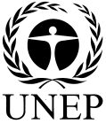 |  | CBD
 |  |  |  | Distr.  GENERAL  UNEP/CBD/COP/11/INF/48  1 October 2012  ORIGINAL: ENGLISH
CONFERENCE OF THE PARTIES TO THE CONVENTION ON BIOLOGICAL DIVERSITY
Eleventh meeting
Hyderabad, India, 8-19 October 2012
The LifeWeb Initiative: A review of progress and options for the future
Note by the Executive Secretary
- introduction
- LifeWeb is a financial mechanism launched at CBD COP 9 in Bonn to speed implementation of the CBD Programme of Work on Protected Areas (PoWPA). LifeWeb has been reinforced by subsequent decisions including IX/18 and X/31 on Protected Areas, X/32 on Sustainable use of biodiversity, X/6 on Poverty eradication and development and X/33 on Biodiversity and climate change.

- This document is intended as a review of the LifeWeb Initiative with suggested strategies to improve its effectiveness beyond 2012. The document begins with the background of LifeWeb, progress made during its first phase between 2009 and 2012, reflections on important trends during its first phase and finally, in the last section, suggestions are made for how LifeWeb can be strengthened to deliver maximum benefit and most effectively facilitate achievement of Aichi Target 11 and other aspects of the Strategic Plan for Biodiversity 2011-2020.

- BackGROUND

- Climate change, land degradation and biodiversity loss will become some of the greatest environmental challenges in the next decades, exacerbated by rising temperatures, more erratic rainfall and rising pressure on land and natural resources. As these pressures increase the role of protected areas will become even more critical for ecosystems, leaving them as refuges that can enhance adaptive capacity among species and ensure the continued provision of ecosystem services in the face of changing climatic conditions. Protected areas, the cornerstones of biodiversity conservation, also contribute significantly to human wellbeing and livelihoods and can help countries and vulnerable communities to cope with a wide range of environmental problems and anthropomorphic pressures. Nearly 1.1 billion people worldwide depend on forest protected areas for their livelihoods. Marine and inland water protected areas provide substantial income and food security from fishing for poverty –stricken households. However, protected areas can only fulfill these functions if they are effectively and equitably planned and managed to maintain healthy ecosystems and are recognized as an essential part of not only environmental conservation but also for their pivotal role in social and economic development.

- The Programme of Work on Protected Areas (PoWPA) represents the commitments made by Parties to establish a comprehensive, effectively managed and ecologically representative global network of protected areas as a conduit for achieving Aichi Target 11 as well as several other related Aichi Targets. Based on publically available data, it is estimated that an expanded and effectively managed protected area network covering 17% of the land and 10% of the sea (Aichi Target 11) will cost about US$270 billion (about US$33.75 billion annually). Although this figure may appear daunting, the benefits and value to all life on earth, now and the generations to come, of such an investment is a clear bargain.

- Sustained and concerted effort implementing the PoWPA by improving and expanding national and regional systems of protected areas must take into account ecosystems with a special relevance for natural carbon storage, climate change adaptation, food and water security as well as several other ecosystem services and benefits vital to ensure human well-being and sustainable development. Supporting countries to implement the PoWPA can be a crucial strategy in the achievement of the Millennium Development Goals (MDGs), the successful implementation of plans for Reducing Emissions from Deforestation and Forest Degradation (REDD plus), the Bonn Restoration Challenge, and the Aichi Biodiversity Targets. During the 9th Conference of the Parties (COP 9) the LifeWeb Initiative was proposed, with full support of all Parties in response to the current lack of sufficient support for protected areas and lack of recognition for the important role they play in meeting environmental, social, and economic goals.

- The CBD LifeWeb Initiative’s goal, complementary with Article 20 of the Convention on Biodiversity (CBD) on Financial Resources, is to help facilitate and catalyze new and additional financial support for national activities which are intended to achieve the objectives of the Convention, in accordance with its national plans, priorities and programs. In particular, LifeWeb works towards strengthening implementation of the CBD Programme of Work on Protected Areas (PoWPA). The LifeWeb Initiative is not a fund in itself where applicants can request funding but it offers a platform where partners can join and build support on a bilateral basis. LifeWeb requires no fee to be paid by recipients, nor does it take any overhead from protected areas funding that it facilitates.

- The specific objectives of the LifeWeb initiative have been to:

- Facilitate partnerships for financing the expansion and effective management of protected areas and national implementation of the PoWPA, in particular for its contribution to climate change mitigation and adaptation and livelihood security of vulnerable communities;

- Enable Parties and indigenous and local communities to publish proposals for the establishment and improved management of protected areas along with the respective needs for financing and international support at a central, easily accessible and clearing-house information platform;

- Provide Donors (donor countries, non-governmental organizations, private sector, foundations, development banks) with a comprehensive overview of concrete funding needs to enable them to better focus and coordinate their support;

- Help build global awareness of the value of protected areas for addressing climate change and other environment, social, and economic goals.

- The benefits of LifeWeb are:

- Facilitation of funding matches.

The LifeWeb Coordination Office offers capacity to generate Expressions of Interest that are consistent with recipient priorities as well as donors’ geographic and thematic focus. It also identifies potential matches and brings these to the attention of donors.

- Assistance to recipients in locating co-financing through donor roundtables.

Opportunities are identified to cost share Expressions of Interest and are brought to the attention of donors for their consideration. This is coordinated through donor roundtables convened or co-convened by the CBD Secretariat.

- A user-friendly clearing house of expressions of interest for viewing recipient priorities.

Expressions of Interest are submitted to the LifeWeb clearing house by national governments. In accordance with the Secretariat’s Programme of Work on Protected Areas, submissions are based on national priorities for ecological representation, management, and sectoral integration.

- Recognition of donor support and innovation for natural solutions.

All financial support provided in association with LifeWeb is monitored by the CBD Secretariat and is therefore actively profiled at various high level intergovernmental for a. Donor support is also aggregated to track overall expenditure and progress toward internationally agreed goals. In order to provide international guidance and inform policy debate, experience gained from concrete projects implemented in association with the LifeWeb will be drawn from.

- Use and strengthening of existing financing mechanisms.

Funding flows directly from donor to recipient through existing development cooperation mechanisms.

- Shaping of international guidance and policy debate.

Lessons learned from project implementation are used to develop international guidance and policy debate associated with the Convention on Biological Diversity.

- Consistency with the Paris Declaration on Aid Effectiveness

- Ownership: recipient governments profile their needs based on national priorities
- Alignment: donors enabled to align their support behind the priorities conveyed.
- Harmonization: Open and simultaneous access to needs enables coordinated support.
- Results: protected areas provide natural solutions to address climate change and livelihoods.
- Mutual Accountability: the Programme of Work on Protected Areas enables reporting and tracking progress on results.

PROGRESS of the LifeWEB Initiative IN PHASE I (2009-2011)
- The first phase (2009 to 2011) of the LifeWeb Initiative has been highly successful with 78 countries and 17 donor agencies participating and profiling the needs of 102 protected area projects totaling approximately €648 Million Euros. The LifeWeb has helped facilitate 62 funding matches totaling close to 200M Euros for the expansion and strengthening of national and regional protected area systems (see Figure 1).

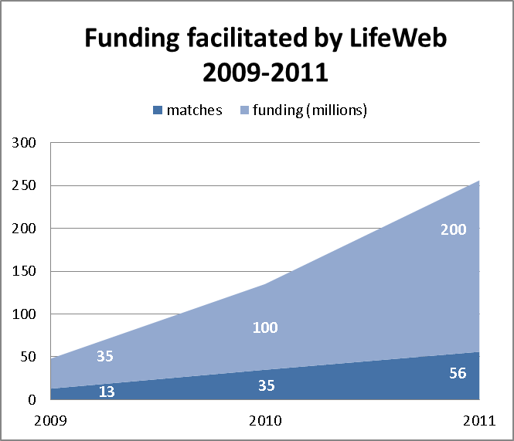

Figure 1. Funding facilitated by LifeWeb, 2009-2011

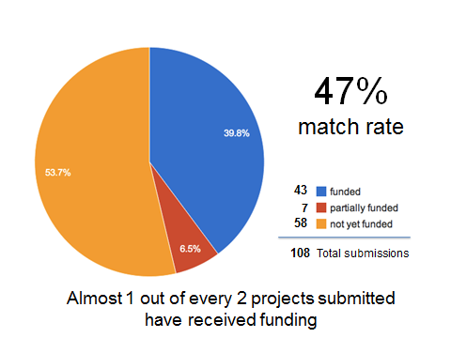

Figure 2. Match rate for CBD LifeWeb Initiative

- The majority of LifeWeb matched projects have contributed towards achieving developmental goals in many developing countries.

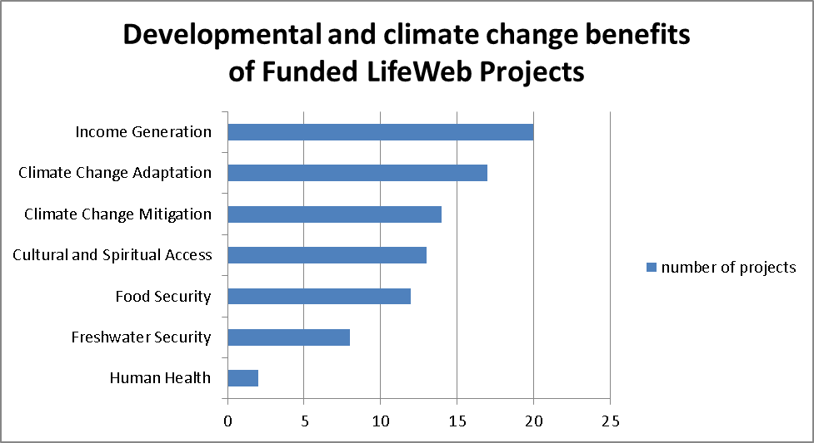

Figure 3. Funded LifeWeb projects by PA benefits

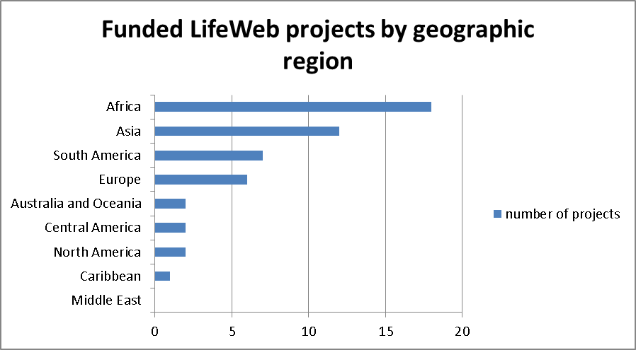

Figure 4. Funded LifeWeb projects by geographic region

- LifeWeb funding matches to-date have focused significantly on improving the effective management of protected areas in order to help secure the vital ecosystem services that great improve human health and well-being for human and wildlife populations, in particular, for vulnerable communities and indigenous people in developing countries.

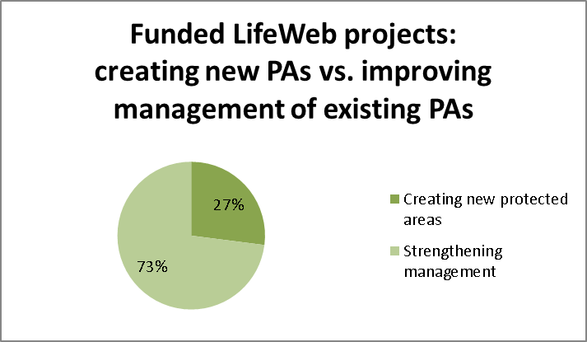

Figure 5. Focus of funded LifeWeb projects

MOVING TOWARD a second phase of LifeWEB

- LifeWeb welcomes participation of Parties and partners in a consultative process to define phase two of the initiative. Reflecting on the first phase of LifeWeb (2009-2011) there have been several trends and shifts noted for consideration that inform the work ahead:

Moving towards improving country ownership and capacity of protected area projects

- In the initial phase of the LifeWeb Initiative there was a sense of urgency to build up a strong user base, enlisting the active participation of Parties and donor agencies and partners in a relatively short time period. Initially, NGO’s and other important implementing agencies and more agile partners were first to respond with interest and participation in the initiative. This support has been vital in helping increase country capacity which has been reflected in greater country ownership and initiation of new project funding needs and submissions profiled on the LifeWeb platform. As LifeWeb mechanisms are becoming better established and refined LifeWeb has received much greater interest and participation of Parties in submitting their own funding needs in accordance with their national plans, priorities and programmes to meet the objectives and commitments to the CBD.

Focusing on more strategic PoWPA implementation

- During the first phase of the LifeWeb Initiative there was significant progress and improvement made by Parties in articulating their financial needs to implement the Programme of Work on Protected Areas (PoWPA) and achieve Aichi Target 11. This improvement can be attributed to the concerted follow up after the landmark COP 10 Protected Area decisions (X/31) and the subsequent capacity building efforts supported by the CBD’s PoWPA regional workshops. The capacity building, supported by LifeWeb, invited Parties to develop PoWPA Action Plans, as part of the NBSAP revision process and use these Action Plans as the main policy document to access their national budgets, streamline access to GEF allocations, as well as bilateral and multilateral funding. These Action Plans can be used to promote national priorities and align technical support from partners for PoWPA implementation. The PoWPA Action Plans are a useful tool to achieve a more effective, strategic and regionally coordinated effort in protected area implementation. Since LifeWeb supports and promotes projects that are firmly based on national action plans Parties who complete detailed PoWPA Action Plans will be better positioned to make use of LifeWeb’s services to mobilize resources and attract funding for protected areas and PoWPA implementation.

Moving from site-based and subnational to national and regional scale projects

- As Parties complete key PoWPA assessments and articulate their needs based on strategic long term planning (NBSAPs and PoWPA Action Plans) a more accurate picture of the total funding required for achieving PoWPA commitments and Aichi Targets for the entire national protected areas systems becomes possible. In recognizing an increasing capacity for Parties to effectively manage their own protected areas systems, LifeWeb has encouraged national and regional submissions of comprehensive funding needs from Parties as the basis for LifeWeb Financing Roundtable discussions aimed at bolstering commitment and political will by elevating the protected areas agenda among sectors and by coordinating and leveraging funding from multiple donors, in the hope that long term and new donor cooperation and strategic and effective investment in protected areas systems is made.

Moving from the CBD Programme of Work on Protected Areas to the 2011-2020 Strategic Plan for Biodiversity

- The CBD LifeWeb Initiative was developed to strengthen and speed the pace of implementation of the Programme of Work on Protected Areas. The 2011-2020 Strategic Plan for Biodiversity and 20 Aichi Targets, agreed at COP10 in Nagoya, Japan in 2010, defined a new blueprint for stemming biodiversity loss by 2020. Aichi Biodiversity Target 11 specifically identifies the need to expand and improve management of protected area systems to at least 17% of terrestrial and inland water habitats and 10% of marine areas globally. The 20 Aichi Targets overlap in regards to geographies, biomes and approaches for implementation so that taking a holistic approach to achieving them is essential and efficient. There are currently a number of different priority actions from PoWPA Action Plans identified by Parties as they relate to relevant Aichi Biodiversity Targets (see Figure 6).

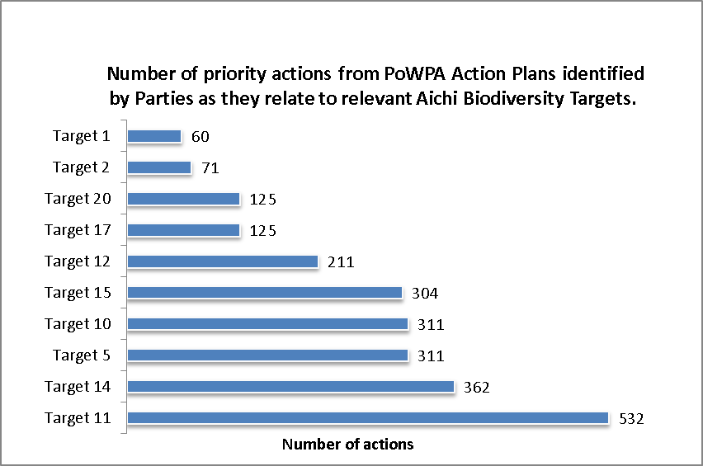

Figure 6. LifeWeb Priority Actions from PoWPA Action Plans

strategies to strengthen LifeWeb in its second phase for consideration by parties
- Taking note of the 4 trends above and in particular, the opportunity that exists with the agreement in Nagoya on the 2011-2020 Strategic Plan for Biodiversity, the following are potential modifications to the CBD LifeWeb Initiative. By their listing in this information document, the CBD LifeWeb Initiative Coordination Unit is seeking advice and comment to guide the work ahead in the next phase of LifeWeb.

More closely align the CBD LifeWeb Initiative with the Strategic Plan for Biodiversity 2011-2020 and support area-based conservation targets.

- Building upon its strengths in supporting protected area conservation projects and recognizing the agreement in Nagoya at CBD COP 10 on the 2011-2020 Biodiversity Strategic Plan, LifeWeb in Phase II can more closely align with the Strategic Plan and support several interrelated area-based Aichi Targets. These targets include 5 (on habitats), 10 (on coral reefs and other ocean habitats), 11 (on protected areas), 12 (on preventing extinctions), 13 (on plant diversity), 14 (on ecosystems) and 15 (on ecosystem resilience and restoration). Assisting with the implementation of area-based conservation targets builds upon the strengths of LifeWeb that currently focuses on protected areas. As LifeWeb in Phase I had the strong technical support of the “PoWPA Friends” group, successful implementation of LifeWeb in Phase II with a wider remit would require strategic partnerships with various institutions and UN agencies.

More closely align CBD LifeWeb with National Biodiversity Strategies and Action Plans (NBSAP) revision process so that country needs can easily be expressed as LifeWeb Expressions of Interest.

- LifeWeb can play critical roles at key junctures in the articulation and implementation of NBSAPs (see ). Beginning with the NBSAP revisioning, LifeWeb can work with Parties to articulate their priority needs as Expressions of Interest compatible with known donor interest. Priority needs can then be profiled at high level events and through other CBD-led processes. LifeWeb can match donors with national needs through roundtables, the clearinghouse website and through direct discussions. Lastly, successful implementation of priority actions can be showcased through events coordinated by LifeWeb at CBD meetings including at Conferences of the Parties.

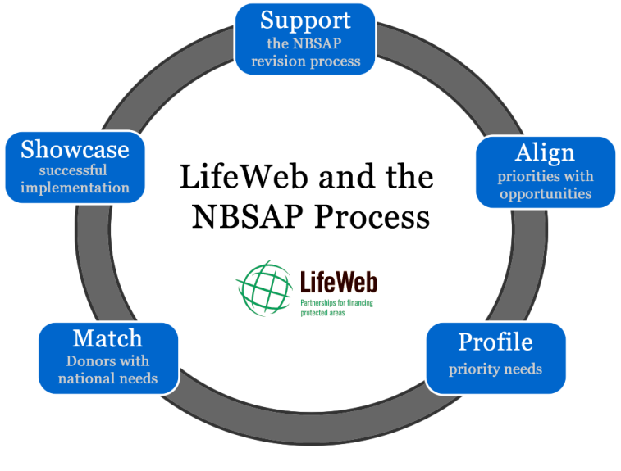
Figure 7. LifeWeb assistance to NBSAP process.

Develop further alignment between CBD LifeWeb Initiative and Overseas Development Aid processes and instruments

- Donor funding cycles vary depending upon the nature of the donor (public, private, etc.) and the type of need the donor is responding to. Alignment of LifeWeb with ODA processes will require comprehensive understanding of national development strategies, institutions and procedures and funding opportunities.

Improve quality of tools, guidance and procedures for the development of LifeWeb Expressions of Interest

- Improvements can include the further development of documentation and guidance to parties on procedures for submission of expressions of interest to ensure they are kept up to date and further updates to the LifeWeb Carbon Calculator (http://www.cbd.int/lifeweb/carbon/) incorporating the latest data and information.

Broaden and strengthen LifeWeb donor support and develop other strategic partnerships

- Increasing the number of Donor Partners that align their funding with national priority actions profiled by the LifeWeb Initiative will be a major focus for the second phase of LifeWeb. Donors of interest include multinational, national and subnational aid agencies, business and foundations. Additional strategic partnerships will also be pursued with other UN agencies, development banks, NGOs, etc.

Comments and advice on potential changes to LifeWeb are welcomed and should be sent to lifeweb@cbd.int.

