 |  | CBD
 |  |  |  | Distr.  GENERAL  UNEP/CBD/COP/11/INF/14  17 September 2012  ORIGINAL: ENGLISH
CONFERENCE OF THE PARTIES TO THE CONVENTION ON BIOLOGICIAL DIVERSITY
Eleventh meeting
Hyderabad, India, 8-19 October 2012

Item 6.2 of the provisional agenda*

WORKING RELATIONSHIP BETWEEN THE UNITED NATIONS FRAMEWORK CONVENTION ON CLIMATE CHANGE AND THE INTERGOVERNMENTAL PANEL ON CLIMATE CHANGE

Note by the Executive Secretary

I. INTRODUCTION
- At its sixteenth meeting, the Subsidiary Body on Scientific, Technical and Technological Advice (SBSTTA) discussed issues, modalities and options for collaboration with the Intergovernmental Science-Policy Platform on Biodiversity and Ecosystem Services (IPBES) on the basis of the analysis by the Executive Secretary contained in the note (UNEP/CBD/SBSTTA/16/2) on this issue.
- In addition to its various recommendations made to the Conference of the Parties with respect to the work of SBSTTA in relation to IPBES (see SBSTTA recommendation XVI/1), SBSTTA initiated a consultation process on how requests from the Convention would be conveyed to IPBES, and requested the Executive Secretary to prepare proposals on that basis. The views submitted, along with the proposals, have been elaborated in document UNEP/CBD/COP/11/19/Add.1.
- As noted in the latter document, the Secretariat reviewed the working relationship between the United Nations Framework Convention on Climate Change (UNFCCC) and the Intergovernmental Panel on Climate Change (IPCC). The Conference of the Parties to the UNFCCC has delegated to the UNFCCC’s Subsidiary Body on Scientific and Technical Advice (SBSTA) the responsibility of requesting assessment reports and other work from IPCC and of considering IPCC outputs.
- Section II of the present note briefly summarizes the role of IPCC. Section III provides a brief overview of the working relationship between UNFCCC and IPCC.

II. ROLE OF IPCC
- Established in 1988 by the United Nations Environment Programme (UNEP) and the World Meteorological Organization (WMO), the IPCC predates UNFCCC by four years. The IPCC played an important role in the creation of UNFCCC and contributed many inputs towards the formation of the Kyoto Protocol.
- The IPCC is the most important source of scientific, technical and socioeconomic information on climate change for UNFCCC. It plays a central role in preparing regular assessment reports of published scientific information on climate change and in communicating these assessments to the Convention. In addition to its regular assessment reports, IPCC prepares special and technical reports, including methodology reports/guidelines, on topics that require in-depth scientific technical assessment, upon request from UNFCCC or other international organizations and conventions.
- The IPCC is funded in part by annual contributions provided by UNFCCC. The funds are deposited to the IPCC Trust Fund in support of the work it conducts on behalf of UNFCCC. The UNFCCC financial contributions to IPCC are contained within the Scientific and Technical Programme of the Core Budget. Additional complementary voluntary contributions are also sought.
- Cooperation between UNFCCC and IPCC has been achieved without a memorandum of understanding between UNFCCC and IPCC.
- Figure 1 below provides the UNFCCC organizational chart demonstrating SBSTA as a link between IPCC and the Conference of the Parties to UNFCCC.

III. OVERVIEW OF THE UNFCCC AND IPCC WORKING RELATIONSHIP
- At its first meeting, in 1995, the Conference of the Parties to UNFCCC considered the mandate and functions of the Convention’s SBSTA and of the Subsidiary Body on Implementation (SBI), including those in relation to the IPCC, in its decision 6/CP.1.
- The Conference of the Parties invited SBSTA and SBI to submit proposals for future cooperation between themselves and IPCC, and delineated certain functions to be carried out by SBSTA and SBI. For example, functions to be carried out by SBSTA included summarizing and converting information from the IPCC into forms appropriate to the needs of the Conference of the Parties (COP), in addition to seeking methodologies from IPCC. Both subsidiary bodies subsequently considered the decision.
- In its consideration, SBI, at its first session, concluded that in order to avoid duplicating work, cooperation with IPCC should be addressed by SBSTA.
- As noted on the UNFCCC website: “SBSTA plays an important role as the link between the scientific information provided by expert sources such as the IPCC on the one hand, and the policy-oriented needs of the COP on the other. It works closely with the IPCC, sometimes requesting specific information or reports from it, and also collaborates with other relevant international organizations that share the common objective of sustainable development.”
- At its first session, SBSTA:
- Identified a preliminary list of areas in which it could draw upon the assistance of the IPCC to provide the Conference of the Parties with timely advice on scientific and technical issues;
- Requested its Bureau to hold joint meetings with the Officers of IPCC and to report to each of its sessions on the outcome of these meetings;
- Agreed it needed to work closely with the IPCC to identify specific proposals for jointly agreed tasks and consider time frames for implementation and financial implications, including contributions to IPCC from the UNFCCC budget.
- At its second session, SBSTA:
- Established time frames and joint tasks for IPCC; and
- Requested the UNFCCC Secretariat to take the above-mentioned activities as the basis for the financial contribution to the IPCC.
- At its second meeting, in 1996, the Conference of the Parties to UNFCCC welcomed the commitment of IPCC to undertake the work programme proposed by SBSTA and urged increased cooperation with IPCC.
- Over the years, the Conference of the Parties to UNFCCC has created a framework for cooperation between itself, SBSTA and IPCC that is premised on flexibility. The framework allows the necessary flexibility for SBSTA to submit scientific and policy relevant requests to IPCC. It also maintains the possibility for the UNFCCC to directly communicate requests to IPCC as necessary.
- SBSTA and the Conference of the Parties have invited assessment reports, technical papers, special reports and workshops and expert meetings, methodologies and guidelines from the IPCC. The IPCC, while assessing available information on the science, the impacts, the economics of, and the options for mitigating and/or adapting to climate change, also provides, on request, scientific, technical, and socioeconomic advice to the Conference of the Parties to UNFCC. The Chairman and/or Secretary of the IPCC, as appropriate, usually provide statements to the Conference of the Parties and/or SBSTA.
- The SBSTA and Conference of the Parties respond to IPCC reports and other products in different ways, for example, by recognizing, considering, taking note, expressing appreciation, encouraging Parties to make use of the information or recommending the use of respective IPCC Guidelines.

- All in all, the working relationship between UNFCCC and IPCC is viewed as successful because ultimately it has allowed the Conference of the Parties to UNFCCC and SBSTA to better fulfill their respective mandates.
Figure 1
UNFCCC organizational chart indicating SBSTA as a link between the IPCC and the COP.
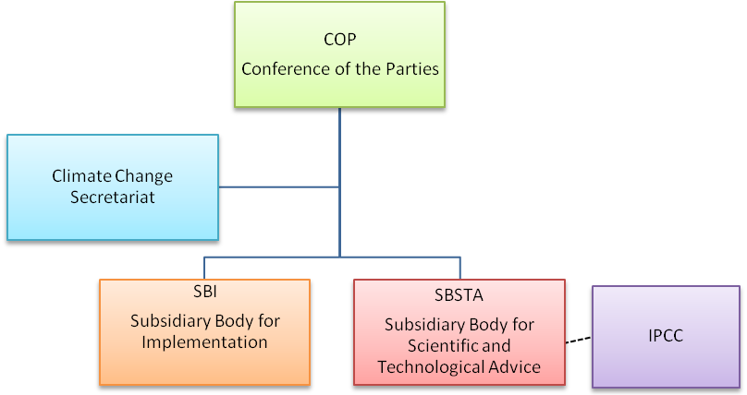

* UNEP/CBD/COP/11/1.
Intergovernmental Panel on Climate Change website (accessed 26 June 2012) (http://www.ipcc.ch/organization/organization_history.shtml).
See annex I (Functions to be carried out by the Subsidiary Bodies) to decision 6/CP.1 (UN Doc FCCC/CP/1995/7/Add.1, 6 June 1995).
See decision 6/CP.1 (The subsidiary bodies established by the Convention) (UN Doc FCCC/CP/1995/7/Add.1, 6 June 1995).
See annex I to decision 6/CP.1 above.
See report of the first SBI session (section III, on elaboration and scheduling of the programme of work) (UN Doc FCCC/SBI/1995/5, 10 October 1995).
See annex (Initial list of items on which the Intergovernmental Panel on Climate Change could provide input to the Subsidiary Body for Scientific and Technical Advice) to the report of the first SBSTA session (UN Doc FCCC/SBSTA/1995/3, 5 October 1995).
See para. 24(c) (in section B, Cooperation with competent international bodies including the Intergovernmental Panel on Climate Change) of the report of the first SBSTTA session (UN Doc FCCC/SBSTA/1995/3, 5 October 1995).
Ibid, para. 24(e).
See annex III (Initial list of items on which the Intergovernmental Panel on Climate Change could provide input to the Subsidiary Body for Scientific and Technical Advice) to the report of the second SBSTA session (UN Doc FCCC/SBSTA/1996/8, 25 April 1996).
See para. 40 (in section B, Cooperation with the Intergovernmental Panel on Climate Change) of the report of the second SBSTA session (UN Doc FCCC/SBSTA/1996/8, 25 April 1996).
See decision 6/CP.2 (Second Assessment Report of the Intergovernmental Panel on Climate Change) (UN Doc FCCC/CP/1996/15/Add.1, 29 October 1996).
See decision 6/CP.2 and report annex (The Geneva Ministerial Declaration) (UN Doc FCCC/CP/1996/15/Add.1, 29 October 1996); and paras. 28-30 (in section IV A, Consideration of the Second Assessment Report of the Intergovernmental Panel on Climate Change) of the report of the second SBSTA session (UN Doc FCCC/SBSTA/1996/8, 25 April 1996).
See Article 7 and Article 9 of the United Nations Framework Convention on Climate Change.
Adapted from the diagram produced on the UNFCCC at: http://www.grida.no/publications/vg/climate/page/3068.aspx (accessed 4 September 2012).

