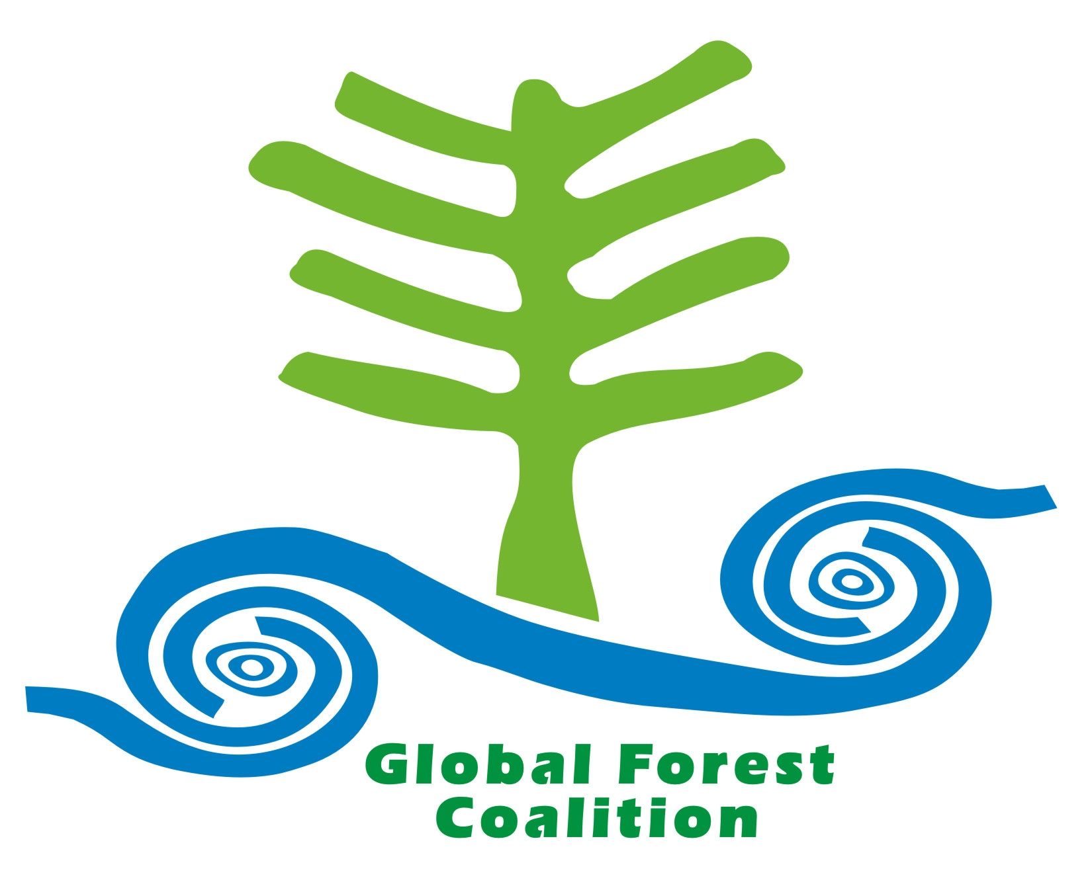

Climate Change, Forest Conservation and Indigenous Peoples Rights
Briefing paper prepared by Estebancio Castro Diaz

Introduction

According to the United Nations Environmental Programme (UNEP), eighty per cent of the world’s biodiversity is found in rainforests. Most of these rainforests are the traditional land and territories of Indigenous Peoples, which they either reside in or have previously used or occupied. Indigenous Peoples have nurtured and maintained their lands and territories which has in turn protected large areas in which these resources are located. The role of Indigenous Peoples is very important in any discussion related to their environment and resources. As the United Nations expert on human rights, Madame Erica Daes stated in her study on land “Indigenous peoples have a distinctive and profound spiritual and material relationship with their lands and with the air, waters, coastal sea, ice, flora, fauna and other resources. This relationship has various social, cultural, spiritual, economic and political dimensions and responsibilities.”

Article 1 of the United Nations Declaration on the Right to Development states that:

1. The right to development is an inalienable human right by virtue of which every human person and all peoples are entitled to participate in, contribute to, and enjoy economic, social, cultural and political development, in which all human rights and fundamental freedoms can be fully realized.
2. The human right to development also implies the full realization of the right of peoples to self-determination, which includes, subject to the relevant provisions of both International Covenants on Human Rights, the exercise of their inalienable right to full sovereignty over all their natural wealth and resources.

This indicates that the right to self determination and permanent sovereignty of Indigenous Peoples over their natural resources has to be taken into account in every deliberation related to their lands, territories and resources. The right to development is also reiterated in the newly adopted UN Declaration on the Rights of Indigenous Peoples.

However, despite recent developments in international law in relation to Indigenous Peoples rights, Indigenous Peoples still have limited or in some instances no participation in the decision-making processes of the United Nations Framework Convention on Climate Change (UNFCCC). The UNFCCC instigated negotiations between Member Parties to explore ways and means to reduce emissions of deforestation and degradation in developing countries (REDD). These negotiations have taken place and continue to take place without any meaningful participation by Indigenous Peoples. Yet Indigenous Peoples rights and their experience in sustainable forest management mean that their participation in these fora is imperative, in the REDD discussions or any other discussions relating to environmental protection.

This discussion paper will argue that Indigenous Peoples full and effective participation at the UNFCCC must transpire. It will also illustrate international Indigenous Peoples human rights law briefly; and provide Indigenous Peoples’ perspectives on UNFCCC climate change adaptation and mitigation policies, especially in relation to REDD implementation on Indigenous lands and territories.

UNFCCC and REDD

There is a collective agreement between Member Parties in relation to the importance of forest conservation for the mitigation of and adaptation to climate change. Member Parties that ratified the UNFCCC have agreed that they shall conserve and enhance forests and other sinks and reservoirs of greenhouse gases. The UNFCCC also obliges developed countries to provide financial assistance to developing countries to achieve these and other obligations. However, despite the identification of the contribution of forest conservation to combating greenhouse gas emissions, global deforestation and forest degradation rates remain high.

The Global Forest Coalition’s (GFC) submission to the UNFCCC Secretariat in March 2007 expressed its views on deforestation and forest degradation. It pointed out that “Unsustainable forest management is the main cause of forest degradation, while the conversion of forests into agricultural land is by far the main cause of deforestation. The expansion of large-scale agro-industrial monocultures for food, fiber and, increasingly, energy production is both an important direct cause of deforestation and an important underlying cause of forest loss; the expansion of monocultures on existing arable land causes cattle ranching and other forms of agriculture to move towards forest areas and other natural ecosystems.”
Deforestation, forest degradation and lack of appropriate legal frameworks are some of the major sources of human rights violations and displacement of Indigenous Peoples from their lands, territories and resources, including forests. Most Indigenous Peoples’ communities rely on forests. Indigenous Peoples use of their environment takes into account the need to preserve the environment for future generations. The Mumbai initiative emphasizes that “Indigenous Peoples and other forest dependent communities living in and using forests for their survival needs are the true protectors and governors of these forests and enjoy inalienable rights over their forests”.

All existing policies and mechanisms and any future developments within the UNFCCC must provide for the engagement of Indigenous Peoples at all levels and in all processes where the reduction of emissions from deforestation and forest degradation and climate change mitigation is being discussed and negotiated. Indigenous Peoples’ views have not been taken into account in discussions where their livelihoods will be directly or indirectly affected. This lack of engagement also leads to the violation of Indigenous Peoples’ economic, social and cultural rights.

A recent example of Indigenous Peoples’ absence in these fora occurred at the UNFCCC at Bali. Indigenous Peoples who were present responded through the International Forum of Indigenous Peoples on Climate Change (IFIPCC) as follows: “We, Indigenous Peoples, have addressed our concerns to the UNFCCC Conference of the Parties since SBSTA 13 in Lyon, France, 2000. However, despite years of experience and efforts to participate in this process, and despite also the resounding support and approval this year of the United Nations Declaration on the Rights of Indigenous Peoples, we are profoundly disappointed that, even as the United Nations’ Second International Decade of Indigenous Peoples begins, Member Parties are still ignoring our demands and contributions and we have even been shut out of this Bali process.”

Indigenous Peoples also reiterated in Bali that Member Parties need to recognize and take effective action to reduce the adverse impacts of climate change on Indigenous Peoples, in particular by considering their adaptation and mitigation schemes and projects. Current proposals for REDD as a solution to climate change, especially where they are based on the inclusion of REDD initiatives in the global carbon market, will devastate Indigenous Peoples’ lands and territories and will cause more human rights violations. Market-based mechanisms like carbon trading, agrofuels and especially voluntary carbon offset projects designed to avoid deforestation often violate the fundamental human rights of Indigenous Peoples.

Member Parties to UNFCCC should also note that the replacement of natural forests by monoculture tree plantations is a form of deforestation and is a significant source of greenhouse gas emissions. In tropical areas, monoculture plantations store at best one-quarter of the carbon stored by natural forests. It is essential that efforts to reduce emissions from deforestation address the emissions caused by the direct or indirect replacement of forests by monoculture plantations. If the political discussion is limited to deforestation, it is important to change the definitions that are used so that the emissions caused by this replacement are taken into account.

In order to reduce emissions from deforestation and forest degradation, deforestation must be banned. In Paraguay, a country plagued by problems of bad governance and impunity, the government succeeded in reducing deforestation by at least 85% in the eastern half of the country between May 2004 and May 2005, thanks to a legally straightforward deforestation moratorium combined with very modest investments in GIS forest monitoring technology and systematic law enforcement based on the satellite information gathered.

Costa Rica and many European countries have used deforestation bans and satellite monitoring as an effective and cheap mechanism that can effectively halt and even reverse deforestation. In Costa Rica the presumed success of the first Payment for Environmental Services scheme (PES) was mainly the result of a deforestation ban that was introduced simultaneously. However, the Costa Rican government tends not to recognize the fact that the scheme was actually accompanied by a nation-wide deforestation ban when it was introduced.

Carbon Markets and Indigenous Peoples’ Rights

The inclusion of REDD initiatives in global carbon markets will impact on Indigenous Peoples rights. For example, PES schemes may impact negatively on land reform campaigns and campaigns to obtain recognition of land titles. Indigenous Peoples have expressed concern that PES systems might lead to (and indeed are already leading to) increased land pressure and a subsequent inflationary impact on land prices. This in turn might make political campaigns for Indigenous land rights and land reform more complicated, as large landholders have an increased incentive to hold on to their land.

Furthermore, if national legal frameworks to protect Indigenous Peoples’ lands are non-existent or are not enforced, the situation could arise whereby those wishing to implement REDD initiatives choose whom they wish to deal with. International REDD transfers will not always find a legitimate and functional land user to receive carbon protection payments. Paying the wrong people could create perverse incentives to threaten to clear even more forest.

The impact of REDD initiatives on Indigenous Peoples’ rights raises a complex set of issues. Member Parties must commit to addressing these both at the international and national level. To do otherwise would lead to the exploitation of their Indigenous citizens.

REDD will impact on Indigenous Peoples

The UN definition of forests includes plantations. This allows the replacement of forest with plantations in the name of climate change. This is hugely detrimental to Indigenous Peoples not only because of the loss of the forest itself, but also because of the impact of pesticides used in monoculture tree plantations on people’s health and the biodiversity on which they rely. It is also extraordinarily detrimental to the climate, as evidenced by research from the Consultative Group on International Agricultural Research (CGIAR)'s showing that untouched primary forest stores significantly greater quantities of carbon than either plantations or logged forests. Even its most conservative estimates indicate that plantations store only 20% of the carbon in untouched old growth forest. This shows how counterproductive and illogical the inclusion of plantations can be.

If REDD uses carbon trading or other, similar financial mechanisms, to compensate those who stop deforesting, this could also exclude Indigenous Peoples (in the absence of land reform), who are not engaged in this practice and therefore may not qualify for compensation. It will also further marginalizes Indigenous Peoples and especially women, who cannot afford to pay for the environmental services they rely on.

Indigenous Peoples’ Rights

It is fundamental to acknowledge specific human rights instruments that are relevant to Indigenous Peoples, their healthy environment, and their economic, social and cultural development. As the Global Consultation identified “the failure to respect the rights of peoples to self determination, the adoption of inappropriate development strategies and the failure to take into account the principles of the Declaration on the Right to Development in agreements between States and international financial institutions, inter alia, as serious obstacles in the implementation of the right to development.”

It has been eighteen years since this statement was made. However, Indigenous Peoples continue to face the direct and indirect consequences of new and old development schemes. The United Nations estimates that the REDD scheme will become a US$100 billion market. Indigenous Peoples and forest dependant communities need to be aware of the future consequences of this scheme and their fundamental rights must be enshrined in national law.

The International Covenant on Economic, Social and Cultural Rights (ICCPR) was adopted by General Assembly resolution 2200 A (XXI) on 16 December 1966 and entered into force in March 1976. Article 12(1)(2) affirms that States must recognize the right of everyone to the enjoyment of the highest attainable standard of physical and mental health. It also necessary that steps are taken to achieve the full realization of this right which shall include “the improvement of all aspects of environmental and industrial hygiene”.

The International Covenant on Civil and Political Rights (IESCR) was adopted by General Assembly resolution 2200 A (XXI) on the same day as the ICCPR and came into effect on the same day also. Article 1 states “all peoples have the right of self-determination. By virtue of that right they freely determine their political status and freely pursue their economic, social and cultural development”.

Article 6(1) states that “every human being has the inherent right to life. This right shall be protected by law. No one shall be arbitrarily deprived of his life”.

Also, article 27 of the IESCR provides that “in States in which ethnic groups, religious or linguistic minorities exist, persons belonging to such minorities shall not be denied the right, in community with the other members of their group, to enjoy their own culture, to profess and practice their own religion, or to use their own language.”

Article 29(e) of the Convention on the Rights of the Child states that “States agree that the education of the child shall be directed to the development of respect for the natural environment.”

Also, article 30 of the same Convention states that “in those States in which ethnic, religious, or linguistic minorities or persons of indigenous origin exist, a child belonging to such a minority or who is indigenous shall not be denied the right, in community with other members of his or her group, to enjoy his or her own culture, to profess and practice his or her own religion, or to use his or her own language.”

With the replacement of native forests by monoculture tree plantations in indigenous lands and territories, Member Parties are already violating both the ICCPR and the IESCR and numerous conventions of the United Nations. Furthermore, pesticides used in monoculture tree plantations also effect Indigenous Peoples’ health and add to the degradation of their lands. If the range of biodiversity is destroyed, the ability of Indigenous Peoples to harvest resources for medicinal and ceremonial purposes will be severely curtailed. For example, the Kuna leader Gilberto Arias stated “the forest is our life and our existence. In the forest we find our food, our medicines, our housing and our knowledge. How can they think that we, the indigenous peoples, could destroy our life, destroying forest? We have used the forest for truly sustainable development, only taking what we need.”

The United Nations Declaration on the Rights of Indigenous Peoples (the Declaration) was adopted by the General Assembly on September 2007 and is the most comprehensive and relevant human rights standard-setting instrument for Indigenous Peoples. The Declaration itself may be not legally binding for States, but it is a reaffirmation of rights that are also found in the UN Charter, both UN Covenants and other legally binding and non-legally binding international instruments relevant to Indigenous Peoples. In order to maintain consistency and comply with emerging international indigenous human rights law, UN agencies must comply with this new instrument. The UNFCCC must include in its discussion articles from the Declaration which are relevant to the REDD discussions, especially articles 10, 26 – 30 and 32.

The main human rights instruments do not necessarily cover or recognize environmental rights. However, environmental rights are still recognized by the two main covenants. Therefore, most of the current proposals for carbon-financed REDD initiatives in Indigenous Peoples’ land, territories and resources as it currently stands will violate article 12(1)(2) of ICECR. Present and future generations have the right to enjoy a healthy life and environment, and a proper quality of life.

Recommendations

- The UNPFII should recommend that the UNFCCC prioritizes bans on deforestation as an important mechanism to reduce greenhouse gases.
- The UNPFII should request that UNFCCC establishes an Expert Group on Climate Change and Indigenous Peoples, with the full and effective participation of Indigenous Peoples. The Expert Group shall include Indigenous Peoples who are experts in this area, such expertise to be determined by experience as well as academic merit.
- The UNPFII should propose that the UNFCCC establishes a Voluntary Fund for Indigenous Peoples’ participation in the upcoming meetings of the UNFCCC.
- The UNPFII should recommend that the UNFCCC facilitates the full and effective participation of Indigenous Peoples in all processes related to climate change and its adaptation and mitigation mechanisms, including any discussion related to forests.
- The UNPFII should recommend that the UNFCCC reject the inclusion of forest-related initiatives in the commercial carbon market.
- The UNPFII should recommend that the UNFCCC parties immediately abandon all forms of political and financial support to large-scale agrofuel production, monoculture tree plantations and other proposed mitigation strategies that destroy Indigenous lands and violate the human rights of Indigenous Peoples.
- The UNPFII should recommend that the UN Food and Agriculture Organization change their definition of forests to exclude plantations.

Conclusion

It has been recognized that the lack of full and effective participation of Indigenous Peoples in the development of any policies, programmes and projects that impact directly on their communities tends to lead to the failure of such projects as well as a loss of biodiversity. In addition, these policies and programmes often contribute to conflicts where Indigenous Peoples are too often the victims. UNFCCC must provide appropriate means to facilitate the full and effective participation of Indigenous Peoples.

Current REDD proposals threaten to damage Indigenous Peoples lands and territories as past and existing development projects have done. For example, the Kuna from the Madungandi area, who provided their lands and territories to create a dam, now live without any electricity or facilities in their communities, thirty years later. However, Panama City benefits from the dam with a constant supply of hydro electricity.

It is imperative that the international community, including but not limited to Member Parties and international agencies, recognize the free prior and informed consent of Indigenous Peoples. In recognizing such consent, Indigenous Peoples will be able to exercise their self determination and their continual responsibility to protect their lands, territories and resources. IFIPCC expressed in SBSTA 27 Agenda 5/REDD that REDD “will increase the violation of our Human Rights, our rights to our lands, territories and resources, steal our land, cause forced evictions, prevent access and threaten indigenous agriculture practices, destroy biodiversity and cultural diversity and cause social conflicts. Under REDD, Member Parties and Carbon Traders will take more control over our forests”.

The historic, cultural, economic and social elements of Indigenous Peoples are important, and Member Parties should take into account Indigenous Peoples’ perspectives in relation to their initiatives, plans and implementation of any programmes, policies and projects at national, regional and international levels. Indigenous Peoples full and effective participation in policies is vital in order to protect their traditional knowledge, world views of their environment, food systems and food sovereignty. The right of self determination and the right to land and territories of Indigenous Peoples must be clearly established and effectively protected.

It is vital that Indigenous Peoples have full and effective participation together with Member Parties to participate in the UNFCCC meetings and deliberations including developing recommendations on climate change and its mitigation and adaptation mechanisms. Policies and processes that will have direct effect on indigenous lands, territories and resources need the effective involvement of Indigenous Peoples in the planning and implementation of initiatives to reduce emissions from deforestation and forest degradation at all levels.

Estebancio Castro Diaz is a Kuna of Panama. He works for Global Forest Coalition. This paper has been prepared for and on behalf of Global Forest Coalition. The Global Forest Coalition is a non governmental organisation made up of Indigenous Peoples organisations and non Indigenous organisations.
See conclusion of the document UNEP/GC.23/INF/23 4 November 2004. Available online www.unep.org
See conclusion of the document E/CN.4/Sub.2/2001/21
As adopted by the General Assembly by resolution 41/128, December 4, 1986. See http://www.unhchr.ch/html/menu3/b/74.htm
“All Parties, taking into account their common but differentiated responsibilities and their specific national and regional development priorities, objectives and circumstances, shall: ...Promote sustainable management, and promote and cooperate in the conservation and enhancement, as appropriate, of sinks and reservoirs of all greenhouse gases not controlled by the Montreal Protocol, including ..., forests ...” (UNFCCC Article 4.1 (d)).
“The developed country Parties and other developed Parties included in Annex II shall provide new and additional financial resources to meet the agreed full costs incurred by developing country Parties in complying with their obligations under Article 12, paragraph 1. They shall also provide such financial resources, including for the transfer of technology, needed by the developing country Parties to meet the agreed full incremental costs of implementing measures that are covered by paragraph 1 of this Article and that are agreed between a developing country Party and the international entity or entities referred to in Article 11, in accordance with that Article. The implementation of these commitments shall take into account the need for adequacy and predictability in the flow of funds and the importance of appropriate burden sharing among the developed country Parties.“ (FCCC Article 4.3)
For the full text of the Mumbai Initiative and more information about this movement go to ^{http://www.wrm.org.uy}
Statement of the International Forum of Indigenous Peoples on Climate Change at the High Level Segment of the 13th Conference of the Parties to the Framework Convention on Climate Change and the 3rdCOP/MOP December 14, 2007
See Global Forest Coalition (March 2008). Potential Policy Approaches and Positive Incentives to Reduce Emissions from Deforestation in Developing Countries A submission to the Secretariat of the Framework Convention on Climate Change
See CENSAT and Global Forest Coalition, 2005. "Life as Commodity", CENSAT, Bogotá
See Seeing REDD to save the forests and the planet, December 14 2007 at ^{www.cifor.cgiar.org}
See Palin et al, ASB Climate Change Working Group, CGIAR, Final report, Phase II, http://www.asb.cgiar.org/pdfwebdocs/Climate%20Change%20WG%20reports/Climate%20Change%20WG%20report.pdf
See www. unhchr,ch/Huridoca/Huridoca.nsf/(Symbol)E.CN.4.1993.16.En?Opendocument
See www.UNFCCC.int/files/meetings/intersessional/awg_4_and_dialogue_4/press/application/pdf/awg4_com_plus_cfm.pdf
See Forest, Indigenous Peoples and Forestry Policy in Panama: an assessment of national implementation of international standards and commitments on traditional forest knowledge and forest related issues by Marcial Arias Garcia.
Statement made by the International Forum of Indigenous Peoples on Climate Change (IFIPCC) The 13th Session of Conference of the Parties to the UNFCCC SBSTA 27, agenda item 5/REDD December 5th, 2007

