
INTERNATIONAL BIODIVERSITY DAY 2007
Biodiversity and Climate Change

The Environmental Protection Agency (EPA), as the National Focal Point for the Convention, coordinated several activities for the commemoration of International Biodiversity Day this year. The television media was involved in most of these activities. Five activities were successfully conducted for International Biodiversity Day.

These were:
- Nature Tour to the Ceiba Biological Research Centre
- A Classroom Discussion for Tour Operators and Customs Officers
- Airing of the CBD video on local television stations
- Appearance on the local morning show, “Guyana Today”
- Panel Discussion on National TV Programme “Close Up”

Nature Tour

A nature tour of the CEIBA Biological Research Centre was held on June 2, 2007. This was done in collaboration with the National Parks Commission (NPC). Thirty students from 15 Environmental Clubs were selected to participate. CEIBA is attempting to minimize biodiversity erosion, preserve a representative sample of white sand forests as well as maintain a laboratory-classroom and other facilities. It is the remnant of a typical Amerindian Village and is involved in programmes of research, education and conservation.

Dr. Godfrey Bourne, a Guyanese scientist currently an Associate Professor at the University of Missouri-St. Louis, USA, and owner of the research centre, gave a brief history of the establishment of the Centre, and emphasized the importance of conservation. Participants were taught about various plant species and basic agricultural techniques.

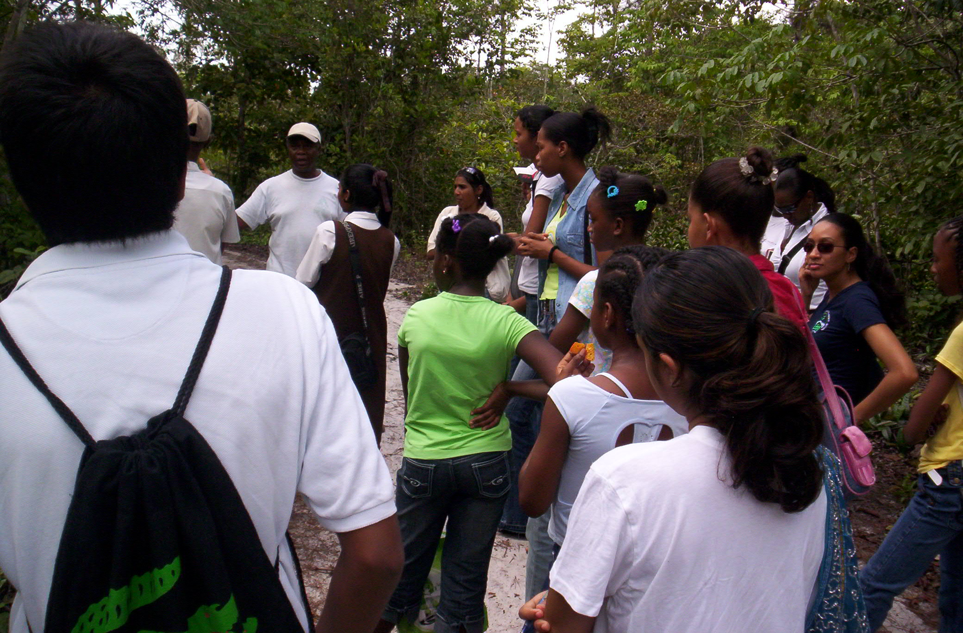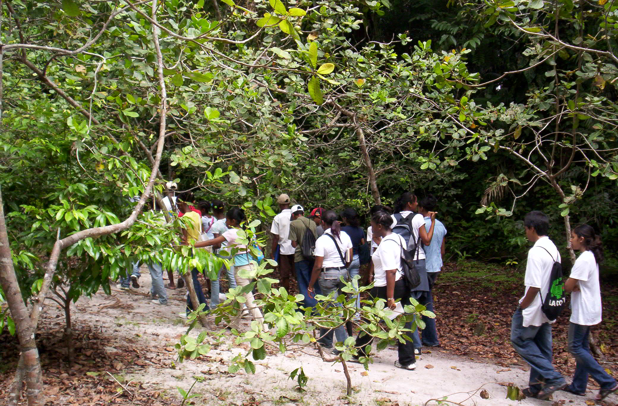
Dr. Bourne gives the students a lecture at The students tour the forest at the Ceiba
the Ceiba Biological Centre. Biological Centre.

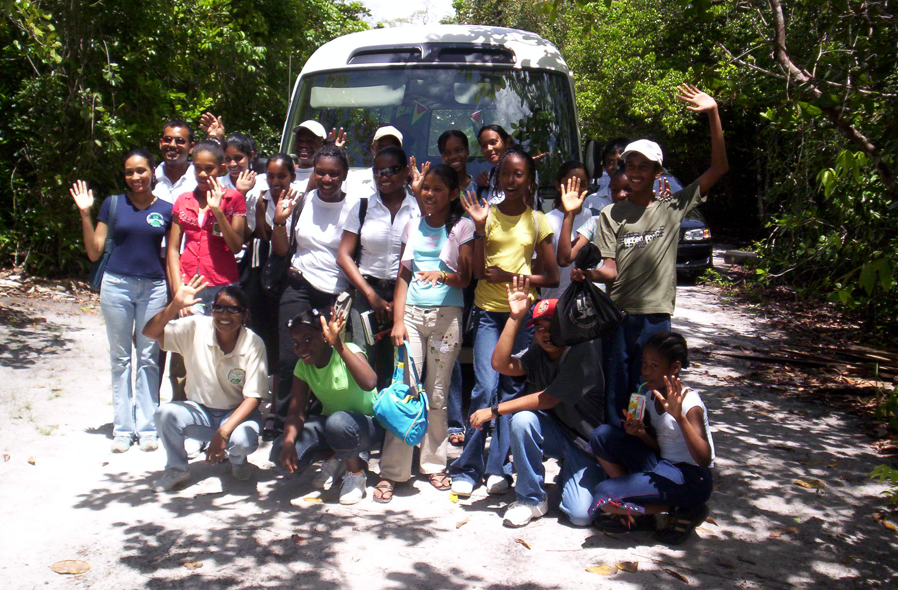
EPA Staff and students at the end of the tour.

Classroom Discussion for Tour Operators and Customs Officers

A Classroom Discussion which targeted Tour Operations in Guyana and Customs and Trade Administration of the Guyana Revenue Authority was held on May 23, 2007.

The Discussion focused on the biodiversity research application and permitting process, the benefits arising from biodiversity research conducted in Guyana, and the role of the public in the process, with an emphasis on Tour Operators and the Customs and Trade Administration.

This activity was planned because it is recognized that Tour Operators and the Customs Department should be informed of the existing national procedures and guidelines. This is mainly because Tour Operators have constant access to the remote areas of Guyana and are often approached by prospective researchers to make arrangements for their research and filming expeditions.

The Customs and Trade Administration is responsible for ensuring that the number and type of specimens listed on the Export Permit issued to Researchers, by the EPA, are reflective of what the Researcher is actually exporting out of Guyana.

Ms. Clydecia McClure and Ms. Chuvika Harilal, Environmental Officers of the EPA, facilitated the Discussion. The group was encouraged to report violations of procedures and guidelines since it is essential as citizens of Guyana that we protect and conserve our resources and encourage equitable access and benefits arising from the use of these resources, which are important to all of us.

Documentary

The CBD Video on Biodiversity and Climate Change was distributed to seven local Television Stations to be aired throughout the course of International Biodiversity Day.

Morning Show and Evening Newscast

Ms. Annie Pitamber, Senior Environmental Officer of the EPA, was interviewed on the Morning Show ‘Guyana Today”. She gave a brief background on the Convention and explained the relationship between Biodiversity and Climate Change. The activities planned for International Biodiversity Day were also highlighted. She was also featured on the evening newscast, along with Ms. Sharifah Razack, Director, Education Information and Training Division.

Panel Discussion

A Panel Discussion was held on the television programme “Close-Up”. Mr. Ramesh Lilwah, Biodiversity Specialist, EPA, Dr. Patrick Chesney, Conservation International-Guyana and Dr. Raquel Thomas, Iwokrama International Centre for Rainforest Conservation, were featured. They discussed the interactions between Biodiversity and Climate Change and emphasized that just as Climate Change affects biodiversity, so changes in biodiversity can also affect the world’s climate. They also highlighted simple ways in which people can adapt to, and mitigate the effects of Climate Change.

